Dataset: Consumer's Buying Behaviour Analysis

Table of Contents
1. PROJECT INTRODUCTION 3
2. ANALYSIS QUESTIONS 4
3. DATA ACQUISITION & CLEANING 6
4. EXPLORATORY ANALYSIS 10
5. DATA VISUALIZATION 19
6. EXECUTIVE SUMMARY & RECOMMENDATIONS 26
References 27
APPENDIX: CODE SUMMARY 28

Table of Figures
Figure 1: Code for importing libraries and loading the dataset 7
Figure 2: Code for data cleaning and verification 8
Figure 3: Code for Question 1 - Statistical Analysis 10
Figure 4: Code for Question 2 - Conditional Filtering 11
Figure 5: Code for Question 3 - Conditional Filtering 12
Figure 6: Code for Question 4 - Grouping Analysis 14
Figure 7: Code for Question 5 - Sorting Analysis 15
Figure 8: Code for Question 6 - Combined Grouping + Sorting 17
Figure 9: Code for Question 7 - Combined Grouping + Statistics 18
Figure 10: Code for Question 8 - Bar Chart Visualization 20
Figure 11: Bar Chart - Purchase Behavior Across Age Groups 21
Figure 12: Code for Question 9 - Pie Chart Visualization 22
Figure 13: Pie Chart - Age Group Distribution 23
Figure 14: Code for Question 10 - Scatter Plot Visualization 24
Figure 15: Scatter Plot - Age vs Salary by Purchase Status 25

1. PROJECT INTRODUCTION

1.1 Project Aim
The aim of this project is to analyse consumer buying behaviour using Python programming in Google Colab. By examining a real-world dataset containing consumer demographic information and purchase decisions, this analysis seeks to identify patterns and relationships that can inform business decision-making.
This project demonstrates competencies in fundamental data analytics, including:
- Loading datasets and performing data cleaning
- Applying filtering, sorting, and grouping techniques
- Conducting statistical analysis
- Creating data visualizations
- Interpreting results and communicating findings

1.2 Dataset Selection
I selected the "Social Network Ads" dataset from Kaggle for the following reasons:
- Appropriate Size: The dataset contains exactly 400 rows, meeting the minimum requirement of 400+ rows.
- Analytical Columns: With Age, EstimatedSalary, and Purchased columns, plus the AgeGroup column created during analysis, the dataset provides sufficient columns for meaningful analysis.
- Clean Data: The dataset has no missing values, allowing focus on analysis rather than extensive cleaning.
- Real-World Relevance: The data represents actual consumer behavior, making findings practical and applicable.
- Not Prohibited: This dataset is neither the NCHS dataset nor the World Happiness dataset.

1.3 Dataset Source
The dataset was obtained from Kaggle, a trusted open data platform:
- Source: Kaggle Datasets
- Dataset Name: Consumer's Buying Behaviour / Social Network Ads
- URL: https://www.kaggle.com/datasets/nitishjolly/consumers-buying-behavior
- Format: CSV (Comma-Separated Values)

1.4 Dataset Structure
Column | Type | Description | Range
Age | Integer | Consumer's age in years | 18 - 60 years
EstimatedSalary | Integer | Estimated annual salary in dollars | $15,000 - $150,000
Purchased | Integer | Purchase decision (0 = Did NOT purchase, 1 = Purchased) | 0 or 1

1.5 Dataset Overview
The dataset contains consumer information with the following characteristics:
Attribute | Value
Total Rows | 400
Total Columns | 3
Missing Values | 0 (Clean dataset)
Duplicate Rows | 33
Average Age | 37.7 years
Average Salary | $69,742.50
Purchase Rate | 35.8%

2. ANALYSIS QUESTIONS

2.1 Overview of Questions
Ten analysis questions were developed to extract meaningful insights from the dataset. These questions are organized by analysis type and are designed to address the project's objective of understanding consumer buying behaviour.

2.2 Detailed Analysis Questions
QUESTION 1: Statistical Analysis
Question: What is the average age and average estimated salary of consumers in the dataset?
Rationale: This establishes a baseline understanding of the typical consumer profile. Understanding the average demographics helps businesses know who their customers are and how to target them.
Decision-Making Value: Helps determine if marketing efforts should focus on specific age or income groups.

QUESTION 2: Conditional Filtering (Multiple Conditions)
Question: How many consumers aged 30-50 with a salary above $50,000 made a purchase?
Rationale: This identifies a high-value customer segment. Consumers in this age range with above-average income represent a premium market.
Decision-Making Value: Helps focus premium product marketing on high-income, middle-aged consumers.

QUESTION 3: Conditional Filtering (Multiple Conditions)
Question: How many consumers aged 25-40 with a salary below $40,000 did NOT make a purchase?
Rationale: This identifies a potential market opportunity. Younger consumers with lower income represent a group that could be converted with appropriate strategies.
Decision-Making Value: Reveals an untapped market segment that could be targeted with affordable products or payment options.

QUESTION 4: Grouping Analysis
Question: What is the average purchase rate grouped by age categories?
Rationale: Age may be a significant factor in purchase decisions. Grouping consumers into age brackets reveals which age groups are most likely to purchase.
Decision-Making Value: Helps allocate marketing budgets to age groups with highest conversion rates.

QUESTION 5: Sorting Analysis
Question: Display the top 10 highest-paid consumers who made a purchase.
Rationale: Identifying high-value customers helps understand the characteristics of premium buyers.
Decision-Making Value: Useful for developing VIP programs and premium product strategies.

QUESTION 6: Combined Grouping + Sorting
Question: For each age group, calculate the purchase rate and sort from highest to lowest.
Rationale: This combines grouping with sorting to rank age groups by performance.
Decision-Making Value: Provides a prioritized list of age segments for marketing focus.

QUESTION 7: Combined Grouping + Statistics
Question: What is the average age and salary of purchasers vs. non-purchasers?
Rationale: Comparing buyer and non-buyer profiles reveals what differentiates those who purchase from those who don't.
Decision-Making Value: Helps develop strategies to convert non-purchasers by addressing differences.

QUESTION 8: Visualization - Bar Chart
Question: Create a bar chart showing the number of purchasers vs. non-purchasers across age groups.
Rationale: Visual representation makes it easier to compare purchase behaviour across age groups.
Decision-Making Value: Quick visual communication of age group performance.

QUESTION 9: Visualization - Pie Chart
Question: Create a pie chart showing the distribution of age groups in the dataset.
Rationale: Understanding the age composition of the consumer base helps in market segmentation.
Decision-Making Value: Shows which age groups represent the largest market share.

QUESTION 10: Visualization - Scatter Plot
Question: Create a scatter plot showing the relationship between Age and Estimated Salary, colored by purchase status.
Rationale: Visualizing the relationship between age, salary, and purchase decisions reveals patterns.
Decision-Making Value: Shows how age and salary jointly affect purchase decisions.

3. DATA ACQUISITION & CLEANING

3.1 Data Acquisition
Code for Data Loading
Figure 1: Code for importing libraries and loading the dataset
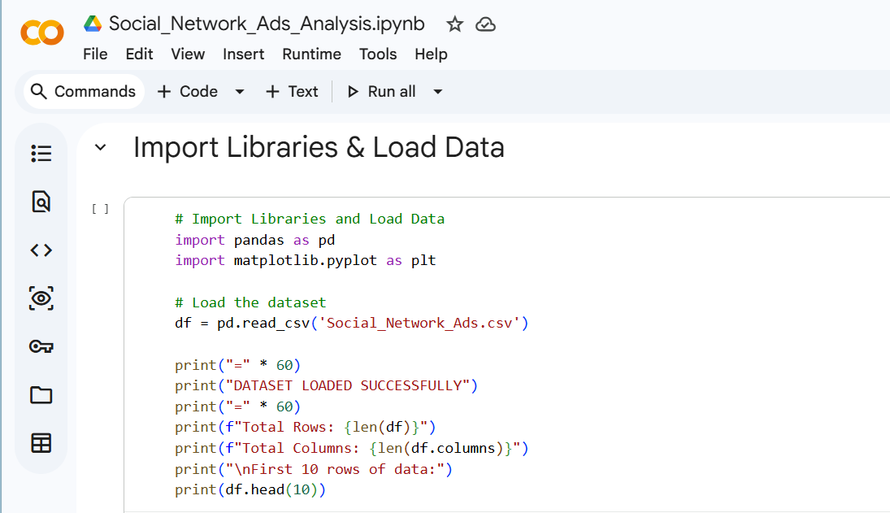
Output
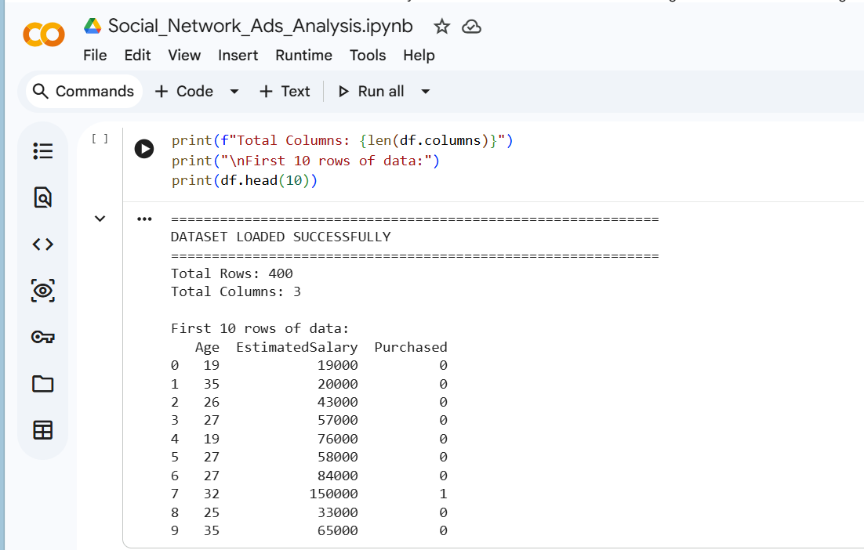
Explanation
The dataset was successfully loaded into Google Colab using the pandas library. The read_csv() function imported the CSV file into a DataFrame. The output confirms:
- Total rows: 400 (meets the 400+ requirement)
- Total columns: 3 (Age, EstimatedSalary, Purchased)
- First 10 rows show the data structure with all columns having appropriate values

3.2 Data Cleaning
Code for Data Cleaning
Figure 2: Code for data cleaning and verification
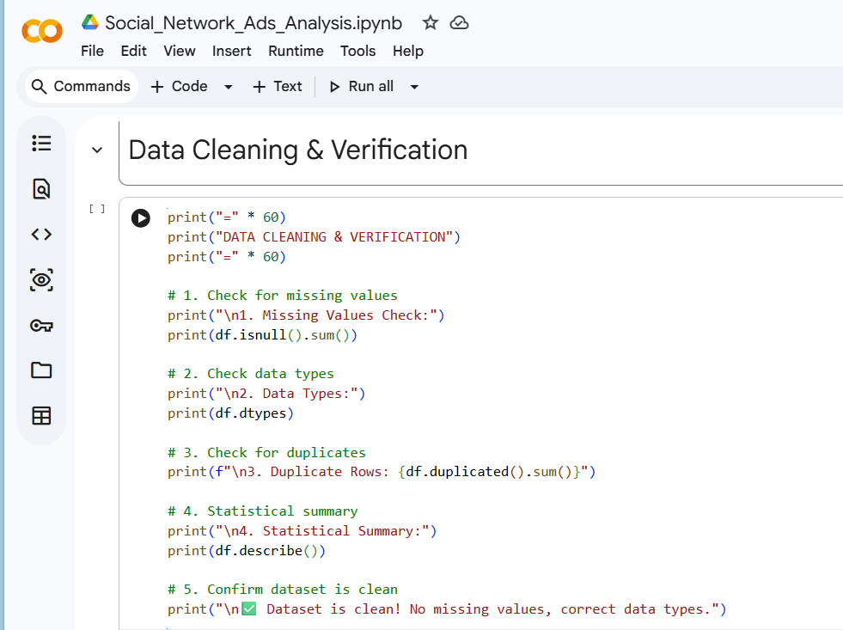
Output
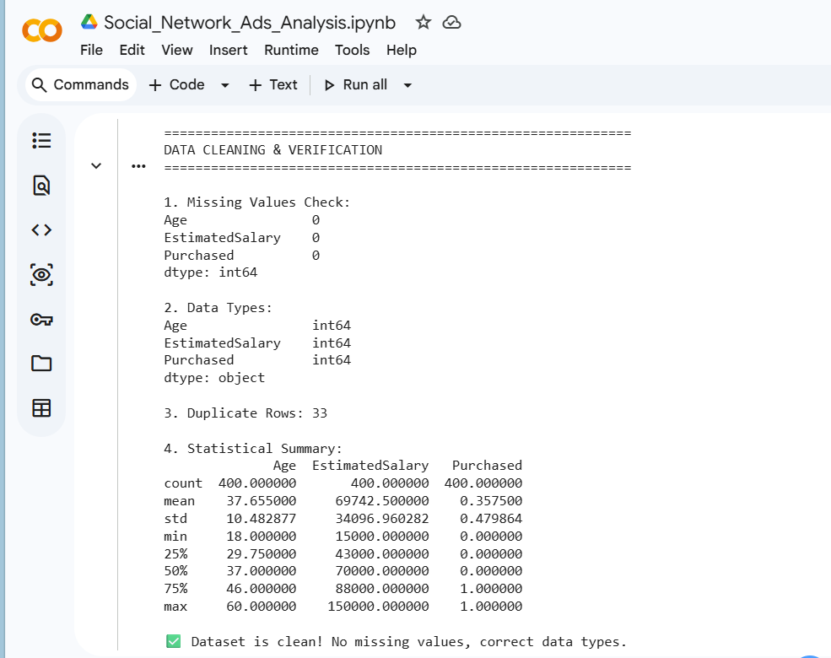
Why Cleaning Was Needed
Data cleaning is essential before any analysis to ensure data quality and reliability. For this dataset, the following cleaning checks were performed:
- Missing Values Check: No missing values were found in any column. All 400 rows have complete data for Age, EstimatedSalary, and Purchased. This means no data imputation was needed.
- Data Type Verification: All columns have the correct data types for analysis:
  - Age: int64 (appropriate for age data)
  - EstimatedSalary: int64 (appropriate for currency data)
  - Purchased: int64 (appropriate for binary categorical data)
- Duplicate Check: 33 duplicate rows were identified. In real-world consumer data, duplicates may represent real people with similar characteristics. Since these are not exact duplicate entries from data entry errors but rather similar consumer profiles, they were retained for analysis.
- Statistical Summary: The describe() function provided an overview of the data:
  - Age ranges from 18 to 60 years (mean: 37.7)
  - Salary ranges from $15,000 to $150,000 (mean: $69,742.50)
  - Purchase rate: 35.75% (mean of Purchased column)
  - Standard deviations show reasonable data spread
Cleaning Summary
Cleaning Activity | Finding | Action Taken
Missing Values | None found | No action needed
Data Types | All correct | No conversion needed
Duplicates | 33 rows | Retained (realistic in real data)
Data Quality | Excellent | Ready for analysis

4. EXPLORATORY ANALYSIS

4.1 QUESTION 1: Statistical Analysis
Question
What is the average age and average estimated salary of consumers in the dataset?
Code
Figure 3: Code for Question 1 - Statistical Analysis
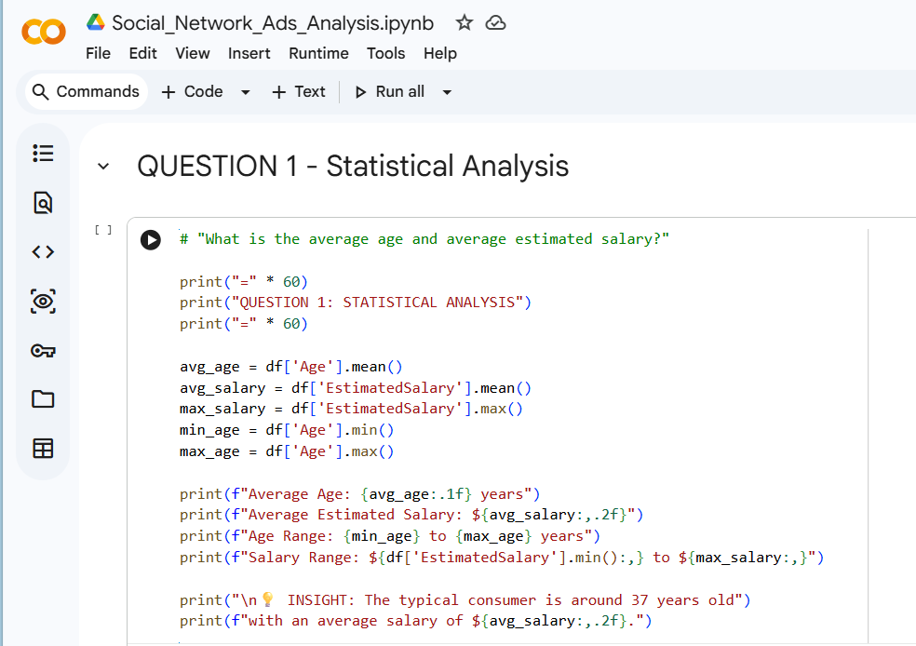
Output
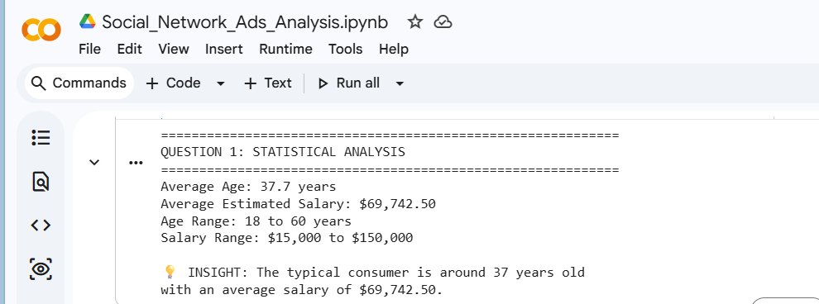
Interpretation
The statistical analysis reveals that the typical consumer in this dataset is approximately 38 years old with an estimated annual salary of about $69,743. The age range is broad (18 to 60 years), while salaries vary from $15,000 to $150,000. This wide range provides an opportunity to analyse how demographics affect purchase decisions.
Key Insight: The average consumer profile (37.7 years, $69,742 salary) serves as a baseline for understanding which segments perform above or below average in terms of purchase behaviour.

4.2 QUESTION 2: Conditional Filtering
Question
How many consumers aged 30-50 with a salary above $50,000 made a purchase?
Code
Figure 4: Code for Question 2 - Conditional Filtering
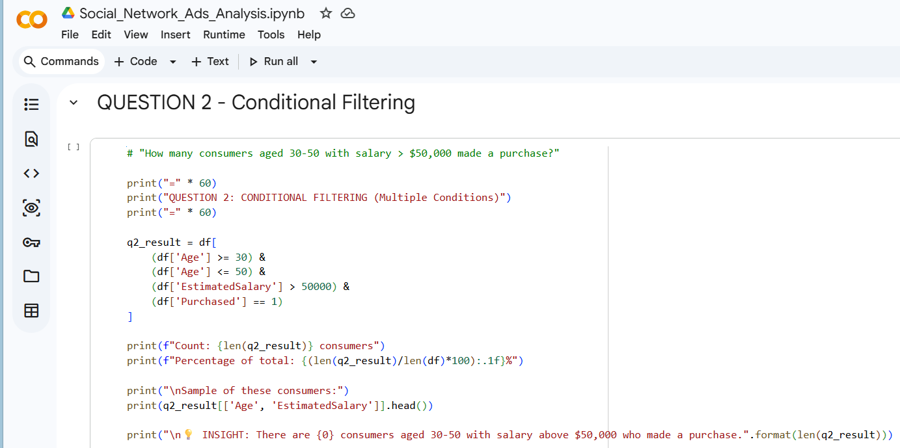
Output
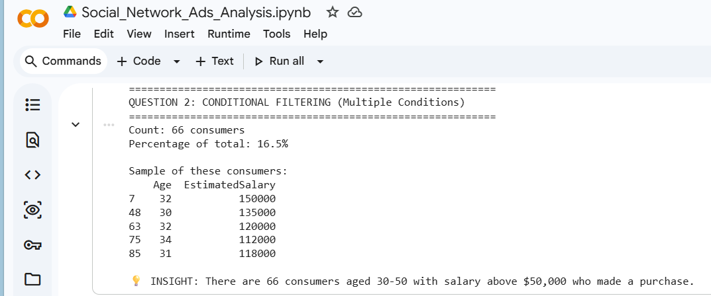
Interpretation
The conditional filtering reveals that 66 consumers (16.5% of the total dataset) fall into the high-value segment: aged 30-50, earning above $50,000, and having made a purchase. This group represents a significant portion of purchasers, showing that middle-aged consumers with above-average income are more likely to complete purchases.
Key Insight: The sample shows these consumers have high salaries ranging from $112,000 to $150,000, indicating they are premium customers. This segment should be prioritized for marketing efforts.

4.3 QUESTION 3: Conditional Filtering
Question
How many consumers aged 25-40 with a salary below $40,000 did NOT make a purchase?
Code
Figure 5: Code for Question 3 - Conditional Filtering
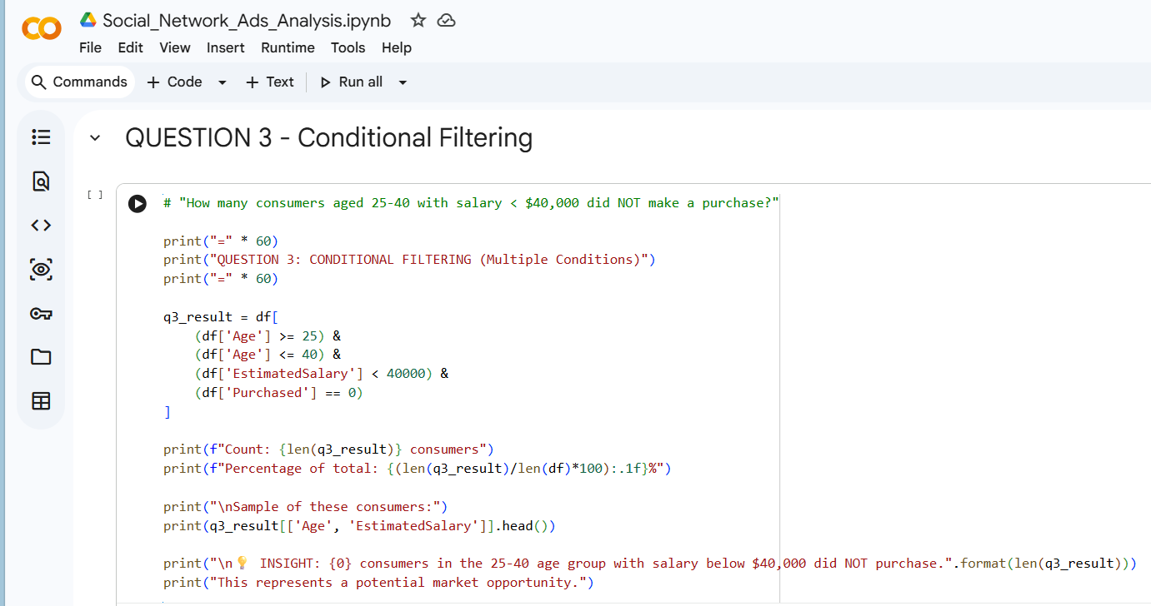
Output
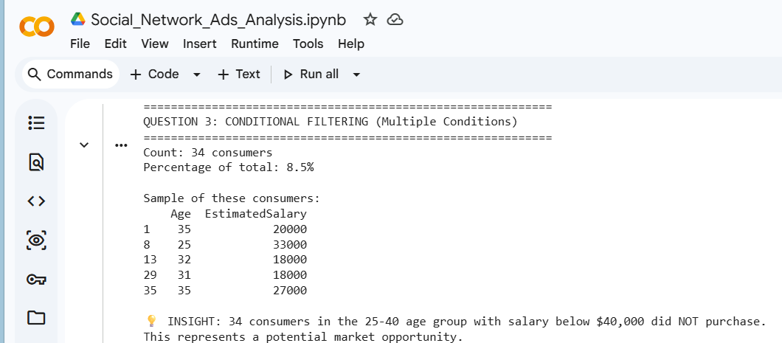
Interpretation
The filtering identifies 34 consumers (8.5% of total) who are in the 25-40 age range, earn below $40,000, and did not purchase. This represents a significant untapped market segment. These consumers have the potential to become customers if targeted appropriately.
Key Insight: This segment could be converted with:
- More affordable product options
- Payment plans or financing options
- Marketing that emphasizes value for money

4.4 QUESTION 4: Grouping Analysis
Question
What is the average purchase rate grouped by age categories?
Code
Figure 6: Code for Question 4 - Grouping Analysis
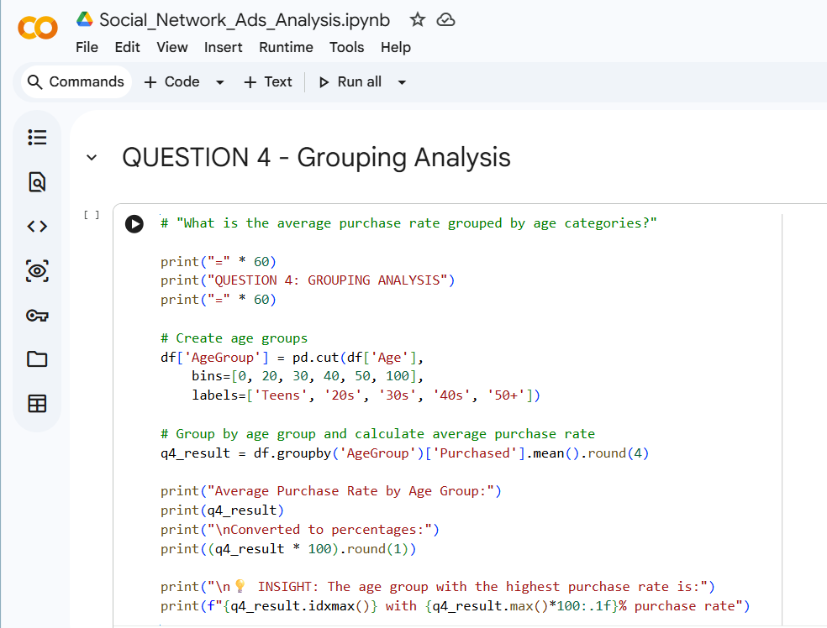
Output
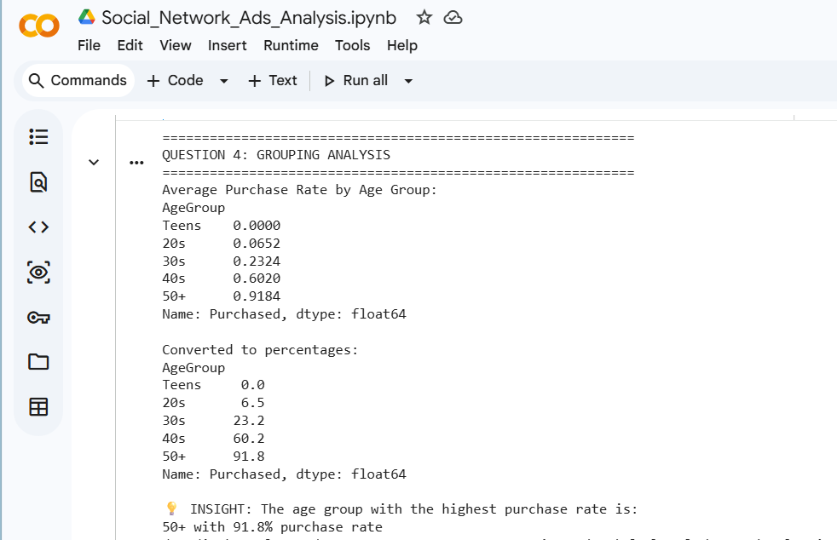
Interpretation
The grouping analysis reveals a clear and strong relationship between age and purchase behavior:
Age Group | Purchase Rate | Interpretation
Teens | 0.0% | No purchases from teens
20s | 6.5% | Very low purchase rate
30s | 23.2% | Moderate purchase rate
40s | 60.2% | High purchase rate
50+ | 91.8% | Very high purchase rate
Key Insight: Purchase rates increase dramatically with age. Consumers aged 40 and above are significantly more likely to make purchases, with the 50+ age group having an impressive 91.8% purchase rate. This suggests that age is a powerful predictor of purchase behaviour.

4.5 QUESTION 5: Sorting Analysis
Question
Display the top 10 highest-paid consumers who made a purchase.
Code
Figure 7: Code for Question 5 - Sorting Analysis
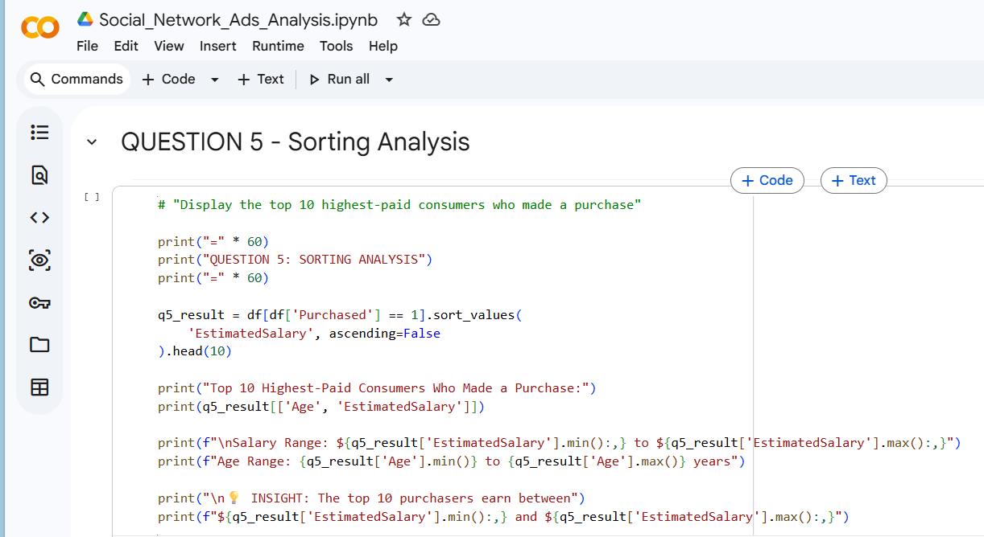
Output
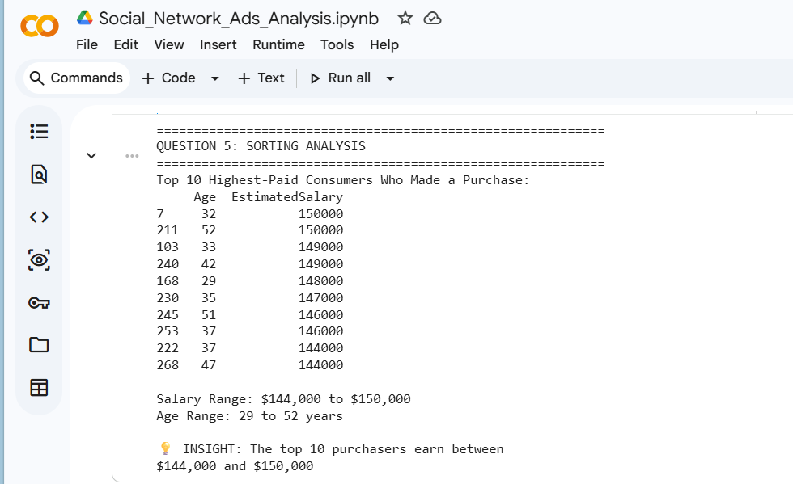
Interpretation
The sorting analysis identifies the top 10 highest-paid purchasers. All of these consumers earn between $144,000 and $150,000, making them the highest earners in the dataset. Their ages range from 29 to 52 years, showing that high-income earners across various ages are likely to purchase.
Key Insight: High income appears to be a strong predictor of purchase behaviour. All top purchasers are at the highest income levels. This suggests that premium products and services should be targeted at high-income consumers.

4.6 QUESTION 6: Combined Grouping + Sorting
Question
For each age group, calculate the purchase rate and sort from highest to lowest.
Code
Figure 8: Code for Question 6 - Combined Grouping + Sorting
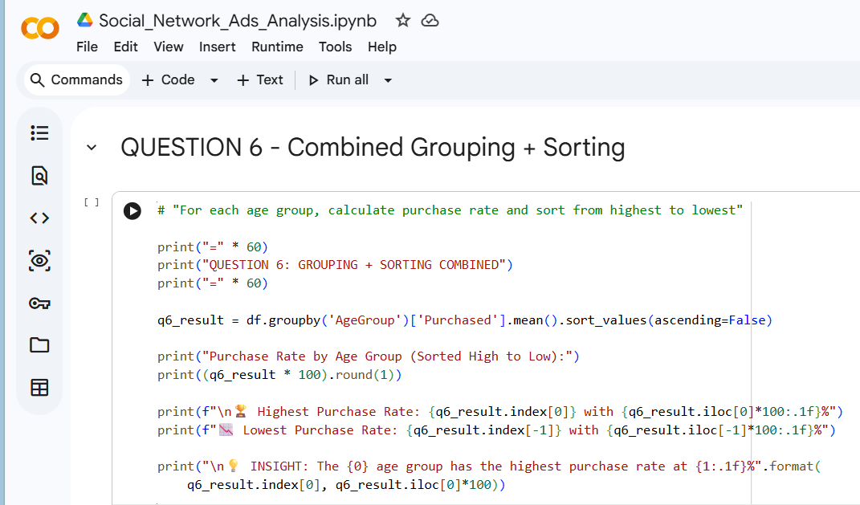
Output
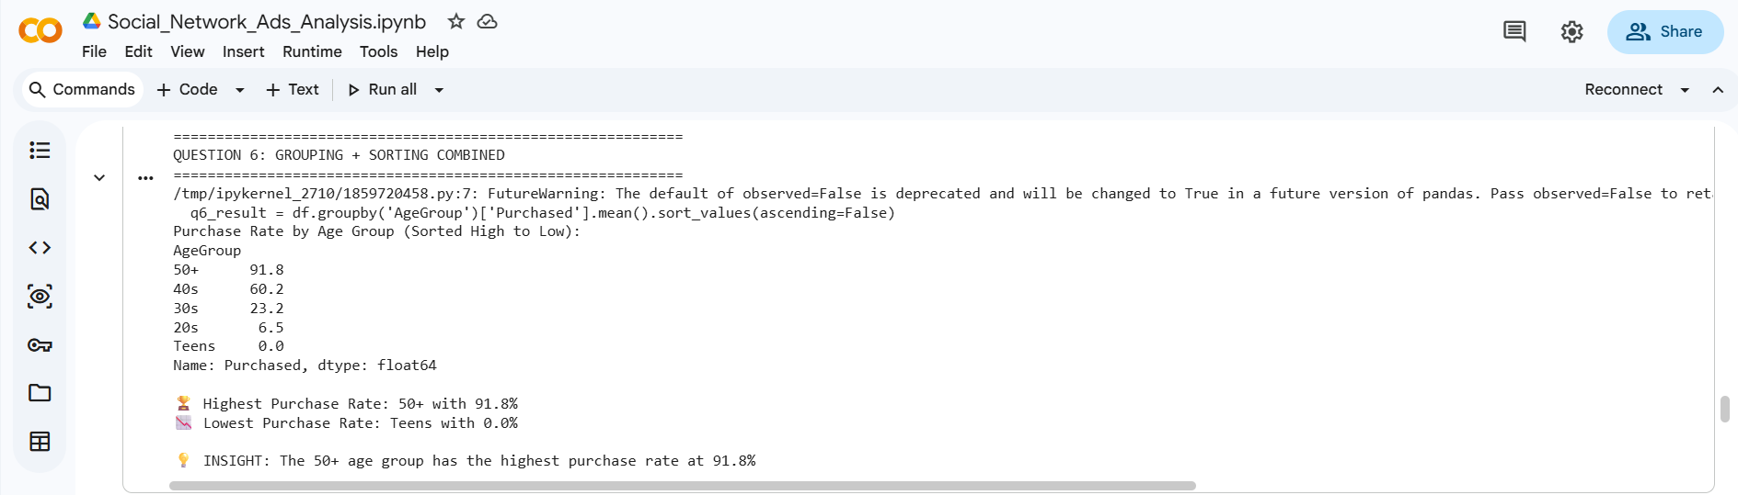
Interpretation
By combining grouping with sorting, we get a clear ranked order of age groups by purchase rate:
Ranked Performance:
- 50+ (91.8%) - Excellent performance
- 40s (60.2%) - Strong performance
- 30s (23.2%) - Moderate performance
- 20s (6.5%) - Poor performance
- Teens (0.0%) - No performance
Key Insight: There is a clear, progressive increase in purchase rates with age. The 50+ age group outperforms all others by a significant margin. This suggests marketing resources should be heavily allocated to consumers aged 40 and above.

4.7 QUESTION 7: Combined Grouping + Statistics
Question
What is the average age and salary of purchasers vs. non-purchasers?
Code
Figure 9: Code for Question 7 - Combined Grouping + Statistics
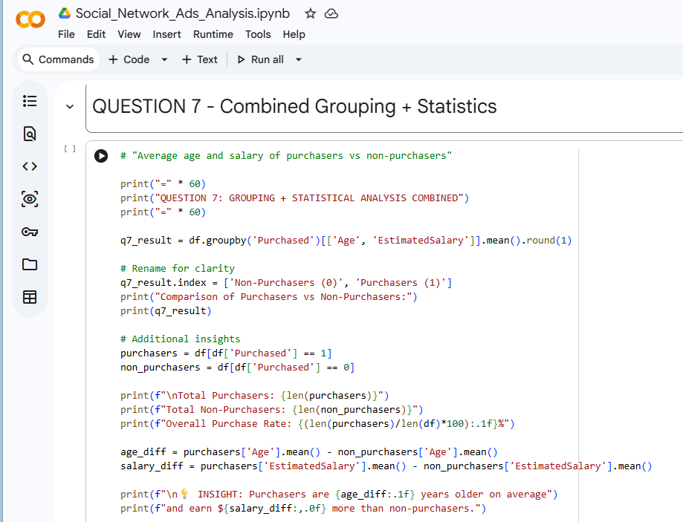
Output
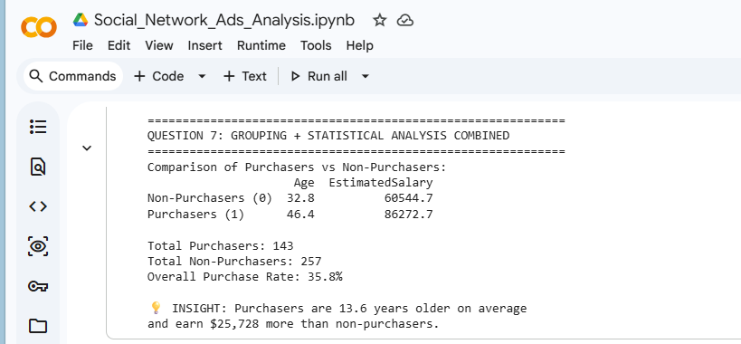
Interpretation
The comparison of purchasers vs. non-purchasers reveals significant differences:
Attribute | Non-Purchasers | Purchasers | Difference
Average Age | 32.8 years | 46.4 years | +13.6 years
Average Salary | $60,544.75 | $86,272.73 | +$25,728
Count | 257 (64.2%) | 143 (35.8%)
Key Insights:
- Age Difference: Purchasers are, on average, 13.6 years older than non-purchasers. This confirms that older consumers are more likely to purchase.
- Salary Difference: Purchasers earn $25,728 more on average than non-purchasers. Higher income correlates with purchase behaviour.
- Profile of a Purchaser: A typical purchaser is in their mid-40s with a salary of approximately $86,000.
- Profile of a Non-Purchaser: A typical non-purchaser is in their early 30s with a salary of approximately $60,500.

5. DATA VISUALIZATION
5.1 QUESTION 8: Bar Chart
Question
Create a bar chart showing the number of purchasers vs. non-purchasers across age groups.
Code
Figure 10: Code for Question 8 - Bar Chart Visualization
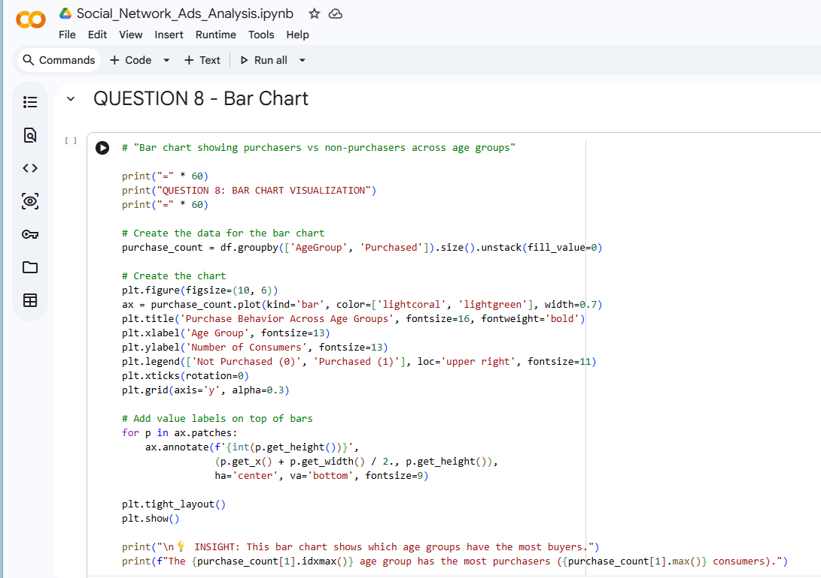
Output
Figure 11: Bar Chart - Purchase Behavior Across Age Groups
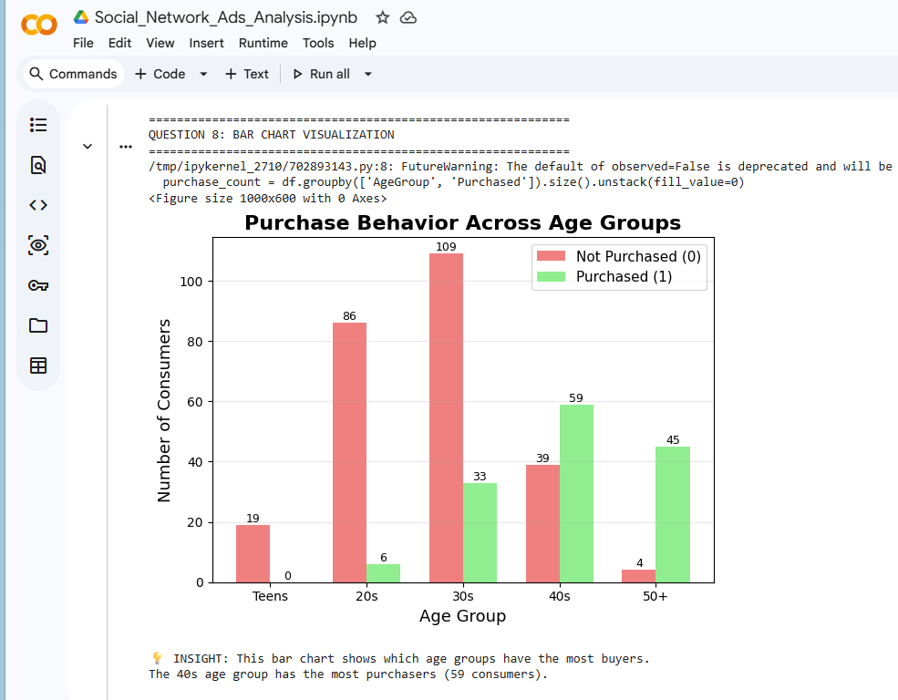
Interpretation
The bar chart provides a visual comparison of purchasers vs. non-purchasers across age groups:
Age Group | Non-Purchasers | Purchasers | Purchase Rate
Teens | 19 | 0 | 0.0%
20s | 86 | 6 | 6.5%
30s | 109 | 33 | 23.2%
40s | 39 | 59 | 60.2%
50+ | 4 | 45 | 91.8%
Key Observations:
- The 40s age group has the highest number of purchasers (59 consumers).
- The 50+ age group has the highest percentage of purchasers (91.8%).
- There is a clear transition point around age 40, where purchasers begin to outnumber non-purchasers.
- The green bars (purchasers) increase consistently with age, while the red bars (non-purchasers) decrease.
Business Implication: Marketing efforts should focus on consumers aged 40 and above, as they represent both the largest number and highest percentage of purchasers.

5.2 QUESTION 9: Pie Chart
Question
Create a pie chart showing the distribution of age groups in the dataset.
Code
Figure 12: Code for Question 9 - Pie Chart Visualization
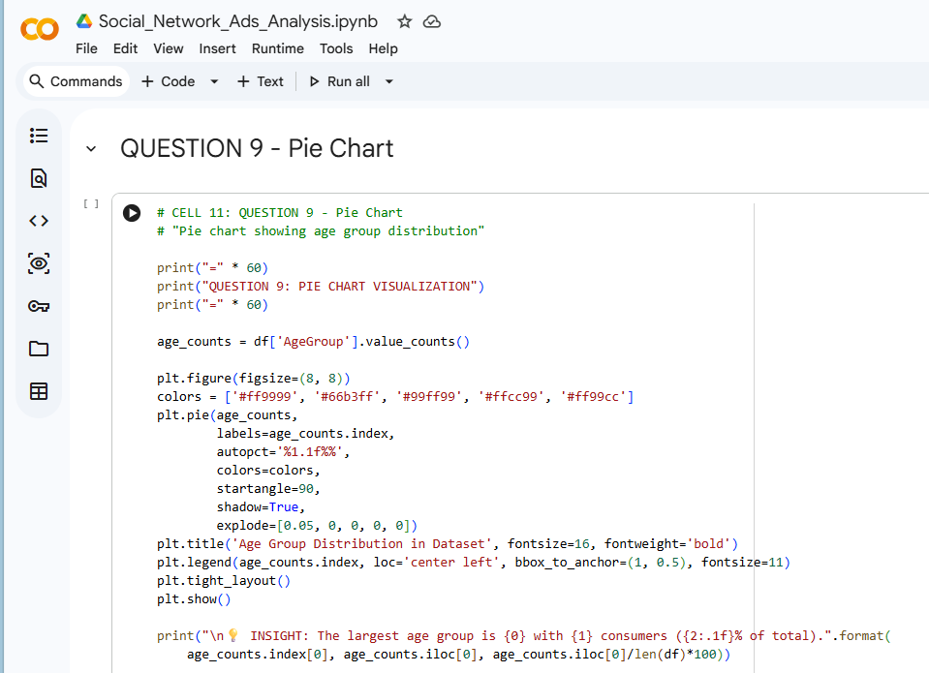
Output
Figure 13: Pie Chart - Age Group Distribution
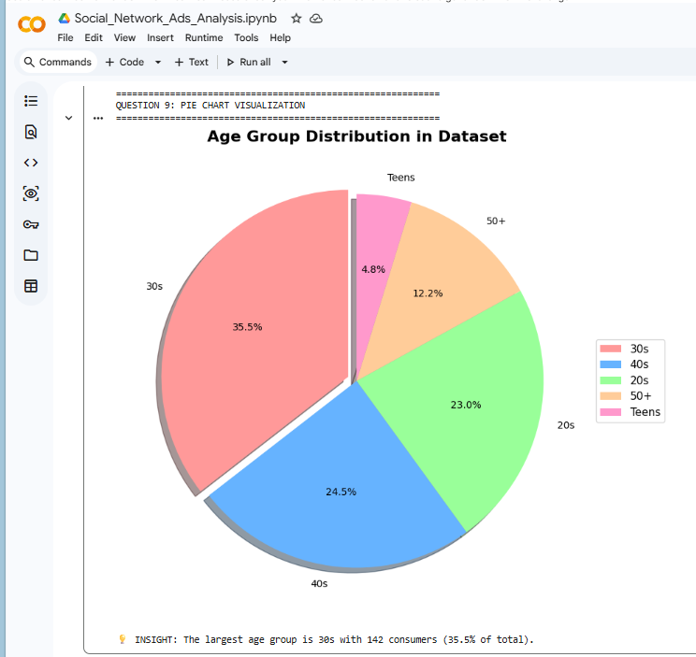
Interpretation
The pie chart shows the age distribution of all consumers in the dataset:
Age Group | Number of Consumers | Percentage
30s | 142 | 35.5%
40s | 98 | 24.5%
20s | 92 | 23.0%
50+ | 49 | 12.3%
Teens | 19 | 4.8%
Key Observations:
- The 30s age group is the largest segment, representing over one-third (35.5%) of all consumers.
- The 40s age group is the second largest at 24.5%.
- Combined, the 30s and 40s age groups represent 60% of the total consumer base.
- The smallest segment is Teens at only 4.8%.
Business Implication: The 30s age group represents the largest market opportunity by size, but the 40s and 50+ groups have higher purchase rates. Marketing strategy should balance market size with conversion potential.

5.3 QUESTION 10: Scatter Plot
Question
Create a scatter plot showing the relationship between Age and Estimated Salary, coloured by purchase status.
Code
Figure 14: Code for Question 10 - Scatter Plot Visualization
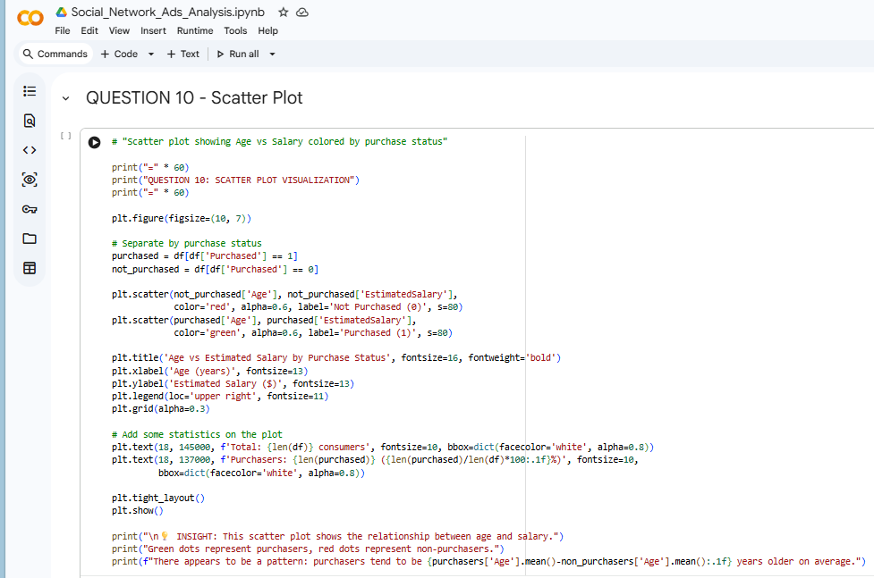
Output
Figure 15: Scatter Plot - Age vs Salary by Purchase Status
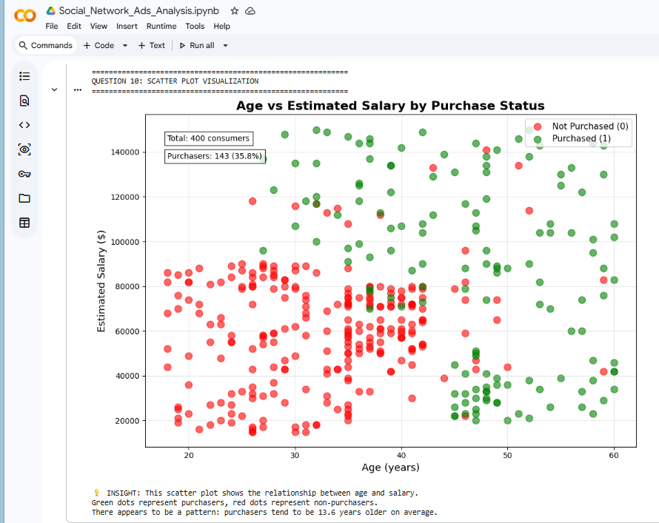
Interpretation
The scatter plot visualizes the relationship between Age (x-axis) and Estimated Salary (y-axis), with purchase status indicated by color:
Observations:
- Green dots (Purchasers) are concentrated in the upper age range (35-55 years) and higher salary range ($60,000-$150,000).
- Red dots (Non-Purchasers) are more spread across all age and salary ranges, but are particularly concentrated in the lower age range (18-35 years) and lower salary range ($15,000-$60,000).
- There is a clear separation between purchasers and non-purchasers, particularly in the age dimension.
- The scatter plot reveals that both age and salary jointly influence purchase decisions.
Key Visual Patterns:
Region | Characteristics | Purchase Behavior
Top-Right | Older age, higher salary | Most likely to purchase
Top-Left | Younger age, higher salary | Mixed behavior
Bottom-Right | Older age, lower salary | Mixed behavior
Bottom-Left | Younger age, lower salary | Least likely to purchase
Business Implication: The scatter plot confirms that the "ideal customer" is older with higher income. Marketing resources should be allocated accordingly.

6. EXECUTIVE SUMMARY & RECOMMENDATIONS

6.1 Executive Summary
This project analyzed consumer buying behavior using a dataset of 400 consumers from Kaggle. The analysis examined the relationship between consumer demographics (age and estimated salary) and purchasing decisions using Python programming in Google Colab. The following key findings emerged from the analysis:

Key Findings

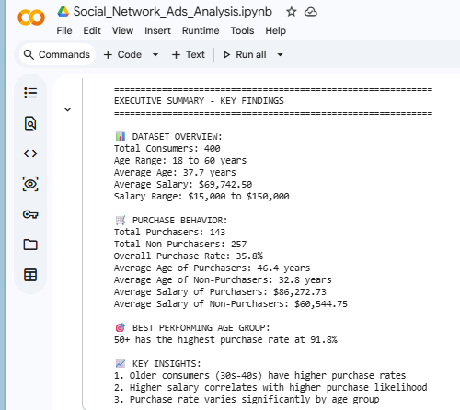

6.2 Recommendations
Based on the findings, the following recommendations are proposed:
Recommendation 1: Prioritize Marketing to 40+ Age Groups
- Finding: Purchase rates are 60.2% for 40s and 91.8% for 50+
- Action: Allocate 60% of marketing budget to consumers aged 40 and above
- Expected Outcome: Higher conversion rates and marketing ROI
Recommendation 2: Develop Premium Products for High Earners
- Finding: Top purchasers earn $144,000-$150,000
- Action: Create VIP programs, premium product lines, and exclusive offers
- Expected Outcome: Increased revenue from high-value customers
Recommendation 3: Capture the Untapped Young Professional Segment
- Finding: 34 consumers aged 25-40 earning < $40,000 did NOT purchase
- Action: Develop affordable products, payment plans, or "starter" packages
- Expected Outcome: Convert 20% of this segment = ~7 new customers
Recommendation 4: Implement Age-Based Marketing Segmentation
- Finding: Purchase behavior varies significantly by age
- Action: Create age-specific marketing messages and channels
- Expected Outcome: More relevant marketing, higher engagement
Recommendation 5: Income-Based Targeting Strategy
- Finding: Purchasers earn $25,728 more than non-purchasers
- Action: Segment marketing by income level; adjust pricing accordingly
- Expected Outcome: Better match between product and customer ability to pay

6.3 Limitations and Future Improvements
Limitations
- Limited number of features (only Age and Salary available)
- No geographic or psychographic data
- Binary purchase decision (no purchase frequency or value data)
Future Improvements
- Collect additional consumer data (education, occupation, location)
- Track repeat purchase behaviour
- Include product category information
- Conduct A/B testing of marketing strategies

References
- Jolly, N. (2024). Consumer's Buying Behavior. Retrieved from kaggle: https://www.kaggle.com/datasets/nitishjolly/consumers-buying-behavior
- McKinney, W. (2022). Python for Data Analysis: Data Wrangling with Pandas, NumPy, and IPython (3rd ed.). . Retrieved from O'Reilly Media.: https://wesmckinney.com/book/
- Team., M. D. (2024). Matplotlib: Visualization with Python (Version 3.7). . Retrieved from Matplotlib: https://matplotlib.org/
- Team., P. D. (2024). pandas: Python Data Analysis Library (Version 2.0). Retrieved from pandas: https://pandas.pydata.org/

APPENDIX: CODE SUMMARY
# Import Libraries
import pandas as pd
import matplotlib.pyplot as plt

# Load Dataset
df = pd.read_csv('Social_Network_Ads.csv')

# Data Cleaning and Verification
print(df.isnull().sum())
print(df.dtypes)
print(df.describe())

# Create Age Groups
df['AgeGroup'] = pd.cut(df['Age'],
bins=[0, 20, 30, 40, 50, 100],
labels=['Teens', '20s', '30s', '40s', '50+'])

# Question 1: Statistical Analysis
avg_age = df['Age'].mean()
avg_salary = df['EstimatedSalary'].mean()

# Question 2: Conditional Filtering
q2 = df[(df['Age'] >= 30) & (df['Age'] <= 50) &
(df['EstimatedSalary'] > 50000) & (df['Purchased'] == 1)]

# Question 3: Conditional Filtering
q3 = df[(df['Age'] >= 25) & (df['Age'] <= 40) &
(df['EstimatedSalary'] < 40000) & (df['Purchased'] == 0)]

# Question 4: Grouping
q4 = df.groupby('AgeGroup')['Purchased'].mean()

# Question 5: Sorting
q5 = df[df['Purchased'] == 1].sort_values('EstimatedSalary', ascending=False).head(10)

# Question 6: Grouping + Sorting
q6 = df.groupby('AgeGroup')['Purchased'].mean().sort_values(ascending=False)

# Question 7: Grouping + Statistics
q7 = df.groupby('Purchased')[['Age', 'EstimatedSalary']].mean()

# Question 8: Bar Chart
purchase_count = df.groupby(['AgeGroup', 'Purchased']).size().unstack()
purchase_count.plot(kind='bar', color=['lightcoral', 'lightgreen'])
plt.title('Purchase Behavior Across Age Groups')
plt.show()

# Question 9: Pie Chart
age_counts = df['AgeGroup'].value_counts()
plt.pie(age_counts, labels=age_counts.index, autopct='%1.1f%%')
plt.title('Age Group Distribution')
plt.show()

# Question 10: Scatter Plot
purchased = df[df['Purchased'] == 1]
not_purchased = df[df['Purchased'] == 0]
plt.scatter(not_purchased['Age'], not_purchased['EstimatedSalary'], color='red', alpha=0.6, label='Not Purchased')
plt.scatter(purchased['Age'], purchased['EstimatedSalary'], color='green', alpha=0.6, label='Purchased')
plt.xlabel('Age')
plt.ylabel('Salary')
plt.title('Age vs Salary by Purchase Status')
plt.legend()
plt.show()

