Programming with Python

Data Visualization using Seaborn Library

Prerequisite libraries to install
pip install pandas
pip install numpy
pip install matplotlib
pip install seaborn
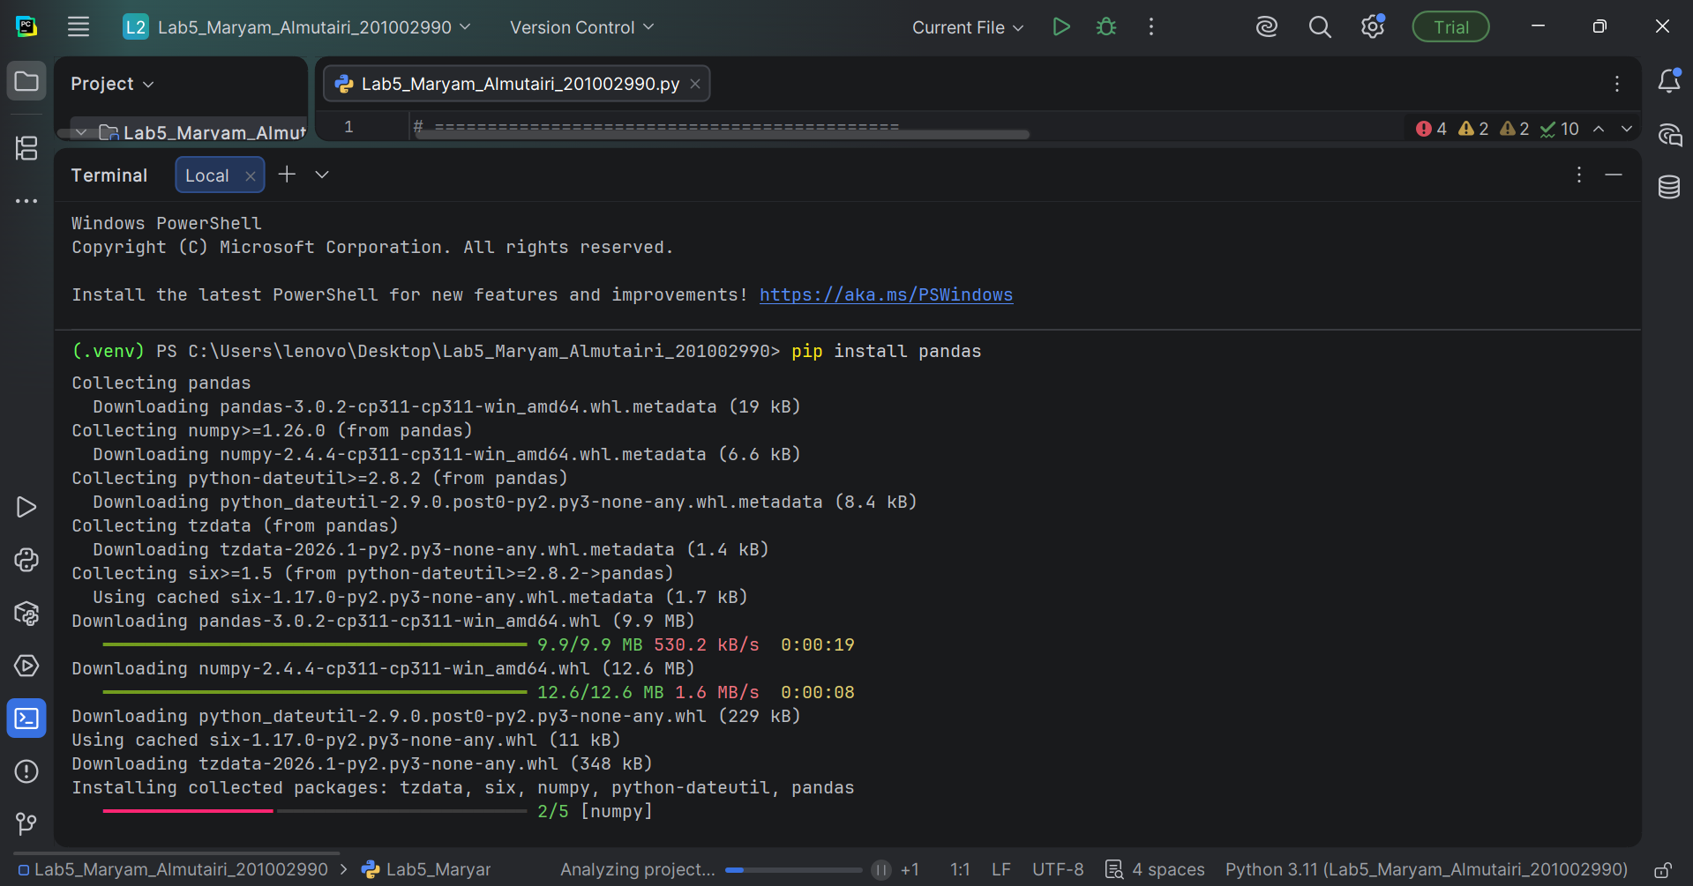

Initialize Setup
# ============================================
# INITIAL SETUP FOR ALL TASKS
# ============================================

# Import required libraries
import pandas as pd
import numpy as np
import matplotlib.pyplot as plt
import seaborn as sns
import warnings
warnings.filterwarnings('ignore')

# Set style for better visualizations
sns.set_style("whitegrid")
plt.rcParams['figure.figsize'] = (12, 8)

print("="*70)
print("CSC 230 - Lab 5: Data Visualization using Seaborn")
print("Student: Maryam Almutairi (201002990)")
print("="*70)

# Load the Titanic Dataset
df = pd.read_csv('Titanic-Dataset.csv')
print("\n✅ Dataset loaded successfully!")
print(f"📊 Dataset shape: {df.shape[0]} rows × {df.shape[1]} columns")
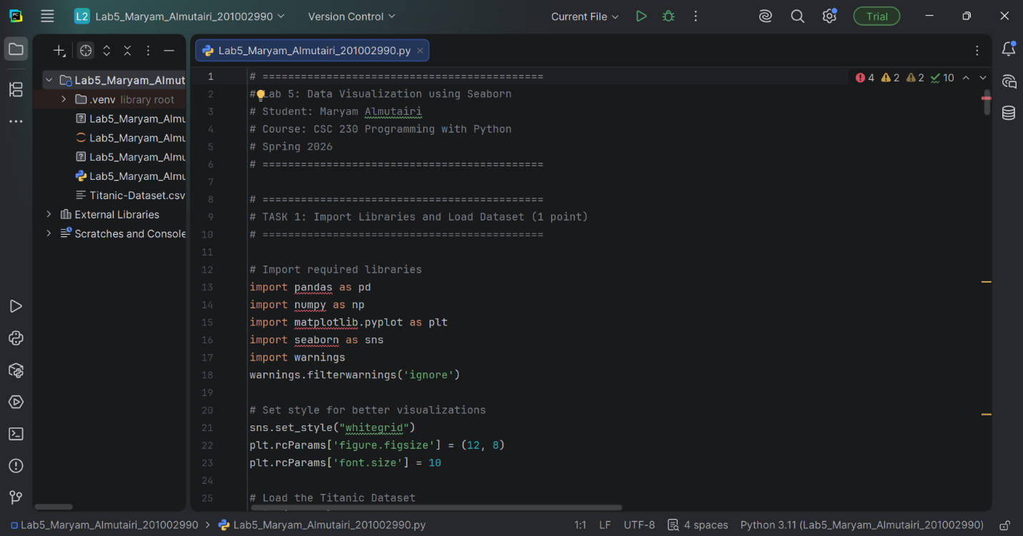

TASK 1: Data Loading
# ============================================
# TASK 1: Data Loading
# ============================================

print("\n" + "="*70)
print("TASK 1: Data Loading")
print("="*70)

# Display first 5 rows
print("\n📋 First 5 rows of the dataset:")
print(df.head())

# Display last 5 rows
print("\n📋 Last 5 rows of the dataset:")
print(df.tail())

# Display random 5 rows
print("\n📋 Random 5 rows of the dataset:")
print(df.sample(5))

print("\n✅ Task 1 Completed: Data loaded successfully!")
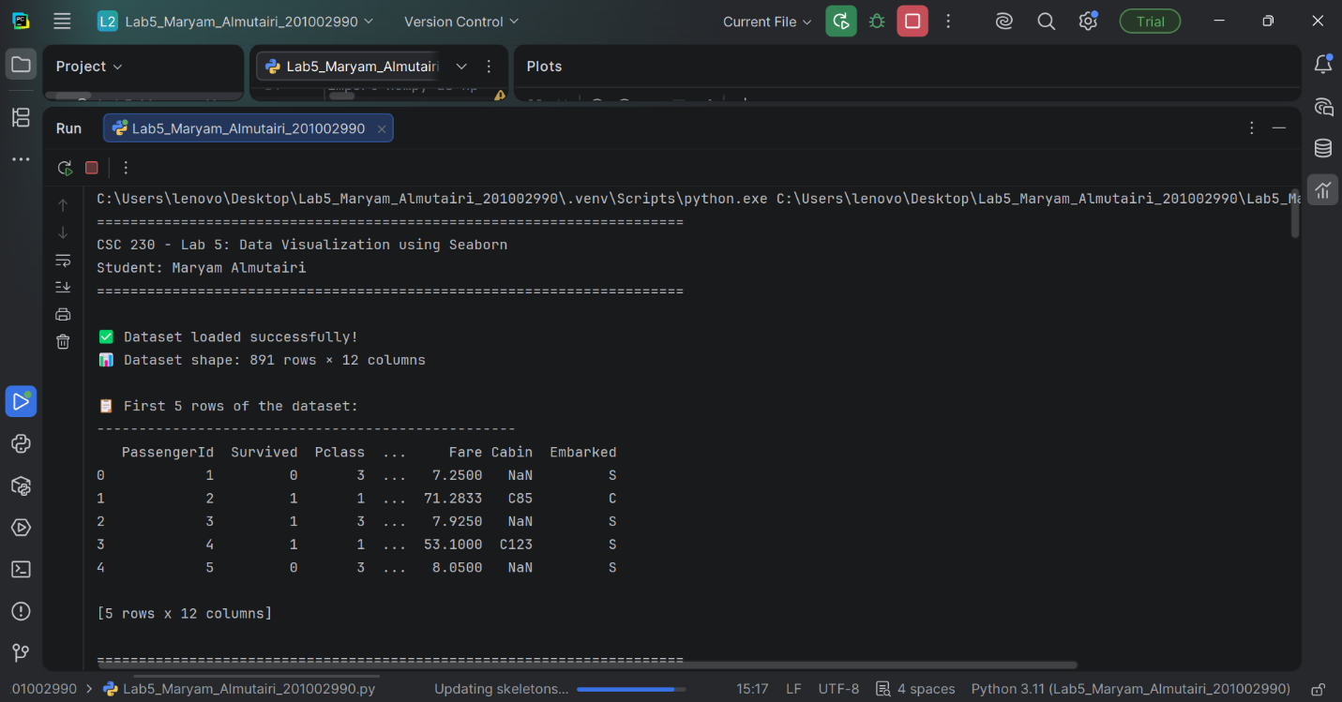

TASK 2: Data Description
# ============================================
# TASK 2: Data Description
# ============================================

print("\n" + "="*70)
print("TASK 2: Data Description")
print("="*70)

# 2.1 Display column names
print("\n📋 Column Names in the Dataset:")
print("-"*50)
for i, col in enumerate(df.columns, 1):
print(f"{i:2}. {col}")

# 2.2 Show dataset information
print("\n📊 Dataset Information:")
print("-"*50)
print(f"Dataset Shape: {df.shape[0]} rows × {df.shape[1]} columns")
print(f"\nMemory Usage: {df.memory_usage(deep=True).sum() / 1024:.2f} KB")
print(f"\nData Types:")
print(df.dtypes)

# 2.3 Find basic statistics
print("\n📈 Basic Statistics of Numerical Columns:")
print("-"*50)
print(df.describe())

# 2.4 Check for missing values
print("\n🔍 Missing Values Analysis:")
print("-"*50)
missing_values = df.isnull().sum()
missing_percent = (df.isnull().sum() / len(df)) * 100
missing_table = pd.DataFrame({'Missing Count': missing_values, 'Missing Percentage': missing_percent})
print(missing_table[missing_table['Missing Count'] > 0])

# 2.5 Display unique values for categorical columns
print("\n🏷️ Unique Values in Categorical Columns:")
print("-"*50)
categorical_cols = ['Sex', 'Embarked']
for col in categorical_cols:
if col in df.columns:
print(f"{col}: {df[col].dropna().unique().tolist()}")

print("\n✅ Task 2 Completed: Data description displayed!")
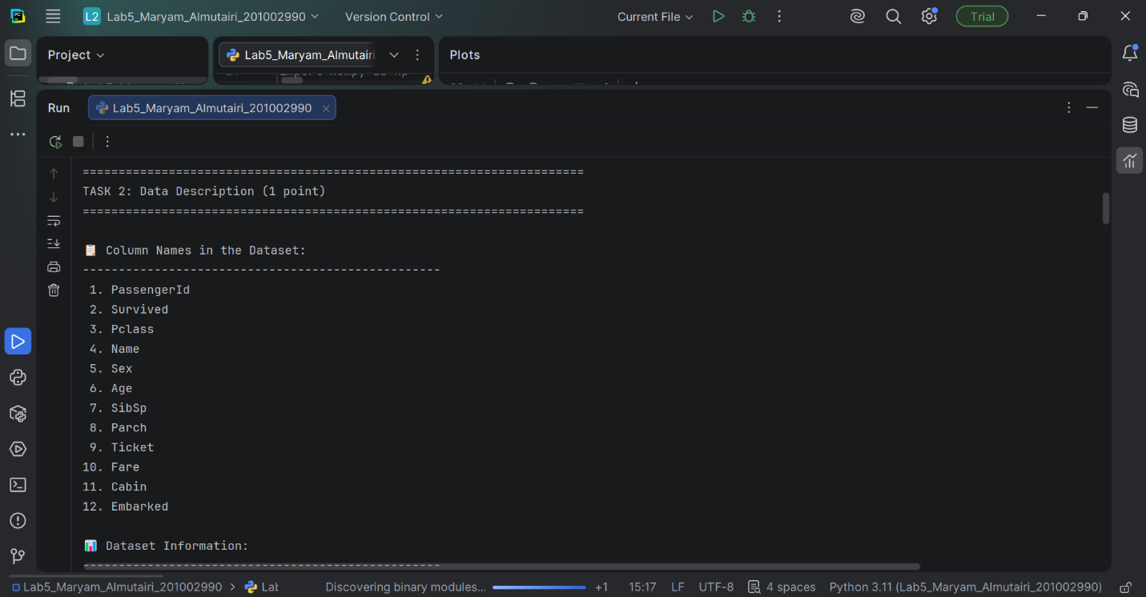
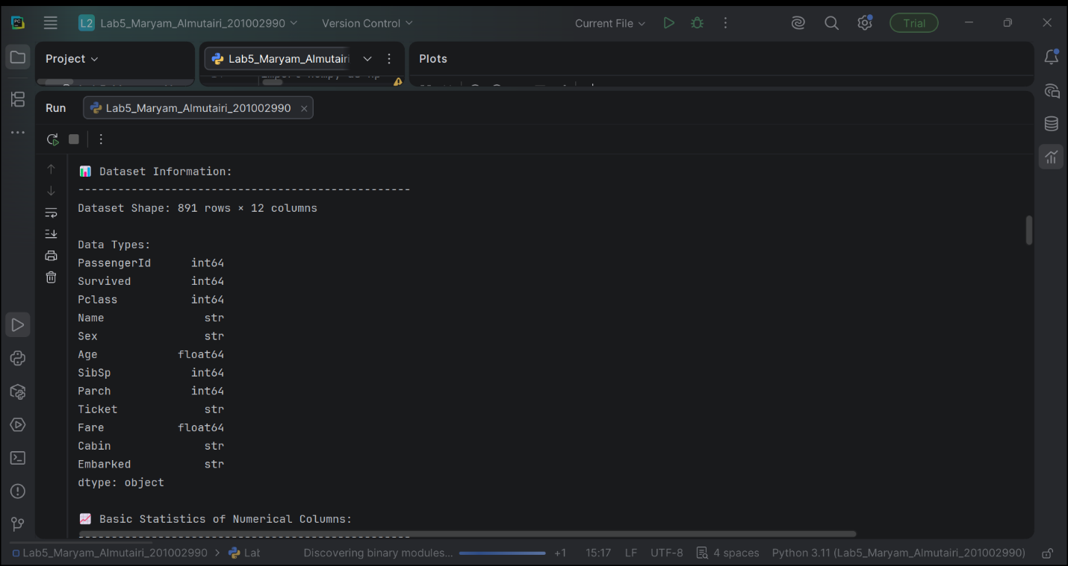
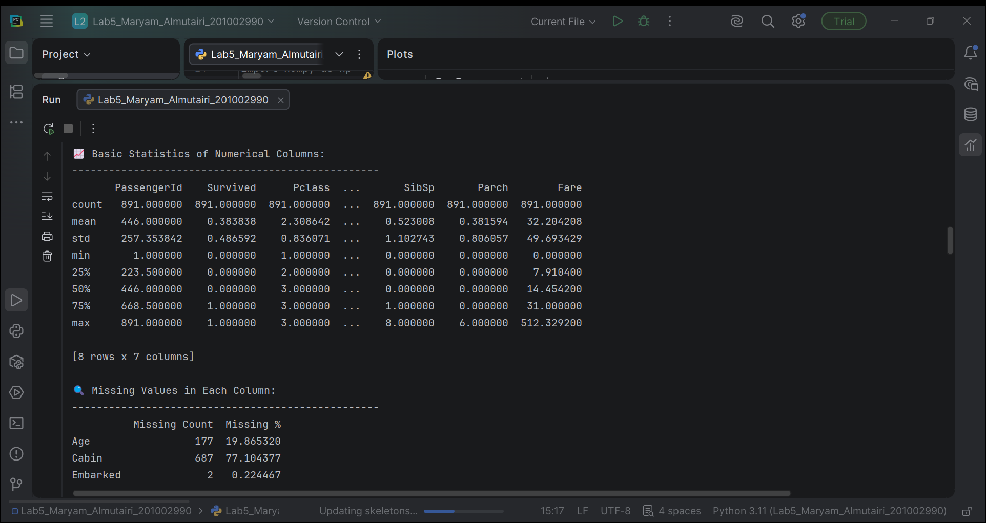

TASK 3: Gender-wise Survival
# ============================================
# DATA PREPROCESSING (Before Task 3)
# ============================================

# Create a clean copy
df_clean = df.copy()

# Fill missing age values with median
df_clean['Age'].fillna(df_clean['Age'].median(), inplace=True)

# Fill missing embarked values with mode
df_clean['Embarked'].fillna(df_clean['Embarked'].mode()[0], inplace=True)

# Drop cabin column (too many missing values)
df_clean.drop('Cabin', axis=1, inplace=True)

print("\n✅ Data preprocessing completed!")

# ============================================
# TASK 3: Gender-wise Survival
# ============================================

print("\n" + "="*70)
print("TASK 3: Gender-wise Survival Visualization")
print("="*70)

# Calculate survival statistics
gender_survival = df_clean.groupby('Sex')['Survived'].agg(['count', 'mean'])
gender_survival['survival_rate'] = gender_survival['mean'] * 100

print("\n📊 Gender-wise Survival Statistics:")
print("-"*50)
print(gender_survival)

# Create visualization
fig, axes = plt.subplots(1, 2, figsize=(14, 6))

# Plot 1: Count plot
sns.countplot(data=df_clean, x='Sex', hue='Survived', ax=axes[0],
palette=['#FF6B6B', '#4ECDC4'])
axes[0].set_title('Gender-wise Survival Count', fontsize=14, fontweight='bold')
axes[0].set_xlabel('Gender', fontsize=12)
axes[0].set_ylabel('Number of Passengers', fontsize=12)
axes[0].legend(title='Survived', labels=['No (0)', 'Yes (1)'])

# Add values on bars
for container in axes[0].containers:
axes[0].bar_label(container, fmt='%d', fontsize=10)

# Plot 2: Survival rate percentage
survival_rate = df_clean.groupby('Sex')['Survived'].mean() * 100
bars = axes[1].bar(survival_rate.index, survival_rate.values, color=['#FF6B6B', '#4ECDC4'])
axes[1].set_title('Survival Rate by Gender (%)', fontsize=14, fontweight='bold')
axes[1].set_xlabel('Gender', fontsize=12)
axes[1].set_ylabel('Survival Rate (%)', fontsize=12)
axes[1].set_ylim(0, 100)

# Add percentage values
for bar, rate in zip(bars, survival_rate.values):
axes[1].text(bar.get_x() + bar.get_width()/2, bar.get_height() + 1,
f'{rate:.1f}%', ha='center', fontsize=12, fontweight='bold')

plt.suptitle('TASK 3: Gender-wise Survival Analysis', fontsize=16, fontweight='bold', y=1.02)
plt.tight_layout()
plt.savefig('Task3_Gender_Survival.png', dpi=150, bbox_inches='tight')
plt.show()

print("\n✅ Task 3 Completed: Gender-wise survival visualization saved!")
print(f"📊 Key Finding: Female survival rate = {survival_rate['female']:.1f}%")
print(f"📊 Key Finding: Male survival rate = {survival_rate['male']:.1f}%")
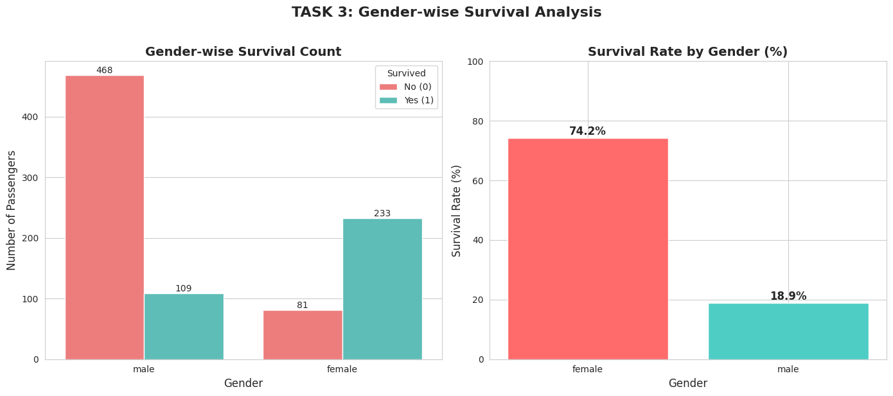
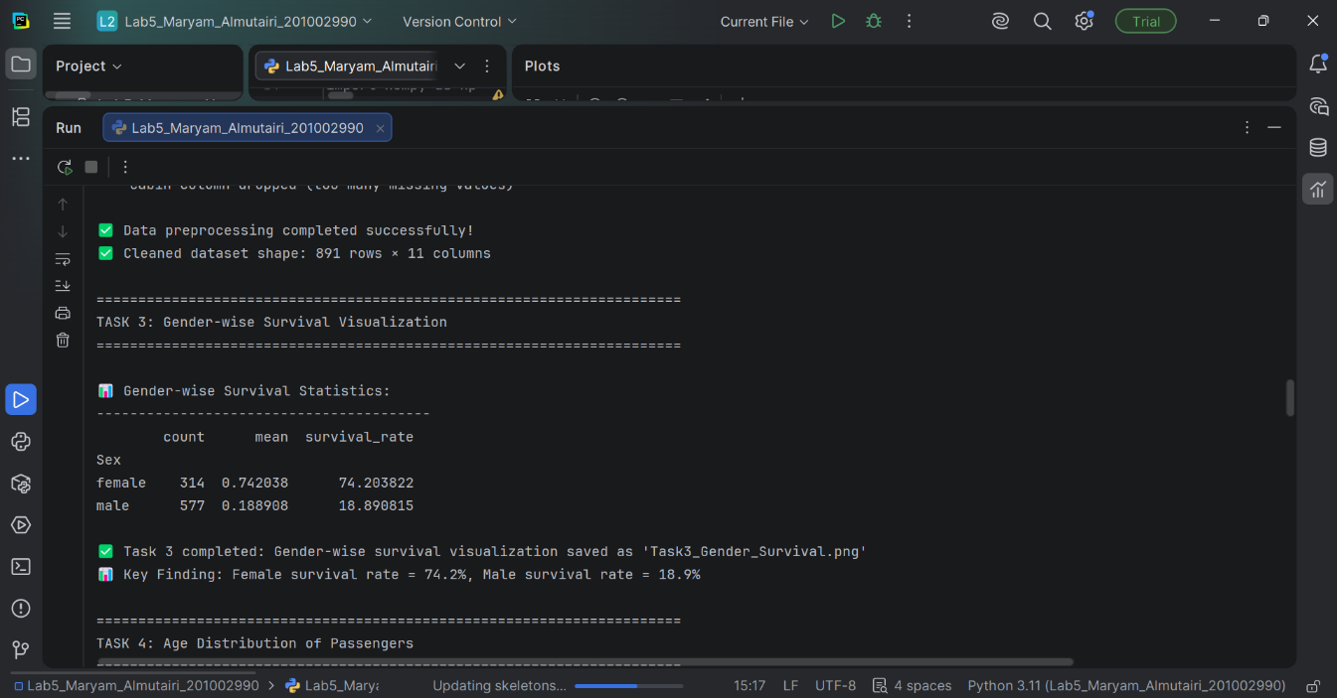

TASK 4: Age Distribution
# ============================================
# TASK 4: Age Distribution
# ============================================

print("\n" + "="*70)
print("TASK 4: Age Distribution of Passengers")
print("="*70)

# Age statistics
print("\n📊 Age Statistics:")
print("-"*50)
print(f"Mean Age: {df_clean['Age'].mean():.2f} years")
print(f"Median Age: {df_clean['Age'].median():.2f} years")
print(f"Standard Deviation: {df_clean['Age'].std():.2f} years")
print(f"Minimum Age: {df_clean['Age'].min():.2f} years")
print(f"Maximum Age: {df_clean['Age'].max():.2f} years")
print(f"Age Range: {df_clean['Age'].max() - df_clean['Age'].min():.2f} years")

# Create visualization
fig, axes = plt.subplots(2, 2, figsize=(15, 10))

# Plot 1: Histogram
axes[0,0].hist(df_clean['Age'], bins=30, color='#4ECDC4', edgecolor='black', alpha=0.7)
axes[0,0].set_title('Age Distribution (Histogram)', fontsize=14, fontweight='bold')
axes[0,0].set_xlabel('Age (years)', fontsize=12)
axes[0,0].set_ylabel('Number of Passengers', fontsize=12)
axes[0,0].axvline(df_clean['Age'].mean(), color='red', linestyle='dashed', linewidth=2,
label=f'Mean: {df_clean["Age"].mean():.1f}')
axes[0,0].axvline(df_clean['Age'].median(), color='green', linestyle='dashed', linewidth=2,
label=f'Median: {df_clean["Age"].median():.1f}')
axes[0,0].legend()

# Plot 2: KDE plot
sns.kdeplot(data=df_clean, x='Age', fill=True, color='#FF6B6B', ax=axes[0,1])
axes[0,1].set_title('Age Density Distribution (KDE Plot)', fontsize=14, fontweight='bold')
axes[0,1].set_xlabel('Age (years)', fontsize=12)
axes[0,1].set_ylabel('Density', fontsize=12)

# Plot 3: Age by survival
sns.histplot(data=df_clean, x='Age', hue='Survived', bins=30, alpha=0.6, ax=axes[1,0],
palette=['#FF6B6B', '#4ECDC4'])
axes[1,0].set_title('Age Distribution by Survival Status', fontsize=14, fontweight='bold')
axes[1,0].set_xlabel('Age (years)', fontsize=12)
axes[1,0].set_ylabel('Number of Passengers', fontsize=12)
axes[1,0].legend(title='Survived', labels=['No (0)', 'Yes (1)'])

# Plot 4: Box plot
sns.boxplot(data=df_clean, x='Survived', y='Age', ax=axes[1,1],
palette=['#FF6B6B', '#4ECDC4'])
axes[1,1].set_title('Age Distribution by Survival (Box Plot)', fontsize=14, fontweight='bold')
axes[1,1].set_xlabel('Survived', fontsize=12)
axes[1,1].set_ylabel('Age (years)', fontsize=12)
axes[1,1].set_xticklabels(['No (0)', 'Yes (1)'])

plt.suptitle('TASK 4: Age Distribution Analysis', fontsize=16, fontweight='bold', y=1.02)
plt.tight_layout()
plt.savefig('Task4_Age_Distribution.png', dpi=150, bbox_inches='tight')
plt.show()

print("\n✅ Task 4 Completed: Age distribution visualization saved!")
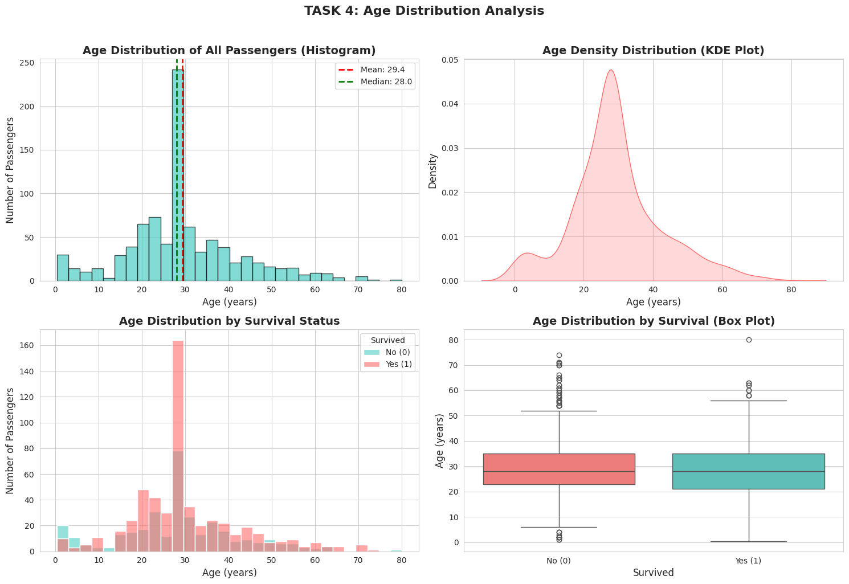
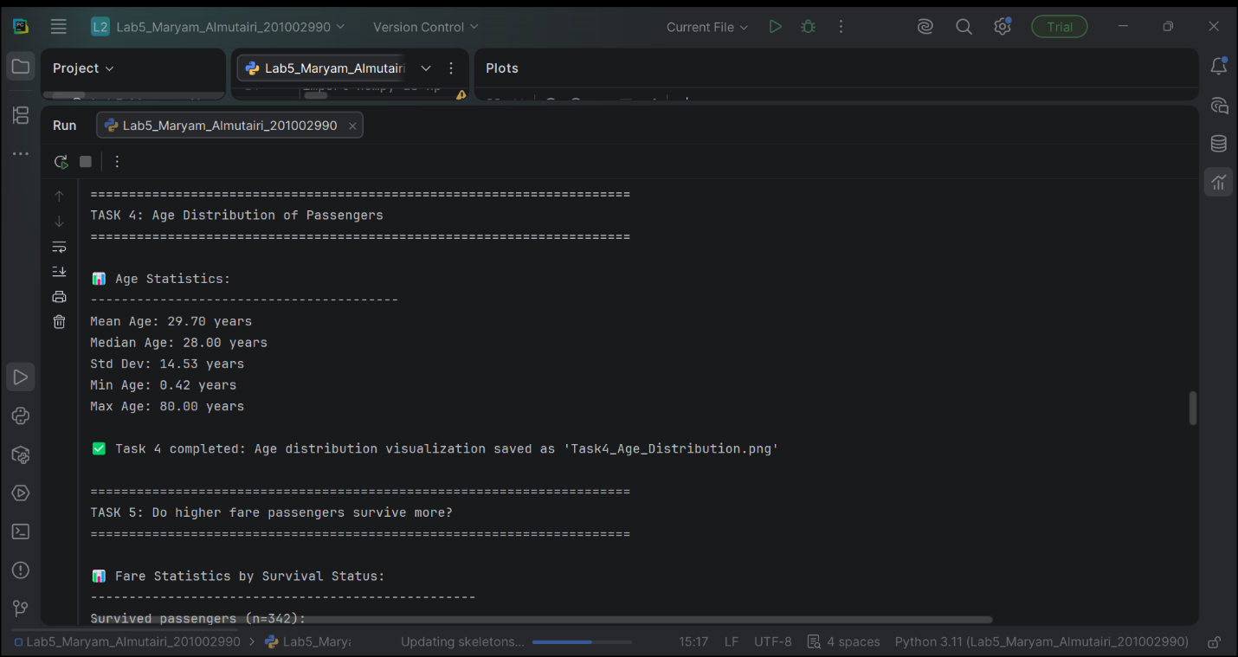

TASK 5: Fare vs Survival Analysis
# ============================================
# TASK 5: Fare vs Survival Analysis
# ============================================

print("\n" + "="*70)
print("TASK 5: Do higher fare passengers survive more?")
print("="*70)

# Fare statistics by survival
survived_fare = df_clean[df_clean['Survived'] == 1]['Fare']
not_survived_fare = df_clean[df_clean['Survived'] == 0]['Fare']

print("\n📊 Fare Statistics by Survival Status:")
print("-"*60)
print(f"\n💰 SURVIVED PASSENGERS (n={len(survived_fare)}):")
print(f" - Mean Fare: ${survived_fare.mean():.2f}")
print(f" - Median Fare: ${survived_fare.median():.2f}")
print(f" - Minimum Fare: ${survived_fare.min():.2f}")
print(f" - Maximum Fare: ${survived_fare.max():.2f}")
print(f" - Standard Deviation: ${survived_fare.std():.2f}")

print(f"\n💀 NON-SURVIVED PASSENGERS (n={len(not_survived_fare)}):")
print(f" - Mean Fare: ${not_survived_fare.mean():.2f}")
print(f" - Median Fare: ${not_survived_fare.median():.2f}")
print(f" - Minimum Fare: ${not_survived_fare.min():.2f}")
print(f" - Maximum Fare: ${not_survived_fare.max():.2f}")
print(f" - Standard Deviation: ${not_survived_fare.std():.2f}")

print(f"\n{'='*60}")
print(f"💰 CONCLUSION: Higher fare passengers survived more!")
print(f" Survivors paid ${survived_fare.mean() - not_survived_fare.mean():.2f} more on average")
print(f"{'='*60}")

# Create visualization
fig, axes = plt.subplots(2, 2, figsize=(15, 10))

# Plot 1: Box plot
sns.boxplot(data=df_clean, x='Survived', y='Fare', ax=axes[0,0],
palette=['#FF6B6B', '#4ECDC4'])
axes[0,0].set_title('Fare Distribution by Survival Status (Box Plot)', fontsize=14, fontweight='bold')
axes[0,0].set_xlabel('Survived', fontsize=12)
axes[0,0].set_ylabel('Fare ($)', fontsize=12)
axes[0,0].set_xticklabels(['No (0)', 'Yes (1)'])

# Plot 2: Violin plot
sns.violinplot(data=df_clean, x='Survived', y='Fare', ax=axes[0,1],
palette=['#FF6B6B', '#4ECDC4'])
axes[0,1].set_title('Fare Distribution (Violin Plot)', fontsize=14, fontweight='bold')
axes[0,1].set_xlabel('Survived', fontsize=12)
axes[0,1].set_ylabel('Fare ($)', fontsize=12)
axes[0,1].set_xticklabels(['No (0)', 'Yes (1)'])

# Plot 3: Scatter plot
sns.stripplot(data=df_clean, x='Survived', y='Fare', alpha=0.5, jitter=True, ax=axes[1,0],
palette=['#FF6B6B', '#4ECDC4'])
axes[1,0].set_title('Individual Fare Values by Survival', fontsize=14, fontweight='bold')
axes[1,0].set_xlabel('Survived', fontsize=12)
axes[1,0].set_ylabel('Fare ($)', fontsize=12)
axes[1,0].set_xticklabels(['No (0)', 'Yes (1)'])

# Plot 4: Average fare bar plot
avg_fare = df_clean.groupby('Survived')['Fare'].mean()
bars = axes[1,1].bar(['Not Survived', 'Survived'], avg_fare.values,
color=['#FF6B6B', '#4ECDC4'])
axes[1,1].set_title('Average Fare by Survival Status', fontsize=14, fontweight='bold')
axes[1,1].set_xlabel('Survival Status', fontsize=12)
axes[1,1].set_ylabel('Average Fare ($)', fontsize=12)

# Add values on bars
for bar, fare in zip(bars, avg_fare.values):
axes[1,1].text(bar.get_x() + bar.get_width()/2, bar.get_height() + 5,
f'${fare:.2f}', ha='center', fontsize=12, fontweight='bold')

plt.suptitle('TASK 5: Fare vs Survival Analysis', fontsize=16, fontweight='bold', y=1.02)
plt.tight_layout()
plt.savefig('Task5_Fare_Survival.png', dpi=150, bbox_inches='tight')
plt.show()

print("\n✅ Task 5 Completed: Fare vs Survival analysis saved!")
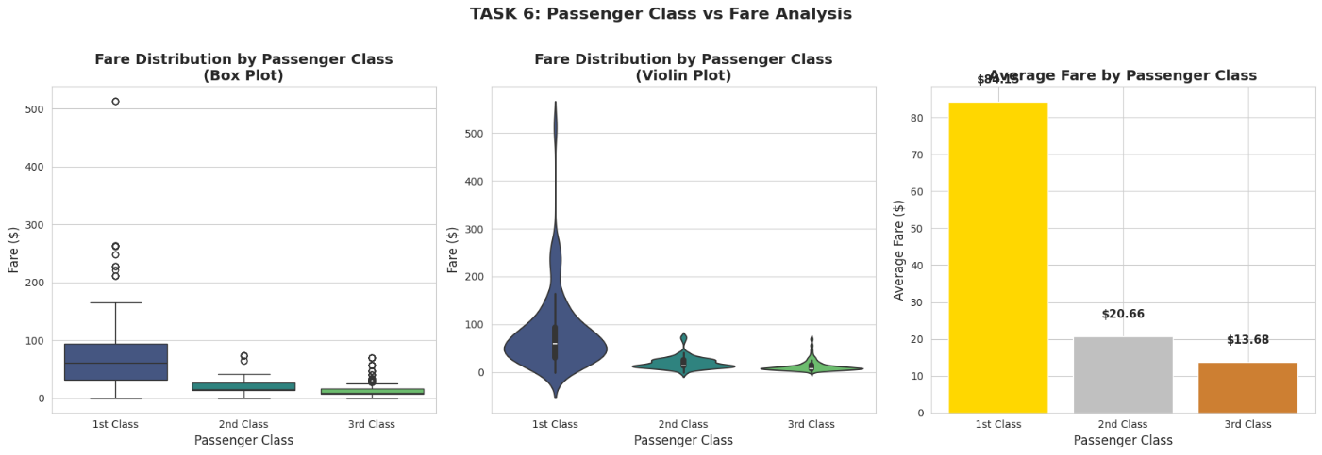
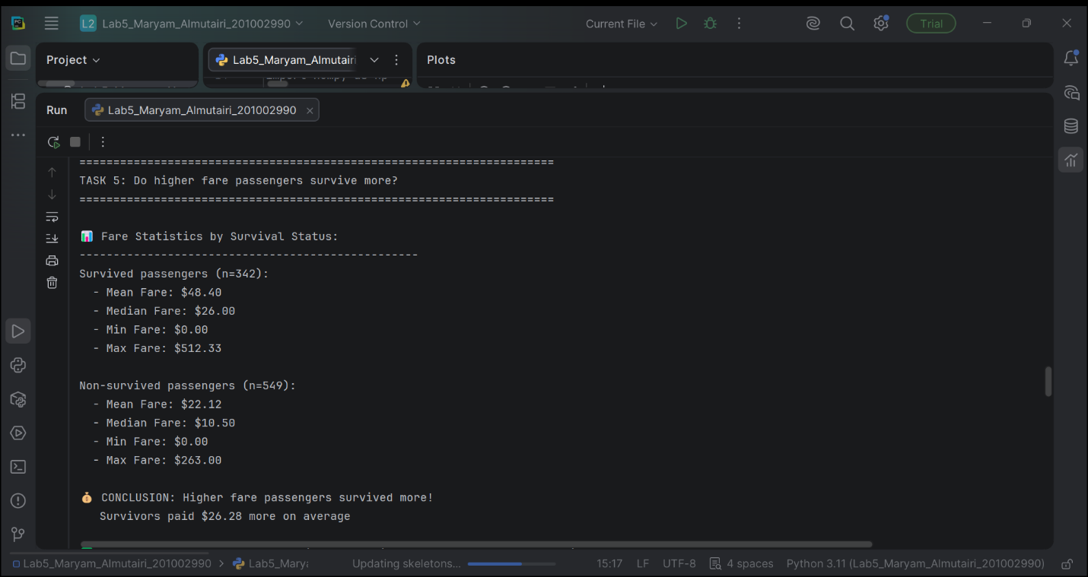

TASK 6: Passenger Class vs Fare
# ============================================
# TASK 6: Passenger Class vs Fare (Box Plot)
# ============================================

print("\n" + "="*70)
print("TASK 6: Find passenger class that paid higher fare using box plot")
print("="*70)

# Class statistics
print("\n📊 Fare Statistics by Passenger Class:")
print("-"*60)

class_fare_stats = df_clean.groupby('Pclass')['Fare'].agg(['count', 'mean', 'median', 'min', 'max'])
class_fare_stats.columns = ['Count', 'Mean Fare', 'Median Fare', 'Min Fare', 'Max Fare']
print(class_fare_stats)

# Create visualization
fig, axes = plt.subplots(1, 3, figsize=(18, 6))

# Plot 1: Box plot
sns.boxplot(data=df_clean, x='Pclass', y='Fare', ax=axes[0], palette='viridis')
axes[0].set_title('Fare Distribution by Passenger Class\n(Box Plot)', fontsize=14, fontweight='bold')
axes[0].set_xlabel('Passenger Class', fontsize=12)
axes[0].set_ylabel('Fare ($)', fontsize=12)
axes[0].set_xticklabels(['1st Class', '2nd Class', '3rd Class'])

# Plot 2: Violin plot
sns.violinplot(data=df_clean, x='Pclass', y='Fare', ax=axes[1], palette='viridis')
axes[1].set_title('Fare Distribution by Passenger Class\n(Violin Plot)', fontsize=14, fontweight='bold')
axes[1].set_xlabel('Passenger Class', fontsize=12)
axes[1].set_ylabel('Fare ($)', fontsize=12)
axes[1].set_xticklabels(['1st Class', '2nd Class', '3rd Class'])

# Plot 3: Average fare bar plot
avg_fare_class = df_clean.groupby('Pclass')['Fare'].mean()
bars = axes[2].bar(['1st Class', '2nd Class', '3rd Class'], avg_fare_class.values,
color=['gold', 'silver', '#CD7F32'])
axes[2].set_title('Average Fare by Passenger Class', fontsize=14, fontweight='bold')
axes[2].set_xlabel('Passenger Class', fontsize=12)
axes[2].set_ylabel('Average Fare ($)', fontsize=12)

# Add values on bars
for bar, fare in zip(bars, avg_fare_class.values):
axes[2].text(bar.get_x() + bar.get_width()/2, bar.get_height() + 5,
f'${fare:.2f}', ha='center', fontsize=11, fontweight='bold')

plt.suptitle('TASK 6: Passenger Class vs Fare Analysis', fontsize=16, fontweight='bold', y=1.02)
plt.tight_layout()
plt.savefig('Task6_Class_Fare.png', dpi=150, bbox_inches='tight')
plt.show()

print("\n✅ Task 6 Completed: Class vs Fare analysis saved!")
print(f"\n💰 CONCLUSION:")
print(f" 1st Class passengers paid the highest fares (avg ${avg_fare_class[1]:.2f})")
print(f" 2nd Class passengers paid avg ${avg_fare_class[2]:.2f}")
print(f" 3rd Class passengers paid avg ${avg_fare_class[3]:.2f}")
print(f" 1st Class fare is {avg_fare_class[1]/avg_fare_class[3]:.1f} times higher than 3rd Class!")
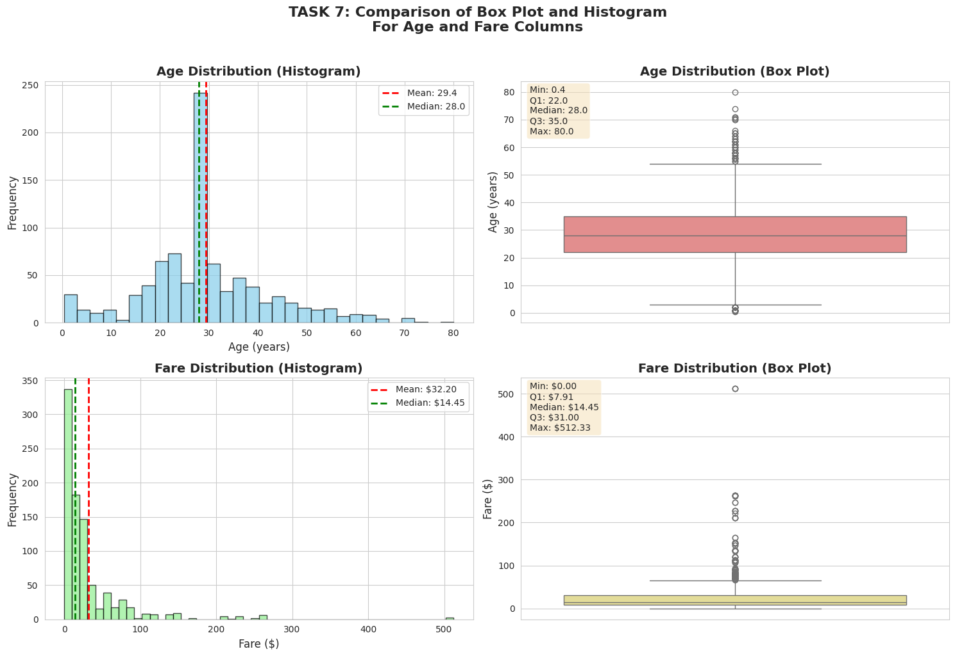
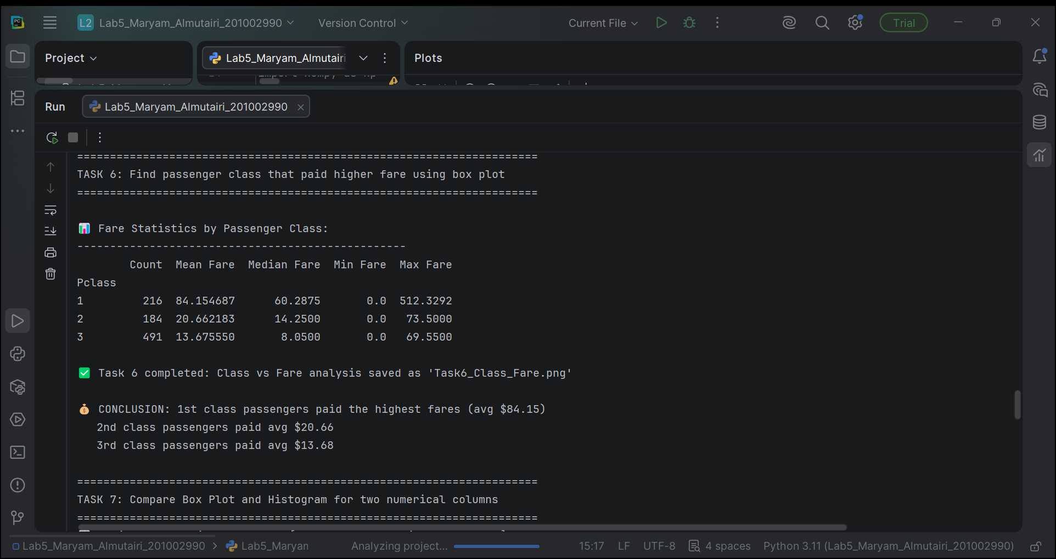

TASK 7: Compare Box Plot and Histogram
# ============================================
# TASK 7: Compare Box Plot and Histogram
# ============================================

print("\n" + "="*70)
print("TASK 7: Compare Box Plot and Histogram for two numerical columns")
print("="*70)

# Select two numerical columns
numerical_cols = ['Age', 'Fare']
print(f"\n📊 Selected numerical columns: {numerical_cols[0]} and {numerical_cols[1]}")

# Create comparison visualization
fig, axes = plt.subplots(2, 2, figsize=(15, 10))

# For Age column
# Histogram of Age
axes[0,0].hist(df_clean['Age'], bins=30, color='skyblue', edgecolor='black', alpha=0.7)
axes[0,0].set_title('Age Distribution (Histogram)', fontsize=14, fontweight='bold')
axes[0,0].set_xlabel('Age (years)', fontsize=12)
axes[0,0].set_ylabel('Frequency', fontsize=12)
axes[0,0].axvline(df_clean['Age'].mean(), color='red', linestyle='dashed', linewidth=2,
label=f'Mean: {df_clean["Age"].mean():.1f}')
axes[0,0].axvline(df_clean['Age'].median(), color='green', linestyle='dashed', linewidth=2,
label=f'Median: {df_clean["Age"].median():.1f}')
axes[0,0].legend()

# Box plot of Age
sns.boxplot(y=df_clean['Age'], ax=axes[0,1], color='lightcoral')
axes[0,1].set_title('Age Distribution (Box Plot)', fontsize=14, fontweight='bold')
axes[0,1].set_ylabel('Age (years)', fontsize=12)

# Add statistics annotation for Age
stats_text_age = f'Statistics:\nMin: {df_clean["Age"].min():.1f}\nQ1: {df_clean["Age"].quantile(0.25):.1f}\nMedian: {df_clean["Age"].median():.1f}\nQ3: {df_clean["Age"].quantile(0.75):.1f}\nMax: {df_clean["Age"].max():.1f}'
axes[0,1].text(0.02, 0.98, stats_text_age, transform=axes[0,1].transAxes,
fontsize=10, verticalalignment='top', bbox=dict(boxstyle='round', facecolor='wheat', alpha=0.5))

# For Fare column
# Histogram of Fare
axes[1,0].hist(df_clean['Fare'], bins=50, color='lightgreen', edgecolor='black', alpha=0.7)
axes[1,0].set_title('Fare Distribution (Histogram)', fontsize=14, fontweight='bold')
axes[1,0].set_xlabel('Fare ($)', fontsize=12)
axes[1,0].set_ylabel('Frequency', fontsize=12)
axes[1,0].axvline(df_clean['Fare'].mean(), color='red', linestyle='dashed', linewidth=2,
label=f'Mean: ${df_clean["Fare"].mean():.2f}')
axes[1,0].axvline(df_clean['Fare'].median(), color='green', linestyle='dashed', linewidth=2,
label=f'Median: ${df_clean["Fare"].median():.2f}')
axes[1,0].legend()

# Box plot of Fare
sns.boxplot(y=df_clean['Fare'], ax=axes[1,1], color='khaki')
axes[1,1].set_title('Fare Distribution (Box Plot)', fontsize=14, fontweight='bold')
axes[1,1].set_ylabel('Fare ($)', fontsize=12)

# Add statistics annotation for Fare
stats_text_fare = f'Statistics:\nMin: ${df_clean["Fare"].min():.2f}\nQ1: ${df_clean["Fare"].quantile(0.25):.2f}\nMedian: ${df_clean["Fare"].median():.2f}\nQ3: ${df_clean["Fare"].quantile(0.75):.2f}\nMax: ${df_clean["Fare"].max():.2f}'
axes[1,1].text(0.02, 0.98, stats_text_fare, transform=axes[1,1].transAxes,
fontsize=10, verticalalignment='top', bbox=dict(boxstyle='round', facecolor='wheat', alpha=0.5))

plt.suptitle('TASK 7: Comparison of Box Plot and Histogram\nFor Age and Fare Columns',
fontsize=16, fontweight='bold', y=1.02)
plt.tight_layout()
plt.savefig('Task7_Boxplot_Histogram_Comparison.png', dpi=150, bbox_inches='tight')
plt.show()

print("\n✅ Task 7 Completed: Box plot vs Histogram comparison saved!")

# Comparison insights
print("\n📊 Comparison Insights:")
print("-"*50)
print("1. HISTOGRAM Insights:")
print(" - Shows the frequency distribution of data")
print(" - Helps identify skewness and modality")
print(" - Age distribution is slightly right-skewed (mean > median)")
print(" - Fare distribution is highly right-skewed with a long tail")
print("\n2. BOX PLOT Insights:")
print(" - Shows median, quartiles, and outliers clearly")
print(" - Age box plot shows relatively symmetric distribution")
print(" - Fare box plot shows many outliers (passengers who paid very high fares)")
print("\n3. When to use each:")
print(" - Use Histogram: To understand overall shape and spread")
print(" - Use Box Plot: To identify outliers and compare distributions")
