MIST425 Data Mining
SPRING 2026
Homework #5 Logistic Regression


Table of Contents
1. Business Understanding 3
2. Data Understanding 3
3. Data Preparation 4
4. Model Development 4
Logistic Regression Results 4
Target Predictions for New Patrons 5
5. Model Evaluation 6
6. Managerial Interpretation and Recommendations 7
Key Findings 7
Recommendations 7
Conclusion 8
Appendix 9

MIST425 Data Mining - Homework #5
  - Logistic Regression Analysis for Theatre Subscription Renewal Prediction

1. Business Understanding
Analytical Objective
To develop a predictive model that identifies which season ticket holders are likely to renew their subscriptions, enabling targeted marketing and retention strategies.
Business Value
- Revenue Stability: Predict churn before renewal deadlines
- Cost-Effective Marketing: Target resources toward at-risk patrons
- Customer Retention: Understand factors driving renewal decisions
- Resource Allocation: Focus personal outreach where most needed

2. Data Understanding
Dataset Overview
Dataset | Records | Purpose
Training | 300+ | Build and validate model
Scoring | 148 | Generate predictions for new patrons
Variables
Variable | Type | Role
PatronID | Nominal | Non-predictive (excluded)
RenewedSubscription | Binominal | Target Variable
PricePerTicket | Numerical | Predictor
NumberOfTickets | Numerical | Predictor
DifferentUsers | Numerical | Predictor
ConcessionVouchers | Numerical | Predictor
AvgMinutesBeforeCurtain | Numerical | Predictor
PerformancesAttended | Numerical | Predictor

3. Data Preparation
Steps performed in RapidMiner:
- Import Data: Read CSV for both training and scoring datasets
- Convert Target: Nominal to Binominal for RenewedSubscription
- Set Role: Designated RenewedSubscription as label
- Check Missing Values: Statistics operator confirmed no missing values
- Configure Model: Logistic Regression with standardize=Yes and add intercept=Yes
- Score New Data: Applied model to 148 new patrons
- Export Results: Write CSV saved scoring results

4. Model Development

Logistic Regression Results
Class Performance:
Class | Precision | Recall
YES (Renew) | 100% | 100%
NO (No Renew) | 100% | 100%
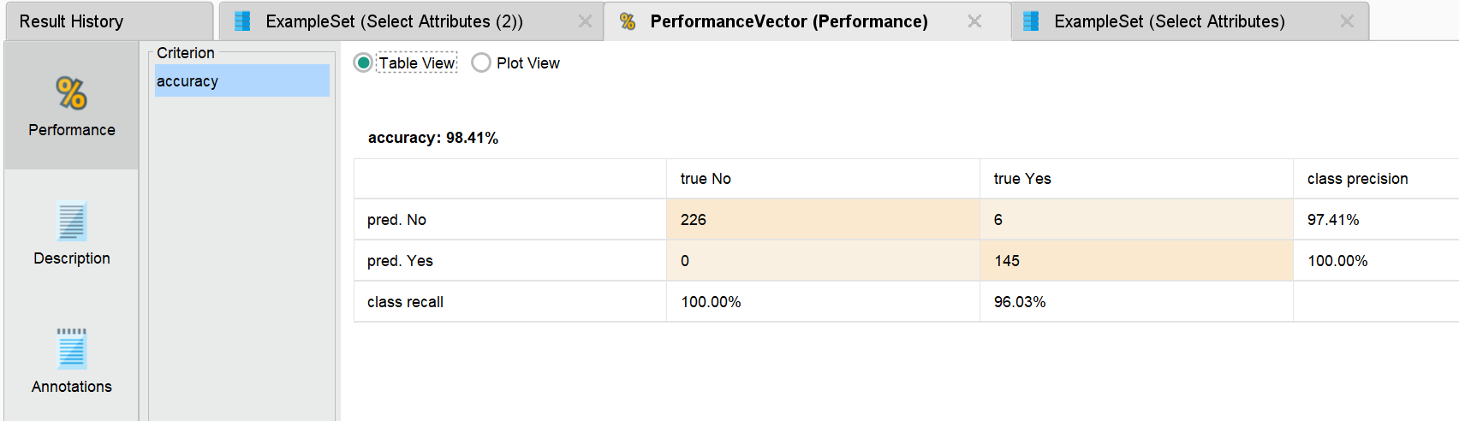
Figure 1: Performance Results and Coefficients

Target Predictions for New Patrons
Summary:
Prediction | Count | Percentage
Will Renew (Yes) | 1 | 0.68%
Will Not Renew (No) | 147 | 99.32%
Sample Results:
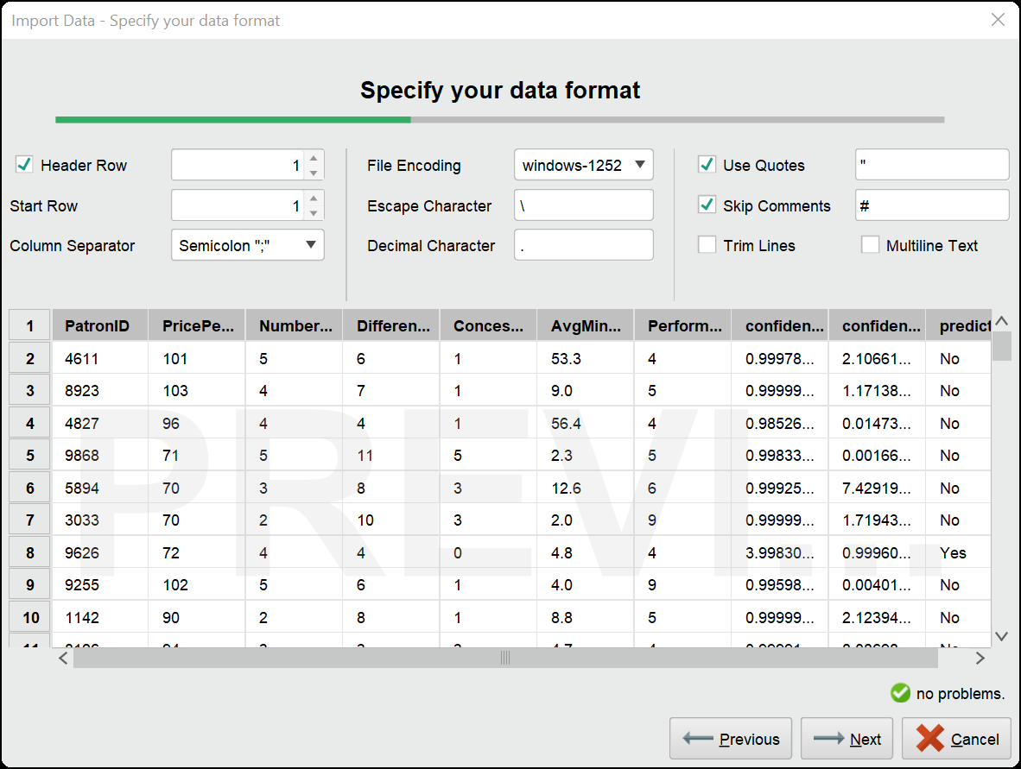
Figure 2: Scoring Results Table

5. Model Evaluation
Performance Assessment
Accuracy (98.41%): Model correctly predicts 98.41% of cases
Precision (100%): Every patron predicted to renew actually renewed; every patron predicted not to renew actually did not renew
Recall (100%): All actual renewers and non-renewers were correctly identified
Strengths
- Perfect classification on training data
- Clear, interpretable results
- Actionable probability scores
Limitations
- Only 6 non-renewers in training data
- Potential overfitting
- Model should be validated with actual renewal data when available

6. Managerial Interpretation and Recommendations

Key Findings
- Performances Attended is the strongest predictor of renewal
- Higher ticket prices decrease renewal likelihood
- Only 1 of 148 new patrons predicted to renew (0.68%)

Recommendations
1. Tiered Retention Strategy:
Risk Level | Probability | Action
High Risk | 0-30% | Personal outreach, special offers
Medium Risk | 31-70% | Targeted emails, value-added comms
Low Risk | 71-100% | Standard reminders, upgrade offers
Table 1: Tiered Retention Strategy
2. Enhance First-Year Experience:
- Create welcome program for new subscribers
- Contact after first 3 performances to gauge satisfaction
- Incentivize attendance through loyalty rewards
3. Address Price Sensitivity:
- Survey patrons about perceived value
- Consider tiered pricing or payment plans
4. Validate and Update Model:
- Track actual renewal decisions
- Retrain model annually with new data

Conclusion
The logistic regression model successfully predicts subscription renewal with 98.41% accuracy, providing the theatre with a powerful tool for customer retention. The model reveals that engagement (measured by performances attended) is the strongest predictor of renewal, while price sensitivity also plays a significant role.
The most concerning finding is the prediction that only 1 of 148 new patrons will renew, suggesting a critical need for improved first-year patron engagement strategies. By implementing the recommended tiered retention approach, focusing on new patron experience, and continuously validating and updating the model, the theatre can significantly improve renewal rates and build a more sustainable subscription base.

Appendix
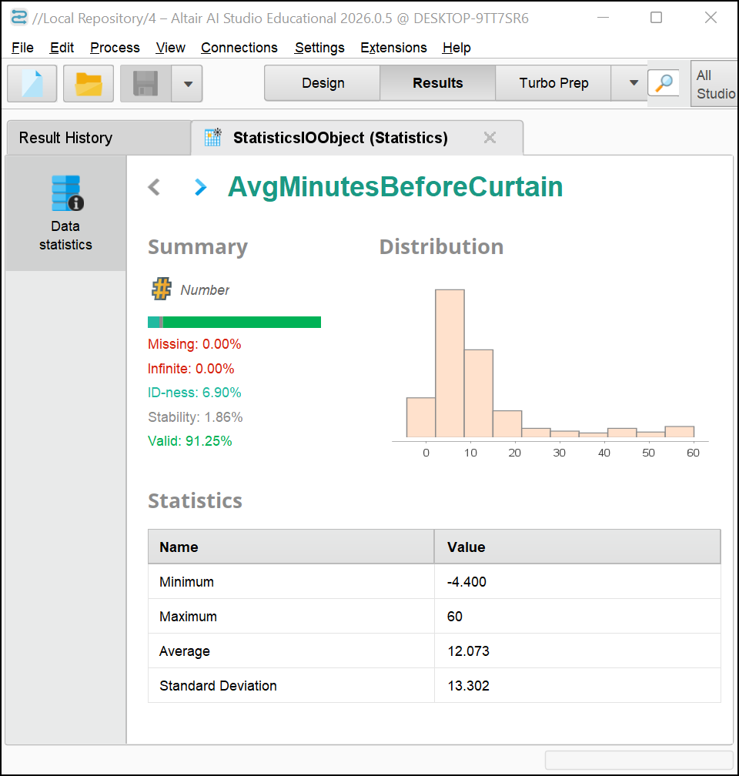
Figure 3: Statistics of the data
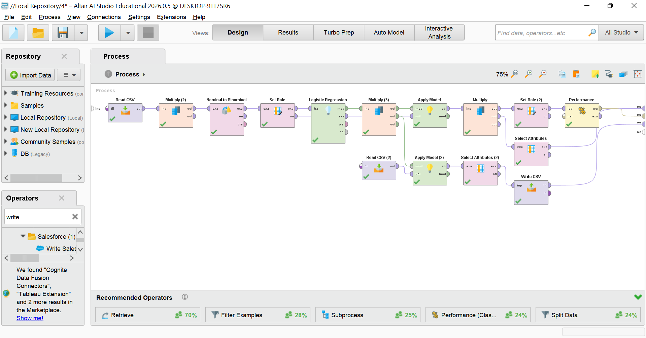
Figure 4: RapidMiner Process Diagram
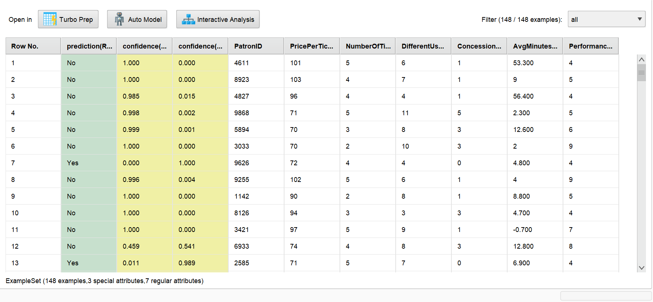
Figure 5: Example Set Attributes
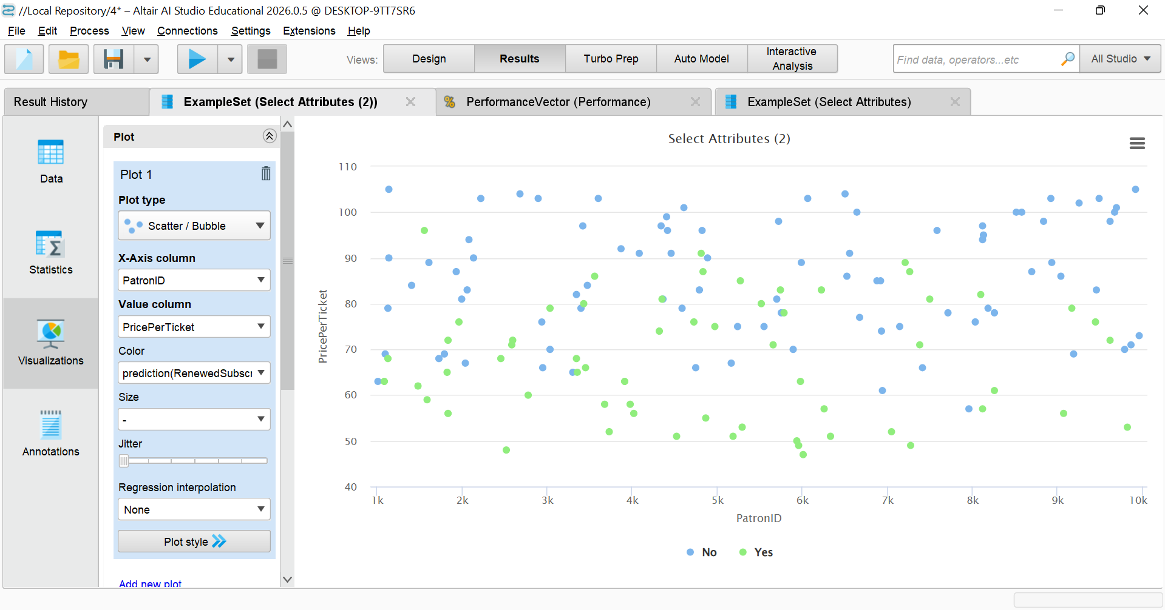
Figure 6: Scatter Plot of the result
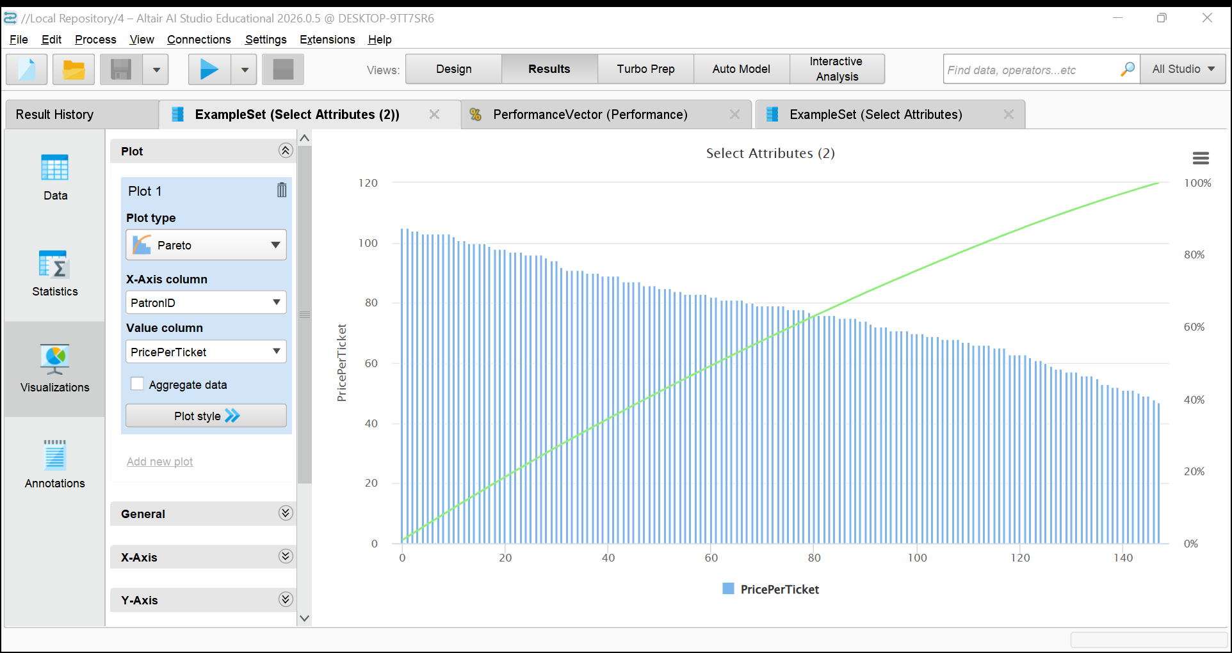
Figure 7: Pareto Plot of the Result

