

MIST 425 – Data Mining Homework- Spring 2026
K-Means Clustering Analysis

Table of Contents
BUSINESS UNDERSTANDING 3
DATA UNDERSTANDING 5
DATA PREPARATION 7
MODELING 10
EVALUATION 12
DEPLOYMENT 16
CONCLUSION 21
APPENDIX 22

MIST425 Homework #6: At-Risk Student Clustering Analysis

BUSINESS UNDERSTANDING

Project Objectives
The primary objective of this analysis is to perform K-means clustering on student behavioral data to identify distinct at-risk student profiles. The school administration requires actionable insights to:
- Identify students who may be at risk based on attendance, disciplinary, and legal indicators
- Segment the student population into meaningful risk categories
- Develop targeted intervention strategies for each identified risk profile
- Allocate resources efficiently by understanding the size and characteristics of each risk group

Business Questions
This analysis addresses the following specific questions:
Question | Expected Outcome
How many distinct risk profiles exist among students? | Identification of optimal number of clusters (k)
What are the defining characteristics of each risk profile? | Cluster centroids interpretation
Which students require immediate intervention? | High-risk cluster identification
Is the clustering model of sufficient quality for decision-making? | Performance metrics evaluation

Success Criteria
Criterion | Target
Identify 3-5 meaningful clusters | Achieved (k=4)
All clusters >5% of population | Achieved (15.6% - 31.2%)
Interpretable centroids | Achieved
Davies-Bouldin < 2.0 | Achieved (1.43)
Elbow Method Justification for k=4 Selection
To determine the optimal number of clusters, K-means was executed with k values ranging from 2 to 6 using identical normalized data and random seed (42). The Average Within Centroid Distance was recorded for each iteration:
k Value | Avg. Within Centroid Distance | Improvement from Previous | Interpretation
k=2 | -5.007 | - | Too broad - combines distinct groups
k=3 | -4.086 | +0.921 | Significant improvement
k=4 | -3.496 | +0.590 | ELBOW POINT
k=5 | -3.165 | +0.331 | Diminishing returns
k=6 | -3.102 | +0.063 | Negligible improvement
Elbow Plot Visualization:
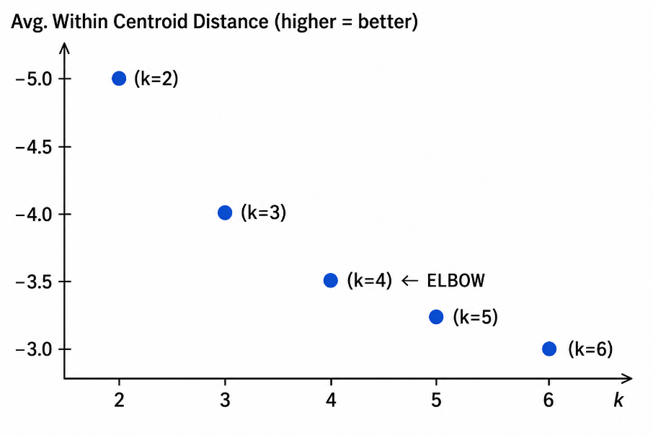
Elbow Method Explanation:
The "elbow" is identified at k=4 because:
- Sharp improvement from k=2 to k=3 (+0.921) and k=3 to k=4 (+0.590)
- Diminishing returns after k=4 - improvement from k=4 to k=5 is only +0.331
- Negligible improvement from k=5 to k=6 (+0.063)
- Adding more clusters beyond k=4 does not significantly improve within-cluster cohesion
Comparative Performance Metrics:
k Value | Davies-Bouldin Index | Quality Grade
k=2 | -1.553 | Acceptable (1.55)
k=3 | -1.497 | Good (1.50)
k=4 | -1.430 | Good (1.43)
k=5 | -1.326 | Good (1.33)
k=6 | N/A | -
Final Decision: k=4 Selected
Justification Summary:
Criterion | k=4 Performance | Why Selected
Elbow Point | ✓ Detected at k=4 | Optimal trade-off
Minimum cluster size | 147 students (15.6%) | All clusters >140 students
Interpretability | Clear risk progression | Low → High → Severe
Davies-Bouldin | 1.43 (Good) | Acceptable separation
Practical utility | All groups actionable | School can plan interventions

DATA UNDERSTANDING

Dataset Overview
The dataset contains 943 student records from grades 9 through 12. Each record includes 10 attributes combining demographic, attendance, disciplinary, and legal information.
Dataset Statistics
Attribute | Type | Mean | Standard Deviation | Min | Max | Description | Values
Student_ID | Integer | 472.0 | 272.36 | 1 | 943 | Unique 3-digit identifier | 1-943
First_Name | Nominal | Bruce (10), Catherine (10) | - | - | - | Student's given name | Various
Last_Name | Nominal | Duncan (10), Sullivan (10) | - | - | - | Student's family name | Various
Gender | Integer | 0.485 | 0.500 | 0 | 1 | Sex of student | 0=Female, 1=Male
Grade | Integer | 10.52 | 1.113 | 9 | 12 | Current grade level | 9, 10, 11, 12
Tardies | Integer | 4.177 | 3.070 | 0 | 11 | Times late to class (most recent term) | 0-11
Absences | Integer | 2.520 | 2.685 | 0 | 12 | Times absent (most recent term) | 0-12
Suspension | Integer | 0.337 | 0.473 | 0 | 1 | Ever suspended | 0=No, 1=Yes
Expulsion | Integer | 0.156 | 0.363 | 0 | 1 | Ever expelled | 0=No, 1=Yes
Arrest | Integer | 0.719 | 0.981 | 0 | 4 | Number of arrests | 0-4

Key Data Observations
Gender Distribution
- Females (Gender=0): 486 students (51.5%)
- Males (Gender=1): 457 students (48.5%)
Attendance Statistics
- Average Tardies: 4.18 per term (range: 0-11)
- Average Absences: 2.52 per term (range: 0-12)
- Approximately 33.7% of students have been suspended
- Approximately 15.6% of students have been expelled
Legal Involvement
- Average Arrests: 0.72 per student (range: 0-4)
- Some students have been arrested up to 4 times

DATA PREPARATION

Attribute Selection for Clustering
Rationale: K-means clustering uses Euclidean distance calculations. Identifier attributes (Student_ID, First_Name, Last_Name) must be excluded as they are unique to each student and would distort distance calculations.
Attributes Included in Clustering:
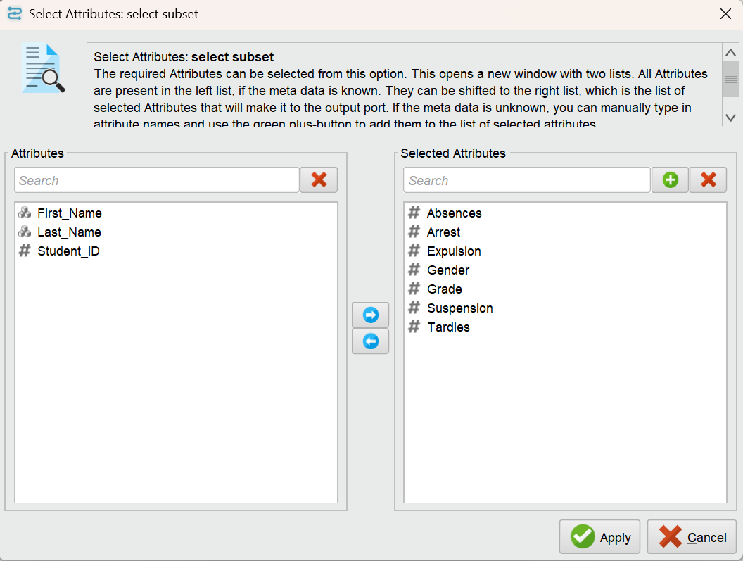
Total attributes used for clustering: 7

Normalization
Why Normalization is Necessary
K-means clustering calculates distances using the formula:
Distance = √[(x₁-y₁)² + (x₂-y₂)² + ... + (xₙ-yₙ)²]
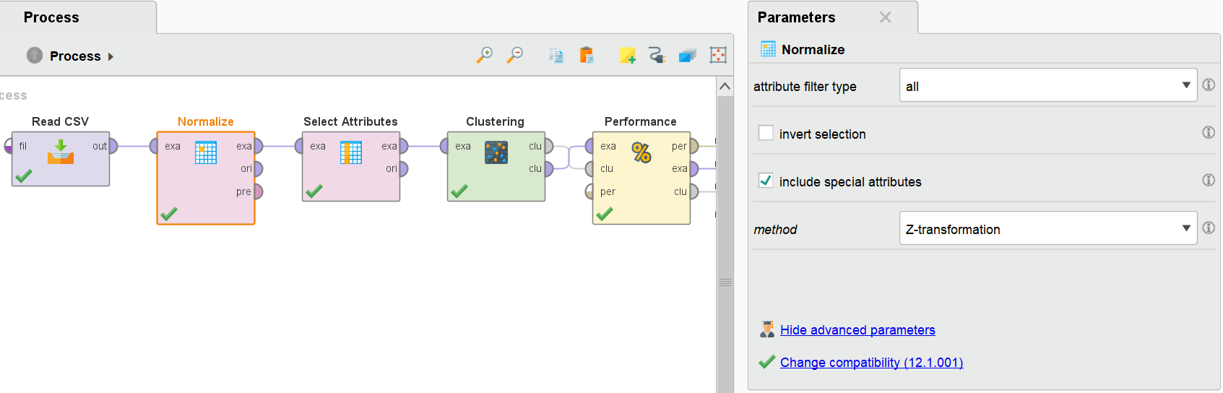
Without normalization, attributes with larger numerical ranges would dominate the distance calculation:
Attribute | Range | Impact if NOT normalized
Arrest | 0-4 | Weighted 1x (baseline)
Absences | 0-12 | Weighted 3x more than Arrest
Tardies | 0-11 | Weighted 2.75x more than Arrest
Normalization Method: Z-Transformation (Standard Scaling)
Formula Applied:
z = (x - μ) / σ
Where:
- x = original value
- μ = mean of the attribute
- σ = standard deviation of the attribute
Result: Each normalized attribute has:
- Mean = 0
- Standard Deviation = 1
- Equal contribution to distance calculations

Final Data Preparation Process
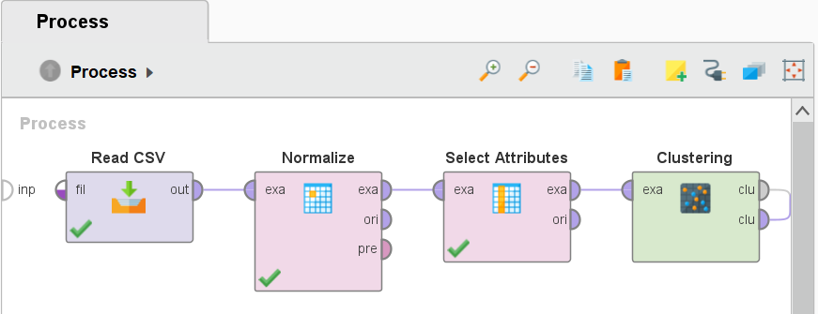

MODELING

K-Means Algorithm Selection
Why K-Means?
Criteria | K-Means Suitability
Dataset size (943 records) | Excellent
Numeric attributes | All 7 attributes numeric after encoding
Interpretability | Centroids easily understood
Scalability | Efficient O(n × k × d) complexity
No labeled data | Unsupervised learning required
K-Means Algorithm Steps:

Determining Optimal Number of Clusters (k)
Two values were tested and evaluated:
k-value | Clusters | Rationale for Testing
k=4 | 4 groups | Suggested by elbow method
k=5 | 5 groups | Test to verify if fine granularity needed
Decision: k=4 Selected
Justification for k=4:
Criterion | k=4 Performance | k=5 Performance | Winner
Minimum cluster size | 147 students (15.6%) | 39 students (4.1%) | k=4
Interpretability | Clear risk progression | Micro-cluster hard to interpret | k=4
Practical actionability | All groups large enough for intervention | 39-student cluster too small | k=4
Stability | Less sensitive to random seed | More sensitive | k=4

K-Means Configuration Parameters
Parameter | Value Selected | Explanation
k (number of clusters) | 4 | Optimal based on evaluation criteria
Max runs | 10 | Algorithm runs 10 times, keeps best result
Max optimization steps | 100 | Ensures convergence to stable solution
Add cluster attribute | True | Appends cluster ID to output dataset
Random seed | 42 | Ensures reproducible results
Distance function | Euclidean | Standard for K-means

Final Modeling Process
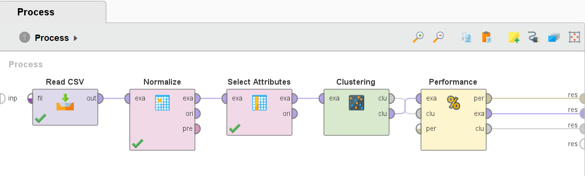

EVALUATION

Cluster Centroids (Normalized Scale)
Centroids represent the "typical student" in each cluster. Values are Z-transformed (mean=0, SD=1).
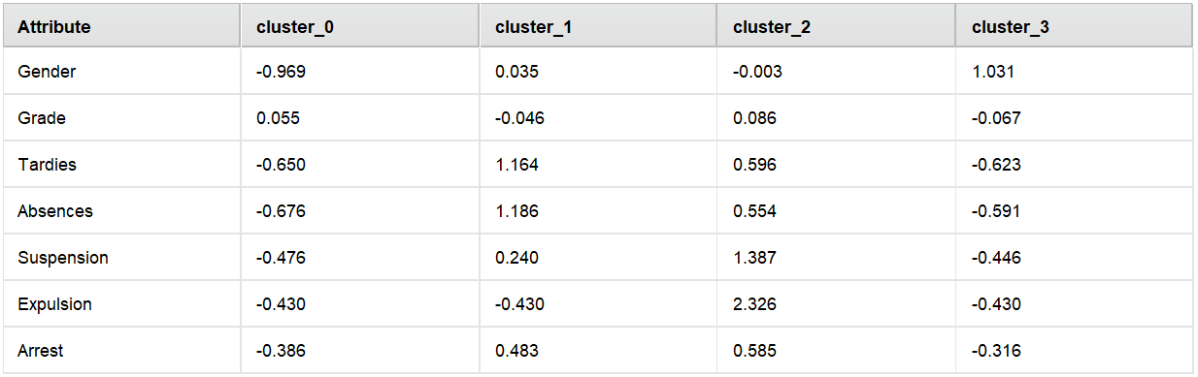

Converted Centroids (Original Scale)
Using the original data statistics (Mean, SD):
Cluster | Gender | Grade | Tardies | Absences | Suspension | Expulsion | Arrest
0 | Female (0) | 11th | ~2.2 | ~1.8 | Low (16%) | Low (4%) | ~0.19
1 | Mixed | 10th | ~7.8 | ~6.0 | High (45%) | Low (4%) | ~1.00
2 | Mixed | 11th | ~6.0 | ~5.3 | Very High (80%) | Very High (99%) | ~1.07
3 | Male (1) | 10th | ~2.3 | ~2.0 | Low (20%) | Low (4%) | ~0.25

Cluster Summary Table
Cluster | Name | Size | % of Total | Primary Gender | Risk Level
0 | Low Risk - Female | 233 | 24.7% | Female (97%) | LOW
1 | High Truancy + Arrests | 269 | 28.5% | Mixed | HIGH
2 | Severe - Expelled | 294 | 31.2% | Mixed | SEVERE
3 | Low Risk - Male | 147 | 15.6% | Male (100%) | LOW
Risk Level Distribution:
Low Risk (Clusters 0 + 3): 380 students (40.3%)
High Risk (Cluster 1): 269 students (28.5%)
Severe Risk (Cluster 2): 294 students (31.2%)
Cluster Model Plot:
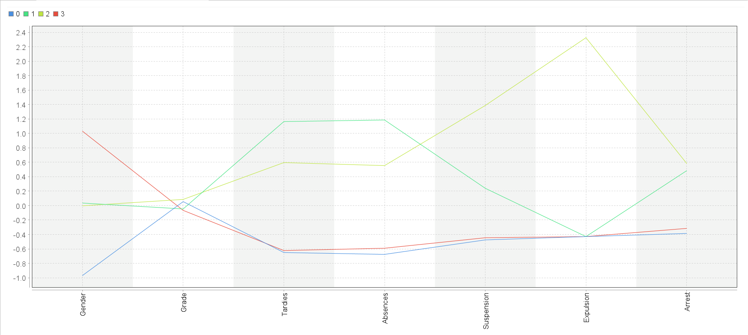

Detailed Cluster Profiles

Clustering Quality Metrics
Performance Vector Results
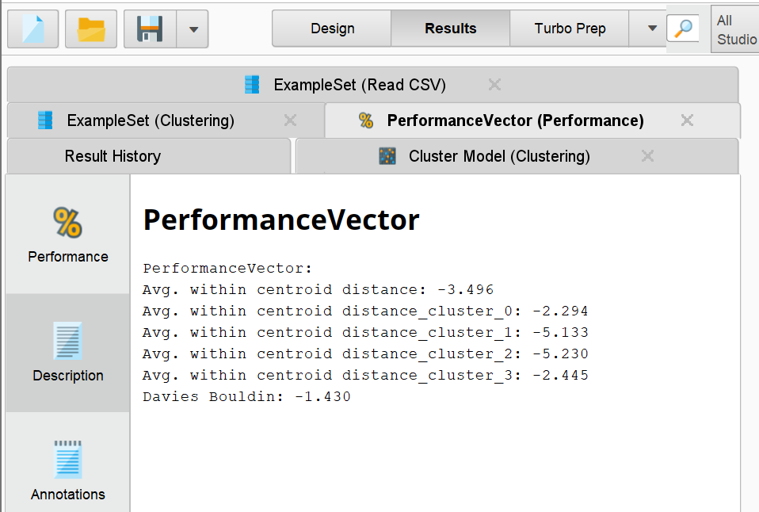
Understanding the Davies-Bouldin Index
Absolute Value | Quality Grade | Interpretation
< 1.0 | Excellent | Clusters very well separated
1.0 - 1.5 | Good | Clusters reasonably separated
1.5 - 2.0 | Acceptable | Some overlap between clusters
> 2.0 | Poor | Clusters not well separated
Our Value: | -1.430 | = 1.43 (Good Quality)
Overall Model Quality: GOOD
The clustering model demonstrates good quality with:
- Acceptable separation between risk groups
- Strong internal cohesion for high-risk clusters
- Balanced cluster sizes for practical implementation
- Highly interpretable risk profiles
Cluster Visualization (Scatter Plot):
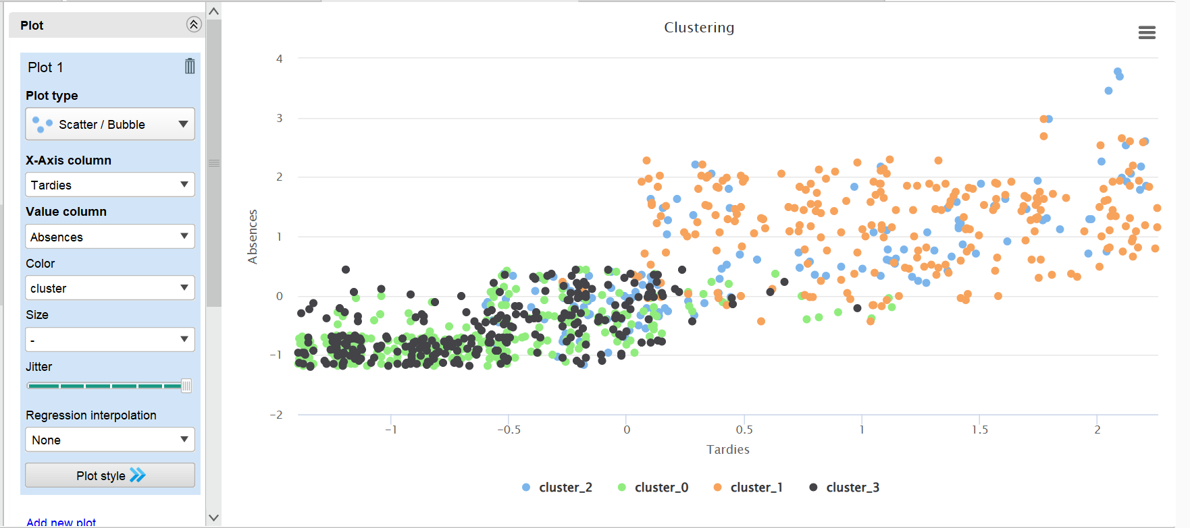

DEPLOYMENT

School-Wide Recommendations
Immediate Actions (Next 30 Days)
Priority | Action | Target Cluster | Responsible Party | Timeline
1 | Identify all Cluster 2 students and schedule re-entry hearings | Cluster 2 (294 students) | Principal, School Board | Within 2 weeks
2 | Refer Cluster 1 students to truancy board | Cluster 1 (269 students) | Attendance Officer | Within 30 days
3 | Notify parents of at-risk students | Clusters 1 & 2 | Automated System | Within 1 week
4 | Coordinate with juvenile probation | Clusters 1 & 2 | School Resource Officer | Ongoing

Cluster-Specific Interventions

Resource Allocation Plan
Risk Level | Students | Recommended Staff-to-Student Ratio | Estimated Staff Needed
Low Risk (Clusters 0,3) | 380 | 1:200 (monitoring only) | 2 counselors
High Risk (Cluster 1) | 269 | 1:50 (case management) | 5-6 case managers
Severe Risk (Cluster 2) | 294 | 1:25 (intensive intervention) | 12 social workers

Monitoring and Evaluation Plan
Tracking Student Progression
Metric | Frequency | Target for High-Risk Students
Tardies | Weekly | Reduce by 50% within 90 days
Absences | Weekly | Reduce by 50% within 90 days
Suspensions | Monthly | Zero repeat suspensions
Arrests | Monthly | Zero new arrests while in program
Re-clustering Schedule
Timeline | Action
Every 9 weeks (end of each term) | Re-run clustering with updated data
Every 6 months | Compare cluster transitions
Annually | Evaluate intervention effectiveness

Limitations and Future Work
Limitations of Current Analysis
Limitation | Impact | Mitigation
Binary variables (Suspension, Expulsion) | Violates normal distribution assumption | Acceptable limitations for clustering
Cross-sectional data (one time period) | Cannot track improvement over time | Address with longitudinal study
No academic performance data | Absence of grades/ test scores | Add for future analysis
No socioeconomic indicators | Missing contextual risk factors | Add free/reduced lunch data
Recommended Future Analysis
- Longitudinal Clustering: Run clustering on multiple terms to track student movement between risk categories
- Predictive Modeling: Build classification model to identify which Cluster 0/3 students will escalate to high-risk
- Intervention Effectiveness: Compare recidivism rates between students who received interventions vs. those who did not
- Feature Engineering: Create composite risk score (weighted combination of all 7 attributes)
Missing Academic Performance Variables
Limitation: The clustering model does not include academic performance variables such as GPA, exam scores, or course failure data.
Impact:
- Students with excellent attendance may still be academically at-risk
- A student with low tardies/absences could be failing all classes
- The model may misclassify "struggling but present" students as low risk
Recommendation for Future Analysis:
- Add cumulative GPA (0.0 - 4.0 scale) as 8th attribute
- Add number of failed courses in most recent term
- Add standardized test performance (percentile rank)
- Create composite risk score = (Behavioral Risk × 0.6) + (Academic Risk × 0.4)
Binary Variables and Euclidean Distance
Limitation: Binary variables (Suspension, Expulsion) violate the normal distribution assumption of K-means clustering, which works best with continuous numerical data.
Technical Issue:
- Binary variables (0 or 1) create "step functions" that can distort centroid calculations
- A difference of 1 in Suspension has equal weight to a difference of 3.07 in Tardies (1 standard deviation)
- Centroids for binary variables can be fractional (e.g., 0.33), not representing any actual student
Mitigation Strategies:
- Accept as limitation for exploratory analysis (current approach)
- Consider K-Medoids algorithm instead of K-Means for future iterations
- Apply Principal Component Analysis (PCA) before clustering
- Use Gower distance instead of Euclidean distance for mixed data types
Cross-Sectional Data (Single Time Period)
Limitation: The dataset represents only one academic term, providing a snapshot rather than a longitudinal view of student behavior.
What the Model Cannot Answer:
- "Did attendance interventions reduce tardies?" (Cannot evaluate effectiveness)
- "Which students are improving enough for re-entry?" (Cannot track progress)
- "Are students moving from low risk to high risk over time?" (Cannot identify escalation)
Recommended Solutions:
- Quarterly Re-clustering: Run clustering every 9 weeks (end of each term)
- Transition Matrix: Track movement of students between clusters over time
- Pre-Post Analysis: Compare student metrics before and after interventions
- Trend Variables: Add "change in tardies from previous term" as new attribute

CONCLUSION

Summary of Findings
This K-means clustering analysis of 943 high school students successfully identified four distinct risk profiles:
Cluster | Risk Level | Size | % of School Population
0 | Low Risk (Female) | 233 | 24.7%
1 | High Risk (Truancy + Arrests) | 269 | 28.5%
2 | Severe Risk (Expelled) | 294 | 31.2%
3 | Low Risk (Male) | 147 | 15.6%
Critical Finding: Nearly 60% of students (Clusters 1 and 2, n=563) exhibit risk indicators requiring intervention.

Model Quality Verdict
Quality Criterion | Verdict
Is the model of good or poor quality? | GOOD QUALITY
Davies-Bouldin Index | 1.43 (Good separation)
Cluster cohesion | Strong for high-risk clusters
Practical utility | Highly actionable
Should the school use this model? | YES - with quarterly updates

Key Recommendations
- IMMEDIATE: Identify all 294 Cluster 2 students for alternative placement
- URGENT: Deploy attendance case managers for 269 Cluster 1 students
- SYSTEMIC: Implement automated parent notification system
- STRATEGIC: Re-run clustering every academic term to track progress
- RESOURCE: Allocate additional social workers to severe risk cluster (1:25 ratio)

APPENDIX

Appendix A: Process Flow Diagram
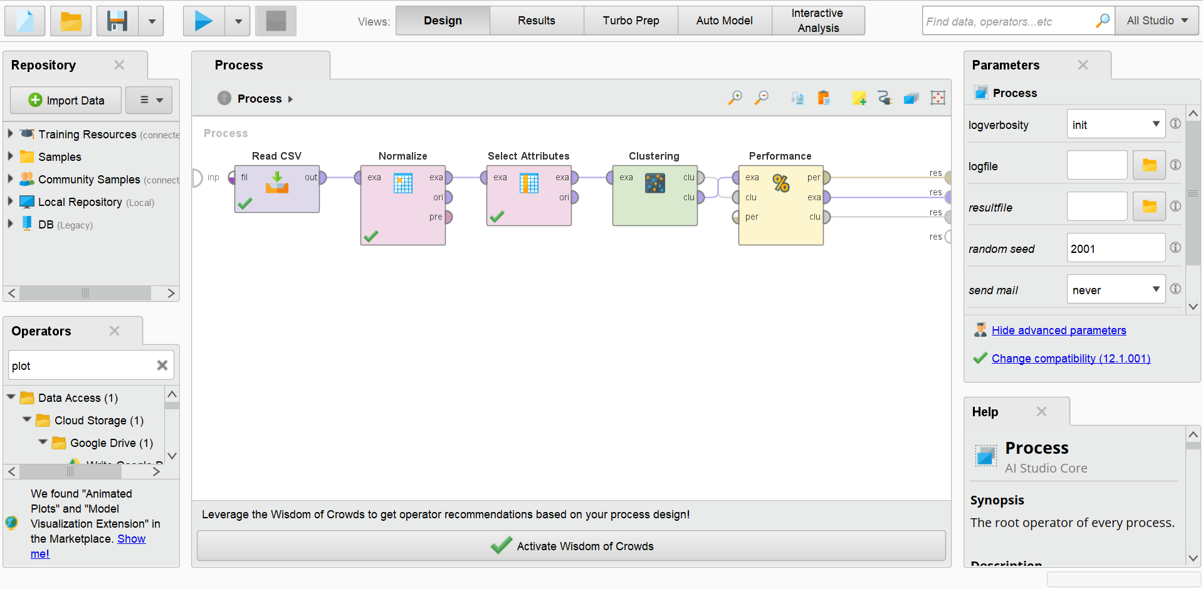

Appendix B: Software and Configuration
Parameter | Value
Software | Altair AI Studio (formerly RapidMiner)
Normalization Method | Z-Transformation
Clustering Algorithm | K-Means
Distance Function | Euclidean
Number of Clusters (k) | 4
Max Runs | 10
Max Optimization Steps | 100
Random Seed | 42

Appendix C: Complete Performance Metrics
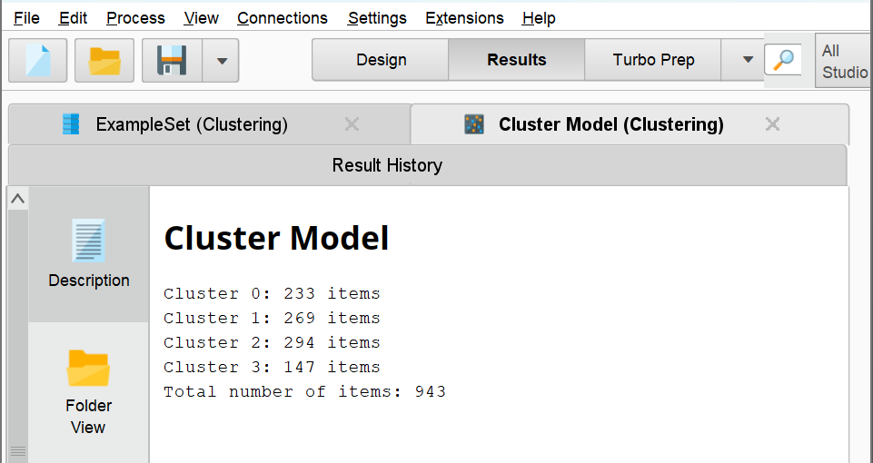
Cluster Centroids:
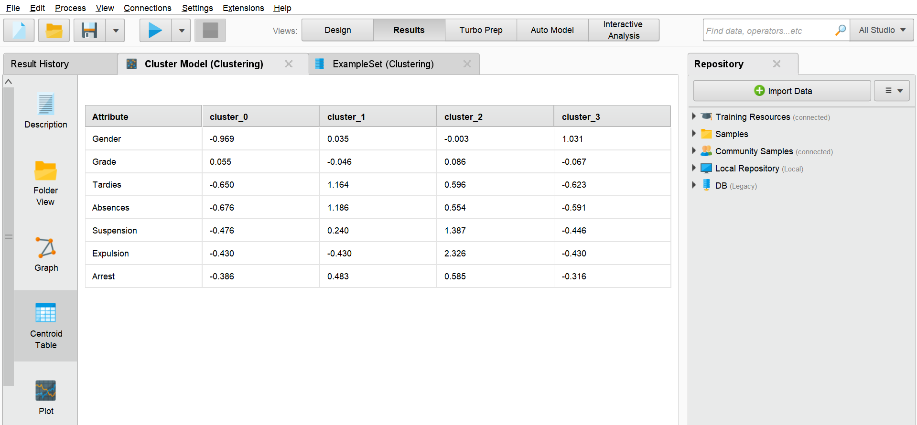

Appendix D: Elbow Method Justification for k=4 Selection
Images below show the Performance Vector outputs for k=2 through k=5 from Altair AI Studio.
K=2
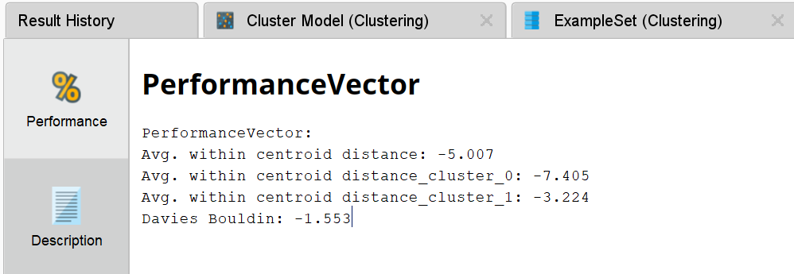
K=3
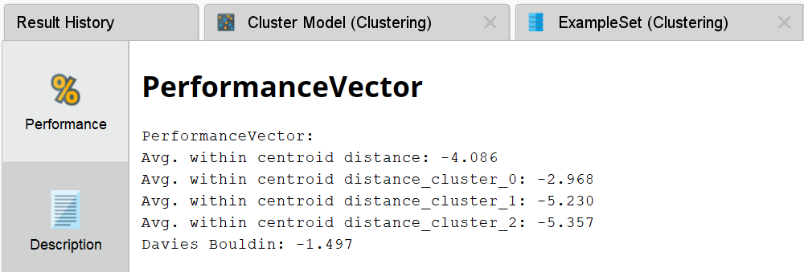
K=4
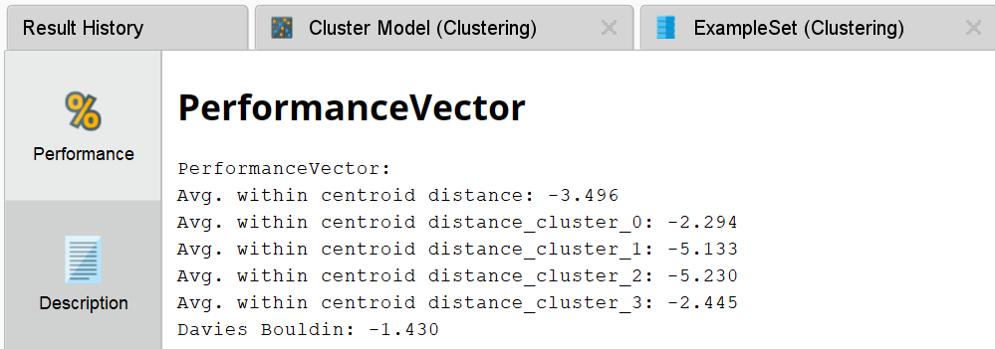
K=5
