Write a C# program to find out the total number of an odd digits and even digits within the given number and print the sum of all odd digits and sum of even digits.
Code:
using System; class Program1{
static void Main(){ Console.Write("Name - Hemant yadu"); Console.Write("Roll no. - 2310174016");
Console.Write(" "); Console.Write("Enter a number: ");
string input = Console.ReadLine();

int oddCount = 0, evenCount = 0; int oddSum = 0, evenSum = 0;

foreach (char digitChar in input){
int digit = digitChar - '0'; // Convert character to integer

if (digit % 2 == 0) // Check if even{ evenCount++;
evenSum += digit;
}
else{ // Odd
oddCount++; oddSum += digit;
}
}
Console.WriteLine($"Total even digits: {evenCount}"); Console.WriteLine($"Sum of even digits: {evenSum}"); Console.WriteLine($"Total odd digits: {oddCount}"); Console.WriteLine($"Sum of odd digits: {oddSum}");
}
}

Output:
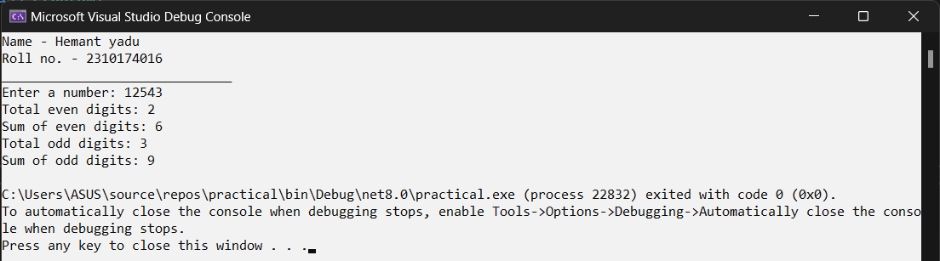

Write a C# program to input a number and check whether the number is Armstrong or not. (A number is Armstrong number if sum of each digit raised to(total digit is = number.
Code:
using System;
using System.Collections.Generic; using System.Linq;
using System.Text;
using System.Threading.Tasks;

namespace practical{ internal class program2{
public program2(){ Console.Write("Enter a number");
int number = int.Parse(Console.ReadLine()); int sum = 0;
int temp = number;
int digits = number.ToString().Length; while (temp > 0){
int digit = temp % 10;
sum += (int)Math.Pow(digit, digits); temp /= 10;
}
if (sum == number){
Console.WriteLine($"{number} is an Armstrong number.");
}
else
{
Console.WriteLine($"{number} is not an Armstrong number. ");
}
Console.ReadLine();
}}}

Output:
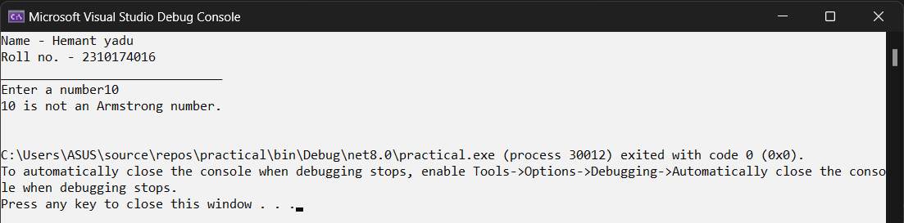

Write a C# program to check whether number is Harshad Number or not.
Code:
using System; namespace practical{
internal class prog3 { static void Main(){
Console.WriteLine("Name : Hemant Yadu "); Console.WriteLine("Class : Mca 3rd sem "); Console.Write("Enter a number: ");
int number = int.Parse(Console.ReadLine()); if (IsHarshadNumber(number){
Console.WriteLine($"{number} is a Harshad number.");
}else{
Console.WriteLine($"{number} is not a Harshad number.");
}
Console.ReadLine();
}
static bool IsHarshadNumber(int n) { int sumOfDigits = 0;
int temp = n; while (temp > 0) {
sumOfDigits += temp % 10; temp /= 10;
}
return n % sumOfDigits == 0;
}}}
Output:
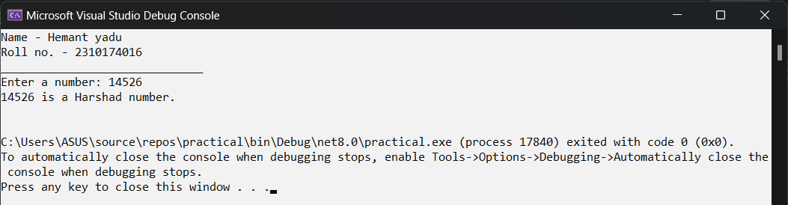

Write a C# program to find prime number between range of start number and end number.
Code: 3
using System; namespace practical{
internal class prog4{
static void Main(string[] args) { Console.WriteLine("Name : Hemant Yadu"); Console.WriteLine("Class : Mca 3rd sem"); Console.WriteLine("Prime Number Finder"); Console.Write("Enter the starting number: "); int start = int.Parse(Console.ReadLine()); Console.Write("Enter the ending number: "); int end = int.Parse(Console.ReadLine());
Console.WriteLine($"Prime numbers between {start} and {end} are:" PrintPrimesInRange(start, end);
Console.ReadKey();}
static void PrintPrimesInRange(int start, int end){ for (int i = start; i <= end; i++) {
if (IsPrime(i)) { Console.WriteLine(i);
}
}
}
static bool IsPrime(int number){ if (number < 2) return false;
for (int j = 2; j <= Math.Sqrt(number); j++){ if (number % j == 0) {
return false;
}
}
return true;
}}}
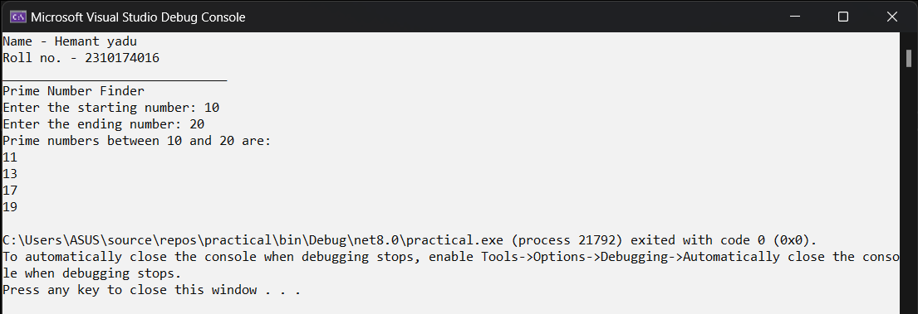
Output:

Write a C# program to find out tin prime numbers between 10 to 1000. Twin primes are defined to be two consecutive odd number which are prime.
Code:
using System; namespace practical{
internal class prog5{
static void Main(string[] args){ Console.WriteLine("Name: Hemant Yadu"); Console.WriteLine("Class: MCA 3rd Sem");
Console.WriteLine("Twin primes between 10 and 1000:"); for (int i = 11; i < 1000; i += 2 {
if (IsPrime(i) && IsPrime(i + 2)){ Console.WriteLine($"({i}, {i + 2})");
}
}
Console.ReadKey();
}
static bool IsPrime(int number) { if (number <= 1) return false; if (number <= 3) return true;
if (number % 2 == 0 || number % 3 == 0) for (int i = 5; i * i <= number; i += 6) {
if (number % i == 0 || number % (i + 2) == 0)
}
return true;
}
}
}
Output:
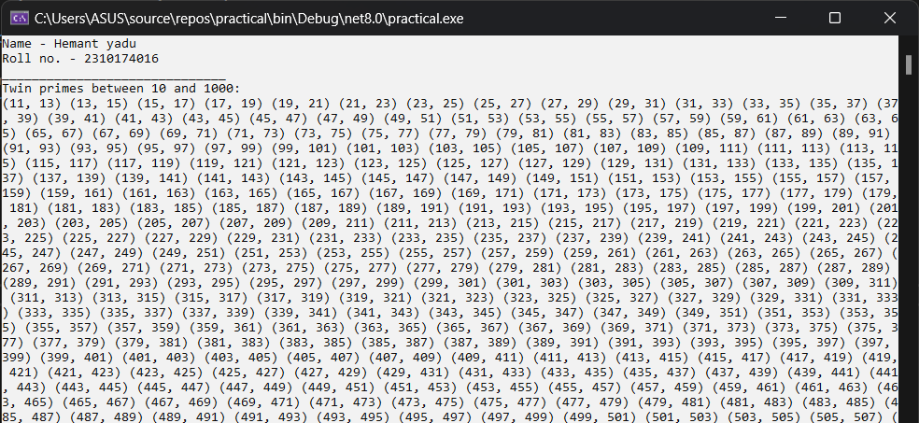

Enter two positive integers and calculate and print out the sum of the products of each pair of digits occupying the same position in the two numbers.
Code:
using System; namespace practical{
internal class prog6{
static void Main(string[] args){ Console.WriteLine("Name : Hemant Yadu"); Console.WriteLine("Class : Mca 3rd sem"); Console.WriteLine("Enter two positive integers:"); Console.Write("Enter the first number: ");
string num1 = Console.ReadLine();

Console.Write("Enter the second number: "); string num2 = Console.ReadLine();

int maxLength = Math.Max(num1.Length, num2.Length); num1 = num1.PadLeft(maxLength, '0');
num2 = num2.PadLeft(maxLength, '0'); int sumOfProducts = 0;
for (int i = 0; i < maxLength; i++){
// Convert character to integer and calculate the product int digit1 = num1[i] - '0';
int digit2 = num2[i] - '0'; sumOfProducts += digit1 * digit2;
}
Console.WriteLine($"The sum of the products of each pair of digits is: {sumOfProducts}"); Console.ReadLine();
}
}
}
Output:
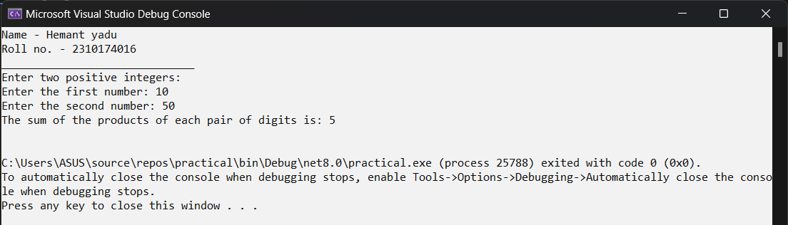

Write a C# program to display factorial series up to nth term 1! 2! 3! 4! …… n!
Code:
using System; namespace practical{
internal class prog7{ static void Main(){
Console.WriteLine("Name : Hemant Yadu"); Console.WriteLine("Class : Mca 3rd sem"); Console.Write("Enter the value of n: ");
int n = int.Parse(Console.ReadLine()); Console.WriteLine("Factorial series up to {0}:", n); for (int i = 1; i <= n; i++) {
Console.Write("{0}! = {1}", i, Factorial(i)); if (i < n) {
Console.Write(", ");
}
}
Console.WriteLine(); // Move to next line after the series Console.ReadLine();
}
static long Factorial(int number) { long result = 1;
for (int i = 1; i <= number; i++) { result *= i;
}
return result;
}
}
}
Output:
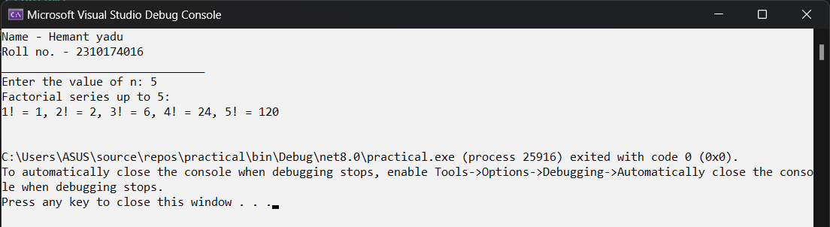

Write the program that display Fibonacci series up to nth term. 0 1 1 2 3 5 8 13 ……n
Code:
using System; namespace practical{
internal class prog8 {
static void Main(string[] args){
int num1 = 0, num2 = 1, num3, range; Console.WriteLine("Name : Hemant Yadu"); Console.WriteLine("Class : Mca 3rd sem");Console.WriteLine("Enter range
: ");
range = Convert.ToInt32(Console.ReadLine()); Console.Write(num1 + " "); Console.Write(num2 + " ");
while (range > 1){
num3 = num1 + num2; Console.Write(num3 + " "); num1 = num2;
num2 = num3; range--;
}
Console.ReadLine();
}
}
}
Output:
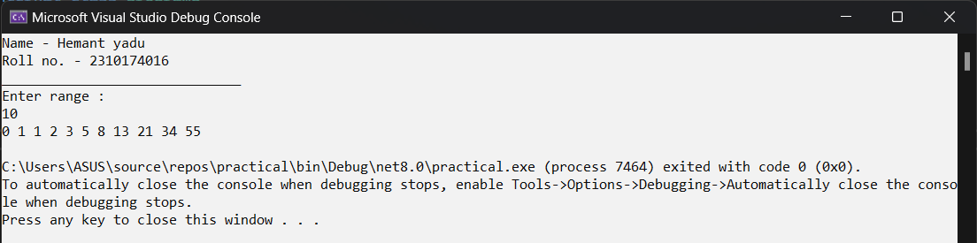

Practical No. 9
Write a C# program to do the following operations:
- Read any two positive integer operands (say op1 & op2) and one character type operator (say opr). Note that opr is any mathematical operator.
- Depending upon the operator, do the appropriate operation.

Code:
using System; namespace practical{
internal class prog9{
static void Main(string[] args){ int opr , int op1;
int op2 , int result; Console.WriteLine("Name : Hemant Yadu"); Console.WriteLine("Class: Mca 3rd sem");
Console.WriteLine("Enter the first number: "); op1 = int.Parse(Console.ReadLine()); Console.WriteLine("Enter the second number: "); op2 = int.Parse(Console.ReadLine()); Console.WriteLine("Enter operation: "); Console.WriteLine("1: Addition"); Console.WriteLine("2: Subtraction"); Console.WriteLine("3: Multiplication"); Console.WriteLine("4: Division");
opr = int.Parse(Console.ReadLine());

switch (opr){ case 1:
result = op1 + op2; break;
case 2:
result = op1 - op2; break;
case 3:
result = op1 * op2; break;
case 4:
if (op2 != 0) // Check for division by zero
{
result = op1 / op2;
}
else
{
Console.WriteLine("Cannot divide by zero!"); return; // Exit the program
}

break; default:
Console.WriteLine("Invalid choice");return; // Exit the program
}
Console.WriteLine("Result: {0}", result); Console.ReadLine(); // Wait for user input before closing
}
}
}

Output:
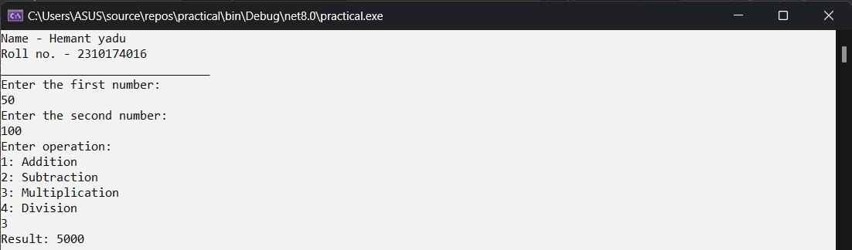
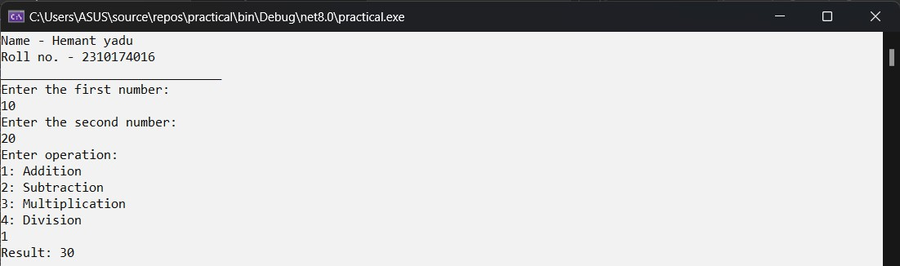

Practical No. 10
Write a C# program to read month (1-12) and 4digited year and display total days in given month and year.
Code:
using System; namespace practical{
internal class prog10 {
static void Main(string[] args) { int month , int year;
Console.WriteLine("Name : Hemant Yadu"); Console.WriteLine("Class : Mca 3rd sem");Console.WriteLine("Enter month: "); month = int.Parse(Console.ReadLine()); Console.WriteLine("Enter year: ");
year = int.Parse(Console.ReadLine()); if (month == 2) {
if (year % 400 == 0 || (year % 4 == 0 && year % 100 != 0)) { Console.WriteLine("Number of days: 29");
} else {
Console.WriteLine("Number of days: 28");
}
}
else if (month == 1 || month == 3 || month == 5 || month == 7 || month == 8 || month == 10 || month == 12) {
Console.WriteLine("Number of days: 31");2
}else{
Console.WriteLine("Number of days: 30");
}
Console.ReadLine();
}
}
}
Output:
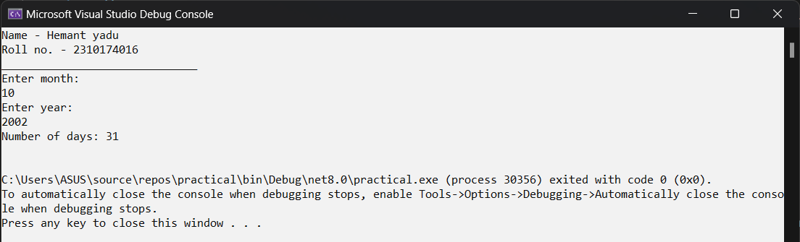

Write a C# program that display following pattern. N=7 1
1 1
1 1 2
1 1 2 3
1 1 2 3 5
1 1 2 3 5 8
Code:
using System; namespace practical{
internal class prog11 {
static void Main(string[] args){ int N = 7;
int[] fib = new int[N]; Console.WriteLine("Name : Hemant Yadu"); Console.WriteLine("Class : Mca 3rd sem");fib[0] = 1;
if (N > 1) {
fib[1] = 1;
for (int i = 2; i < N; i++){ fib[i] = fib[i - 1] + fib[i - 2];
}
}
for(int i = 1; i<=N; i++) { for(int j = 0; j < i; j++){ Console.Write(fib[j]);
}
Console.WriteLine(); Console.ReadLine();
}}}}
Output:
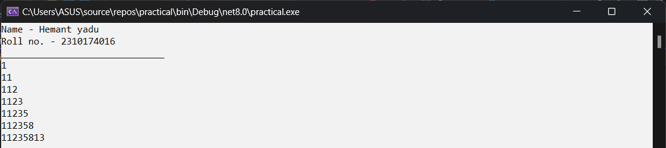

Practical No. 12
Design the form having 1 Text box and buttons like Bold, Italic, Red & Blue, show and hide When user presses an y of this command buttons then the content of text box will be changed to red or blue or bold or italic and Clicking on the “Show” button it will display a Textbox & when user clicks on “Hide” button then it will remove the Textbox. (Use Visible Property).
Code:
namespace Form1
{
public partial class Form1 : Form
{
public Form1()
{
InitializeComponent();
}
private void button1_Click(object sender, EventArgs e)
{
textBox1.Font = new Font(textBox1.Font, FontStyle.Bold);
}
private void button2_Click(object sender, EventArgs e)
{
textBox1.Font = new Font(textBox1.Font, FontStyle.Italic);
}
private void button4_Click(object sender, EventArgs e)
{
textBox1.ForeColor = Color.Blue;
}
private void button5_Click(object sender, EventArgs e)
{
textBox1.ForeColor = Color.Red;
}
private void button3_Click(object sender, EventArgs e)
{
textBox1.Visible = true;
}
private void button6_Click(object sender, EventArgs e)
{
textBox1.Visible = false;
}
}
}

Form :
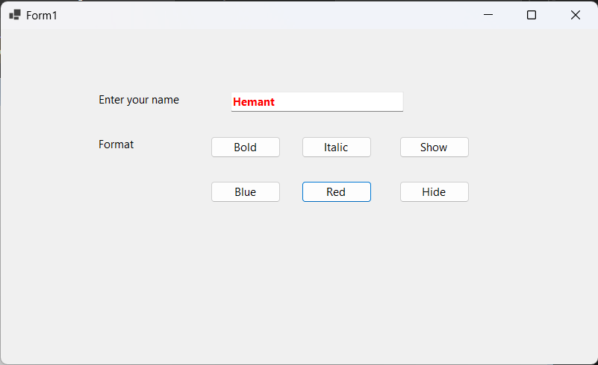

Practical No. 13
Design the form that calculates Sum, Multiplication, Division and Subtraction of two numbers.
Code:
namespace Form2
{
public partial class Form1 : Form
{
public Form1()
{
InitializeComponent();
}
private void Add_Click(object sender, EventArgs e)
{
int num1 = Convert.ToInt32(number1.Text); int num2 = Convert.ToInt32(number2.Text); int sum = num1 + num2;
label5.Text = sum.ToString();
}

private void Sub_Click(object sender, EventArgs e)
{
int num1 = Convert.ToInt32(number1.Text); int num2 = Convert.ToInt32(number2.Text); int sub = num1 - num2;
label5.Text = sub.ToString();
}
private void Mul_Click(object sender, EventArgs e)
{
int num1 = Convert.ToInt32(number1.Text); int num2 = Convert.ToInt32(number2.Text); int mul = num1 * num2;
label5.Text = mul.ToString();
}
private void Div_Click(object sender, EventArgs e)

{
int num1 = Convert.ToInt32(number1.Text); int num2 = Convert.ToInt32(number2.Text); int div = num1 / num2;
label5.Text = mul.ToString();
}
private void Mod_Click(object sender, EventArgs e)
{
int num1 = Convert.ToInt32(number1.Text); int num2 = Convert.ToInt32(number2.Text); int mod = num1 % num2;
label5.Text = mod.ToString();
}
}
}

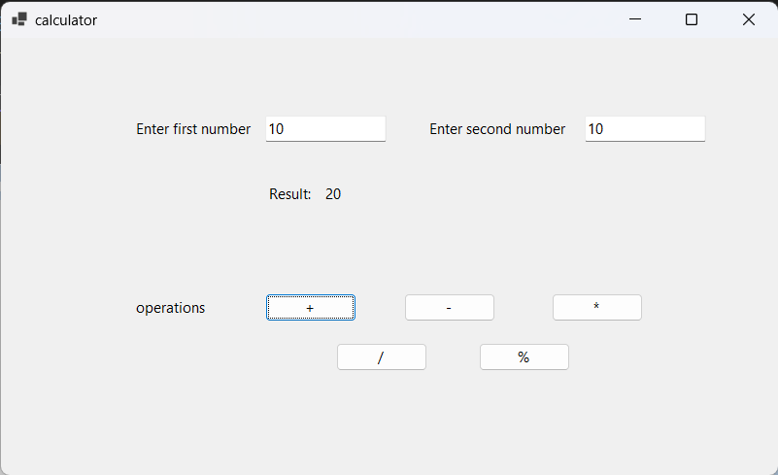
Calculator:

Practical No. 14
Design the following form.
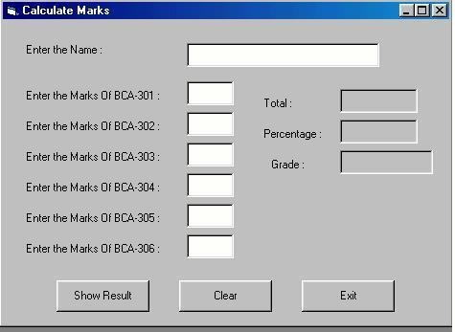

Code:
namespace C_List2
{
public partial class Form1 : Form
{
public Form1()
{
InitializeComponent();
name.KeyPress += new KeyPressEventHandler(name_KeyPress); bca1.KeyPress += new KeyPressEventHandler(bca1_KeyPress); bca2.KeyPress += new KeyPressEventHandler(bca2_KeyPress); bca3.KeyPress += new KeyPressEventHandler(bca3_KeyPress); bca4.KeyPress += new KeyPressEventHandler(bca4_KeyPress); bca5.KeyPress += new KeyPressEventHandler(bca5_KeyPress); bca6.KeyPress += new KeyPressEventHandler(bca6_KeyPress); bca1.TextChanged += new EventHandler(bca1_TextChanged); bca2.TextChanged += new EventHandler(bca2_TextChanged); bca3.TextChanged += new EventHandler(bca3_TextChanged); bca4.TextChanged += new EventHandler(bca4_TextChanged); bca5.TextChanged += new EventHandler(bca5_TextChanged); bca6.TextChanged += new EventHandler(bca6_TextChanged);
}

//validating form.
private void name_KeyPress(object sender, KeyPressEventArgs e) { if (!char.IsControl(e.KeyChar) && !char.IsLetter(e.KeyChar)){
e.Handled = true;
}
}
private void name_TextChanged(object sender, EventArgs e){
if (!System.Text.RegularExpressions.Regex.IsMatch(name.Text, @"^[a-zA-Z]*$")) { MessageBox.Show("Please Enter Valid Name.");
name.Text = "";
}
}

private void bca1_KeyPress(object sender, KeyPressEventArgs e){ if (!char.IsControl(e.KeyChar) && !char.IsDigit(e.KeyChar)){

e.Handled = true;
17 Hemant

}
}
private void bca1_TextChanged(object sender, EventArgs e) { if(int.TryParse(bca1.Text, out int value)) {
if (value > 100) {
MessageBox.Show("Please Enter Positive Number less than or equal to 100");
}
}
}
private void bca2_KeyPress(object sender, KeyPressEventArgs e){ if (!char.IsControl(e.KeyChar) && !char.IsDigit(e.KeyChar)){
e.Handled = true;
}
}
private void bca2_TextChanged(object sender, EventArgs e){ if (int.TryParse(bca2.Text, out int value)){
if (value > 100){
MessageBox.Show("Please Enter Positive Number less than or equal to 100");
}
}
}
private void bca3_KeyPress(object sender, KeyPressEventArgs e){ if (!char.IsControl(e.KeyChar) && !char.IsDigit(e.KeyChar)){
e.Handled = true;
}
}
private void bca3_TextChanged(object sender, EventArgs e){ if (int.TryParse(bca3.Text, out int value)){
if (value > 100){
MessageBox.Show("Please Enter Positive Number less than or equal to 100");
}
}
}
private void bca4_KeyPress(object sender, KeyPressEventArgs e){ if (!char.IsControl(e.KeyChar) && !char.IsDigit(e.KeyChar)){
e.Handled = true;
}
}
private void bca4_TextChanged(object sender, EventArgs e){ if (int.TryParse(bca4.Text, out int value))
{
if (value > 100){
MessageBox.Show("Please Enter Positive Number less than or equal to 100");
}
}
}
private void bca5_KeyPress(object sender, KeyPressEventArgs e){ if (!char.IsControl(e.KeyChar) && !char.IsDigit(e.KeyChar)){
e.Handled = true;
}
}
private void bca5_TextChanged(object sender, EventArgs e){ if (int.TryParse(bca5.Text, out int value)){
if (value > 100){
MessageBox.Show("Please Enter Positive Number less than or equal to 100");
}
}
}

private void bca6_KeyPress(object sender, KeyPressEv1e8ntArgs e){
Hemant

if (!char.IsControl(e.KeyChar) && !char.IsDigit(e.KeyChar)){ e.Handled = true;
}
}
private void bca6_TextChanged(object sender, EventArgs e){ if (int.TryParse(bca6.Text, out int value)){
if (value > 100){
MessageBox.Show("Please Enter Positive Number less than or equal to 100");
}
}
}

private void result_Click(object sender, EventArgs e){ int num1, num2, num3, num4, num5, num6;
num1 = Convert.ToInt32(bca1.Text); num2 = Convert.ToInt32(bca2.Text); num3 = Convert.ToInt32(bca3.Text); num4 = Convert.ToInt32(bca4.Text); num5 = Convert.ToInt32(bca5.Text); num6 = Convert.ToInt32(bca6.Text);
int Total = num1 + num2 + num3 + num4 + num5 + num6; double percent = Total / 6;
String grade;
if (percent >= 80){ grade = "A";
}
else if (percent >= 70){ grade = "B";
}
else if (percent >= 60){ grade = "C";
}
else if (percent >= 50){ grade = "D";
}
else if (percent >= 40){ grade = "E";
}
else{
grade = "F";
}
total.Text = Total.ToString(); percentage.Text = percent.ToString(); grades.Text = grade.ToString();
}
private void clear_Click(object sender, EventArgs e){ name.Text = string.Empty;
bca1.Text = string.Empty; bca2.Text = string.Empty; bca3.Text = string.Empty; bca4.Text = string.Empty; bca5.Text = string.Empty; bca6.Text = string.Empty; total.Text = string.Empty; percentage.Text = string.Empty;

}

private void exit_Click(object sender, EventArgs e){ this.Close();
}
}
}

Output:
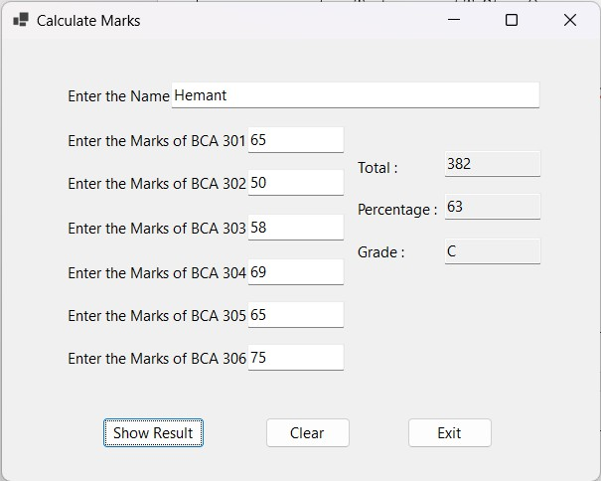

Practical No. 15
Design a form to create conversion calculator like
- Decimal number to Binary, Octal & Hexadecimal.
- Binary number to Decimal, Octal & Hexadecimal.
- Octal number to hexa, binary ,decimal etc.

Code:
using System;
using System.Collections.Generic; using System.ComponentModel; using System.Data;
using System.Drawing; using System.Linq; using System.Text;
using System.Threading.Tasks; using System.Windows.Forms;

namespace C_List2
{
public partial class Form2 : Form
{
public Form2()
{
InitializeComponent();
binary.KeyPress += new KeyPressEventHandler(binary_KeyPress); octal.KeyPress += new KeyPressEventHandler(octal_KeyPress); deci.KeyPress += new KeyPressEventHandler(deci_KeyPress); binary.TextChanged += new EventHandler(binary_TextChanged); octal.TextChanged += new EventHandler(octal_TextChanged); deci.TextChanged += new EventHandler(deci_TextChanged);
}
private void binary_KeyPress(object Sender, KeyPressEventArgs e)
{
if (!char.IsControl(e.KeyChar) && e.KeyChar != '0' && e.KeyChar != '1')
{
e.Handled = true; // Ignore any key that isn't 0, 1, or control (backspace, delete)
}
}
private void binary_TextChanged(object Sender, EventArgs e)
{
if (int.TryParse(binary.Text, out int value))
{
if (value < 0 )
{
MessageBox.Show("Pls Enter Valid Numbers.");
}
}
octal.Clear(); deci.Clear();
}
private void octal_KeyPress(object Sender, KeyPressEventArgs e)
{
if (!char.IsControl(e.KeyChar) && (e.KeyChar < '0' || e.KeyChar > '7'))
{
e.Handled = true; // Ignore any key that isn't 0-7 or control

}
private void octal_TextChanged(object Sender, EventArgs e)
{
if (int.TryParse(octal.Text, out int value))
{
if (value < 0 )
{
MessageBox.Show("Pls Enter Valid Numbers.");
}
}
binary.Clear(); deci.Clear();

}
private void deci_KeyPress(object Sender, KeyPressEventArgs e)
{
if (!char.IsControl(e.KeyChar) && !char.IsDigit(e.KeyChar))
{
e.Handled = true;
}
}
private void deci_TextChanged(object Sender, EventArgs e)
{
if (int.TryParse(deci.Text, out int value))
{
if (value < 0)
{
MessageBox.Show("Pls Enter Valid Numbers.");
}
binary.Clear(); octal.Clear();
}

}

private void button1_Click(object sender, EventArgs e)
{
if (string.IsNullOrWhiteSpace(deci.Text))
{
MessageBox.Show("Please enter a decimal value before performing this action."); return; // Exit the method without performing any further action
}
else {
//converting
int number1 = int.Parse(deci.Text);
string binary = Convert.ToString(number1, 2); string octal = Convert.ToString(number1, 8); string hex = number1.ToString("X");
//assigning values.
result1.Text = Convert.ToString(binary); result2.Text = Convert.ToString(octal); result3.Text = Convert.ToString(hex);
}
}

private void button2_Click(object sender, EventArgs e)
{

{
MessageBox.Show("Please enter a binary value before performing this action."); return; // Exit the method without performing any further action
}
else {
//first convert to binary.
int number1 = Convert.ToInt32(binary.Text, 2);
//converting
string octal = Convert.ToString(number1, 8); string deci = Convert.ToString(number1, 10); string hex = number1.ToString("X");
//assigning values.
result1.Text = Convert.ToString(octal); result2.Text = Convert.ToString(deci); result3.Text = Convert.ToString(hex);
}

}

private void button3_Click(object sender, EventArgs e)
{

if (string.IsNullOrWhiteSpace(octal.Text))
{
MessageBox.Show("Please enter a octal value before performing this action."); return; // Exit the method without performing any further action
}
else
{
int number1 = Convert.ToInt32(octal.Text, 8);
//converting
string binary = Convert.ToString(number1, 2); string deci = Convert.ToString(number1, 10); string hexa = Convert.ToString(number1, 16);
//assigning values.
result1.Text = Convert.ToString(binary); result2.Text = Convert.ToString(deci); result3.Text = Convert.ToString(hexa);
}
}
private void button4_Click(object sender, EventArgs e)
{
binary.Clear(); octal.Clear(); deci.Clear(); result1.Text = ""; result2.Text = ""; result3.Text = "";
}
}
}

Output:
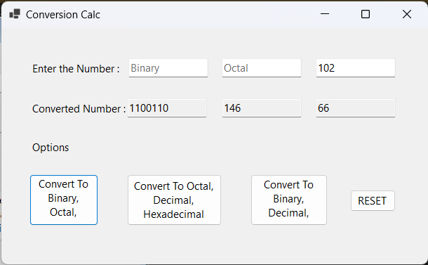
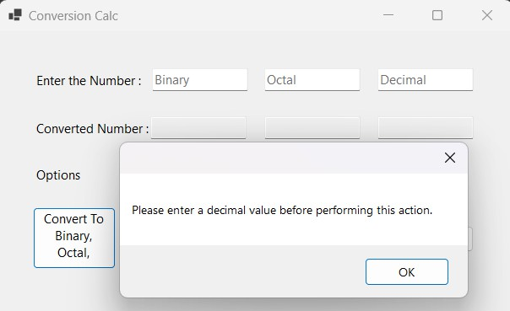

Practical No. 16
Design the following form. So when user clicks on Radio Button then select appropriate checkbox.
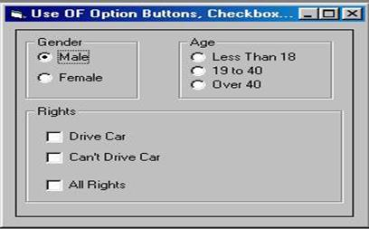
Code:
using System;
using System.Collections.Generic; using System.ComponentModel; using System.Data;
using System.Drawing; using System.Linq; using System.Text;
using System.Threading.Tasks; using System.Windows.Forms;

namespace C_List2
{
public partial class Form3 : Form
{
public Form3()
{
InitializeComponent();
}
private void male_CheckedChanged(object sender, EventArgs e)
{
if (male.Checked) female.Checked = false;
}

private void female_CheckedChanged(object sender, EventArgs e)
{
if (female.Checked) male.Checked = false;
}
private void ls18_CheckedChanged(object sender, EventArgs e)
{
if (ls18.Checked && (male.Checked || female.Checked))
{
allrights.Enabled = true; ls1940.Checked = false; ov40.Checked = false;

allrights.Checked = false; drive.Checked = false; nodrive.Enabled = false; drive.Enabled = false;
}
}

private void ls1940_CheckedChanged(object sender, EventArgs e)
{
if (ls1940.Checked && (male.Checked || female.Checked))
{
drive.Enabled = true; nodrive.Enabled = true; ls18.Checked = false; ov40.Checked = false; allrights.Checked = true; allrights.Enabled = false;

}
}
private void ov40_CheckedChanged(object sender, EventArgs e)
{
if (ov40.Checked && (male.Checked || female.Checked))
{
drive.Enabled = true; nodrive.Enabled = true; ls18.Checked = false; ls1940.Checked = false; allrights.Checked = true; allrights.Enabled = false;

}
}

private void drive_CheckedChanged(object sender, EventArgs e)
{
if (drive.Checked) nodrive.Checked = false;
}
private void nodrive_CheckedChanged(object sender, EventArgs e)
{
if (nodrive.Checked) drive.Checked = false;
}
}
}

Output:
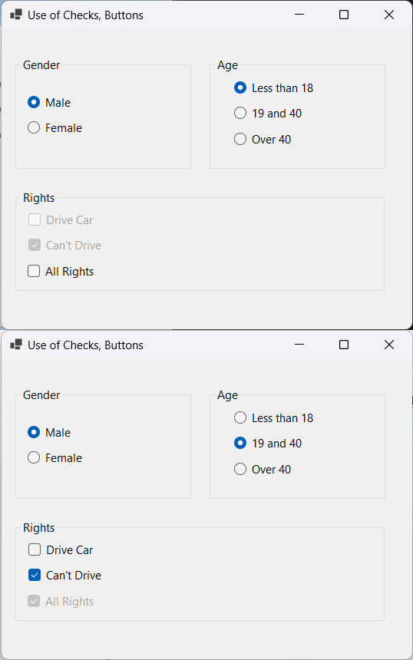

Practical No. 17
program shows the functionality of listbox:
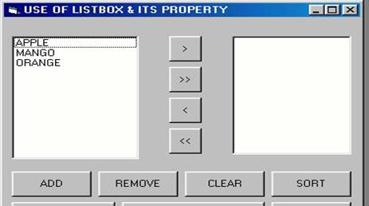

Code:
using System;
using System.Collections.Generic; using System.ComponentModel; using System.Data;
using System.Drawing; using System.Linq; using System.Text;
using System.Threading.Tasks; using System.Windows.Forms;
using static System.Net.Mime.MediaTypeNames;

namespace C_List2
{
public partial class Form4 : Form{ string SelectedItem;
Boolean sortFlag = true; public Form4(){
InitializeComponent(); listView1.View = View.List; listView2.View = View.List; listView1.MultiSelect = false;
}
private void button5_Click(object sender, EventArgs e){ using (TextInput Dialog = new TextInput()){
if (Dialog.ShowDialog() == DialogResult.OK){ string list = Dialog.InputText;
if (!string.IsNullOrEmpty(list)){ listView1.Items.Add(new ListViewItem(list));
}
}

}
}
private void button6_Click(object sender, EventArgs e){
// Check if there is any selected item
if (listView1.SelectedItems.Count > 0){
// Remove the selected item listView1.Items.Remove(listView1.SelectedItems[0]);
}
else{
MessageBox.Show("No item selected to remove.");
}

private void button7_Click(object sender, EventArgs e){ listView1.Clear();
listView2.Clear();
}
private void button8_Click(object sender, EventArgs e){ if (sortFlag == true){
listView1.Sorting = SortOrder.Ascending; listView2.Sorting = SortOrder.Ascending; sortFlag = false;
}
else{
listView1.Sorting = SortOrder.Descending; listView2.Sorting = SortOrder.Descending; sortFlag = true;
}
listView1.Sort(); listView2.Sort();
}
private void button1_Click(object sender, EventArgs e){
// Check if there is any selected item
if (listView1.SelectedItems.Count > 0){
foreach (ListViewItem item in listView1.SelectedItems) { SelectedItem = item.Text; // Get the text of the item
}
listView2.Items.Add(SelectedItem);
// Remove the selected item listView1.Items.Remove(listView1.SelectedItems[0]);
}
else {
MessageBox.Show("No item selected to transfer.");
}
}
private void button2_Click(object sender, EventArgs e) { foreach (ListViewItem item in listView1.Items) {
ListViewItem list = (ListViewItem)item.Clone(); listView2.Items.Add(list);
}
listView1.Clear();
}
private void button3_Click(object sender, EventArgs e){
// Check if there is any selected item
if (listView2.SelectedItems.Count > 0) {
foreach (ListViewItem item in listView2.SelectedItems){ SelectedItem = item.Text; // Get the text of the item
}
listView1.Items.Add(SelectedItem);
// Remove the selected item listView2.Items.Remove(listView2.SelectedItems[0]);
}
else{
MessageBox.Show("No item selected to transfer.");
}
}
private void button4_Click(object sender, EventArgs e){ foreach (ListViewItem item in listView2.Items){
ListViewItem list = (ListViewItem)item.Clone();

listView1.Items.Add(list);
29 Hemant

}
listView2.Clear();
}
}
}
Output:
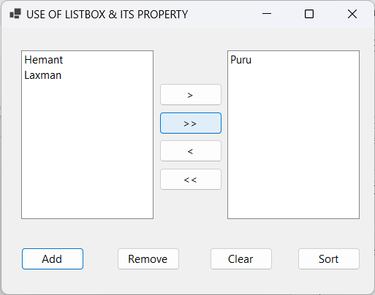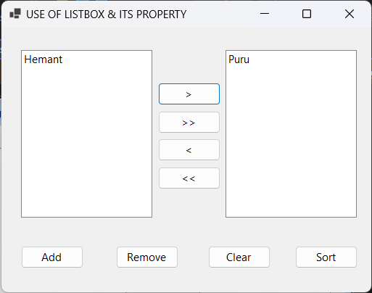
Listbox and Its Property :
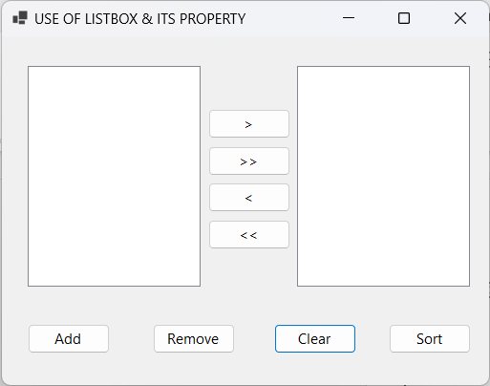
Code for add Form
using System;
using System.Collections.Generic; using System.ComponentModel; using System.Data;
using System.Drawing; using System.Linq; using System.Text;
using System.Threading.Tasks; using System.Windows.Forms; namespace C_List2
{
public partial class TextInput : Form{
public string InputText { get; private set; } public TextInput(){
InitializeComponent();
}
private void button1_Click(object sender, EventArgs e){
// Set the InputText property to the text entered by the user

InputText = textBox1.Text;
30 Hemant

this.DialogResult = DialogResult.OK; // Close the dialog with OK result this.Close(); // Close the dialog
}
private void button2_Click(object sender, EventArgs e){
// Close the dialog with Cancel result this.DialogResult = DialogResult.Cancel; this.Close();
}
}
}
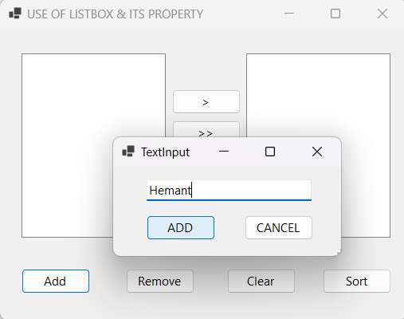
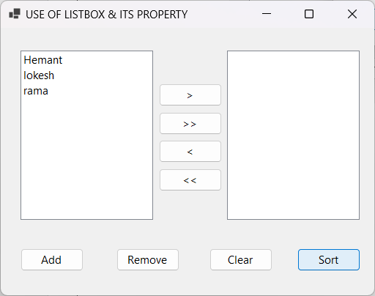
Adding Items In List: Sort

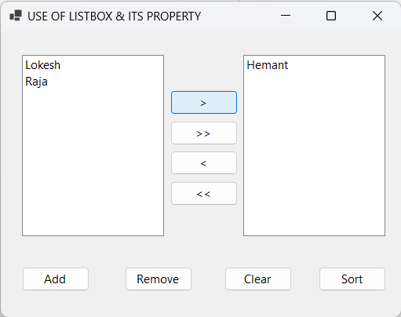
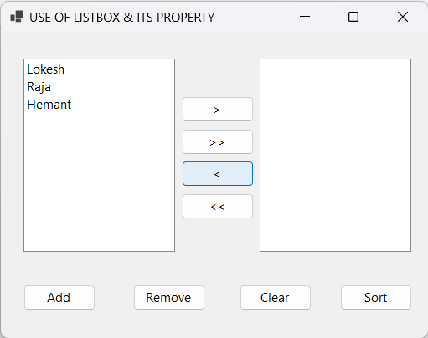
Transfer Selected Item :

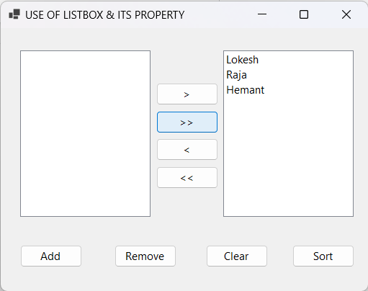
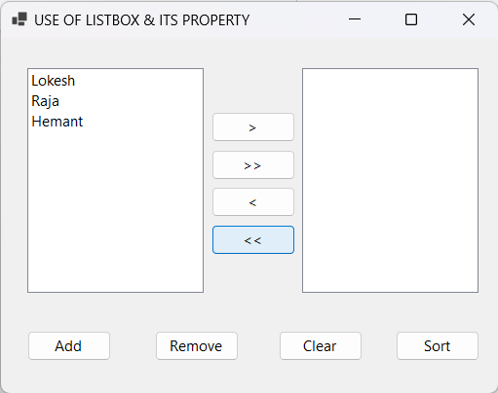
Transfer ALL To Another List :

31
Hemant

Clear List :
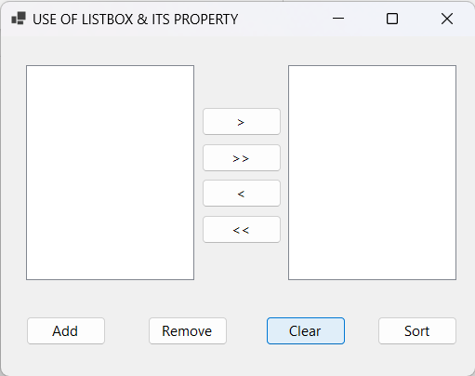

Practical No. 18
Design one form to create application like Rich text document using 1 Rich Text box and different buttons. When user presses any of this command buttons then the selected content of Rich textbox will be changed accordingly.
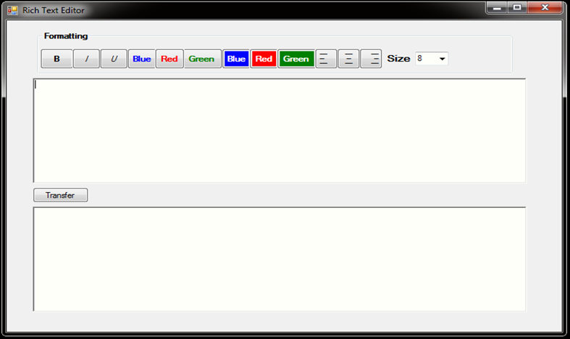
Code:
namespace C_List2
{
public partial class Form5 : Form{ public Form5(){
InitializeComponent();
}
private void Form5_Load(object sender, EventArgs e){ for (int i = 8; i < 40; i++){ //loop to add items in size.
if (i % 2 == 0){
comboBox1.Items.Add(i);
}
}
}
private void button1_Click(object sender, EventArgs e){
if (richTextBox1.SelectionLength > 0){ // Check if any text is selected
// Get the current font of the selected text
Font currentFont = richTextBox1.SelectionFont; if (currentFont != null){
// Toggle bold: if the text is bold, remove bold; otherwise, make it bold
FontStyle newFontStyle = currentFont.Bold ? FontStyle.Regular : FontStyle.Bold;
// Apply the new font style to the selected text richTextBox1.SelectionFont = new Font(currentFont, newFontStyle);
}
}
else{
MessageBox.Show("Please select text to make bold.");
}
}
private void button13_Click(object sender, EventArgs e){
// Check if there is any text selected in richTextBox1
if (!string.IsNullOrEmpty(richTextBox1.SelectedText)){
// Check if the existing text in richTextBox2 ends with a space
if (!richTextBox2.Text.EndsWith(" ") && richTextBox2.Text.Length > 0){
// If not, add a space before appending the new text richTextBox2.AppendText(" ");
}

richTextBox2.SelectedRtf = richTextBox1.SelectedRtf;
//alignment copy
richTextBox2.SelectionAlignment = richTextBox1.SelectionAlignment;
// Remove the selected text from richTextBox1 richTextBox1.SelectedText = string.Empty;
}
else{
MessageBox.Show("Please select some text to transfer.");
}
}
private void button2_Click(object sender, EventArgs e){
if (richTextBox1.SelectionLength > 0){ // Check if any text is selected
// Get the current font of the selected text
Font currentFont = richTextBox1.SelectionFont; if (currentFont != null){
// Toggle Italic: if the text is italic, remove italic; otherwise, make it italic FontStyle newFontStyle = currentFont.Italic ? FontStyle.Regular : FontStyle.Italic;
// Apply the new font style to the selected text richTextBox1.SelectionFont = new Font(currentFont, newFontStyle);
}
}
else{
MessageBox.Show("Please select text to make bold.");
}
}
private void button3_Click(object sender, EventArgs e){
if (richTextBox1.SelectionLength > 0){ // Check if any text is selected
// Get the current font of the selected text
Font currentFont = richTextBox1.SelectionFont; if (currentFont != null){
// Toggle Underline: if the text is underline, remove underline; otherwise, make it UnderLine FontStyle newFontStyle = currentFont.Underline ? FontStyle.Regular : FontStyle.Underline;
// Apply the new font style to the selected text richTextBox1.SelectionFont = new Font(currentFont, newFontStyle);
}
}
else{
MessageBox.Show("Please select text to make underline.");
}
}
private void button4_Click(object sender, EventArgs e){
if (richTextBox1.SelectionLength > 0){ // Check if any text is selected
richTextBox1.SelectionColor = (richTextBox1.SelectionColor == Color.Blue) ? Color.Black : Color.Blue;
}
else{
MessageBox.Show("Please select text to make color.");
}
}
private void button5_Click(object sender, EventArgs e){
if (richTextBox1.SelectionLength > 0){ // Check if any text is selected
richTextBox1.SelectionColor = (richTextBox1.SelectionColor == Color.Red) ? Color.Black : Color.Red;
}
else{
MessageBox.Show("Please select text to make color.");
}
}
private void button6_Click(object sender, EventArgs e){ if (richTextBox1.SelectionLength > 0){

}
else{
MessageBox.Show("Please select text to make color.");
}
}
private void button7_Click(object sender, EventArgs e){ if (richTextBox1.SelectionLength > 0){
richTextBox1.SelectionBackColor = (richTextBox1.SelectionBackColor == Color.Blue) ? Color.Black : Color.Blue;
}
else{
MessageBox.Show("Please select text to make bg color.");
}
}
private void button8_Click(object sender, EventArgs e)
{
if (richTextBox1.SelectionLength > 0){
richTextBox1.SelectionBackColor = (richTextBox1.SelectionBackColor == Color.Red) ? Color.Black : Color.Red;
}
else{
MessageBox.Show("Please select text to make bg color.");
}
}
private void button9_Click(object sender, EventArgs e){ if (richTextBox1.SelectionLength > 0){
richTextBox1.SelectionBackColor = (richTextBox1.SelectionBackColor == Color.Green) ? Color.Black : Color.Green;
}
else{
MessageBox.Show("Please select text to make bg color.");
}
}
private void button10_Click(object sender, EventArgs e){ richTextBox1.SelectionAlignment = HorizontalAlignment.Left;
}
private void button11_Click(object sender, EventArgs e)
{
richTextBox1.SelectionAlignment = HorizontalAlignment.Center;
}
private void button12_Click(object sender, EventArgs e){ richTextBox1.SelectionAlignment = HorizontalAlignment.Right;
}
private void comboBox1_SelectedIndexChanged(object sender, EventArgs e){ float newFontSize = Convert.ToSingle(comboBox1.SelectedItem);
Font currentFont = richTextBox1.SelectionFont; if (currentFont != null){
// Apply the selected font size to the selected text
richTextBox1.SelectionFont = new Font(currentFont.FontFamily, newFontSize, currentFont.Style);
}
}
}
}

Output:
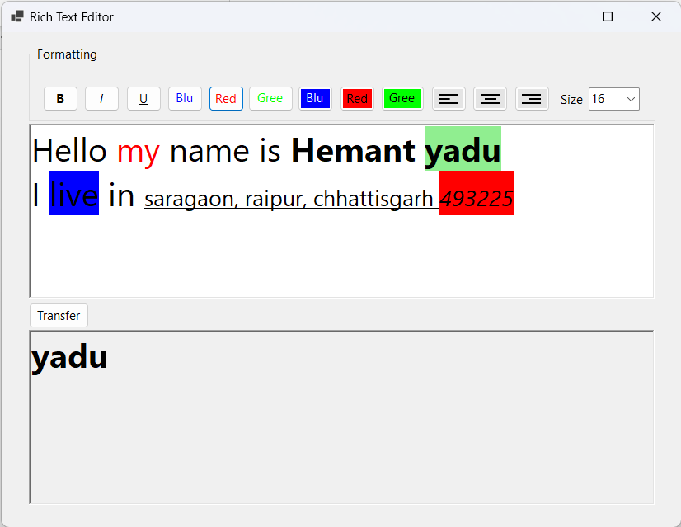

Practical No. 19
Design the digital watch using Timer Control.
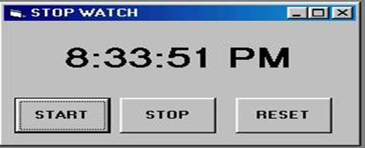
Code:
namespace C_List2
{
public partial class Form6 : Form{
// Counters for hours, minutes, and seconds private int hours = 0;
private int minutes = 0; private int seconds = 0; public Form6(){
InitializeComponent();
timer1.Interval = 1000; // Set timer interval to 1000 ms (1 second) timer1.Tick += Timer1_Tick; // Attach Tick event handler
}
private void button1_Click(object sender, EventArgs e){
// Start or resume the timer timer1.Start();
}
private void button2_Click(object sender, EventArgs e){
// Stop (pause) the timer timer1.Stop();
}
private void button3_Click(object sender, EventArgs e){
// Reset the timer to 00:00:00 and stop it timer1.Stop();
hours = 0;
minutes = 0;
seconds = 0; UpdateTimeDisplay();
}
private void Timer1_Tick(object sender, EventArgs e){ seconds++; // Increment seconds
// Update minutes and hours based on seconds if (seconds == 60){
seconds = 0; minutes++;
if (minutes == 60){ minutes = 0; hours++;
}
}
// Update the display after each tick

}
private void UpdateTimeDisplay(){
// Format and display time as hh:mm:ss hrs.Text = hours.ToString("D2") + ":"; minute.Text = minutes.ToString("D2") + ":"; second.Text = seconds.ToString("D2");
}
}
}
Output:
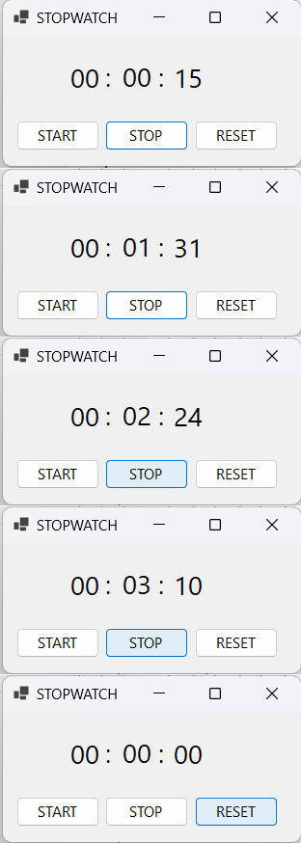

Practical No. 20
Design the following form using horizontal scrollbar. In this, when user click on particular scroll bar then back color of shape will be changed to Red, Green & Blue color.
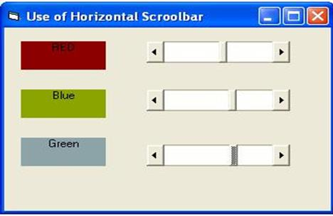
Code:
namespace C_List2{
public partial class Form7 : Form{ public Form7(){
InitializeComponent();
}
private void Form7_Load(object sender, EventArgs e){ button1.ForeColor = Color.White; button2.ForeColor = Color.White; button3.ForeColor = Color.White;
// Set scrollbar properties (0 to 255 for color intensity) hScrollBar1.Minimum = 0;
hScrollBar1.Maximum = 255;
hScrollBar2.Minimum = 0;
hScrollBar2.Maximum = 255;
hScrollBar3.Minimum = 0;
hScrollBar3.Maximum = 255;
// Initialize button colors to dark
button1.BackColor = Color.FromArgb(0, 0, 0); // Dark Red button2.BackColor = Color.FromArgb(0, 0, 0); // Dark Green button3.BackColor = Color.FromArgb(0, 0, 0); // Dark Blue
}
private void hScrollBar1_Scroll(object sender, ScrollEventArgs e){
// Adjust the red component for button1 based on scrollbar value int redIntensity = hScrollBar1.Value;
button1.BackColor = Color.FromArgb(redIntensity, 0, 0);
}
private void hScrollBar2_Scroll(object sender, ScrollEventArgs e){
// Adjust the blue component for button3 based on scrollbar value int blueIntensity = hScrollBar2.Value;
button2.BackColor = Color.FromArgb(0, 0, blueIntensity);
}
private void hScrollBar3_Scroll(object sender, ScrollEventArgs e){
// Adjust the green component for button2 based on scrollbar value int greenIntensity = hScrollBar3.Value;
button3.BackColor = Color.FromArgb(0, greenIntensity, 0);
}
}
}

Output:
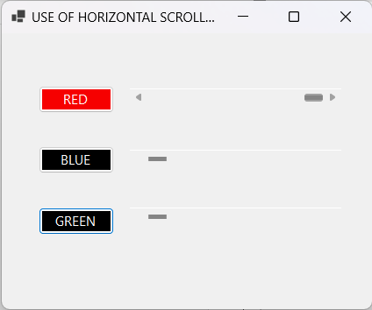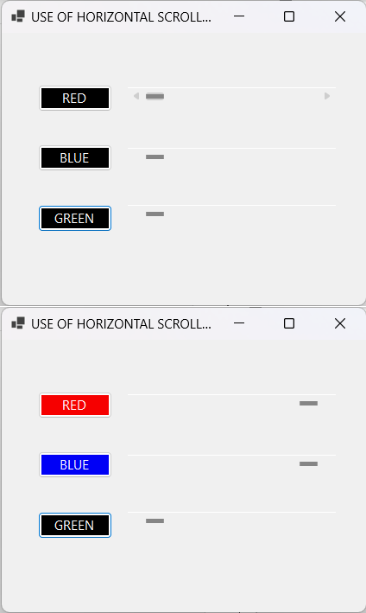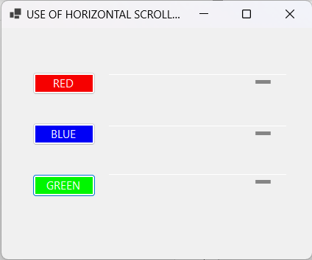

Practical No. 21
Design the following form using vertical scrollbar. In this, when user click on particular scroll bar then back color of shape will be changed to Red, Green & Blue color.
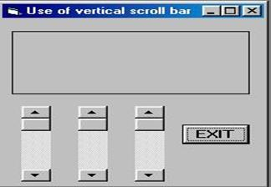
Code:
namespace C_List2{
public partial class Form8 : Form{ public Form8(){
InitializeComponent();
vScrollBar1.Scroll += vScrollBar1_Scroll; vScrollBar2.Scroll += vScrollBar2_Scroll; vScrollBar3.Scroll += vScrollBar3_Scroll;
}
private void Form8_Load(object sender, EventArgs e){
// Set scrollbar properties to control RGB (0 to 255 for color intensity) vScrollBar1.Minimum = 0;
vScrollBar1.Maximum = 255 + vScrollBar1.LargeChange - 1; vScrollBar2.Minimum = 0;
vScrollBar2.Maximum = 255 + vScrollBar2.LargeChange - 1; vScrollBar3.Minimum = 0;
vScrollBar3.Maximum = 255 + vScrollBar3.LargeChange - 1;
// Set initial color of the button UpdateButtonColor();
}
private void vScrollBar1_Scroll(object sender, ScrollEventArgs e){
// Update button color when red scrollbar changes UpdateButtonColor();
}
private void vScrollBar2_Scroll(object sender, ScrollEventArgs e){
// Update button color when green scrollbar changes UpdateButtonColor();
}
private void vScrollBar3_Scroll(object sender, ScrollEventArgs e){
// Update button color when blue scrollbar changes UpdateButtonColor();
}
private void UpdateButtonColor(){
// Get the values from each scrollbar int red = vScrollBar1.Value;
int green = vScrollBar2.Value; int blue = vScrollBar3.Value;
// Set the button's background color using the RGB values button1.BackColor = Color.FromArgb(red, green, blue);
}

private void button2_Click(object sender, EventArgs e){ this.Close();
}
}
}
Output:
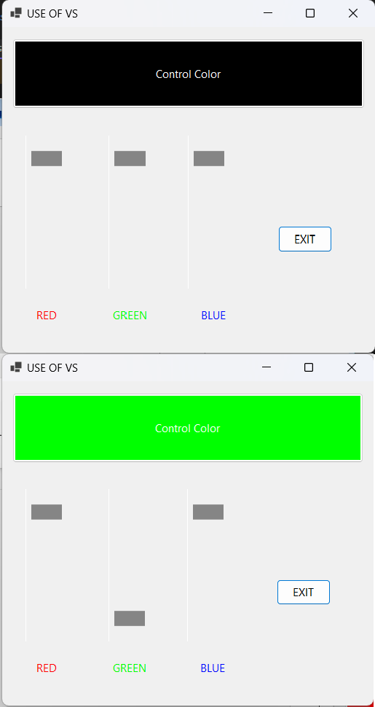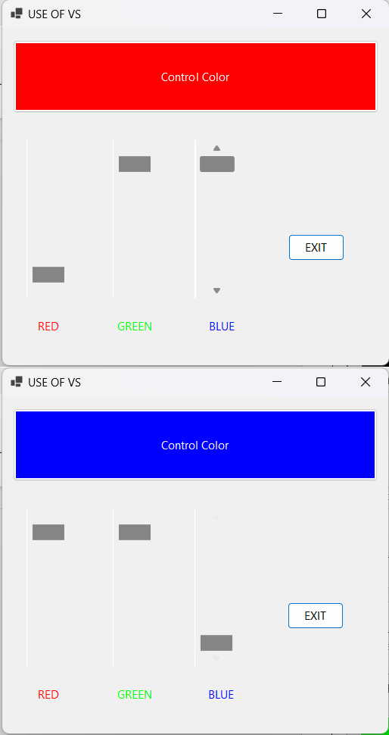

Design the following Tic-tac-toe game.

Practical No. 22

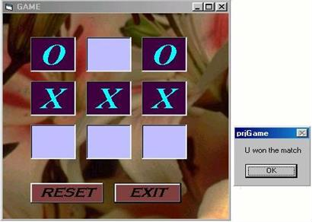
Code:
namespace C_List2{
public partial class Form9 : Form{
private string currentPlayer = "X"; // Start with player X private Button[] buttons;
public Form9(){ InitializeComponent(); InitializeTicTacToe();
}
private void InitializeTicTacToe(){
buttons = new Button[] { button1, button2, button3, button4, button5, button6, button7, button8, button9 }; foreach (var button in buttons){
button.Text = ""; button.Enabled = true;
button.Click += Button_Click; // Attach the click event handler
}
}
private void Button_Click(object sender, EventArgs e){ Button clickedButton = sender as Button;
if (clickedButton != null && clickedButton.Text == ""){ clickedButton.Text = currentPlayer;
clickedButton.Enabled = false; // Disable button after clicked if (CheckForWinner()){
ShowWinnerDialog(currentPlayer); // Show winner dialog ResetGame();
return;
}
currentPlayer = currentPlayer == "X" ? "O" : "X"; // Switch players
}
}
private bool CheckForWinner(){
int[,] winningCombinations = new int[,]{
{ 0, 1, 2 }, { 3, 4, 5 }, { 6, 7, 8 }, // Rows
{ 0, 3, 6 }, { 1, 4, 7 }, { 2, 5, 8 }, // Columns
{ 0, 4, 8 }, { 2, 4, 6 } // Diagonals
};
for (int i = 0; i < winningCombinations.GetLength(0); i++){
if (buttons[winningCombinations[i, 0]].Text == currentPlayer && buttons[winningCombinations[i, 1]].Text == currentPlayer &&

return true;
}
}
return false;
}
private void ResetGame(){ foreach (var button in buttons){
button.Text = ""; button.Enabled = true;
}
currentPlayer = "X"; // Start with player X again
}
private void ShowWinnerDialog(string winner){ // Method to show the winner dialog Winner winnerForm = new Winner(winner);
winnerForm.ShowDialog(); // Show as a modal dialog
}
private void buttonReset_Click(object sender, EventArgs e){ // Reset Button Click event handler ResetGame(); // Reset the game board
}
private void buttonExit_Click(object sender, EventArgs e){ // Exit Button Click event handler this.Close(); // Close the current form (Form9)
}
}
}
Output:
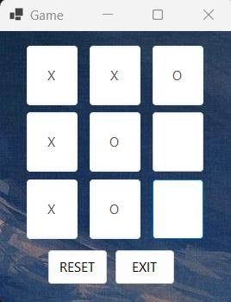
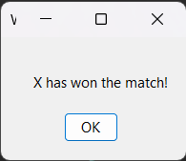

Practical No. 23
Write a .Net console application to store student details in file and display it in console. Code:
using System;
using System.IO; namespace practical{
class Prog24{
private string filePath = "students.txt"; public Prog24(){
int choice; do{
Console.WriteLine("1. Add Student\n2. Display Students\n3. Exit"); Console.Write("Enter your choice: ");
choice = int.Parse(Console.ReadLine()); if (choice == 1) AddStudent();
else if (choice == 2) DisplayStudents();
else if (choice != 3) Console.WriteLine("Invalid choice. Try again.");
} while (choice != 3);
}
private void AddStudent(){ Console.Write("Enter Name: "); string name = Console.ReadLine(); Console.Write("Enter Age: ");
int age = int.Parse(Console.ReadLine()); Console.Write("Enter Grade: ");
string grade = Console.ReadLine(); File.AppendAllText(filePath, $"{name},{age},{grade}\n"); Console.WriteLine("Student details saved.\n");
}
private void DisplayStudents(){ if (File.Exists(filePath)){
Console.WriteLine("\nList of Students:");
foreach (string student in File.ReadAllLines(filePath)){ var details = student.Split(',');
Console.WriteLine($"Name: {details[0]}, Age: {details[1]}, Grade: {details[2]}");
}
Console.WriteLine();
}
else Console.WriteLine("No records found.\n");
}
}
}

Output:
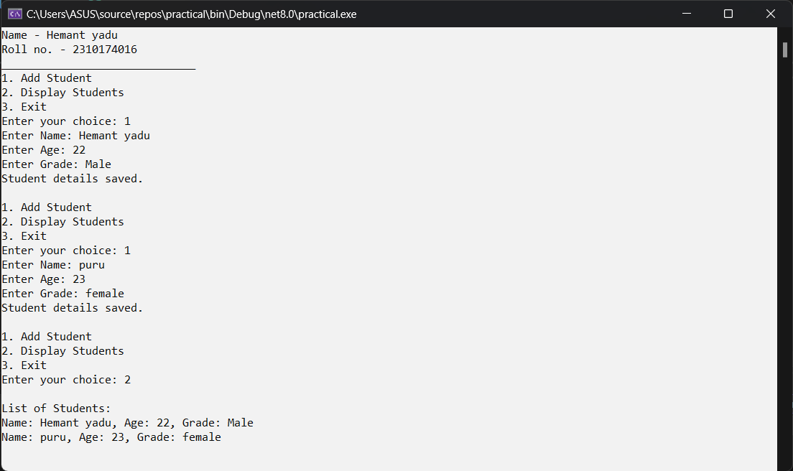

Practical No. 23
Write a .Net window application to enter the student details in form with proper GUI component and store in a file and display in another form.
Code:
namespace C_List2
{
public partial class Form10 : Form{ public Form10(){
InitializeComponent();
button2.Click += new EventHandler(button2_Click);
}
private void button1_Click(object sender, EventArgs e){ string name = textBox1.Text;
string age = textBox2.Text;
string studentClass = textBox3.Text; string rollNumber = textBox4.Text; string address = textBox5.Text;
// Saving to file
using (StreamWriter writer = new StreamWriter("student.txt", true)){ writer.WriteLine($"{name},{age},{studentClass},{rollNumber},{address}");
}

MessageBox.Show("Student details saved successfully.");
}
private void button2_Click(object sender, EventArgs e) { Form11 form11 = new Form11(); form11.ShowDialog();
}
}
}
Output:
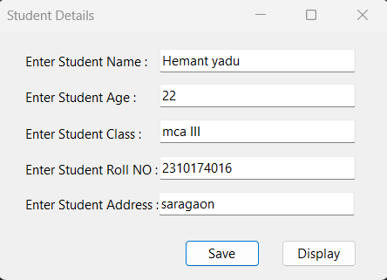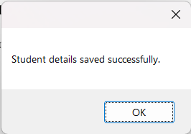
Display
