- Write a C++ program to get the size of different type of datatypes.
Code :-
#include<iostream>
using namespace std;
int main()
{
cout<<"Name :- Alisha Khan"<<endl;
cout<<"Class :- MCA-I"<<endl;
cout<<"Date :- "<<endl;
cout<<"*******************************************"<<endl;
cout<<endl;
cout<<"Number of Bytes taken by int = "<<sizeof(int)<<" Bytes"<<endl;
cout<<"Number of Bytes taken by char = "<<sizeof(char)<<" Byte"<<endl;
cout<<"Number of Bytes taken by float = "<<sizeof(float)<<" Bytes"<<endl;
cout<<"Number of Bytes taken by double = "<<sizeof(double)<<" Bytes"<<endl;
cout<<"Number of Bytes taken by boolean = "<<sizeof(bool)<<" Byte"<<endl;
cout<<"Number of Bytes taken by short = "<<sizeof(short)<<" Bytes"<<endl;
cout<<"Number of Bytes taken by long = "<<sizeof(long)<<" Bytes"<<endl;
return 0;
}
OUTPUT :-
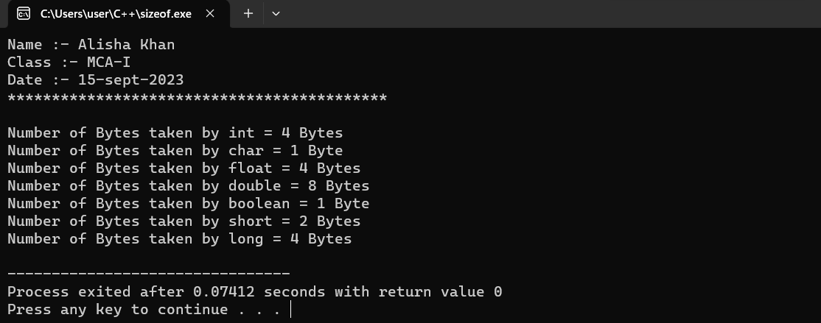
- Write a C++ program to perform arithmetic operations using arithmetic operators.
Code:-
#include<iostream>
using namespace std;
int main()
{
cout<<"Name :- Alisha Khan"<<endl;
cout<<"Class :- MCA-I"<<endl;
cout<<"Date :- "<<endl;
cout<<"*******************************************"<<endl;
cout<<endl;
int a,b;
cout<<"Enter the value of A = ";
cin>>a;
cout<<"Enter the value of B = ";
cin>>b;
int add=a+b;
cout<<"Addition of A and B is = "<<add<<endl;
int sub=a-b;
cout<<"Subtraction of A and B is = "<<sub<<endl;
int mul=a*b;
cout<<"Multiplication of A and B is = "<<mul<<endl;
float div=a/b;
cout<<"Division of A and B is = "<<div<<endl;
return 0;
}
OUTPUT :-
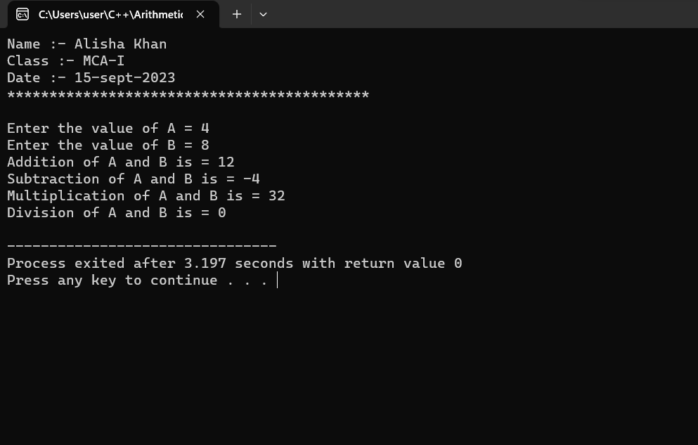

- Write a C++ program to demonstrate the different types of relational operators.
Code:-
#include<iostream>
using namespace std;
int main()
{
cout<<"Name :- Alisha Khan"<<endl;
cout<<"Class :- MCA-I"<<endl;
cout<<"Date :- "<<endl;
cout<<"*******************************************"<<endl;
cout<<endl;
int a,b;
cout<<"Enter the value of A = ";
cin>>a;
cout<<"Enter the value of B = ";
cin>>b;
cout<<endl;
if(a==b) {
cout<<"A is equal to B "<<endl;
}
else {
cout<<"A is not equal to B "<<endl;
}
if(a<b){
cout<<"A is less than B "<<endl;
}
else{
cout<<"A is not less than B "<<endl;
}
if(a>b){
cout<<"A is greater than B "<<endl;
}
else {
cout<<"A is not greater than B "<<endl;
}
return 0;
}

OUTPUT :-

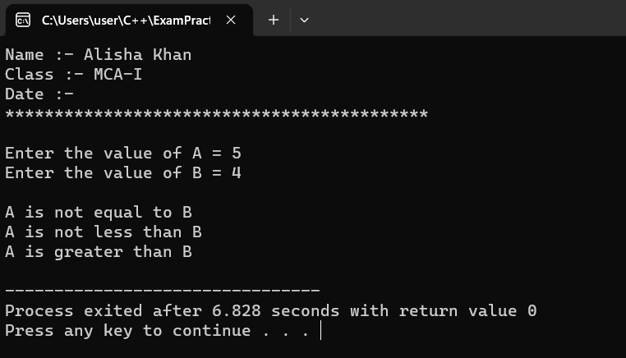

- Write a C++ program to demonstrate the logical operators(&&,||,!) .
Code :-
#include<iostream>
using namespace std;
int main()
{
cout<<"Name :- Alisha Khan"<<endl;
cout<<"Class :- MCA-I"<<endl;
cout<<"Date :- 18-sept-2023"<<endl;
cout<<"*******************************************"<<endl;
cout<<"Logical Operator \n";
cout<<endl;

int num;
cout<<"Logical AND "<<endl;
num = (3!=5)&&(3<5);
cout<<"(3!=5)&&(3<5); is = "<<num<<endl;
cout<<"\n";

cout<<"Logical OR"<<endl;
num = (3==5)||(3<5);
cout<<"(3==5)||(3<5); is = "<<num<<endl;
cout<<"\n";

cout<<"Logical NOT"<<endl;
num = !(3==3);
cout<<"!(3==3); is = "<<num<<endl;

return 0;
}
OUTPUT :-
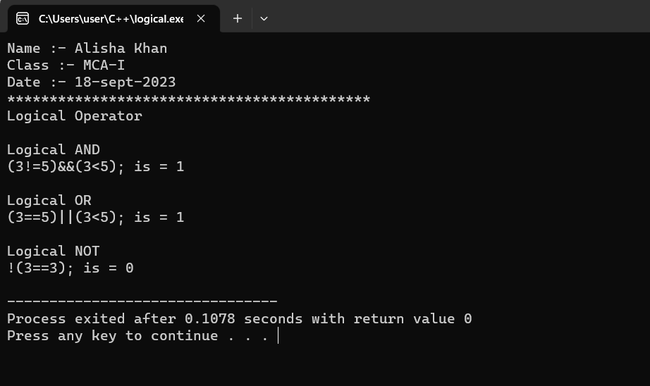
- Write a C++ program to demonstrate the Bitwise operators.
Code :-
#include<iostream>
using namespace std;
int main()
{
cout<<"Name :- Alisha Khan"<<endl;
cout<<"Class :- MCA-I"<<endl;
cout<<"Date :- 18-sept-2023"<<endl;
cout<<"*******************************************"<<endl;
cout<<endl;
int a,b;
cout<<"Enter the value of A = ";
cin>>a;
cout<<"Enter the value of B = ";
cin>>b;
cout<<"a&b = "<<(a&b)<<endl;
cout<<"a|b = "<<(a|b)<<endl;
cout<<"a^b = "<<(a^b)<<endl;
cout<<"~a = "<<~a<<endl;
cout<<"a<<2 = "<<(a<<2)<<endl;
cout<<"b<<2 = "<<(b<<2)<<endl;
cout<<"a>>2 = "<<(a>>2)<<endl;
cout<<"b>>2 = "<<(b>>2)<<endl;
return 0;
}
OUTPUT :-
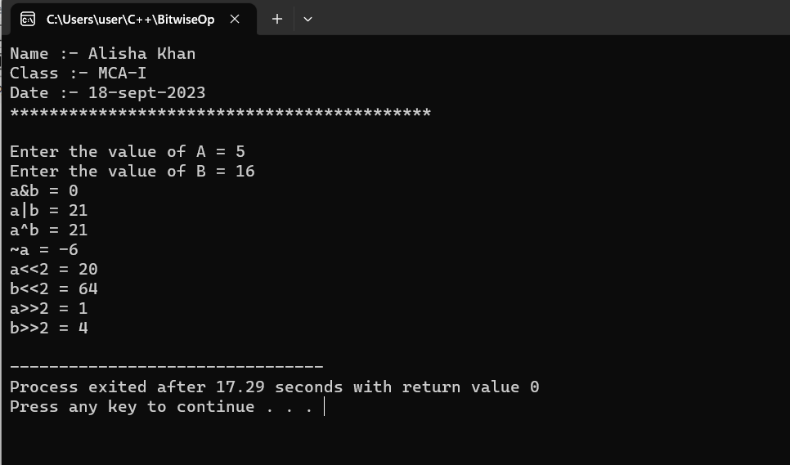
- Write a C++ program to read radius of a circle, calculate area and perimeter and display them.(using const constant).
Code :-
#include<iostream>
using namespace std;
int main()
{
cout<< "Name :- Alisha Khan\n";
cout<< "Class :- MCA I sem\n";
cout<<"Date :- 23-09-2023 "<<endl;
cout<<"*******************************************"<<endl;
cout<<"\n";
float rad;
int opt;
const float pi=3.14;

cout<<"What do you want to calculate :"<<endl;
cout<<"Press 1 to calculate area"<<endl;
cout<<"Press 2 to calculate Perimeter"<<endl;
cin>>opt;
cout<<"Enter the value of radius : ";
cin>>rad;
switch(opt)
{
case 1:
cout<<"Area of Circle : "<<pi*rad*rad;
break;

case 2:
cout<<"Perimeter of Circle : "<<2*pi*rad;
break;
}
return 0;
}

OUTPUT :-

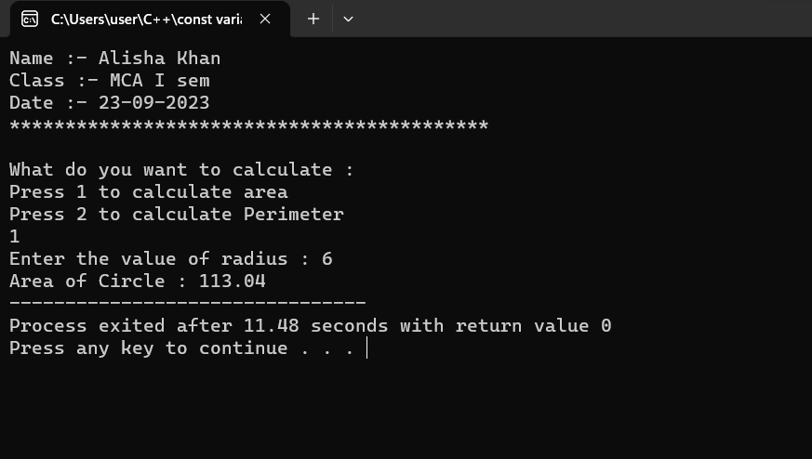

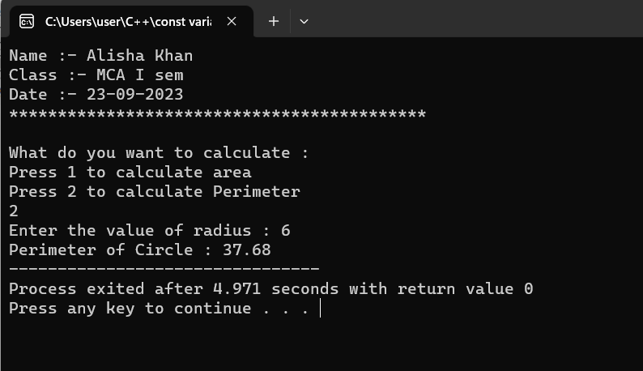

- Write a C++ program for Assuming that res starts with the value 25 and p with 3,so print the following code:-
- cout<<res--;
cout<<++res;
- p=p*++res;
Code :-
#include<iostream>
using namespace std;
int main()
{
cout<<"Name :- Alisha Khan "<<endl;
cout<<"Class :- MCA-I "<<endl;
cout<<"Date :- 2-11-2023"<<endl;
cout<<"******************************";
cout<<endl;
int res=25;
int p=3;
cout<<"Value of variable res is "<<res<<endl;
cout<<"\n";
cout<<"res-- = "<<res--<<endl;
cout<<"Value of res after post decrement = "<<res<<endl;
cout<<"\n";
cout<<"++res = "<<++res<<endl;
cout<<"Value of res after post increment = "<<res<<endl;
cout<<"\n";

p=p*++res;
cout<<"p=p*++res"<<endl;
cout<<"Value of p = "<<p;
return 0;
}

OUTPUT :-

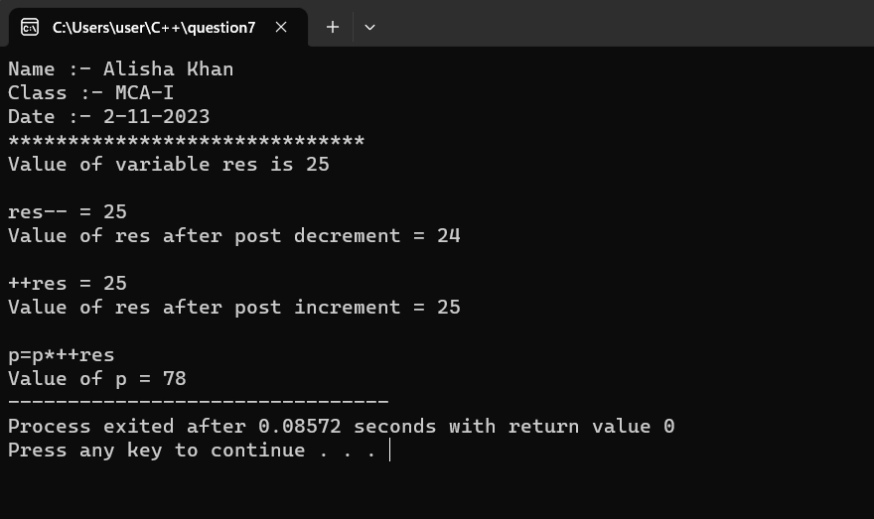

- Write a C++ program to input number of weeks day(1-7) and translate to its equivalent name of the day of the week using switch case.

Code :-
#include<iostream>
using namespace std;
int main()
{
cout<< "Name :- Alisha Khan\n";
cout<< "Class :- MCA I sem\n";
cout<<"Date :- 02-11-2023"<<endl;
cout<<"******************************"<<endl;;
cout<<"\n";
int n;
cout<<"Enter number of week day : ";
cin>>n;
cout<<"\n";
switch(n)
{
case 1:
cout<<"1st Day of week is :- Monday"<<endl;
break;

case 2:
cout<<"2nd Day of week is :- Tuesday"<<endl;
break;

case 3:
cout<<"3rd day of week is :- Wednesday"<<endl;
break;

case 4:
cout<<"4th day of week is :- Thursday"<<endl;
break;

case 5:
cout<<"5th day of week is :- Friday"<<endl;
break;

case 6:
cout<<"6th day of week is :- Saturday"<<endl;
break;

case 7:
cout<<"7th day of week is :- Sunday"<<endl;
break;

default:
cout<<"Invalid Input!! Please enter a number between 1-7";

}
return 0;
}

OUTPUT :-
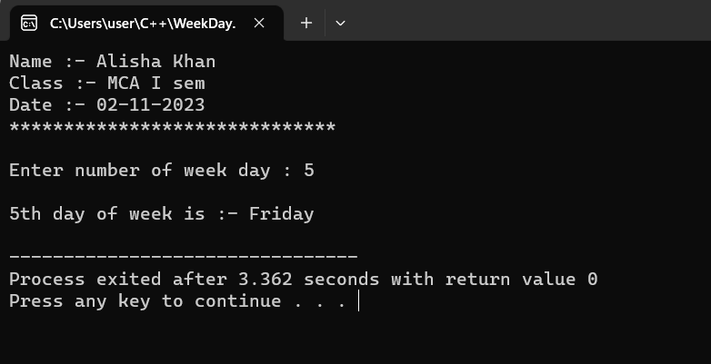

- Write a C++ program to make basic calculator using switch case.

Code :-
#include<iostream>
using namespace std;
int main()
{
cout<<"Name :- Alisha Khan"<<endl;
cout<<"Class :- MCA-I"<<endl;
cout<<"Date :- 06-11-2023 "<<endl;
cout<<"*******************************************"<<endl;
cout<<" ";
cout<<endl;

float a,b;
char sign;
cout<<"Enter an operator : +, -, *, / "<<endl;
cin>>sign;

cout<<"Enter value of A : " ;
cin>>a;
cout<<"Enter value of B : " ;
cin>>b;

switch(sign)
{
case '+':
cout<<"Value of A+B = "<<a+b;
break;

case '-':
cout<<"Value of A-B = "<<a-b;
break;

case '*':
cout<<"Value of A*B = "<<a*b;
break;

case '/':
cout<<"Value of A/B = "<<a/b;
break;

default:
cout<<"Please Enter Correct Operator";
break;
}
return 0;
}
OUTPUT:-

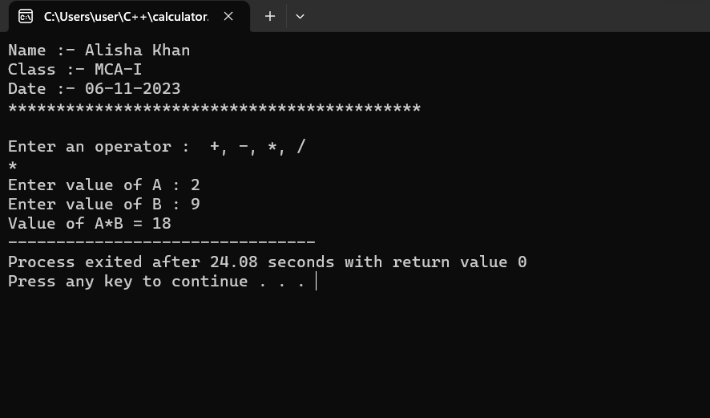

- Write a C++ program to find largest number among three number using ternary operator.

Code :-
#include<iostream>
using namespace std;
int main()
{
cout<<"Name :- Alisha Khan"<<endl;
cout<<"Class :- MCA-I"<<endl;
cout<<"Date :- 23-09-2023 "<<endl;
cout<<"*******************************************"<<endl;
cout<<" ";
cout<<endl;

float a,b,c,max;
cout<<"Program to check largest number among three numbers \n"<<endl;

cout<<"\n Enter first number = ";
cin>>a;
cout<<"\n Enter second number = ";
cin>>b;
cout<<"\n Enter third number = ";
cin>>c;

max = (a > b)?
(a > c ? a : b) :
(b > c ? b : c) ;

cout<<"\n Largest number among "<<a<<", "<<b<<", "<<c<<" is "<<max;

return 0;
}

OUTPUT :-

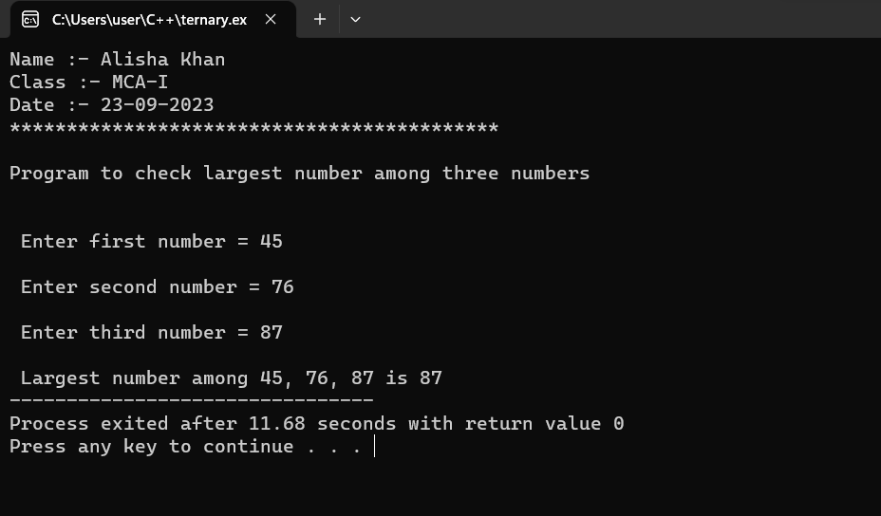

- Write a C++ program using for loop to print numbers from 1 to 10.

Code :-
#include<iostream>
using namespace std;
int main()
{
cout<<"Name :- Alisha Khan"<<endl;
cout<<"Class :- MCA-I"<<endl;
cout<<"Date :- 6-11-2023 "<<endl;
cout<<"*******************************************"<<endl;
cout<<" ";
cout<<endl;

cout<<"Program to print numbers from 1 to 10 using loop \n";

for(int i=1; i<=10; i++)
{
cout<<i<<" "<<endl;
}
return 0;
}
OUTPUT :-

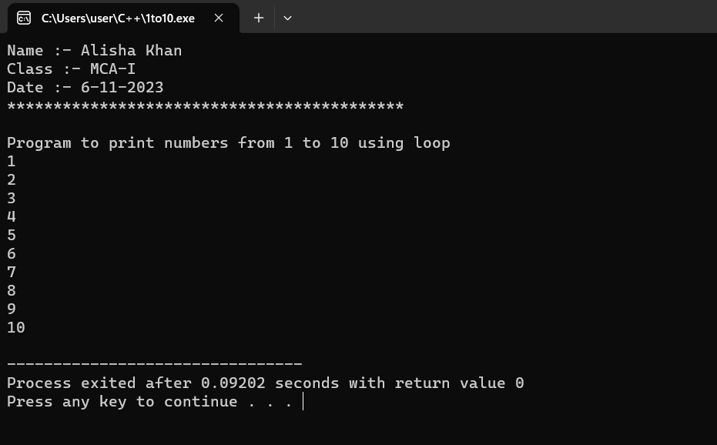

- Write a C++ program to display 2,4,6,8…….,18,20 using while loop.

Code :-
#include<iostream>
using namespace std;
int main()
{
cout<<"Name :- Alisha Khan"<<endl;
cout<<"Class :- MCA-I"<<endl;
cout<<"Date :- 23-09-2023 "<<endl;
cout<<"*******************************************"<<endl;
cout<<" ";
cout<<endl;
int i;
cout<<"Program to display Even numbers from 1 to 20 \n";
for(i=1; i<=20; i++)
{
if(i%2==0)
{
cout<<i<<" "<<endl;
}
}
return 0;
}
OUTPUT :-

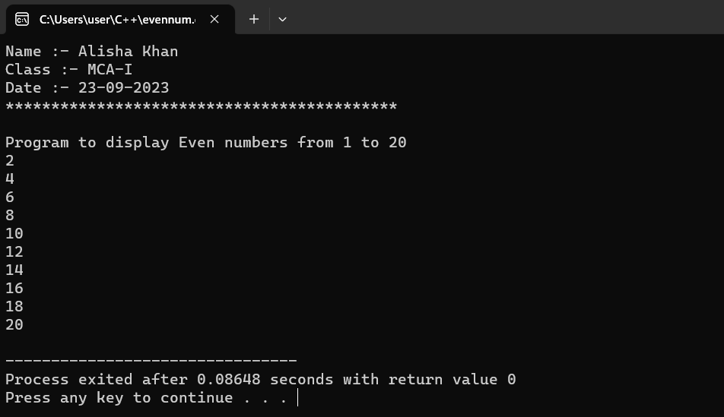

- (A)Write a C++ program to print following patterns-
* * * *
* * *
* *
*
Code:-
#include<iostream>
using namespace std;
int main() {
cout<<"Name :- Alisha Khan"<<endl;
cout<<"Class :- MCA-I"<<endl;
cout<<"Date :- 08-11-2023"<<endl;
cout<<"*******************************************"<<endl;
int i,j,n;
cout<<"Enter number of lines = ";
cin>>n;
for( i=1; i<=n; i++ )
{
for( j=n; j>=i; j-- )
cout<<"*"<<" ";
cout<<endl;
}
return 0;
}

OUTPUT :-

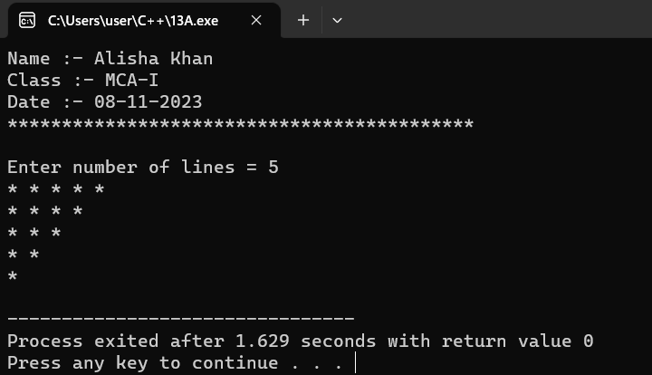

13.(B)Write a C++ program to print following pattern-
*
* *
* * *
* * * *
Code :-
#include<iostream>
using namespace std;
int main()
{
cout<<"Name :- Alisha Khan"<<endl;
cout<<"Class :- MCA-I"<<endl;
cout<<"Date :- 08-11-2023"<<endl;
cout<<"*******************************************"<<endl;
cout<<"\n";
int i,j,n;
cout<<"Enter number of lines = ";
cin>>n;
for( i=1; i<=n; i++ )
{
for( j=1; j<=i; j++ )
cout<<"*"<<" ";
cout<<endl;
}
return 0;
}

OUTPUT :-

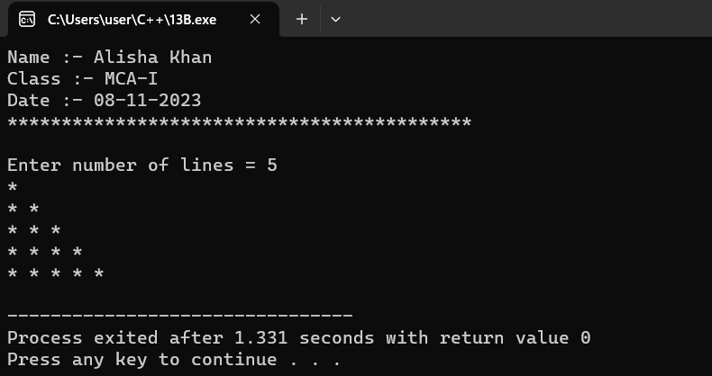

13.(C) Write a C++ program to print following pattern-
1
1 2
1 2 3
1 2 3 4
Code :-
#include<iostream>
using namespace std;
int main()
{
cout<<"Name :- Alisha Khan"<<endl;
cout<<"Class :- MCA-I"<<endl;
cout<<"Date :- 08-11-2023"<<endl;
cout<<"*******************************************"<<endl;
cout<<"\n";
int i,j,n;
cout<<"Enter number of lines = ";
cin>>n;
for( i=1; i<=n; i++ )
{
for( j=1; j<=i; j++ )
cout<<j<<" ";
cout<<endl;
}
return 0;
}

OUTPUT :-

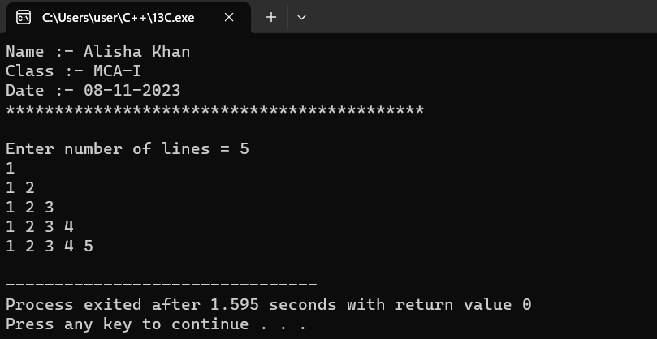

13.(D) Write a C++ program to print following pattern-
*
* *
* * *
* * * *
Code :-
#include<iostream>
using namespace std;
int main()
{
cout<<"Name :- Alisha Khan"<<endl;
cout<<"Class :- MCA-I"<<endl;
cout<<"Date :- 08-11-2023"<<endl;
cout<<"*******************************************"<<endl;
cout<<"\n";
int i,j,n;
cout<<"Enter number of lines = ";
cin>>n;
for (int i = 1; i <= n; i++)
{
for (int j = 1; j <= n - i; j++) {
cout << " ";
}
for (int j = 1; j <= i; j++) {
cout << "* ";
}
cout <<endl;
}
return 0; }

OUTPUT :-

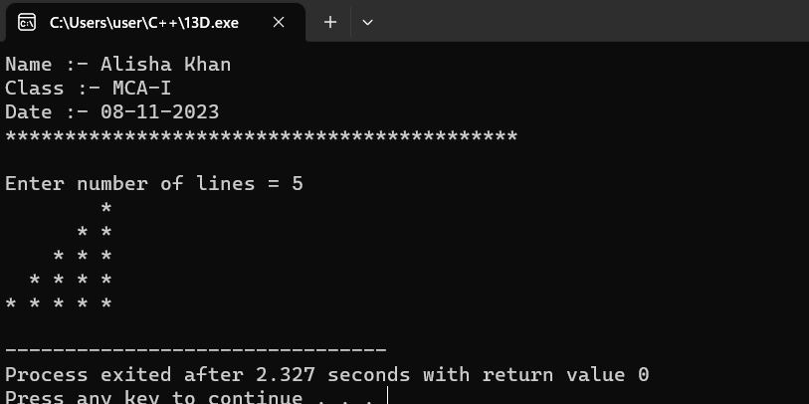

- Write a C++ program to display the cube of the number upto an integer.

Code :-

#include<iostream>
using namespace std;
int main()
{
cout<<"Name :- Alisha Khan "<<endl;
cout<<"Class :- MCA-I "<<endl;
cout<<"Date :- 8-11-2032"<<endl;
cout<<"******************************"<<endl;
int n,cube;
cout<<"Enter a number : ";
cin>>n;
cube = n*n*n;
cout<<"cube of "<<n<<" is : "<<cube;
return 0;
}

OUTPUT :-
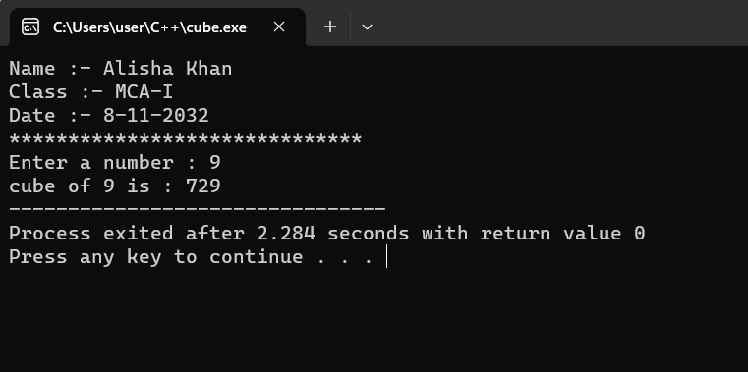

- Write a C++ program to check for equality of two numbers without using arithmetic or comparison operator.

Code :-
#include<iostream>
using namespace std;
int main()
{
cout<<"Name :- Alisha Khan"<<endl;
cout<<"Class :- MCA-I"<<endl;
cout<<"Date :- 02-11-2023 "<<endl;
cout<<"*******************************************"<<endl;
cout<<"Check equality of two numbers "<<endl;
cout<<"\n";

int a,b;

cout<<"Enter first number = ";
cin>>a;
cout<<"Enter second number = ";
cin>>b;

if(a ^ b)
cout<<"Not equal"<<endl;
else
cout<<"Both numbers are equal "<<endl;
return 0;
}

OUTPUT :-
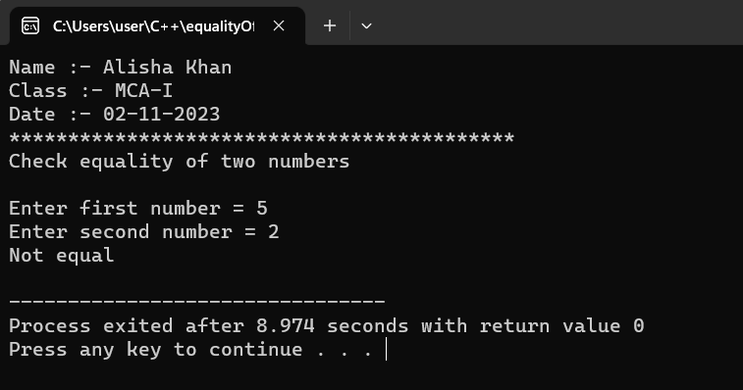

- Write a C++ program to calculate value of 132 x 8 without using “ * ”operator.

Code :-
#include<iostream>
using namespace std;
int main()
{
cout<<"Name :- Alisha Khan"<<endl;
cout<<"Class :- MCA-I"<<endl;
cout<<"Date :- 02-11-2023"<<endl;
cout<<"*******************************************"<<endl;
cout<<"Multiply 132 * 8 without using * operator "<<endl;
cout<<"\n";

int n1 = 132;
int n2= 8;
int pro;

while(n2>0)
{
pro = pro + n1;
n2--;
}
cout<<endl<<"The product of 132*8 is = "<<pro<<endl;
cout<<"\n";
return 0;
}

OUTPUT :-
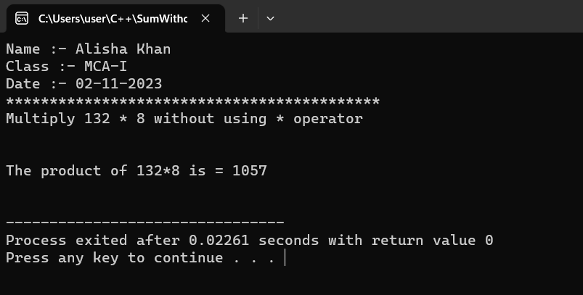

- Write a C++ program to find Area of rectangle (using #define).

Code :-
#include<iostream>
using namespace std;
#define length 10
#define width 5
int main()
{
cout<<"Name :- Alisha Khan "<<endl;
cout<<"Class :- MCA-I "<<endl;
cout<<"Date :- 02-11-2023 "<<endl;
cout<<"*******************************************"<<endl;

cout<<"Find area of reactangle using #define constant"<<endl;
cout<<"\n";
int area;
cout<<"length = "<<length<<endl;
cout<<"width = "<<width<<endl;
area = length*width;
cout<<"area of rectangle is : "<<area;

return 0;
}

OUTPUT :-
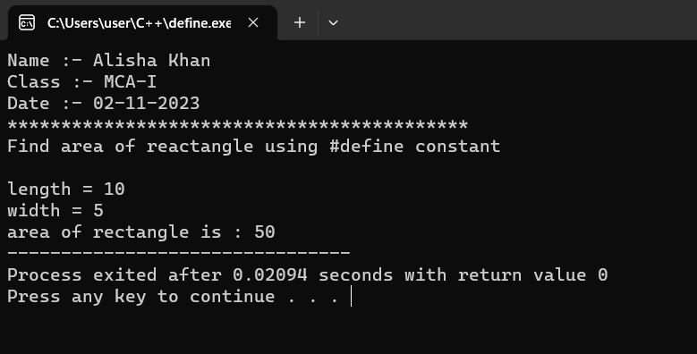

- Write a C++ program to demonstrate explicitly typecasting.

Code :-
#include<iostream>
using namespace std;
int main()
{
cout<<"Name :- Alisha Khan"<<endl;
cout<<"Class :- MCA-I"<<endl;
cout<<"Date :- 08-11-2023 "<<endl;
cout<<"*******************************************"<<endl;

cout<<"\nExplicitly typecast the double value to an int "<<endl;
cout<<"\n";

double dvalue = 3.14159;
int ivalue;

ivalue = (int)dvalue;

cout<<"Original double value = "<<dvalue<<endl;
cout<<"Typcasted Int value = "<<ivalue<<endl;
cout<<"\n";

return 0;
}

OUTPUT :-

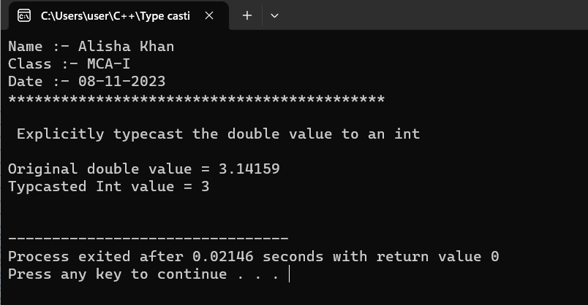

- Write a C++ program to display addition of first 1 to 20 odd numbers and also display addition of first 1 to 20 even number.

Code :-
#include<iostream>
using namespace std;
int main()
{
cout<<"Name :- Alisha Khan \n";
cout<<"Class :- MCA-I \n";
cout<<"Date :- 26-Sept-2023 \n";
cout<<"*******************************************"<<endl;
cout<<"\n";

int num, max, Evensum, Oddsum;
cout<<"\n Please enter the maximum Limit for even and odd numbers : ";
cin>>max;

for(num=1; num<=max; num++)
{
if(num%2==0)
{
Evensum=Evensum+num;
}
else
{
Oddsum=Oddsum+num;
}
}

cout<<"\n The sum of all even number betwwen 0 and "<<max<<" = "<<Evensum<<endl;
cout<<"\n The sum of all odd number betwwen 0 and "<<max<<" = "<<Oddsum<<endl;

return 0;
}

OUTPUT :-

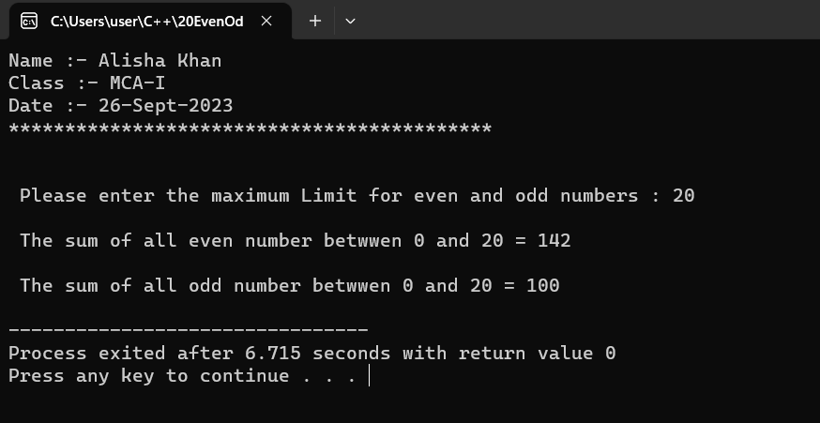

- Write a C++ program for a given problem – where age will be taken as input by the user and if age is greater than 18 and gender is “Male(M/m)” than print message to send him to “Room number 10” for voting and if gender is “Female(F/f)” than print message to send her to “Room number 12”,if gender is none of these two than send them to “Room number 8”. also given message “Not eligible for voting” in case of age is less than 18.(using nested if control structure).

Code :-
#include<iostream>
using namespace std;
int main()
{
cout<< "Name :- Alisha Khan\n";
cout<< "Class :- MCA I sem\n";
cout<<"Date :- 02-11-2023 "<<endl;
cout<<"*******************************************"<<endl;
cout<<"\n";

int age;
char gender;
cout<<"Enter your age :- ";
cin>>age;
cout<<"Enter your Gender : "<<endl;
cout<<"Press M/m for male"<<endl;
cout<<"Press F/f for Female"<<endl;
cout<<"Press T/t for others"<<endl;
cout<<"Gender :- ";
cin>>gender;

if(age>=18)
{
if(gender=='M'|| gender=='m')
{
cout<<"Send him to room number 10 for voting";
}
else if(gender=='F' || gender=='f')
{
cout<<"Send her to room number 12 for voting";
}

else if(gender=='T' || gender=='t')
{
cout<<"send to room number 8 ";
}
}
else
{
cout<<"You are not eligible for voting ";
}

return 0;
}

OUTPUT :-

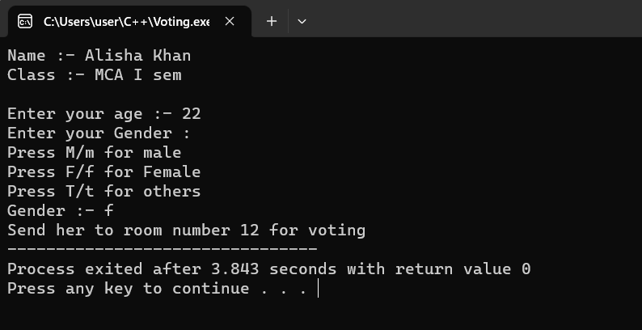

- Write a C++ program to print Hollow square pattern using for loop.

Code :-
#include<iostream>
using namespace std;
int main()
{
cout<<"Name :- Alisha Khan"<<endl;
cout<<"Class :- MCA-I"<<endl;
cout<<"Date :- 08-11-2023"<<endl;
cout<<"*******************************************"<<endl;
cout<<"Hollow square pattern "<<endl;
cout<<"\n";

int n;
cout<<"Input the size of square = ";
cin>>n;

//Outer loop for rows
for(int i=1; i<=n; i++)
{
//Inner loop for columns
for(int j=1; j<=n; j++)
{
if(i==1 || i==n || j==1 || j==n)
{
cout<<"* ";
}
else
{
cout<<" ";
}
}
//move to next line after each row
cout<<endl;
}

return 0;
}

OUTPUT :-

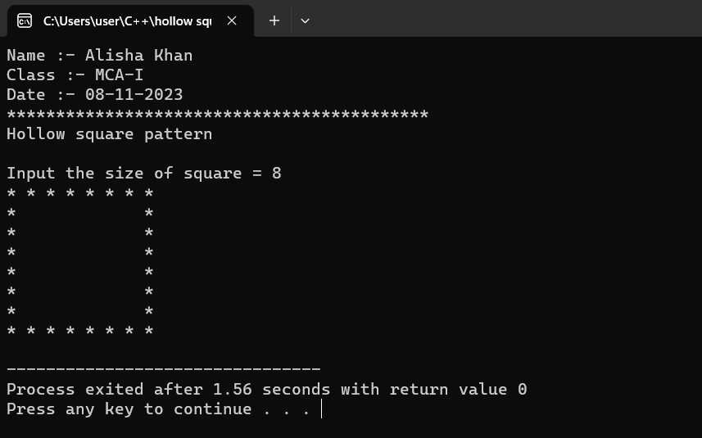

- Write a C++ program to take input between 1-25 at runtime and display “Thank you user” for selecting number between 1-25 otherwise display ”please enter number between 1-25 only!!”.(using while loop)

Code :-
#include<iostream>
using namespace std;
int main()
{
cout<<"Name :- Alisha Khan"<<endl;
cout<<"Class :- MCA-I"<<endl;
cout<<"Date :- 08-11-2023 "<<endl;
cout<<"*******************************************"<<endl;
cout<<"\n";

int num;
cout<<"Enter number between 1 to 25 = ";
cin>>num;

while (num<=25)
{
cout<<"Thank you user"<<endl;
break;
}
while (num>25)
{
cout<<"Please enter number between 1-25 only!!"<<endl;
break;
}
return 0;
}

OUTPUT :-

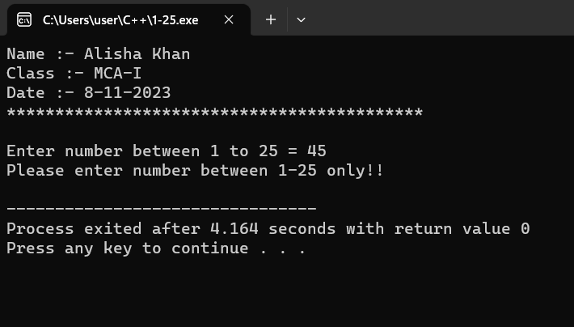

- Write a C++ program to find number is positive, negative or zero using “ goto ” jump statement.

Code :-
#include<iostream>
using namespace std;
int main()
{
cout<<"Name :- Alisha Khan"<<endl;
cout<<"Class :- MCA-I"<<endl;
cout<<"Date :- 08-11-2023 "<<endl;
cout<<"*******************************************"<<endl;
cout<<"\n C++ program to find +ve, -ve, and zero using goto. "<<endl;
cout<<"\n";

int num;
cout<<"Enter a number = ";
cin>>num;

if(num > 0)
goto positive;
else if(num < 0)
goto negative;
else
goto zero;

positive:
cout<<"The number is positive.\n";
goto end;

negative:
cout<<"The number is negative.\n";
goto end;

zero:
cout<<"The number is zero.\n";
end:
return 0; }

OUTPUT :-

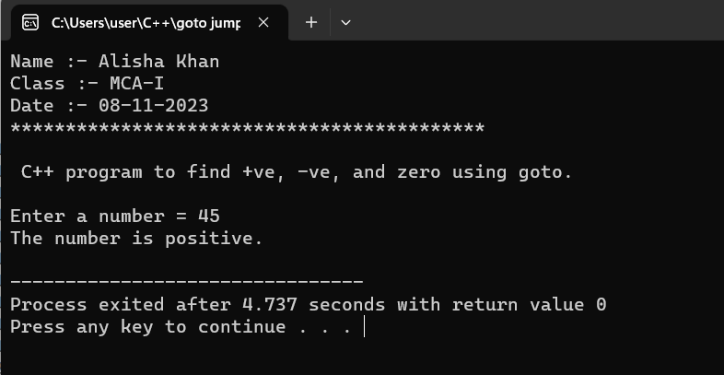

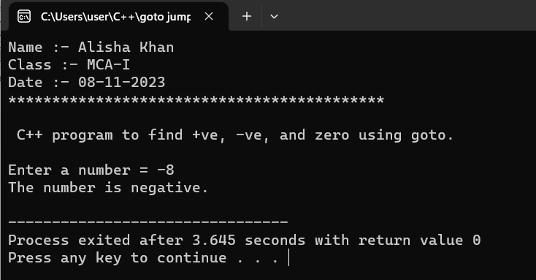

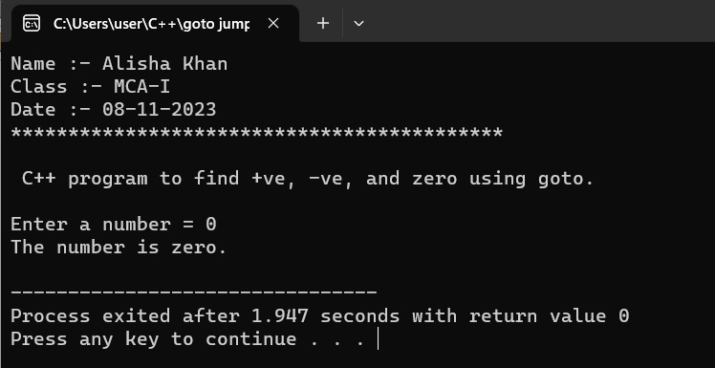

- Write a C++ program to differentiate break and continue jump statement.
Code :-
#include<iostream>
using namespace std;
int main()
{
cout<<"Name :- Alisha Khan"<<endl;
cout<<"Class :- MCA-I"<<endl;
cout<<"Date :- 08-11-2023 "<<endl;
cout<<"*******************************************"<<endl;
cout<<"\nBreak and continue statement "<<endl;
cout<<"\n";
int i;
for(int i=1; i<=10; i++)
{
if(i==5)
{
cout<<"Skipping 5"<<endl;
continue;
} //skip the rest of the loop body for i=5
else if (i==9)
{
cout<<"Breaking Loop";
break;
}
cout<<i<<endl;
}
return 0;
}
OUTPUT :-
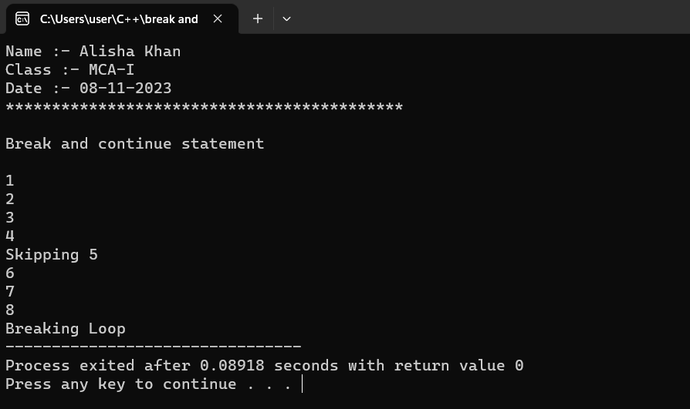
- Write a C++ program to display details of 5 students’ detail should contained student name, roll number, marks using structure.
Code :-
#include<iostream>
using namespace std;
struct student
{
char name[50];
int roll;
float marks;
}s[5];
int main()
{
cout<<"Name :- Alisha Khan"<<endl;
cout<<"Class :- MCA-I"<<endl;
cout<<"Date :- 8-11-2023 "<<endl;
cout<<"*******************************************"<<endl;
cout<<"\nProgram to display student record "<<endl;
cout<<"\n";

cout<<"Enter information of students:"<<endl;
for(int i=0; i<5; ++i)
{
s[i].roll = i+1;
cout<<"For Roll Number "<<s[i].roll<<", "<<endl;

cout<<"Enter name = ";
cin>>s[i].name;

cout<<"Enter marks = ";
cin>>s[i].marks;

cout<<endl;

}
cout<<"Displaying Information "<<endl;
for(int i=0; i<5; ++i)
{
cout<<"\nRoll number = "<<i+1<<endl;
cout<<"Name = "<<s[i].name<<endl;
cout<<"Marks = "<<s[i].marks<<endl;

}
return 0;
}

OUTPUT :-
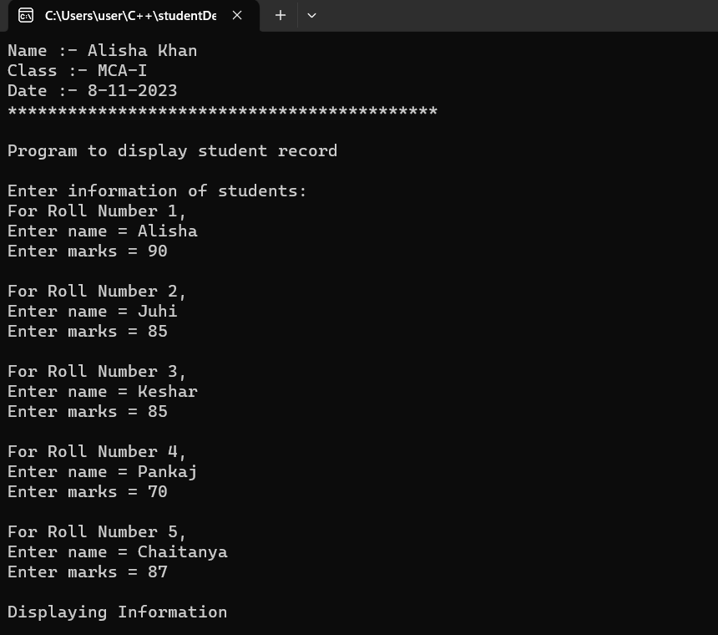

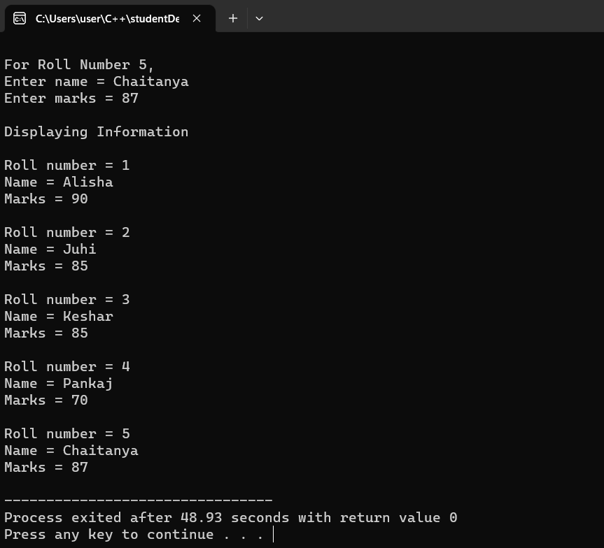

- Write a C++ program to create a structure named “Date” which contains three members Day, Month, Year and display current date entered by the user using function definition.
Code :-
#include <iostream>
using namespace std;
struct Date {
int day;
int month;
int year;
};
void displayDate(const Date& date) {
cout << "Current Date: " << date.day << "/" << date.month << "/" << date.year << endl;
}
int main()
{
cout<<"Name :- Alisha Khan"<<endl;
cout<<"Class :- MCA-I"<<endl;
cout<<"Date :- 10-12-2023"<<endl;
cout<<"*******************************************"<<endl;
cout<<"\nProgram to print current date.\n";

Date currentDate;
cout << "\nEnter the current date :" << endl;
cout << "Day: ";
cin >> currentDate.day;
cout << "Month: ";
cin >> currentDate.month;
cout << "Year: ";
cin >> currentDate.year;
displayDate(currentDate);
return 0;
}

OUTPUT :-

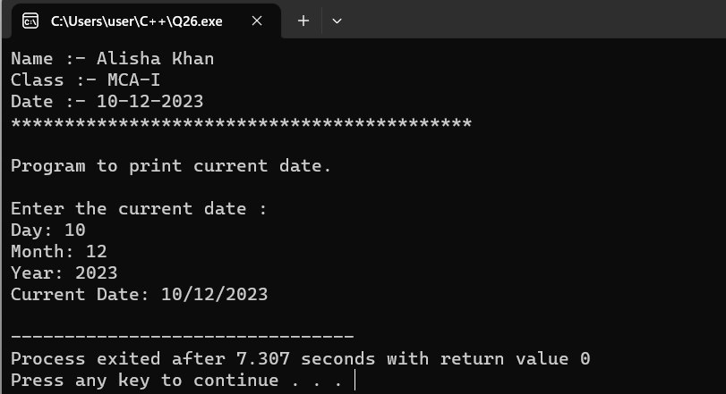

- Write a C++ program to demonstrate enum with switch case.
Code :-
#include<iostream>
using namespace std;
enum Choice
{
EASY = 1, MEDIUM = 2, HARD = 3
};
int main()
{
cout<<"Name :- Alisha Khan"<<endl;
cout<<"Class :- MCA-I"<<endl;
cout<<"Date :- 8-11-2023 "<<endl;
cout<<"*******************************************"<<endl;
cout<<"\nProgram to demonstrate enum with switch case "<<endl;
cout<<"\n";

int i = -1;
cout<<"Select level of difficulty"<<endl;
cout << "1 - Easy "<<endl;
cout << "2 - Medium "<<endl;
cout << "3 - Hard "<<endl;
cout<<"\n";
cout<<"Enter your choice = ";
cin >> i;

switch(i)
{
case EASY:
cout << "You Picked Easy Level!!\n";
break;
case MEDIUM:
cout << "You Picked Medium Level!!\n";
break;
case HARD:
cout << "Hard Level!!\n";
break;
default:
cout << "Invalid Selection!!\n";
break;
}
return 0;
}

OUTPUT :-

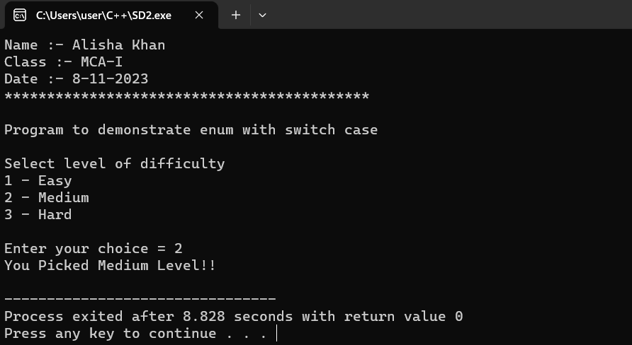

- Write a C++ program to create an enum having number of enum list or elements and count the size of elements inside the enum.

Code :-
#include<iostream>
using namespace std;
enum Myenum
{
Element1,Element2,Element3,Element4,Element5,count
};
int main()
{
cout<<"Name :- Alisha Khan"<<endl;
cout<<"Class :- MCA-I"<<endl;
cout<<"Date :- 25-11-2023 "<<endl;
cout<<"*******************************************"<<endl;
cout<<"Program to count the size of elements inside enum "<<endl;
cout<<"\n";

int NumOfelement = count;
Myenum myVariable;
cout<<"number of elements inside enum = "<<count<<endl;
cout<<"Size of enum variable = "<<sizeof(myVariable)<< "bytes"<<endl;

return 0;
}

OUTPUT :-

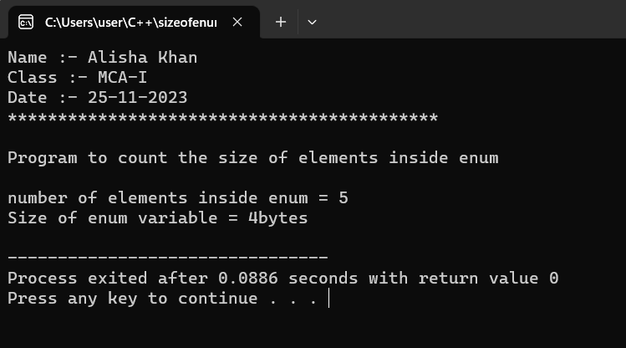

- Write a C++ program to swap two values without using third variable.

Code :-
#include<iostream>
using namespace std;
int main()
{
cout<<"Name :- Alisha Khan"<<endl;
cout<<"Class :- MCA-I"<<endl;
cout<<"Date :- 25-11-2023 "<<endl;
cout<<"*******************************************"<<endl;
cout<<"\nProgram to swap two values without usinng third variable "<<endl;
cout<<"\n";

int a,b;
cout<<"Enter value of A = ";
cin>>a;
cout<<"Enter value of B = ";
cin>>b;
cout<<"\n";

cout<<"Before swapping value of A = "<<a<<endl;
cout<<"Before swapping value of B = "<<b<<endl;

a = a + b;
b = a - b;
a = a - b;

cout<<"\nAfter swapping value of A = "<<a<<endl;
cout<<"After swapping value of B = "<<b<<endl;

return 0;
}

OUTPUT :-

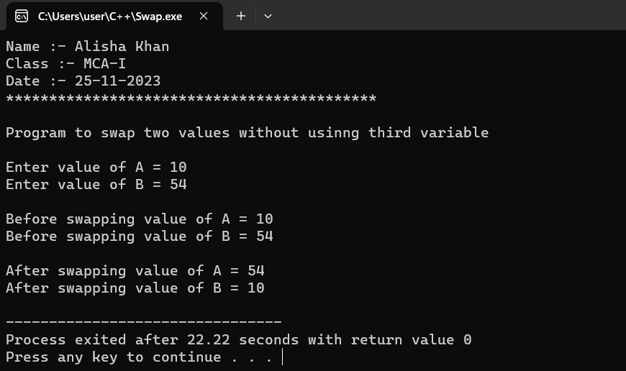

- Write a C++ program to swap two values using third variable of call by address function invoking.

Code :-
#include<iostream>
using namespace std;
int swap(int*x, int*y)
{
int temp;
temp = *x;
*x = *y;
*y = temp;
}
int main()
{
cout<<"Name :- Alisha Khan"<<endl;
cout<<"Class :- MCA-I"<<endl;
cout<<"Date :- 25-11-2023 "<<endl;
cout<<"*******************************************"<<endl;
cout<<"\nSwapping through call by address function call "<<endl;
cout<<"\n";

int a,b;
cout<<"Enter value of A = ";
cin>>a;
cout<<"Enter value of B = ";
cin>>b;
cout<<"\n";

cout<<"Before swapping value of A = "<<a<<endl;
cout<<"Before swapping value of B = "<<b<<endl;

swap(&a,&b);

cout<<"\nAfter swapping value of A = "<<a<<endl;
cout<<"After swapping value of B = "<<b<<endl;
return 0;
}

OUTPUT :-

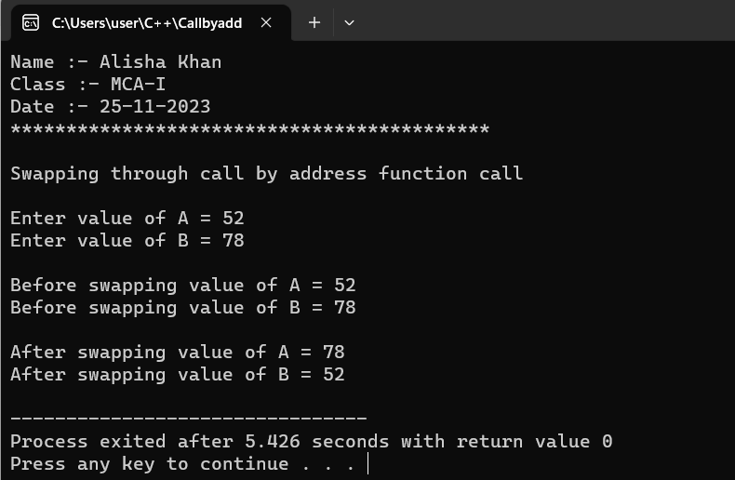

- Write a C++ program to illustrate working of call by value of a function invoking.
Code :-
#include<iostream>
using namespace std;
void callbyvalue(int x)
{
cout<<"Inside the function : Recieved Value = "<<x<<endl;
cout<<"\nLet's put x = 20"<<endl;
x = 20;
cout<<"Inside the function : Modified value = "<<x<<endl;
}
int main()
{
cout<<"Name :- Alisha Khan"<<endl;
cout<<"Class :- MCA-I"<<endl;
cout<<"Date :- 25-11-2023 "<<endl;
cout<<"*******************************************"<<endl;
cout<<"\nProgram to demonstrate Call by value :- "<<endl;
cout<<"\n";

int value;
cout<<"Enter a value = ";
cin>>value;

cout<<"\nBefore function call : Value = "<<value<<endl;

callbyvalue(value);

cout<<"\nAfter function call : Value = "<<value;

return 0;
}

OUTPUT :-

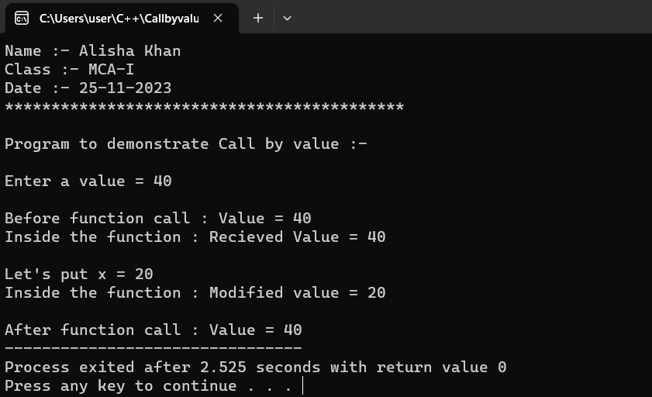

- Write a C++ program to illustrate working of call by reference method of a function invoking.
Code :-
#include<iostream>
using namespace std;
void callbyvalue(int &x)
{
cout<<"Inside the function : Recieved Value = "<<x<<endl;
cout<<"\nLet's put x = 20"<<endl;
x = 20;
cout<<"Inside the function : Modified value = "<<x<<endl;
}
int main()
{
cout<<"Name :- Alisha Khan"<<endl;
cout<<"Class :- MCA-I"<<endl;
cout<<"Date :- 25-11-2023 "<<endl;
cout<<"*******************************************"<<endl;
cout<<"\nProgram to demonstrate Call by Reference method :- "<<endl;
cout<<"\n";

int value;
cout<<"Enter a value = ";
cin>>value;

cout<<"\nBefore function call : Value = "<<value<<endl;

callbyvalue(value);

cout<<"\nAfter function call : Value = "<<value;

return 0;
}

OUTPUT :-

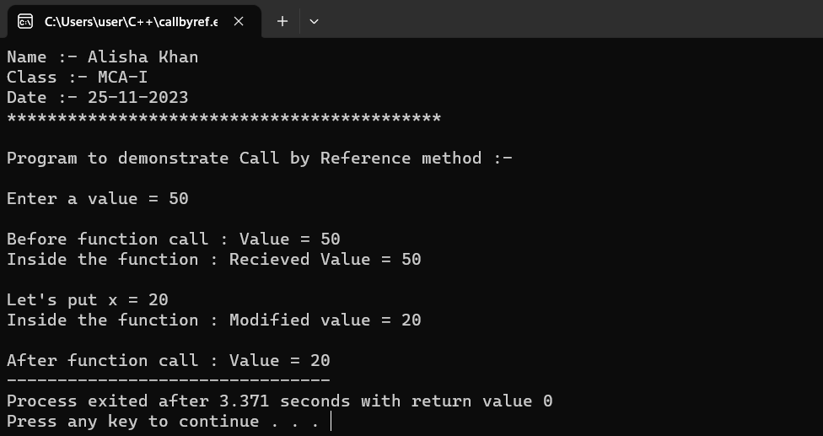

- Write a C++ program to calculate simple interest using default arguments.
Code :-
#include<iostream>
using namespace std;
float SI(float P, float R ,float T=1)
{
float result;
result = (P * R * T)/100;
return result;
}
int main()
{
cout<<"Name :- Alisha Khan"<<endl;
cout<<"Class :- MCA-I"<<endl;
cout<<"Date :- 25-11-2023 "<<endl;
cout<<"*******************************************"<<endl;
cout<<"\nprogram to calculate simple interest using default arguments :- "<<endl;
cout<<"\n";

float P, R, T;
cout<<"Enter Principal amount = ";
cin>>P;
cout<<"Enter Rate = ";
cin>>R;

float sum = SI(P, R);
cout<<"\nSimple Interest = "<<sum;
return 0;
}
OUTPUT :-
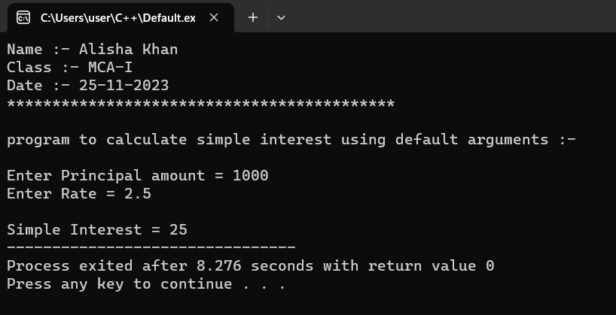

- Write a C++ program using function template to add two integers and two float number
Code:-
#include <iostream>
using namespace std;
template <typename T>
T add(T a, T b) {
return a + b;
}
int main()
{
cout<<"Name :- Alisha Khan"<<endl;
cout<<"Class :- MCA-I"<<endl;
cout<<"Date :- 28-11-2023"<<endl;
cout<<"*******************************************"<<endl;
cout<<"\n";
int num1, num2;
float num3, num4;
cout<<"Enter 2 integer values :-"<<endl;
cout<<"Enter first value = ";
cin>>num1;
cout<<"Enter second value = ";
cin>>num2;
cout<<"\nEnter 2 float values :-"<<endl;
cout<<"Enter first value = ";
cin>>num3;
cout<<"Enter second value = ";
cin>>num4;

int sum1 = add(num1, num2);
cout << "\nSum of integers: " << sum1 << endl;
float sum2 = add(num3, num4);
cout << "Sum of float numbers: " << sum2 << endl;
return 0;
}

OUTPUT :-

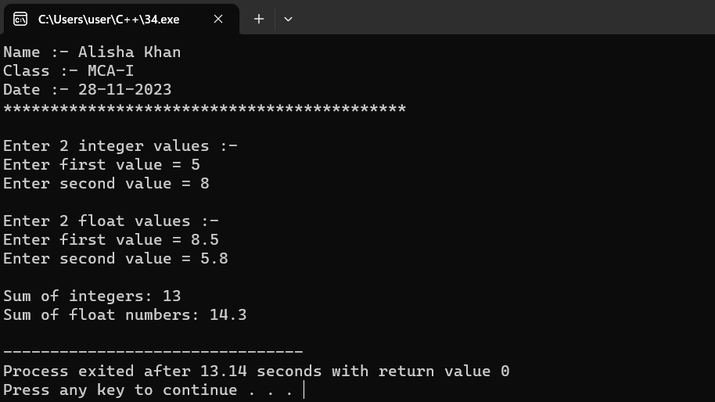

- Write a C++ program to create simple calculator using class templates.
Code :-
#include <iostream>
using namespace std;

template <class T>
class Calculator {
private:
T num1, num2;
public:
Calculator(T n1, T n2) {
num1 = n1;
num2 = n2;
}
void displayResult() {
cout << "Numbers: " << num1 << " and " << num2 << ".\n" << endl;
cout <<"Addition : " << num1 << " + " << num2 << " = " << add() << endl;
cout <<"Subtraction : " << num1 << " - " << num2 << " = " << subtract() << endl;
cout <<"Multiplication : " << num1 << " * " << num2 << " = " << multiply() << endl;
cout <<"Division : " << num1 << " / " << num2 << " = " << divide() << endl;
}

T add() { return num1 + num2; }
T subtract() { return num1 - num2; }
T multiply() { return num1 * num2; }
T divide() { return num1 / num2; }
};

int main()
{
cout<<"Name :- Alisha Khan"<<endl;
cout<<"Class :- MCA-I"<<endl;
cout<<"Date :- 30-11-2023"<<endl;
cout<<"*******************************************\n"<<endl;

int num1, num2;
float num3, num4;
cout<<"Enter 2 integer values :-"<<endl;
cout<<"Enter first value = ";
cin>>num1;
cout<<"Enter second value = ";
cin>>num2;

cout<<"\nEnter 2 float values :-"<<endl;
cout<<"Enter first value = ";
cin>>num3;
cout<<"Enter second value = ";
cin>>num4;

Calculator<int> intCalc(num1, num2);
Calculator<float> floatCalc(num3, num4);

cout << "\nInt results:" << endl;
intCalc.displayResult();

cout << endl
<< "Float results:" << endl;
floatCalc.displayResult();

return 0;
}
OUTPUT :-
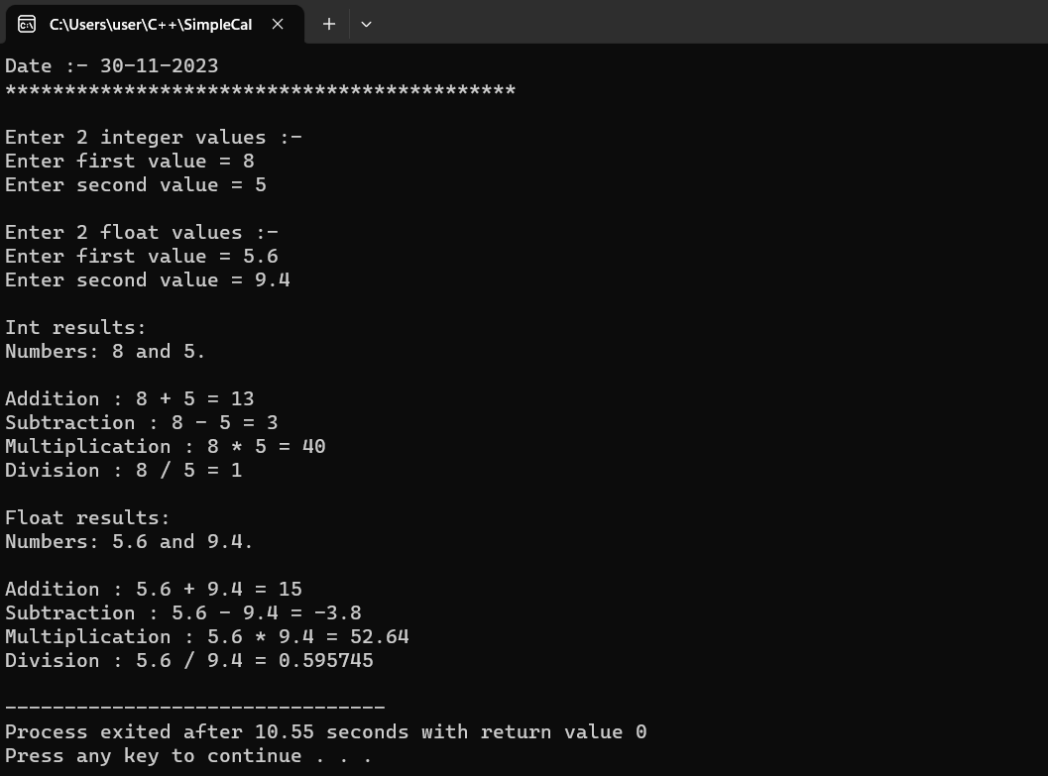

- Write a C++ program using inline function to calculate area of circle.
Code :-
#include<iostream>
using namespace std;

inline float Area(float radius)
{
return 3.1415 * radius * radius;
}
int main()
{
cout<<"Name :- Alisha Khan"<<endl;
cout<<"Class :- MCA-I"<<endl;
cout<<"Date :- 30-11-2023"<<endl;
cout<<"**********************************************"<<endl;
cout<<"\nProgram to calculate area of circle using inline function.\n"<<endl;

float radius;
cout<<"Enter Radius of circle = ";
cin>>radius;
cout<<"Area of circle using Inline Function is : "<<Area(radius)<<"\n";
return 0;

}
OUTPUT :-
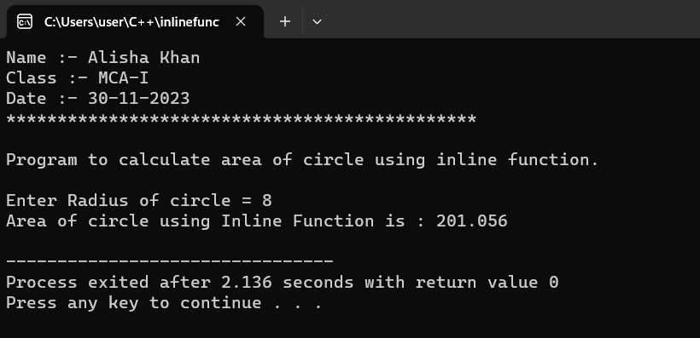

- Write a C++ program to demonstrate function overloading.
Code :-
#include <iostream>
#include <cmath>
using namespace std;

// Function to calculate the area of a rectangle
double calculateArea(double length, double width) {
return length * width;
}

// Function to calculate the area of a circle
double calculateArea(double radius) {
return M_PI * radius * radius;
}

// Function to calculate the volume of a cube
double calculateVolume(double side) {
return side * side * side;
}

// Function to calculate the volume of a rectangular prism
double calculateVolume(double length, double width, double height) {
return length * width * height;
}

int main()
{
cout<<"Name :- Alisha Khan"<<endl;
cout<<"Class :- MCA-I"<<endl;
cout<<"Date :- 30-11-2023"<<endl;
cout<<"**********************************************"<<endl;
cout<<"\nProgram to demonstrate function overloading.\n"<<endl;

// Test the overloaded functions
cout << "Area of rectangle: " << calculateArea(4.0, 6.0) << endl;
cout << "Area of circle: " << calculateArea(3.0) << endl;

cout << "Volume of cube: " << calculateVolume(3.0) << endl;
cout << "Volume of rectangular prism: " << calculateVolume(2.0, 4.0, 5.0) << endl;

return 0;
}

OUTPUT :-

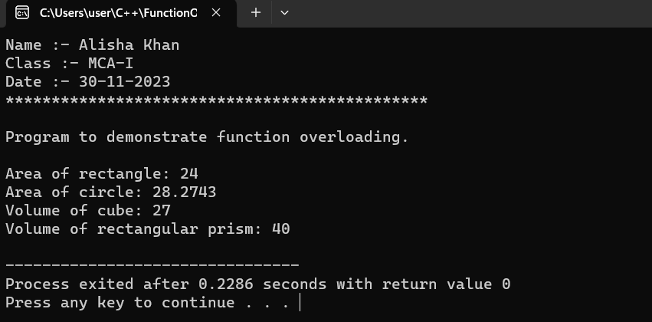

- Write a C++ program to find the size of 1-D, 2-D and multidimensional array.
Code :-
#include <iostream>
using namespace std;
int main()
{
cout<<"Name :- Alisha Khan"<<endl;
cout<<"Class :- MCA-I"<<endl;
cout<<"Date :- 30-11-2023"<<endl;
cout<<"*******************************************"<<endl;
cout<<"\nProgram to find size of 1-D, 2-D and multidimensional Array.\n";
// 1D Array
int oneDArray[] = {1, 2, 3, 4, 5};
int sizeOf1DArray = sizeof(oneDArray) / sizeof( int );

cout << "Size of 1D Array: " << sizeOf1DArray << endl;

// 2D Array
int twoDArray[3][4] = {{1, 2, 3, 4},
{5, 6, 7, 8},
{9, 10, 11, 12}};
int rows = sizeof(twoDArray) / sizeof(twoDArray[0]);
int cols = sizeof(twoDArray[0]) / sizeof(int);

cout << "Size of 2D Array: " << rows << " rows x " << cols << " columns" << endl;

// Multidimensional Array (3D for example)
int threeDArray[2][3][4] = {
{{1, 2, 3, 4},
{5, 6, 7, 8},
{9, 10, 11, 12}},
{{13, 14, 15, 16},
{17, 18, 19, 20},
{21, 22, 23, 24}}};
int depth = sizeof(threeDArray) / sizeof(threeDArray[0]);
rows = sizeof(threeDArray[0]) / sizeof(threeDArray[0][0]);
cols = sizeof(threeDArray[0][0]) / sizeof( int );

cout << "Size of 3D Array: " << depth << " depth x " << rows << " rows x " << cols << " columns" << endl;
return 0;
}

//sizeof() operator return the size of a type in bytes.
//To find out how many element an array has, you have to divide the size of array by the size of the data type it contains.

OUTPUT :-
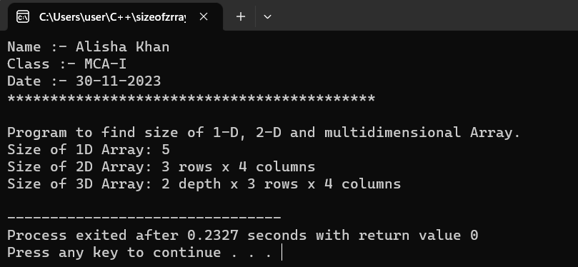

38A.Write a C++ program to find the size of 1-D, 2-D and multidimensional array.
Code:-
#include <iostream>
using namespace std;
int main() {
cout<<"Name :- Alisha Khan"<<endl;
cout<<"Class :- MCA-I"<<endl;
cout<<"Date :- 30-11-2023"<<endl;
cout<<"*******************************************"<<endl;
cout<<"\nProgram to find size of 1-D, 2-D and multidimensional Array.\n";
int oneDArray[] = {1, 3, 5, 7, 9 };
int twoDArray[3][4] = {{1, 2, 3, 4}, {5, 6, 7, 8}, {9, 10, 11, 12}};
int multiDArray[2][3][4] = {
{{1, 2, 3, 4}, {5, 6, 7, 8}, {9, 10, 11, 12}},
{{13, 14, 15, 16}, {17, 18, 19, 20}, {21, 22, 23, 24}}
};
cout << "Size of 1-D array: " << sizeof(oneDArray) << " bytes" << endl;
cout << "Size of 2-D array: " << sizeof(twoDArray) << " bytes" << endl;
cout << "Size of 3-D array: " << sizeof(multiDArray) << " bytes" << endl;
return 0;
}
OUTPUT :-
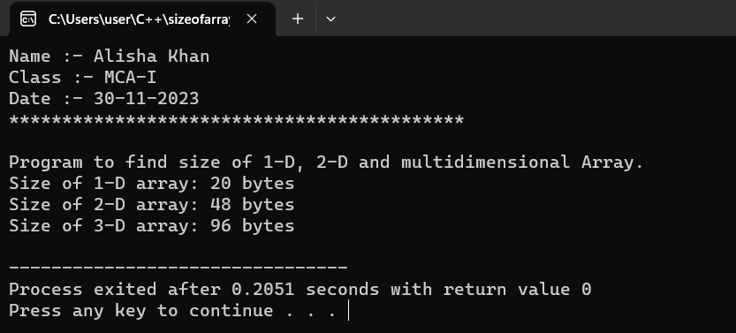

- Write a C++ program create and display one-D array of size 7 and also display average of all the elements.
Code :-
#include <iostream>
using namespace std;
int main()
{
cout<<"Name :- Alisha Khan"<<endl;
cout<<"Class :- MCA-I"<<endl;
cout<<"Date :- 10-12-2023"<<endl;
cout<<"*******************************************"<<endl;
cout<<"\n";
const int size = 7;
int arr[size];

cout << "Enter " << size << " elements for the array:\n";
for (int i = 0; i < size; ++i) {
cout << "Element " << i + 1 << ": ";
cin >> arr[i];
}

cout << "Elements of the array:\n";
for (int i = 0; i < size; ++i) {
cout << arr[i] << " ";
}

int sum = 0;
for (int i = 0; i < size; ++i) {
sum += arr[i];
}
double average = static_cast<double>(sum) / size;

cout << "\nAverage of the elements: " << average << std::endl;

return 0;
}

OUTPUT :-

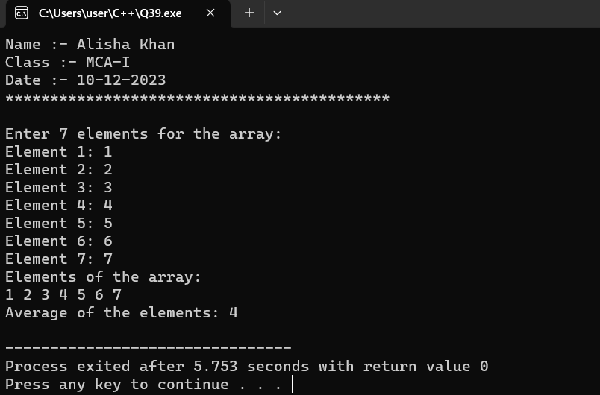

- Write a C++ program to input 5 numbers in an array and print all the numbers from the backside of the array.
Code :-
#include <iostream>
using namespace std;
int main()
{
cout<<"Name :- Alisha Khan"<<endl;
cout<<"Class :- MCA-I"<<endl;
cout<<"Date :- 10-12-2023"<<endl;
cout<<"*******************************************"<<endl;
cout<<"\nProgram to print numbers in an array in reverse order.\n";

const int size = 5;
int numbers[size];
cout << "\nEnter 5 numbers:\n";
for (int i = 0; i < size; ++i) {
cout << "Number " << i + 1 << ": ";
cin >> numbers[i];
}
cout << "Numbers in reverse order:\n";
for (int i = size - 1; i >= 0; --i) {
cout << numbers[i] << " ";
}
cout <<endl;
return 0;
}
OUTPUT :-
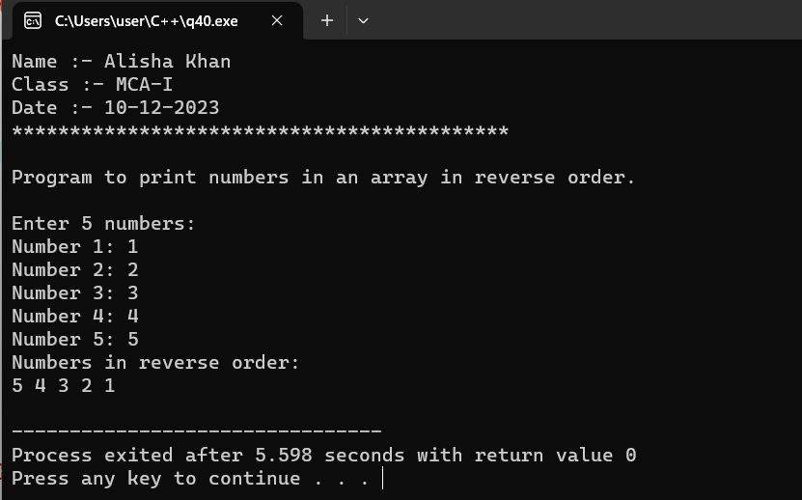
- Write a C++ program create class named “Student”, having two data member of private specifier name rollno and marks. and make marks data member as array of size 5. Student class also contains public member function named getdata( ) , showdata( ), and totalmarks( ) which will define outside of the class. getdata( ) will take input from the user only, showdata( ) will show the input data from the user, and totalmarks( ) will sum all the 5 marks of subject and display the total marks.

Code :-
#include<iostream>
using namespace std;
class student
{
private:
int rollno;
int marks[5];
public:
void getdata();
void showdata();
void totalmarks();
};
void student::getdata()
{
cout<<"Enter Roll Number = ";
cin>>rollno;
cout<<"\nEnter marks for five subjects :- "<<endl;
for(int i=1; i<=5; ++i)
{
cout<<"Subject "<<i<<" = ";
cin>>marks[i];
}
}
void student::showdata()
{
cout<<"\nStudent Details :- "<<endl;
cout<<"Roll number = "<<rollno<<"\n";
cout<<"Marks :- "<<endl;
for(int i=1; i<=5; ++i)
{
cout<<"Subject "<<i<<" = "<<marks[i]<<"\n";
}
}

void student::totalmarks()
{
int total ;
for (int i=1; i<=5; ++i)
{
total += marks[i];
}
cout<<"Total marks = " <<total<<"\n";
}
int main()
{
cout<<"Name :- Alisha Khan"<<endl;
cout<<"Class :- MCA-I"<<endl;
cout<<"Date :- 25-11-2023 "<<endl;
cout<<"*******************************************"<<endl;
cout<<"\n";
student s;
s.getdata();
s.showdata();
s.totalmarks();
return 0;
}

OUTPUT :-
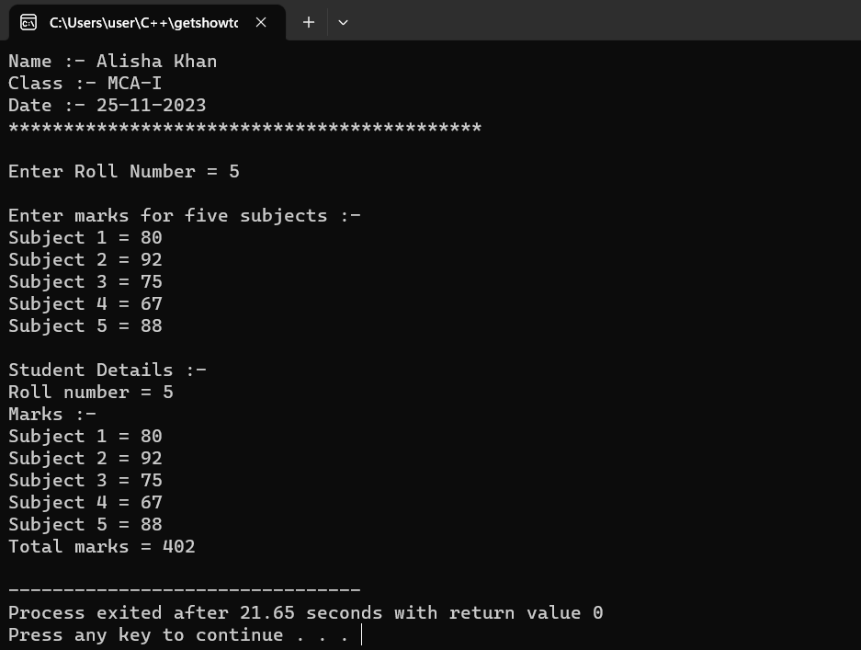

- Write a C++ program to find greatest number among three numbers implementing the nesting of member function .

Code :-
#include<iostream>
using namespace std;
class nesting
{
private:
int num1,num2,num3;
public:
void getdata();
void showdata();
};
void nesting :: getdata()
{
cout<<"Enter three numbers = \n";
cin>>num1>>num2>>num3;
}
void nesting :: showdata()
{
if(num1 >= num2)
{
if(num1 >= num3)
cout<<"Largest Number = "<<num1<<endl;
else
cout<<"Largest Number = "<<num3<<endl;
}
else
{
if(num2 >= num3)
{
cout<<"Largest Number = "<<num2;
}
else
{
cout<<"Largest Number = "<<num3;
}
}
}

int main()
{
cout<<"Name :- Alisha Khan"<<endl;
cout<<"Class :- MCA-I"<<endl;
cout<<"Date :- "<<endl;
cout<<"*******************************************"<<endl;
cout<<"\nNesting of member function :- "<<endl;
cout<<"\n";

nesting N;
N.getdata();
N.showdata();
return 0;
}

OUTPUT :-

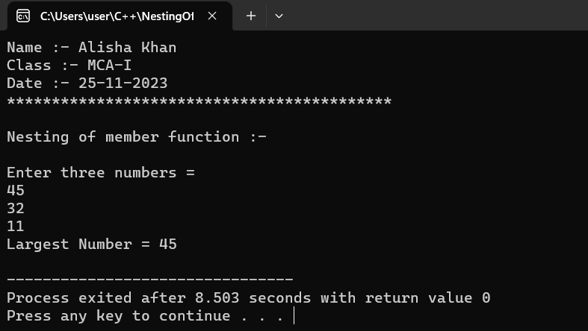

- Write a C++ program to create class named “My_class”, having two private member of integer type and perform addition, multiplication, and subtraction
operation inside the class body.

Code :-
#include<iostream>
using namespace std;
class Myclass
{
private:
int num1,num2;
public:
void getdata()
{
cout<<"Enter First Number = ";
cin>>num1;
cout<<"Enter Second Number = ";
cin>>num2;
}
void Op()
{
int sum = num1 + num2;
int sub = num1 - num2;
int product = num1 * num2;

cout<<"\nAddition of given numbers = "<<sum<<"\n";
cout<<"Subtraction of given numbers = "<<sub<<"\n";
cout<<"Multiplication of given numbers = "<<product<<"\n";
}
};
int main()
{
cout<<"Name :- Alisha Khan"<<endl;
cout<<"Class :- MCA-I"<<endl;
cout<<"Date :- 25-11-2023"<<endl;
cout<<"*******************************************"<<endl;
cout<<"\n";
Myclass result;
result.getdata();
result.Op();
return 0;
}

OUTPUT :-

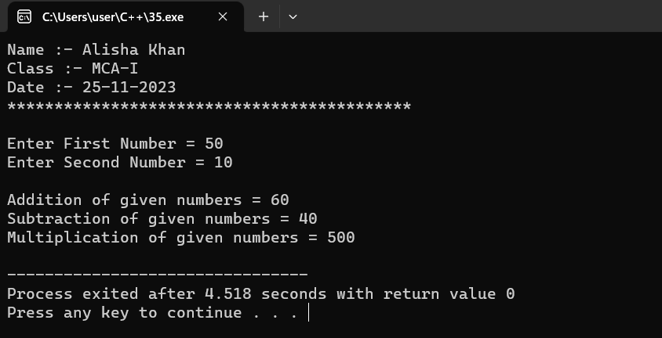

- Write a C++ program to make outside function inline.
Code :-
#include<iostream>
using namespace std;
class Myclass
{
public:
void callmyfunction();
};
inline void myfunction(); //Declaration of inline function

//Definition of the inline function outside the class
void myfunction()
{
cout<<"[This is an inline function!!]"<<endl;
}

void Myclass :: callmyfunction()
{
myfunction(); //call to the inline function
}

int main()
{
cout<<"Name :- Alisha Khan"<<endl;
cout<<"Class :- MCA-I"<<endl;
cout<<"Date :- 26-11-2023 "<<endl;
cout<<"*******************************************"<<endl;
cout<<"\nProgram to make outside function inline :- \n"<<endl;

Myclass obj;
obj.callmyfunction();

return 0;
}

OUTPUT :-

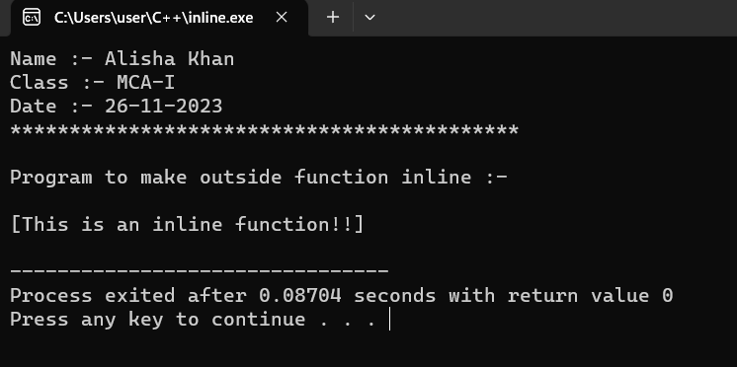

- Write a C++ program to keep count of created object using static member.
Code :-
#include<iostream>
using namespace std;
class myclass
{
private:
static int objcount;
//Static member to keep count of objects
public:
myclass()
{
objcount++;
//Increment count when an object is created
}
~myclass()
{
objcount--;
//Decrement count when an object is destroyed
}
static int getobjcount()
{
return objcount;
//Returns the current count of object
}
};
//Initialize the static member
int myclass::objcount = 0;

int main()
{
cout<<"Name :- Alisha Khan"<<endl;
cout<<"Class :- MCA-I"<<endl;
cout<<"Date :- 26-11-2023"<<endl;
cout<<"*******************************************"<<endl;
cout<<"\nProgram to count the number of objects using static member \n"<<endl;

//create objects
myclass obj1,obj2,obj3;

//display the count of objects
cout<<"Number of objects created = "<<myclass::getobjcount()<<endl;

return 0;
}

OUTPUT :-

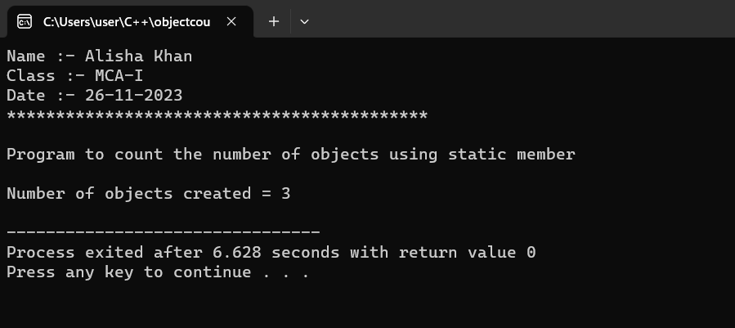

- Define a class candidate in C++ with the following description:=
Private member:-
  - A data member RNo (Registration Number) of type long.
  - A data member Name of type string.
  - A data member Score of type float.
  - A data member Remarks of type string.
  - A member function AssignRem( ) to assign Remarks as per the Score obtained by a candidate.
  - Score range and the respective Remarks are shown as follows:
Score Remarks
>=50 Selected
Less than 50 Not Selected
Public member:-
  - A member function Enter( ) to allow user to enter values for RNo, Name, Score and call function AssignRem( ) to assign the remarks.
  - A member function DISPLAY( ) to allow user to view the content of all the data members.

Code :-
#include <iostream>
#include <string>
using namespace std;

class Candidate
{
private:
long RNo;
string Name;
float Score;
string Remarks;

// Private member function to assign Remarks based on the Score
void AssignRem()
{
if (Score >= 50) {
Remarks = "Selected";
} else {
Remarks = "Not Selected";
}
}

public:
// Public member function to allow user to enter values and assign remarks
void Enter()
{
cout << "Enter Registration Number: ";
cin >> RNo;

cout << "Enter Name: ";
cin.ignore(); // Ignore newline character from previous input
getline(std::cin, Name);

cout << "Enter Score: ";
cin >> Score;

// Call AssignRem to assign Remarks based on Score
AssignRem();
}

// Public member function to display the content of all data members
void DISPLAY() const
{
cout << "\nRegistration Number: " << RNo << endl;
cout << "Name: " << Name << endl;
cout << "Score: " << Score << endl;
cout << "Remarks: " << Remarks << endl;
}
};
int main()
{
cout<<"Name :- Alisha Khan"<<endl;
cout<<"Class :- MCA-I"<<endl;
cout<<"Date :- 10-12-2023"<<endl;
cout<<"*******************************************\n"<<endl;
cout<<"Enter Student Details :-\n"<<endl;
// Create an object of the Candidate class
Candidate candidate;

// Call Enter to allow user to enter values and assign remarks
candidate.Enter();

// Call DISPLAY to display the content of all data members
candidate.DISPLAY();

return 0;
}

OUTPUT :-

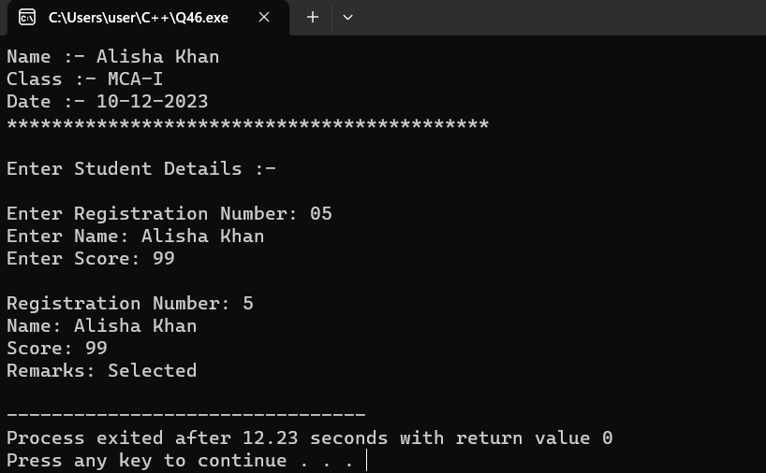

- Write a C++ program to implement single inheritance.
Code :-
#include<iostream>
using namespace std;
// Base class
class Parent
{
public:
int id_p;
};

// Sub class inheriting from Base Class(Parent)
class Child : public Parent
{
public:
int id_c;
};

// main function
int main()
{

cout<<"Name :- Alisha Khan"<<endl;
cout<<"Class :- MCA-I"<<endl;
cout<<"Date :- 10-12-2023"<<endl;
cout<<"*******************************************\n"<<endl;
cout<<"Program to implement single innheritence.\n";
Child obj1;
// An object of class child has all data members and member functions of class parent
obj1.id_c = 7;
obj1.id_p = 91;

cout << "Child id is: " << obj1.id_c << '\n';
cout << "Parent id is: " << obj1.id_p << '\n';

return 0;
}

OUTPUT :-

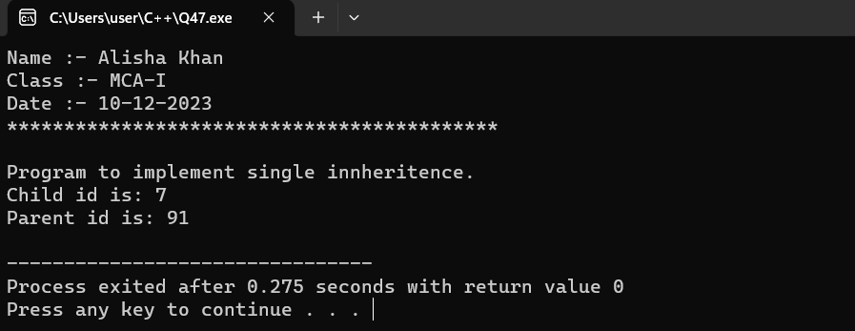

- Write a C++ program to implement multiple inheritance.
Code :-
#include <iostream>
using namespace std;

// base class1
class student_detail
{
protected:
int rno, sum = 0, i, marks[5];
public:
void detail()
{
cout << " Enter the Roll No: " << endl;
cin >> rno;
cout << " Enter the marks of five subjects " << endl;
// use for loop
for (i = 0; i < 5; i++)
{
cin >> marks[i];
}

for ( i = 0; i < 5; i++)
{
// store the sum of five subject
sum = sum + marks[i];
}
}
};
// create base class2
class sports_mark
{
protected:
int s_mark;

public:
void get_mark()
{
cout << "\n Enter the sports mark: ";
cin >> s_mark;
}
};

/* create a result as the child class to inherit functions of the parent class:*/
class result: public student_detail, public sports_mark
{
int tot, avg;
public:
// create member function of child class
void disp ()
{
tot = sum + s_mark;
avg = tot / 6; // total marks of six subject
cout << " \n \n \t Roll No: " << rno << " \n \t Total: " << tot << endl;
cout << " \n \t Average Marks: " << avg;
}
};
int main ()
{
cout<<"Name :- Alisha Khan"<<endl;
cout<<"Class :- MCA-I"<<endl;
cout<<"Date :- 10-12-2023"<<endl;
cout<<"*******************************************\n"<<endl;
cout<<"Program to implement multiple innheritence.\n";
result obj; // create an object of the derived class

// call the member function of the base class
obj.detail();
obj.get_mark();
obj.disp();
}
OUTPUT :-
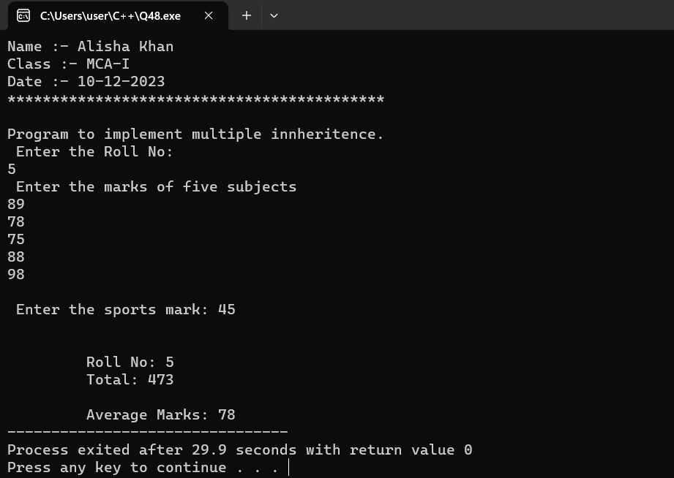

- Write a C++ program to implement multilevel inheritance.
Code :-
#include <iostream>
#include <string>
using namespace std;

// Base class
class Person {
protected:
string name;
int age;
public:
Person(const string& n, int a) : name(n), age(a) {}

void displayPerson() {
cout << "Person - Name: " << name << ", Age: " << age << endl;
}
};
// First derived class
class Student : public Person {
private:
int studentId;

public:
Student(const string& n, int a, int id) : Person(n, a), studentId(id) {}

void displayStudent() {
// Accessing members from the base class
displayPerson();

cout << "Student ID: " << studentId << endl;
}
};
// Second derived class
class GraduateStudent : public Student {
private:
string researchTopic;

public:
GraduateStudent(const string& n, int a, int id, const string& topic)
: Student(n, a, id), researchTopic(topic) {}

void displayGraduateStudent()
{
// Accessing members from the base and immediate parent classes
displayStudent();

cout << "Research Topic: " << researchTopic << endl;
}
};
int main()
{
cout<<"Name :- Alisha Khan"<<endl;
cout<<"Class :- MCA-I"<<endl;
cout<<"Date :- 10-12-2023"<<endl;
cout<<"*******************************************\n"<<endl;
cout<<"Program to implement multi level innheritence.\n";

// Creating an object of the most derived class
GraduateStudent gradStudent("Alisha Khan", 22, 786, "Programming in C++");

// Calling member functions of the base and derived classes
cout << "\n Displaying information using multilevel inheritance:\n";
gradStudent.displayGraduateStudent();
return 0;
}
OUTPUT :-

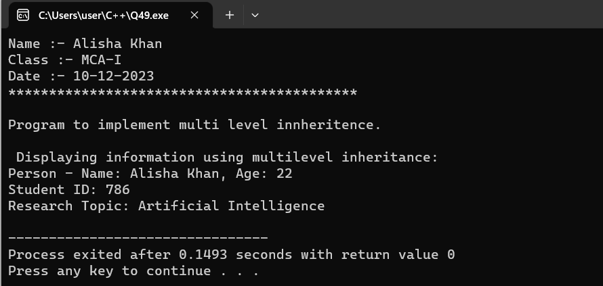

- Write a C++ program to initialize three integer values through constructor using parameter.
Code :-
#include <iostream>
using namespace std;

// Class with a constructor that initializes three integers
class ThreeIntegers {
private:
int first;
int second;
int third;

public:
// Constructor with parameters
ThreeIntegers(int a, int b, int c) : first(a), second(b), third(c) {}

// Function to display the values
void displayValues() {
cout << "\nFirst: " << first << ", Second: " << second << ", Third: " << third << endl;
}
};
int main()
{
cout<<"Name :- Alisha Khan"<<endl;
cout<<"Class :- MCA-I"<<endl;
cout<<"Date :- 14-12-2023"<<endl;
cout<<"*******************************************\n"<<endl;
cout<<"\nProgram to initialize three integer values through constructor using parameter.\n";
// Creating an object of the class and initializing values through the constructor
ThreeIntegers myNumbers(10, 20, 30);

// Displaying the initialized values
myNumbers.displayValues();

return 0;
}

OUTPUT :-

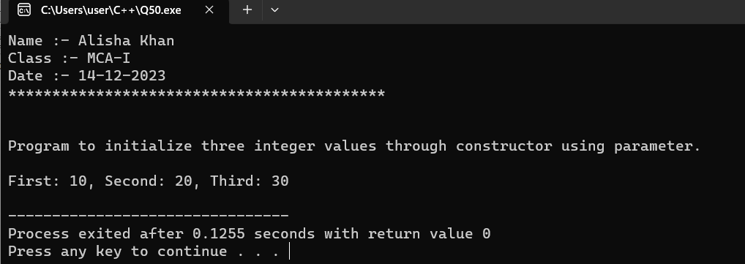

- Write a C++ program to illustrate order of invocation for these, Define two class first class named
“Sub” and second named “Mark” in C++ with the following description:=
Class “Sub” contains -
Private member:-
• A data member ppr1_code of type int.
• A data member ppr2_code of type int.
Public member:-
• A default constructor which initializes and display the private member of its class.
Class “Mark” contains –
Private member:-
• A data member ppr1_mark of type float.
• A data member ppr2_mark of type float.
Public member:-
• A Parameterized constructor which initializes and display the private member of its class.
create an object of Sub class inside these class.
Code:-
#include <iostream>
using namespace std;

// Forward declaration of the class Sub
class Sub;
// Class Mark
class Mark {
private:
float ppr1_mark;
float ppr2_mark;

public:
// Parameterized constructor
Mark(float mark1, float mark2) : ppr1_mark(mark1), ppr2_mark(mark2) {
cout << "Mark class parameterized constructor invoked." << endl;
display();
}
// Function to display private members
void display() {
cout << "Mark class - Paper 1 Mark: " << ppr1_mark << ", Paper 2 Mark: " << ppr2_mark << endl;
}
};

// Class Sub
class Sub {
private:
int ppr1_code;
int ppr2_code;
Mark marks; // Object of Mark class

public:
// Default constructor
Sub() : ppr1_code(101), ppr2_code(102), marks(80.5, 90.5) {
cout << "\nSub class default constructor invoked." << endl;
display();
}

// Function to display private members
void display() {
cout << "Sub class - Paper 1 Code: " << ppr1_code << ", Paper 2 Code: " << ppr2_code << endl;
}
};
int main()
{
cout<<"Name :- Alisha Khan"<<endl;
cout<<"Class :- MCA-I"<<endl;
cout<<"Date :- 14-12-2023"<<endl;
cout<<"*******************************************\n"<<endl;
cout<<"\n "<<endl;
// Creating an object of Sub class
Sub mySub;
return 0;
}
OUTPUT :-
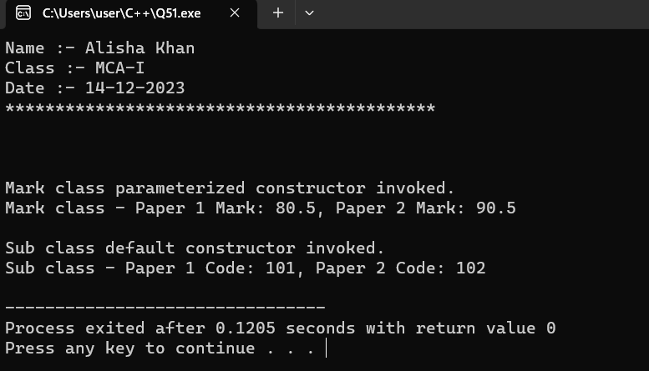
- Write a C++ program to invoke a constructor having default argument.
Code :-
#include <iostream>
#include <string>
using namespace std;

class Book {
private:
string title;
string author;
int publicationYear;
public:
// Constructor with default arguments
Book(const string& bookTitle = "No Title", const string& bookAuthor = "Unknown Author", int year = 2022)
: title(bookTitle), author(bookAuthor), publicationYear(year) {
cout << "Book constructor invoked with Title: " << title << ", Author: " << author
<< ", Year: " << publicationYear << endl;
}

// Function to display book information
void displayInfo() {
cout << "Title: " << title << ", Author: " << author << ", Year: " << publicationYear << endl;
}
};
int main()
{
cout<<"Name :- Alisha Khan"<<endl;
cout<<"Class :- MCA-I"<<endl;
cout<<"Date :- 14-12-2023"<<endl;
cout<<"*******************************************\n"<<endl;
cout<<"\nProgram to invoke a constructor using degault argument.\n "<<endl;
// Creating objects with and without arguments
Book defaultBook; // Will use default values
Book customBook("The Catcher in the Rye", "J.D. Salinger", 1951); // Will use custom values

// Displaying book information
cout << "\nDefault Book Information:" << endl;
defaultBook.displayInfo();

cout << "\nCustom Book Information:" << endl;
customBook.displayInfo();
return 0;
}

OUTPUT :-

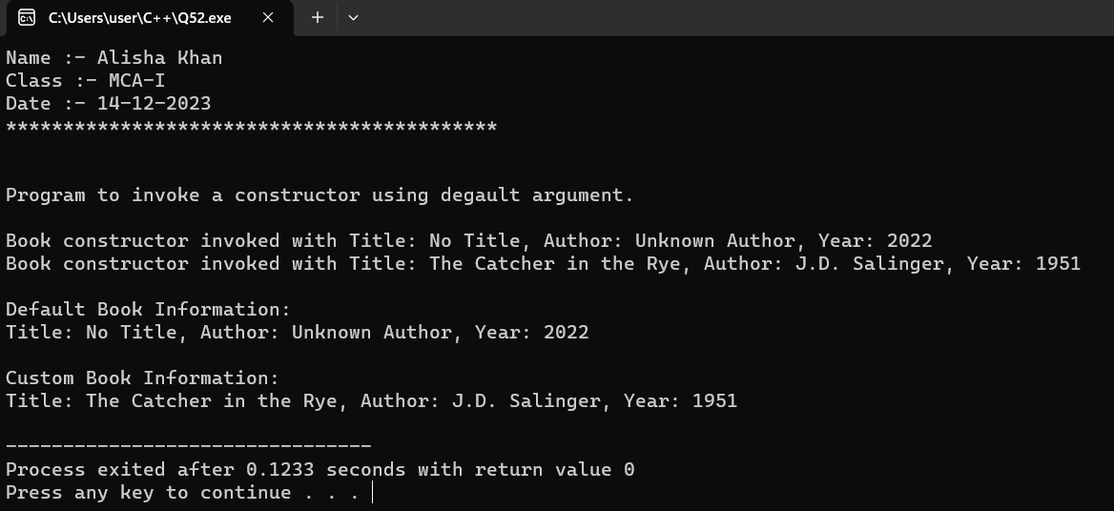

- Write a C++ program to copy one object variable to another object using copy constructor.
Code :-
#include <iostream>
#include <string>
using namespace std;
class Student
{
private:
string name;
int age;
public:
// Parameterized constructor
Student(const string& studentName, int studentAge) : name(studentName), age(studentAge) {
cout << "\nParameterized constructor invoked for " << name << endl;
}

// Copy constructor
Student(const Student& otherStudent) : name(otherStudent.name), age(otherStudent.age) {
cout << "\nCopy constructor invoked for " << name << endl;
}

// Function to display student information
void displayInfo() {
cout << "Name: " << name << ", Age: " << age << endl;
}
};

int main()
{
cout<<"Name :- Alisha Khan"<<endl;
cout<<"Class :- MCA-I"<<endl;
cout<<"Date :- 14-12-2023"<<endl;
cout<<"*******************************************\n"<<endl;
cout<<"\nProgram to copy one object variable to another object using copy constructor.\n "<<endl;
// Creating an object using parameterized constructor
Student originalStudent("Alisha", 22);

// Copying the object using copy constructor
Student copiedStudent = originalStudent;

// Displaying information for both objects
cout << "Original Student Information:" << endl;
originalStudent.displayInfo();

cout << "\nCopied Student Information:" << endl;
copiedStudent.displayInfo();

return 0;
}

OUTPUT :-

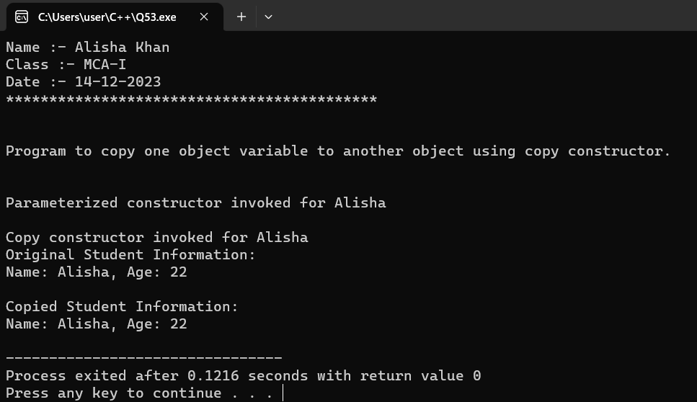

- Write a C++ program to perform constructor overloading having three constructor within a class.
Code :-
#include <iostream>
#include <string>
using namespace std;
class Employee
{
private:
string name;
int employeeId;
double salary;
public:
// Default constructor
Employee() : name("Alisha Khan"), employeeId(101), salary(80000) {
cout << "Default constructor invoked." << endl;
}

// Parameterized constructor with two parameters
Employee(const std::string& empName, int empId) : name(empName), employeeId(empId), salary(0.0) {
cout << "Parameterized constructor with two parameters invoked." << endl;
}

// Parameterized constructor with three parameters
Employee(const string& empName, int empId, double empSalary) : name(empName), employeeId(empId), salary(empSalary) {
cout << "Parameterized constructor with three parameters invoked." << endl;
}

// Function to display employee information
void displayInfo() {
cout << "Name: " << name << ", Employee ID: " << employeeId << ", Salary: $" << salary << endl;
}
};

int main()
{
cout<<"Name :- Alisha Khan"<<endl;
cout<<"Class :- MCA-I"<<endl;
cout<<"Date :- 14-12-2023"<<endl;
cout<<"*******************************************"<<endl;
cout<<"\nProgram to perform constructor overloading having three constructor within a class. \n "<<endl;

// Creating objects using different constructors
Employee emp1; // Default constructor
Employee emp2("Juhi Chauhan", 102); // Parameterized constructor with two parameters
Employee emp3("Keshar Marapi", 103, 50000.0); // Parameterized constructor with three parameters

// Displaying employee information
cout << "\nEmployee 1 Information:" << endl;
emp1.displayInfo();

cout << "\nEmployee 2 Information:" << endl;
emp2.displayInfo();

cout << "\nEmployee 3 Information:" << endl;
emp3.displayInfo();

return 0;
}

OUTPUT :-

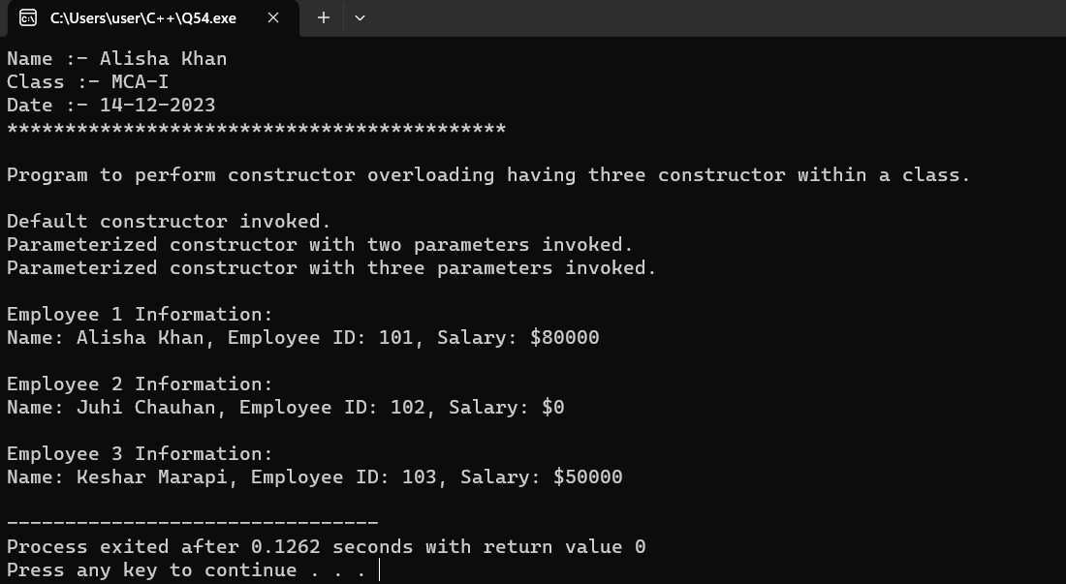

- Write a C++ program to allocate and deallocate memory at run time for a variable.
Code :-
#include <iostream>
using namespace std;
int main()
{
cout<<"Name :- Alisha Khan"<<endl;
cout<<"Class :- MCA-I"<<endl;
cout<<"Date :- 14-12-2023"<<endl;
cout<<"*******************************************"<<endl;
cout<<"\nProgram to allocate and deallocate memory at run time for a variable. \n "<<endl;
// Allocate memory for an integer variable
int* dynamicInt = new int;

// Check if memory allocation is successful
if (dynamicInt != nullptr) {
// Assign a value to the dynamically allocated variable
*dynamicInt = 42;

// Display the value
cout << "Dynamically allocated integer value: " << *dynamicInt << endl;

// Deallocate the memory
delete dynamicInt;
}
else {
cout << "Memory allocation failed." << endl;
}
return 0;
}
OUTPUT :-
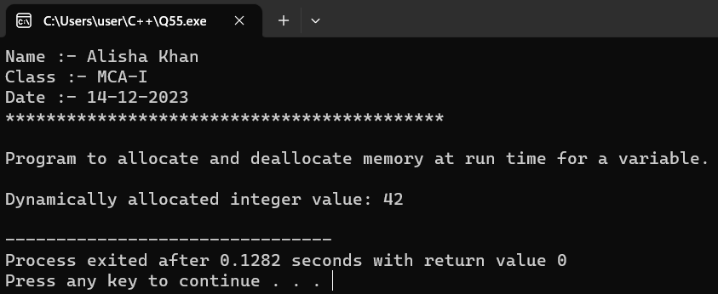

- Write a C++ program to demonstrate run time polymorphism(function overriding).
Code :-
#include <iostream>
using namespace std;
// Base class with a virtual function
class Shape {
public:
// Virtual function for area calculation
virtual void calculateArea() const {
cout << "Area calculation in base class." << endl;
}
};
// Derived class overriding the virtual function
class Circle : public Shape {
private:
double radius;
public:
Circle(double r) : radius(r) {}

// Overriding the virtual function for area calculation
void calculateArea() const override {
double area = 3.14159 * radius * radius;
cout << "Area of Circle: " << area << endl;
}
};

// Another derived class overriding the virtual function
class Rectangle : public Shape {
private:
double length;
double width;

public:
Rectangle(double l, double w) : length(l), width(w) {}

// Overriding the virtual function for area calculation
void calculateArea() const override {
double area = length * width;
cout << "Area of Rectangle: " << area << endl;
}
};

// Function that demonstrates polymorphic behavior
void displayArea(const Shape& shape)
{
shape.calculateArea();
}
int main()
{
cout<<"Name :- Alisha Khan"<<endl;
cout<<"Class :- MCA-I"<<endl;
cout<<"Date :- 14-12-2023"<<endl;
cout<<"*******************************************"<<endl;
cout<<"\nProgram to demonstrate run time polymorphism(function overriding). \n "<<endl;

// Creating objects of the derived classes
Circle circle(5.0);
Rectangle rectangle(4.0, 6.0);

// Using polymorphism to display areas
cout << "\n Using polymorphism to display areas:\n";
displayArea(circle);
displayArea(rectangle);

return 0;
}
OUTPUT :-

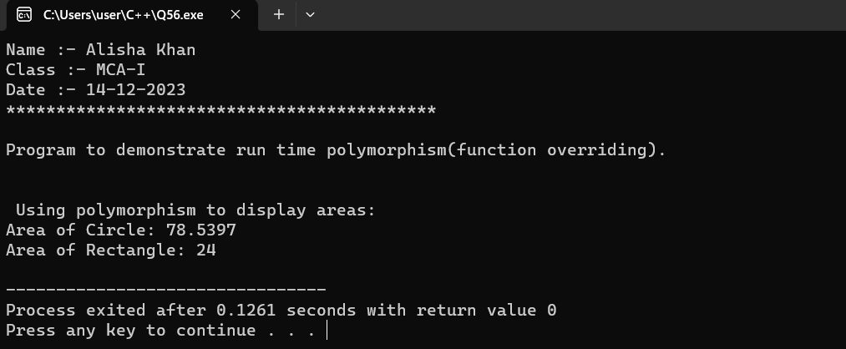

- Write a C++ program to create a class named “Student” having two private member name type. string and age type int. and in public section class contain one member function named “Stu_info” which initializes the data members of its class at run time and one another member function named “Show_info” which display the detail of a student (name,age). And invoke them using pointer to object.
Code :-
#include <iostream>
#include <string>
using namespace std;

// Class definition for Student
class Student {
private:
string name;
int age;
public:
// Member function to initialize data members at runtime
void Stu_info(const string& n, int a) {
name = n;
age = a;
}

// Member function to display student details
void Show_info() const {
cout << "\nStudent Information:\n";
cout << "Name: " << name << "\nAge: " << age << endl;
}
};

int main()
{
cout<<"Name :- Alisha Khan"<<endl;
cout<<"Class :- MCA-I"<<endl;
cout<<"Date :- 14-12-2023"<<endl;
cout<<"*******************************************"<<endl;

// Creating an object of the Student class using dynamic memory allocation
Student* studentPtr = new Student;

// Invoking the member function to initialize data members
studentPtr->Stu_info("Alisha", 22);

// Invoking the member function to display student details
studentPtr->Show_info();

// Deallocating the dynamically allocated memory
delete studentPtr;

return 0;
}

OUTPUT :-

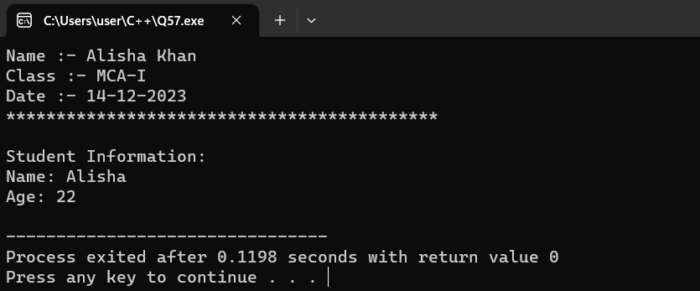

- Write a C++ program to illustrate functioning of this pointer.
Code :-
#include <iostream>
using namespace std;
class MyClass {
private:
int data;

public:
void setData(int value) {
// Using this pointer to distinguish between member variable and function parameter
this->data = value;
}

// Getter function using this pointer
int getData() const {
return this->data;
}
// Function to display the address of the current object using this pointer
void displayAddress() const {
cout << "Address of the current object: " << this << endl;
}
};
int main()
{
cout<<"Name :- Alisha Khan"<<endl;
cout<<"Class :- MCA-I"<<endl;
cout<<"Date :- 14-12-2023"<<endl;
cout<<"*******************************************"<<endl;
cout<<"\nProgram to illustrate functioning of this pointer.\n";
// Creating an object of MyClass
MyClass myObject;

// Setting data using the setData function
myObject.setData(42);

// Displaying data using the getData function
cout << "Data: " << myObject.getData() << endl;

// Displaying the address of the current object using the displayAddress function
myObject.displayAddress();

return 0;
}

OUTPUT :-

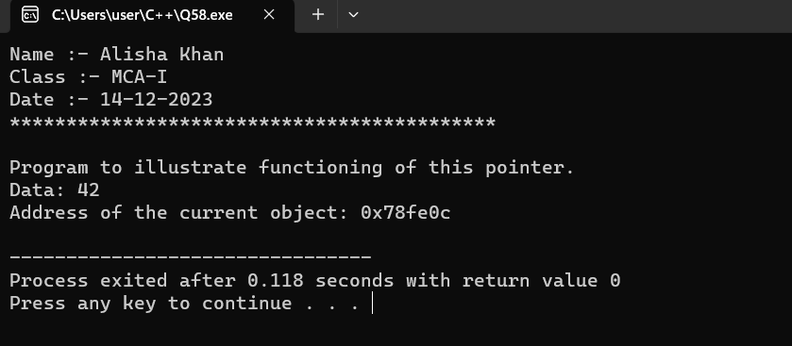

- Write a C++ program to create two classes (named First_class and Second_class), and perform multiplication of two number (where first number is public data member of First_class and second number is public data member of Second_class) using friend function.
Code :-
#include <iostream>
using namespace std;

// Forward declaration of Second_class to let First_class know about it
class Second_class;

// Class definition for First_class
class First_class {
private:
int first_number;

public:
// Constructor to initialize first_number
First_class(int num) : first_number(num) {}

// Friend function declaration
friend int multiply(const First_class&, const Second_class&);
};

// Class definition for Second_class
class Second_class {
private:
int second_number;

public:
// Constructor to initialize second_number
Second_class(int num) : second_number(num) {}

// Friend function declaration
friend int multiply(const First_class&, const Second_class&);
};

// Friend function definition to perform multiplication
int multiply(const First_class& firstObj, const Second_class& secondObj) {
return firstObj.first_number * secondObj.second_number;
}

int main()
{
cout<<"Name :- Alisha Khan"<<endl;
cout<<"Class :- MCA-I"<<endl;
cout<<"Date :- 14-12-2023"<<endl;
cout<<"*******************************************"<<endl;

// Creating objects of First_class and Second_class
First_class firstObj(5);
Second_class secondObj(10);

// Performing multiplication using the friend function
int result = multiply(firstObj, secondObj);

// Displaying the result
cout << "\nMultiplication Result: " << result << endl;

return 0;
}
OUTPUT :-

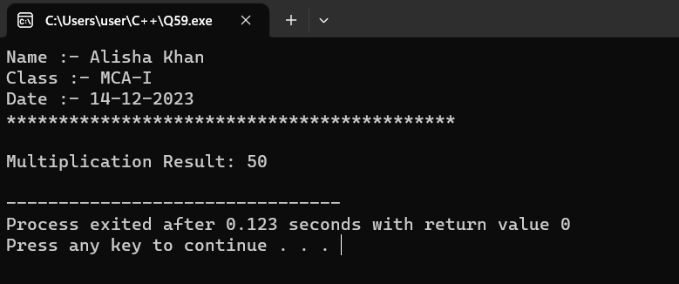

- Write a C++ program to the working of virtual function.
Code :-
#include <iostream>
#include <cmath>
using namespace std;
// Base class
class Shape {
public:
// Virtual function for calculating area
virtual double calculateArea() const {
return 0.0;
}
};
// Derived class 1
class Circle : public Shape {
private:
double radius;
public:
// Constructor
Circle(double r) : radius(r) {}

// Overriding the virtual function to calculate area for a circle
double calculateArea() const override {
return 3.14 * pow(radius, 2);
}
};

// Derived class 2
class Square : public Shape {
private:
double side;
public:
// Constructor
Square(double s) : side(s) {}

// Overriding the virtual function to calculate area for a square
double calculateArea() const override {
return pow(side, 2);
}
};

int main()
{
cout<<"Name :- Alisha Khan"<<endl;
cout<<"Class :- MCA-I"<<endl;
cout<<"Date :- 14-12-2023"<<endl;
cout<<"*******************************************\n"<<endl;
cout<<"\nProgram to show the working of virtual function.\n"<<endl;
// Creating objects of derived classes
Circle myCircle(5.0);
Square mySquare(4.0);

// Calculating and displaying the area of different shapes
cout << "Area of the circle: " << myCircle.calculateArea() << endl;
cout << "Area of the square: " << mySquare.calculateArea() << endl;

// Using polymorphism through a function to calculate and display areas
const Shape* shapePtr1 = &myCircle;
const Shape* shapePtr2 = &mySquare;

cout << "\nUsing polymorphism to calculate and display areas:" << std::endl;
cout << "Area of the circle: " << shapePtr1->calculateArea() << std::endl;
cout << "Area of the square: " << shapePtr2->calculateArea() << std::endl;

return 0;
}
OUTPUT :-
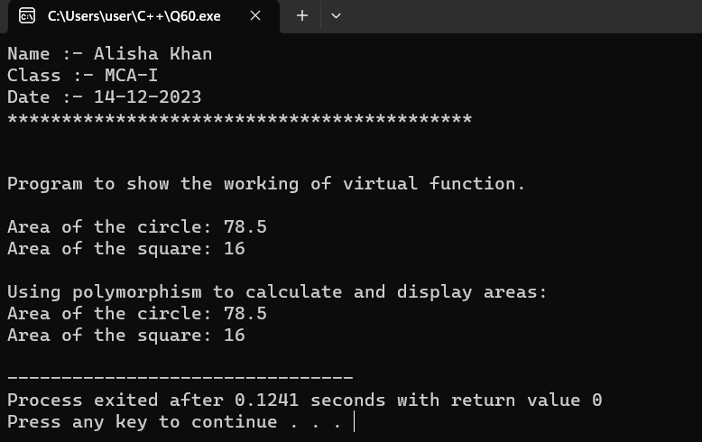

- Write a C++ program to show the working of pure virtual function.
Code :-
#include <iostream>
using namespace std;
// Abstract base class with a pure virtual function
class Shape {
public:
// Pure virtual function to calculate area (making the class abstract)
virtual double calculateArea() const = 0;

// Virtual destructor (important when dealing with polymorphism and pointers)
virtual ~Shape() {}
};

// Derived class 1
class Circle : public Shape {
private:
double radius;

public:
// Constructor
Circle(double r) : radius(r) {}

// Implementation of the pure virtual function to calculate area for a circle
double calculateArea() const override {
return 3.14 * radius * radius;
}
};

// Derived class 2
class Square : public Shape {
private:
double side;

public:
// Constructor
Square(double s) : side(s) {}

// Implementation of the pure virtual function to calculate area for a square
double calculateArea() const override {
return side * side;
}
};

int main()
{
cout<<"Name :- Alisha Khan"<<endl;
cout<<"Class :- MCA-I"<<endl;
cout<<"Date :- 15-12-2023"<<endl;
cout<<"*******************************************"<<endl;
cout<<"\nProgram to show the working of pure virtual function."<<endl;
// Creating objects of derived classes
Circle myCircle(5.0);
Square mySquare(4.0);

// Using polymorphism through pointers to the base class to calculate areas
const Shape* shapePtr1 = &myCircle;
const Shape* shapePtr2 = &mySquare;

// Displaying areas
cout << "Area of the circle: " << shapePtr1->calculateArea() << endl;
cout << "Area of the square: " << shapePtr2->calculateArea() << endl;

return 0;
}
OUTPUT :-

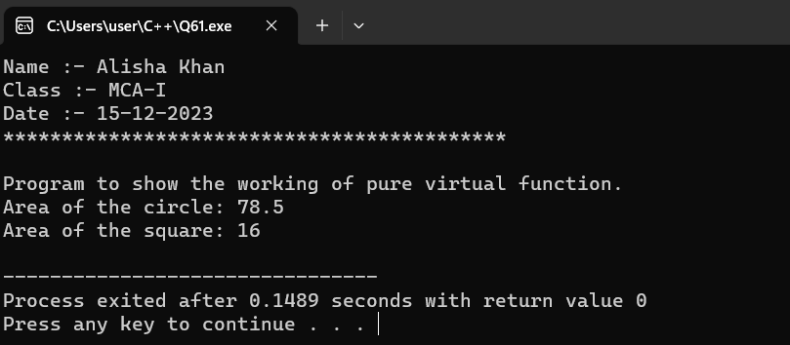

- Write a C++ program to find large number between two number using friend class.
Code :-
#include <iostream>
using namespace std;

class CompareNumbers {
private:
int num1;
int num2;
public:
CompareNumbers(int a, int b) : num1(a), num2(b) {}
friend void findLarger(const CompareNumbers& obj);
};

void findLarger(const CompareNumbers& obj) {
if (obj.num1 > obj.num2) {
cout << obj.num1 << " is larger." << endl;
} else if (obj.num1 < obj.num2) {
cout << obj.num2 << " is larger." << endl;
} else {
cout << "Both numbers are equal." << endl;
}
}
int main()
{
cout<<"Name :- Alisha Khan"<<endl;
cout<<"Class :- MCA-I"<<endl;
cout<<"Date :- 15-12-2023"<<endl;
cout<<"*******************************************"<<endl;
cout<<"\nProgram to find large number between two number using friend class. \n"<<endl;
int num1, num2;

cout << "Enter the first number: ";
cin >> num1;

cout << "Enter the second number: ";
cin >> num2;

// Create an object of CompareNumbers
CompareNumbers numbers(num1, num2);

// Call the friend function to find the larger number
findLarger(numbers);
return 0;
}

OUTPUT :-

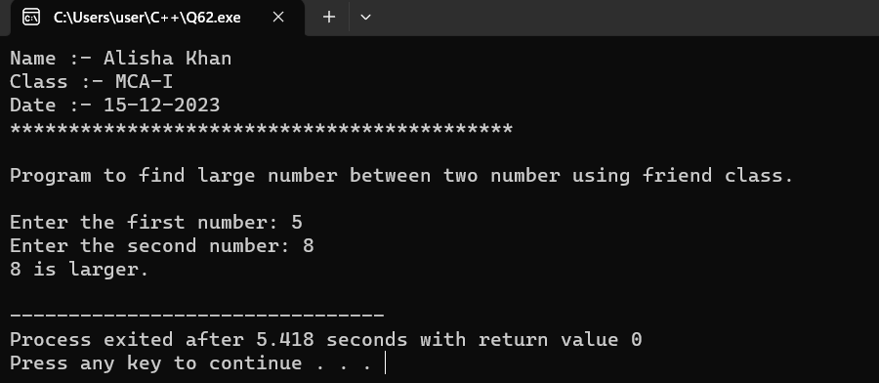

- Write a C++ program for operator overloading to compare two objects are equal or not using = =operator.
Code :-
#include <iostream>
using namespace std;

class EqualityCheck {
private:
int value;
public:
EqualityCheck(int val) : value(val) {}

// Overloading the == operator
bool operator==(const EqualityCheck& other) const {
return this->value == other.value;
}
};

int main()
{
cout<<"Name :- Alisha Khan"<<endl;
cout<<"Class :- MCA-I"<<endl;
cout<<"Date :- 15-12-2023"<<endl;
cout<<"*******************************************"<<endl;
cout<<"\nProgram for operator overloading. \n"<<endl;
// Creating objects
EqualityCheck obj1(5);
EqualityCheck obj2(5);
EqualityCheck obj3(10);

// Comparing objects using ==
if (obj1 == obj2) {
cout << "obj1 and obj2 are equal." << endl;
} else {
cout << "obj1 and obj2 are not equal." << endl;
}

if (obj1 == obj3) {
cout << "obj1 and obj3 are equal." << endl;
} else {
cout << "obj1 and obj3 are not equal." << endl;
}
return 0;
}

OUTPUT :-

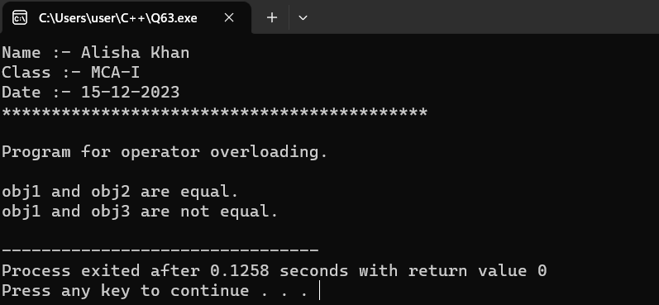

- Write a C++ program to illustrate unary operator overloading on increment operator by using member function.

Code :-
#include <iostream>
using namespace std;

// Class definition for Counter
class Counter {
private:
int count;

public:
// Constructor to initialize count
Counter(int initialCount = 0) : count(initialCount) {}

// Member function to overload the unary increment operator (++)
Counter operator++() {
// Incrementing the count
count++;
// Returning the modified object
return *this;
}

// Member function to display the count
void display() const {
cout << "Count: " << count << endl;
}
};

int main()
{
cout<<"Name :- Alisha Khan"<<endl;
cout<<"Class :- MCA-I"<<endl;
cout<<"Date :- 15-12-2023"<<endl;
cout<<"*******************************************\n"<<endl;

// Creating an object of Counter
Counter counterObj(5);

// Displaying the initial count
cout << "Initial ";
counterObj.display();

// Overloading the unary increment operator (++), and displaying the updated count
cout << "After Increment ";
(++counterObj).display();

return 0;
}

OUTPUT :-

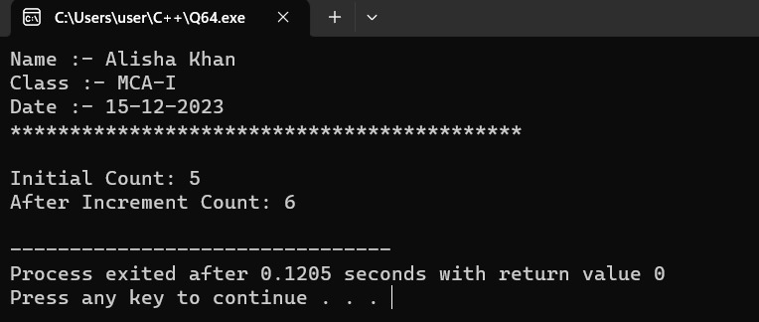

- Write a C++ program to add two complex number using + operator overloading by friend function.

Code :-
#include <iostream>

using namespace std;

// Class definition for ComplexNumber
class ComplexNumber {
private:
double real;
double imag;

public:
// Constructor to initialize real and imaginary parts
ComplexNumber(double r, double i) : real(r), imag(i) {}

// Friend function declaration for operator overloading
friend ComplexNumber operator+(const ComplexNumber& c1, const ComplexNumber& c2);

// Member function to display the complex number
void display() const {
cout << "Complex Number: " << real << " + " << imag << "i" << endl;
}
};

// Friend function definition for operator overloading
ComplexNumber operator+(const ComplexNumber& c1, const ComplexNumber& c2) {
// Adding the real and imaginary parts separately
ComplexNumber result(c1.real + c2.real, c1.imag + c2.imag);
return result;
}

int main()
{
cout<<"Name :- Alisha Khan"<<endl;
cout<<"Class :- MCA-I"<<endl;
cout<<"Date :- 15-12-2023"<<endl;
cout<<"*******************************************\n"<<endl;
cout<<"\nProgram to add two complex number using + operator overloading by friend function \n";

// Creating two objects of ComplexNumber
ComplexNumber complex1(3.0, 4.0);
ComplexNumber complex2(1.5, 2.5);

// Displaying the original complex numbers
cout << "\n Original Complex Numbers:\n";
complex1.display();
complex2.display();

// Adding two complex numbers using operator overloading
ComplexNumber sum = complex1 + complex2;

// Displaying the result
cout << "\nSum of Complex Numbers:\n";
sum.display();

return 0;
}

OUTPUT :-

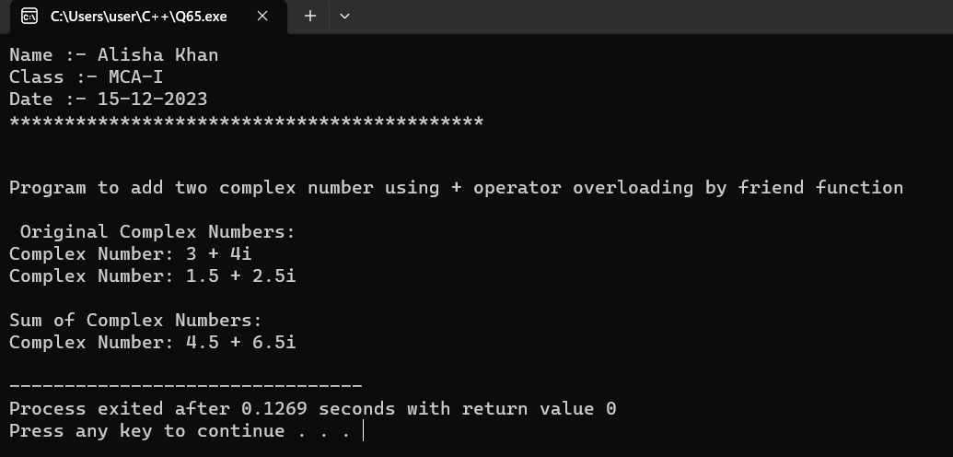

- Write a C++ program to illustrate unary minus operator overloading using friend function.
Code :-
#include <iostream>
using namespace std;
class Number {
private:
int value;
public:
Number(int val) : value(val) {}

// Declare the friend function for unary minus operator overloading
friend Number operator-(const Number& num);

// Display the value
void display() const {
cout << "Value: " << value << endl;
}
};
// Define the friend function for unary minus operator overloading
Number operator-(const Number& num) {
Number result(-num.value);
return result;
}

int main()
{
cout<<"Name :- Alisha Khan"<<endl;
cout<<"Class :- MCA-I"<<endl;
cout<<"Date :- 15-12-2023"<<endl;
cout<<"*******************************************"<<endl;
cout<<"\nProgram to illustrate unary minus operator overloading using friend function. \n";
Number num(7);

cout << "\nOriginal Number: ";
num.display();

// Using the overloaded unary minus operator
Number negNum = -num;

cout << "After Unary Minus: ";
negNum.display();

return 0;
}

OUTPUT :-

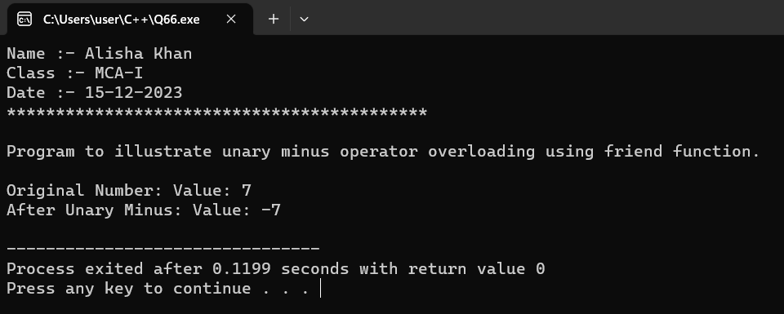

- WAP to demonstrate the use of >> and getline( ) for reading the string.
Code :-
#include <iostream>
#include <string>
using namespace std;
int main()
{
cout<<"Name :- Alisha Khan"<<endl;
cout<<"Class :- MCA-I"<<endl;
cout<<"Date :- 15-12-2023"<<endl;
cout<<"*******************************************"<<endl;
string firstName, lastName;

// Using >> to read a single word
cout << "Enter your first name: ";
cin >> firstName;

// Using getline() to read a line (including spaces)
cout << "Enter your last name: ";
cin.ignore(); // Ignore the newline character left by previous input
getline(cin, lastName);

// Displaying the entered names
cout << "First Name: " << firstName << endl;
cout << "Last Name: " << lastName << endl;

return 0;
}
OUTPUT :-
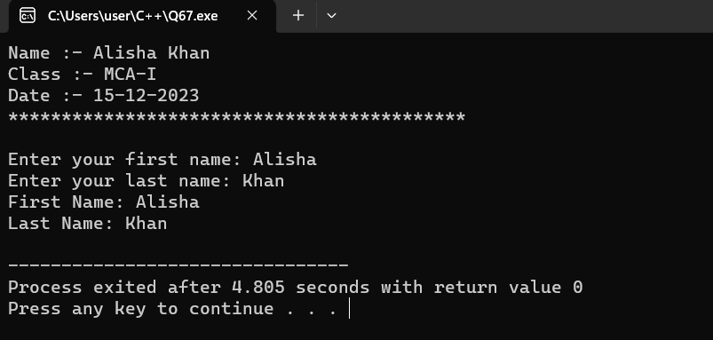

- WAP to create a file named “Rudra” using constructor.
Code :-
#include <iostream>
#include <fstream>
using namespace std;
int main()
{
cout<<"Name :- Alisha Khan"<<endl;
cout<<"Class :- MCA-I"<<endl;
cout<<"Date :- 15-12-2023"<<endl;
cout<<"*******************************************"<<endl;
cout<<"\nProgram to create a file named Rudra using constructor. \n";

// Creating an instance of ofstream (output file stream) with the file name "Rudra"
ofstream outFile("Rudra.txt");

// Checking if the file is successfully opened
if (outFile.is_open()) {
cout << "\n File 'Rudra.txt' created successfully." << endl;

// You can perform additional operations on the file if needed
// Closing the file
outFile.close();
} else {
cerr << "Error: Unable to create the file 'Rudra.txt'." << endl;
}
return 0;
}
OUTPUT :-
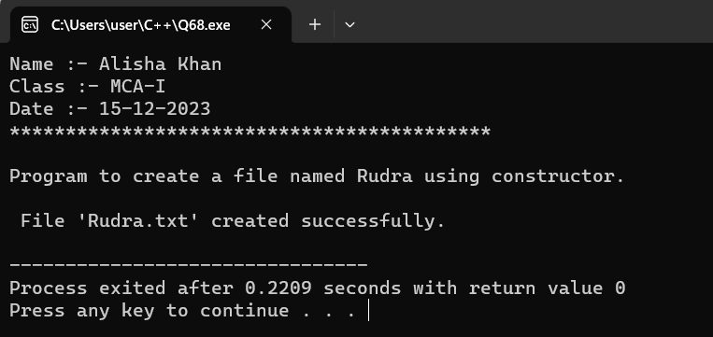

- WAP to create a file name “Info” using open function having details about your name,age,class and address.and display them into the console using eof( ).

Code :-
#include <iostream>
#include <fstream>

using namespace std;

int main()
{
cout<<"Name :- Alisha Khan"<<endl;
cout<<"Class :- MCA-I"<<endl;
cout<<"Date :- 15-12-2023"<<endl;
cout<<"*******************************************"<<endl;
// Creating an instance of ofstream (output file stream) with the file name "Info.txt"
ofstream outFile("Info.txt");

// Checking if the file is successfully opened for writing
if (outFile.is_open()) {
// Writing details to the file
outFile << "Name: Alisha Khan\n";
outFile << "Age: 22\n";
outFile << "Class: MCA\n";
outFile << "Address: Amanaka, Raipur\n";

// Closing the file
outFile.close();
cout << "\nFile 'Info.txt' created and details written successfully." << endl;

// Reopening the file for reading
ifstream inFile("Info.txt");

// Checking if the file is successfully opened for reading
if (inFile.is_open()) {
// Reading and displaying details from the file using eof()
cout << "\nReading details from 'Info.txt':\n";
while (!inFile.eof()) {
string line;
getline(inFile, line);
cout << line << endl;
}

// Closing the file
inFile.close();
} else {
cerr << "Error: Unable to open the file 'Info.txt' for reading." << endl;
}
} else {
cerr << "Error: Unable to create the file 'Info.txt'." << endl;
}

return 0;
}
OUTPUT :-

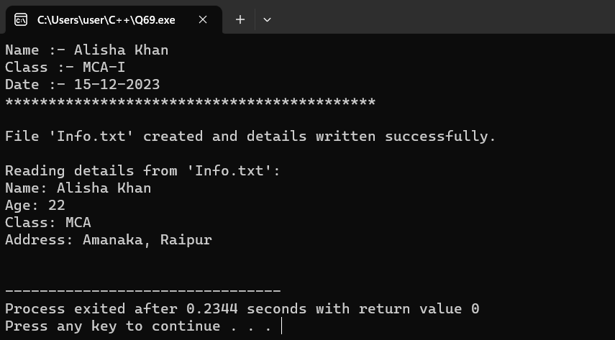

70.WAP to perform truncate operation in a file existing file named “File”.
Code :-
#include <iostream>
#include <fstream>
using namespace std;

int main()
{
cout<<"Name :- Alisha Khan"<<endl;
cout<<"Class :- MCA-I"<<endl;
cout<<"Date :- 15-12-2023"<<endl;
cout<<"*******************************************"<<endl;

// Opening the file in truncation mode
ofstream outFile("File.txt", ios::trunc);

// Checking if the file is successfully opened for writing
if (outFile.is_open()) {
// Writing new content to the file after truncation
outFile << "This is a truncated file.";

// Closing the file
outFile.close();
cout << "File 'File.txt' truncated successfully." << endl;

// Reopening the file for reading
ifstream inFile("File.txt");

// Checking if the file is successfully opened for reading
if (inFile.is_open()) {
// Reading and displaying the new content from the file
cout << "\nReading content from 'File.txt':\n";
string content;
getline(inFile, content);
cout << content << endl;

// Closing the file
inFile.close();
} else {
cerr << "Error: Unable to open the file 'File.txt' for reading." << endl;
}
} else {
cerr << "Error: Unable to open the file 'File.txt' for truncation." << endl;
}

return 0;
}

OUTPUT :-

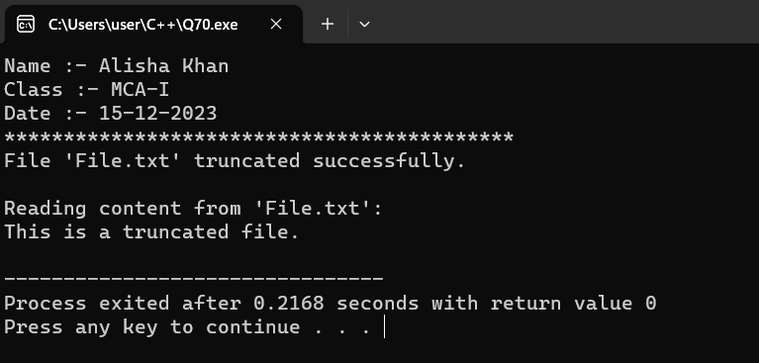

71.WAP to open a existing file name “Shiva” in append mode to add some content in a file.
Code :-
#include <iostream>
#include <fstream>

using namespace std;

int main()
{
cout<<"Name :- Alisha Khan"<<endl;
cout<<"Class :- MCA-I"<<endl;
cout<<"Date :- 15-12-2023"<<endl;
cout<<"*******************************************"<<endl;

// Opening the existing file in append mode
ofstream outFile("Shiva.txt", ios::app);

// Checking if the file is successfully opened for writing
if (outFile.is_open()) {
// Adding new content to the file
outFile << "This is new content added in append mode.\n";

// Closing the file
outFile.close();
cout << "\n Content added to 'Shiva.txt' in append mode successfully." << endl;

// Reopening the file for reading
ifstream inFile("Shiva.txt");

// Checking if the file is successfully opened for reading
if (inFile.is_open()) {
// Reading and displaying the content from the file
cout << "\nReading content from 'Shiva.txt':\n";
string content;
while (getline(inFile, content)) {
cout << content << endl;
}

// Closing the file
inFile.close();
} else {
cerr << "Error: Unable to open the file 'Shiva.txt' for reading." << endl;
}
} else {
cerr << "Error: Unable to open the file 'Shiva.txt' in append mode." << endl;
}

return 0;
}

OUTPUT :-

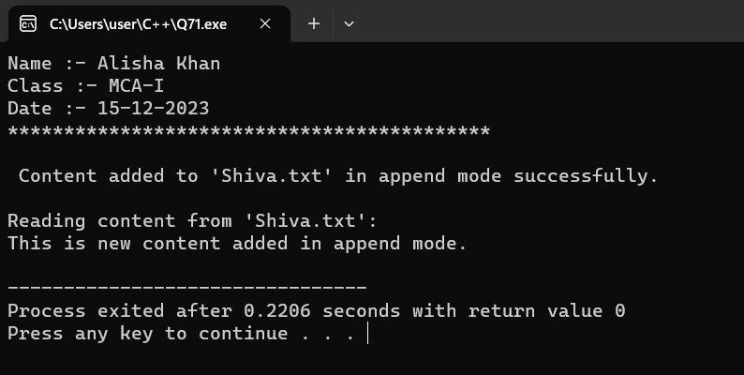

72.WAP to find current position of input/output pointer of a file.
Code :-
#include <iostream>
#include <fstream>

using namespace std;

int main() {
cout<<"Name :- Alisha Khan"<<endl;
cout<<"Class :- MCA-I"<<endl;
cout<<"Date :- 15-12-2023"<<endl;
cout<<"*******************************************"<<endl;

// Open a file for reading and writing
fstream file("SampleFile.txt", ios::in | ios::out | ios::trunc);

// Checking if the file is successfully opened
if (file.is_open()) {
// Writing data to the file
file << "Hello, World!";

// Getting the current position of the input pointer
streampos inputPos = file.tellg();

// Getting the current position of the output pointer
streampos outputPos = file.tellp();

cout << "\n Current position of the input pointer: " << inputPos << endl;
cout << "\n Current position of the output pointer: " << outputPos << endl;

// Closing the file
file.close();
} else {
cerr << "Error: Unable to open the file." << endl;
}

return 0;
}

OUTPUT :-

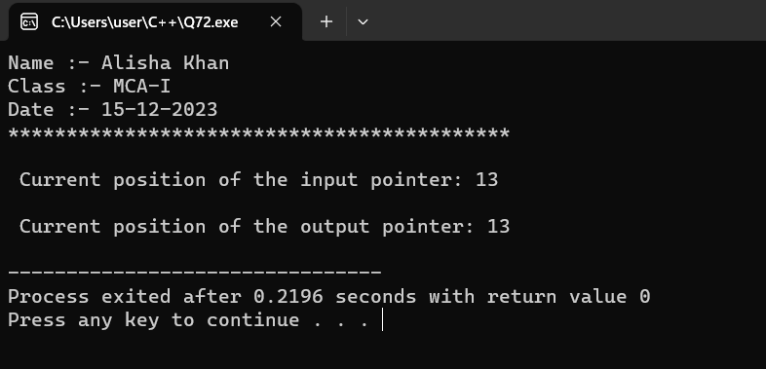

73.WAP to differentiate read( ) and getline( ) function.
Code :-
#include <iostream>
#include <fstream>
#include <string>
using namespace std;

int main()
{
cout<<"Name :- Alisha Khan"<<endl;
cout<<"Class :- MCA-I"<<endl;
cout<<"Date :- 15-12-2023"<<endl;
cout<<"*******************************************"<<endl;
cout<<"\nProgram to differentiate read( ) and getline( ) function.\n";

ifstream inputFile("SampleFile.txt");

if (inputFile.is_open()) {
// Using read() to read 10 characters
char bufferRead[11];
inputFile.read(bufferRead, 10);
bufferRead[10] = '\0'; // Null-terminate the buffer
cout << "\n Using read(): " << bufferRead << endl;

// Clearing the buffer and resetting the file pointer
inputFile.clear();
inputFile.seekg(0, ios::beg);

// Using getline() to read a full line
string line;
getline(inputFile, line);
cout << "Using getline(): " << line << endl;

inputFile.close();
} else {
cerr << "\nError: Unable to open the file." << endl;
}

return 0;
}

OUTPUT :-
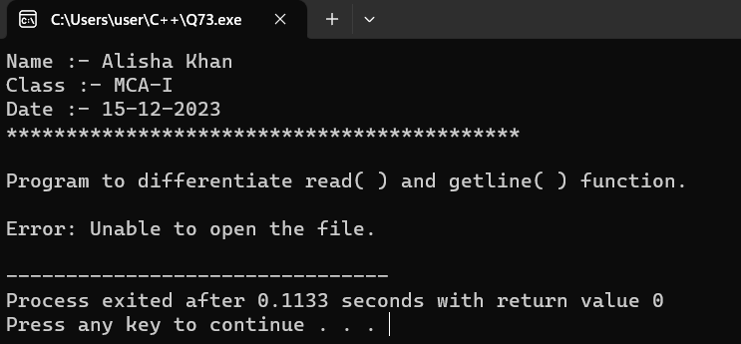

74. WAP to demonstrate manupulators(setw, setprecision, setbase, setfill).
Code :-
#include <iostream>
#include <iomanip>

using namespace std;

int main()
{
cout<<"Name :- Alisha Khan"<<endl;
cout<<"Class :- MCA-I"<<endl;
cout<<"Date :- 15-12-2023"<<endl;
cout<<"*******************************************"<<endl;
cout<<"\nProgram to demonstrate Manipulator\n";

// Demonstrate setw (set width)
cout << "\n Demonstrating setw:\n";
cout << setw(10) << "Name" << setw(10) << "Age" << setw(10) << "Grade\n";
cout << setw(10) << "Alisha" << setw(10) << 22 << setw(10) << 'A' << endl;
cout << setw(10) << "Juhi" << setw(10) << 20 << setw(10) << 'B' << endl;
cout << endl;

// Demonstrate setprecision (set precision for floating-point numbers)
cout << "Demonstrating setprecision:\n";
double pi = 3.141592653589793;
cout << setprecision(4) << "Pi (4 decimal places): " << pi << endl;
cout << setprecision(8) << "Pi (8 decimal places): " << pi << endl;
cout << endl;

// Demonstrate setbase (set numeric base for integers)
cout << "Demonstrating setbase:\n";
int decimalNumber = 255;
cout << "Decimal: " << decimalNumber << endl;
cout << "Hexadecimal: " << setbase(16) << decimalNumber << endl;
cout << "Octal: " << setbase(8) << decimalNumber << endl;
cout << "Back to Decimal: " << setbase(10) << decimalNumber << endl;
cout << endl;

// Demonstrate setfill (set fill character)
cout << "Demonstrating setfill:\n";
int width = 8;
cout << setw(width) << setfill('*') << "123" << endl;
cout << setw(width) << setfill('0') << "456" << endl;

return 0;
}
OUTPUT :-
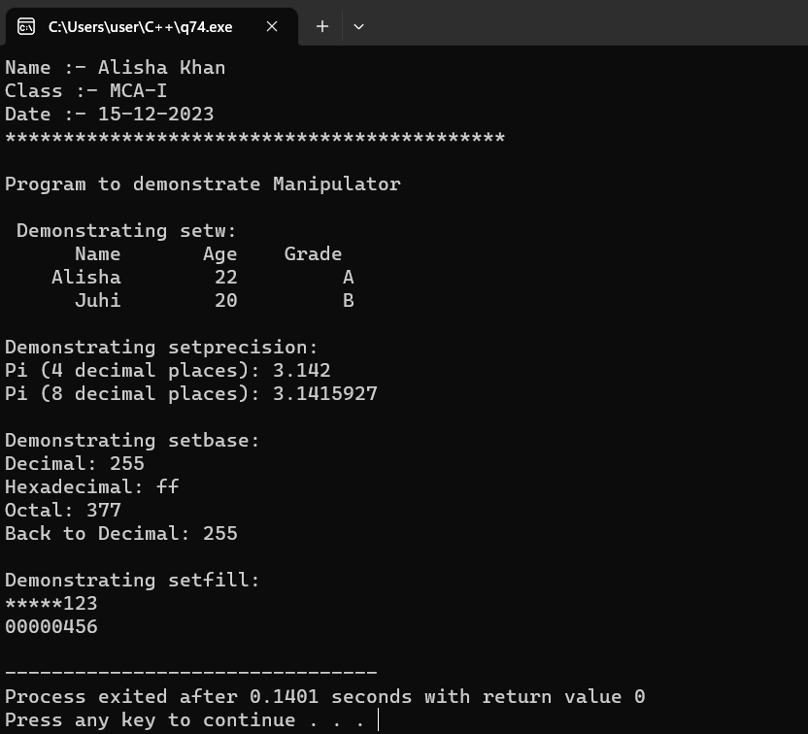

75.WAP which reads input from the keyboard whose width specified with 8 and unused space filled with '#'and input should be left-justified.
Code :-
#include <iostream>
#include <iomanip>
#include <string>
using namespace std;

int main()
{
cout<<"Name :- Alisha Khan"<<endl;
cout<<"Class :- MCA-I"<<endl;
cout<<"Date :- 15-12-2023"<<endl;
cout<<"*******************************************"<<endl;

// Reading input with specified width and left-justification
cout << "\n Enter a string (up to 8 characters): ";
string userInput;
cin >> setw(8) >> setfill('#') >> left >> userInput;

// Displaying the input
cout << "You entered: " << userInput << endl;

return 0;
}
OUTPUT :-

