NIP Project — Submission Template
Pega Platform project · This document is your complete submission
Read this before you start:
1. Fill in Section 1 completely. The Pega application name must follow the format NIP-[Project]-[YourName].
2. Create a new Operator in Pega with your full name and log in as that operator before taking any screenshot.
3. When you create your test case, enter YOUR FULL NAME in the Issue Description (Vehicle) or Movie Name (Movie) field.
4. Complete only the section for your chosen project. Delete the other project section.
5. Paste one screenshot per user story (10 total). Follow the screenshot rules in your selected project section.
6. Answer every question in Sections 3 and 4 in your own words.
7. Save the file using this format: ProjectName_FirstName_LastName.docx. Use VehicleService or MovieTicket as the ProjectName. Examples: VehicleService_Ravi_Kumar.docx or MovieTicket_Ravi_Kumar.docx.

Section 1 — Your Details
Full Name | ALISHA AHMED
Email ID (registered on NIP) | alisha.ahmed.india@gmail.com
Phone Number | 8639387008
College Name | Muffakham Jah College of Engineering and Technology
Course (e.g. IT, CS) | Computer Science and Engineering
State | Telangana
Project Chosen (Vehicle Service OR Movie Ticket Booking) | Vehicle Service
Pega Application Name (e.g. NIP-VehicleService-YourName) | NIP_vehicle service management_Alisha_Ahmed
Case Type Name (exact) | Vehicle Service Request
Pega Instance URL | https://rifrgemu.pegaacademy.net/  prweb/app/vehicle-service-management/  hvcpWh0V8YahOwtpkcPzn1MihCxH7XPi*/!STANDARD?pzuiactionzzz=  CXtycX0yN2JiMTc2MDlkMDZjNjgxM2U0ZjIwYjY5NTlhO  GZjMDNjOTEwYTE4ZmQ1ZmQ4MzRiZGQyZjIxN2FhM  2JhNWZmYWYwNzljMzNiZGU0NzkxYzJjOGIz  NjExNGQyMDFkNWQ=*
Operator Name (created in Pega with your full name) | Alisha Ahmed (alishaahmed@vsm)

Section 2A — Vehicle Service Management Application
Complete this section only if you selected this project. Delete the other project section before submitting.

Screenshot rules — IMPORTANT before you start:
1. Name your Pega application as: NIP-VehicleService-YourName OR NIP-MovieTicket-YourName
2. Create a new Operator in Pega with your full name (Security → Operators) and log in as that operator.
3. When you create your test case, enter YOUR FULL NAME in the Issue Description (Vehicle) or Movie Name (Movie) field.
4. The logged-in operator name must be visible in every screenshot wherever the Pega interface displays it.
5. The student's full name must be visible in all running-case screenshots.
6. Configuration screenshots must clearly show the relevant application or rule name.
Screenshots that do not show these will not be accepted.

US-001 — Submit Vehicle Service Request
What is expected:
Case created, customer submits Vehicle ID, Vehicle Model, Issue Description. Validation applied.
Screenshot — paste your screenshot below this line:
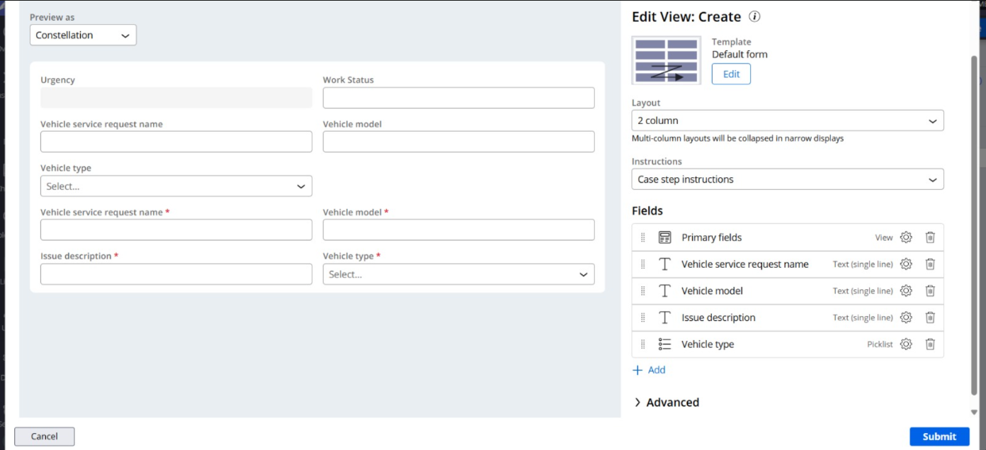

What I built for this (1–2 lines in your own words):
Configued process named Capture Request along with capturing information like vehicle ID, model and Issue Description.

US-002 — Perform Vehicle Inspection
What is expected:
Inspection stage with Service Advisor step. Inspection Notes and Condition Rating captured.
Screenshot — paste your screenshot below this line:
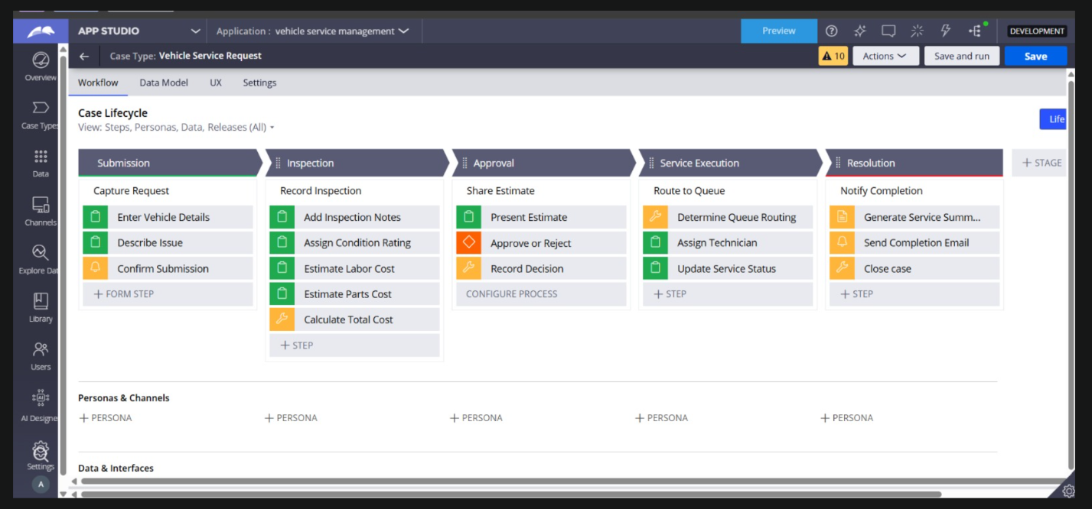
I had started doing the project and was done with this part, it was after this that we were instructed to make changes to the application name, hence, the application name looks different from the ones shown later

What I built for this (1–2 lines in your own words):
Created the Inspection stage to record vehicle assessment using Inspection Notes and Condition Rating.

US-003 — Generate Service Estimate
What is expected:
Labor Cost and Parts Cost captured. Total Cost calculated automatically by declare expression.
Screenshot — paste your screenshot below this line:
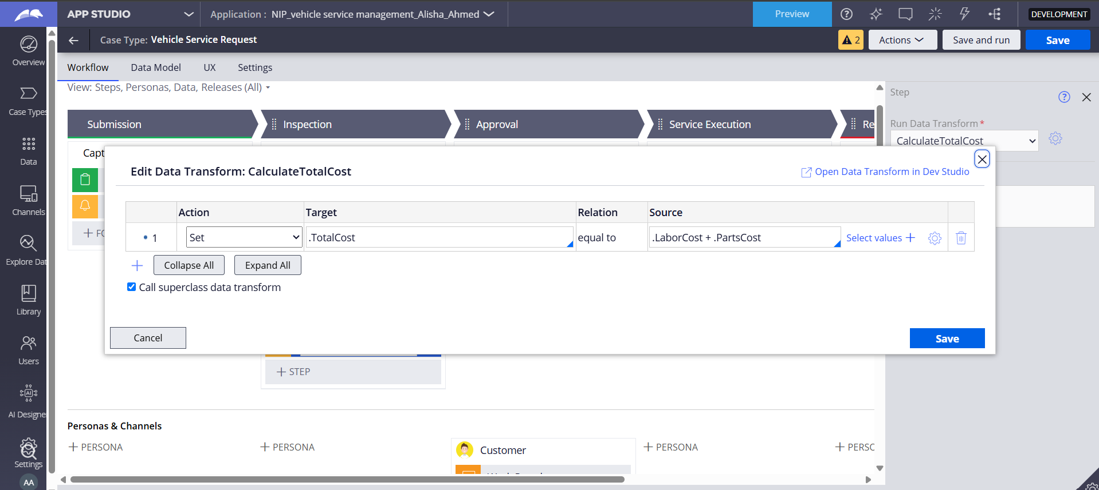

What I built for this (1–2 lines in your own words):
Added Labor Cost and Parts Cost, then configured CalculateTotalCost to compute Total Cost = Labor Cost + Parts Cost

US-004 — Approve Service Estimate
What is expected:
Approval stage assigned to Customer. Approval Status captured. Flow branches on approve/reject.
Screenshot — paste your screenshot below this line:
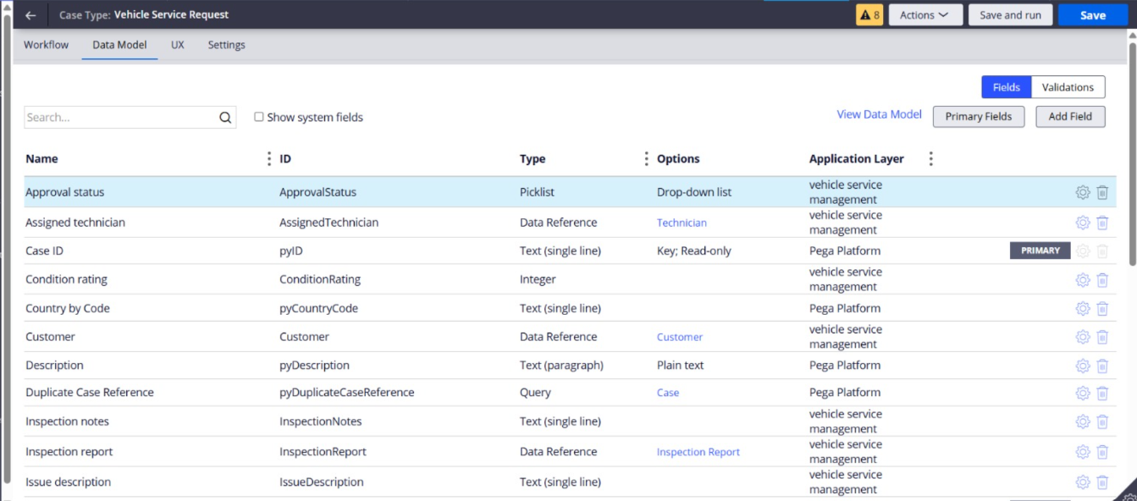

What I built for this (1–2 lines in your own words):
Built Approval stage with an Approve/Reject step assigned to the customer which captures Approval status.

US-005 — Maintain Vehicle Data
What is expected:
Reusable Vehicle data object created with Vehicle ID, Model, Type — linked to case.
Screenshot — paste your screenshot below this line:
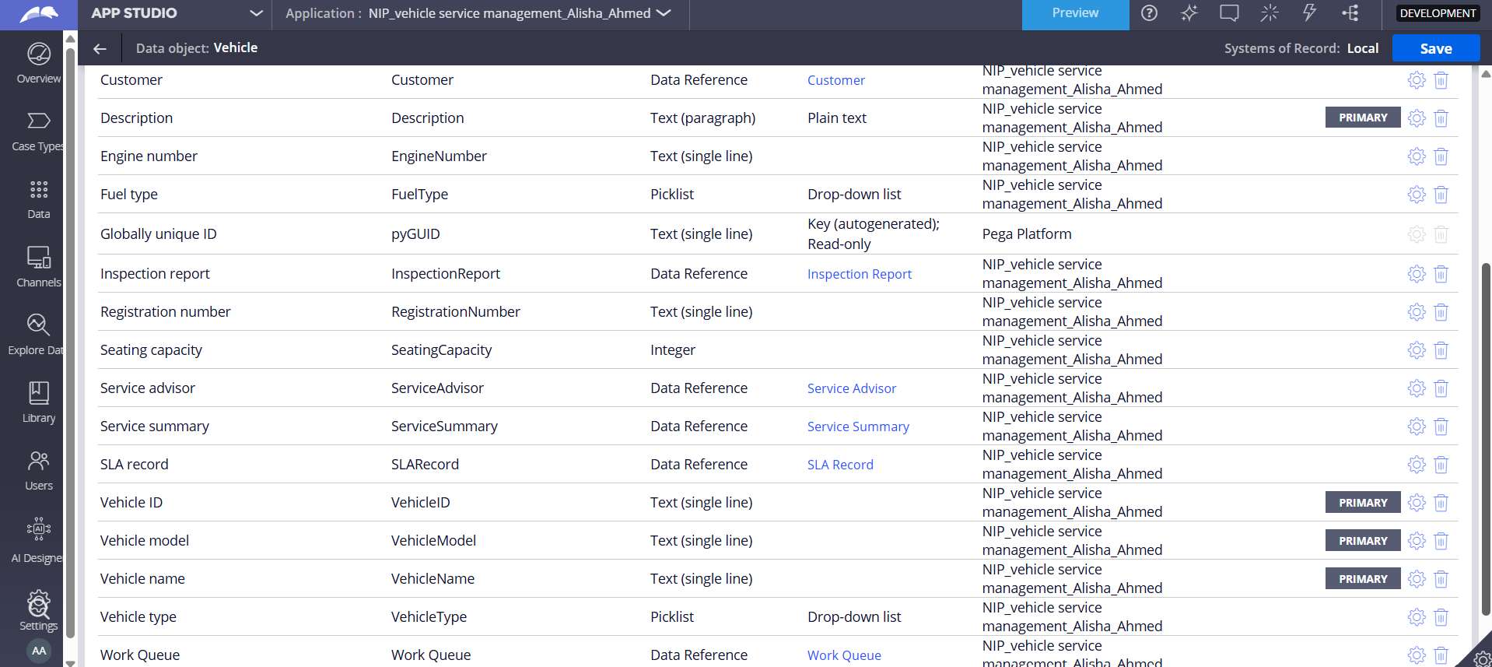

What I built for this (1–2 lines in your own words):
Made a reusable vehicle data object having properties Vehicle ID, Vehicle Model, and Vehicle Type associated with the case type to maintain vehicle history across requests.

US-006 — Review Service Estimate
What is expected:
Approval screen shows Labor Cost, Parts Cost and Total Cost clearly to the Customer persona.
Screenshot — paste your screenshot below this line:
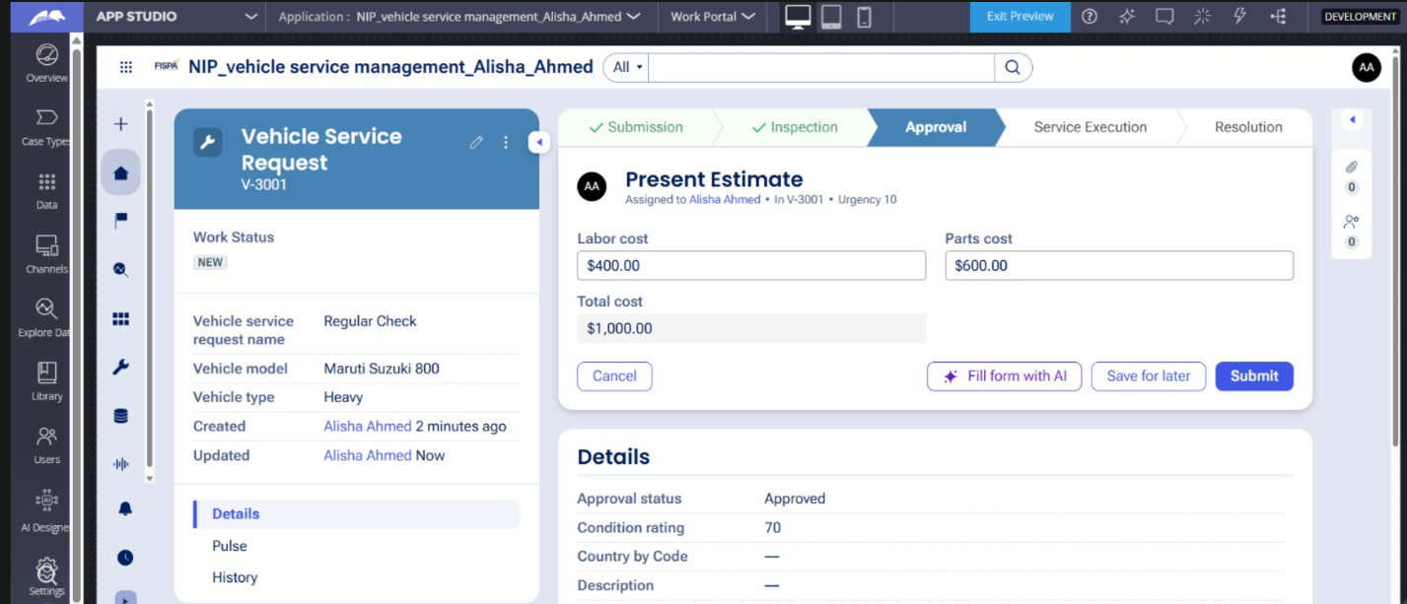

What I built for this (1–2 lines in your own words):
Designed a read-only estimate in the Approval stage that shows Labor Cost, Parts Cost, and the computed Total Cost for customer review before deciding.

US-007 — Auto Assign Technician
What is expected:
Service Execution stage with routing to HeavyVehicleQueue or LightVehicleQueue. Assigned Technician and Service Status properties maintained.
Screenshot — paste your screenshot below this line:
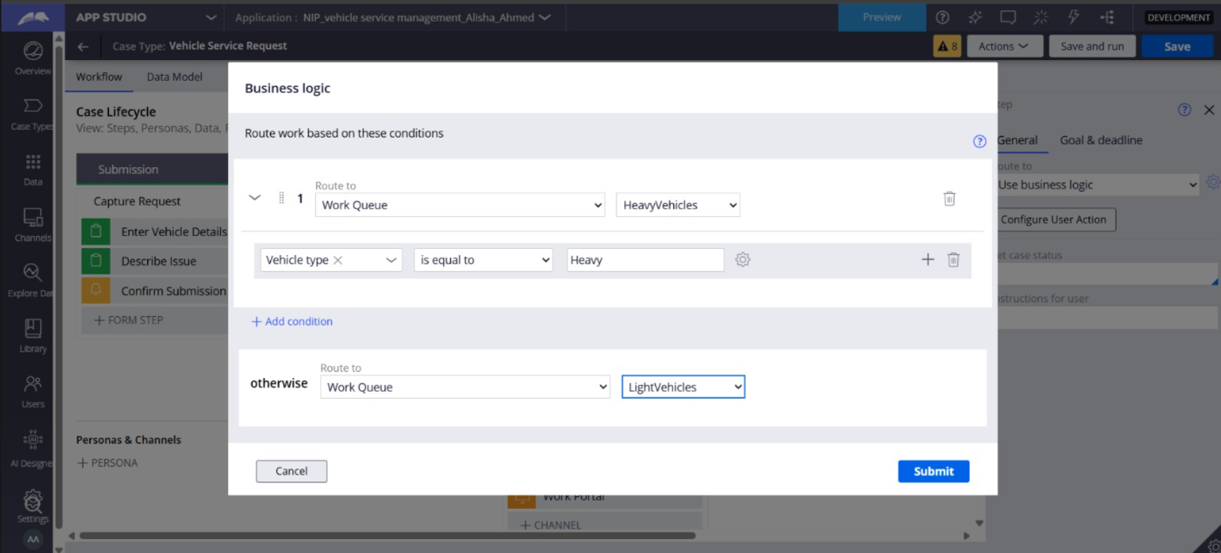

What I built for this (1–2 lines in your own words):
Service Execution stage was added to capture fulfillment and Service Execution stage keeps Assigned Technician and Service Status properties during work tracking.

US-008 — Notify Service Completion
What is expected:
Correspondence rule created and triggered on case resolution. Email includes case and vehicle details.
Screenshot — paste your screenshot below this line:
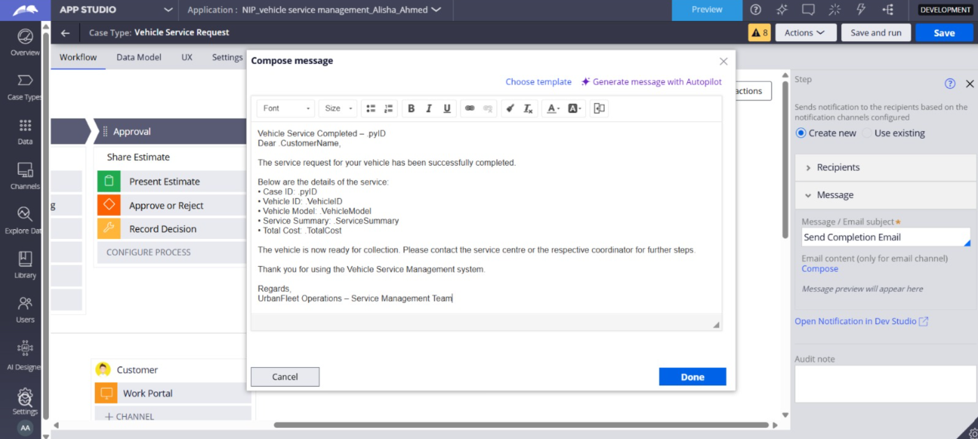

What I built for this (1–2 lines in your own words):
Created correspondence rule and a notification step in the Resolution stage that sends an automated completion email containing Case ID, Vehicle ID, Model, Service Summary, and Total Cost upon case resolution.

US-009 — Define Service SLA
What is expected:
SLA configured on the case type. Goal: 2 days. Deadline: 3 days. Priority increases on breach.
Screenshot — paste your screenshot below this line:
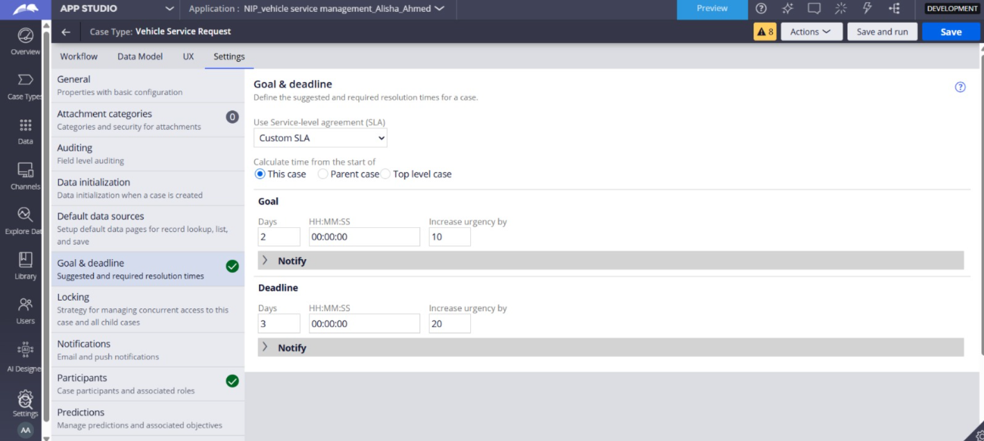

What I built for this (1–2 lines in your own words):
Created a Case-level SLA with a Goal of 2 days and a Deadline of 3 days from creation, raising case priority upon milestone breach.

US-010 — Route by Vehicle Type
What is expected:
Routing rule or Decision Table routes to HeavyVehicleQueue or LightVehicleQueue based on Vehicle Type property.
Screenshot — paste your screenshot below this line:
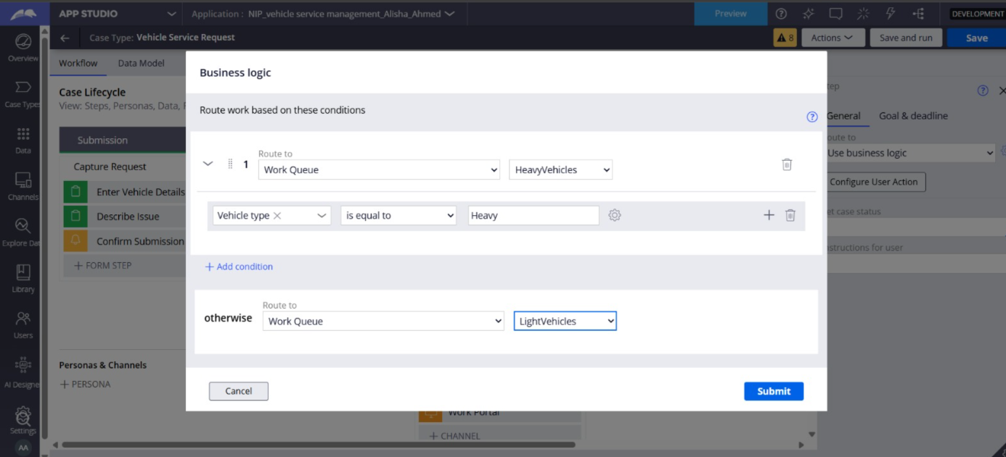

What I built for this (1–2 lines in your own words):
Implemented Business Logic routing on the Assign Technician step to route the case to HeavyVehicles queue if Vehicle Type is Heavy, otherwise routing to LightVehicles queue
Section 3 — About Your Application
These answers are checked against your screenshots. Write exactly what is in your application.

Q1. List your stages in the order they appear in your case lifecycle.
Stage names in order, separated by commas.
Submission, Inspection, Approval, Service Execution, Resolution

Q2. Name the data object(s) you created and the properties inside them.
Data object name and its properties.
Data object: Vehicle
Properties: Description, Vehicle ID, Vehicle Model, Vehicle name

Q3. What is the exact name and type of the rule you used to calculate Total Cost?
Provide:
• Rule Name
• Rule Type
• Properties used in the calculation
• Formula used
Rule Name: CalculateTotalCost
Rule Type: Data Transform
Properties used in the calculation: .LaborCost, .PartsCost, .TotalCost
Formula used: .TotalCost = .LaborCost + .PartsCost

Section 4 — Your Understanding
Short, honest and specific answers score well.

Q4. What did Blueprint generate for you, and what did you add or change yourself afterwards?
Be specific about what was already there and what you built or modified on top.
The initial stages were already generated by blueprint, at the end of the project I had changed names so that they match the description of that as per the project requirements.
A few of the steps were also, already created, but needed renaming but new ones like cost calculation steps(labour cost, parts cost and total cost steps) and email sending steps had to be created

Q5. Was there anything Blueprint created that you had to correct or configure further? Describe one example.
A real example from your own work.
Blueprint had created different names for stages and processes, those had to be renamed later on.
Furthermore, it had created extra steps which were redundant and needed to be cleared out.
For Example:Record Inspection was previously titled Estimate Preparation

Q6. Explain your case flow from creation to resolution, in order.
What happens first, who does what, when the case closes.
First, the Customer submits a request with vehicle details and issue descriptions in Submission. Then, a Service Advisor evaluates the car, logs notes, condition rating, labor and parts costs, and generates the total estimate in Inspection.
After that,the customer reviews the estimate and approves or rejects it in Approval. Then, the case routes automatically to either HeavyVehicles or LightVehicles work queue in Service Execution, where a technician performs the work and updates the service status. Finally, the case reaches Resolution, sending a completion email to the customer and closes the case.

Q7. Pick two design choices you made in your application and explain why you made them.
For each design choice, provide:
• What you implemented
• Why you chose that approach
• What benefit it provides to the application
Reusable Vehicle Data Object.
What I implemented: Separated vehicle attributes (Vehicle ID, Model, Type) into a standalone data object referenced by the case.
Why: Decouples core vehicle master data from transactional case instances.
Benefit: Promotes data consistency, avoids duplicate data entry, and allows future tracking of service history across multiple service requests for the same vehicle.
Automated Business Logic Queue Routing.
What I implemented: Dynamic routing on the Assign Technician step based on Vehicle Type.
Why: Eliminates manual triage by service coordinators.
Benefit: Dispatches specialized heavy machinery work directly to certified heavy vehicle technicians while sending standard vehicles to light queues, reducing turnaround time.

Q8. What was the hardest part, and how exactly did you fix it?
Specific and honest. A real challenge scores much better than a generic answer.
For me, the biggest hurdle was importing the blueprint into the app studio and starting the work on it. It took a lot of time and kept redirecting me back to the Fraud Investigation Application, it was after several tries that I realized that the new operator was to be created and given the permissions to access the imported blueprint.

Q9. If the approval step was only needed when Total Cost is above a certain amount, what would you change in your application?
Explain what you would change and where. You do not need to build this.
I would select the Approval stage and under the step approve/reject, add another condition and would define the condition as .TotalCost > [amount] .
If the condition is false, the engine skips the Approval stage and moves directly to Service Execution.

Q10. List three exact rule names from your application that you personally created or modified.
Include the rule name and rule type for each one (for example: CalculateTotalCost - Declare Expression).
CalculateTotalCost -Data Transform
RecordDecision -Data Transform
SendCompletionEmail -Correspondence
Q11. List all personas used in your application.
List the persona names exactly as they appear in your application.
Customer, Service Advisor, Technician

Q12. List all work queues used in your application and explain when each one is used.
For each work queue, provide its exact name and the condition or type of work routed to it.
HeavyVehicles: Used during the Service Execution stage when Vehicle Type equals Heavy.
LightVehicles: Used during the Service Execution stage for all non-heavy vehicle service requests (Vehicle Type equals heavy is false)
Before You Submit — Check These
Read through once before uploading.
1. Section 1 filled in. Application named as NIP-[Project]-[YourName]. Names match the actual application.
2. New Operator created in Pega with my full name. I logged in as that operator for all screenshots.
3. Only my chosen project section remains — the other project section is deleted.
4. All 10 user story screenshots are pasted and follow the operator, running-case, application, and rule-name evidence requirements.
5. Every question in Sections 3 and 4, including Q10, Q11, and Q12, is answered in my own words.
6. This file is named using the required format: ProjectName_FirstName_LastName.docx (for example, VehicleService_Ravi_Kumar.docx or MovieTicket_Ravi_Kumar.docx) and uploaded as required.

