# CS 255 System Design Document

## UML Diagrams

### UML Use Case Diagram

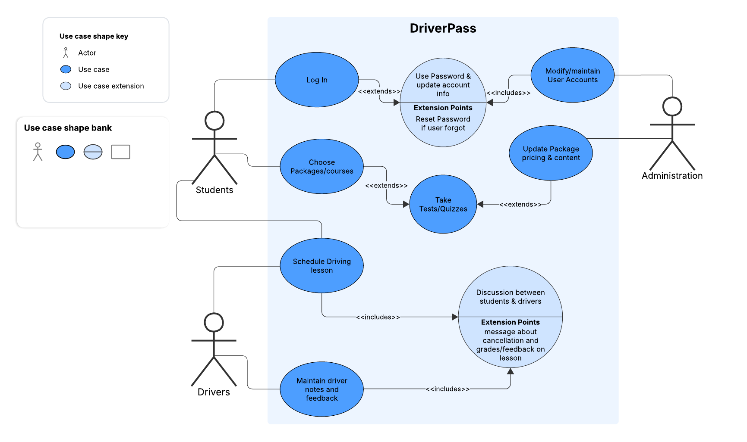

### UML Activity Diagrams

For the first activity diagram I chose the “Log in” use case. In the activity diagram I accounted for the forgot password option shown in use case. I also included the security feature of disabling account after 4 attempts: as mentioned in the Business requirement document.

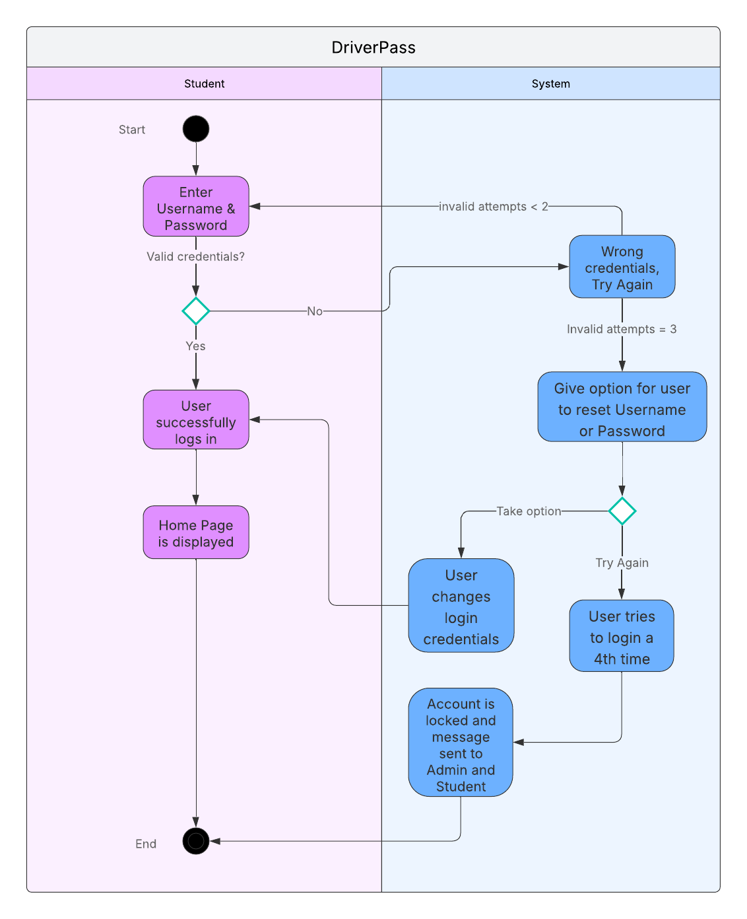

For the second activity diagram I chose the “Schedule Driving Lesson” use case. This activity follows through on the goal listed in the business requirements document, “scheduling function for the instructors and students to reserve driving time.”.

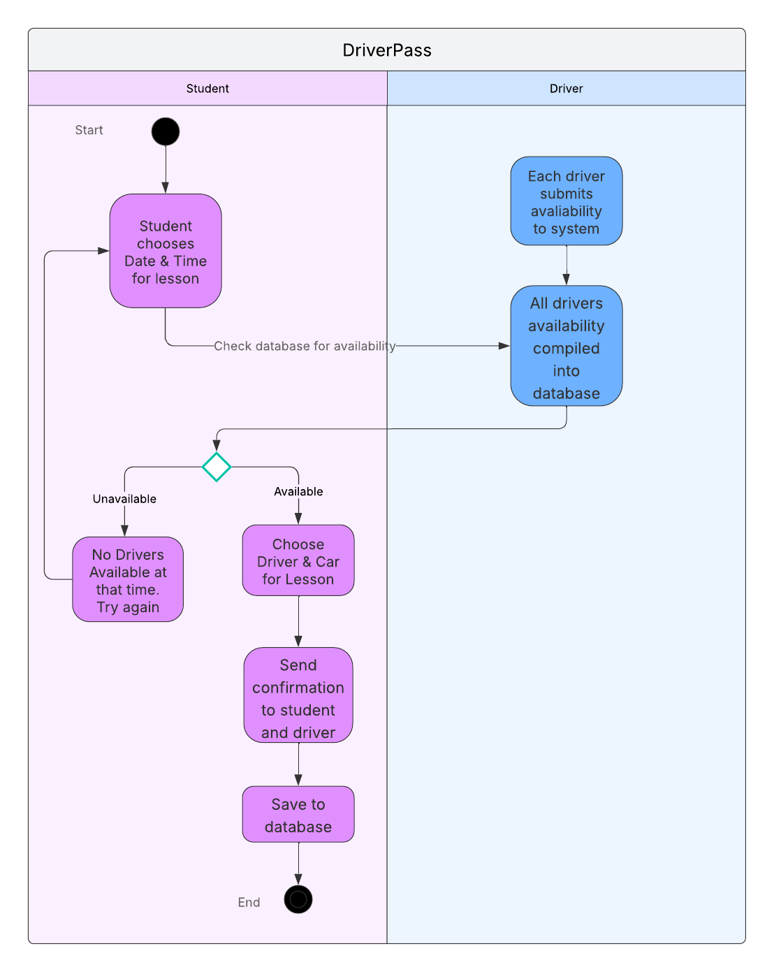

### UML Sequence Diagram

The following is a sequence diagram describing the initial use case of the student choosing the package/class and paying for it.

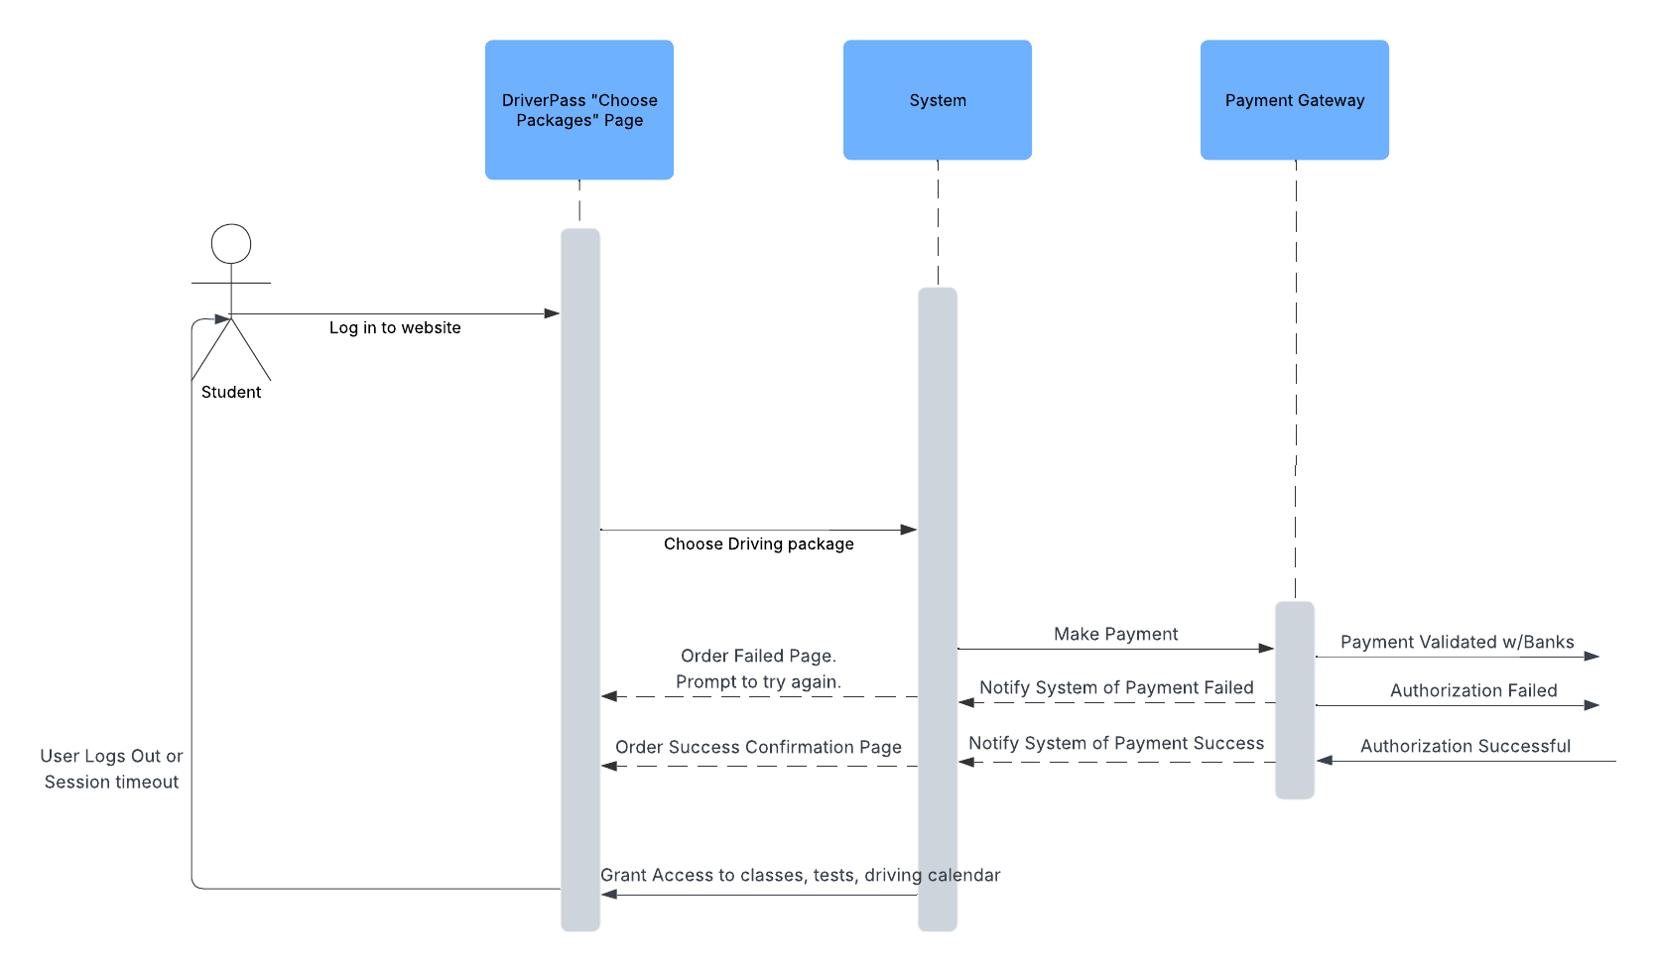

### UML Class Diagram

Below is the Class diagram created for DriverPass. I compiled 5 classes based on the user requirements and demonstrate their relationship with each other.

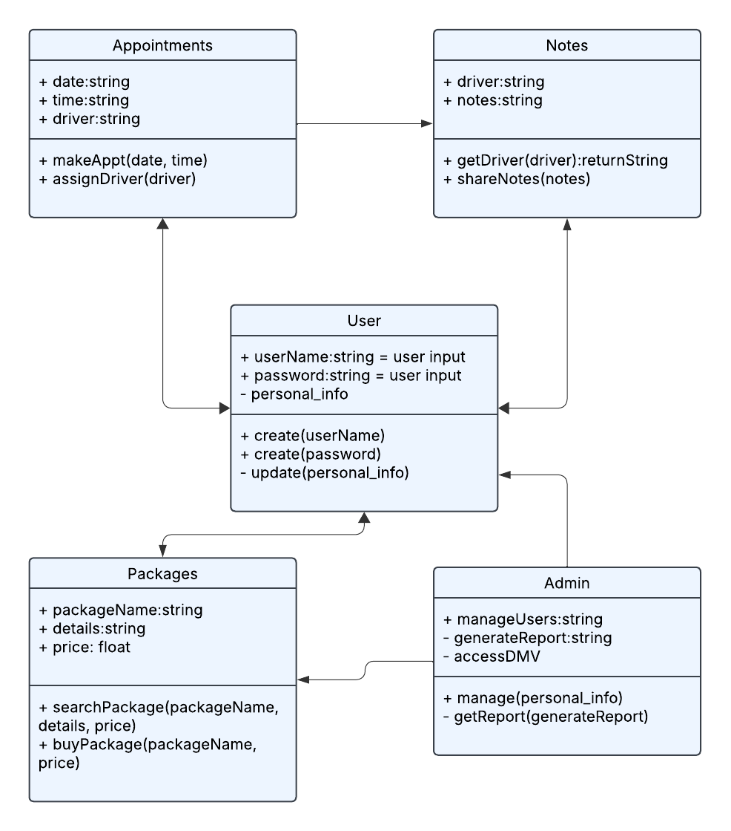

## Technical Requirements

To meet the needs of the DriverPass system we will need a cloud-based server setup to handle the data for students, packages, tests, and driving calendars and notes. The application will need to be able to work on any web browser so a webserver using Javascript for the front-end and Python for backend development. Cloud-based storage will be useful as well for scalability and will need regular backups for data security.