**CONTINOUS DISTRIBUTION****¶**

In [3]:

*# for inline plots in jupyter*  
%**matplotlib** inline  
*# import matplotlib*  
**import** **matplotlib.pyplot** **as** **plt**  
*# for latex equations*  
**from** **IPython.display** **import** Math, Latex  
*# for displaying images*  
**from** **IPython.core.display** **import** Image

In [4]:

*# import seaborn*  
**import** **seaborn** **as** **sns**  
*# settings for seaborn plotting style*  
sns.set(color_codes=**True**)  
*# settings for seaborn plot sizes*  
sns.set(rc={'figure.figsize':(5,5)})

**NORMAL DISTRIBUTION****¶**

Normal Distribution 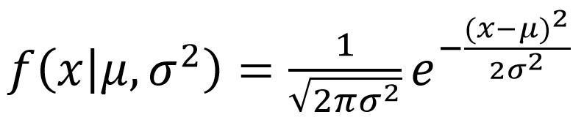

In [5]:

**from** **scipy.stats** **import** norm  
*# generate random numbers from N(0,1)*  
data_normal = norm.rvs(size=10000,loc=0,scale=1)

You can generate a normally distributed random variable using scipy.stats module's norm.rvs() method. The loc argument corresponds to the mean of the distribution. scale corresponds to standard deviation and size to the number of random variates. If you want to maintain reproducibility, include a random_state argument assigned to a number.

In [6]:

ax = sns.distplot(data_normal,  
 bins=100,  
 kde=**True**,  
 color='skyblue',  
 hist_kws={"linewidth": 15,'alpha':1})  
ax.set(xlabel='Normal Distribution', ylabel='Frequency')

Out[6]:

[Text(0, 0.5, 'Frequency'), Text(0.5, 0, 'Normal Distribution')]

**Exponential Distribution****¶**

The exponential distribution describes the time between events in a Poisson point process, i.e., a process in which events occur continuously and independently at a constant average rate. It has a parameter λ

called rate parameter, and its equation is described as : 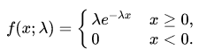

A decreasing exponential distribution looks like : 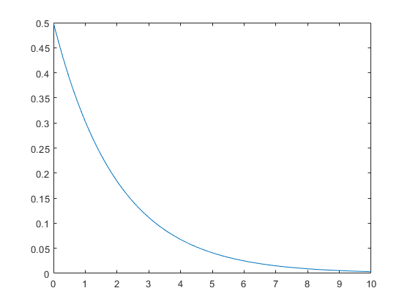

In [7]:

**from** **scipy.stats** **import** expon  
data_expon = expon.rvs(scale=1,loc=0,size=1000)

In [8]:

ax = sns.distplot(data_expon,  
 kde=**True**,  
 bins=100,  
 color='skyblue',  
 hist_kws={"linewidth": 15,'alpha':1})  
ax.set(xlabel='Exponential Distribution', ylabel='Frequency')

Out[8]:

[Text(0, 0.5, 'Frequency'), Text(0.5, 0, 'Exponential Distribution')]

**Chi Square Distribution****¶**

Chi Square distribution is used as a basis to verify the hypothesis.

It has two parameters:

df - (degree of freedom).

size - The shape of the returned array.

Draw out a sample for chi squared distribution with degree of freedom 2 with size 2x3:

In [10]:

**from** **numpy** **import** random  
  
x = random.chisquare(df=2, size=(2, 3))  
  
print(x)

[[2.20013641 0.54550656 1.13905515]  
 [7.58237423 3.75240345 0.53023675]]

In [11]:

**from** **numpy** **import** random  
**import** **matplotlib.pyplot** **as** **plt**  
**import** **seaborn** **as** **sns**  
  
sns.distplot(random.chisquare(df=1, size=1000), hist=**False**)  
  
plt.show()

In [ ]: