**Riphah University**

**Alisha Ishrat**

**40851**

**OS_LAB**

**Lab Task #1**

**CS-6**

**Task 1:**

Start by creating two directories named **OS_Course** and **OS_Lab**

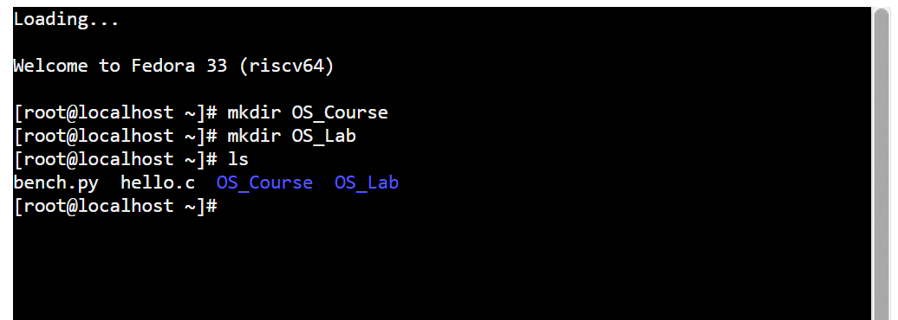

switch to the **OS_Lab** directory. Within OS_Lab, create three more directories named **LAB_Class_Task, LAB_Activities, and Lab_Practice**.

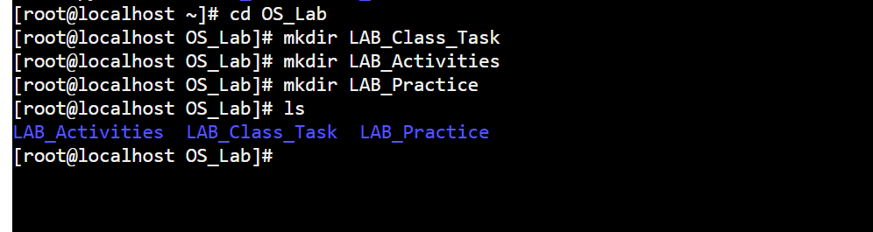

go into the **Lab_Practice** directory and create a file named example.cpp.

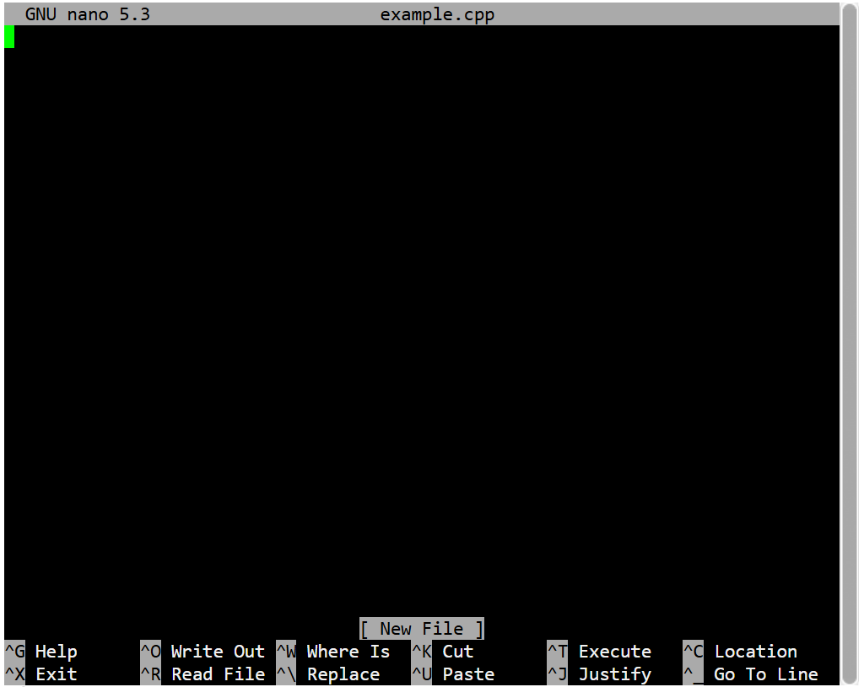

Finally, move back to your home directory

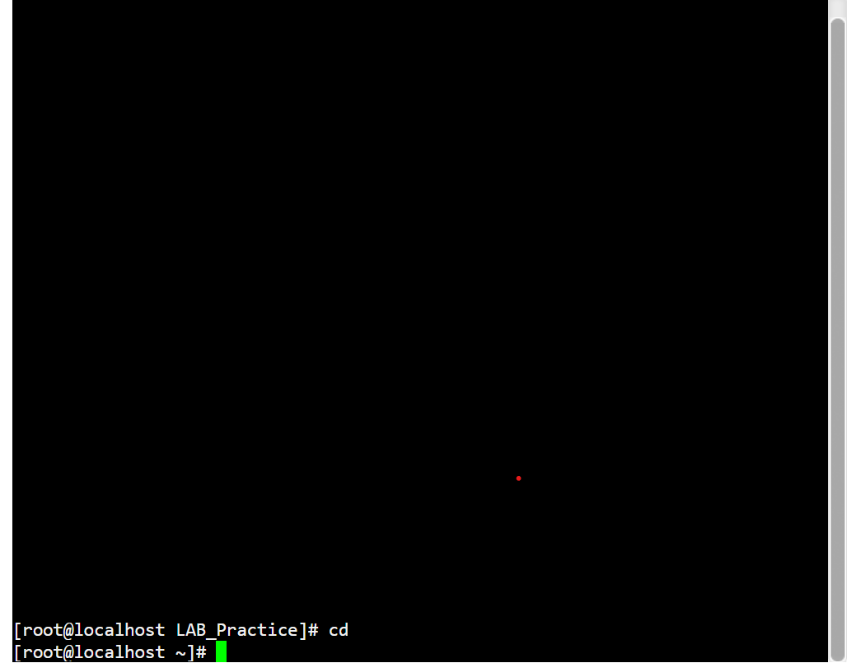

**Task 2:**

**Absolute Path:**

An **absolute path** is a complete path from the root directory to the desired file or directory. It specifies the exact location in the file system, regardless of the current working directory.

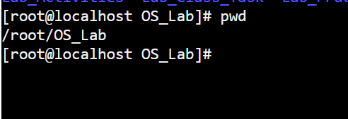

**Relative Path:**

A **relative path** is a path that is relative to the current working directory. It does not start from the root but from the current directory, making it shorter and more flexible for navigation.

**cd…/Lab_Activities**

**Task 3:**

When you press and hold the power button, the operating system receives a signal to initiate the shutdown process. The system saves any unsaved data to prevent loss. Running applications are closed, and their state is saved if possible. The system sends a signal to the motherboard to cut off power to various components. When you turn the computer back on, the power supply starts providing electricity to the components. The motherboard performs a series of checks to ensure hardware components are functioning correctly, including the CPU, RAM, and storage devices. The quick startup of a computer after being turned off is a result of a well-coordinated process involving the shutdown sequence, POST, boot process, and optimized hardware and software components.

**Explaining with example,**

When you turn off the computer, it's like parking the car. You save your work (like parking a car safely), and the computer goes to sleep. When you turn the computer back on, it's like starting the car. It checks everything is okay (like the engine, brakes, etc.), and then starts up. The computer is smart. It remembers things you did before, so it can start up faster. It's like a car that knows the way to work every morning.