**Riphah International University**

**Alisha Ishrat**

**40851**

**Lab: 11**

**29/10/2024**

**Task 1:**

How do you create a basic for loop in a shell script to iterate over a list of numbers from 1 to 5?

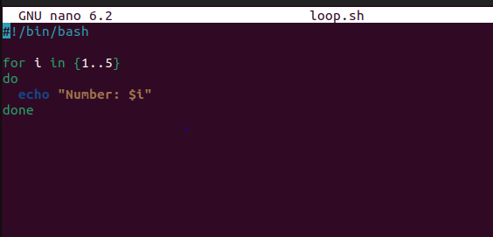

**Output:**

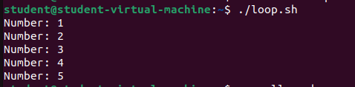

**Task 2:**

What is the syntax for a while loop that counts from 1 to 10 and prints each number?

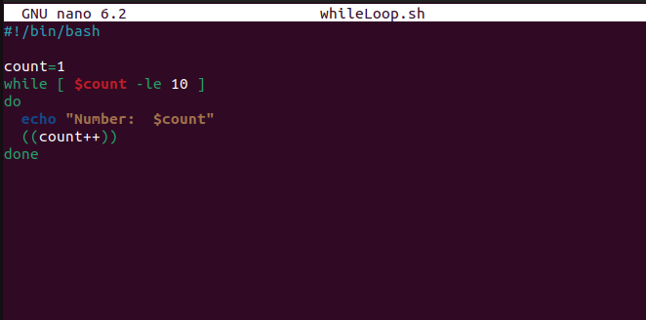

**Output:**

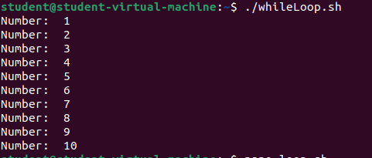

**Task 3:**

How would you write a nested loop in shell scripting to print a multiplication table from 1 to 3?

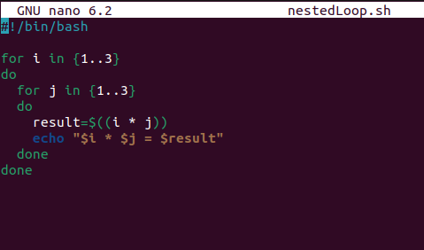

**Output:**

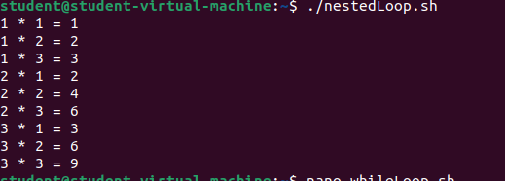

**Task 4:**

Write a for-in loop that iterates over the items in an array named fruits containing apple, banana, and cherry.

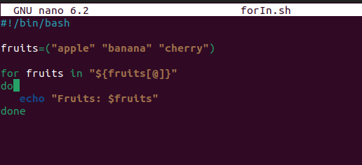

**Output:**

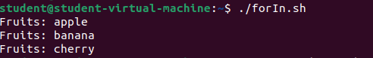

**Task 5:**

Write a while loop that reads user input until the user types "exit".

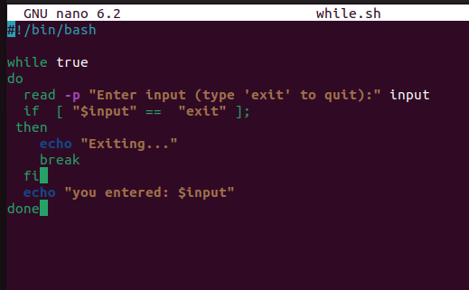

**Output:**

