**Riphah University**

**Alisha Ishrat**

**40851**

**CS-6**

**Lab 12**

**12/11/2024**

**Task 1**

Which command would you use to find the process ID (PID) of a process named OSLab without running it. After obtaining the PID, which command would you use to kill the process?

**Command used to find Processor named OSLab:**

*pgrep OSLab*

**Example to obtain PID:**

*pgrep OSLab*

*2345 // PID of OSLab.*

**Command used to kill PID:**

*Kill 2345*

**Task 2:**

How would you write a script that uses a signal trap to handle specific signals, and what is the purpose of a signal trap in such a script?

**Code:**

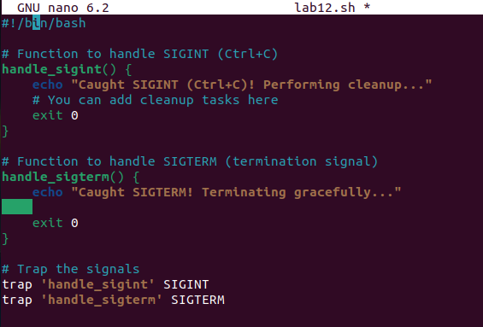

**Output:**

