OUTPUTS

SAN FRANSISCO ALOS1

Output of read_tif_file.py:

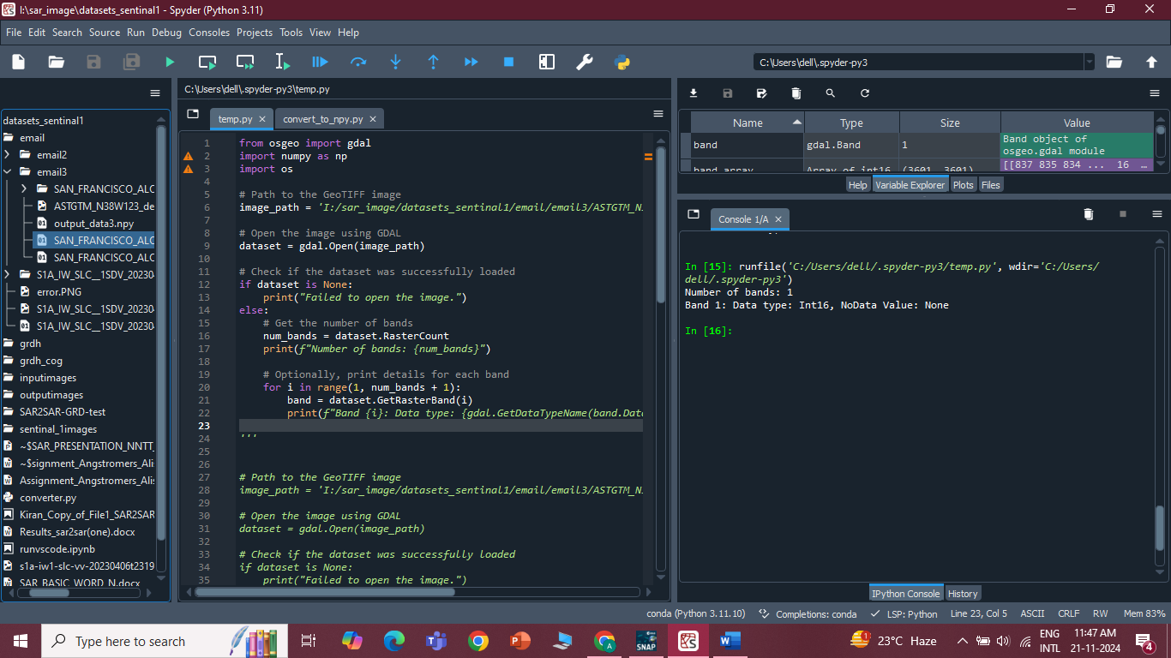

Output of other gdal functions other_gdal.py : 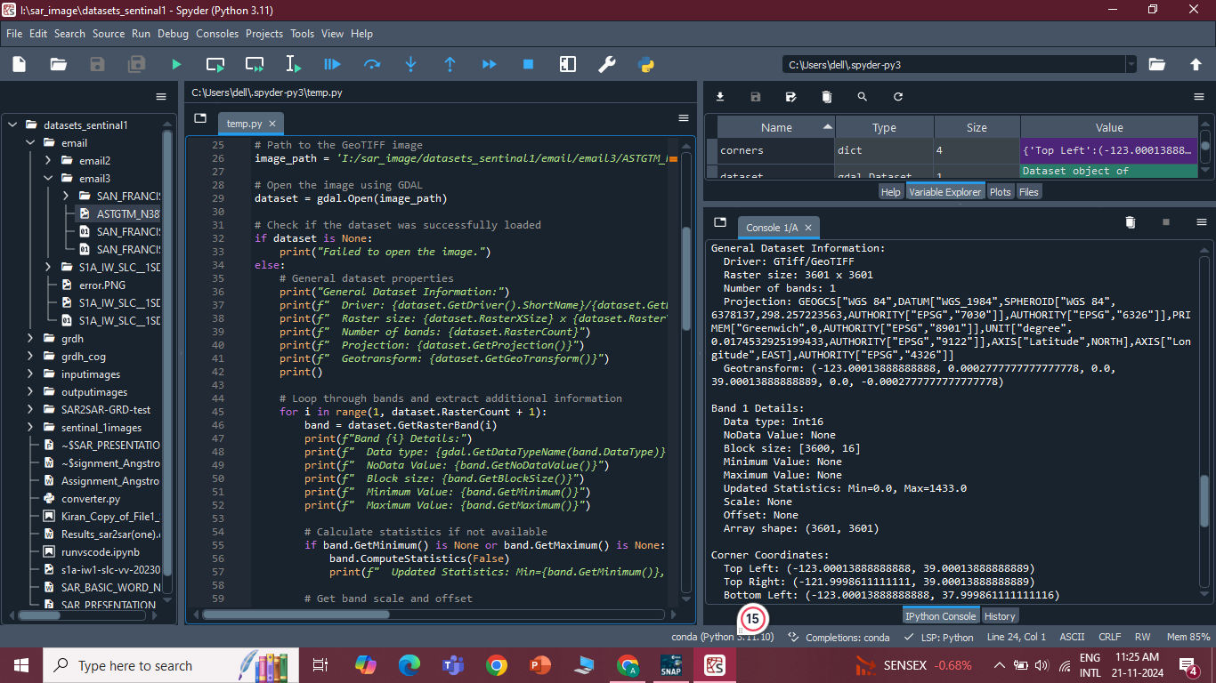

Converting it to.npy by convert_to_npy.py:

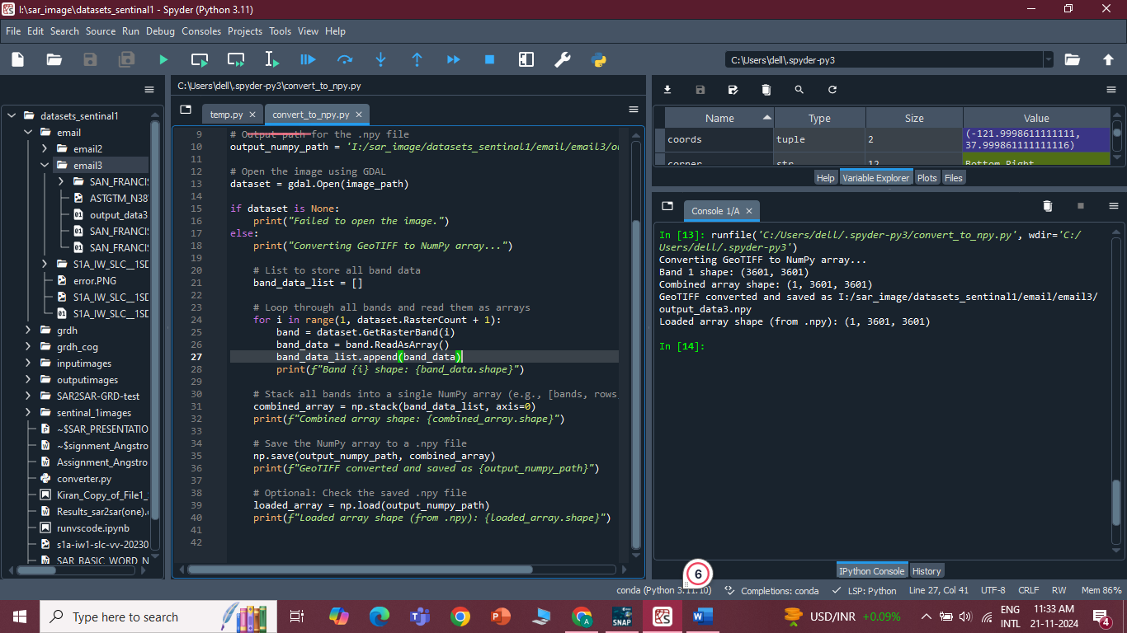

S1A-IW-SLC

Output of read_tif_file.py:

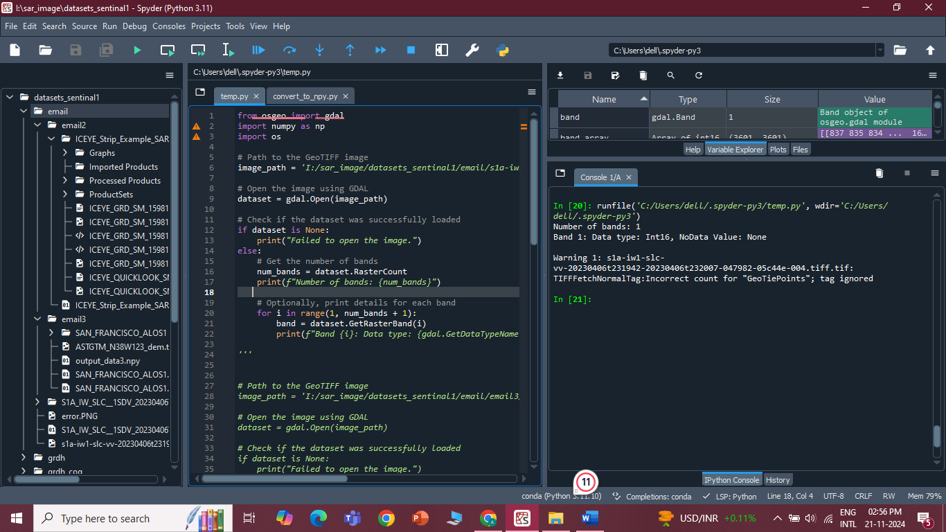

Output of other gdal functions other_gdal.py :

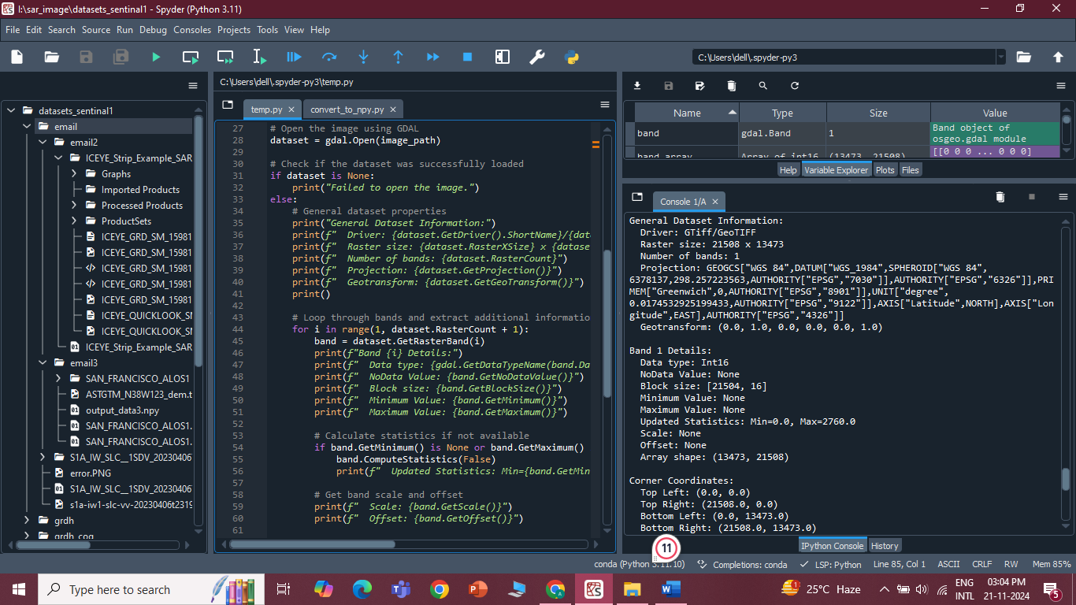

Converting it to.npy by convert_to_npy.py:

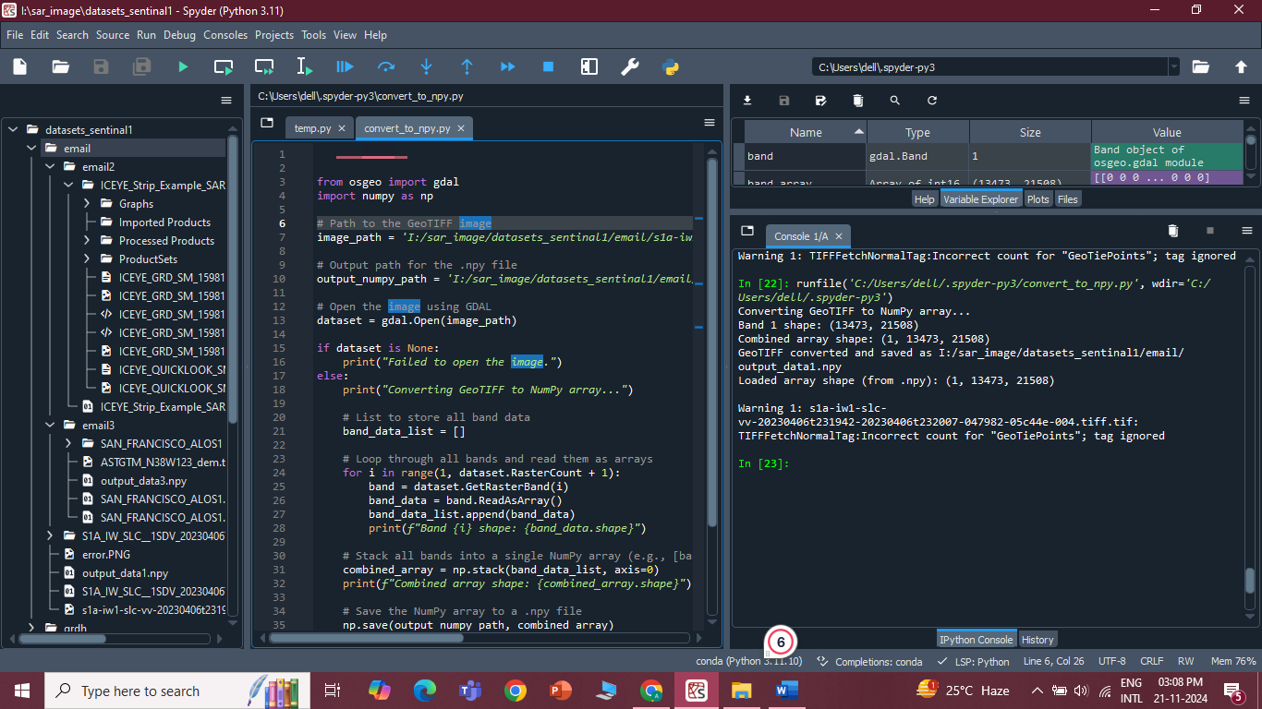

ICEYE-STRIP-EXAMPLE-SINGAPORE

Output of read_tif_file.py:

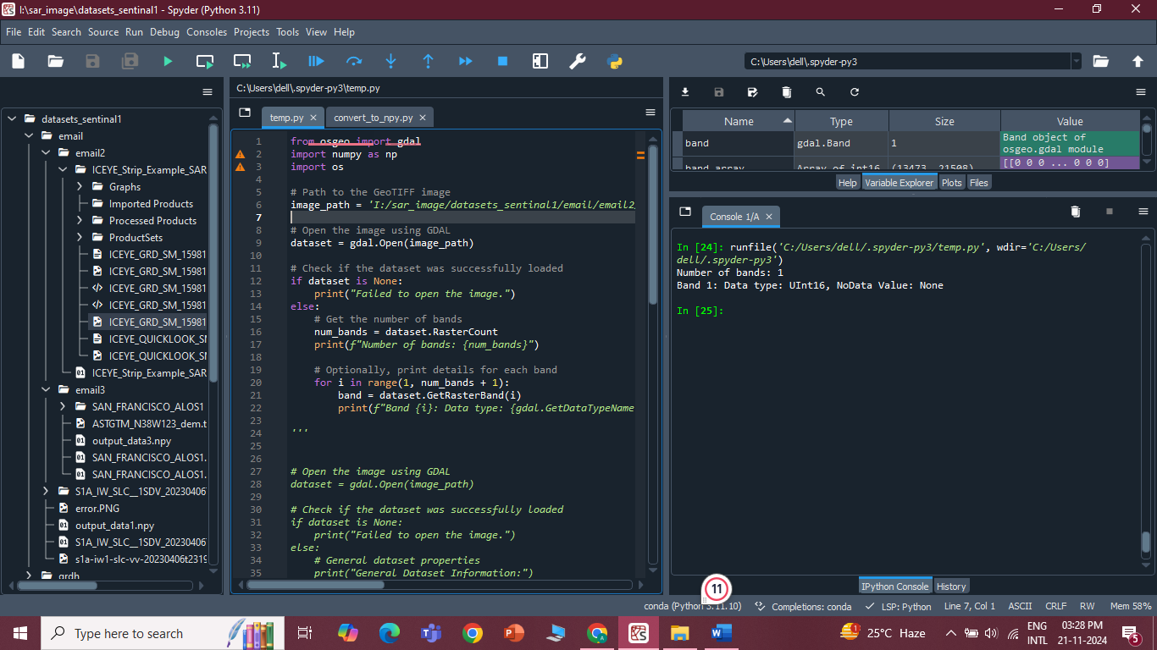

Output of other gdal functions other_gdal.py :

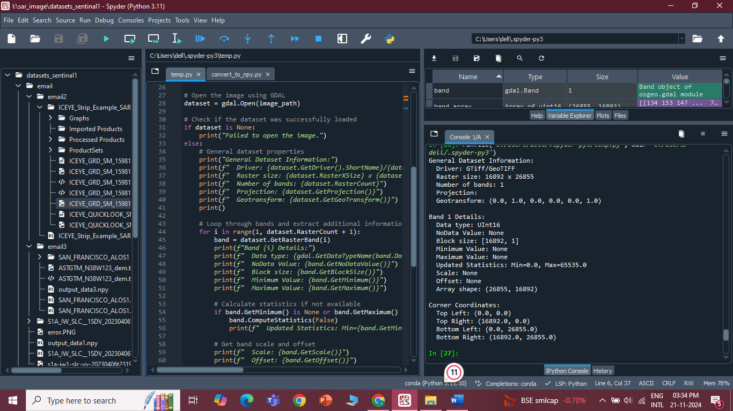

Converting it to.npy by convert_to_npy.py:

