**RESULTS**

**SAR2SAR: A Semi-Supervised Despeckling Algorithm for SAR Images**

**Input image given as .npy file and output noised and denoised images in PNG format**

**Damoh 21**

Input as **Damoh 21**.npy below converted to png

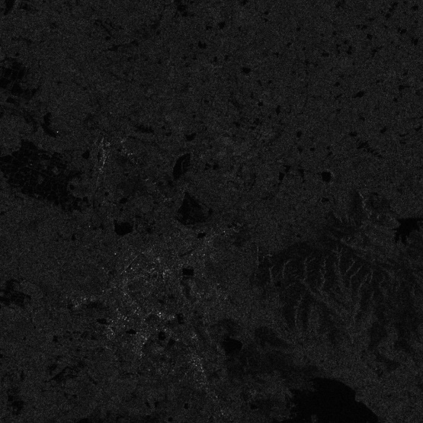

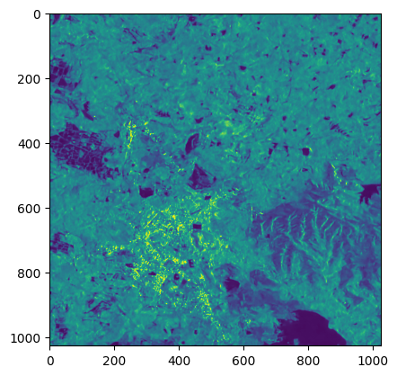**Output: denoised Damoh 21.png noisy_Damoh_21.png**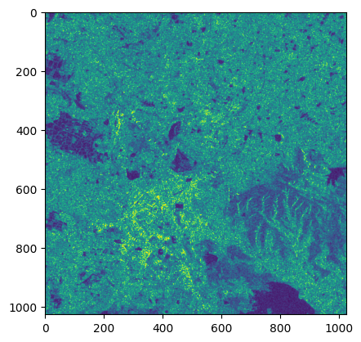

***Alpes1_21***

Input as ***Alpes1_21***.npy below converted to png

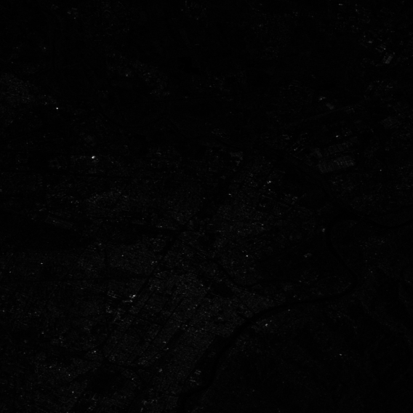

**Output: denoised_Alpes_21.png noisy_Alphes1_21.png**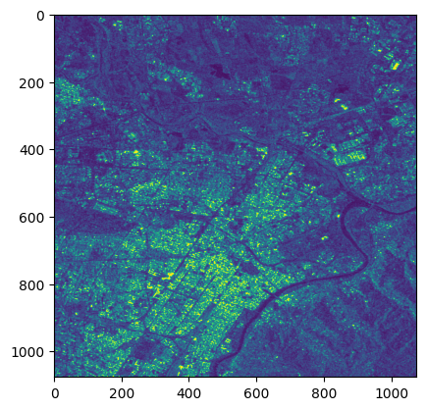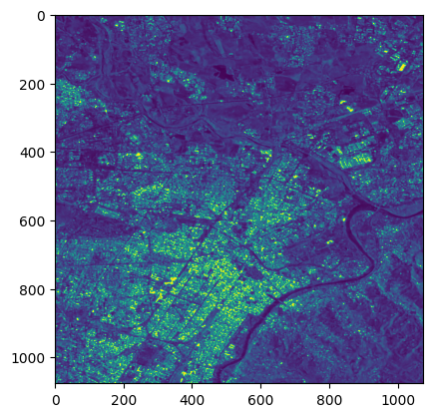

**DesMoines 21**

Input as **DesMoines 21**.npy below converted to png

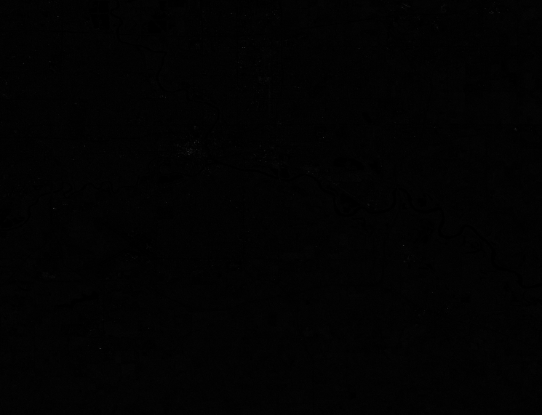

**Output: denoised DesMoines 21.png noisy_DesMoines_21.png**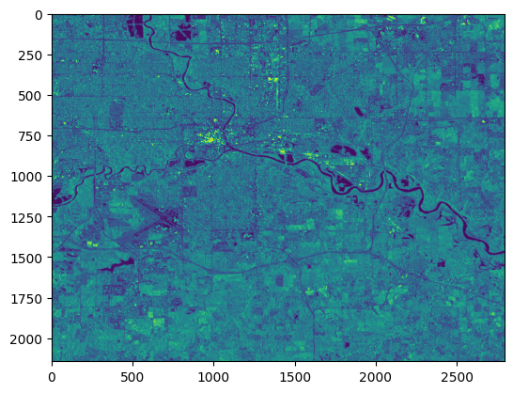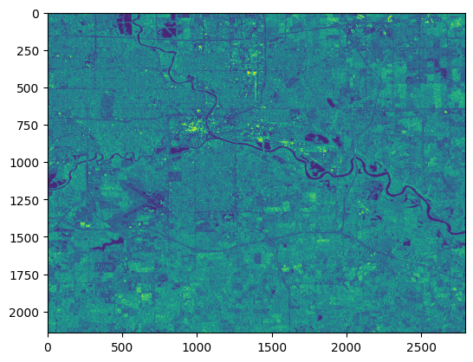

**Rennes 26**

Input as **Rennes 26**.npy below converted to png

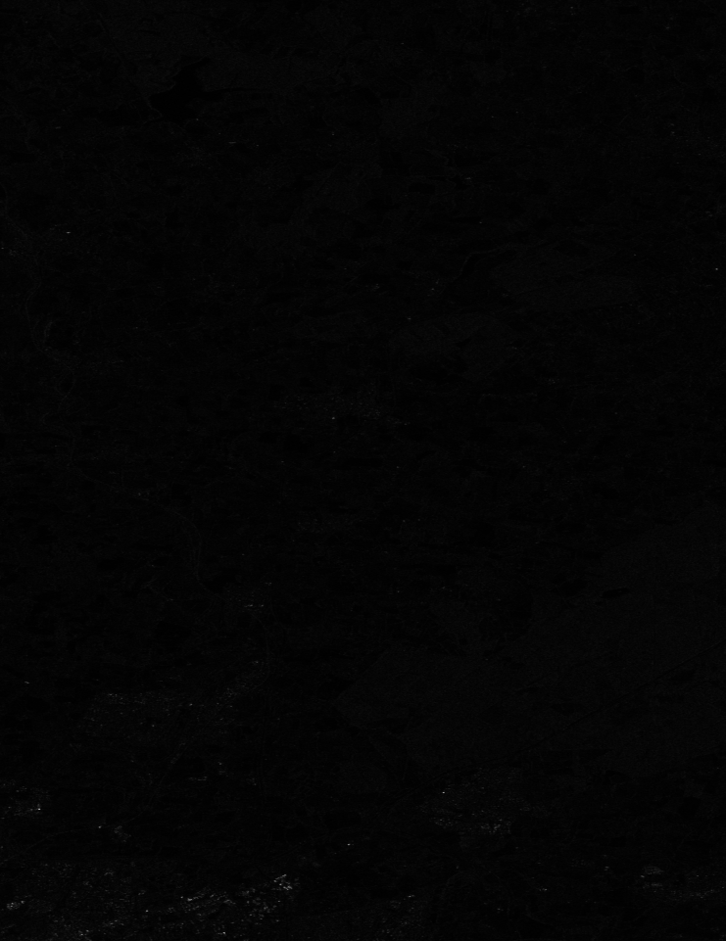

**Output: denoised Rennes 26.png noisy_Rennes_26.png**