**ReactJS:**

ReactJS, often simply referred to as React, is an open-source JavaScript library used for building user interfaces (UIs) for web applications. It was developed and is maintained by Facebook, and it is widely used by developers and organizations to create dynamic and interactive web applications.

-----------------------------------------------------------------------------------------------------------

**Creation of React App:**

npx create-react-app appname

npm run start

**Using vite:**

npm create [vite@latest](mailto:vite@latest)

npm install

npm run dev

**-----------------------------------------------------------------------------------------------------------**

**File Structure:**

**my-react-app/**

**├── node_modules/ # Dependencies installed by npm or yarn**

**├── public/ # Public assets**

**│ ├── index.html # Main HTML file**

**│ ├── favicon.ico # Favicon**

**│ └── ...**

**├── src/ # Source code**

**│ ├── components/ # React components**

**│ │ ├── App.js # Main application component**

**│ │ ├── Header.js # Header component**

**│ │ ├── Footer.js # Footer component**

**│ │ └── ...**

**│ ├── containers/ # Container components (optional)**

**│ ├── styles/ # CSS or stylesheets**

**│ │ ├── main.css # Main CSS file**

**│ │ └── ...**

**│ ├── assets/ # Other assets like images, fonts, etc.**

**│ ├── App.js # Entry point of your application**

**│ └── index.js # JavaScript entry point**

**├── package.json # Dependency and script configuration**

**├── package-lock.json # Dependency lock file (generated by npm)**

**├── yarn.lock # Dependency lock file (generated by yarn)**

**├── .gitignore # Git ignore file**

**├── README.md # Project documentation**

**└── …**

### **What is Virtual DOM?**

React uses Virtual DOM exists which is like a lightweight copy of the actual DOM(a virtual representation of the DOM). So for every object that exists in the original DOM, there is an object for that in React Virtual DOM. It is exactly the same, but it does not have the power to directly change the layout of the document.

**Manipulating DOM is slow, but manipulating Virtual DOM is fast** as nothing gets drawn on the screen. So each time there is a change in the state of our application, the virtual DOM gets updated first instead of the real DOM.

Reconciliation:

Reconciliation is the process by which React updates the actual DOM to reflect changes made to the Virtual DOM.

**React Fiber:**

React Fiber is an internal rewrite of the core algorithm that drives React's rendering and reconciliation process. It was introduced to enable better control over the timing and prioritization of updates.

----------------------------------------------------------------------------------------------------------------------------

**Life cycle of Reactjs:**

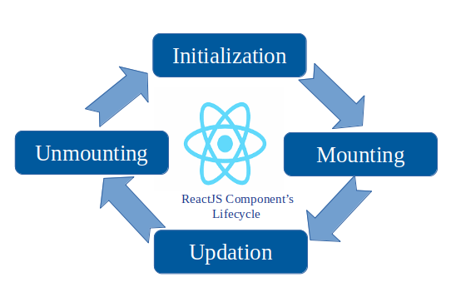

**Hooks:**

In React, "hooks" are functions that allow you to use state and other React features in functional components.

**UseState:**

useState allows you to add state to your functional components. It returns an array with the current state value and a function to update it.

import { useState } from "react";

function App() {

let [counter, setCounter] = useState(0);

const Addvalue = () => {

//console.log("Increase Value:", counter);

counter++;

setCounter(counter);

}

const Removevalue = () => {

counter--;

setCounter(counter--);

}

return (

<>

<h1> My Counter: {counter}</h1>

<button onClick={Addvalue}> Increase </button>

<button onClick={Removevalue}> Decrease </button>

</>

)

}

export default App;

-----------------------------------------------------------------------------------------------------------------------------------

**Props:**

In React.js, "props" is a short form of "properties," and it refers to the mechanism for passing data from a parent component to a child component. Props are a fundamental concept in React and play a crucial role in building reusable and composable components.

<App description = “ReactJS” />

{props.description}

----------------------------------------------------------------------------------------------------------------------------