PRESENTATION SCRIPT
SLIDE 1 — TITLE :
Good morning/afternoon everyone.
Today we are going to present our project, Offline Document AI Chatbot – AI-Powered Local Document Question Answering System.
Our project allows a user to upload a document and ask questions about that document.
The main feature of our project is that the processing is done locally, so we do not need to send the user's documents to an external AI server.
Our team members are Tarik Nasardi, Ali, Premjeet and Bahar.

SLIDE 2 — PROBLEM STATEMENT :
The main problem is that many existing AI document systems depend on cloud services.
For example, if we have a private document and want to ask questions about it, we may have to upload that document to an external server.
This creates a privacy risk.
Also, cloud-based systems require an internet connection and may have subscription or API costs.
The response can also depend on network speed.
So, our project tries to solve these problems by processing the documents and questions locally.

SLIDE 3 — OBJECTIVES :
The main objective of our project is to build an intelligent document question-answering system that works offline and protects user privacy.
Our other objectives are to support multiple file formats, automatically extract information from documents, generate embeddings, perform semantic search and provide accurate answers.
We also want to store the conversation history locally.
Overall, our goal is to provide a secure and useful document question-answering system without depending on external servers.

SLIDE 4 — PROPOSED SOLUTION :
To solve the problems mentioned earlier, we developed an Offline Document AI Chatbot.
First, the user uploads a document.
The system extracts the text from that document and cleans it.
Then the text is divided into smaller parts called chunks.
These chunks are converted into embeddings using Sentence Transformers.
The embeddings are stored in ChromaDB.
When the user asks a question, the system searches ChromaDB and finds the most relevant information.
Finally, the Mistral model generates the answer using the retrieved information.

SLIDE 5 — SYSTEM ARCHITECTURE :
This slide shows the architecture of our system.
First, the user interacts with our application.
The authentication system checks whether the user is allowed to access the application.
Flask handles the backend of the application.
The document processor extracts and processes the document.
Then the embedding engine converts the text into vectors.
These vectors are stored in ChromaDB.
When the user asks a question, ChromaDB retrieves the relevant information.
Ollama runs the Mistral model locally, which generates the final answer.
The answer is then shown to the user through the application.

SLIDE 6 — TECHNOLOGIES USED :
We used different technologies for different parts of the project.
Python is the main programming language.
Flask is used to create the backend web application.
Ollama is used to run the AI model locally.
Mistral is the language model that generates answers.
Sentence Transformers is used to create embeddings.
ChromaDB is used to store and search those embeddings.
PyPDF is used for PDF processing, and Python-Docx is used for DOCX files.
We also use NumPy and Scikit-learn for numerical and machine-learning operations.

SLIDE 7 — FEATURES :
Our system provides several useful features.
It supports local storage and completely offline operation.
It provides intelligent semantic search to find relevant information from documents.
It also provides privacy protection because the data is processed locally.
The system supports multiple file uploads and user authentication.
It also manages chat history and provides vector database support.
Overall, these features make the system secure, private and convenient for document question answering.

SLIDE 8 — SUPPORTED FILE FORMATS :
Our system supports multiple types of documents.
The supported formats are PDF, DOCX, TXT and CSV.
When the user uploads one of these files, the system extracts the information.
Then it cleans the text and divides it into smaller chunks.
After that, metadata and embeddings are generated so that the information can be efficiently searched.

SLIDE 9 — DOCUMENT PROCESSING WORKFLOW :
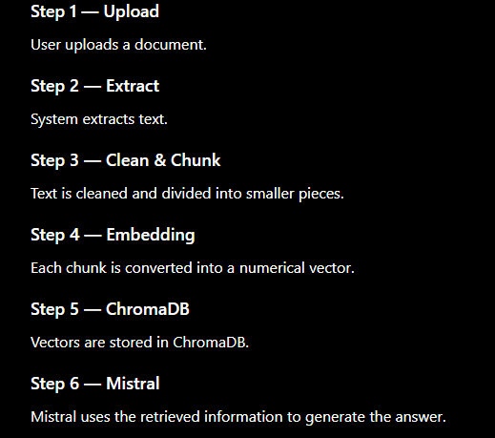
This slide shows the complete document processing workflow.
First, the user uploads a document.
Second, the system extracts the text from the document.
Third, the text is cleaned and divided into smaller chunks.
Fourth, the Sentence Transformer model converts these chunks into numerical embeddings.
Fifth, these embeddings are stored in ChromaDB.
When the user asks a question, the system searches ChromaDB and retrieves the relevant chunks.
Finally, the retrieved information is given to the Mistral model, which generates the final answer for the user.

SLIDE 10 — AUTHENTICATION MODULE :
The authentication module is used to secure our application.
Before accessing the chatbot, the user has to log in.
The system verifies the login information and creates a user session.
It also provides logout functionality and access control.
Therefore, only authenticated users can access the main application.

SLIDE 11 — EMBEDDING ENGINE :
The embedding engine is responsible for converting text into numerical vector representations called embeddings.
We use the all-MiniLM-L6-v2 model from Sentence Transformers.
It converts document chunks into embeddings.
When the user asks a question, the question is also converted into an embedding.
The system can then compare the question with the document embeddings and find the information that has similar meaning.
This helps our chatbot perform semantic search instead of only matching exact keywords.

SLIDE 12 — CHROMADB VECTOR DATABASE :
ChromaDB is the vector database used in our project.
After the document text is converted into embeddings, those embeddings are stored in ChromaDB.
When the user asks a question, the question is converted into an embedding.
ChromaDB compares that query with the stored embeddings and finds the most relevant document chunks.
These relevant chunks are then provided to the Mistral model to generate the answer.
So, in simple words, ChromaDB helps us store and quickly find relevant information from the documents.

SLIDE 13 — FUTURE SCOPE :
There are several improvements that can be added to our project in the future.
We can improve OCR so that the system can understand scanned documents and images.
We can add better user management and GPU acceleration for faster processing.
Voice-based interaction can also be added.
We can support more file formats and develop a mobile application.
Finally, multi-language support can be added so that users can interact with the system in different languages.

SLIDE 14 — CONCLUSION :
To conclude, our Offline Document AI Chatbot provides an intelligent way to interact with documents without depending on cloud servers or the internet.
The system extracts information from documents, creates embeddings, stores them in ChromaDB and uses semantic search to find relevant information.
The Mistral model then uses this information to generate the final answer.
The main advantage of our project is privacy because the processing is performed locally.
Therefore, our project provides a secure, private and cost-effective approach to document question answering.

Questions to be asked and their answers :
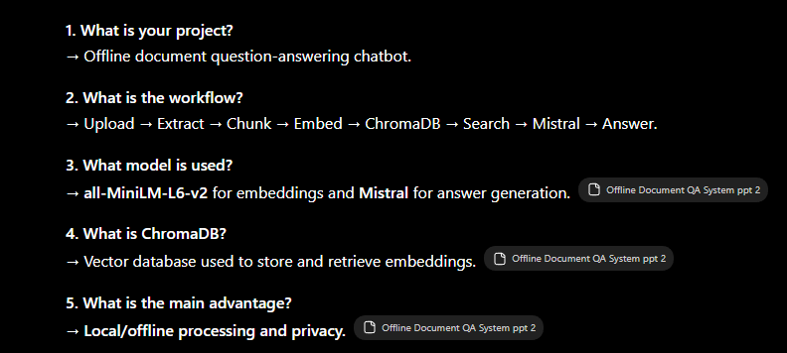

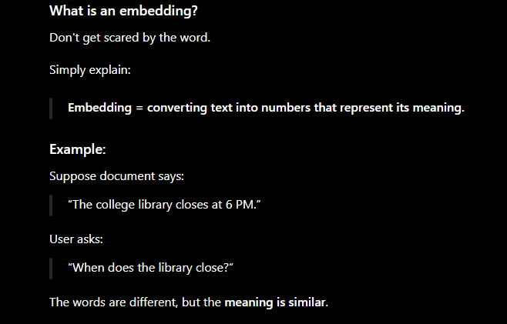

SUPPORTED FILE FORMATS : PDF, DOCX , TXT, CSV.

