SIGNALLINGPROJECT
Milestone 1 — Authentication and Profile Management
Comprehensive Implementation & Testing Report

Course / project | Submission details
Course | NETW704 — Signalling Project
Student | Ali Shaker
University | German University in Cairo (GUC)
Milestone | 1 — Individual
Report date | 30 September 2026
Repository | https://github.com/Alishakergith/SignallingProject

Note: Verify your course code, student ID, instructor and GitHub repository contents before submission. The repository is private; grant your evaluator access if required.

1. Executive Summary
This report documents the implementation of Milestone 1 of SignallingProject, an Android application developed in Kotlin and XML. The milestone focuses on user registration and login with Firebase Authentication, profile entry and editing, and persistent profile storage in Firebase Realtime Database. The application was run on a Pixel 6 Android emulator. Login, profile saving, profile retrieval and logout were exercised during development; screenshots from the Firebase console confirm that the test account and its profile record exist.

2. Objectives and Scope
The objective is to establish a working identity and profile-management foundation for later project milestones. The implemented scope consists of an email/password login screen, an account-registration screen, a protected profile screen, and a backend record keyed by the authenticated user’s Firebase UID. Product catalogs, separate buyer/seller applications, AWS S3 uploads, ordering and VoIP are outside this individual milestone.

3. Tools and Technologies
Component | Purpose
Android Studio / Kotlin | Native Android application logic and activity navigation
XML layouts | Login, registration and profile user interfaces
Firebase Authentication | Email/password account registration and sign-in
Firebase Realtime Database | Persistent JSON-tree profile records indexed by UID
Gradle / Google Services | Firebase SDK dependencies and application configuration
Pixel 6 emulator | Local build, deployment and interaction testing
GitHub | Source-code repository for milestone submission

4. Application Design

4.1 Screens and navigation
MainActivity provides the login interface and a route to SignupActivity. After successful authentication, the user reaches ProfileActivity. The profile screen displays editable name, address and phone fields, a Save Profile button and a Logout button. When there is no authenticated user, ProfileActivity redirects to MainActivity.

4.2 Identity and storage model
Firebase Authentication assigns each account a unique UID. The application writes each user’s profile to the Realtime Database path users/{uid}. This structure associates profile information with the signed-in account and avoids relying on an editable email address as the database key.
JSON field | Type / meaning
name | String — display name
address | String — address
phone | String — telephone number
email | String — authenticated account email

5. Implementation

5.1 Authentication
The application uses FirebaseAuth to register or sign in users with email and password. ProfileActivity checks auth.currentUser and redirects unauthenticated users to the login activity. Logout calls auth.signOut() and returns to MainActivity, clearing the activity task so the prior profile screen is not left available through Back navigation.

5.2 Realtime Database integration
The corrected implementation uses com.google.firebase.database.FirebaseDatabase, not Cloud Firestore. On opening the profile screen, it reads users/{uid} and populates the three editable fields if a record exists. Save Profile trims user input, rejects empty name/address/phone fields, and calls setValue(profile). Success and failure listeners show a Toast message reflecting the result.
Representative Kotlin logic:
val database = FirebaseDatabase.getInstance()
.getReference("users").child(user.uid)
database.get() // load existing profile
database.setValue(profile) // save updated profile
The Firebase BoM coordinates SDK versions. The app-level Gradle dependencies include firebase-auth and firebase-database. The earlier Firestore implementation was replaced to match the milestone requirement for Realtime Database.

5.3 Security considerations
Database access should be restricted so authenticated users can read and write only users/{their UID}. The recommended Realtime Database rules use auth != null and auth.uid === $uid for both read and write operations. The current console Rules tab was not included in the provided evidence, so the published rules should be verified before final submission. Passwords are handled by Firebase Authentication and are not stored in the profile record.

6. Testing and Results
Test case | Observed result
Build and launch | App installed and launched on Pixel 6 emulator
Registration | Existing test email reported as already registered; account appears in Firebase Authentication
Login | Existing test account signed in and opened profile
Profile save | App displayed “Profile saved successfully”
Database verification | Realtime Database console shows users/{uid} with name, address, phone and email
Persistence | Profile details were reported to reload after reopening/signing in
Logout | Logout was exercised and returned to login

These are functional tests observed during the development conversation, not a comprehensive automated test suite. Additional recommended checks include invalid credentials, offline behavior, concurrent edits, input validation, and access rules.

7. Evidence
Figure 1 shows the final Firebase Realtime Database record. The record is under users and is keyed by the Firebase Authentication UID, with the four required profile fields.
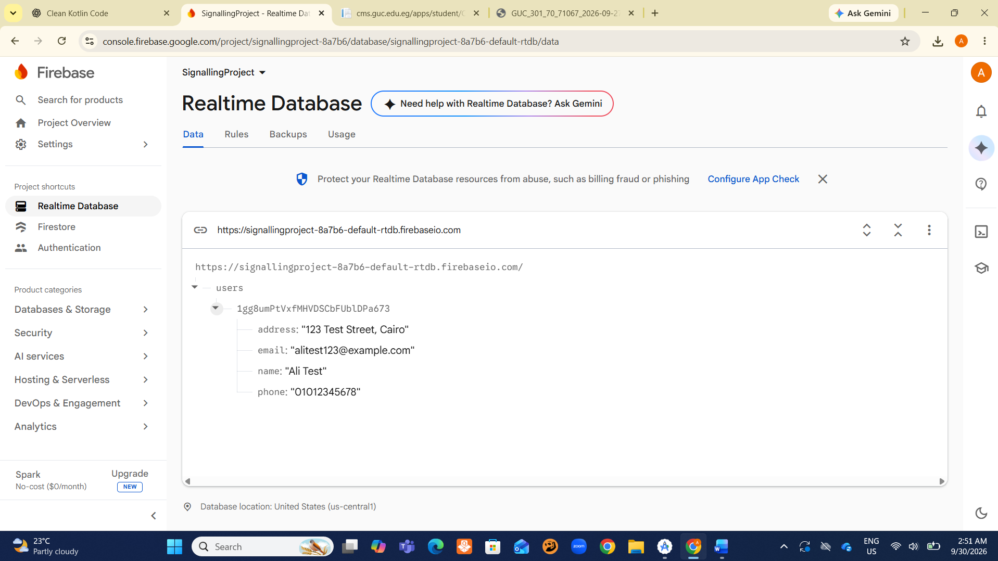
Figure 1. Firebase Realtime Database — saved test profile.
Figure 2 shows the Firebase Authentication Users page and the registered test account. The UID links the authentication identity to the database profile.
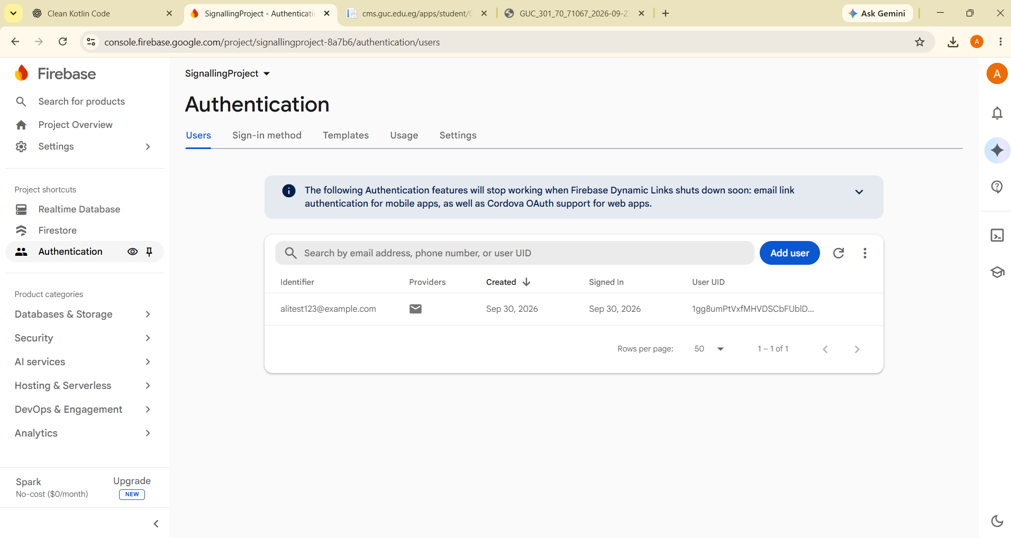
Figure 2. Firebase Authentication — registered test account.

8. Challenges and Resolutions
Issue | Resolution
Emulator storage and launch difficulties | Freed disk space, completed emulator setup and reran the application
Previous app instance could not be terminated | Relaunched the application after stopping the old instance
Initially used Cloud Firestore | Updated Kotlin code and Gradle dependency to Firebase Realtime Database; saved the profile again
Realtime Database initially displayed null | Retested the corrected build and confirmed the users/{uid} record
Git executable unavailable | Used GitHub’s browser-based repository upload workflow

9. Repository and Submission
Repository URL: https://github.com/Alishakergith/SignallingProject
The repository was created as private. Before submitting, confirm that all essential Kotlin/XML source files, Gradle scripts, Gradle wrapper files and Firebase application configuration were successfully committed. Do not upload local.properties, generated build directories, passwords or service-account private keys. Invite the course evaluator if private-repository access is required.
Submission evidence includes the Realtime Database screenshot and the Firebase Authentication screenshot. Add the team formation form confirmation and any institution-specific cover information if requested by the course.

10. Conclusion
The implemented milestone demonstrates a functional Android authentication and profile-management workflow using Firebase Authentication and Firebase Realtime Database. The app was built and launched, the test account was visible in Firebase Authentication, and the profile data was visible in the required Realtime Database structure. Remaining pre-submission checks concern the published database security rules, completeness and accessibility of the GitHub repository, and any additional course administrative requirements.

References
GUC NETW704, Signalling Project — Milestone 1 instructions and tutorial slides (2026).
Firebase Documentation, Authentication for Android: https://firebase.google.com/docs/auth/android/password-auth
Firebase Documentation, Realtime Database for Android: https://firebase.google.com/docs/database/android/start
Android Developers, Android Studio: https://developer.android.com/studio

