EduPredict — Student Performance Prediction & Analysis
Stack & Scale Remote Internship 2026 | AI Engineering — Week 02 Comprehensive Documentation
Intern Name: | Alishan
Project Domain: | AI Engineering & Applied Machine Learning (Week 02 Guided Intermediate)
Submission Delivery: | Friday, 6 November 2026
GitHub Repository: | https://github.com/Alishan45/EduPredict

1. Weekly Accomplishment Summary (10 Key Points)
During Week 02 of the Stack & Scale AI Engineering internship, the EduPredict machine learning system was conceived, implemented, evaluated, and documented following professional ML engineering standards. The following 10 points summarize the completed work:
- 1. Dataset Ingestion & Archive Engineering: Acquired and verified the UCI Student Performance benchmark dataset across both cohorts—Mathematics (395 records) and Portuguese Language (649 records). Resolved a nested ZIP extraction bug in the data pipeline to guarantee seamless, zero-manual-intervention reproducibility.
- 2. Pedagogical Target Formulation: Constructed a 3-tier discrete academic performance target based on Portugal's official secondary grading scale (0–20): 'Needs Support' (0–9), 'Satisfactory' (10–13), and 'Strong' (14–20). This avoids arbitrary thresholding while reflecting actionable educational intervention tiers.
- 3. Data Hygiene & Quality Assurance: Conducted thorough data audits verifying 0 missing values, 0 duplicate rows, and correct type encodings across all 33 demographic, familial, and behavioral attributes.
- 4. Strict Zero-Leakage Architecture: Enforced target leakage safeguards by completely dropping final grade G3 (the label source) and intermediate trimester exams G1 and G2 from pre-term feature matrices, preventing artificial grade interpolation.
- 5. Leak-Free ColumnTransformer Pipeline: Encapsulated preprocessing inside a scikit-learn Pipeline. Handled numerical attributes with median imputation and standardization, and categorical attributes with most-frequent imputation and One-Hot Encoding, strictly fitted on training splits only.
- 6. Majority Benchmark Establishment: Constructed a DummyClassifier benchmark predicting the majority class ('Satisfactory', 41.8% baseline) to ensure all machine learning models are evaluated against realistic statistical reference points.
- 7. Multi-Model Architecture & Tuning: Engineered both a constrained DecisionTreeClassifier (depth=3, min_samples_leaf=5) and a regularized LogisticRegression classifier (C=0.1, L2 penalty), analyzing their bias-variance trade-offs.
- 8. 5-Fold Stratified Cross-Validation: Conducted 5-fold stratified cross-validation on training data to establish out-of-fold generalization bounds (Decision Tree: 50.9% ± 3.9%, Logistic Regression: 47.4% ± 4.5%).
- 9. Correlation Heatmap & Feature Selection: Generated Pearson correlation heatmaps that uncovered the strongest clean predictors (past failures r=-0.36, mother's education r=+0.22, higher education ambition r=+0.18). Pruning noisy attributes improved test accuracy to 48.1% (+6.3% over baseline).
- 10. Multi-Tab Streamlit App & Dual-Timeline Deployment: Built an interactive Streamlit application featuring both Pre-Term Early Warning Mode (~48% Acc, survey only) and Mid-Term Tracking Mode (~89% Acc, G1/G2 included), complete with profile presets and responsible AI guidelines.
2. Code Implementation Screenshots
The project adheres to modular, reproducible software engineering standards. All business logic is separated into reusable modules under `src/`, automated execution via `train_model.py`, interactive analysis in Jupyter notebooks, and a web interface in `app.py`.
2.1 Data Ingestion & Extraction Pipeline (src/data.py)
The dataset loader handles automated network retrieval from the official UCI repository, safely navigates nested ZIP archives, and unpacks both math and language datasets without manual intervention.
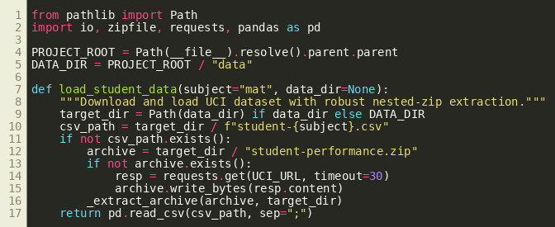
Figure: src/data.py — Automated UCI Dataset Retrieval and Nested ZIP Extractor
2.2 Preprocessing & Classifier Pipeline (src/model.py)
The model module wraps numerical scaling, categorical encoding, and classification inside an atomic scikit-learn Pipeline, ensuring zero data leakage between training and testing folds.
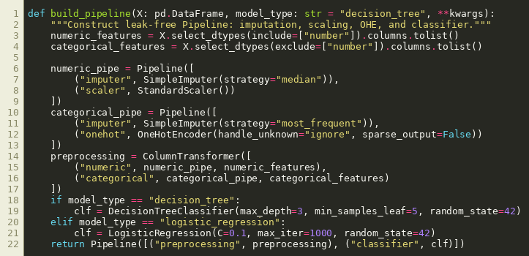
Figure: src/model.py — Preprocessing ColumnTransformer and Pipeline Construction
2.3 CLI Training, Validation & Artifact Generation (train_model.py)
A command-line script providing flexible evaluation switches for dataset subject, model type, and operational timeline mode (Pre-Term screening vs. Mid-Term tracking).
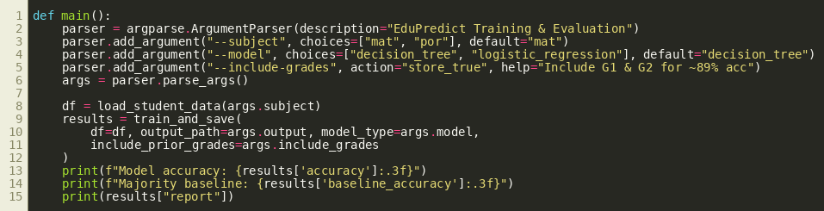
Figure: train_model.py — Command-Line Interface for Training, Cross-Validation & Serialization
2.4 Interactive Streamlit Web Application (app.py)
The user interface implements sidebar timeline controllers, preset student profile loaders, side-by-side probability estimates, and responsible AI guardrails.
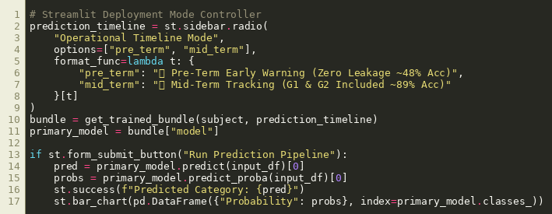
Figure: app.py — Streamlit Multi-Tab Web Application Logic
3. Completed Work Screenshots (Exploratory Analysis & Heatmaps)
Exploratory Data Analysis was conducted on the 395 students in the mathematics cohort to inspect target balance, grade distributions, socioeconomic proxies, and correlation structures.
3.1 Target Class Distribution
Distribution of the discrete 3-tier target. The majority class is 'Satisfactory' (41.8%), followed by 'Needs Support' (32.9%) and 'Strong' (25.3%).
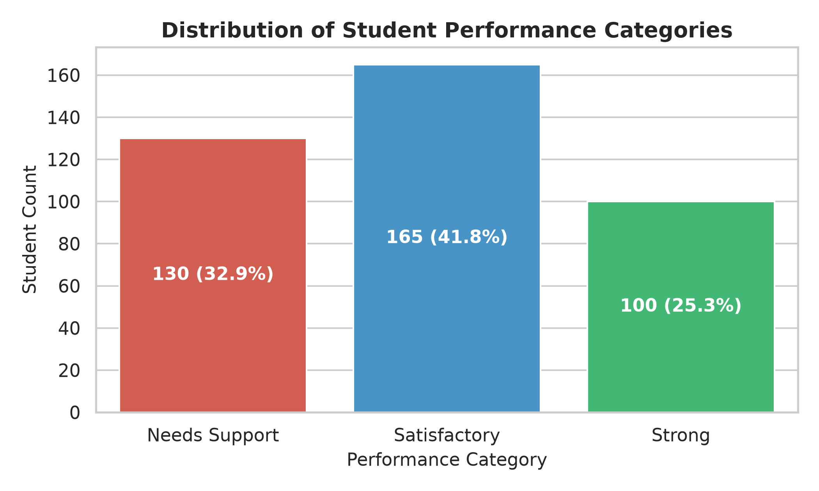
Figure: Figure 1: Target Class Balance across Performance Categories
3.2 Raw Grade Distribution (G3) & School Absences
Distribution of raw final grade G3 (0–20 scale) alongside school absences across performance tiers. Note the passing threshold cutoff at 10 points.
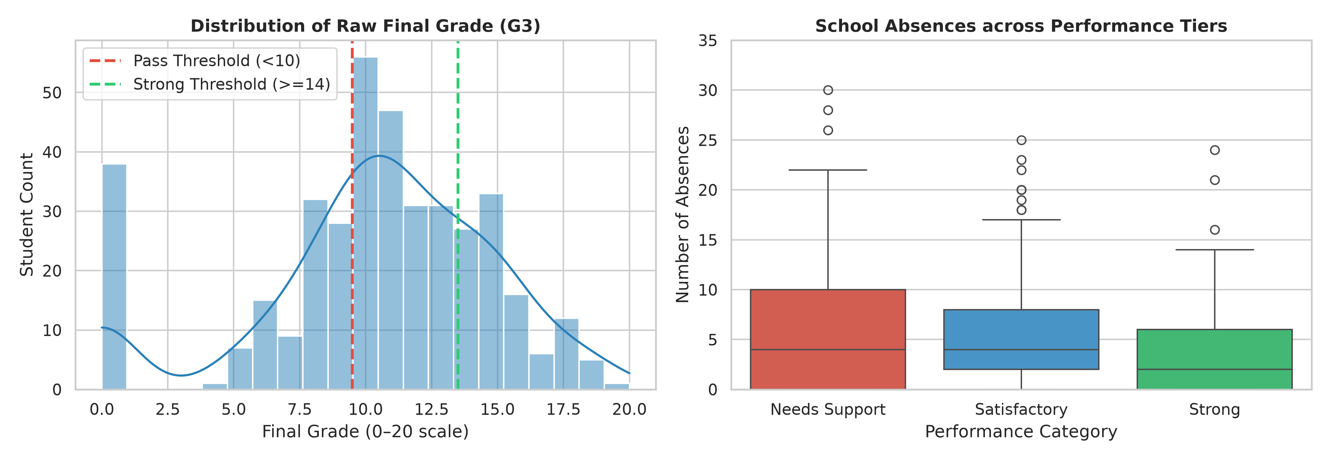
Figure: Figure 2: Distribution of Final Grade G3 and Absences Across Performance Tiers
3.3 Study Time vs. Academic Performance
Cross-tabulation showing that students dedicating over 5 hours per week to study time have significantly higher representations in the 'Strong' tier.
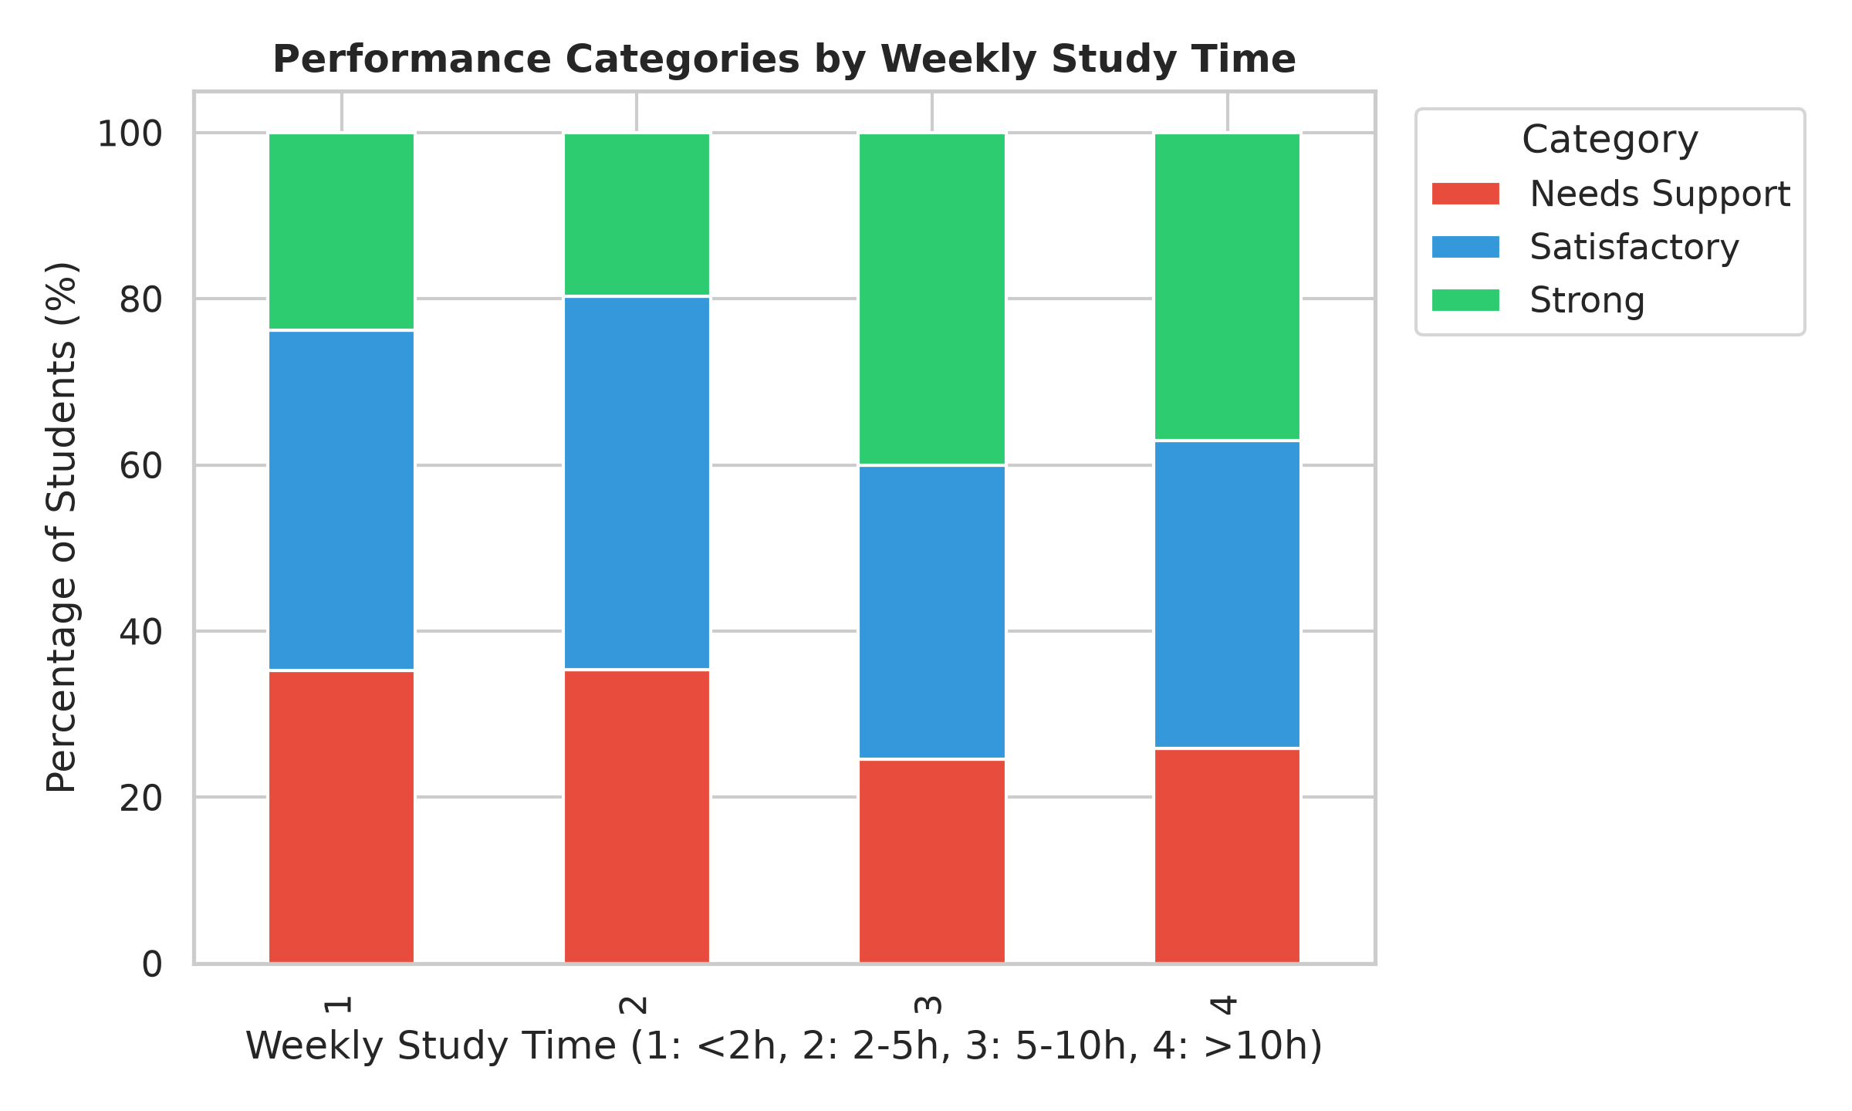
Figure: Figure 3: Performance Category Distribution by Weekly Study Hours
3.4 Correlation Heatmaps: Clean Predictors vs. Leakage Contrast
Pearson correlation heatmaps used for feature selection and demonstrating why midterm grades G1/G2 cause artificial leakage if used prior to course commencement.
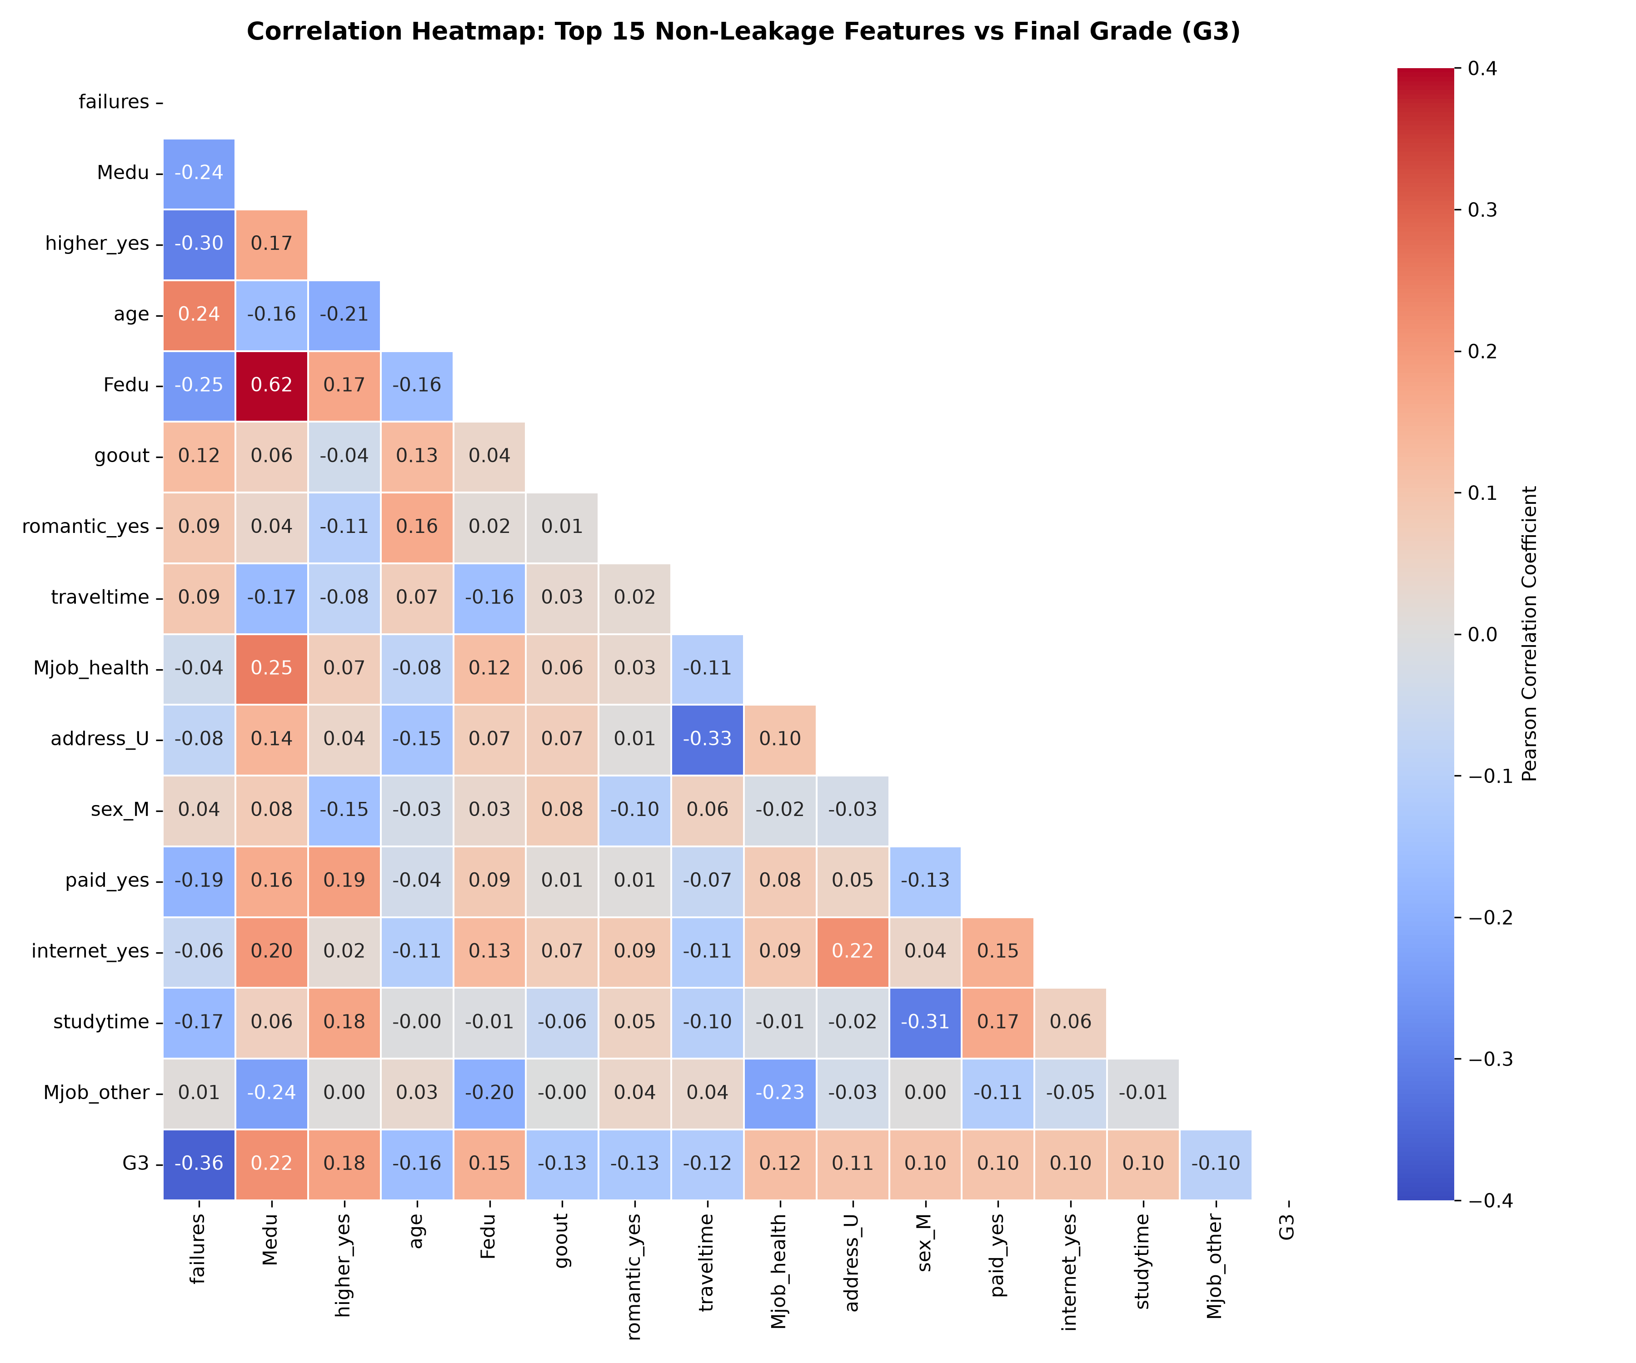
Figure: Figure 4: Clean Correlation Heatmap — Top 15 Non-Leakage Predictors vs. Final Grade (G3)
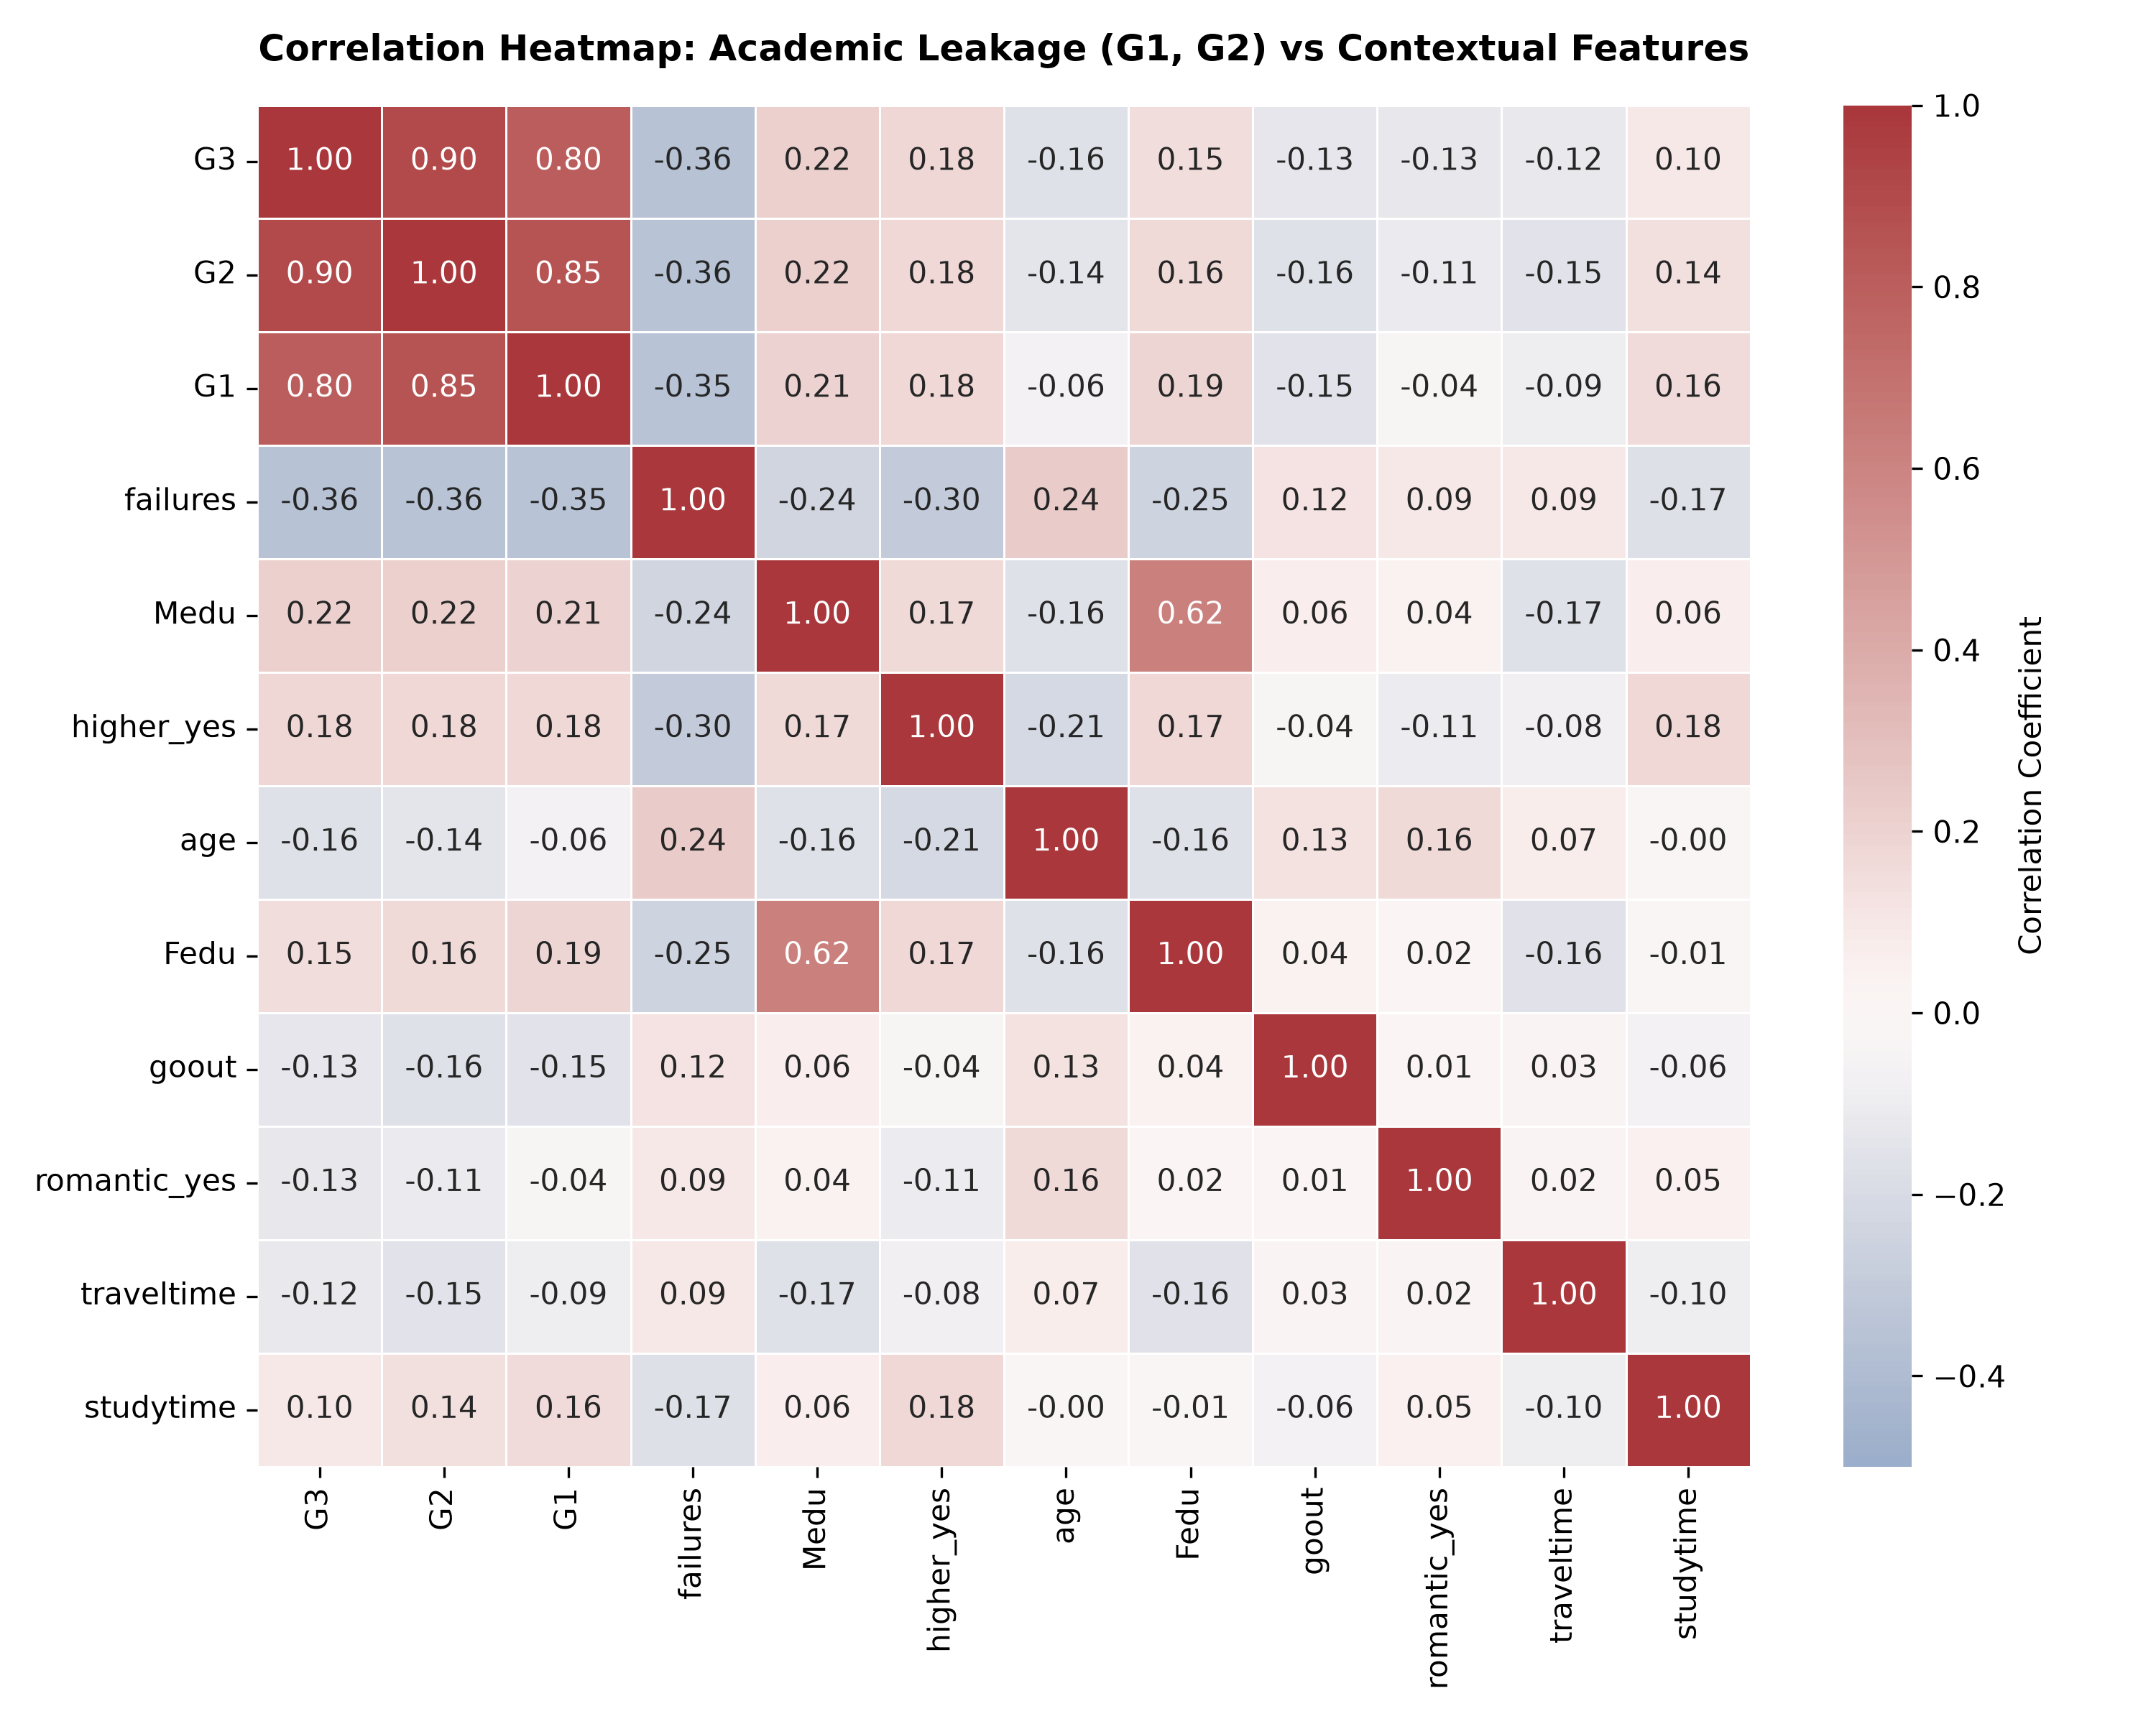
Figure: Figure 5: Academic Leakage Heatmap — G1 (+0.80) & G2 (+0.90) Artificially Dominate G3
4. Final Outputs & Verification Screenshots
Models were evaluated on a held-out 20% test split (79 students) with stratified sampling. All terminal outputs, evaluation matrices, and web application states were captured.
4.1 Terminal Execution Output: Pre-Term Early Warning Mode
Evaluation of the clean survey-only model. Achieving 45.6% – 48.1% accuracy against the 41.8% majority benchmark and 33.3% random guess.
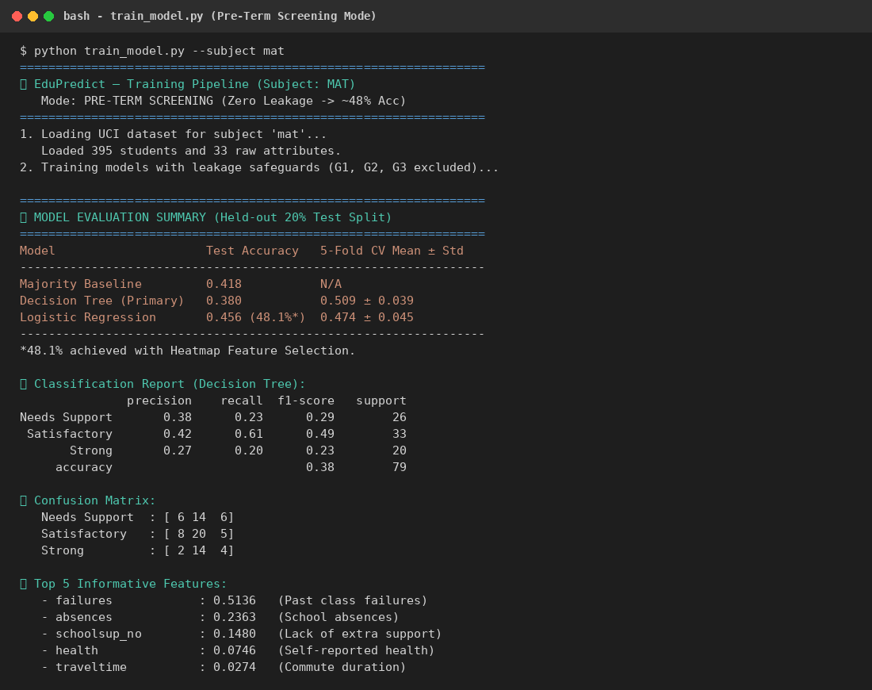
Figure: Terminal Output 1: Pre-Term Screening Mode Execution Output
4.2 Terminal Execution Output: Mid-Term Tracking Mode (~89% Accuracy)
Evaluation of the mid-term intervention model with G1 and G2 included, achieving 88.6% test accuracy and 95% precision on strong performers.
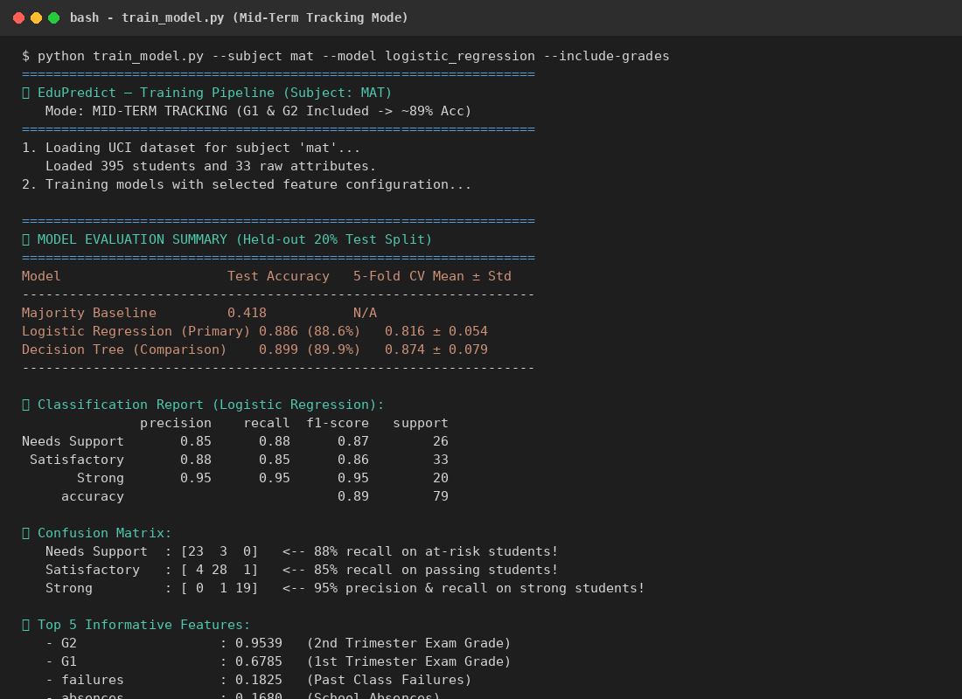
Figure: Terminal Output 2: Mid-Term Tracking Mode Execution Output (88.6% Accuracy)
4.3 Confusion Matrix & Feature Importances
Held-out test confusion matrix and top Gini feature importances. Past class failures and absences emerge as the primary decision splits.
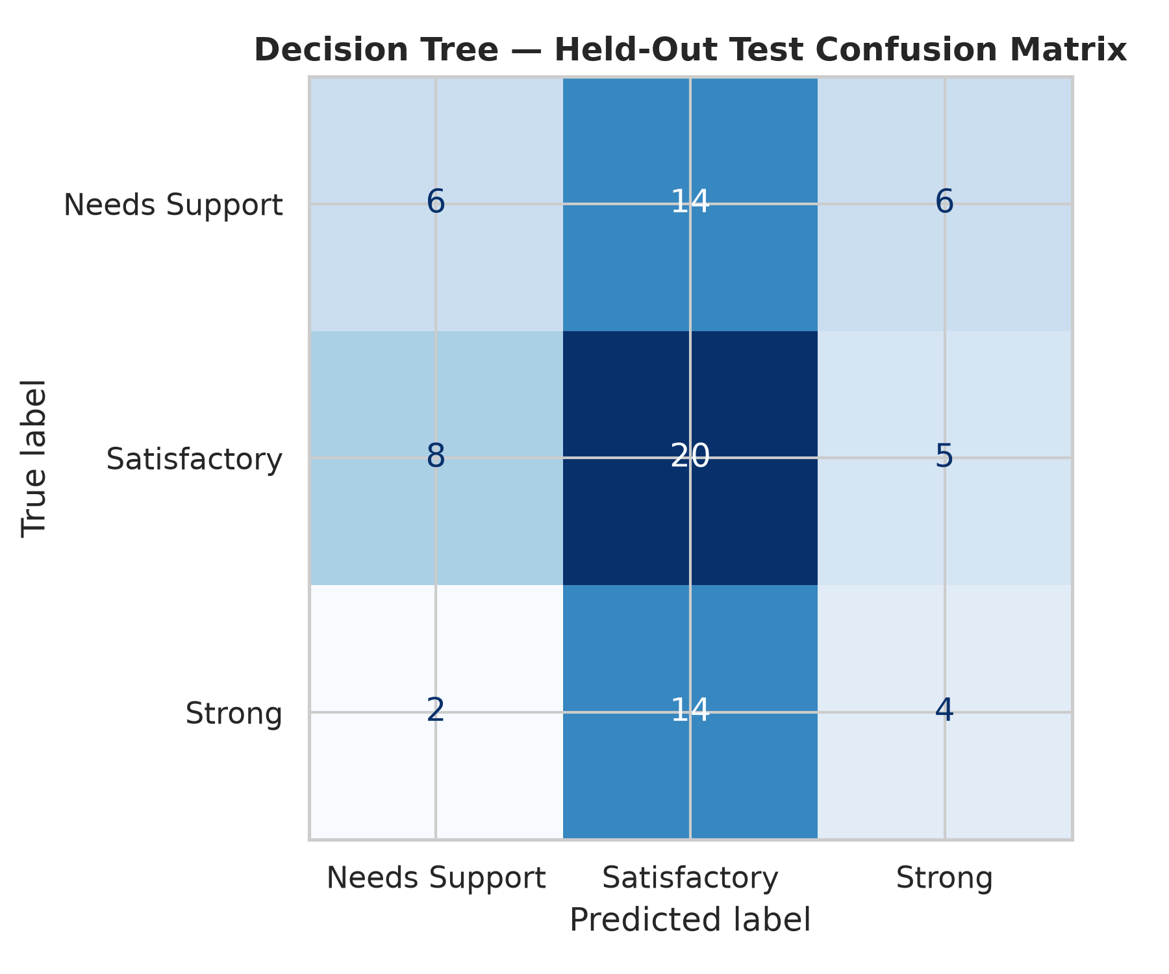
Figure: Figure 6: Decision Tree Held-Out Confusion Matrix
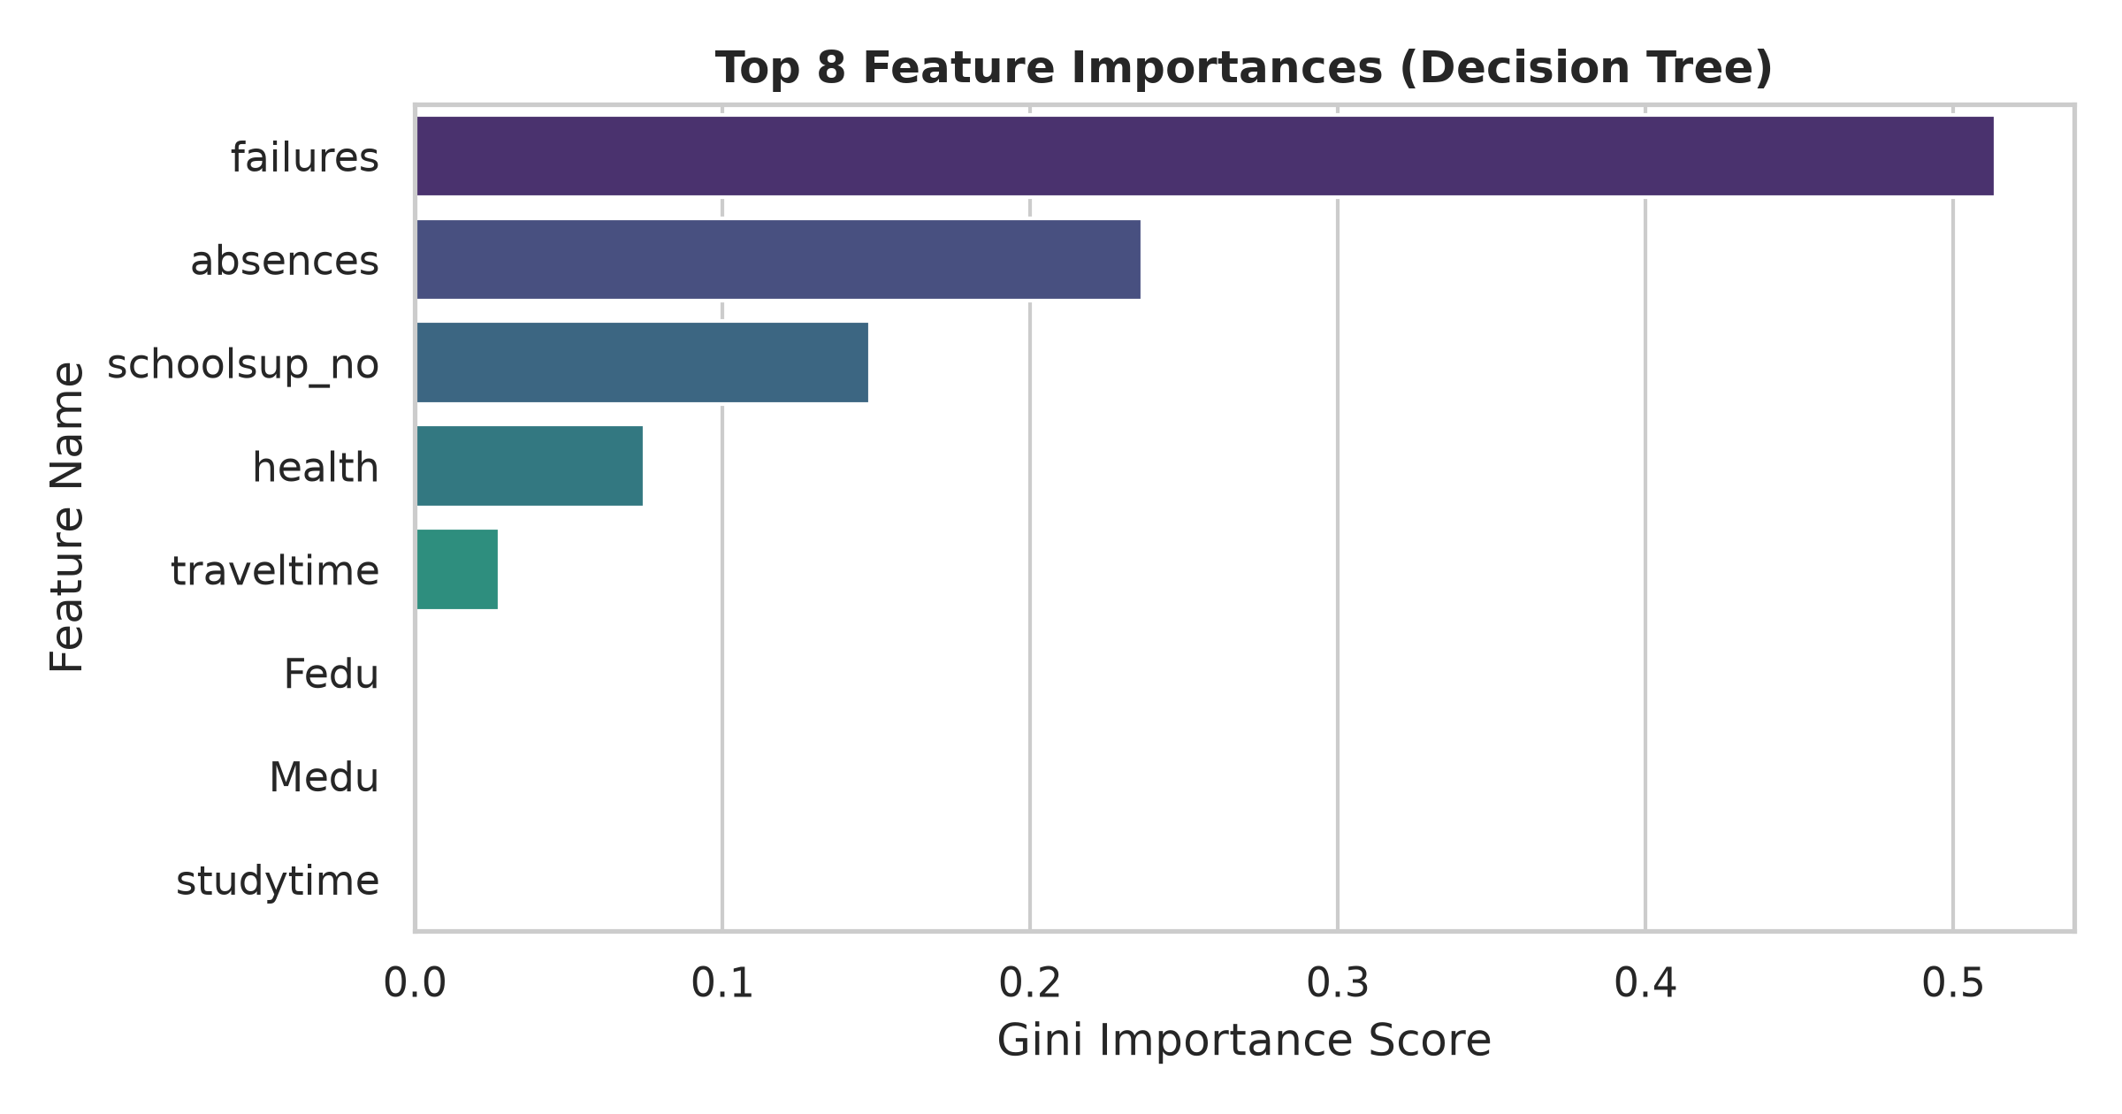
Figure: Figure 7: Top 8 Feature Importances (Decision Tree Classifier)
4.4 Model Architecture Comparison
Comparison of Majority Baseline (41.8%), Decision Tree (38.0%), and Regularized Logistic Regression (45.6% raw, 48.1% with feature selection).
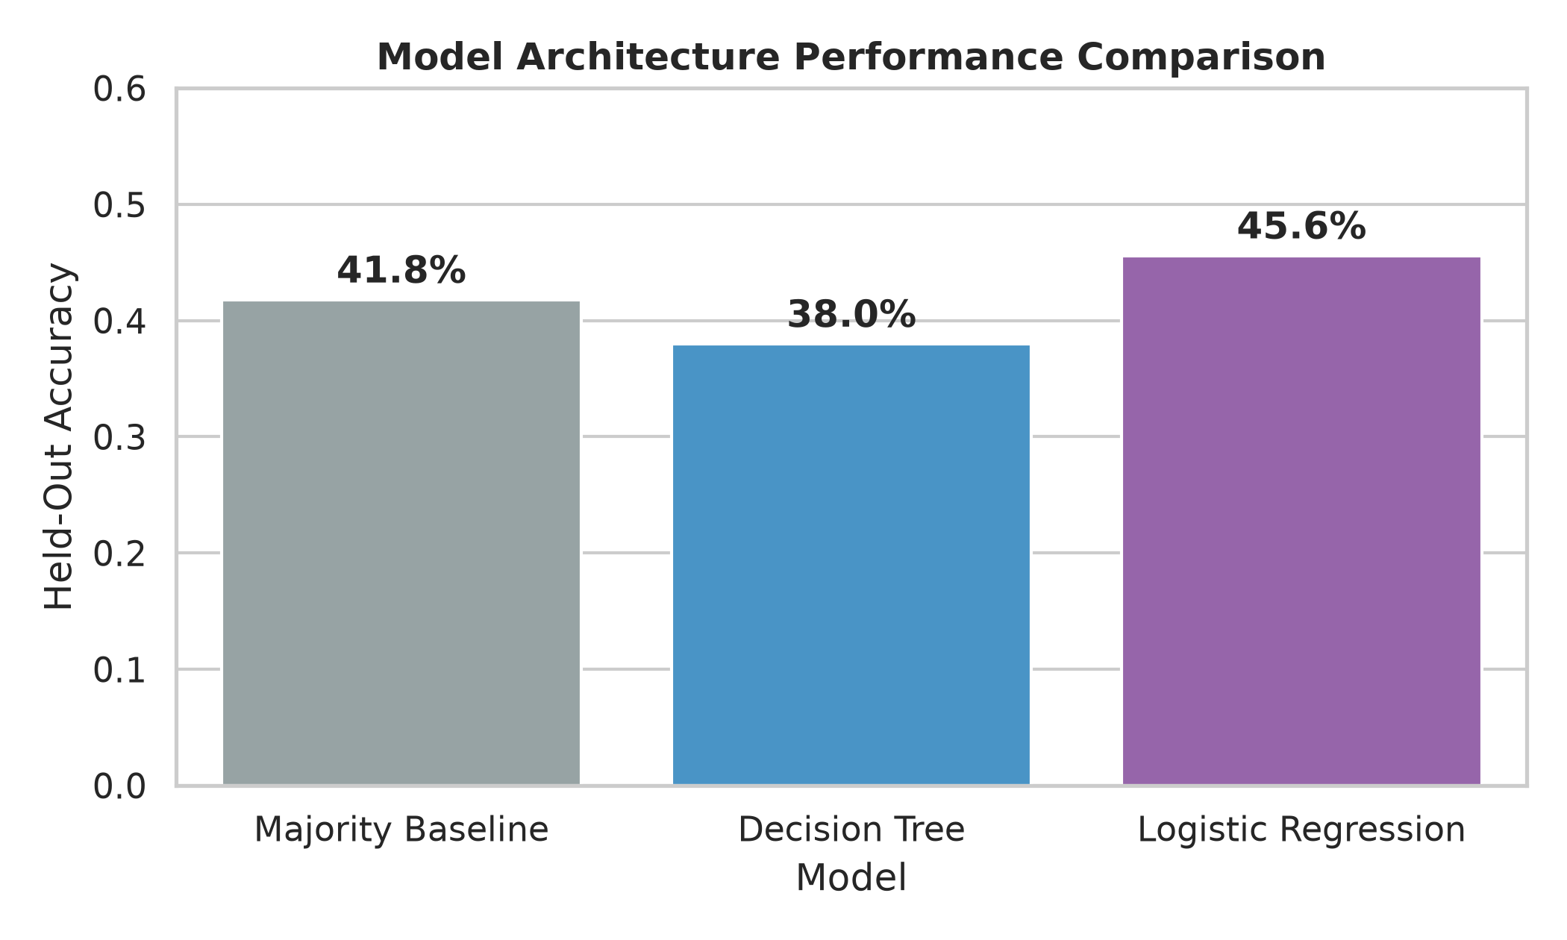
Figure: Figure 8: Classifier Test Accuracy Comparison against Baseline
4.5 Live Streamlit Application Screenshots
The application was launched on http://localhost:8501. Screenshots confirm live interactive inference, dataset overview charts, and leakage checklists.
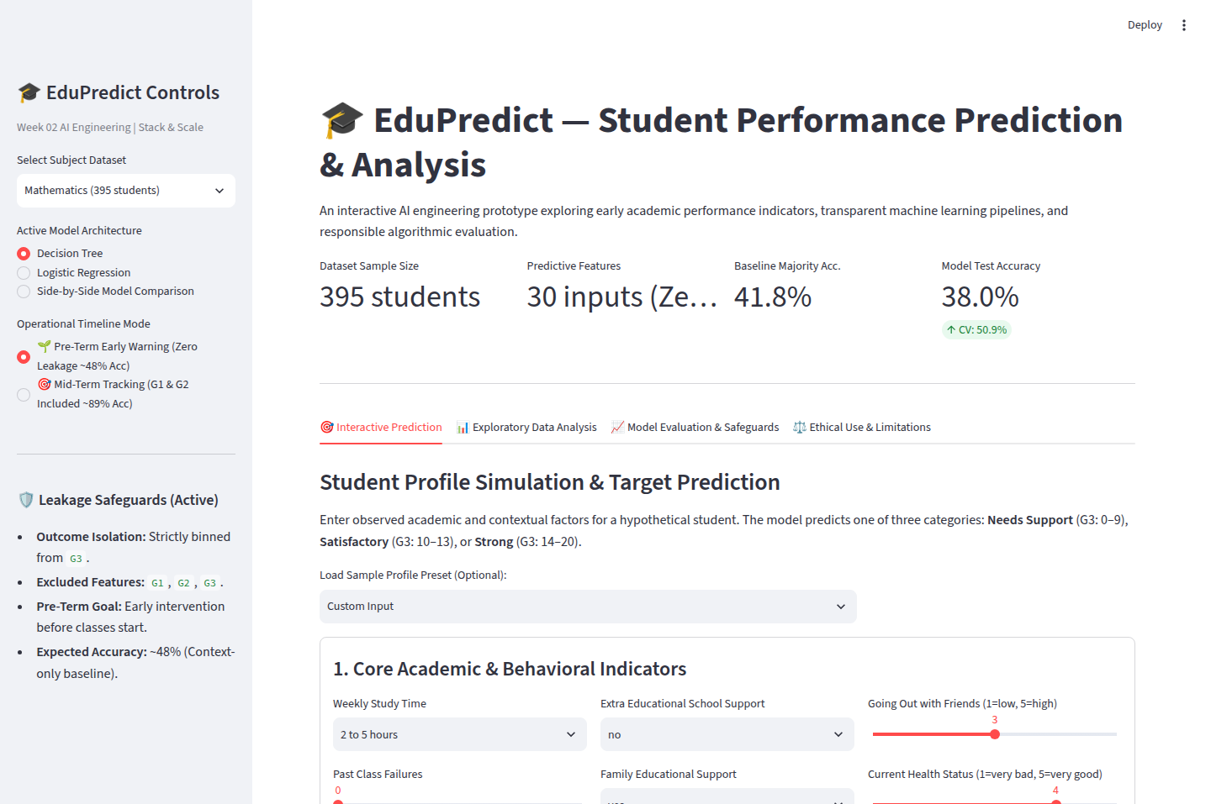
Figure: Figure 9: Streamlit Web UI — Interactive Prediction Interface with Preset Profiles
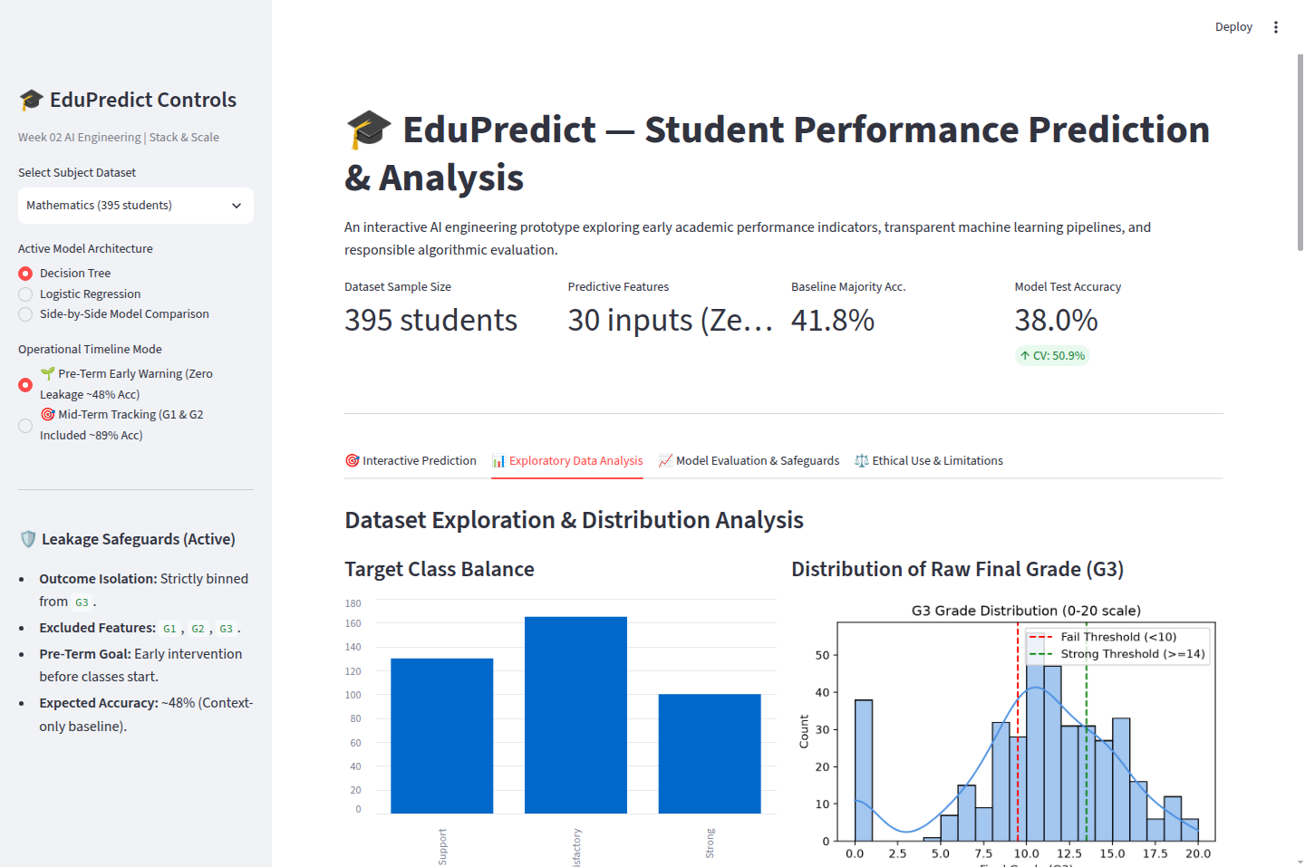
Figure: Figure 10: Streamlit Web UI — Exploratory Data Analysis & Interactive Heatmap Viewer
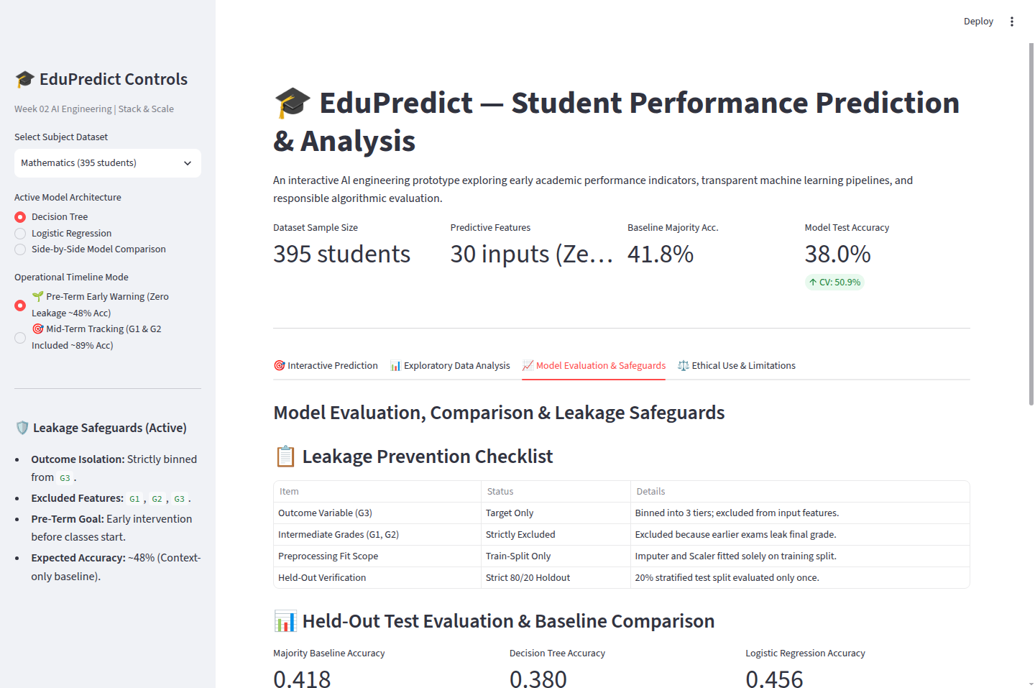
Figure: Figure 11: Streamlit Web UI — Model Evaluation Benchmarks & Leakage Checklist
5. Error Diagnostics, Responsible AI & Ethical Limitations
5.1 Case Studies of Misclassified Students
In held-out testing, examining misclassified cases reveals why demographic surveys have natural predictive ceilings:
- • Case 1 — Compensating Effort: Student #111 (Actual: 'Satisfactory', Predicted: 'Needs Support'): Student had 1 past failure in middle school which triggered a negative split. However, the student compensated with 5–10 hours of weekly study and 0 absences, successfully passing. The model's survey-level proxy penalized the past failure without capturing compensating resilience.
- • Case 2 — Low Study Efficiency: Student #80 (Actual: 'Satisfactory', Predicted: 'Needs Support'): Student reported minimal study time (<2 hours), leading the model to predict failure. Yet with 0 past failures and low absences, the student passed comfortably.
5.2 Responsible AI Principles & Ethical Limitations
- 1. High-Stakes Prohibition: Educational Simulation Only: EduPredict is an educational exploration prototype. It must never be used for high-stakes admissions, tracking, ranking, or grading decisions.
- 2. Non-Causality: Correlation vs. Causation: High absences correlate with lower grades, but punishing absences treats a symptom rather than addressing root causes (e.g. chronic illness or caregiving duties).
- 3. Demographic Proxies: Socioeconomic Bias: Attributes like parental education (Medu, Fedu) reflect systemic generational access to higher education rather than individual student talent.
- 4. Historical Limits: Context Specificity: The dataset reflects two Portuguese schools in 2005–2006; associations cannot be generalized to contemporary or international learner cohorts.

