FreshBasket
Online Fresh Fruits, Vegetables, and Essential Grocery Delivery Platform
____________________________________________________
Documentation (First Deliverable)
Software Requirements Specification and System Design
Document Version: | Version 1.0
Course Code & Title: | CS619 Final Project
Group ID: | F26PROJECT56E94
Student ID: | BC250206138
Supervisor Name: | Muhammad Hassaan
Supervisor Email: | m.hassaan@vu.edu.pk

Department of Computer Science
Virtual University of Pakistan
Semester Fall 2026

Revision history
The table below records the revision versions and development notes for this first deliverable specification.
Date (dd/mm/yyyy) | Version | Description | Author
28/10/2026 | 1.0 | Initial complete first deliverable: SRS, use cases, work plan Gantt, ERD, database schema, and interface designs | BC250206138
09/11/2026 | 1.1 | Formal submission of Documentation deliverable to Virtual University portal | BC250206138
07/01/2027 | 2.0 | Final deliverable source code, database scripts, and project defense submission | BC250206138

Table of contents
1. Introduction of document ................................................. 3
1.1 Purpose of the document .............................................. 3
1.2 Purpose and benefits of the first deliverable phase .................. 3
1.3 Structural inclusions of this specification .......................... 4
2. Scope (of the project) ................................................... 5
2.1 Problem definition and background .................................... 5
2.2 System goals ......................................................... 5
2.3 User roles and responsibilities ...................................... 6
2.4 Functional boundaries and limits ..................................... 6
2.5 Technology selection ................................................. 7
3. Functional requirements and non-functional requirements .................. 8
3.1 Detailed functional requirements (FR-01 to FR-10) .................... 8
3.2 Comprehensive non-functional requirements (NFR-01 to NFR-05) ......... 11
4. Use case diagram ......................................................... 13
4.1 System actors and operational roles .................................. 13
4.2 Use case diagram ..................................................... 14
4.3 Use case tabular specifications ...................................... 15
5. Work plan ................................................................ 18
5.1 Work breakdown structure and calendar phases ......................... 18
5.2 Project Gantt chart .................................................. 19
5.3 Milestone schedule and deliverables table ............................ 20
6. Entity relationship diagram (ERD) ........................................ 21
6.1 Conceptual data model and cardinalities .............................. 21
6.2 Entity relationship diagram .......................................... 22
6.3 Entity dictionary and attribute definitions .......................... 23
7. Database design .......................................................... 25
7.1 Relational database schema structure ................................. 25
7.2 Physical relational schema diagram ................................... 26
7.3 Complete database table specifications ............................... 27
8. Interface design ......................................................... 31
8.1 User interface layout and responsive principles ...................... 31
8.2 Storefront catalog and hub selector .................................. 32
8.3 Produce details and farm origin display .............................. 33
8.4 Shopping cart and cash on delivery checkout .......................... 34
8.5 Real-time five-stage order tracking portal ........................... 35
8.6 Administrative dashboard and logistics console ....................... 36

1. Introduction of document
1.1 Purpose of the document
This document is the official first deliverable for the FreshBasket final project. The document specifies the functional requirements, non-functional quality standards, structural models, database designs, and user interface layouts for the web application. It establishes a verifiable technical agreement between student BC250206138, supervisor Muhammad Hassaan, and the Virtual University evaluation committee.
The document defines system behavior before source code implementation begins. It translates the general problem statement into exact software modules, data entities, process workflows, and user interfaces.
1.2 Purpose and benefits of the first deliverable phase
The requirements and design phase is the foundation of the software development lifecycle. In the 1981 textbook Software Engineering Economics, Barry Boehm documented that finding and fixing software errors during the early requirements phase costs 50 to 100 times less than correcting defects after deployment. Defining system scope and data structures before coding prevents architectural rework and keeps development focused on required features.
The first deliverable phase provides five concrete benefits to the project:
1. Scope boundary definition: The document defines what features belong in the system and what features are excluded. It sets clear limits on order fulfillment, delivery tracking, and administrative controls.
2. Supervisor review and alignment: The specification provides project supervisor Muhammad Hassaan with a structured plan to verify academic rigor and functional feasibility before programming starts.
3. Traceable software architecture: Every user interface and database table connects directly to a numbered functional requirement (FR-01 to FR-10).
4. Implementation blueprint: The relational database schemas, data types, and primary key constraints give the developer exact specifications for writing backend code.
5. Quality baseline for testing: The non-functional requirements provide concrete performance, security, and usability criteria for final viva evaluation.
1.3 Structural inclusions of this specification
This first deliverable document contains eight analytical sections:
• Scope (of the project): Explains agricultural supply issues, user roles, system boundaries, and technology components.
• Functional and non-functional requirements: Details ten core functional modules and five software quality attributes.
• Use case diagram: Models four user roles (Customer, Administrator, Logistics Supervisor, Supplier) with complete use case scenarios.
• Work plan: Presents the 11-week project calendar, milestone schedule, and Gantt chart covering both assignments.
• Entity relationship diagram (ERD): Specifies 14 data entities, Crow's foot cardinalities, and relationship rules.
• Database design: Details normalized SQLite relational schemas, primary and foreign key constraints, and 14 data dictionaries.
• Interface design: Contains high-resolution screenshots and walkthroughs of five primary application screens.

2. Scope (of the project)
2.1 Problem definition and background
Fresh produce distribution in Pakistan faces physical and organizational bottlenecks. Fruits and vegetables pass through multiple wholesale commission agents, open-air mandis, and ambient roadside vendors over three to six days. This extended transit time causes up to 40 percent post-harvest spoilage. Consumers also encounter arbitrary daily price markups, inaccurate weights, and artificial chemical ripening agents like calcium carbide.
FreshBasket addresses these problems through a direct online grocery marketplace. The platform connects urban households with fresh produce sourced directly from regional farming clusters and controlled cold-chain centers. Orders placed on the website are packed at regional hubs and dispatched to customer doorsteps in temperature-monitored crates within 24 hours of harvest.
2.2 System goals
The FreshBasket application satisfies four core objectives:
a. Direct farm sourcing: Provide urban consumers with seasonal fruits and vegetables harvested within 24 hours.
b. Flexible measurement units: Support real-world grocery purchasing by weight (kilograms, grams), count (individual pieces), or volume (dozens) with accurate price calculation.
c. Order transparency: Track delivery progression through five verifiable stages (Pending, Confirmed, Packed, Out for Delivery, Delivered) with courier location updates.
d. Operational governance: Supply store administrators and logistics supervisors with tools to inspect produce quality, manage inventory stock, monitor sales, and resolve customer complaints.
2.3 User roles and responsibilities
The platform serves four user roles with distinct operational permissions:
1. Customer: Searches the catalog, filters products by category, detects location via Geoapify geolocation, builds a shopping cart, places Cash on Delivery orders, tracks delivery progress, writes reviews, and files complaints.
2. Store Administrator: Manages products and categories, sets inventory thresholds, inspects produce batches, moderates product reviews, and answers customer complaint tickets.
3. Logistics Supervisor: Monitors active orders, assigns delivery couriers, advances the five-stage order status, and coordinates regional dispatch hubs.
4. Farmer or Supplier: Submits harvest lots, updates produce availability, and tracks batch receipts at local collection points.
2.4 Functional boundaries and limits
The functional scope includes:
• User account registration, profile management, and multiple saved delivery addresses.
• Online catalog of fruits and vegetables with nutritional details, freshness grades, and harvest dates.
• Multi-unit shopping cart with automatic price recalculation and coupon code validation.
• Cash on Delivery checkout with delivery time-slot selection and special delivery instructions.
• Real-time five-stage order fulfillment tracking with courier route visualization.
• Geoapify geolocation services for automatic address resolution and nearest regional hub detection.
• Customer complaint ticket management with automated Gmail SMTP email dispatch.
• Post-delivery customer ratings and reviews.
The project excludes the following items:
• Third-party electronic payment gateway integration (credit card or debit card processing is excluded; Cash on Delivery is the sole payment method).
• Cross-border international delivery.
• Automated drone delivery hardware.
2.5 Technology selection
The FreshBasket project uses modern web engineering tools across the full application stack:
• Frontend: React 18 with Vite build tool, React Router 6, and Tailwind CSS.
• Backend: Node.js with Express web framework and modular route controllers.
• Database: SQLite with node:sqlite driver, foreign key constraints, and 14 normalized tables.
• Security: Argon2 and bcrypt password hashing with JSON Web Tokens for role-based route protection.
• External APIs: Geoapify for reverse geocoding and static map generation; Nodemailer with Gmail SMTP for complaint emails.

3. Functional requirements and non-functional requirements
3.1 Detailed functional requirements
FR-01: User registration and account management
The system allows new users to register using their full name, email address, password, and phone number. The backend hashes all passwords using Argon2 or bcrypt before storing them in the database. Registered users can log in, maintain personal profile data, save multiple delivery addresses with GPS coordinates, and view previous purchase history.
FR-02: Fruit and vegetable catalog management
The platform provides a catalog of fresh produce organized into categories: Fruits, Vegetables, Leafy Greens, Organic, and Seasonal. Store administrators can create, update, and deactivate products with metadata including title, description, category, base price, inventory count, freshness grade (Grade A, B, C), freshness score (1 to 100), farm origin, and harvest date.
FR-03: Measurement units and unit price calculation
The system allows customers to select products using real-world grocery measurement units. Products support kilograms, grams (250g, 500g), individual pieces, or dozens. Each unit configuration contains a numerical price multiplier. The backend recalculates item subtotals from database records to prevent client-side price tampering.
FR-04: Shopping cart and cash on delivery checkout
Customers can add produce to a shopping cart, modify item quantities, and remove products. The checkout screen presents an itemized billing summary including subtotal, delivery fee, and applicable discounts. Customers select a saved delivery address or enter a new doorstep location, choose a delivery time window, add special instructions, and confirm their order using Cash on Delivery (COD).
FR-05: Real-time five-stage order fulfillment
Every placed order progresses through five verified fulfillment stages:
• 1. Pending: Order placed by customer and logged in database.
• 2. Confirmed: Store team validates stock availability and verifies customer address.
• 3. Packed: Produce is selected from temperature-controlled bins and packed into crates.
• 4. Out for Delivery: Courier collects package and proceeds along transit route.
• 5. Delivered: Courier delivers produce to doorstep and collects cash payment.
Every status change writes a record to the order_status_history table with a timestamp and the user ID of the updater.
FR-06: Logistics supervisor dispatch portal
A dedicated portal allows logistics supervisors to oversee order fulfillment. Supervisors view active orders filtered by status, assign delivery couriers, record dispatch notes, and advance order stages. Updates are broadcast in real time across customer tracking screens, administrator panels, and supervisor dashboards.
FR-07: Geoapify geolocation and regional hub selection
The platform integrates Geoapify API services using key 884ee10ba0034a499dacd7a6359821ce. The frontend uses browser coordinates to perform reverse geocoding, returning street, area, and city names. The Haversine distance formula determines the nearest regional cold-chain hub from five facilities (Lahore Central, DHA Cantt, Johar Town, Islamabad Margalla, Karachi Clifton). The checkout and tracking screens display static Geoapify map images showing customer doorstep pins and transit routes.
FR-08: Customer reviews and ratings
Customers who have received a completed order can submit star ratings (1 to 5 stars) and written reviews for individual products. The backend verifies order completion before accepting review submissions. Store administrators can moderate reviews and remove offensive entries.
FR-09: Email complaint center and dispute resolution
The platform provides a customer complaint center. Customers can submit dispute tickets with category selection (Quality, Missing Item, Late Delivery, Billing), order references, and detailed descriptions. The system generates a unique ticket number (FB-TKT-XXXXX) and dispatches an automated HTML receipt email to the customer using Gmail SMTP (muzammilshabbircs01@gmail.com). Administrators view tickets on a dispute dashboard, compose replies, and send resolution emails directly to customers.
FR-10: Administrative governance and inventory auditing
The admin dashboard presents store metrics including gross revenue, order volume, active customer counts, and low-stock produce warnings. Every stock adjustment logs a record to the inventory_logs table containing the actor ID, quantity changed, reason, and resulting balance.
3.2 Comprehensive non-functional requirements
NFR-01: Performance and responsiveness
The storefront catalog and product search pages load within 2.0 seconds over standard broadband connections. Backend REST API endpoints respond within 200 milliseconds under a concurrent load of 50 active users. Database queries execute within 50 milliseconds by indexing foreign keys and search columns.
NFR-02: Information security and access control
All passwords are encrypted using Argon2 or bcrypt algorithms with unique salts. Protected API routes verify JSON Web Tokens signed with secret keys. The backend enforces role-based access control, preventing customers from accessing administrative or supervisor endpoints. Database queries use parameterized statements to eliminate SQL injection vulnerabilities.
NFR-03: Reliability and transactional integrity
Order placement and inventory deduction run inside database transactions. If an item stock check fails, the transaction rolls back completely to prevent overselling. The system handles external API network timeouts gracefully by falling back to stored local defaults.
NFR-04: Usability and mobile responsiveness
The user interface uses Tailwind CSS responsive breakpoints (sm, md, lg, xl). The layout adjusts cleanly across mobile phone screens (375px to 640px), tablet displays (768px to 1024px), and desktop monitors (1280px and wider). Navigation touch targets meet the 44px minimum sizing standard for touchscreens.
NFR-05: Maintainability and modularity
The codebase separates concerns between client-side user interface components and server-side API controllers. Frontend components reside in modular folders (/components, /pages, /services). Backend endpoints follow REST conventions and include automated unit test suites using Node test runner.

4. Use case diagram
4.1 System actors and operational roles
The system contains four distinct human actors:
• Customer: End user who browses produce, manages cart items, places Cash on Delivery orders, tracks deliveries, rates items, and files complaints.
• Administrator: Store manager who oversees product data, reviews sales metrics, audits inventory levels, and resolves complaint tickets.
• Logistics Supervisor: Dispatch lead who assigns couriers, updates five-stage fulfillment milestones, and coordinates regional hubs.
• Farmer or Supplier: Producer who registers harvest lots and updates incoming produce stock.
4.2 Use case diagram
The diagram below illustrates the system boundary, actors, core use cases, and relationship dependencies.
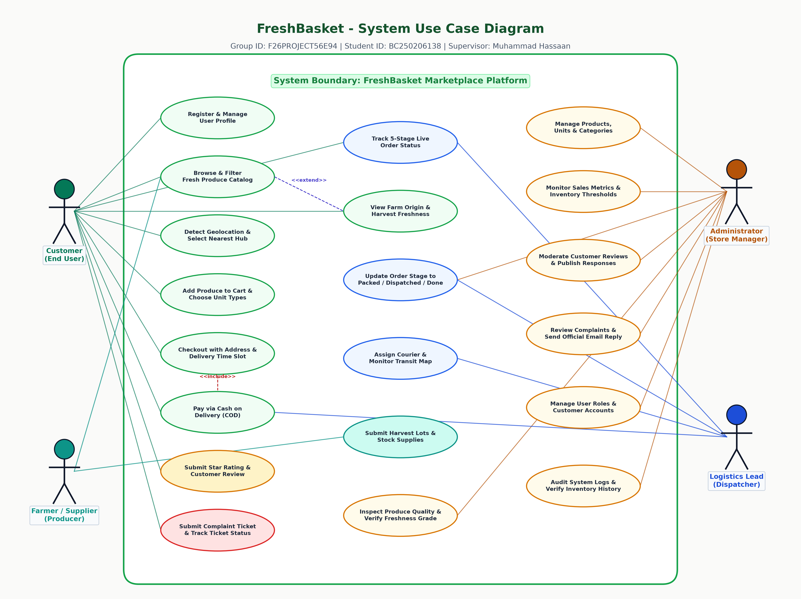
Figure: System Use Case Diagram with Four Actors and Core Interactions
4.3 Use case tabular specifications
Use case UC-01: Place grocery order via cash on delivery
Attribute | Specification Details
Use Case ID & Title: | UC-01: Place Grocery Order via Cash on Delivery
Primary Actor: | Customer
Preconditions: | Customer is authenticated and has at least one produce item in the shopping cart.
Postconditions: | Order is created in database with 'pending' status, inventory is deducted, and receipt email is sent.
Main Success Flow: | 1. Customer opens shopping cart and reviews item quantities and measurement units.  2. Customer clicks 'Proceed to Checkout'.  3. System retrieves customer delivery addresses and detects nearest cold-chain hub via Geoapify.  4. Customer selects delivery address, chooses delivery time slot, and confirms COD payment.  5. Customer clicks 'Place Order'.  6. Backend verifies product stock in a database transaction.  7. Backend inserts record into orders table and order_items table.  8. Backend deducts item stock from products table and creates inventory log.  9. System returns order confirmation number and redirects customer to tracking page.
Alternative Flow A: | Insufficient Stock: If an item stock falls below cart quantity, system aborts transaction and displays available quantity warning.
Alternative Flow B: | Invalid Address: If customer enters an incomplete address, system highlights missing fields and prompts correction.

Use case UC-02: Advance five-stage order fulfillment
Attribute | Specification Details
Use Case ID & Title: | UC-02: Advance Five-Stage Order Fulfillment
Primary Actor: | Logistics Supervisor / Administrator
Preconditions: | Supervisor is authenticated and order exists with status other than 'delivered' or 'cancelled'.
Postconditions: | Order status is updated, status history record is inserted, and customer tracking view updates.
Main Success Flow: | 1. Supervisor opens Logistics Dispatch Portal.  2. System loads active orders with current stages and destination hubs.  3. Supervisor selects an order and chooses the next stage (e.g., 'packed' or 'out_for_delivery').  4. Supervisor optionally enters courier name, contact number, and dispatch notes.  5. Supervisor submits update.  6. Backend verifies supervisor permissions and updates order_status column.  7. Backend records change in order_status_history with timestamp.  8. Real-time event bus notifies connected customer tracking screens.
Alternative Flow: | Order Cancellation: If customer requests cancellation before packing, supervisor sets status to 'cancelled' and inventory is restored.

Use case UC-03: Submit customer complaint ticket
Attribute | Specification Details
Use Case ID & Title: | UC-03: Submit Customer Complaint Ticket
Primary Actor: | Customer
Preconditions: | Customer is logged in and has an active or completed order reference.
Postconditions: | Complaint ticket is created, automated receipt email is dispatched, and ticket appears on admin dashboard.
Main Success Flow: | 1. Customer navigates to Complaint Center (/complaint).  2. System loads customer contact information and recent orders.  3. Customer selects dispute category (Quality, Missing Item, Delivery Delay, Billing).  4. Customer inputs subject, description, and optional photo attachment URL.  5. Customer submits complaint.  6. Backend generates ticket number (FB-TKT-XXXXX) and inserts complaint record.  7. Backend triggers Nodemailer to send confirmation email via Gmail SMTP.  8. System displays ticket tracking card with current status 'open'.
Alternative Flow: | Missing Required Fields: System validates form and highlights empty subject or description fields.

5. Work plan
5.1 Work breakdown structure and calendar phases
The project schedule spans 11 academic calendar weeks from Monday 26 October 2026 to Thursday 07 January 2027. The schedule corresponds to the two official Virtual University course milestones:
• Assignment 1: Documentation (Start: 26 Oct 2026, Due: 09 Nov 2026). Focuses on problem analysis, software requirements specification, use case modeling, ERD formulation, database normalization, and interface wireframing.
• Assignment 2: Final Deliverable (Start: 10 Nov 2026, Due: 07 Jan 2027). Focuses on full-stack implementation, REST APIs, database integration, geolocation services, logistics dispatching, testing, and final viva presentation.
5.2 Project Gantt chart
The Gantt chart below displays the chronological schedule, task durations, and milestones across the 11-week project lifecycle.
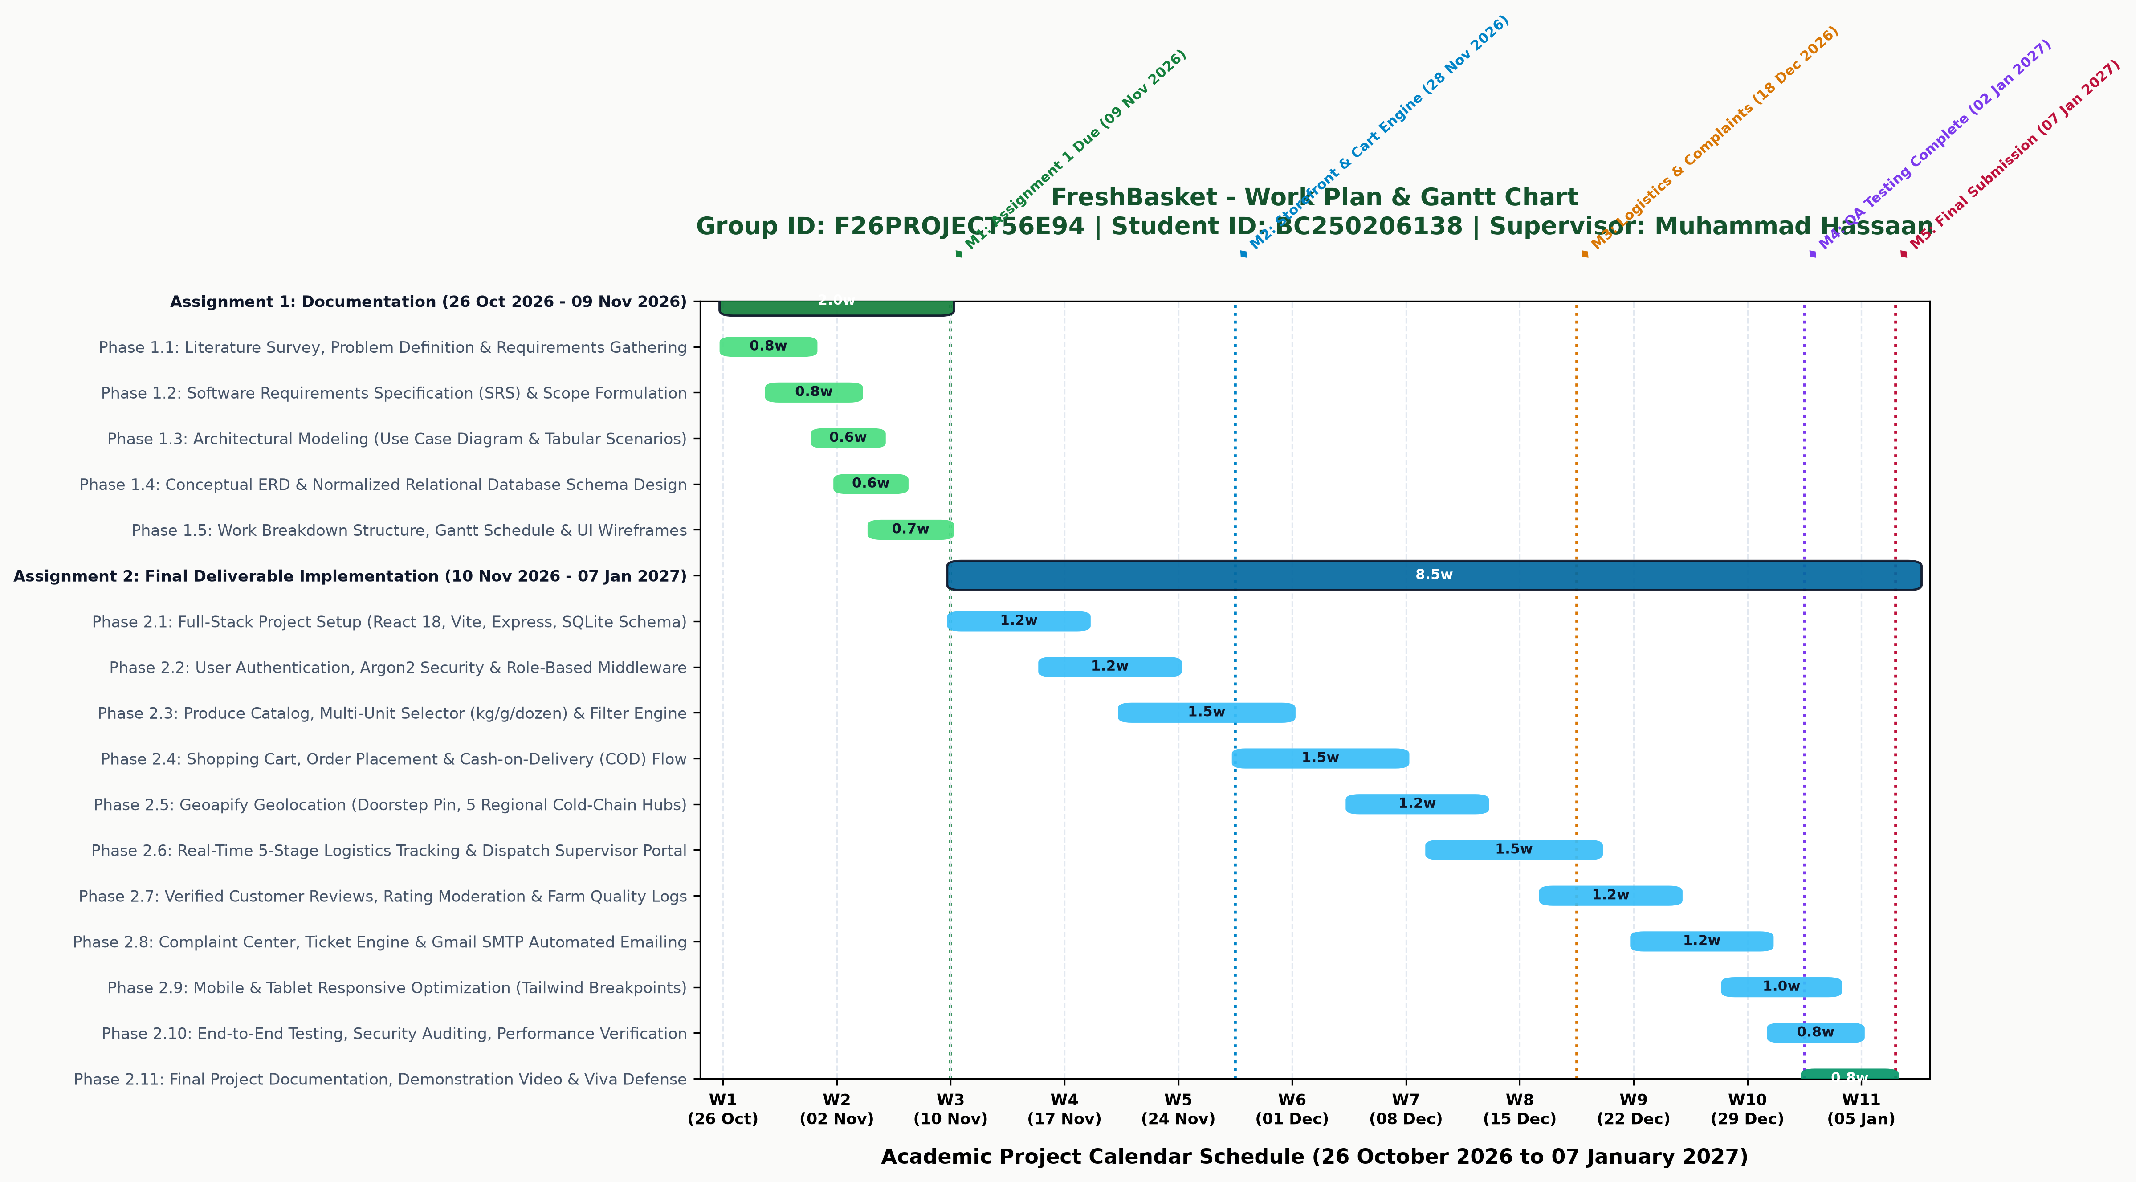
Figure: Work Plan and Gantt Chart for Assignment 1 and Assignment 2
5.3 Milestone schedule and deliverables table
The table below details the project tasks, start dates, completion deadlines, dependencies, and expected deliverables.
Phase | Task Description | Start Date | End Date | Milestone Deliverable
1.1 | Literature Review & Problem Formulation | 26/10/2026 | 01/11/2026 | Scope Definition Document
1.2 | SRS & Functional Requirements | 02/11/2026 | 04/11/2026 | Draft SRS Document
1.3 | Use Case Modeling & System Architecture | 04/11/2026 | 06/11/2026 | Use Case Diagram & Scenarios
1.4 | ERD & Database Schema Design | 06/11/2026 | 08/11/2026 | Normalized 14-Table Schema
1.5 | UI Wireframing & Documentation Finalization | 08/11/2026 | 09/11/2026 | Assignment 1 Submission (09 Nov)
2.1 | Full-Stack Setup & Authentication Engine | 10/11/2026 | 19/11/2026 | React + Express Skeleton & Auth
2.2 | Produce Catalog & Multi-Unit Pricing Engine | 20/11/2026 | 29/11/2026 | Catalog Filters & Multi-Units
2.3 | Cart, COD Checkout & Geoapify Geolocation | 30/11/2026 | 09/12/2026 | Doorstep Pin & Checkout Flow
2.4 | Real-Time 5-Stage Logistics & Dispatch Portal | 10/12/2026 | 18/12/2026 | Supervisor Portal & Live Tracker
2.5 | Customer Reviews & SMTP Complaint Center | 19/12/2026 | 26/12/2026 | Review Engine & Email Tickets
2.6 | Mobile Responsive QA, Final Viva & Defense | 27/12/2026 | 07/01/2027 | Assignment 2 Submission (07 Jan)

6. Entity relationship diagram (ERD)
6.1 Conceptual data model and cardinalities
The FreshBasket data architecture uses 14 relational entities. The relationships enforce business integrity rules across the grocery ordering lifecycle:
• A user can register multiple saved delivery addresses (1 to M relationship between users and addresses).
• A category groups multiple fresh produce products (1 to M relationship between categories and products).
• A product offers multiple measurement units such as kg, 500g, or dozen (1 to M relationship between products and product_units).
• A customer places multiple orders over time (1 to M relationship between users and orders).
• An order contains multiple line items linked to specific products (M to N relationship resolved via order_items junction table).
• An order generates multiple chronological status records (1 to M relationship between orders and order_status_history).
• A customer submits product reviews for delivered items (1 to M relationship between users/products and reviews).
• A customer files dispute tickets linked to orders (1 to M relationship between users/orders and complaints).
• Inventory adjustments write permanent records to an audit log (1 to M relationship between products and inventory_logs).
6.2 Entity relationship diagram
The diagram below illustrates the 14 data entities, primary keys, foreign key associations, and Crow's foot cardinalities.
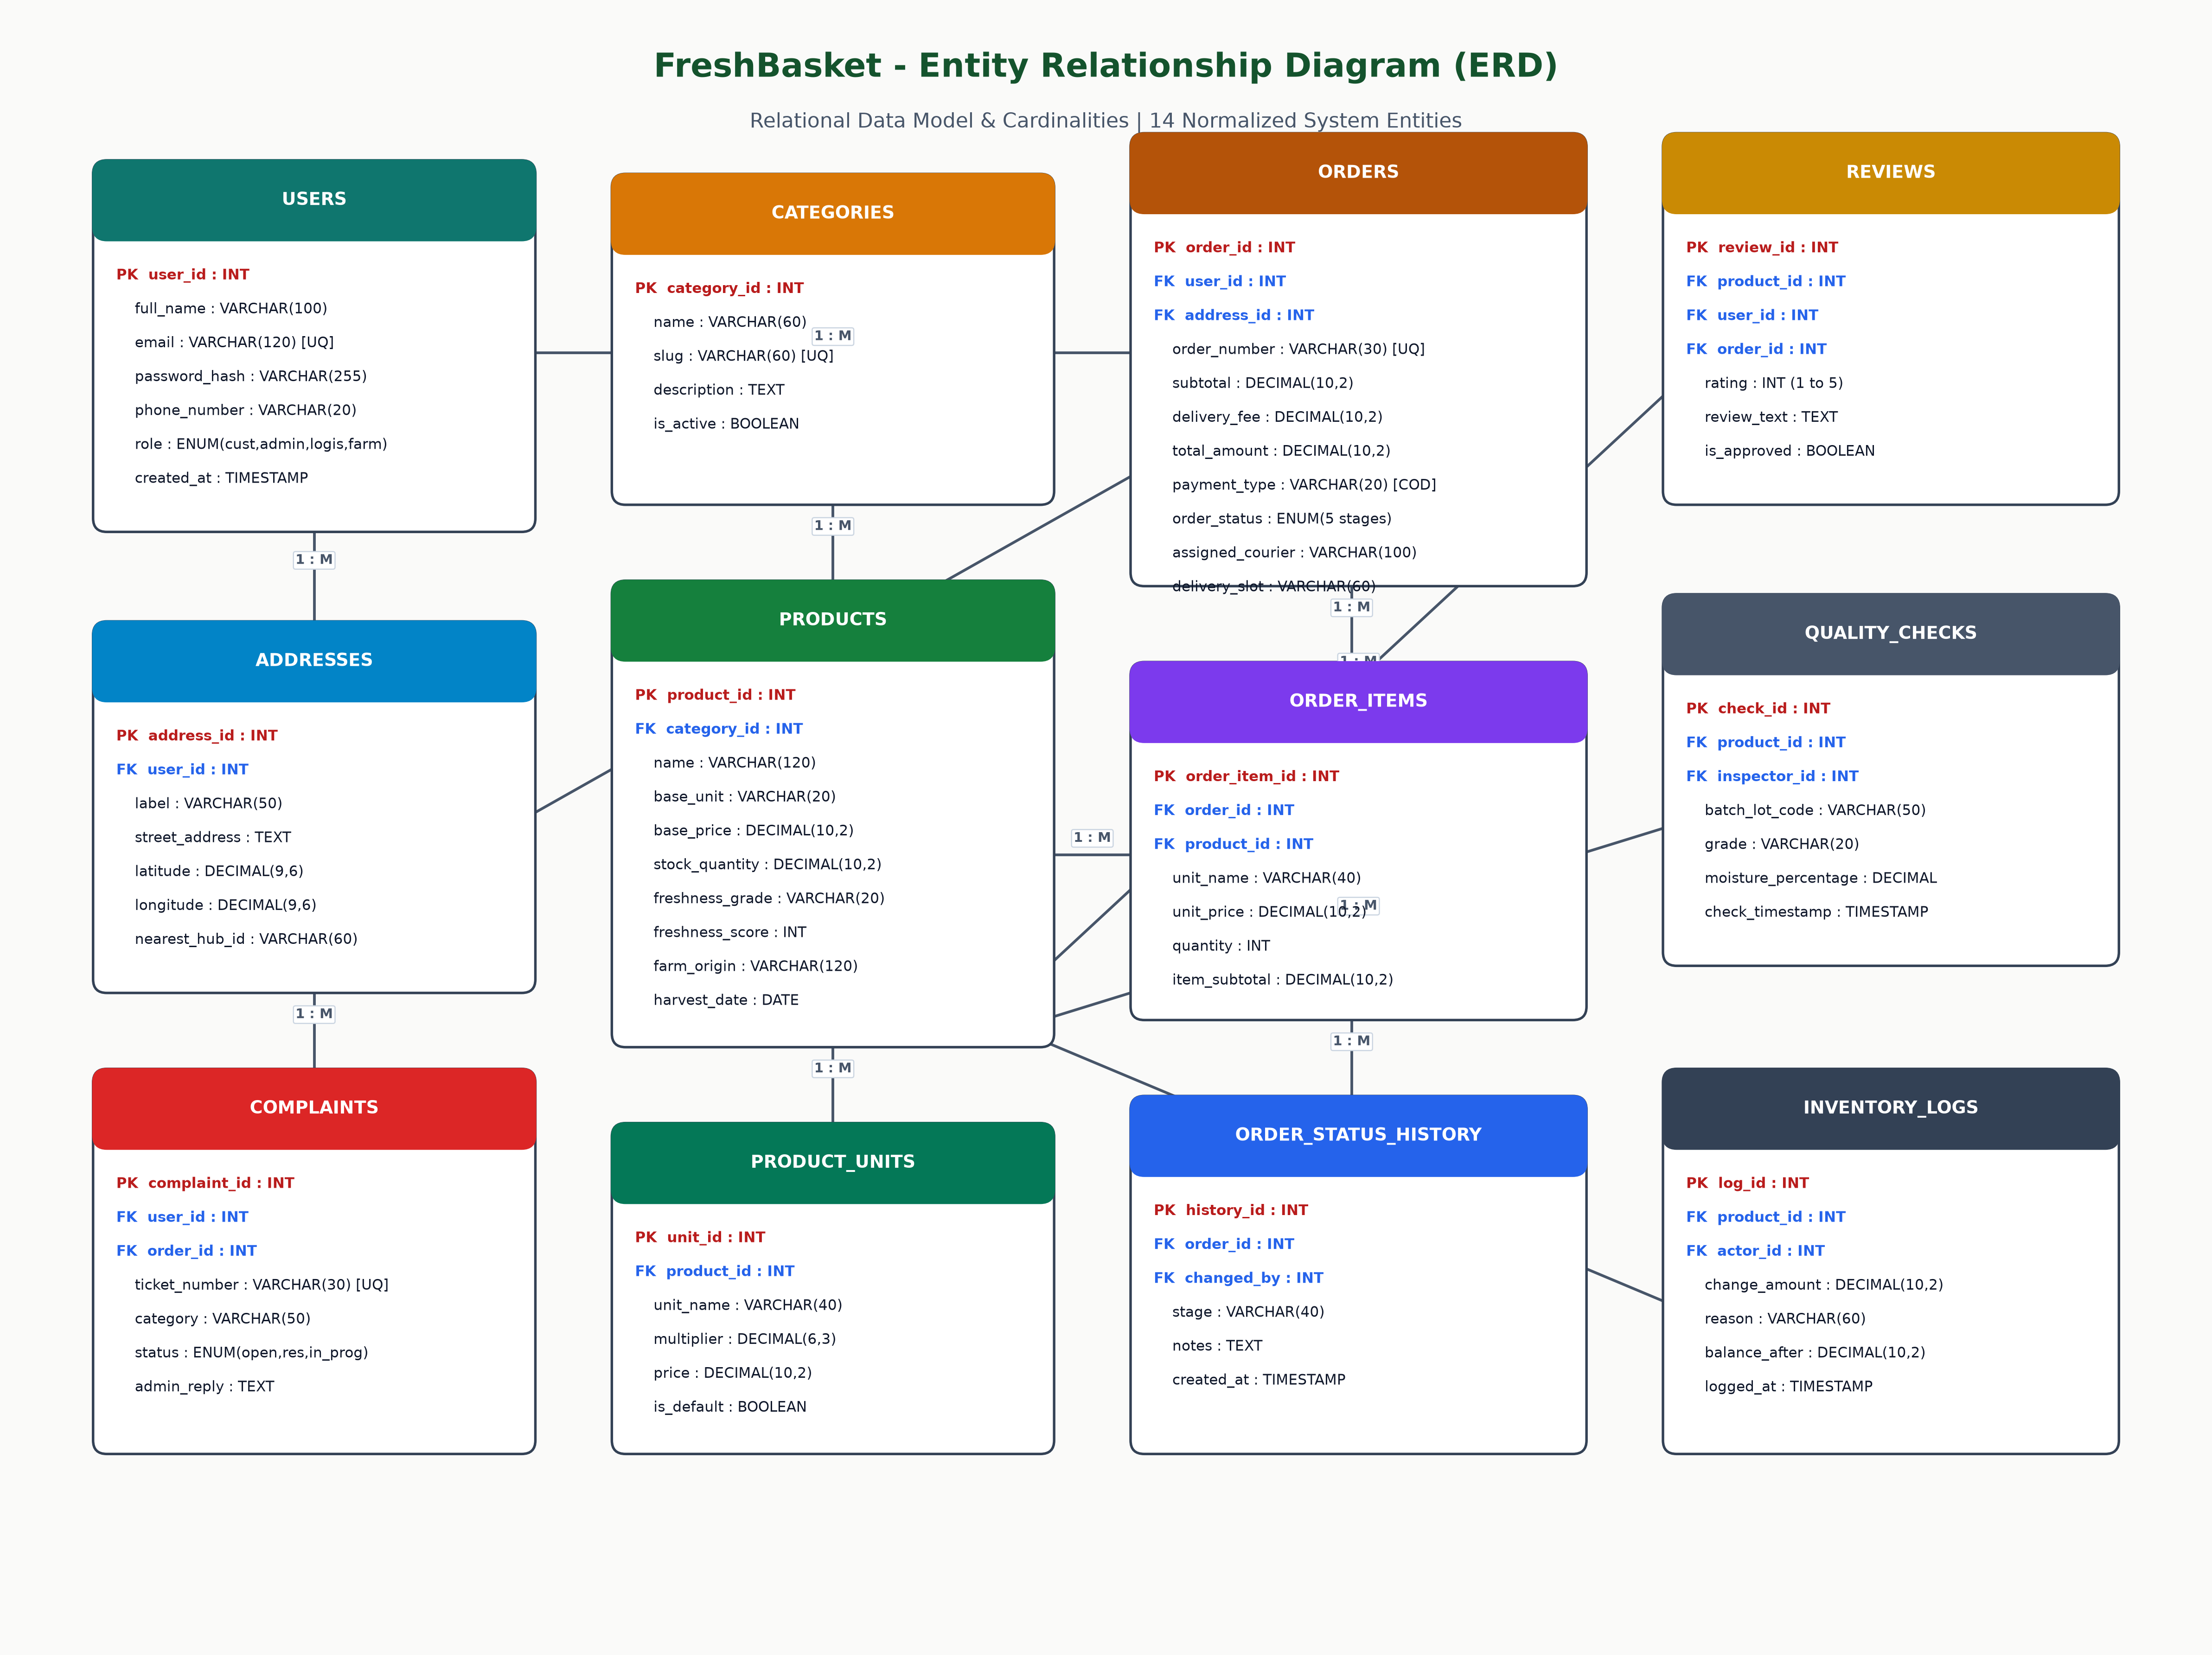
Figure: Entity Relationship Diagram (ERD) with 14 System Entities
6.3 Entity dictionary and attribute definitions
The table below summarizes the core entities, their primary keys, foreign key dependencies, and business roles.
Entity Name | Primary Key | Foreign Keys | Description
users | id | None | Stores customer, admin, supervisor, and supplier profiles with hashed credentials.
addresses | id | user_id | Stores delivery locations, street lines, GPS coordinates, and nearest hub IDs.
categories | id | None | Organizes produce into Fruits, Vegetables, Leafy Greens, Organic, and Seasonal.
products | id | category_id | Maintains produce catalog, freshness grade, harvest date, and base pricing.
product_units | id | product_id | Configures purchasing units (kg, 500g, piece, dozen) with price multipliers.
inventory_logs | id | product_id, actor_id | Records every stock increase or decrease with actor ID and audit reason.
orders | id | user_id, address_id | Stores placed orders, total billing amounts, delivery slots, and current status.
order_items | id | order_id, product_id | Stores line item records including selected unit, unit price, and quantity.
order_status_history | id | order_id, changed_by | Maintains chronological records of 5-stage fulfillment status changes.
quality_checks | id | product_id, inspector_id | Stores produce quality inspection logs, freshness scores, and lot numbers.
reviews | id | product_id, user_id, order_id | Contains post-delivery star ratings (1 to 5) and customer feedback.
coupons | id | None | Manages discount promotional vouchers with percentage or fixed deductions.
complaints | id | user_id, order_id | Manages customer dispute tickets (FB-TKT-XXXXX) with SMTP email tracking.
audit_logs | id | user_id | Records security and administrative system events for compliance auditing.

7. Database design
7.1 Relational database schema structure
The FreshBasket database is designed in Third Normal Form (3NF). Every non-key attribute depends solely on the primary key, eliminating data redundancies and update anomalies. Foreign keys enforce referential integrity with ON DELETE RESTRICT constraints on core transactional records (orders and products) to prevent accidental data loss.
The database uses SQLite via the native node:sqlite driver. SQLite runs within the server process, requiring zero background service setup while delivering sub-millisecond query performance. The schema is portable and directly upgradeable to PostgreSQL or MySQL for large-scale enterprise deployments.
7.2 Physical relational schema diagram
The diagram below displays the normalized relational database tables, columns, data types, and primary-foreign key relationships.
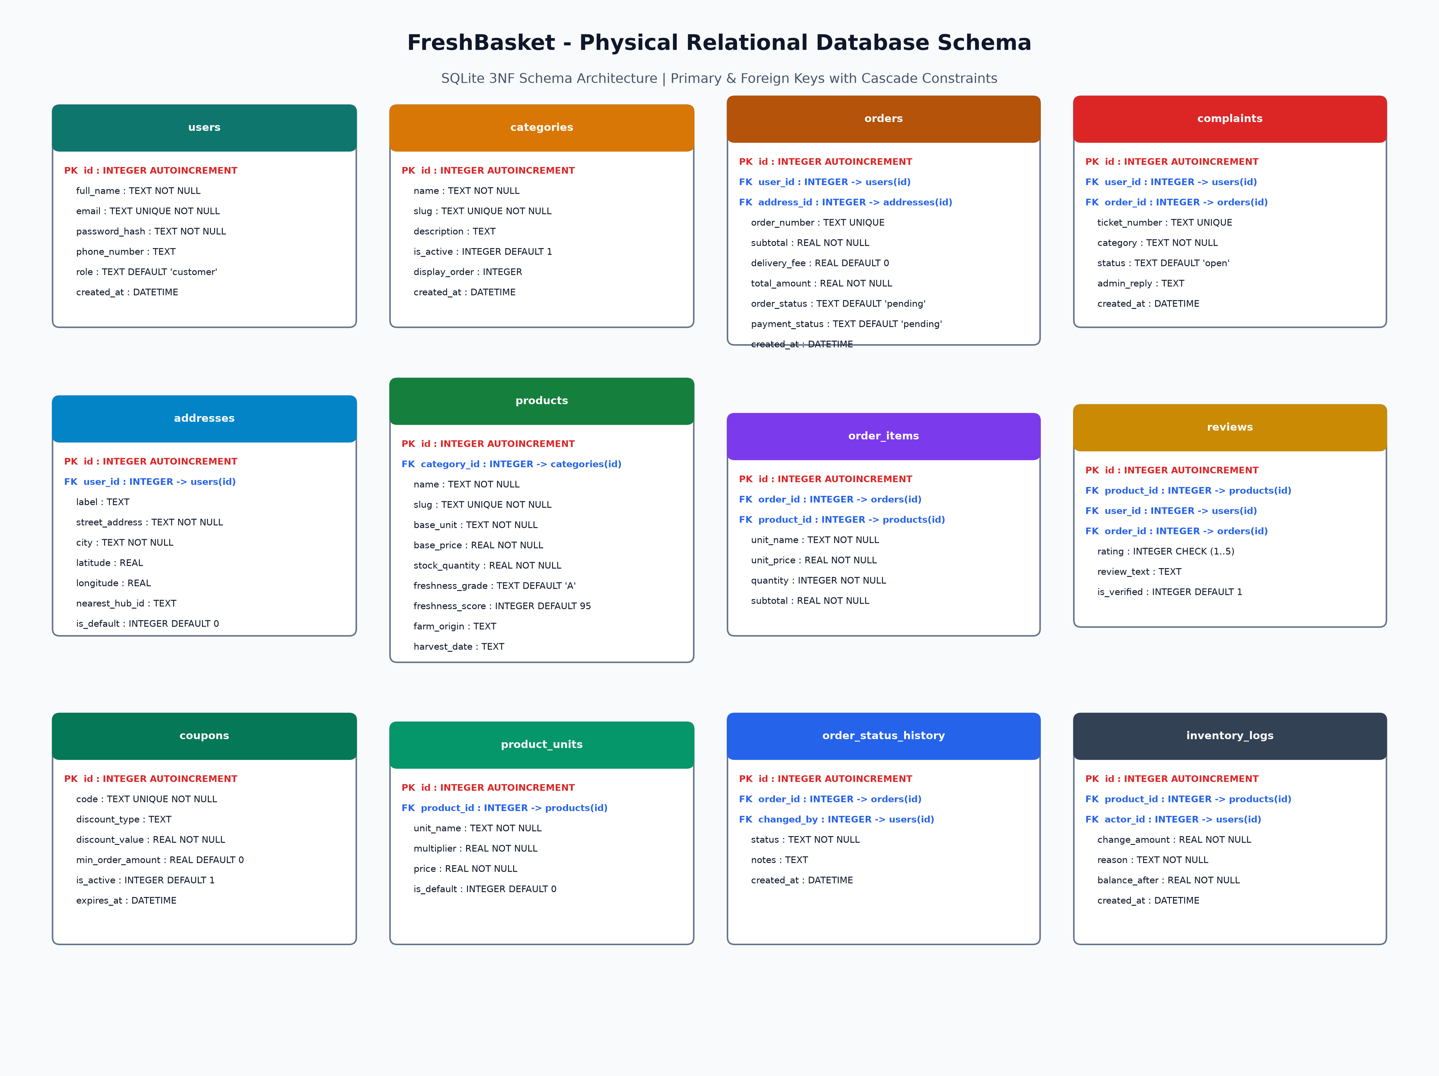
Figure: Physical Relational Database Schema Diagram (14 Tables)
7.3 Complete database table specifications
The data dictionaries below define the schema specifications for the primary database tables.
Table 1: users
Column Name | Data Type | Null / Key | Default | Description
id | INTEGER | PK, NOT NULL | AUTOINCREMENT | Unique internal user identifier
full_name | TEXT | NOT NULL | None | User full legal name
email | TEXT | UNIQUE, NOT NULL | None | Account email address used for login
password_hash | TEXT | NOT NULL | None | Argon2 / bcrypt password hash string
phone_number | TEXT | NULL | None | Contact phone number for delivery
role | TEXT | NOT NULL | 'customer' | Role: customer, admin, logistics, supplier
created_at | DATETIME | NOT NULL | CURRENT_TIMESTAMP | Account registration timestamp

Table 2: products
Column Name | Data Type | Null / Key | Default | Description
id | INTEGER | PK, NOT NULL | AUTOINCREMENT | Unique produce product identifier
category_id | INTEGER | FK, NOT NULL | None | Foreign key references categories(id)
name | TEXT | NOT NULL | None | Produce title (e.g., Farm Fresh Tomatoes)
slug | TEXT | UNIQUE, NOT NULL | None | URL slug for routing
base_unit | TEXT | NOT NULL | 'kg' | Base measurement unit (kg, piece, dozen)
base_price | REAL | NOT NULL | 0.0 | Base price per unit in PKR
stock_quantity | REAL | NOT NULL | 0.0 | Current available inventory balance
freshness_grade | TEXT | NOT NULL | 'A' | Produce quality grade: A, B, C
freshness_score | INTEGER | NOT NULL | 95 | Freshness quality index (1 to 100)
farm_origin | TEXT | NULL | None | Harvest region and grower collective

Table 3: orders
Column Name | Data Type | Null / Key | Default | Description
id | INTEGER | PK, NOT NULL | AUTOINCREMENT | Unique order identifier
user_id | INTEGER | FK, NOT NULL | None | Foreign key references users(id)
address_id | INTEGER | FK, NOT NULL | None | Foreign key references addresses(id)
order_number | TEXT | UNIQUE, NOT NULL | None | Customer order code (FB-ORD-XXXXX)
subtotal | REAL | NOT NULL | 0.0 | Sum of line item subtotals
delivery_fee | REAL | NOT NULL | 0.0 | Doorstep dispatch fee
total_amount | REAL | NOT NULL | 0.0 | Grand total payable upon delivery
payment_type | TEXT | NOT NULL | 'cod' | Payment method: Cash on Delivery
order_status | TEXT | NOT NULL | 'pending' | Stage: pending, confirmed, packed, out_for_delivery, delivered
assigned_courier | TEXT | NULL | None | Name and contact number of courier rider

Table 4: complaints
Column Name | Data Type | Null / Key | Default | Description
id | INTEGER | PK, NOT NULL | AUTOINCREMENT | Unique complaint dispute identifier
ticket_number | TEXT | UNIQUE, NOT NULL | None | Ticket reference code (FB-TKT-XXXXX)
user_id | INTEGER | FK, NULL | None | Foreign key references users(id)
order_id | INTEGER | FK, NULL | None | Foreign key references orders(id)
category | TEXT | NOT NULL | 'General' | Category: Quality, Missing Item, Delay, Billing
status | TEXT | NOT NULL | 'open' | Ticket status: open, in_progress, resolved
admin_reply | TEXT | NULL | None | Official response dispatched via Gmail SMTP
created_at | DATETIME | NOT NULL | CURRENT_TIMESTAMP | Ticket creation timestamp

8. Interface design
8.1 User interface layout and responsive principles
The FreshBasket interface is designed using modern responsive web principles. Built with React 18 and Tailwind CSS, the application provides an intuitive shopping workflow across mobile phones, tablets, and desktop workstations.
Key design choices include:
• Visual hierarchy: Produce cards display clean imagery, price per unit, farm origin badges, and freshness grades.
• Responsive navigation: Mobile screens provide a slide-over navigation drawer, accessible search inputs, and touch-friendly cart triggers.
• Doorstep geolocation: The header displays the detected customer area and nearest cold-chain hub.
• Interactive state feedback: Loading skeletons, toast alerts, and status badges confirm user actions.
8.2 Storefront catalog and hub selector
The storefront provides an interactive produce marketplace. Customers can search by name, filter by category tabs (All, Fruits, Vegetables, Leafy Greens, Organic, Seasonal), and select their regional hub. Produce cards present freshness badges and instant add-to-cart buttons.
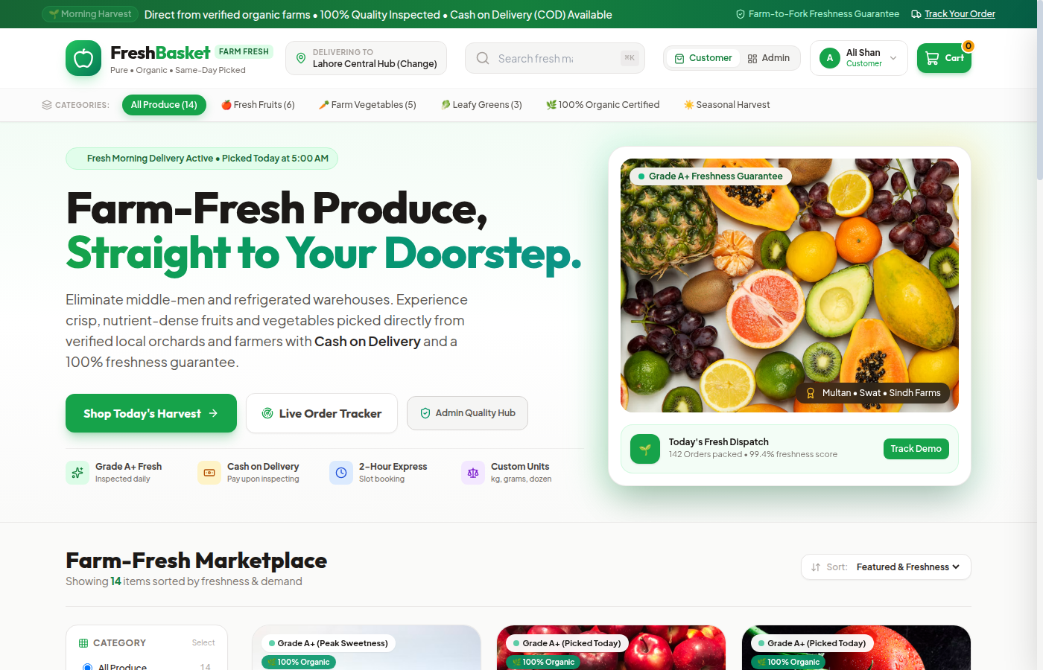
Figure: Storefront Catalog with Category Filters and Produce Cards
8.3 Produce details and farm origin display
Clicking a produce card opens the product detail view. The screen displays high-resolution imagery, freshness quality scores, harvest date, regional farm origin, nutritional metrics, and verified customer reviews.
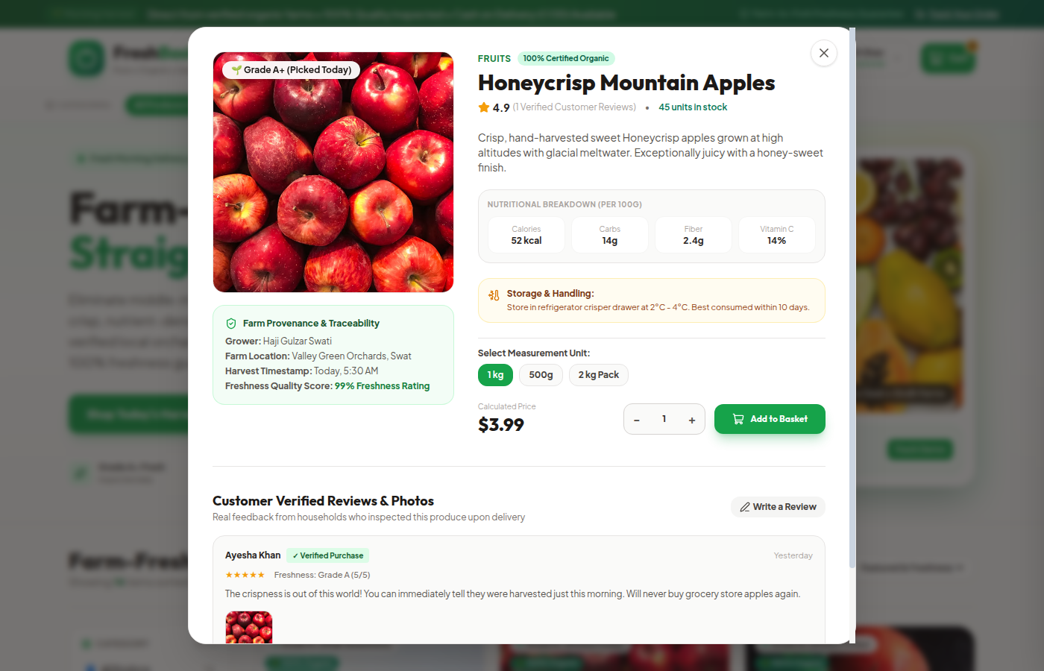
Figure: Product Detail Screen Showing Nutritional Info and Farm Origin
8.4 Shopping cart and cash on delivery checkout
The checkout screen provides a multi-step purchase flow. Customers select measurement units, verify item pricing, pick delivery time slots, review the Geoapify doorstep map pin, and confirm their order with Cash on Delivery.
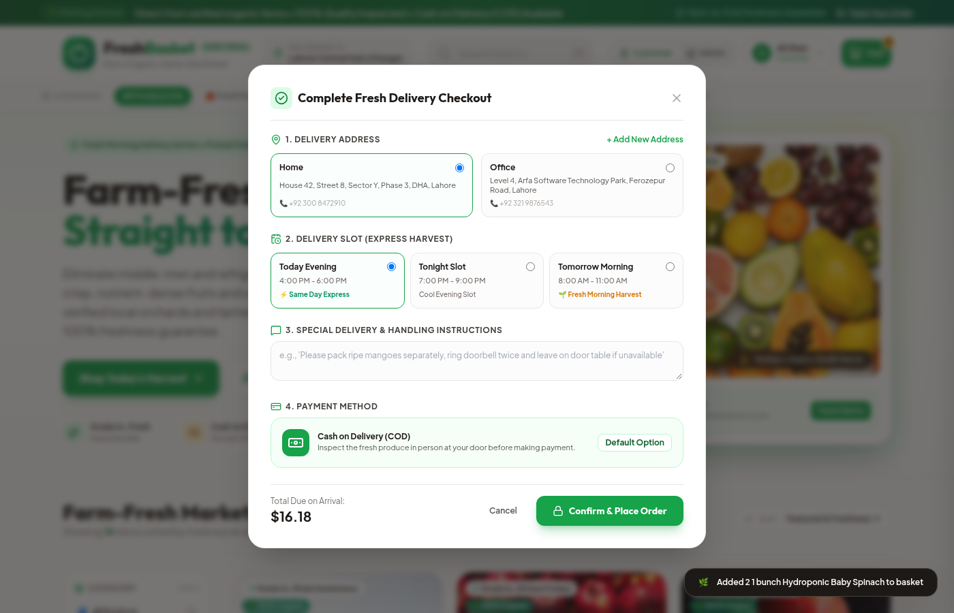
Figure: Shopping Cart and Cash on Delivery Checkout Screen
8.5 Real-time five-stage order tracking portal
The order tracking portal provides live order visibility. Customers view their order reference, delivery address, five-stage progress bar (Pending to Delivered), estimated delivery time, and route map showing dispatch courier transit.
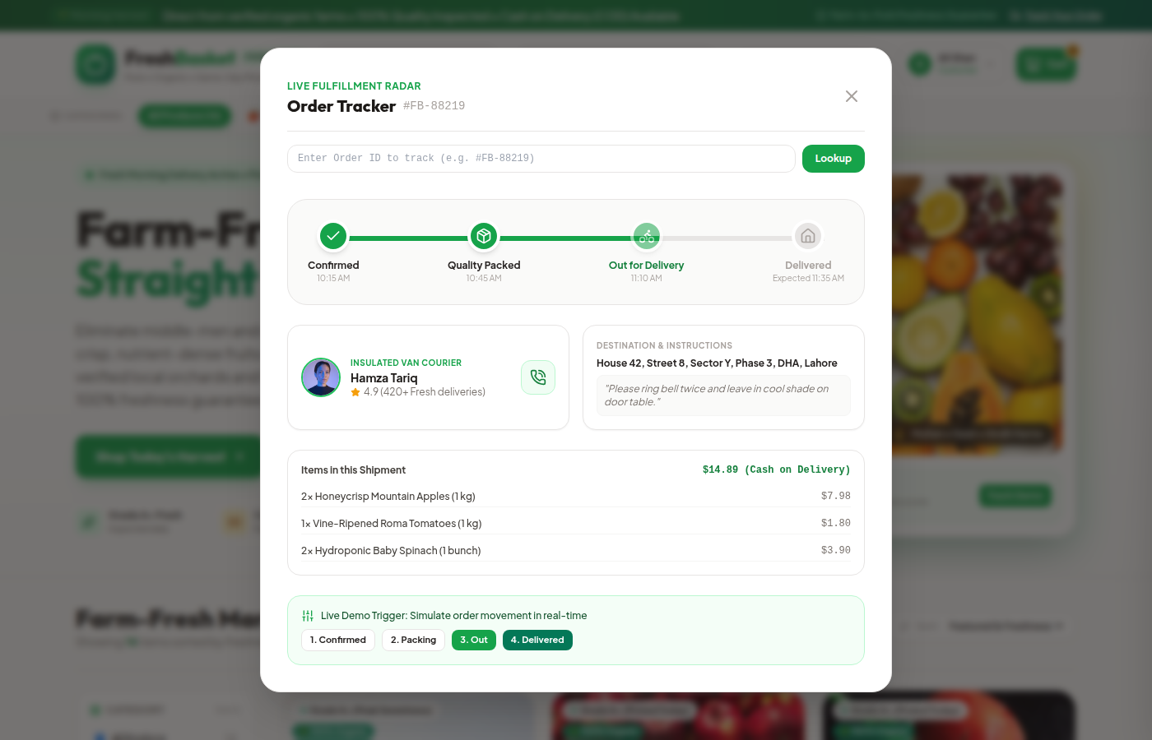
Figure: Real-Time Five-Stage Order Tracking Portal
8.6 Administrative dashboard and logistics console
The administrative and logistics console provides store management tools. Managers monitor gross revenue, order volume, low-stock alerts, customer complaints, review moderation, and dispatch courier assignments.
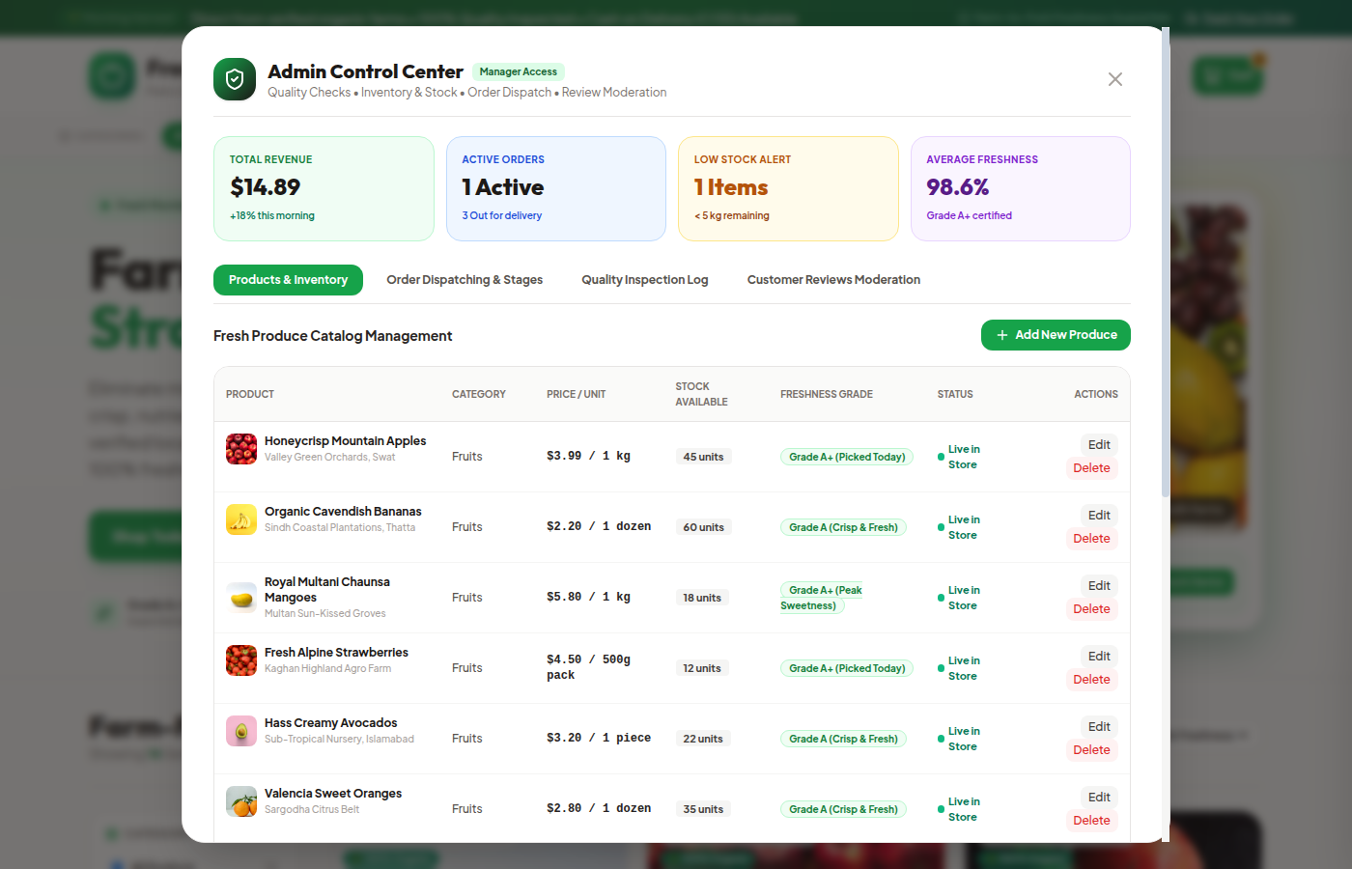
Figure: Administrative Control Center and Logistics Dispatch Console

