# **Tasks**

**Learners have to develop a dashboard to support the answers to the following questions.**

**Objective Questions**:

1. What is the total no. of tables present in the data?

=> There is 1 tables

1. What is the total no. of attributes present in the data?

=> 35

1. The data consists of some inconsistent and missing values so ensure that the data used for further analysis is cleaned.

**Data Cleaning Process:**Removed several irrelevant columns: the time-duration column (considered unnecessary based on the presentation), along with the isWhiteListUser and queue columns, which contained only single values.

Conducted cleaning and extraction on the following columns: createdAT, updatedAt, chatStartTime, and chatEndTime.

Swapped the names of the chatStartTime and chatEndTime columns to accurately reflect the time period and ensure consistency.

Created a new column, named CreatedMonthYear , CreatedDate derived from createdAT to categorize the timeframe.

1. What is the average daily call volume over the day by day and what’s the change on it?  
   => The Average number of calls is calculated by the aggregate Function AVERAGE()

|  |  |  |
| --- | --- | --- |
| **CreatedDate** | **Count of CallSid** | **Percentage change** |
| 2023-12-01 | 228 | First Data |
| 2023-12-02 | 332 | 31% |
| 2023-12-03 | 383 | 13% |
| 2023-12-04 | 364 | -5% |
| 2023-12-05 | 253 | -44% |
| 2023-12-06 | 254 | 0% |
| 2023-12-07 | 254 | 0% |
| 2023-12-08 | 138 | -84% |
| 2023-12-09 | 288 | 52% |
| 2023-12-10 | 430 | 33% |
| 2023-12-11 | 424 | -1% |
| 2023-12-12 | 358 | -18% |
| 2023-12-13 | 348 | -3% |
| 2023-12-14 | 226 | -54% |
| 2023-12-15 | 276 | 18% |
| 2023-12-16 | 258 | -7% |
| 2023-12-17 | 185 | -39% |
| 2023-12-18 | 233 | 21% |
| 2023-12-19 | 209 | -11% |
| 2023-12-20 | 178 | -17% |
| 2023-12-21 | 159 | -12% |
| 2023-12-22 | 163 | 2% |
| 2023-12-23 | 241 | 32% |
| 2023-12-24 | 232 | -4% |
| 2023-12-25 | 258 | 10% |
| 2023-12-26 | 255 | -1% |
| 2023-12-27 | 242 | -5% |
| 2023-12-28 | 181 | -34% |
| 2023-12-29 | 260 | 30% |
| 2023-12-30 | 179 | -45% |
| 2023-12-31 | 158 | -13% |
| 2024-01-01 | 115 | -37% |
| 2024-01-02 | 196 | 41% |
| 2024-01-03 | 107 | -83% |
| **Grand Total** | **8365** |  |

|  |  |
| --- | --- |
| Average | 246.0294118 |

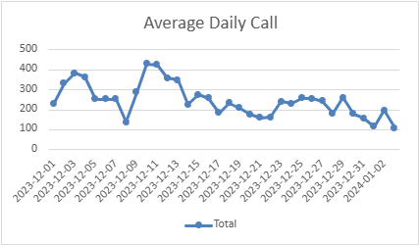

In the above graph we can determine the daily call volumes and with time the average call volumes are decreasing

1. Which months experienced the highest and lowest call volumes?

|  |  |  |
| --- | --- | --- |
| **CreatedMonthYear** | **Count of CallSid** | **Rank** |
| 1/2024 | 339 | Lowest |
| 12/2023 | 6986 | Highest |
| **Grand Total** | **7325** |  |

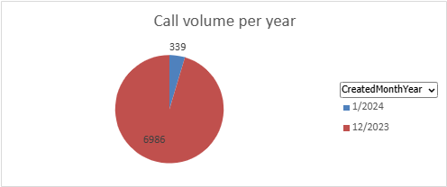

1. What is the total operational cost for that month?

|  |  |
| --- | --- |
| **Row Labels** | **Sum of amount** |
| 1/2024 | 11826.69 |
| 12/2023 | 202239.2087 |
| **Grand Total** | **214065.8987** |

Total operational cost for the month of Dec 2023: 202239.2087

Total operational cost for the month of Jan 2024: 11826.69

1. What is the average number of calls handled per agent per day?

=> The average no of calls handled by per agent per day is : **1.97**  
This is being calculated by aggregating the sum of all calls divided by the count of all gurus and further divided by the number of unique days

|  |  |
| --- | --- |
| Average call per agent | 1.976524555 |

This is being calculated by aggregating the sum of all calls divided by the count of all gurus and further divided by the number of unique days.

1. How many repeat callers are there, and what percentage of total calls do they represent?

* **Approach to Identify Repeat and Non-Repeat Callers**

For Total Repeat callers, selected the dataset and derived a pivot table with user_id as Rows and Callsid as values.

Total unique callers is being calculated from the pivot table using =COUNTIF(T48:T10391,"=1")

Total callers is the count of Row Labels column of the pivot table which comes out as 10344

Repeat callers is the difference between Total callers & Total Unique Callers which is 7991

Total number of calls = 8365

Calls done by repeat callers = 6012

Total First calls of repeat callers (To be excluded from call percentage calculation) = 1275

Percentage of total calls done by repeat callers = 56.62 %

|  |  |
| --- | --- |
| Total Unique Callers | 2353 |
| Total Callers | 10344 |
| Repeat Callers | 7991 |
|  |  |
| **Total Calls** | 8365 |
| Calls done by repeat callers | 6012 |
| Total First calls of repeat callers | 1275 |
| **Calls Considered for repeat calls** | 4737 |
| **% of Total calls repeat callers represent** | 56.62881052 |

|  |  |
| --- | --- |
| **uid** | **Count of CallSid** |
| 1 |  |
| 162 |  |
| 437 | 9 |
| 507 | 1 |
| 511 | 2 |
| 535 |  |
| 543 | 6 |
| 576 |  |
| 595 |  |
| 735 |  |
| 787 | 20 |
| 910 |  |
| 939 |  |
| 995 |  |
| 1103 | 4 |
| 1105 | 6 |
| 1213 |  |
| 1233 | 1 |
| 1280 |  |
| 1326 |  |

1. What is the total sales generated by the call centre for each product category?

|  |  |  |  |  |
| --- | --- | --- | --- | --- |
| User Distribution |  |  | Revenue Distribution |  |
|  |  |  |  |  |
| **website** | **Count of user** |  | **website** | **Sum of netAmount** |
| app | 7800 |  | app | 125267.382 |
| dashboard | 2 |  | dashboard |  |
| gurucool | 20225 |  | gurucool | 88719.93333 |
| **Grand Total** | **28027** |  | **Grand Total** | **213987.3153** |

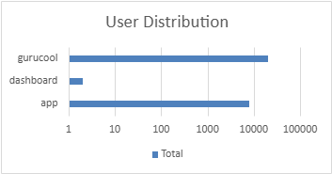

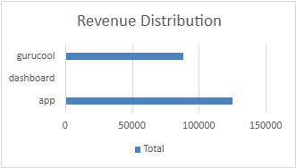

The comprehensive sales revenue generated by different product categories is mentioned in the pivot table.

1. How many calls were made for each user ID and guru ID?

The mentioned pivot tables identify the number of calls done by each user and each guru respectively.

|  |  |  |  |  |
| --- | --- | --- | --- | --- |
| gid | Count of CallSid |  | uid | Count of CallSid |
| 8 | 4 |  | 1 |  |
| 12 | 17 |  | 437 | 9 |
| 13 | 6 |  | 507 | 1 |
| 14 | 195 |  | 511 | 2 |
| 16 | 2 |  | 543 | 6 |
| 18 | 22 |  | 787 | 20 |
| 19 | 437 |  | 1103 | 4 |
| 22 | 10 |  | 1105 | 6 |
| 26 | 12 |  | 1233 | 1 |
| 28 | 18 |  | 1520 | 5 |
| 30 | 92 |  | 1555 | 2 |
| 44 | 10 |  | 1935 | 6 |
| 49 | 21 |  | 2044 | 15 |
| 60 | 82 |  | 2228 | 4 |
| 64 | 4 |  | 2329 | 10 |
| 72 | 5 |  | 2347 | 4 |
| 75 | 232 |  | 2394 | 10 |
| 76 | 2 |  | 2429 | 6 |
| 77 | 84 |  | 2727 | 2 |
| 78 | 1 |  | 2735 | 20 |
| 82 | 5 |  | 2878 | 1 |
| 83 | 5 |  | 2887 | 7 |
| 85 | 41 |  | 2958 | 4 |
| 87 | 252 |  | 2986 | 11 |
| 91 | 58 |  | 3100 | 6 |
| 92 | 2 |  | 3473 | 1 |
| 95 | 119 |  | 3615 | 10 |
| 96 | 26 |  | 3642 | 1 |
| 98 | 97 |  | 3829 | 1 |
| 99 | 2 |  | 4020 | 5 |
| 100 | 9 |  | 4071 | 6 |
| 101 | 71 |  | 4295 | 1 |
| 110 | 71 |  | 4352 | 13 |
| 111 | 8 |  | 4529 | 5 |
| 112 | 7 |  | 4534 | 1 |
| 115 | 134 |  | 4640 | 1 |
| 117 | 37 |  | 4855 | 5 |
| 121 | 16 |  | 5065 | 2 |
|  |  |  | 6145 | 2 |

1. What is the correlation between call duration and customer satisfaction?

|  |  |
| --- | --- |
| Correlation | -0.000202451 |

The correlation between call duration and customer satisfaction is derived by the correlation function: =CORREL(data!AK2:data!AK28028,data!AJ2:AJ28028)

1. Which guru have the highest and lowest customer satisfaction scores?

|  |  |
| --- | --- |
| Highest Satisfaction rate | Tarot Mystical |
| Lowest Satisfaction rate | Tarot Rittika |

Then sorting the pivot table in descending and ascending on the average of the rating column

Tarot Mystical scored the highest overall rating while Tarot Rittika scored the lowest overall rating.

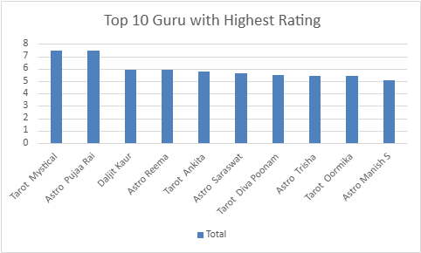

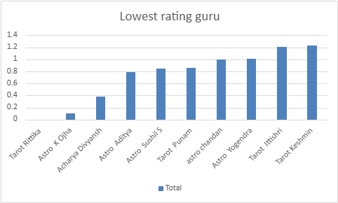

1. What is the average customer satisfaction score by month?

|  |  |
| --- | --- |
| CreatedMonthYear | Average of rating |
| 1/2024 | 2.676413255 |
| 12/2023 | 2.949637572 |
| Grand Total | 2.93463446 |

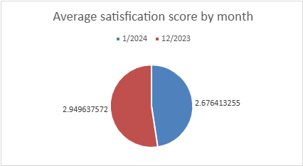

The average satisfaction score by month is derived by taking a pivot table, taking the month attribute as rows and Average of rating attribute in the values tab. Inserting a column chart clearly depicts the average monthly ratings.

1. How many categorical columns are there in the data? [Search about categorical and continuous data, and try to answer this question]

There are 15 categorical columns in the dataset which are mentioned below:

chatStatus, consultationType, website, refundStatus, isWhiteListUser, queue, freeCall, freeChat, callChannel, callIvrType, callStatus, astrologerCallStatus, region, userCallStatus, rating

Subjective Question:

1. Should the investment be used to hire more agents, improve training programs, or upgrade call center technology?

* **Hiring More Agents**

The current trend of decreasing call volume suggests that hiring additional agents may not be a viable solution. With fewer calls being received, adding more staff could lead to underutilization and increased operational costs without addressing the root issue of low customer retention. Therefore, investing in hiring more agents is not recommended at this time.

### **Improving Training Programs**

Enhancing training programs could be beneficial in improving the efficiency and effectiveness of existing agents. Given the uneven distribution of calls and chats, focused training could empower agents to manage their workloads better and improve customer interactions. This may lead to increased customer satisfaction and retention over time. Thus, while it may not address immediate operational inefficiencies, it can build a stronger foundation for long-term service quality and agent performance.

### **Upgrading Call Center Technology**

Investing in technology appears to be the most strategic option. Upgrading systems can help streamline operations, improve the routing of calls and chats to the appropriate agents, and enhance data analytics capabilities. This would not only alleviate some of the operational inefficiencies caused by uneven workloads but also provide valuable insights into customer behavior, potentially addressing the underlying issues of declining customer retention.

### **Recommendation**

Given the analysis, the investment should be primarily directed towards upgrading call center technology. This will improve operational efficiency, better manage call/chat volumes, and ultimately enhance customer service quality. Improving training programs should also be considered as a complementary strategy to ensure agents are equipped to handle customer interactions effectively. Hiring more agents should be deferred until call volumes stabilize or increase.



|  |  |
| --- | --- |
| **Highest Satisfaction rate** | Tarot Mystical |
| **Lowest Satisfaction rate** | Tarot Rittika |
| **Guru With Highest Rating top 10** | |
| **guruName** | **Average of rating** |
| Tarot Mystical | 7.5 |
| Astro Pujaa Rai | 7.5 |
| Daljit Kaur | 5.945945946 |
| Astro Reema | 5.9 |
| Tarot Ankita | 5.75 |
| Astro Saraswat | 5.611111111 |
| Tarot Diva Poonam | 5.462686567 |
| Astro Trisha | 5.424324324 |
| Tarot Oormika | 5.4 |
| Astro Manish S | 5.048780488 |
| **Grand Total** | **5.523809524** |

|  |  |
| --- | --- |
| **Guru With Lowest Rating top 10** | |
| **guruName** | **Average of rating** |
| Tarot Rittika | 0 |
| Astro K Ojha | 0.102272727 |
| Acharya Divyansh | 0.387387387 |
| Astro Aditya | 0.794392523 |
| Astro Sushil S | 0.851851852 |
| Tarot Punam | 0.859477124 |
| astro chandan | 1 |
| Astro Yogendra | 1.006802721 |
| Tarot Ittishri | 1.203821656 |
| Tarot Keshmin | 1.235294118 |
| **Grand Total** | **0.933900851** |

### **Analysis of Satisfaction Ratings**

1. **Highest Satisfaction Rates**
   1. **Key Insight:** The highest satisfaction ratings are held by "Tarot Mystical" and "Astro Pujaa Rai," both at 7.5. This indicates that there are gurus who excel in customer satisfaction, suggesting that the call center has potential strengths to leverage.
   2. **Chart Type:** Bar chart comparing the average ratings of the top-rated gurus.
2. **Lowest Satisfaction Rates**
   1. **Key Insight:** "Tarot Rittika" has the lowest satisfaction rate at 0, with several others showing very low scores as well. This highlights areas that require immediate attention, possibly through improved training or oversight.
   2. **Chart Type:** Bar chart showing the average ratings of the lowest-rated gurus.
3. **Top 10 Gurus by Satisfaction**
   1. **Chart Data:** Display the average ratings of the top 10 gurus, as shown in your data. This will illustrate the disparity between high and low performers.
   2. **Chart Type:** Horizontal bar chart for better readability, with clear labels for each guru.
4. **Bottom 10 Gurus by Satisfaction**
   1. **Chart Data:** Similar to the top 10, show the average ratings of the bottom 10 gurus. This can visually highlight the urgent need for intervention in training or processes.
   2. **Chart Type:** Horizontal bar chart to maintain consistency with the previous chart.
5. **Overall Satisfaction Overview**
   1. **Key Insight:** The grand total average rating across all gurus is 5.52, which is relatively low and suggests that overall customer satisfaction can be improved.
   2. **Chart Type:** Gauge chart or line chart representing the overall average rating, which can serve as a benchmark for future performance.

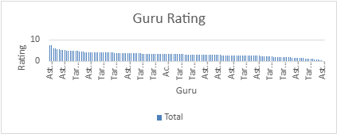

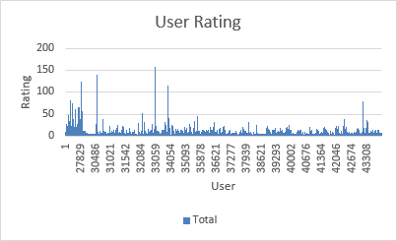

1. What are the potential risks of each investment option (hiring, training, technology upgrades), and how can they be mitigated?

* Hiring more agents may lead to underutilization and higher costs, which can be mitigated by using data to forecast needs accurately. Training programs could be costly with uncertain ROI, which can be addressed by tailoring training to specific performance gaps. Upgrading technology involves high initial costs and integration risks, mitigated by phased implementation and careful technology selection.

Hiring Risks:

1. High Initial Expenses: Recruiting new agents with diverse expertise in Astrology can lead to substantial upfront costs.
   1. Mitigation Strategy: Focus on hiring mid-level candidates who demonstrate strong passion and adaptability, ensuring they are eager to learn.
2. Adaptation Period: New hires may need time to adjust to the rapid growth of the organization, potentially delaying return on investment.
   1. Mitigation Strategy: Align organizational and employee objectives by implementing comprehensive training programs to boost motivation and facilitate adaptation to new technologies.

Training Risks:

1. Costly Training Programs: Investing in specialized training can impose significant costs, affecting both short- and long-term productivity.
   1. Mitigation Strategy: Continuously evaluate the effectiveness of training initiatives and gather feedback to improve future training quality.
2. Employee Turnover: Post-training, employees may seek better-paying opportunities elsewhere.
   1. Mitigation Strategy: Introduce recognition programs and retention bonuses to encourage trained employees to stay longer.

Technology Upgrade Risks:

1. Implementation Challenges: While upgrading technology can positively impact growth, it may also lead to various technical issues during rollout.
   1. Mitigation Strategy: Adopt a phased implementation approach, allowing for bug fixes and adjustments at each stage to ensure smooth integration.
2. High Costs: New technologies often require significant investment and ongoing operational costs, potentially straining the budget long-term.
   1. Mitigation Strategy: Conduct a thorough Return on Investment analysis to facilitate informed budgeting and resource allocation for necessary changes.

Name the chart/spreadsheet function you will use for solving the problem?

For risk analysis, Excel offers various functions:

* What-If Analysis: Utilizing Goal Seek and Scenario Manager can help assess potential risks in future investment decisions.
* Forecasting: This tool provides projected values for ROI, aiding in data-driven decision-making for the near future.

1. How does AstroSage call center performance compare to that of AstroGuru in terms of average call volume, customer satisfaction, and agent performance?

Will you use any aggregation function or a visualization here to solve the problem?

* AstroSage performs comparably to AstroGuru in terms of call volume and satisfaction; however, a detailed comparison is not present at the moment as data is not available.

1. How can the call center improve its handling of peak call periods to ensure high customer satisfaction?

Mention the functionality which you will use for giving the suggestions, will it be any aggregated function or a visualization?

* **Approach**

To improve handling of peak call periods, analyze historical call data using predictive analytics to identify trends and forecast peak times. Implement flexible staffing strategies based on these insights and upgrade call routing technology to efficiently manage high call volumes.

### **Insights**

The data indicates that the majority of calls are placed between 6:00 AM and 10:00 AM, leading to significant congestion during these hours. This high volume correlates with a low success rate of 41.25%, highlighting the need for enhanced management during peak times.

### **Recommendation**

Implement a combination of flexible staffing to ensure adequate coverage during peak hours and upgrade call routing technology to optimize call distribution. Use visualization tools, such as column charts derived from pivot tables, to continuously monitor call volume trends and adjust strategies accordingly.

.

|  |  |
| --- | --- |
| **Count of total Call** | 8363 |
| **Count of success call** | 3450 |
| **Success rate as percentage** | 41.25 |

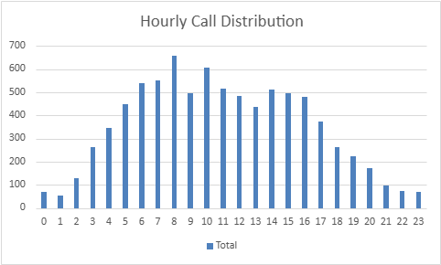

|  |  |
| --- | --- |
| Peak time Call Percentage | 40.2965443 |
| 6 AM - 10 AM |

1. Based on historical data, what strategic initiatives should be prioritized to improve overall efficiency and customer satisfaction?

* Based on an analysis of historical data, specific agents have been identified as having high failure rates during customer interactions, which correlates with lower customer satisfaction levels. This highlights an opportunity for targeted interventions that could significantly enhance both agent performance and the overall customer experience.

Key Issues Identified:

1. High Failure Rates: Certain agents are consistently noted for elevated failure rates in calls or customer interactions. This may stem from various challenges, including poor communication skills, insufficient problem-solving techniques, or gaps in technical knowledge.
2. Low Customer Ratings: Agents with high failure rates tend to receive below-average ratings in customer satisfaction, reflecting dissatisfaction with the service rendered during their interactions.

Recommended Initiatives:

To tackle these challenges, it is advisable to implement focused training programs that concentrate on the following critical areas:

* Enhancing Communication Skills: Training should focus on improving agents' ability to communicate effectively with customers, ensuring they can clearly articulate solutions and maintain professionalism, even in difficult situations.
* Improving Problem-Solving Skills: Agents should be trained in techniques to handle intricate customer inquiries more effectively, minimizing frustration and reducing the duration of interactions.
* Strengthening Technical Knowledge: For agents who face difficulties with system functionalities or product-related queries, additional training in these technical areas will enhance their competence and confidence during customer engagements.

Post-Training Evaluation:

Following the completion of targeted training, it is essential to assess the effectiveness of these initiatives by monitoring key performance indicators (KPIs), such as:

* Reduction in Failure Rates: Tracking whether there is a decrease in the failure rates of agents after training will provide insight into the effectiveness of the intervention.
* Improvement in Customer Satisfaction: By analyzing customer satisfaction ratings post-training, we can determine if there has been a significant rise in positive feedback as a result of the training initiatives.

|  |  |
| --- | --- |
| Staus | Count |
| Chat Completed | 5535 |
| Chat Incompleted | 6640 |
| Call Completed | 3450 |
| Call Busy | 1270 |

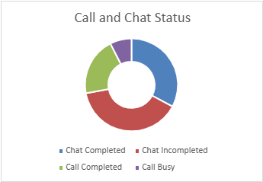

### **Approach**

Analyze historical data to identify agents with high failure rates in customer interactions, which correlate with lower customer satisfaction levels. Focus on targeted training interventions aimed at improving communication skills, problem-solving techniques, and technical knowledge.

### **Insights**

Agents with high failure rates struggle with communication and problem resolution, leading to dissatisfaction among customers. The correlation between failure rates and low customer ratings indicates a critical need for training to enhance agent capabilities and overall service quality.

### **Recommendation**

Implement focused training programs that improve communication, problem-solving, and technical skills for agents with high failure rates. Post-training, monitor key performance indicators (KPIs) to assess reductions in failure rates and improvements in customer satisfaction ratings.

1. What can be the key factors contributing to high customer satisfaction scores, and how can these be leveraged to improve overall performance?

What is the basis for the suggestions? And mention how did you decide if the satisfaction score affect the ratings?

* **Key Factors Contributing to High Customer Satisfaction Scores**

**Approach:** High customer satisfaction is influenced by several key factors, including fast response times, quality interactions, and efficient issue resolution. Analyzing customer feedback and satisfaction scores reveals that interactions with expert agents and lower call volumes significantly impact customer experiences.

### **Insights**

**Interaction with Expert Agents:** Agents with higher expertise tend to deliver better consultations, leading to higher satisfaction ratings. For example, "Tarot Mystical" and "Astro Pujaa Rai," both with high average ratings, exemplify this trend.

**Low Call Volumes:** Agents handling fewer customers can provide more focused and personalized interactions. Overburdened agents often result in rushed consultations, negatively impacting customer satisfaction. This is reflected in the lower ratings of agents like "Tarot Rittika," who appears to be struggling with customer demand.

### **Recommendations**

**Enhance Training Programs:** Invest in comprehensive training for agents to boost their expertise and ensure quality interactions, thereby improving customer satisfaction.

**Optimize Scheduling:** Adjust staffing levels to manage call volumes effectively. This will help prevent agent overload and allow them to dedicate more time to each customer, enhancing the overall experience.

**Monitor Performance Metrics:** Regularly analyze satisfaction scores to identify trends and areas for improvement. This includes tracking the performance of top-rated agents to replicate their success across the team.

### **Basis for Suggestions**

The suggestions are based on the correlation between satisfaction scores and factors such as agent expertise and call volume management. By analyzing the average ratings of both high-performing and low-performing agents, it’s evident that expert interactions and manageable workloads are crucial for maintaining high satisfaction levels.

**Satisfaction Score Impact:** The evaluation of satisfaction scores was conducted by comparing the ratings of agents with varying levels of customer interaction and expertise. The stark contrast between high-rated agents (e.g., "Tarot Mystical" at 7.5) and low-rated agents (e.g., "Tarot Rittika" at 0) clearly indicates that both quality of interaction and agent workload directly influence customer perceptions and satisfaction.

|  |  |
| --- | --- |
| Highest Satisfaction rate | Tarot Mystical |
| Lowest Satisfaction rate | Tarot Rittika |

|  |
| --- |
| Highest top 10 |

|  |  |
| --- | --- |
| guruName | Average of rating |
| Tarot Mystical | 7.5 |
| Astro Pujaa Rai | 7.5 |
| Daljit Kaur | 5.945945946 |
| Astro Reema | 5.9 |
| Tarot Ankita | 5.75 |
| Astro Saraswat | 5.611111111 |
| Tarot Diva Poonam | 5.462686567 |
| Astro Trisha | 5.424324324 |
| Tarot Oormika | 5.4 |
| Astro Manish S | 5.048780488 |
| Grand Total | 5.523809524 |



|  |
| --- |
| Lowest top 10 |

|  |  |
| --- | --- |
| guruName | Average of rating |
| Tarot Rittika | 0 |
| Astro K Ojha | 0.102272727 |
| Acharya Divyansh | 0.387387387 |
| Astro Aditya | 0.794392523 |
| Astro Sushil S | 0.851851852 |
| Tarot Punam | 0.859477124 |
| astro chandan | 1 |
| Astro Yogendra | 1.006802721 |
| Tarot Ittishri | 1.203821656 |
| Tarot Keshmin | 1.235294118 |
| Grand Total | 0.933900851 |



1. How should the call center balance the workload among agents to ensure optimal performance and avoid burnout?

Mention your approach and spreadsheet function for the answer?

* To enhance overall performance and mitigate the risk of agent burnout, a comprehensive approach is essential. Below are strategic initiatives along with corresponding spreadsheet functions to effectively manage workloads.

1. Data-Driven Scheduling Adjustments

Strategy: Utilize historical call data to identify busy periods and adjust staffing schedules accordingly.

Recommendation: Incorporate advanced analytics tools that analyze real-time data for more accurate forecasting. By using AI to anticipate demand fluctuations, such as during sales promotions or unexpected surges, schedules can be optimized to meet customer needs.

1. Flexible Shift Structures

Strategy: Create a flexible shift system that prevents agents from facing continuous high-pressure situations.

Recommendation: Implement a customizable scheduling approach that allows agents to choose shifts based on their preferences. This could include options for shorter shifts during peak times or extended breaks to recharge, promoting overall job satisfaction and reducing fatigue.

1. Enhanced Call Routing Mechanisms

Strategy: Adopt intelligent call routing systems that match calls to agents based on expertise and experience levels.

Recommendation: Move toward a machine learning-based routing system that evolves with agent performance metrics. This can ensure that more complex issues are directed to skilled agents while enabling quicker resolution of straightforward queries.

1. Robust Mental Health Initiatives

Strategy: Provide accessible mental health resources to support agents in managing work-related stress.

Recommendation: Develop a comprehensive wellness program that includes not just mental health resources but also regular wellness checks, team-building activities, and stress management workshops. Promoting a supportive culture can significantly enhance agent well-being.

1. Proactive Workload Monitoring and Management

Strategy: Implement tools for real-time tracking of call metrics and agent workloads.

Recommendation: Use an automated system that continuously evaluates call distribution and workload. This system can redistribute tasks dynamically, preventing any single agent from becoming overwhelmed. Dashboards can also provide agents with insights to manage their time effectively.

|  |  |  |  |  |
| --- | --- | --- | --- | --- |
| User Distribution |  |  | Revenue Distribution |  |
|  |  |  |  |  |
| **website** | **Count of user** |  | **website** | **Sum of netAmount** |
| app | 7800 |  | app | 125267.382 |
| dashboard | 2 |  | dashboard |  |
| gurucool | 20225 |  | gurucool | 88719.93333 |
| **Grand Total** | **28027** |  | **Grand Total** | **213987.3153** |



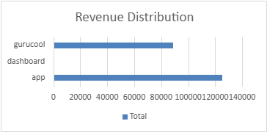

|  |  |
| --- | --- |
| Staus | Count |
| Chat Completed | 5535 |
| Chat Incompleted | 6640 |
| Call Completed | 3450 |
| Call Busy | 1270 |

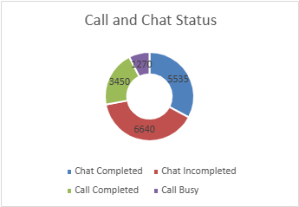

### **Approach**

To balance the workload among agents, implement strategies that include data-driven scheduling adjustments based on historical call data to identify busy periods, create flexible shift structures that allow agents to choose their shifts, adopt enhanced call routing mechanisms that match calls to agents based on expertise, provide robust mental health initiatives to support agents, and implement proactive workload monitoring tools for real-time tracking of call metrics.

### **Insights**

These strategies will help optimize staffing during peak times, reduce continuous high-pressure situations for agents, improve call handling efficiency, and promote agent well-being. A focus on mental health and flexible scheduling can lead to higher job satisfaction and reduced burnout rates.

### **Recommendation**

Integrate these strategies to foster a supportive environment that balances workloads effectively, enhances overall performance, and reduces the risk of agent burnout, ultimately leading to improved customer service quality.

1. What new technologies or tools could be implemented to enhance call center operations and customer service?

* **1. AI-Based Call Routing**

**Approach:**

**Data Collection:** Gather data on call patterns, customer behavior, and agent performance.

**Algorithm Development:** Implement machine learning algorithms to analyze historical data and predict the best agent for each call based on skill sets, availability, and past performance.

**Integration:** Integrate AI routing with existing call management systems for seamless operation.

**Testing and Optimization:** Conduct A/B testing to refine algorithms and ensure accuracy in call distribution.

**Insights:**

AI routing can reduce average handling times by directing calls to the most qualified agents.

Customer satisfaction scores improve when calls are resolved more quickly and effectively.

**Recommendations:**

Invest in a robust AI routing platform and continuously train the model with new data to improve its efficiency.

Monitor performance metrics regularly to adjust routing parameters based on changing customer needs.

**2. Customer Relationship Management (CRM) Systems**

**Approach:**

**Needs Assessment:** Evaluate the current customer engagement processes and identify gaps.

**CRM Selection:** Choose a CRM solution that fits the specific needs of the call center, focusing on scalability and integration capabilities.

**Implementation:** Roll out the CRM system, ensuring data migration from legacy systems is smooth and secure.

**Training:** Conduct comprehensive training sessions for staff on how to use the CRM effectively.

**Insights:**

A well-implemented CRM system centralizes customer data, allowing agents to access relevant information quickly.

Personalized service increases customer loyalty and reduces churn rates.

**Recommendations:**

Regularly update the CRM to incorporate new features and integrations.

Utilize CRM analytics to gain insights into customer behavior and preferences, tailoring services accordingly.

### **3. Advanced Analytics Tools**

**Approach:**

**Data Aggregation:** Compile data from various sources, including call logs, customer interactions, and feedback surveys.

**Analytics Implementation:** Use data visualization tools and dashboards to analyze key performance indicators (KPIs) like call volume, response times, and customer satisfaction.

**Predictive Analytics:** Employ predictive modeling to anticipate customer needs and potential issues.

**Insights:**

Analytics can reveal trends in call volume, helping to forecast peak times and manage staffing accordingly.

Identifying patterns in customer complaints can lead to proactive measures that enhance service quality.

**Recommendations:**

Invest in advanced analytics software that allows for real-time monitoring and reporting.

Foster a culture of data-driven decision-making among staff, encouraging them to utilize insights in their daily operations.

1. What metrics should be included in the final dashboard to provide a comprehensive view of call center performance and guide investment decisions?

* **Metrics for Call Center Performance Dashboard**

**Approach:** To create a comprehensive dashboard, include essential metrics that reflect overall call center performance and guide investment decisions. These metrics should capture various aspects of operations, customer interactions, and financial performance. Additionally, implement filters to allow for in-depth analysis across different dimensions.

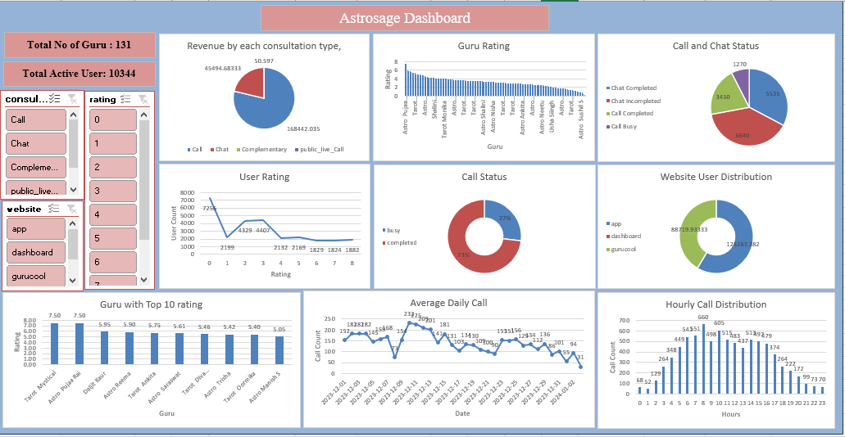

**Insights:** The metrics collectively provide a holistic view of call center efficiency, customer satisfaction, and revenue generation. Key observations include:

High call volumes and longer handling times may indicate staffing needs.

Customer satisfaction scores are crucial for identifying areas for improvement.

Tracking revenue against user engagement can highlight the effectiveness of services.

**Recommendations:** Include the following metrics in the final dashboard:

**Total Call Volume**: Measures the number of calls handled within a specific timeframe.

**Average Handling Time (AHT)**: Calculates the average duration of calls, highlighting efficiency.

**Customer Satisfaction Scores (CSAT)**: Captures customer feedback on service quality.

**Agent Performance Metrics**: Evaluates individual agent effectiveness based on KPIs like resolution rates and customer feedback.

**Peak Call Times**: Identifies busy hours to optimize staffing and reduce wait times.

**Filters:**

**Consultation Type Filter**: Analyze performance based on consultation types (e.g., call, chat).

**Platform Filter**: Differentiate activities between the website and app.

**Month Filter**: Track performance trends monthly.

**Additional Metrics for Analysis:**

**Total Revenue Generated**: Displays overall revenue and can be filtered by consultation type and platform.

**Total Active Gurus/Agents**: Indicates the number of agents available, refined by filters for insights.

**Total Active Users**: Tracks daily user engagement levels across platforms.

**Daily Activity on Astrosage**: Visualizes engagement trends with filters for specific performance metrics.

**Users vs. Revenue**: Compares user numbers against revenue to assess income generation.

**Platform Activity Overview**: Illustrates activity distribution across consultation types.

**Call Volumes Across Hours**: Displays peak call times to inform staffing strategies.

**Consultation Status**: Summarizes completed versus failed consultations to evaluate performance.

**Average Customer Rating Distribution**: Visualizes customer ratings, offering insights into service quality.

1. How would you allocate a 1 crore rupee investment to optimize operational efficiency, enhance customer satisfaction, and boost profitability, and what analysis-based recommendations would you offer to support this?

[you have to give bullet pointers in order to answer this question]

* **Approach**

Allocate a total investment of 1 crore rupees across key areas to optimize operational efficiency, enhance customer satisfaction, and boost profitability.

Focus on technology upgrades, training and development, staffing enhancements, and customer engagement initiatives.

**Insights**

Investing 40% in technology upgrades will streamline operations through advanced call routing and CRM systems, enabling better customer insights and efficiency.

Allocating 30% to training and development will enhance agent skills, addressing performance gaps and improving interaction quality.

Increasing staffing with 20% of the budget will reduce wait times during peak hours, leading to higher customer satisfaction.

Using 10% for customer engagement initiatives will provide valuable feedback and foster loyalty, further enhancing customer satisfaction.

**Recommendations**

**Technology Investments:** Prioritize the implementation of AI-driven analytics and advanced call routing systems to improve operational efficiency.

**Training Programs:** Develop targeted training sessions for agents to enhance communication, problem-solving, and technical skills.

**Flexible Staffing Models:** Introduce hiring strategies that align with call volume patterns to ensure adequate coverage during peak periods.

**Customer Feedback Mechanisms:** Establish regular feedback collection processes to continuously improve service quality and customer satisfaction.

**Ensure that you put the slicers for choosing the country and year in order to observe the dashboard since the management will be having a long discussion which can go for weeks.**

**Note: The dashboard would be more interactive and user-friendly, allowing management to explore data in detail and make informed decisions.**