**School of Computer Science**

**UNIVERSITY OF PETROLEUM AND ENERGY STUDIES**

**DEHRADUN, UTTARAKHAND**



System Monitoring And Configuration Management

**Lab File**

**(2023-2024)**

**for**

**6th Semester**

Submitted To: Submitted By:

Dr. Hitesh Kumar Sharma Pragya Mittal

B. Tech. CSE DevOps

[6h Semester]

Sap id- 500090986

Batch 1

R2142210570

**LAB EXERCISE 9**

**Aim: Creating Multiple EC2 Instances with for each in Terraform**

Step 1: Create a main.tf file

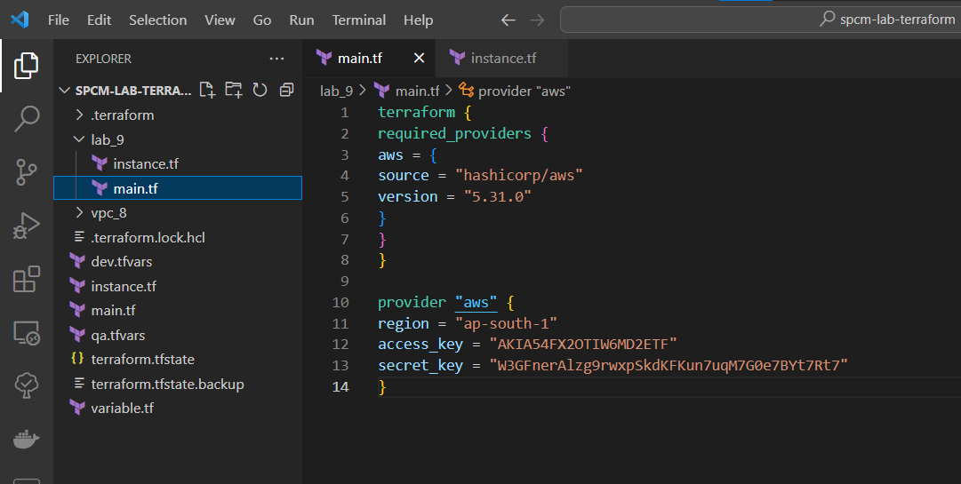

Step 2: Create a instance.tf file

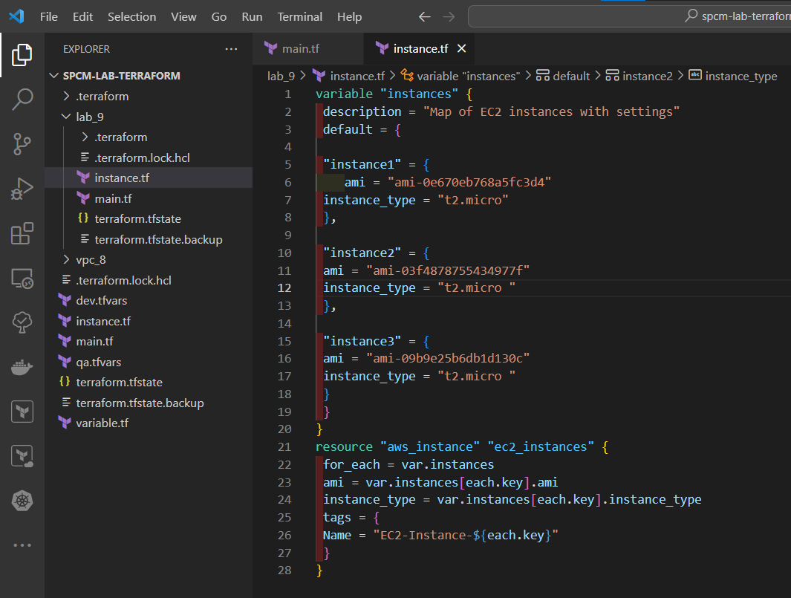

Step 3: Now run terraform init command to Initialize.

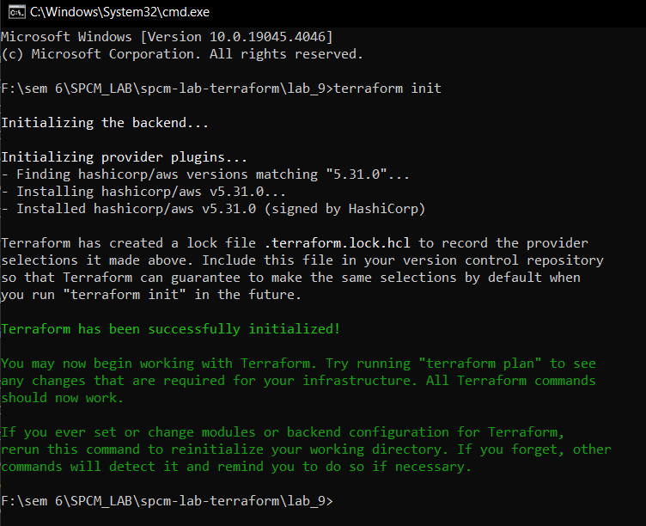

Step 4: Now run the terraform validate command to check if any error is present or not.

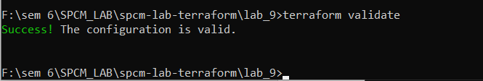

Step 5: Now run terraform plan command.

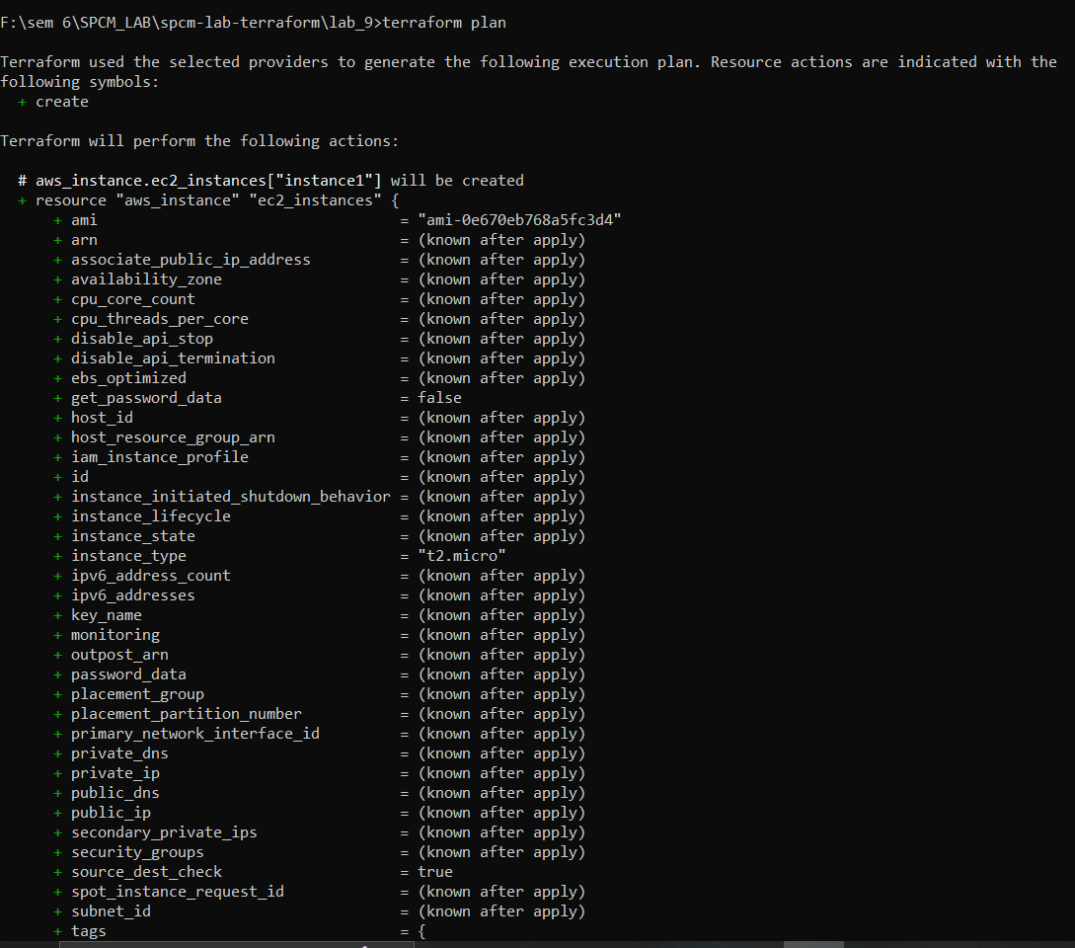

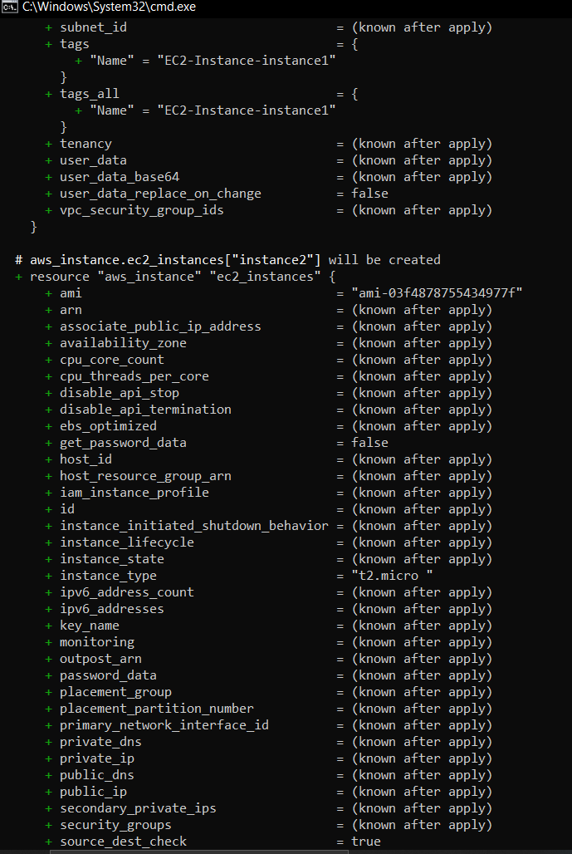

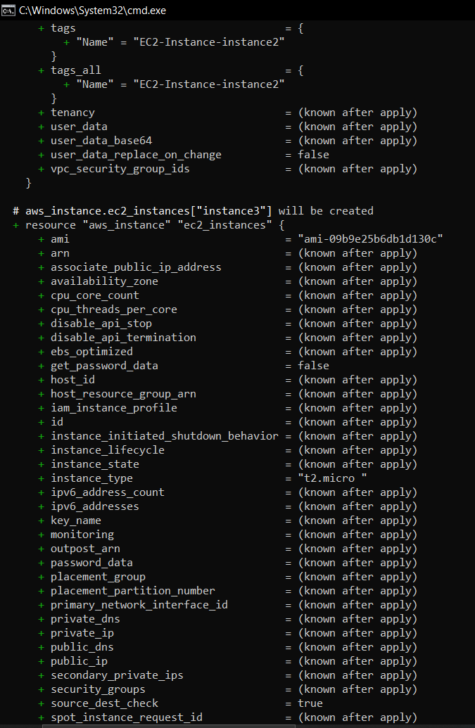

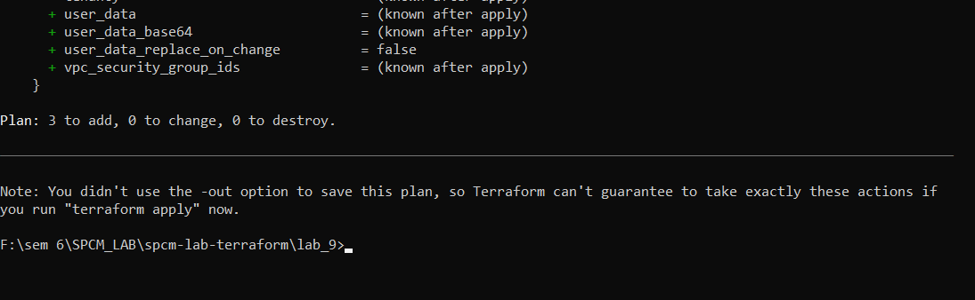

**LAB EXERCISE 10**

**Aim: Creating an AWS RDS Instance in Terraform**

Step 1: Create a main.tf file

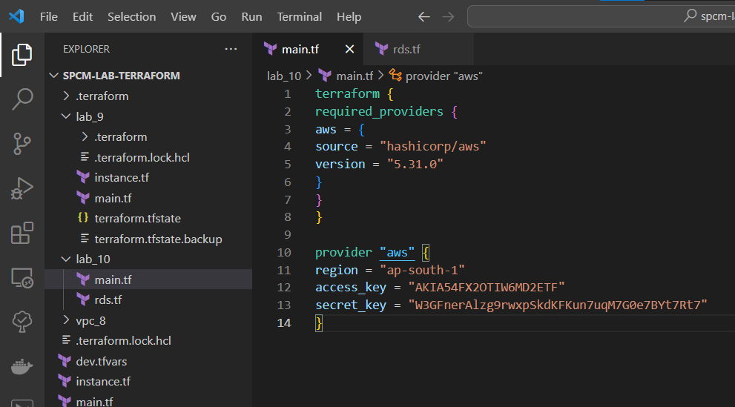

Step 2: Create a rds.tf file

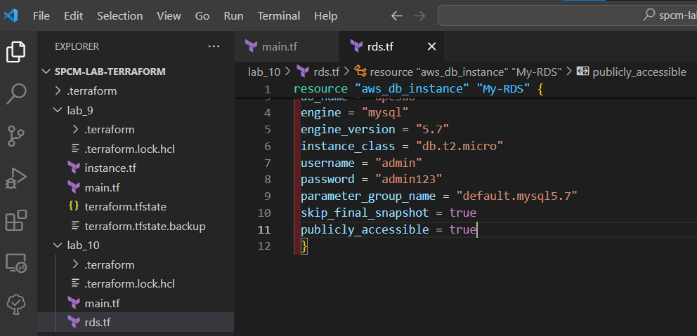

Step 3: Now run terraform init command to Initialize.

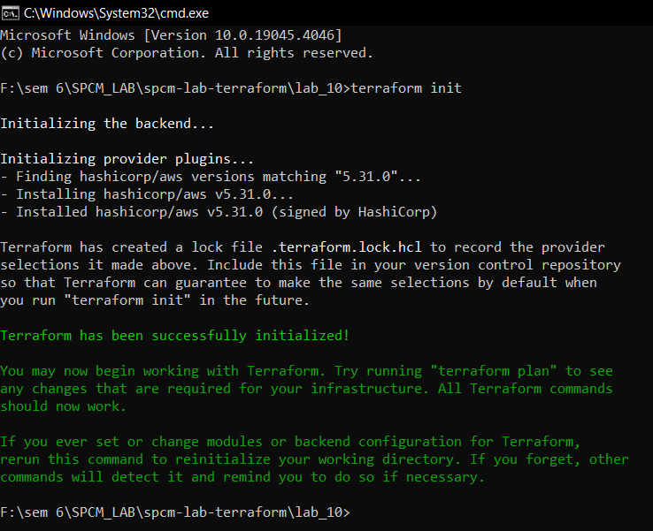

Step 4: Now run the terraform validate command to check if any error is present or not.

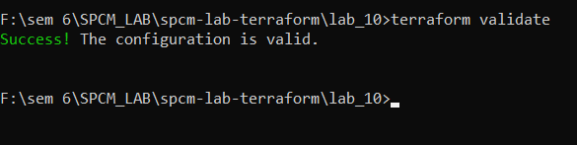

Step 5: Now run terraform plan command.

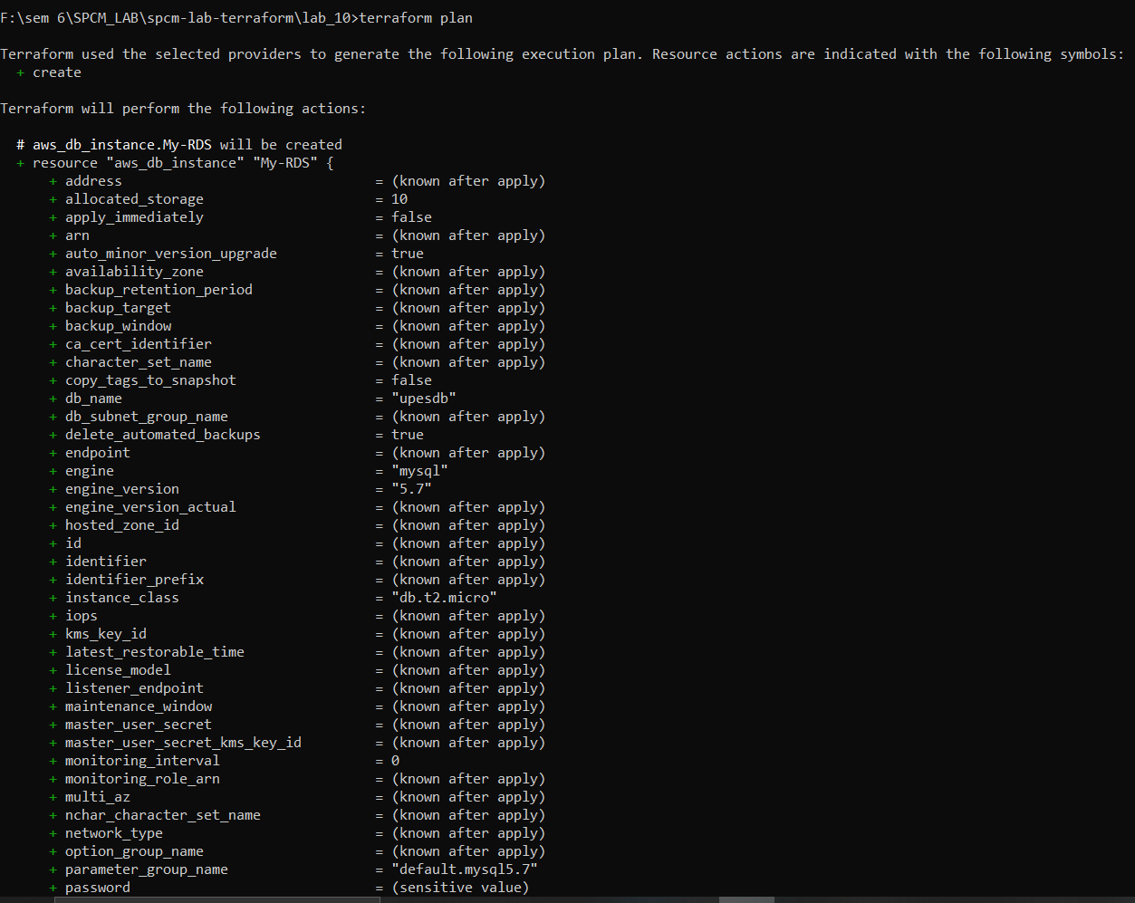

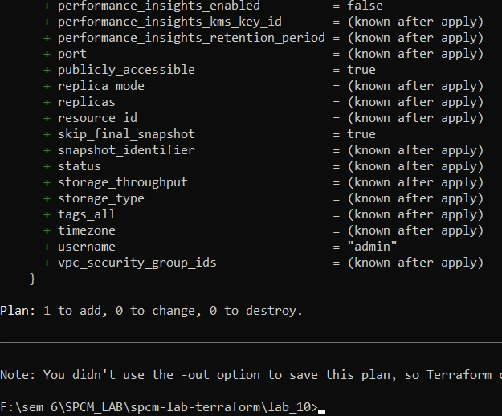

Step 6: Now run the terraform apply command to apply the rds.

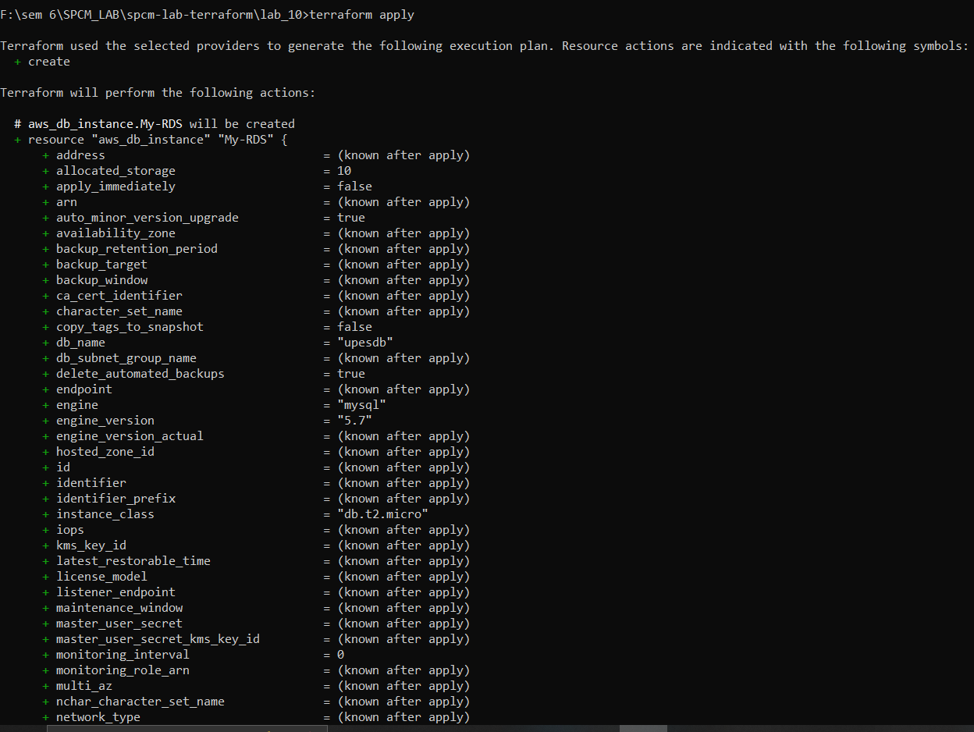

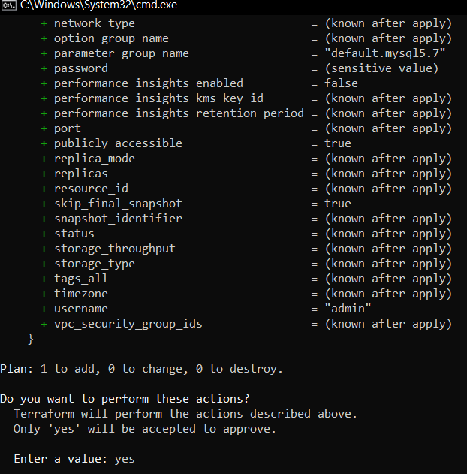

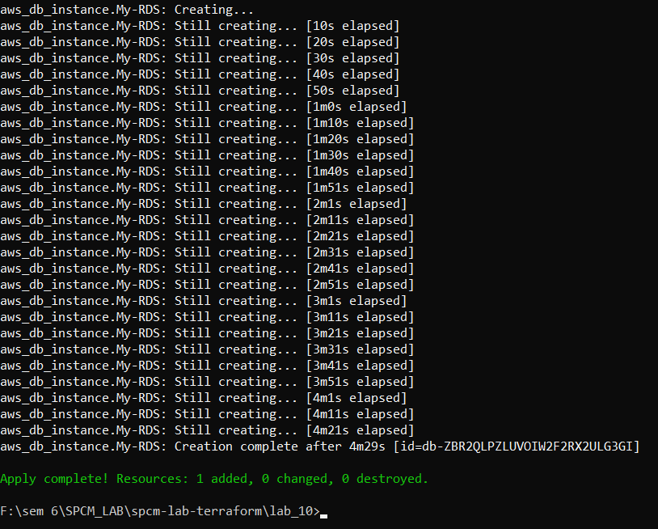

Step 7: Verify the RDS Instance in AWS Console.

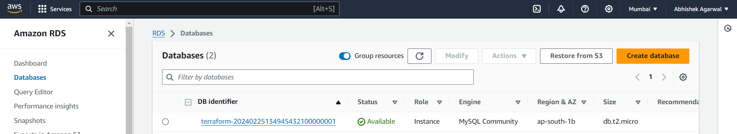

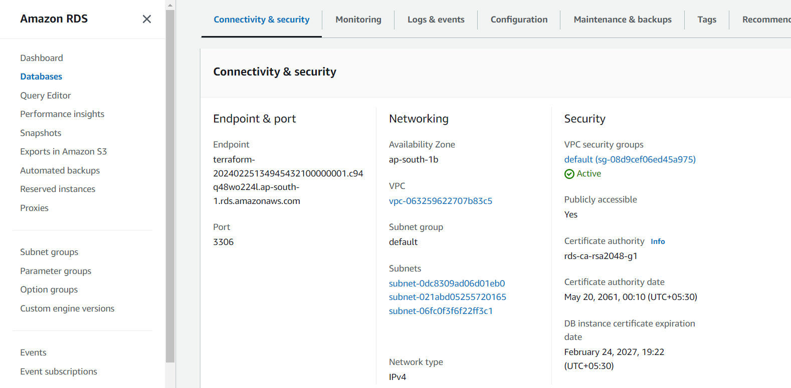

Step 8: Connect To MYSQL Workbench.

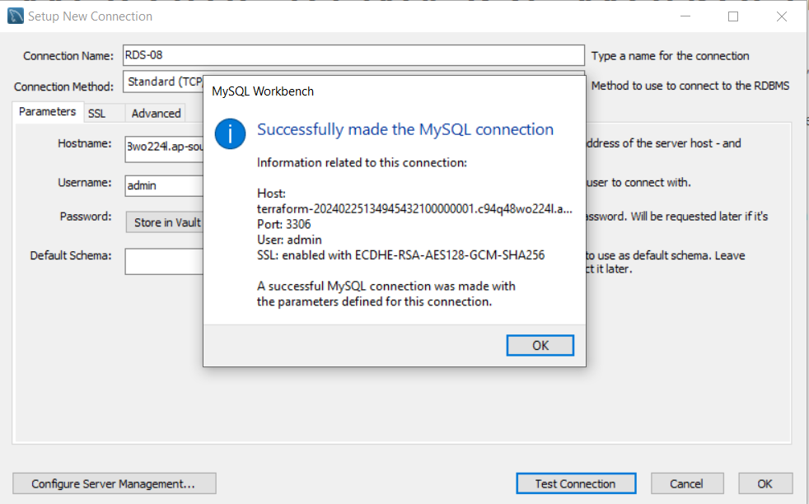

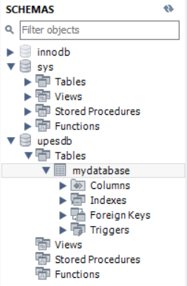

Step 9: Now Destroying the rds created.

