**Lab-10**

**Creating an Aws RDS Instance in Terraform**

Step 1: Create a Terraform Directory

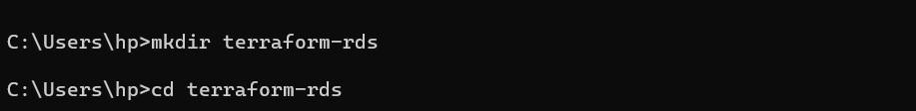

Step 2: Create a Terraform Configuration Files

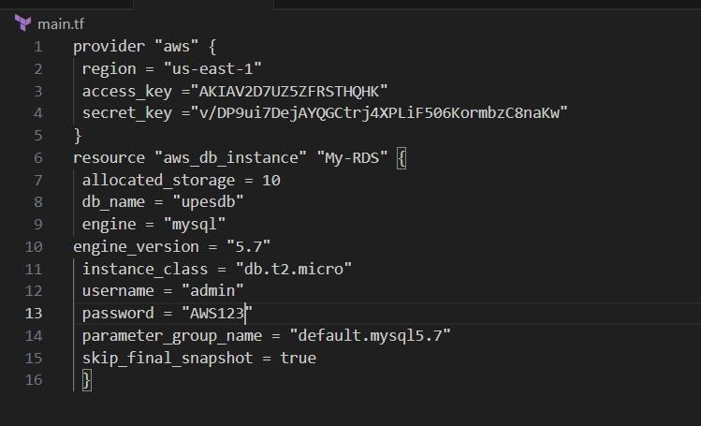

Step 3: Initialize and Apply

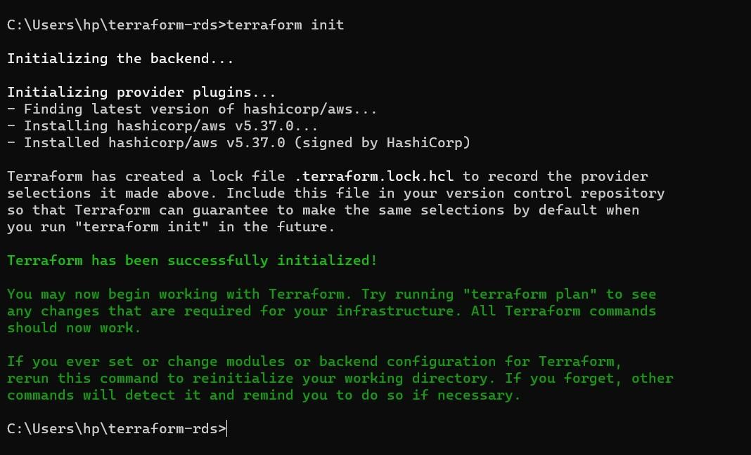

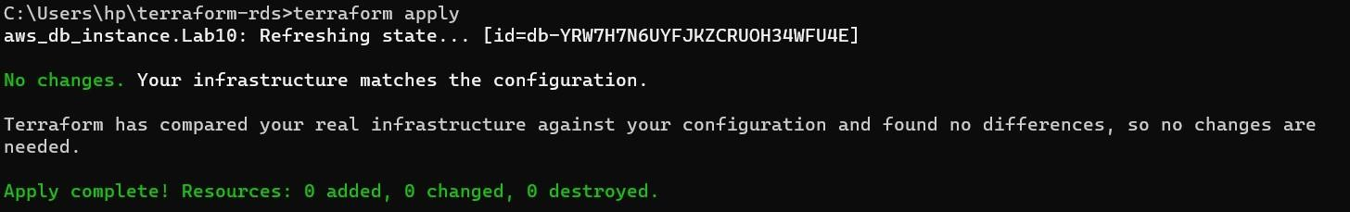

Step 4: Verify RDS Instance in AWS console

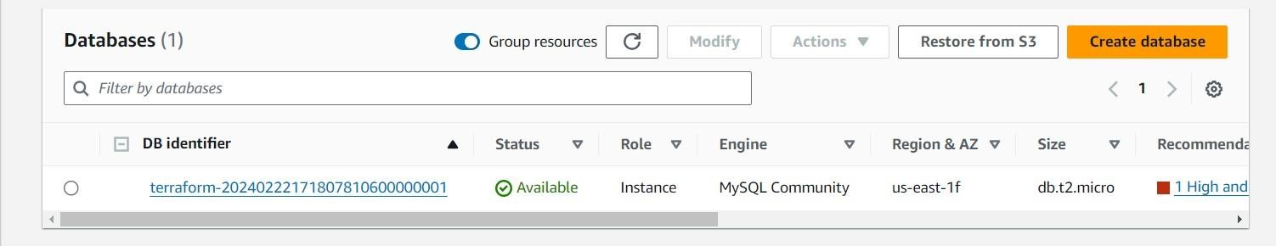

Step 5: MYSQL Workbench Connection

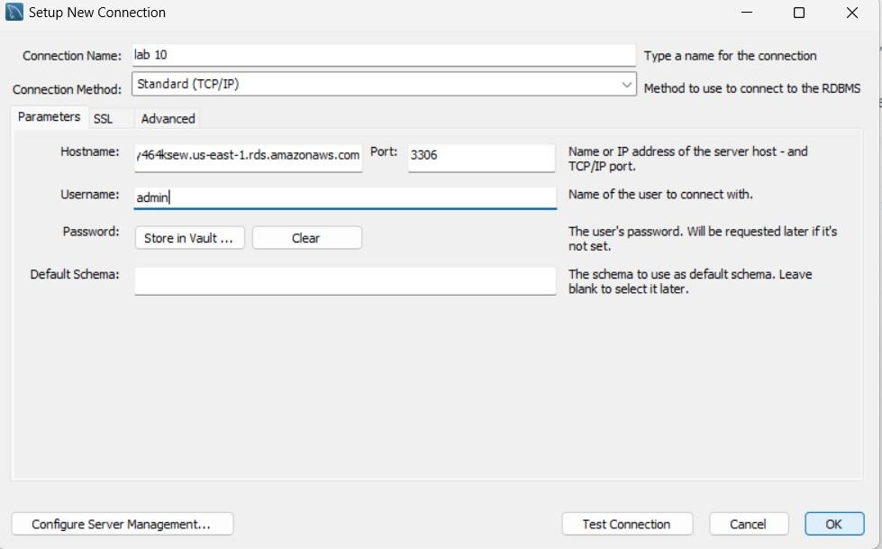

Step 6: Clean up

