

**SYSTEM PROVISIONING AND CONFIGURATION MANAGEMENT**

**Submitted to:**

**Dr. Hitesh Kumar Sharma**

**Submitted By:**

**Name: Diya khandelwal**

**SAP ID: 500090939**

**B. tech CSE DevOps B1**

**Roll no.: R2142210293**

**EXPERIMENT- 1**

Install Terraform

• Check the installation of terraform

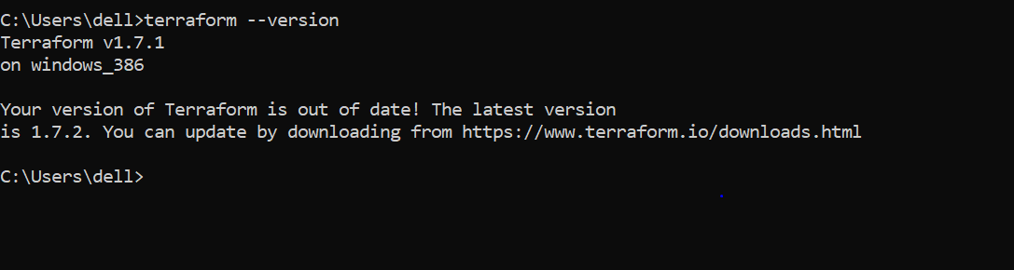

**EXRERIMENT-2**

Terraform AWS Provider and IAM User Setting

Create a file named main.tf with the following content:

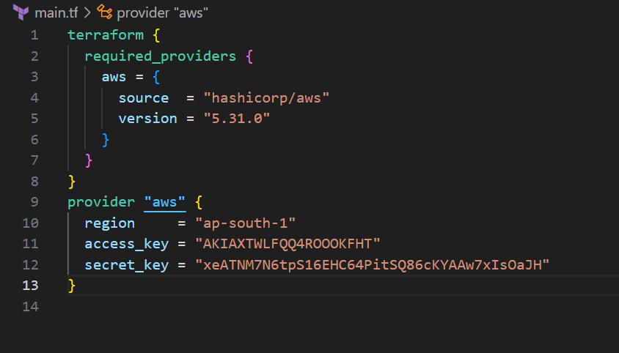

**Initialize Terraform:**

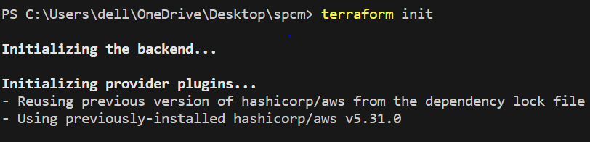

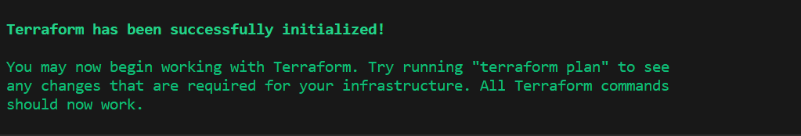

**EXPERIMENT-3**

Provisioning an EC2 Instance on AWS

Main.tf file

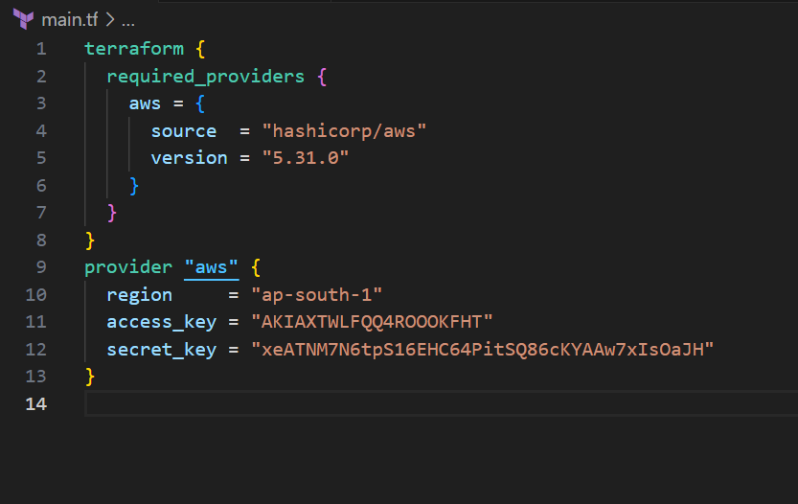

Create Terraform Configuration File for EC2 instance (instance.tf): Create a file named instnace.tf with the following content:

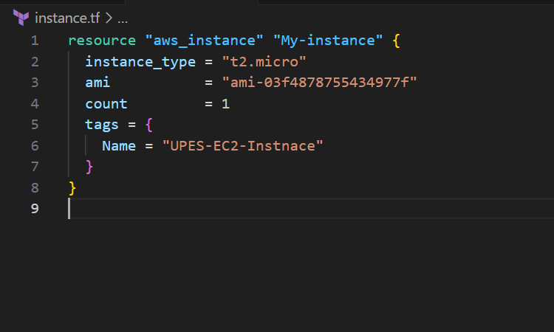

Run the command “terraform plan” and review the plan to ensure it aligns with your expectations.

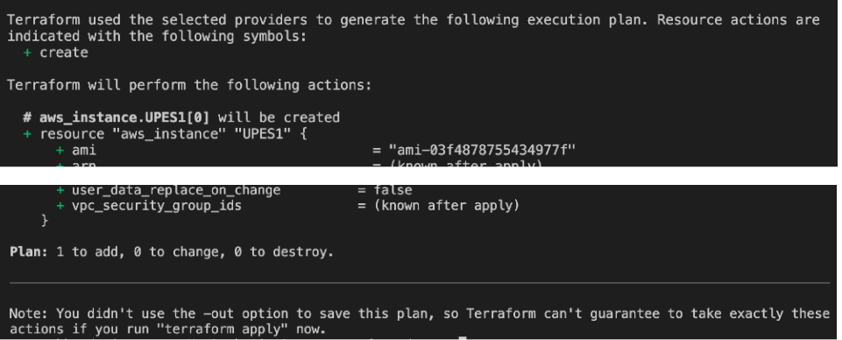

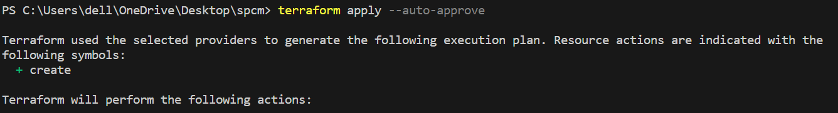

• After the terraform apply command completes, log in to your AWS Management Console and navigate to the EC2 dashboard. Verify that the EC2 instance has been created.

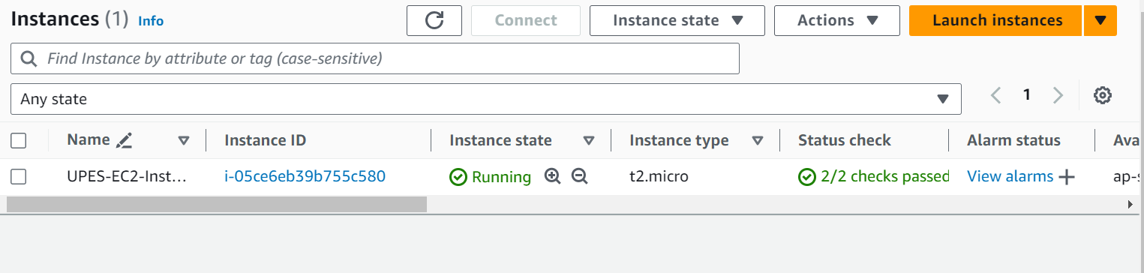

**EXPERIMENT-4**

Terraform Variables

Create a file variable.tf with the following contents

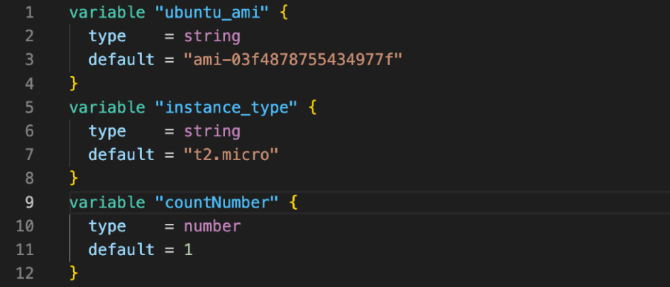

Use the variable declared and defined in variable.tf in instance.tf

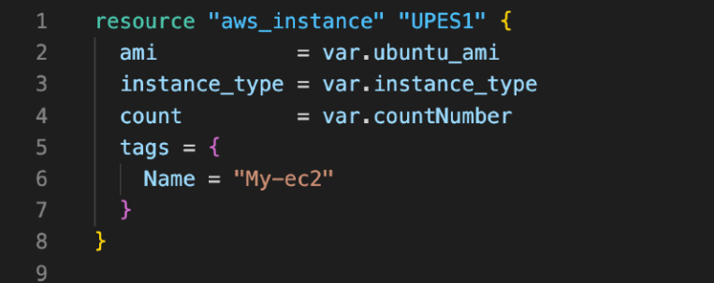

Run the command terraform plan and review the plan to see if it meets your expectations

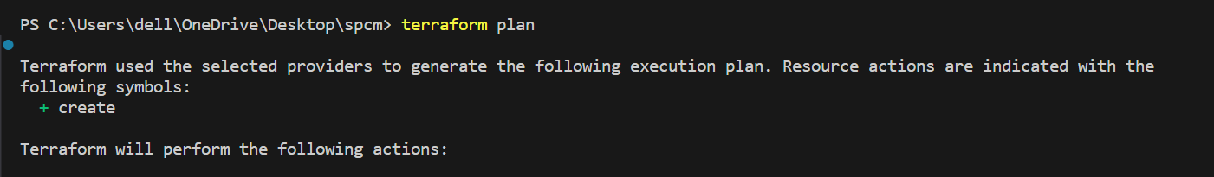

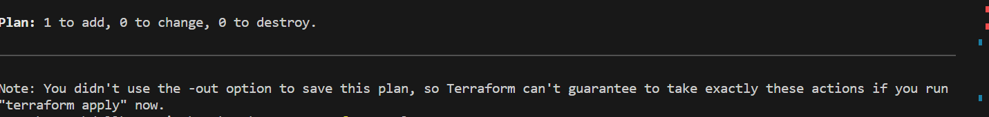

• Run terraform apply and create the resources.



**EXPERIMENT -5**

Terraform Variables with Command Line Arguments

Create a file named variables.tf: # variables.tf

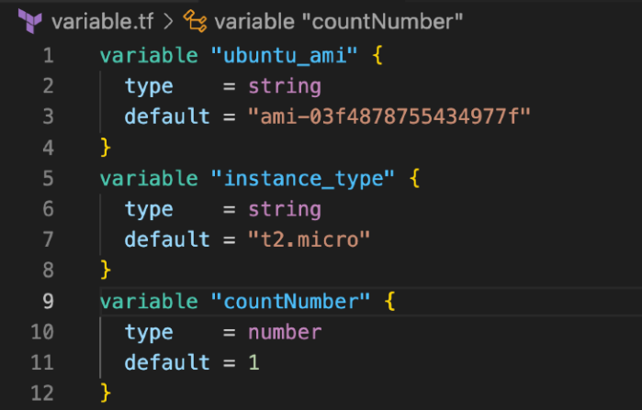

Use the variable declared and defined in variable.tf in instance.tf

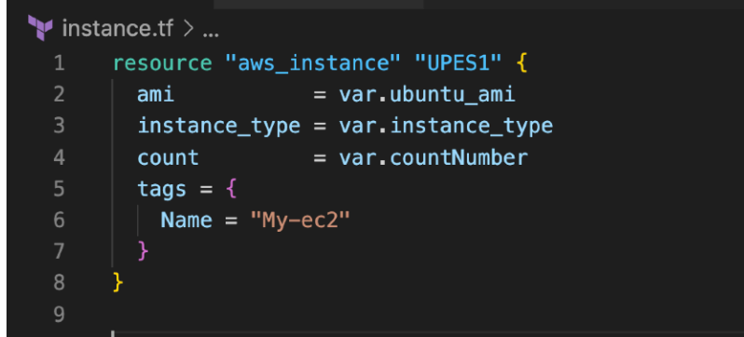

Run the command terraform plan and review the plan to see if it meets your expectations

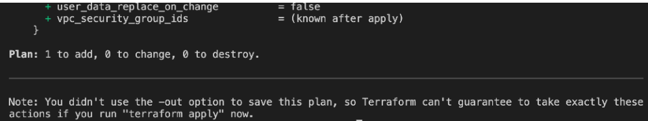

Run terraform apply and create the resources.

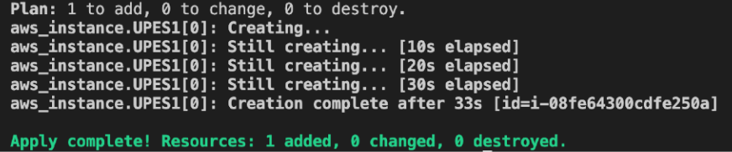

**EXPERIMENT-6**

Terraform Multiple tfvars Files

