# School of Computer Science

## UNIVERSITY OF PETROLEUM AND ENERGY STUDIES DEHRADUN, UTTARAKHAND



**Application Containerization and Orchestration**

**(2023-2024)**

**for**

**5th Semester**

## Submitted To:

Hitesh Kumar Sharma

## Submitted By:

Garv Gopalia

B. Tech. CSE [DevOps] 500091394

R2142210307

B1- DevOps (Non-Hons)

1. Create Terraform Configuration File  
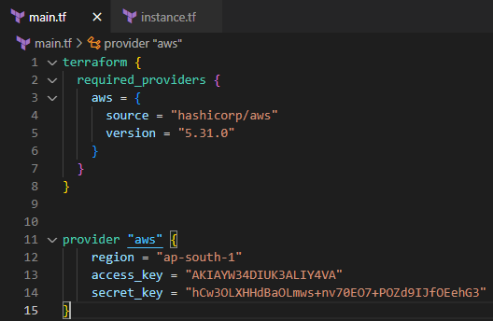

2. Initialize Terraform  
