**School of Computer Science**

**UNIVERSITY OF PETROLEUM AND ENERGY STUDIES**

**DEHRADUN, UTTARAKHAND**



**System Provisioning and Configuration Management**

**Lab File (2021-2025)**

# **6th Semester**

| *Submitted To:*  ***Dr. Hitesh Kumar Sharma*** | *Submitted By:*  *Prakhar Gupta*  *(500093012)*  *B Tech CSE*  *DevOps[6th Semester]*  *R2142210572*  *Batch - 2* |
| --- | --- |

**Lab Exercise 4– Terraform Variables**

Objective: Learn how to define and use variables in Terraform configuration.

Steps: 1. Create a Terraform Directory:

• Create a new directory for your Terraform project.

2. Create a Terraform Configuration File:

• Create a file named main.tf within your project directory. # main.tf

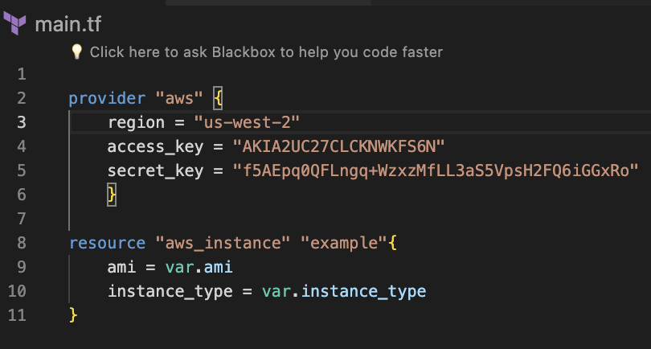

3. Define Variables: • Open a new file named variables.tf. Define variables for region, ami, and instance_type. # variables.tf

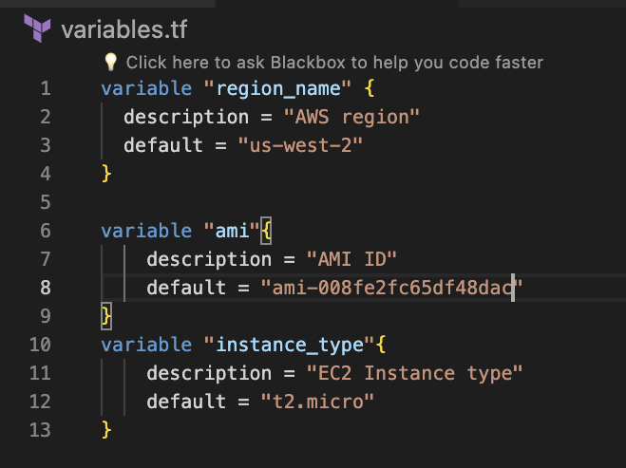

4. Use Variables in main.tf: • Modify main.tf to use the variables. # main.tf

5. Initialize and Apply: • Run the following Terraform commands to initialize and apply the configuration.

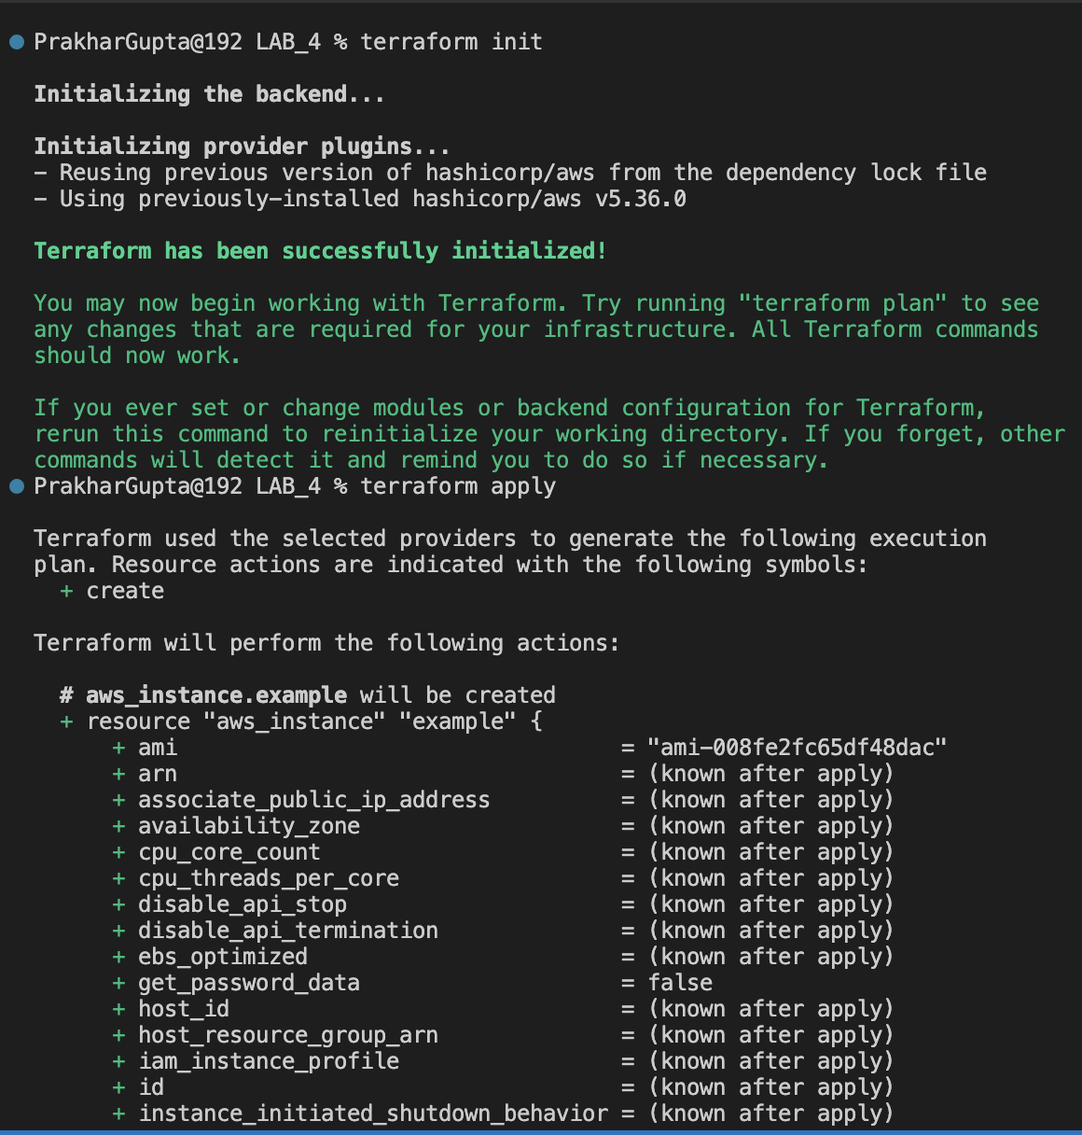

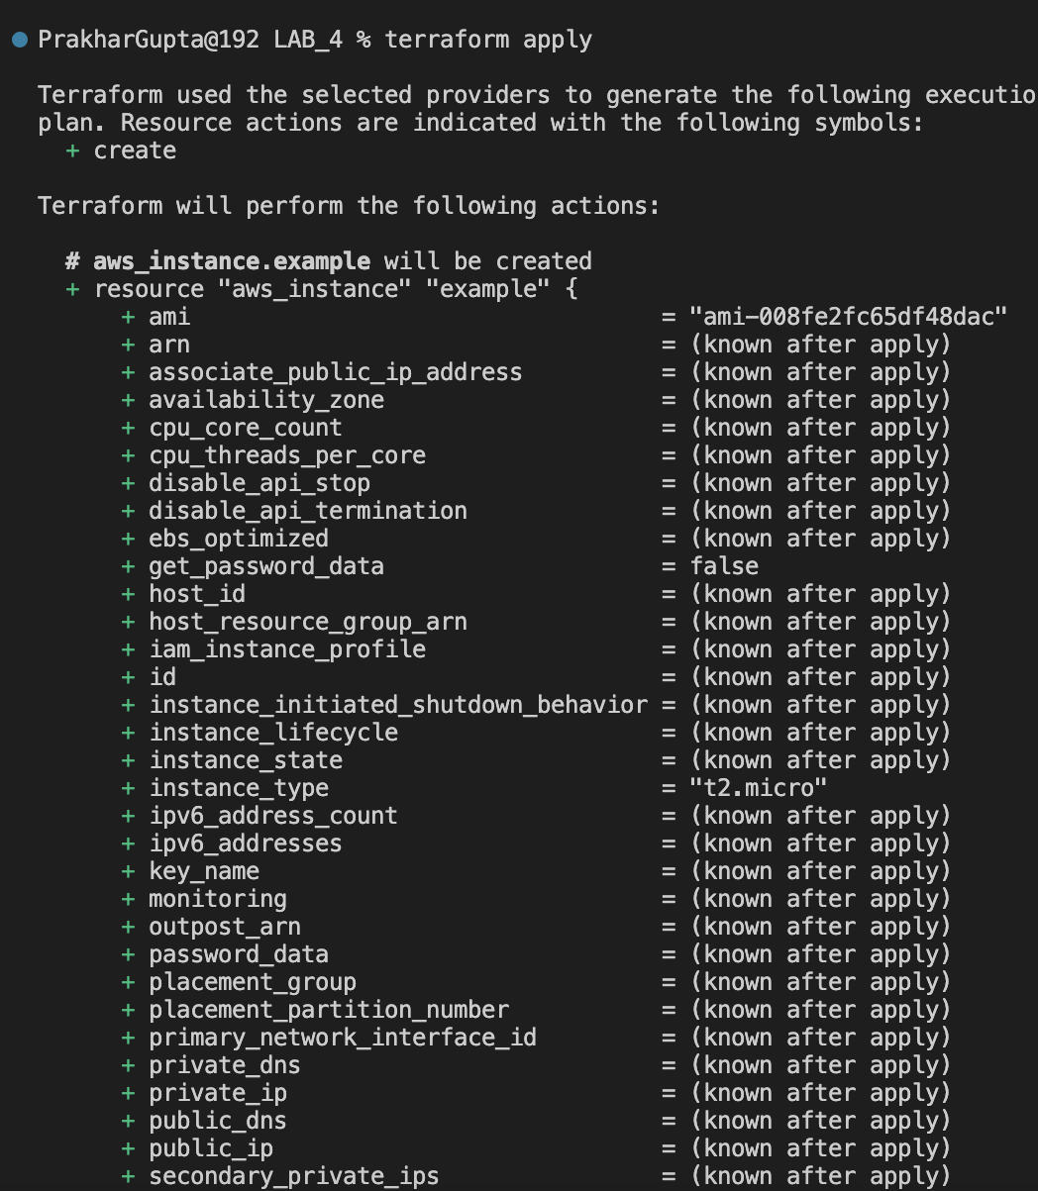

Observe how the region changes based on the variable override.

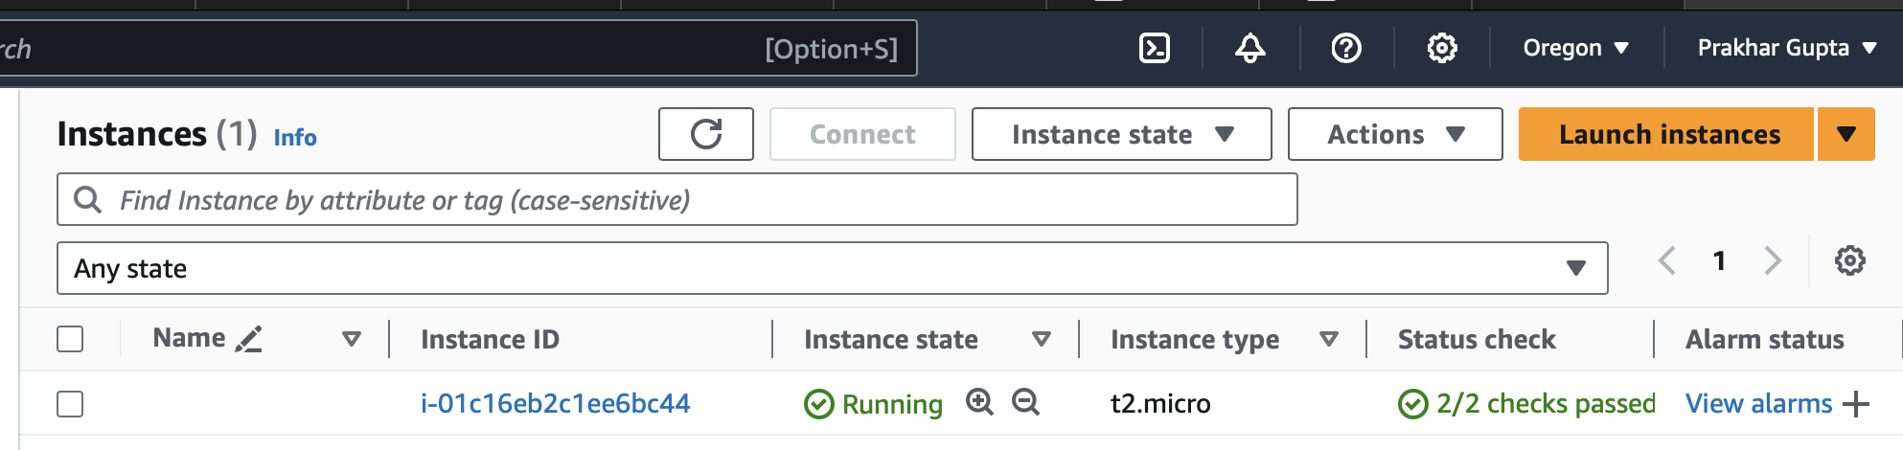

6. Clean Up: After testing, you can clean up resources.

