**Lab Exercise 2– Terraform AWS Provider and IAM User Setting**

**Priyansh Choudhary**

**500093657, R2142210596**

**B. Tech. CSE-DevOps – B2, 6th SEM**

1. Create Terraform Configuration File  
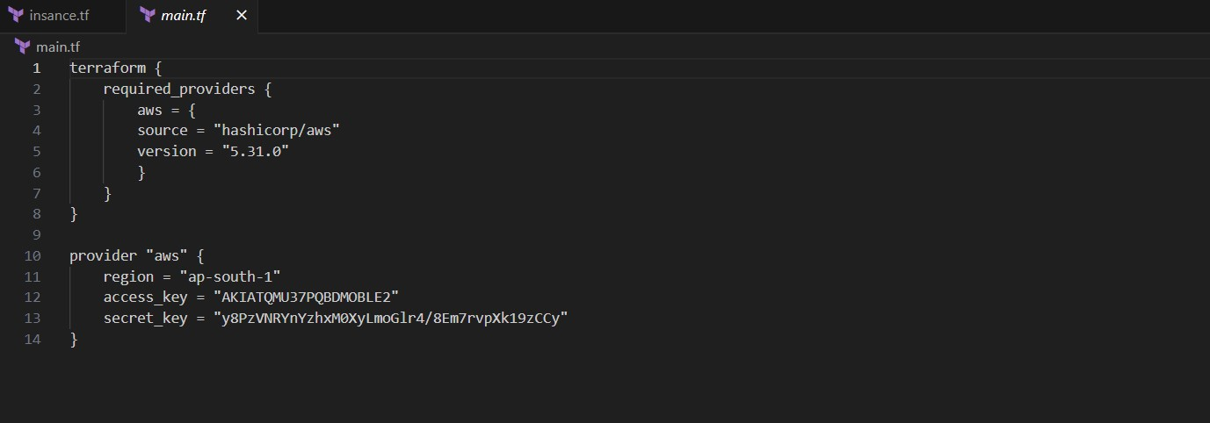

2. Initialize Terraform  
