**Lab Exercise 3– Provisioning an EC2 Instance on AWS**

**Priyansh Choudhary**

**500093657, R2142210596**

**B. Tech. CSE-DevOps – B2, 6th SEM**

1. Create Terraform Configuration File

Main.tf:

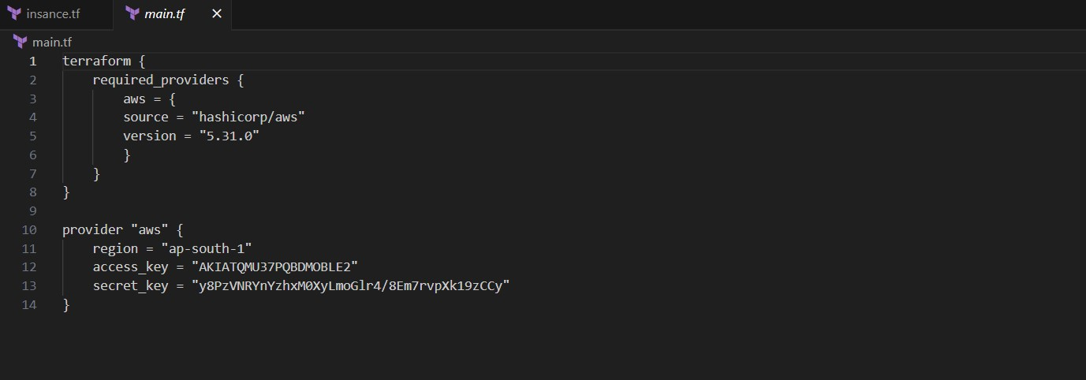

Instance.tf:  
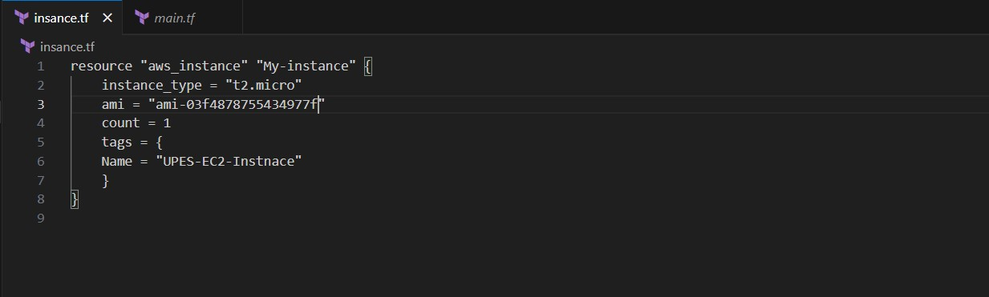

2. Review Plan & Apply Changes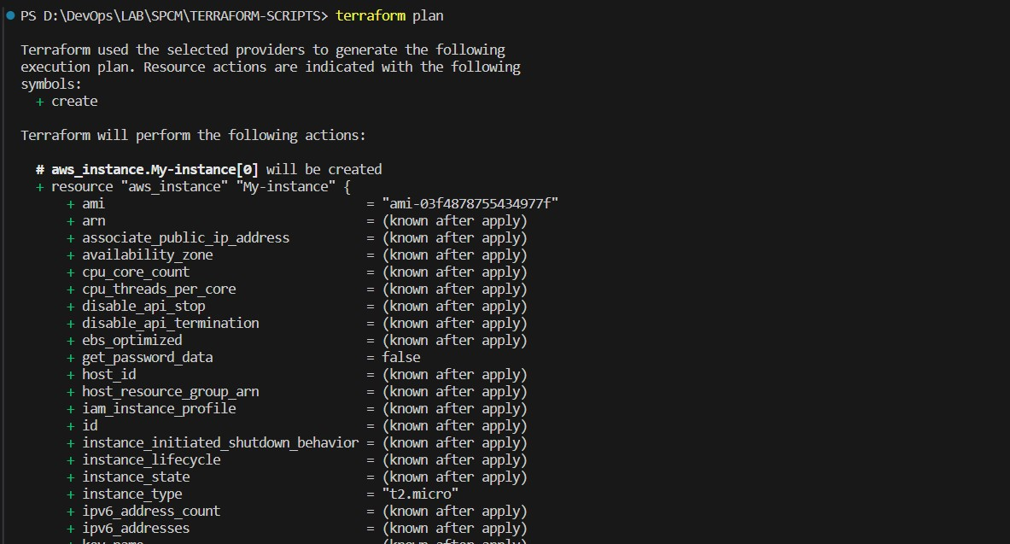

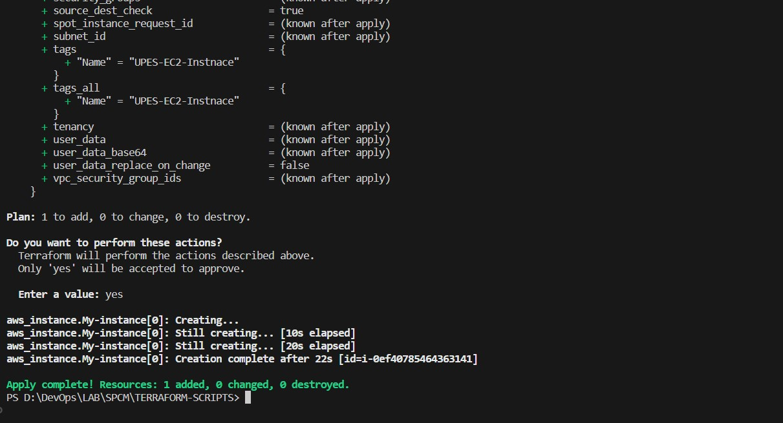

3. Check the AWS Console

