**Lab Exercise 4– Terraform Variables**

**Priyansh Choudhary**

**500093657, R2142210596**

**B. Tech. CSE-DevOps – B2, 6th SEM**

1. Create Terraform Configuration File:

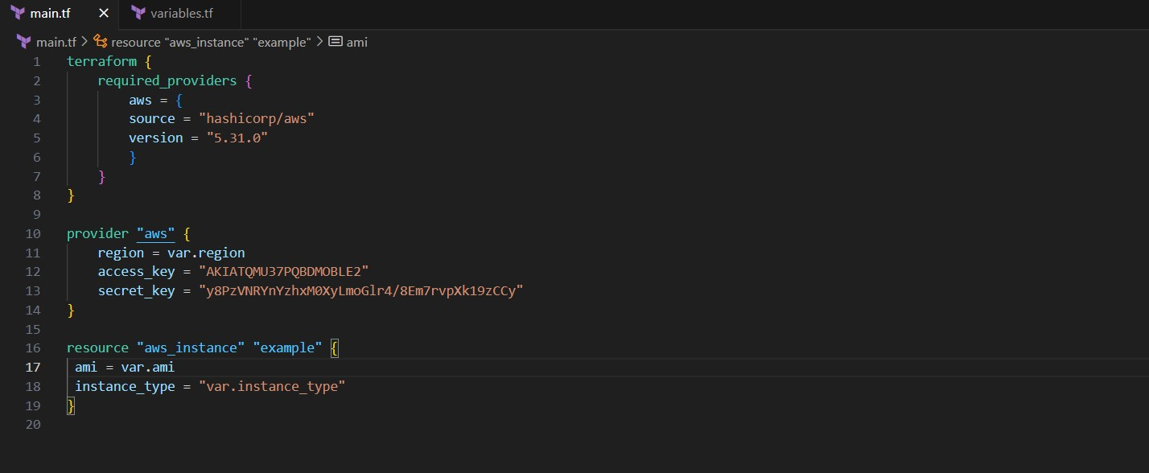

1. Define Variables

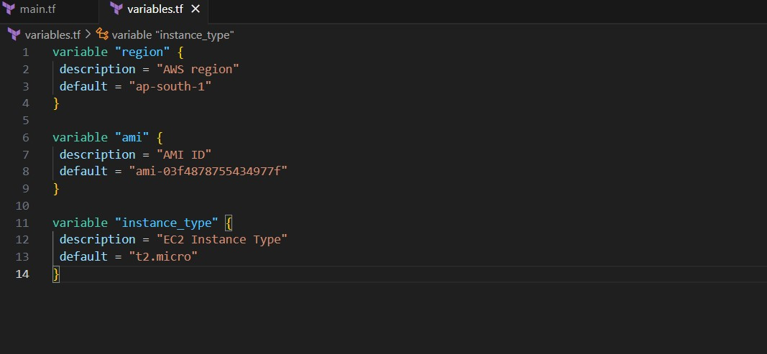

1. Initialize and Apply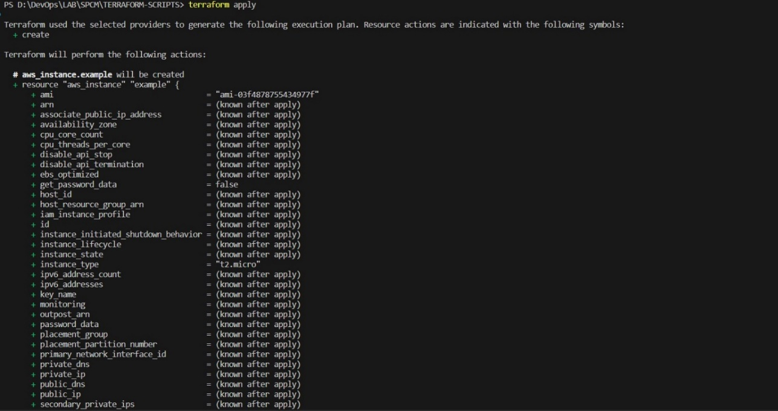

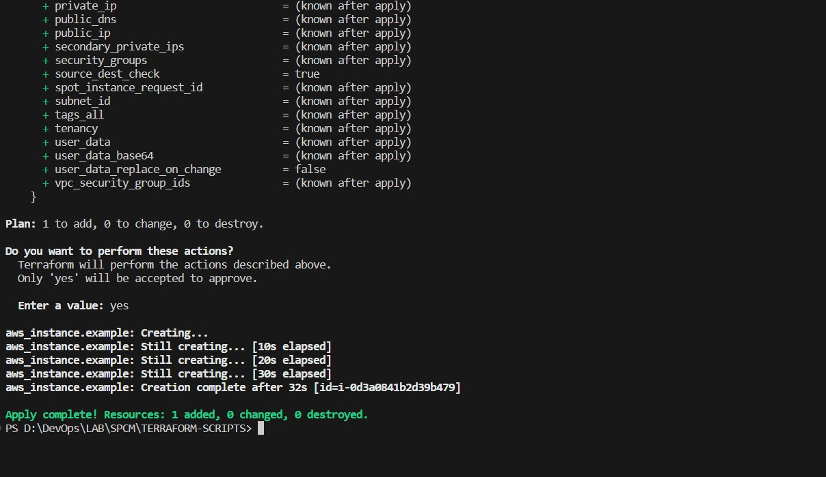

1. Check the AWS Console

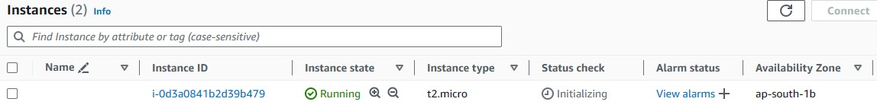

1. Clean Up

