**Lab Exercise 5– Terraform Variables with Command**

**Line Arguments**

**Priyansh Choudhary**

**500093657, R2142210596**

**B. Tech. CSE-DevOps – B2, 6th SEM**

1. Create Terraform Configuration File:

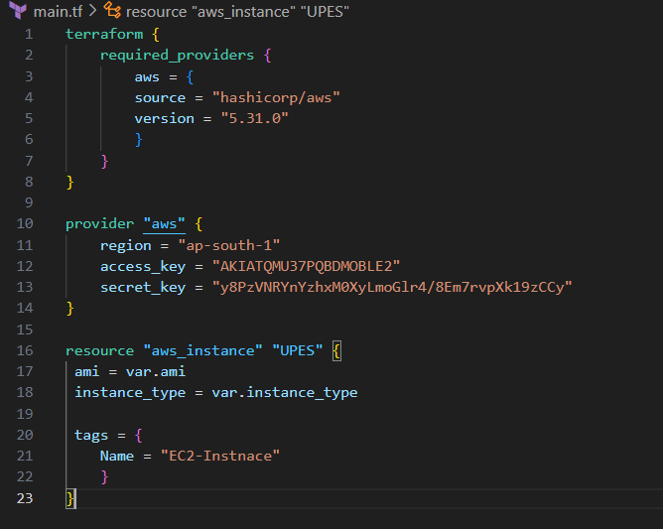

1. Define Variables

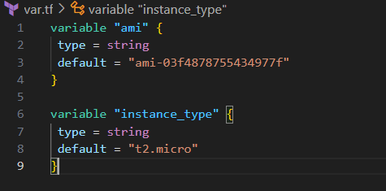

1. Use Command Line Arguments

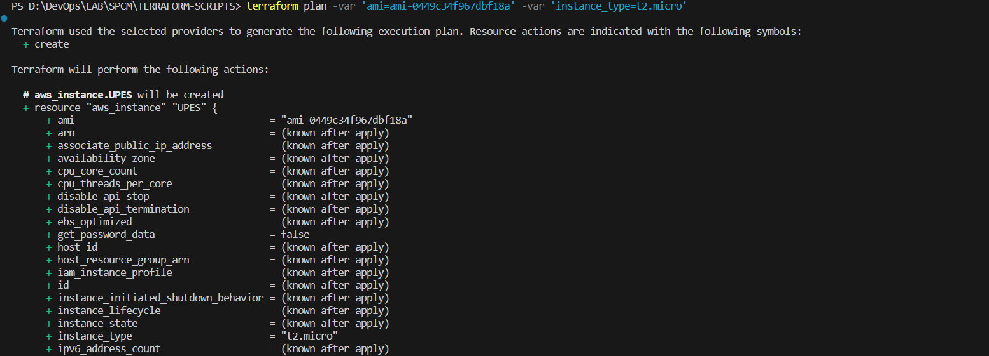

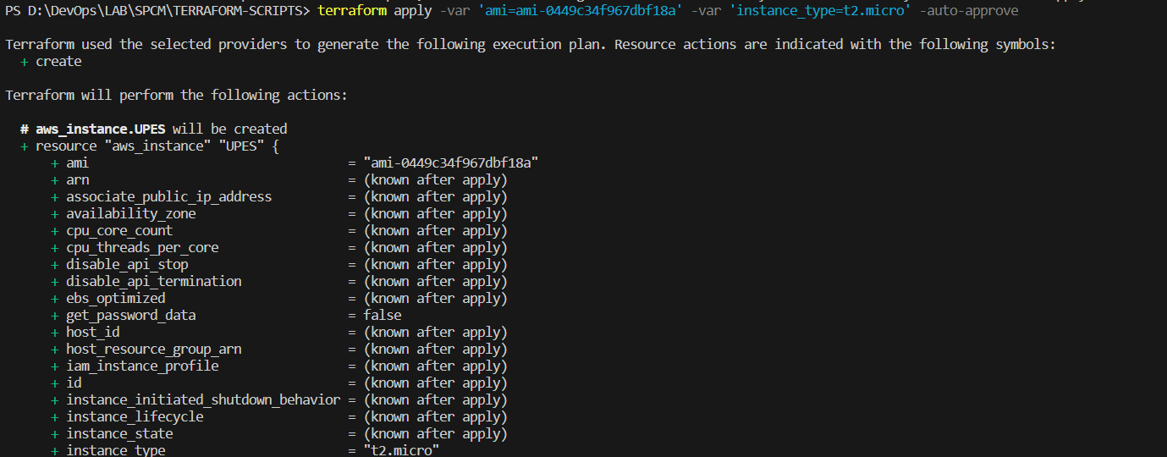

1. Check Console

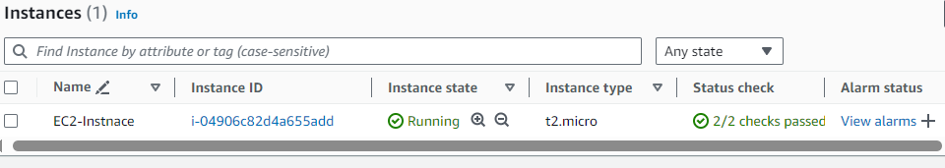

1. Clean Up

