**Lab Exercise 6– Terraform Multiple tfvars Files**

**Priyansh Choudhary**

**500093657, R2142210596**

**B. Tech. CSE-DevOps – B2, 6th SEM**

1. Create Terraform Configuration Files:  
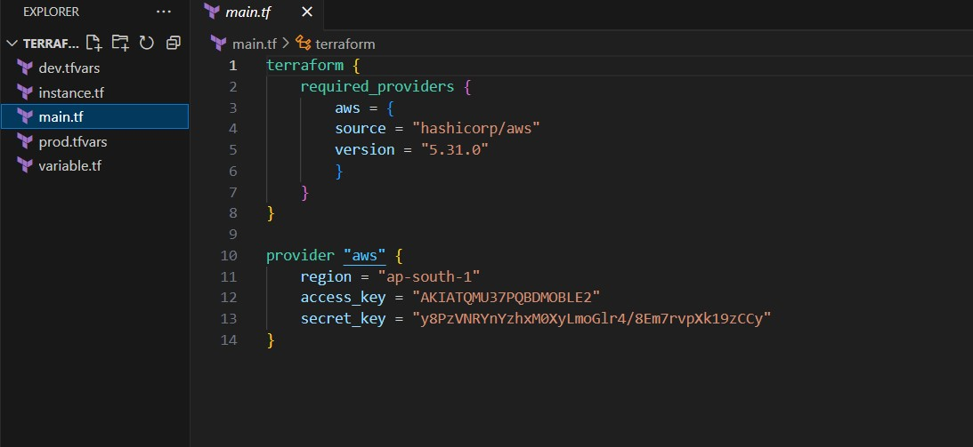

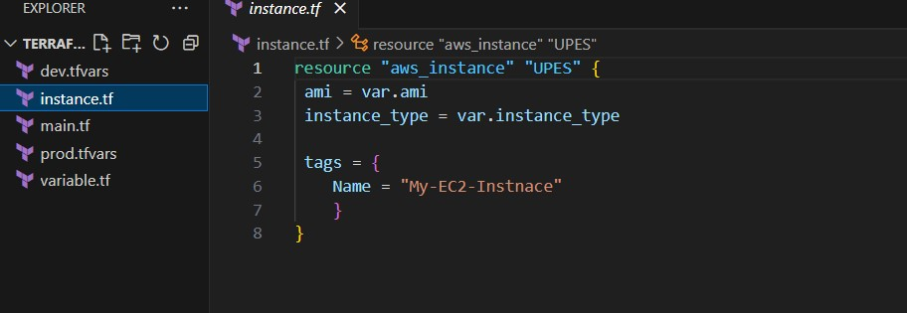

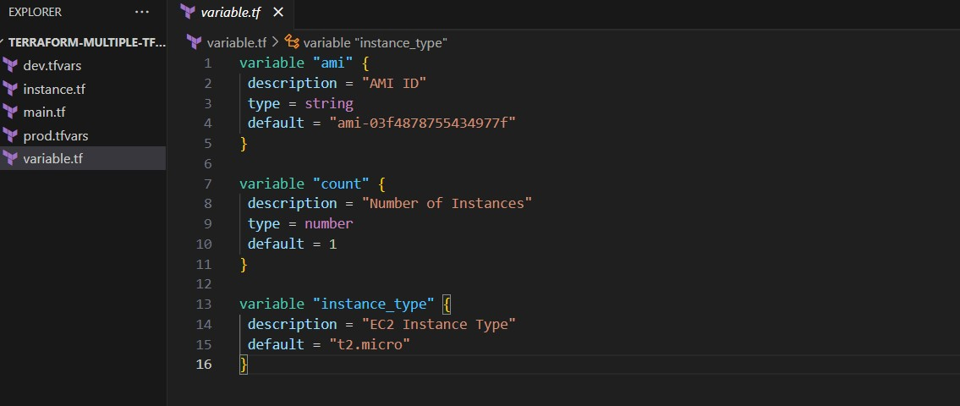

2. Create Multiple tfvars Files:

• Create a file named dev.tfvars:

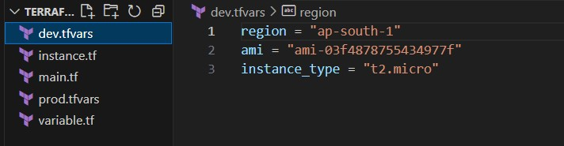

• Create a file named prod.tfvars:

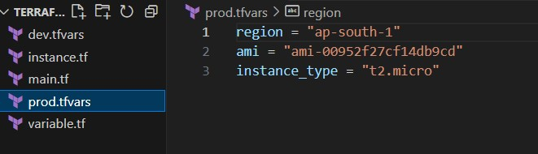

3. Initialize and Apply for Dev Environment:

Run the following Terraform commands to initialize and apply the configuration

for the dev environment:

terraform apply -var-file=”dev.tfvars”

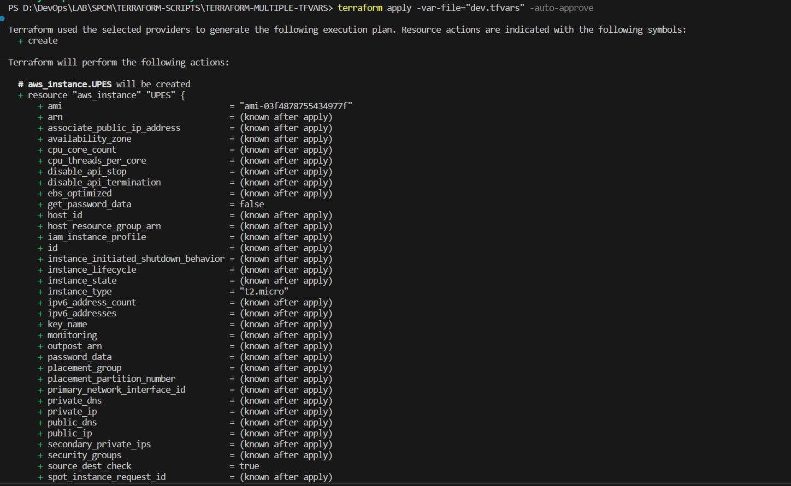

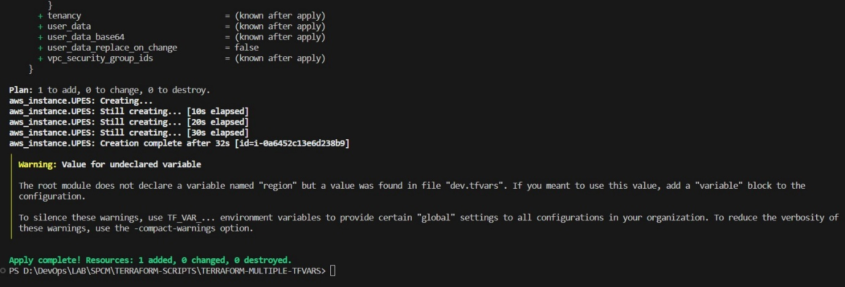

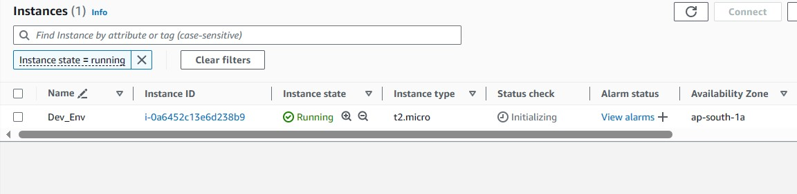4. Initialize and Apply for Prod Environment:

• Run the following Terraform commands to initialize and apply the configuration

for the prod environment:

terraform apply -var-file=”prod.tfvars”  
