**Lab Exercise 7– Creating Multiple IAM Users in Terraform**

**Priyansh Choudhary**

**500093657, R2142210596**

**B. Tech. CSE-DevOps – B2, 6th SEM**

1. Create Terraform Configuration Files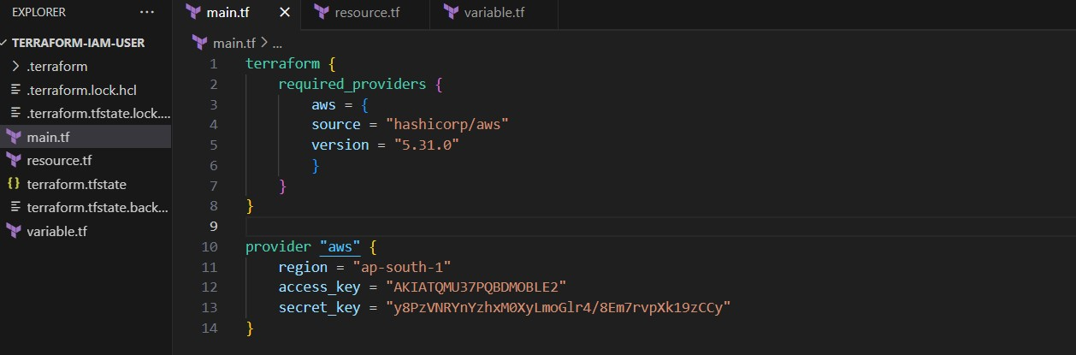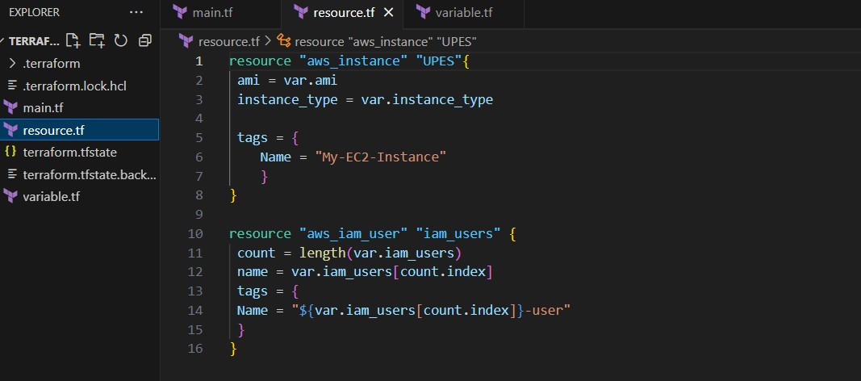

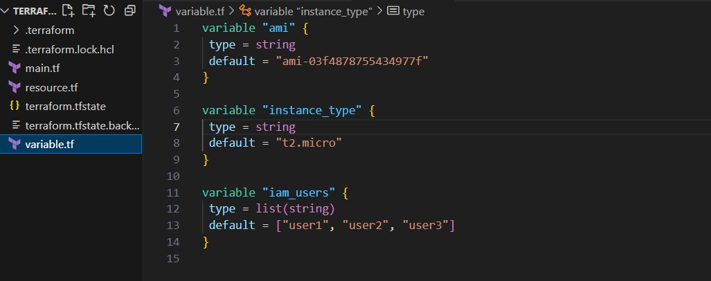  
  
2. Define a list variable iam_users containing the names of the IAM users we want to create  


3. Initialize & Apply  
terraform apply  
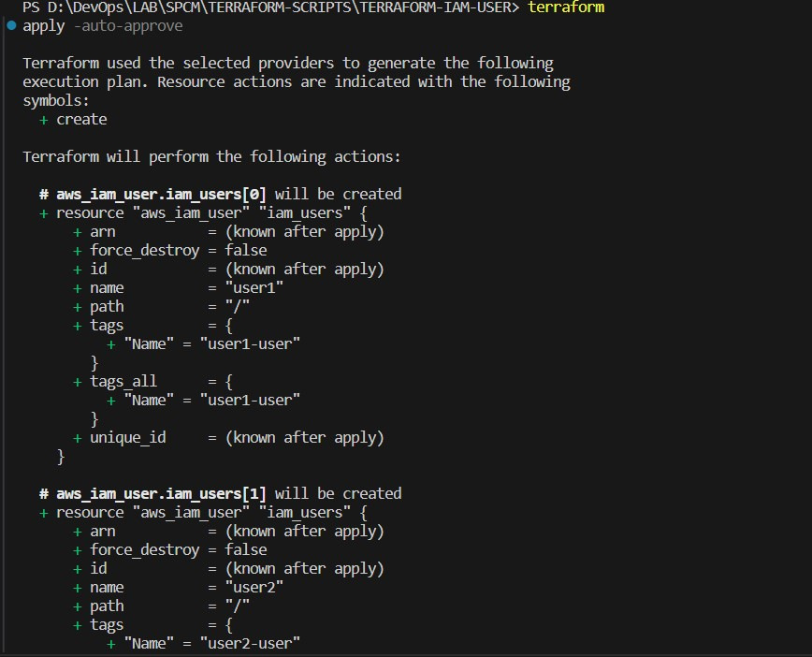

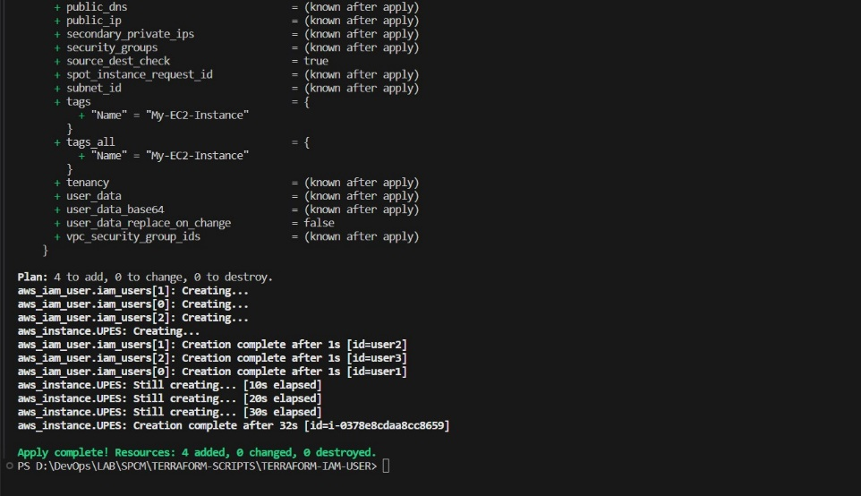

3. Verify Users in AWS Console