**Lab Exercise 8– Creating a VPC in Terraform**

**Priyansh Choudhary**

**500093657, R2142210596**

**B. Tech. CSE-DevOps – B2, 6th SEM**

1. Create Terraform Configuration Files

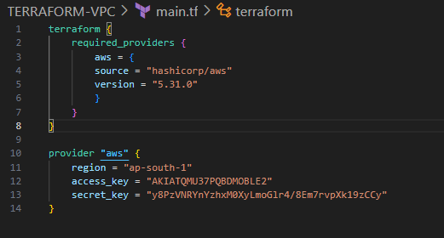

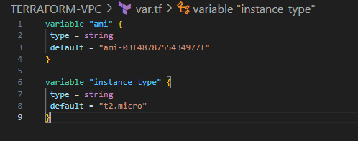

2. Define a VPC with a specified CIDR block, and two subnets within the VPC

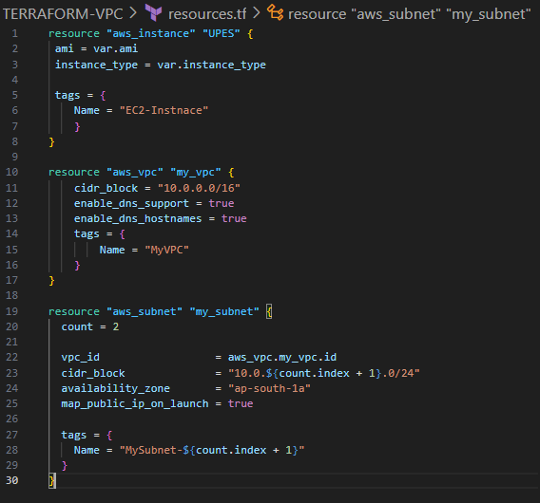

3. Initialize & Apply

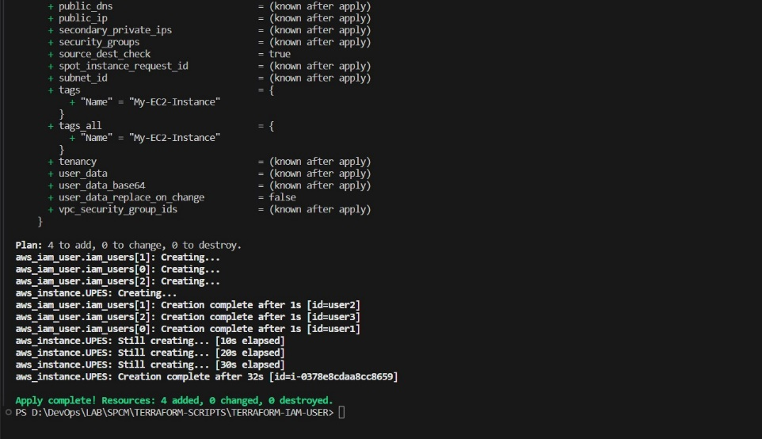

4. Check the AWS Console

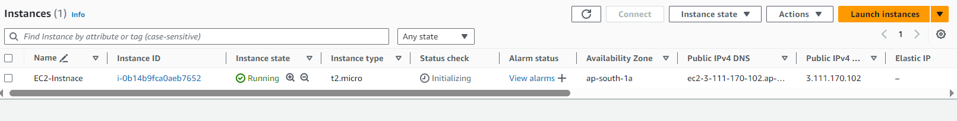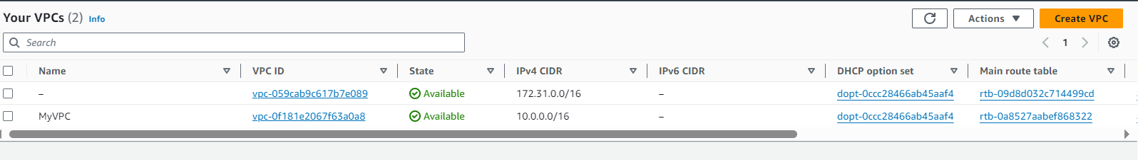

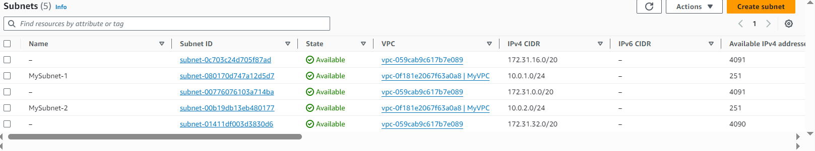

5. Clean Up

