# School of Computer Science

## UNIVERSITY OF PETROLEUM AND ENERGY STUDIES DEHRADUN, UTTARAKHAND



**System Provisioning and Configuration Management**

**2024**

**for**

**6th Semester**

## Submitted To:

Dr. Hitesh Kumar

## Submitted By:

Rajyavardhan Bhandari

B. Tech. CSE [DevOps] 500090957

R2142210624

B1- DevOps (Non-Hons)

**Lab Experiment 3**

1. Create Terraform Configuration File

Main.tf:

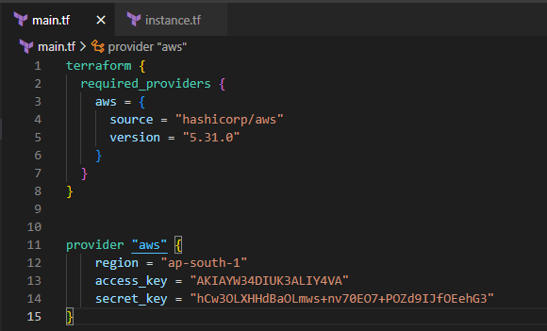

Instance.tf:  
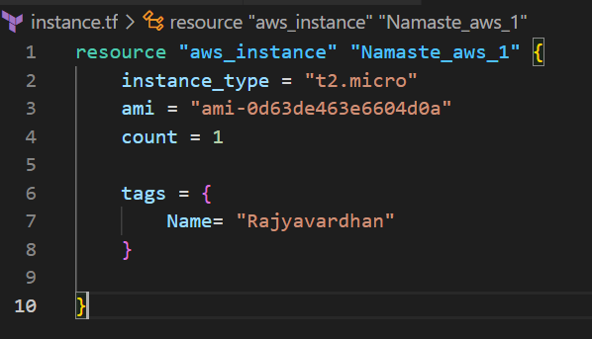

2. Review Plan & Apply Changes 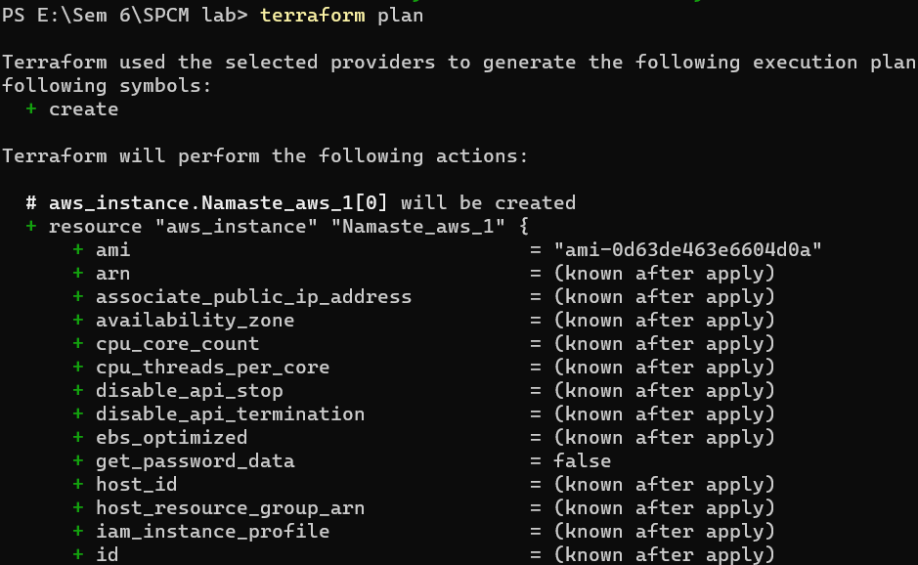

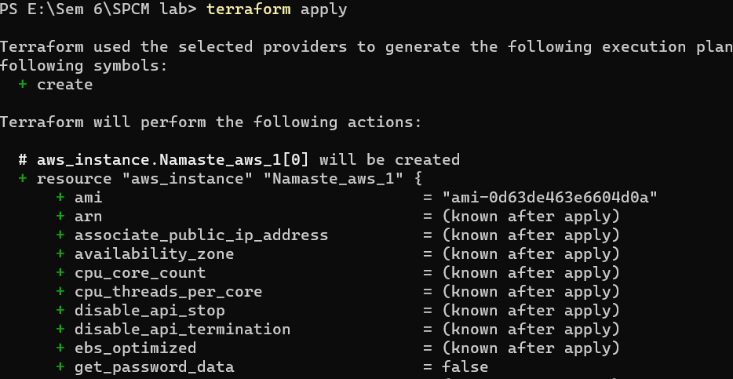

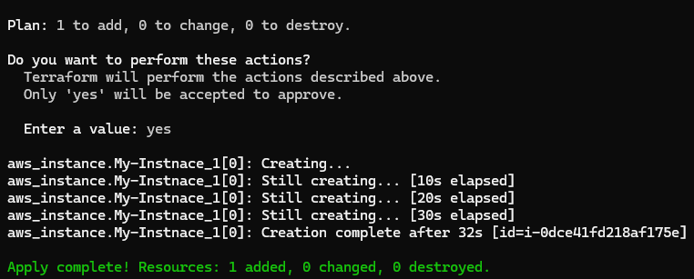

3. Check the AWS Console

