WEEK 2

Decision Trees, k-Nearest Neighbors (kNN), Naive Bayes, and Train/Test Split & Cross-Validation

1. Decision Trees

Concept
A Decision Tree is a supervised learning algorithm used for classification and regression. It splits data into branches based on feature values, forming a tree-like structure of decisions leading to a final prediction (leaf node).

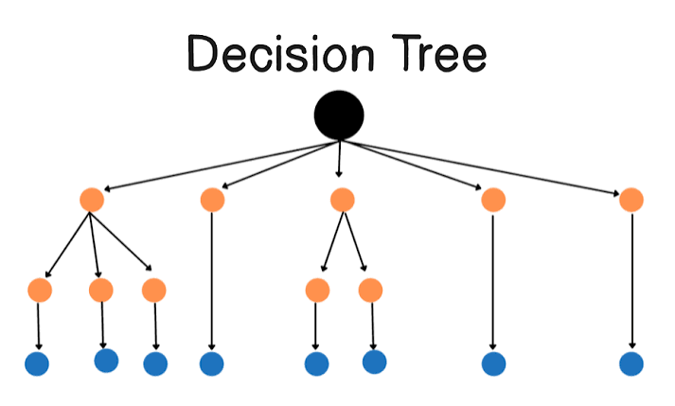

Structure
- Root Node: The topmost node representing the entire dataset.
- Internal (Decision) Nodes: Represent a test on a feature.
- Branches: Outcome of the test.
- Leaf Nodes: Final output/class label or value.

How It Works
- Select the best feature to split the data (based on a splitting criterion).
- Split the dataset into subsets.
- Repeat recursively for each subset until a stopping condition is met (pure node, max depth, min samples, etc.).

Splitting Criteria

Entropy & Information Gain (ID3, C4.5)
Entropy: H(S) = -Σ p_i log2(p_i)
Information Gain: IG = H(parent) - Σ (weighted) H(children)

Gini Index (CART)
Gini = 1 - Σ p_i²

Variance Reduction
Used for regression trees.

Advantages
- Easy to understand and visualize
- Handles both numerical and categorical data
- Requires little data preprocessing (no need for feature scaling)

Disadvantages
- Prone to overfitting, especially with deep trees
- Sensitive to small changes in data (high variance)
- Can create biased trees if classes are imbalanced

Solutions to Overfitting
- Pruning (pre-pruning / post-pruning)
- Setting max depth, min samples per leaf/split
- Using ensemble methods (Random Forest, Gradient Boosting)

Use Cases
Credit scoring, medical diagnosis, customer churn prediction

2. k-Nearest Neighbors (kNN)

Concept
kNN is a lazy, instance-based supervised learning algorithm used for classification and regression. It makes predictions based on the 'k' closest data points in the training set.

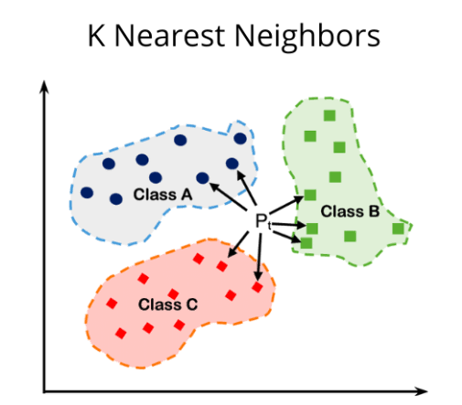

How It Works
- Choose the number of neighbors, k.
- Compute the distance between the query point and all training points.
- Select the k nearest points.
- Classification: Assign the majority class among neighbors.
- Regression: Take the average (or weighted average) of neighbor values.

Distance Metrics
Euclidean Distance: d = √Σ(x_i - y_i)²
Manhattan Distance: d = Σ|x_i - y_i|
Minkowski Distance (generalized form) and Hamming Distance (for categorical data) are also used.

Choosing k
- Small k → sensitive to noise, low bias, high variance (overfitting risk)
- Large k → smoother decision boundary, higher bias, lower variance (underfitting risk)
- Often chosen using cross-validation; odd values preferred for binary classification to avoid ties

Advantages
- Simple, intuitive, no training phase
- Naturally handles multi-class problems
- No assumptions about data distribution

Disadvantages
- Computationally expensive at prediction time (especially with large datasets)
- Sensitive to irrelevant features and feature scaling
- Struggles with high-dimensional data (curse of dimensionality)
- Sensitive to imbalanced datasets

Preprocessing Tips
- Normalize/standardize features (since distance-based)
- Remove irrelevant/redundant features

Use Cases
Recommendation systems, pattern recognition, image classification

3. Naive Bayes

Concept
Naive Bayes is a probabilistic classifier based on Bayes' Theorem, with a "naive" assumption that all features are conditionally independent given the class label. Its use in Spam filtering, sentiment analysis, document/text classification, medical diagnosis
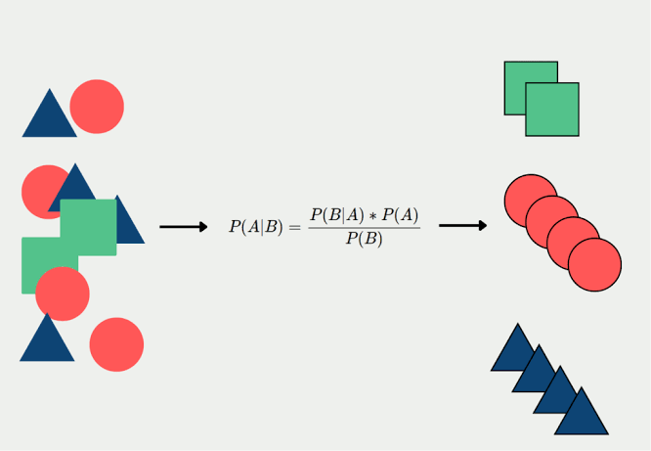

Bayes' Theorem
P(C|X) = [P(X|C) * P(C)] / P(X)
Where:
- P(C|X) = Posterior probability of class C given features X
- P(X|C) = Likelihood of features given class C
- P(C) = Prior probability of class C
- P(X) = Evidence (normalizing constant)

Types of Naive Bayes
Variant | Use Case
Gaussian NB | Continuous features (assumes normal distribution)
Multinomial NB | Discrete counts (e.g., word counts in text classification)
Bernoulli NB | Binary/boolean features (e.g., word presence/absence)

Advantages
- Fast to train and predict
- Works well with high-dimensional data (e.g., text classification)
- Requires relatively small training data

Disadvantages
- Independence assumption is often unrealistic
- Zero-frequency problem: if a category wasn't seen in training, probability becomes 0
- Not ideal for estimating probabilities precisely (though good at classification)

4. Train/Test Split and Cross-Validation

Concept
Train/Test Split and Cross-Validation are model evaluation techniques used to estimate how well a machine learning model will generalize to unseen data, and to guard against overfitting to the training set.
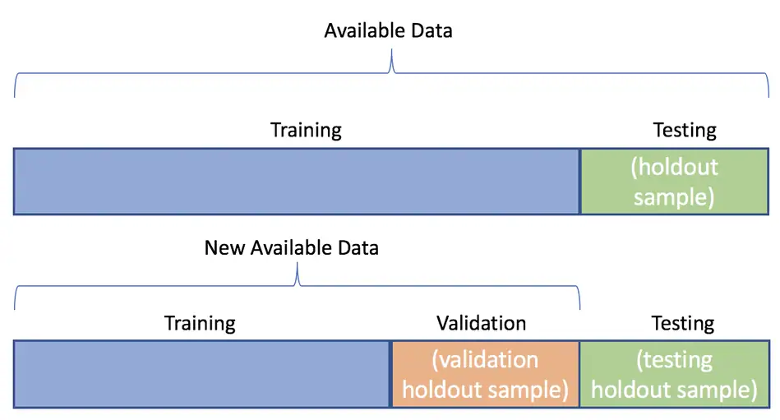

Train/Test Split
The dataset is divided into two subsets: a training set used to fit the model, and a test set held back to evaluate its performance on unseen data.
- Common split ratios: 70/30, 80/20, or 90/10, depending on dataset size
- Splitting should be randomized to avoid ordering bias
- A larger training set improves model fit; a larger test set gives a more reliable performance estimate

Cross-Validation
Cross-validation extends the train/test split idea by repeatedly partitioning the data, so every observation gets a chance to be used for both training and testing.

k-Fold Cross-Validation
The dataset is divided into k equally sized folds. The model is trained on k-1 folds and tested on the remaining fold; this is repeated k times so each fold serves as the test set once. The final performance is the average across all k runs.
- Typical values: k = 5 or k = 10
- Reduces the impact of any single, potentially unrepresentative, train/test split

Stratified k-Fold
A variant of k-fold cross-validation that preserves the class distribution within each fold, which is especially important for imbalanced classification problems.

Leave-One-Out Cross-Validation (LOOCV)
A special case of k-fold cross-validation where k equals the number of samples (n). Each observation is used once as the test set while the rest form the training set.
- Makes maximal use of the available data
- Computationally expensive for large datasets, since the model is trained n times
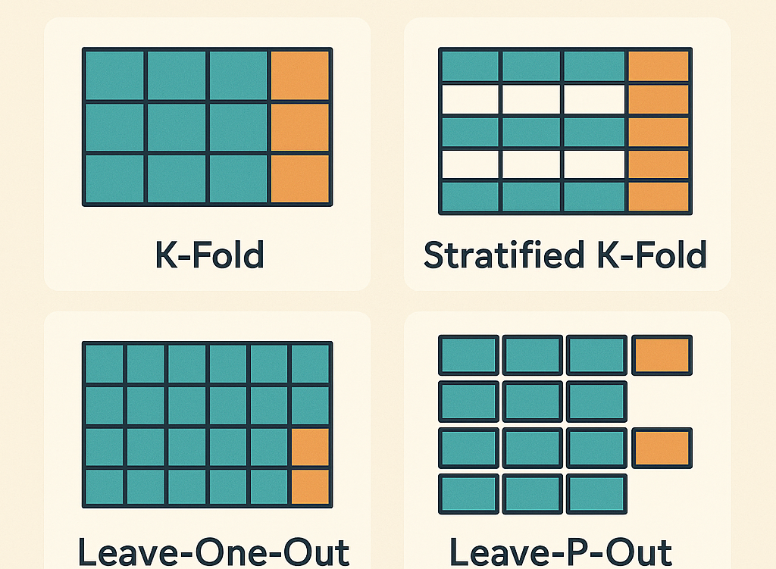

Why Use Cross-Validation
- Gives a more reliable estimate of model performance than a single train/test split
- Reduces variance caused by a particularly lucky or unlucky split
- Makes efficient use of limited data, since every sample is used for both training and testing
- Commonly used for model selection and hyperparameter tuning (e.g., choosing k in kNN)

Advantages
- More robust and less biased estimate of model performance
- Helps detect overfitting before deployment
- Makes better use of small datasets compared to a single fixed split

Disadvantages
- More computationally expensive than a single train/test split, especially for large k or LOOCV
- Not ideal for time-series data unless using time-aware variants (e.g., rolling/expanding window validation)
- Results can still vary depending on how folds are constructed

Use Cases
Model evaluation, hyperparameter tuning, comparing algorithms, and validating models before deployment in any supervised learning task.

5. Feature Scaling, Handling Missing Data, and Encoding Categorical Features
Before feeding data into a machine learning model, raw data almost always needs preprocessing. Three of the most common preprocessing steps are scaling numeric features, dealing with missing values, and converting categorical (non-numeric) features into a numeric form the model can use.
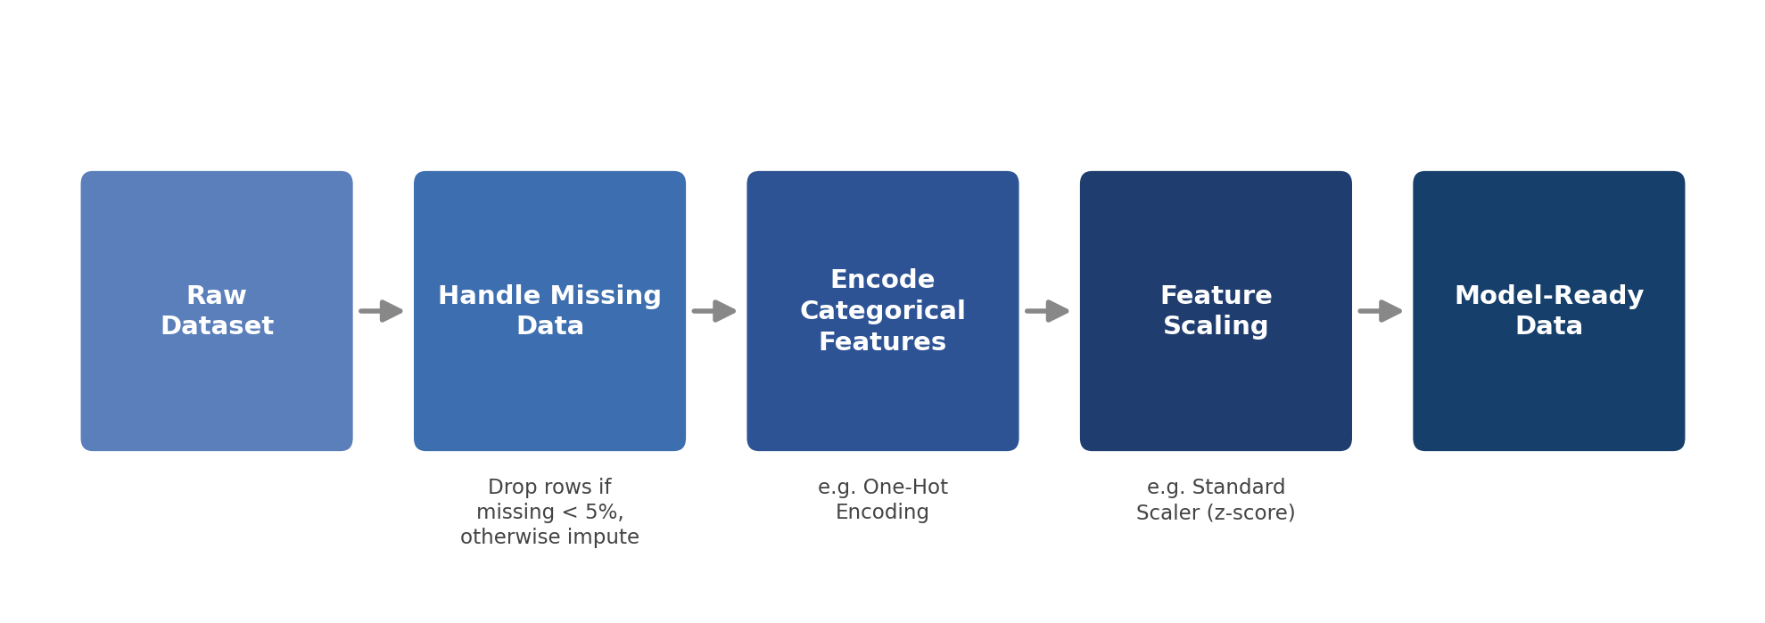

Feature Scaling
Feature scaling brings numeric features onto a comparable range. Many algorithms (kNN, gradient descent-based models, SVMs, PCA) are distance- or gradient-based, so features with larger numeric ranges can dominate the result unless all features are scaled similarly.

Min-Max Normalization
X_scaled = (X - X_min) / (X_max - X_min)
Rescales values into a fixed range, usually [0, 1]. Sensitive to outliers, since a single extreme value stretches the whole range.

Standardization (Z-score / StandardScaler)
X_scaled = (X - μ) / σ
Rescales features to have mean 0 and standard deviation 1. Implemented in scikit-learn as StandardScaler. Less sensitive to outliers than min-max scaling, and is the default choice for most distance-based and gradient-based algorithms.

When It Matters
- Needed for: kNN, k-Means, SVM, PCA, logistic/linear regression with gradient descent, neural networks
- Not needed for: tree-based models (Decision Trees, Random Forest, Gradient Boosting) and Naive Bayes, since they are not distance- or gradient-based
- Scaler should always be fit on the training set only, then used to transform both train and test sets (never fit on the full dataset, to avoid data leakage)

Handling Missing Data
Real-world datasets almost always have missing values (NaN/null entries), which most algorithms cannot handle directly. The right strategy depends mainly on how much data is missing.

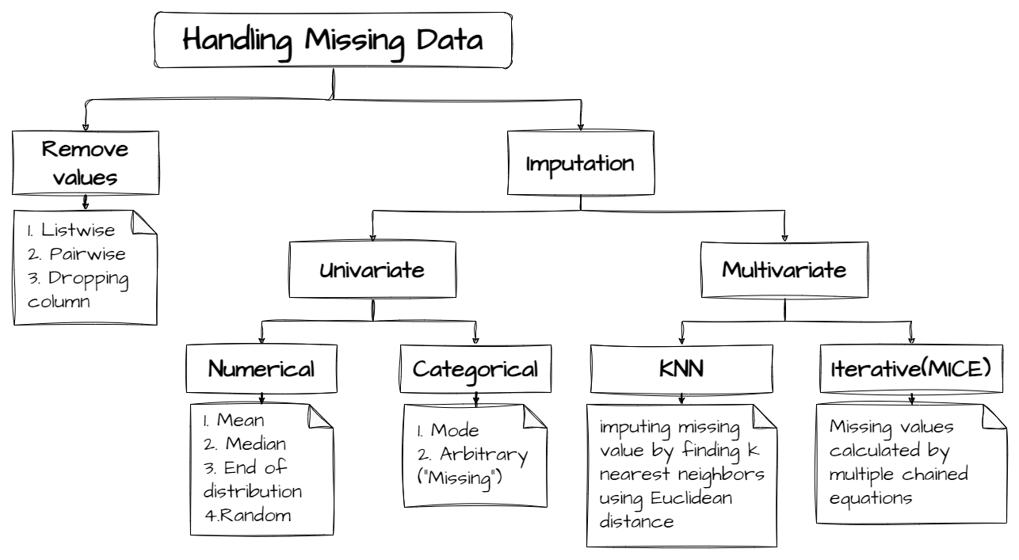

Deletion
- Row (listwise) deletion: drop rows containing missing values. A common rule of thumb is to drop the rows only if the missing values make up less than about 5% of the data — the information lost is minimal and it avoids introducing any imputation bias.
- Column deletion: drop an entire feature/column if a very large proportion of its values are missing (commonly cited threshold: above 30-40%)

Imputation
- Mean/Median imputation: fill missing numeric values with the column's mean (or median, if the data has outliers/skew)
- Mode imputation: fill missing categorical values with the most frequent category
- Model-based imputation: predict missing values using other features (e.g., kNN imputation, regression imputation)

Quick Guideline by Missing Percentage
Missing % | Recommended Action
Less than 5% | Remove (drop) the affected rows
5% - 30% | Impute (mean/median/mode or model-based)
Above 30-40% | Consider dropping the entire column, unless it is known to be important

Encoding Categorical Features
Most ML algorithms require numeric input, so categorical (text/label) features must be converted into numbers before training.
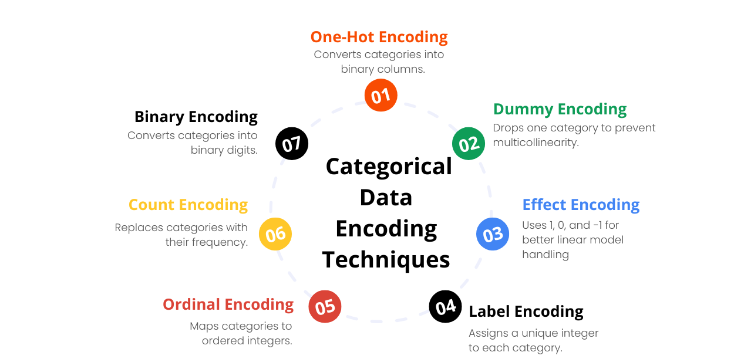

Label Encoding
Assigns each category an integer (e.g., Red=0, Green=1, Blue=2). Compact, but implies a false ordinal relationship between categories, so it's best reserved for naturally ordered (ordinal) categories or for tree-based models, which don't assume a linear relationship between the encoded values.

One-Hot Encoding
Creates a new binary (0/1) column for each category, with a 1 marking which category is present. For a "Color" feature with values Red/Green/Blue, one-hot encoding produces three columns: Color_Red, Color_Green, Color_Blue. It avoids implying any order between categories, which makes it the standard choice for nominal (unordered) categorical features, especially for distance-based and linear models.
- Increases dimensionality — can become impractical for features with very high cardinality (many unique categories)
- One column is sometimes dropped (drop_first) to avoid redundant/collinear columns for linear models

Use Cases
Applied as standard preprocessing steps before nearly any supervised or unsupervised learning task — especially kNN, SVM, linear/logistic regression, clustering, and neural networks, where unscaled or non-numeric inputs would otherwise distort the model.

Quick Comparison Table
Aspect | Decision Tree | kNN | Naive Bayes
Type | Tree-based | Instance-based (lazy) | Probabilistic
Training Time | Moderate | None (lazy learner) | Fast
Prediction Time | Fast | Slow (large datasets) | Fast
Handles Categorical Data | Yes | Needs encoding | Yes (esp. Multinomial/Bernoulli)
Sensitive to Feature Scaling | No | Yes | No
Interpretability | High | Low | Moderate
Overfitting Risk | High (if unpruned) | Depends on k | Low
Assumptions | None | None | Feature independence

Summary
- Decision Trees split data using feature-based rules; easy to interpret but prone to overfitting.
- kNN classifies based on proximity to neighboring points; simple but computationally costly at prediction time.
- Naive Bayes applies probability theory with an independence assumption; fast and effective, especially for text data.
- Train/Test Split and Cross-Validation estimate how well a model generalizes to unseen data and help guard against overfitting during evaluation.
- Feature Scaling, Handling Missing Data, and Encoding Categorical Features prepare raw data for modeling: scale numeric ranges (e.g., StandardScaler), drop or impute missing values depending on how much is missing (e.g., drop rows below 5%), and convert categories into numbers (e.g., one-hot encoding).

