Introduction to Deep Learning and Neural Networks
Neuron • Weights • Bias • Activation Functions

1. What is Deep Learning?
Deep Learning is a branch of Machine Learning that uses neural networks with multiple layers to learn patterns from data. It is commonly used for image classification, speech recognition, Natural Language Processing (NLP), recommendation systems, and many other AI tasks.

2. What is a Neural Network?
A neural network is made of connected neurons (also called nodes). A simple neural network usually has an input layer, one or more hidden layers, and an output layer.
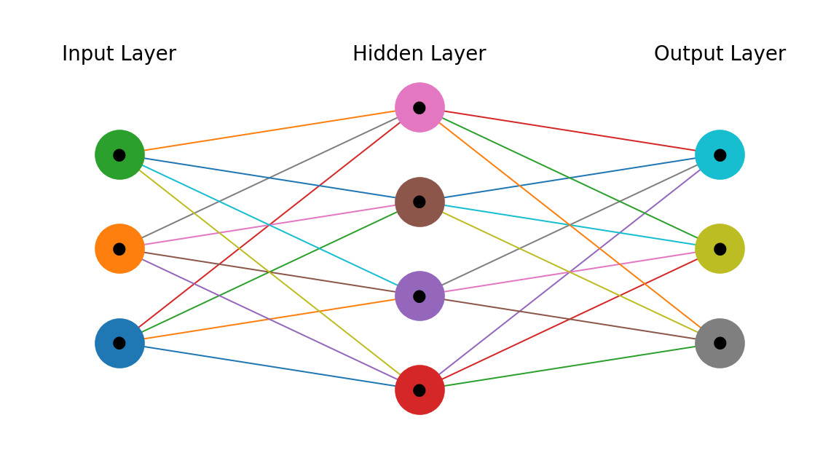

3. Artificial Neuron
An artificial neuron receives input values, multiplies each input by a weight, adds a bias, and then passes the result through an activation function.
Basic formula:
z = w₁x₁ + w₂x₂ + … + wₙxₙ + b
Here, x = input, w = weight, b = bias, z = weighted sum before activation, and the activation function converts z into the neuron's output.
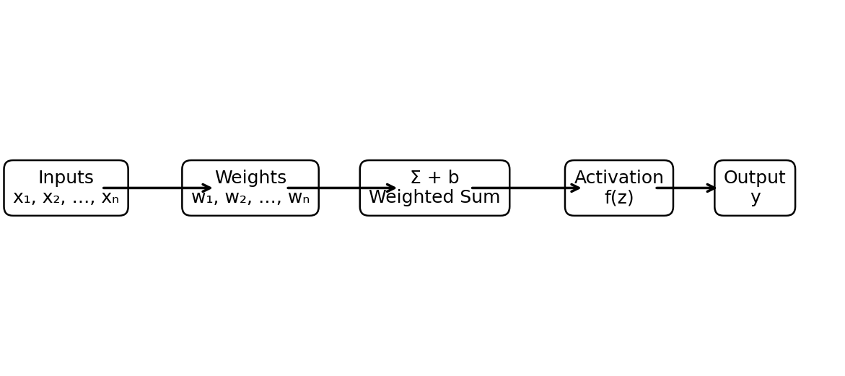

4. Weights
A weight tells the neuron how important an input is. A larger positive weight increases the effect of an input, while a negative weight can reduce or reverse its effect. During training, the model adjusts weights to reduce prediction error.
Example: If x₁ = 2 and w₁ = 0.5, then x₁w₁ = 1.0.

5. Bias
Bias is an additional learnable value added to the weighted sum. It allows the neuron to shift its activation and fit patterns more flexibly.
Example: z = w₁x₁ + w₂x₂ + b

6. Activation Functions
Activation functions introduce non-linearity into a neural network. Without non-linear activations, stacking many layers would still behave like a simple linear transformation.
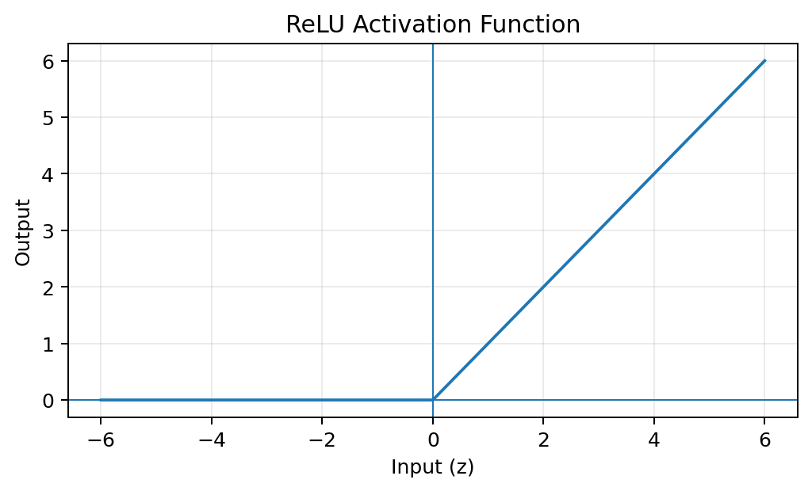
Formula: ReLU(z) = max(0, z). Negative values become 0; positive values stay unchanged.
Range: [0, ∞). Commonly used in hidden layers.
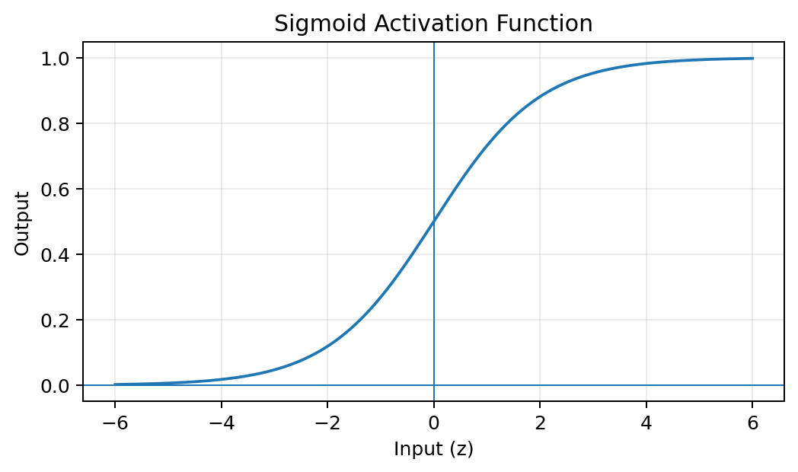
Formula: σ(z) = 1 / (1 + e⁻ᶻ). It maps any input to a value between 0 and 1.
Range: (0, 1). Useful for binary classification output probabilities.
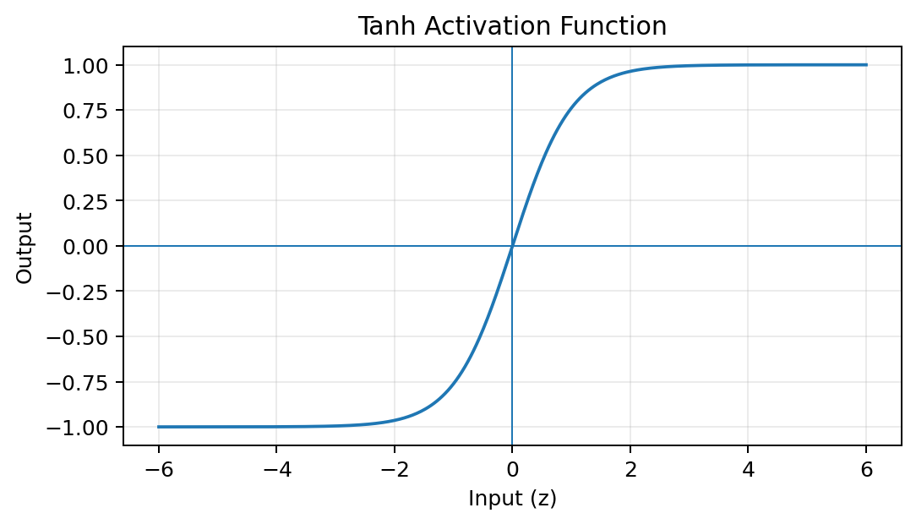
Formula: tanh(z) = (eᶻ − e⁻ᶻ) / (eᶻ + e⁻ᶻ). It maps values to approximately −1 to +1.
Range: (−1, 1). It is zero-centered and can be used in neural network layers.

7. Quick Comparison
Function | Output Range | Main Idea | Common Use
ReLU | 0 to ∞ | Negative → 0 | Hidden layers
Sigmoid | 0 to 1 | Probability-like output | Binary classification
Tanh | −1 to 1 | Zero-centered output | Hidden layers / sequence models

8. Worked Example
Suppose a neuron receives x₁ = 2 and x₂ = 3, with weights w₁ = 0.5 and w₂ = 0.2, and bias b = 1.
Step 1: Calculate weighted sum:
z = (0.5 × 2) + (0.2 × 3) + 1 = 2.6
Step 2: Apply ReLU:
ReLU(2.6) = 2.6
So, the neuron produces an output of 2.6 after ReLU.

9. Key Takeaways
- A neuron receives inputs and produces an output.
- Weights control the importance of inputs.
- Bias shifts the weighted sum and improves flexibility.
- The weighted sum is z = Σ(wx) + b.
- Activation functions add non-linearity.
- ReLU is widely used in hidden layers.
- Sigmoid outputs values between 0 and 1 and is common for binary classification.
- Tanh outputs values between −1 and 1 and is zero-centered.

