CUSTOMER SEGMENTATION
CAPSTONE PROJECT REPORT
K-Means Clustering with Streamlit Deployment

Project Type | Machine Learning Capstone Project
Learning Approach | Unsupervised Learning
Algorithm | K-Means Clustering
Dataset | Mall Customers.xlsx
Deployment | Streamlit Community Cloud

Live Application
https://customer-segmentation-quqj27qyxjfnaysgaaqfbg.streamlit.app/

1. Executive Summary
This project develops an end-to-end customer segmentation solution using K-Means clustering. The objective is to group customers according to two behavioral/business variables: Annual Income and Spending Score. The dataset contains 200 customer records. After exploratory data analysis and evaluation of multiple values of K, a five-cluster K-Means model was used for the deployed application. The model assigns a cluster to a customer based on the similarity of the supplied income and spending score. The trained workflow was then integrated into a Streamlit web application and deployed on Streamlit Community Cloud.

2. Problem Statement
Businesses often have customer information but need a practical way to identify groups with similar economic and spending characteristics. Manual grouping can be subjective and difficult to scale. This project addresses the problem by applying unsupervised machine learning to discover customer segments without requiring predefined target labels.

3. Project Objectives
- Understand the customer dataset and inspect its structure and quality.
- Perform exploratory data analysis to understand income and spending behavior.
- Apply K-Means clustering to create customer segments.
- Use the Elbow Method and Silhouette Score to evaluate candidate values of K.
- Summarize the characteristics of the resulting clusters.
- Build an interactive Streamlit application for predicting a customer's cluster.
- Deploy the application online so it can be accessed through a web browser.

4. Dataset Description
The project uses the Mall Customers dataset. It contains 200 records and seven columns. The complete dataset includes demographic and customer-behavior fields; the clustering model uses Annual Income (k$) and Spending Score (1-100) as its two input features.
Column | Type | Used in Model | Description
CustomerID | Numeric | No | Unique customer identifier
Gender | Categorical | No | Customer gender
Age | Numeric | No | Customer age
Education | Categorical/Numeric | No | Education information
Marital Status | Categorical | No | Marital-status information
Annual Income (k$) | Numeric | Yes | Annual income in thousands of dollars
Spending Score (1-100) | Numeric | Yes | Customer spending score

5. Methodology
Step | Stage | Implementation
1 | Problem Understanding | Define customer segmentation as an unsupervised learning problem.
2 | Data Loading | Load the Excel dataset using pandas.
3 | Data Inspection | Check shape, columns, missing values, and duplicates.
4 | Feature Selection | Select Annual Income and Spending Score for clustering.
5 | Exploratory Analysis | Visualize the relationship between income and spending.
6 | Model Selection | Evaluate K values from 2 to 10 using inertia and silhouette score.
7 | Clustering | Train K-Means with K=5, random_state=42 and n_init=10.
8 | Interpretation | Compare cluster size, average income, age, and spending score.
9 | Deployment | Expose the model through an interactive Streamlit application.

6. Data Preprocessing and EDA
The dataset was loaded from Excel and inspected before modeling. The selected clustering variables are numeric, so no categorical encoding is required for the final two-feature K-Means model. The project also checks for missing values and duplicate rows before proceeding.
The main exploratory visualization is an income-versus-spending scatter plot. This visualization helps identify natural groupings and provides an intuitive view of the variables used by K-Means.

7. Choosing the Number of Clusters
Candidate values of K from 2 through 10 were evaluated. The Elbow Method examines the reduction in inertia as K increases, while the Silhouette Score measures how well observations fit their assigned cluster relative to neighboring clusters.
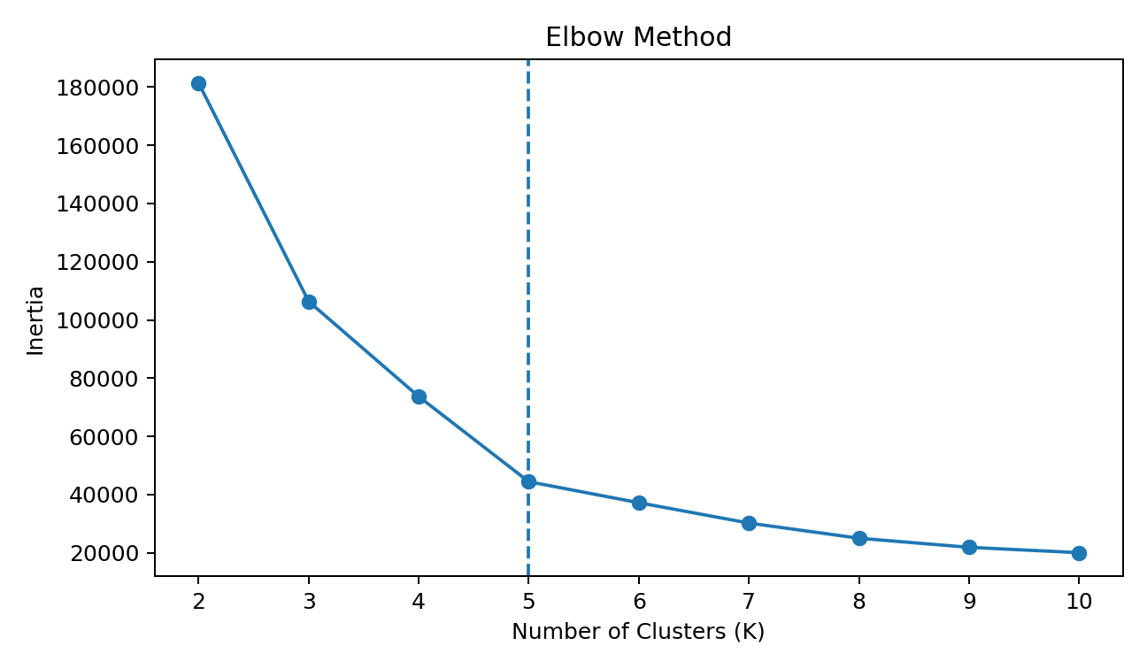
Figure 1. Elbow Method results. K=5 was selected for the final application after considering the evaluation results.
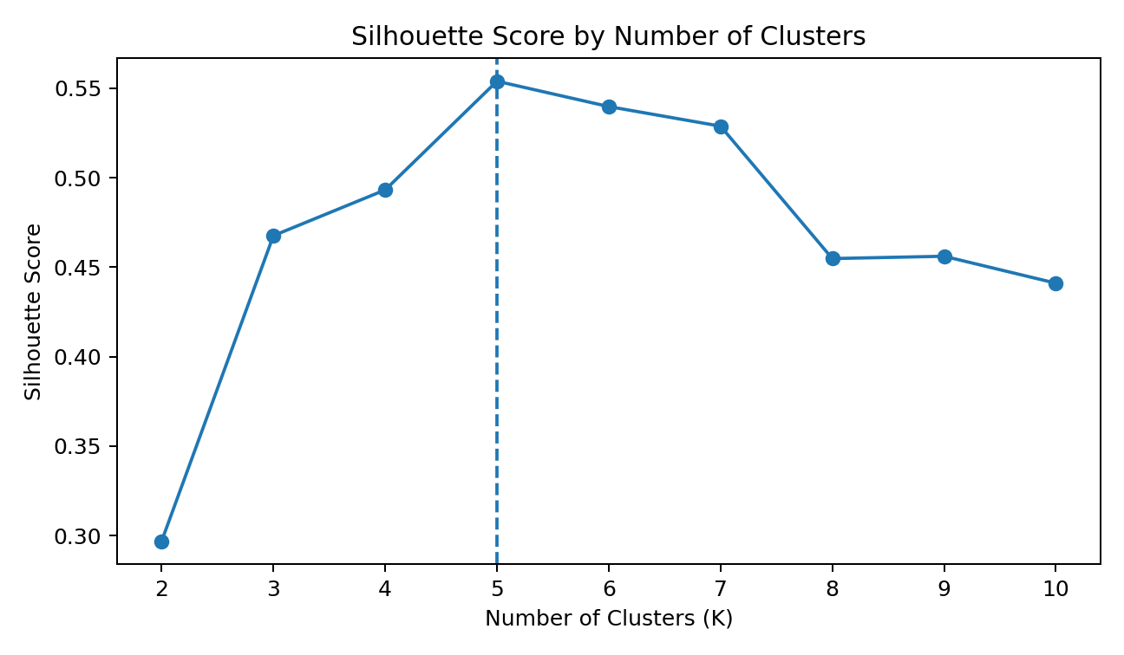
Figure 2. Silhouette Score results. The silhouette score at K=5 is 0.5539.

8. K-Means Model
K-Means is an unsupervised clustering algorithm that partitions observations into K groups by minimizing within-cluster squared distances to cluster centroids. In this project, the final model uses K=5.
- Algorithm: KMeans
- Number of clusters: 5
- Random state: 42
- n_init: 10
- Input features: Annual Income (k$), Spending Score (1-100)

9. Clustering Results
The five clusters differ primarily in their average income and spending score. The cluster number is an algorithmic label and does not itself represent a business category; interpretation should be based on the cluster statistics.
Cluster | Customers | Avg. Age | Avg. Income (k$) | Avg. Spending
0 | 81 | 42.72 | 55.3 | 49.52
1 | 39 | 32.69 | 86.54 | 82.13
2 | 22 | 25.27 | 25.73 | 79.36
3 | 35 | 41.11 | 88.2 | 17.11
4 | 23 | 45.22 | 26.3 | 20.91
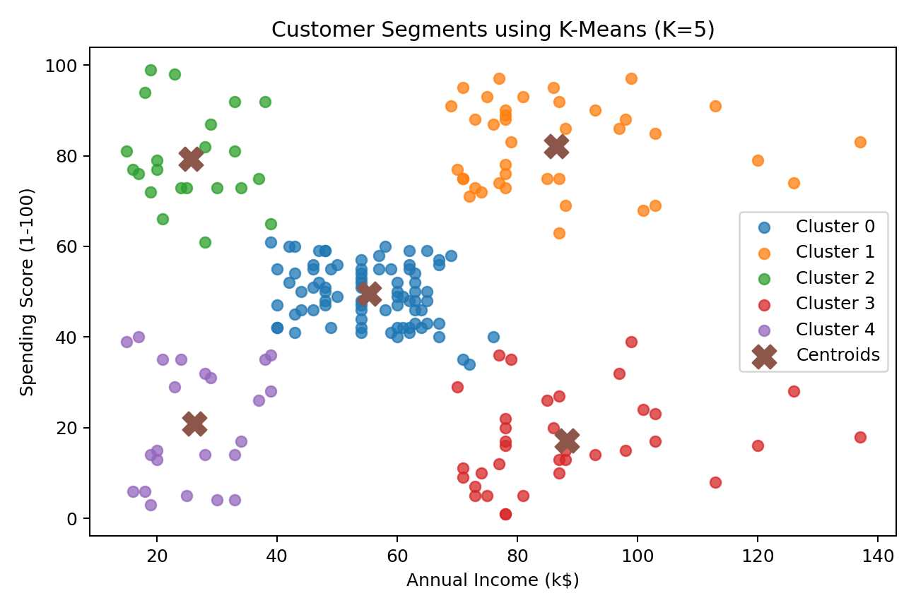
Figure 3. Final customer clusters and K-Means centroids.

10. Cluster Interpretation
Cluster 0: Largest group with mid-range average income and approximately mid-range spending.
Cluster 1: Higher-income group with high average spending.
Cluster 2: Lower-income group with high average spending.
Cluster 3: Higher-income group with low average spending.
Cluster 4: Lower-income group with low average spending.
These descriptions summarize the observed cluster statistics; they are not labels produced by K-Means itself. A business could later map these statistical segments to internal marketing terminology if appropriate.

11. Streamlit Application
The trained clustering workflow was converted into an interactive Streamlit application. The application loads the Excel dataset, trains the K-Means model, accepts a customer's Annual Income and Spending Score, and returns the predicted cluster.
- Interactive inputs for Annual Income and Spending Score.
- Prediction of the customer's K-Means cluster.
- Project information and model explanation.
- Dataset preview.
- Responsive web interface with custom styling.

12. Deployment
The application was deployed using Streamlit Community Cloud and is accessible through the following live URL:
https://customer-segmentation-quqj27qyxjfnaysgaaqfbg.streamlit.app/
The deployment uses a GitHub repository containing the Streamlit application, dataset, requirements file, README, and project notebook. The requirements include pandas, NumPy, openpyxl, scikit-learn, matplotlib, seaborn, Plotly, and Streamlit.

13. Technologies and Tools
Technology/Tool | Purpose
Python | Core programming language
Pandas | Data loading and manipulation
NumPy | Numerical operations
Scikit-learn | K-Means and evaluation metrics
Matplotlib / Seaborn | Data visualization
OpenPyXL | Reading Excel data
Streamlit | Interactive web application
GitHub | Version control and project hosting
Streamlit Community Cloud | Online deployment

14. Limitations
- The model uses only two features, so other customer characteristics are not directly included in clustering.
- K-Means requires the number of clusters to be specified in advance.
- Cluster labels are arbitrary numeric identifiers and do not have intrinsic business meaning.
- The current application retrains the K-Means model when the Streamlit app runs rather than using a separately serialized production model.
- The dataset is a relatively small sample, so results should not automatically be generalized to a different customer population.

15. Future Enhancements
- Add more customer features after appropriate preprocessing and feature selection.
- Compare K-Means with Hierarchical Clustering or DBSCAN.
- Add cluster profiles and interactive visualizations to the Streamlit dashboard.
- Save and load a trained model using joblib for a cleaner production workflow.
- Add automated data validation and input-range checks.
- Connect the segmentation output to a database or business dashboard.

16. Conclusion
The project demonstrates a complete unsupervised machine-learning workflow for customer segmentation. The dataset was inspected and analyzed, candidate cluster counts were evaluated, and a K-Means model with five clusters was implemented. The resulting model was integrated into a Streamlit application and successfully deployed online. This capstone demonstrates the practical progression from a raw dataset to exploratory analysis, model evaluation, clustering, interpretation, application development, and deployment.

17. Project Deliverables
- Customer_Segmentation.ipynb — analysis and model development notebook.
- app.py — Streamlit application.
- Mall Customers.xlsx — project dataset.
- requirements.txt — Python dependencies.
- README.md — project documentation.
- customer_segments.csv — optional clustering output.

