MACHINE LEARNING CAPSTONE PROJECT
Titanic Survival Prediction
An End-to-End Classification Project with Streamlit Deployment
Live Demo: Streamlit

Abstract
This project builds a machine-learning model that predicts whether a passenger survived the sinking of the Titanic, using the passenger's ticket class, sex, age, family size, fare, and port of embarkation. The work covers the complete data-science workflow: problem definition, data inspection, exploratory analysis, preprocessing, feature engineering, model comparison with cross-validation, hyperparameter tuning, evaluation, and deployment as a web application. Five algorithms were compared. A tuned Random Forest achieved the best cross-validated accuracy (82.9%) and scored 82.7% accuracy and 0.86 ROC-AUC on unseen test data. Sex, passenger title, and family size were the most influential features. The trained pipeline is served through a Streamlit app, and all code is published in a GitHub repository.

1. Introduction

1.1 Problem statement
On 15 April 1912 the RMS Titanic sank after hitting an iceberg, and more than 1,500 of the people on board died. Survival was not random: it depended on who a passenger was and where they were on the ship. The task is to learn this pattern from historical records and predict, for a given passenger, whether they survived.

1.2 Objectives
- Understand and explore the dataset to find which factors influenced survival.
- Build a leak-free preprocessing pipeline that handles missing values and categorical data.
- Compare several classification algorithms fairly and tune the most promising ones.
- Evaluate the final model honestly on data it has never seen.
- Deploy the model as an interactive web application.

1.3 Problem type and metric
This is a supervised binary classification problem, where the target Survived is 0 (did not survive) or 1 (survived). About 38% of passengers survived, so the classes are moderately imbalanced. Accuracy is used as the main metric, supported by precision, recall, F1-score, and ROC-AUC.

2. Dataset
The data is the Kaggle Titanic training set: 891 passengers and 12 columns. The table below describes each column and how it was used.
Column | Description | Use
Survived | 0 = No, 1 = Yes | Target
Pclass | Ticket class (1 = upper, 3 = lower) | Feature
Sex, Age | Gender and age in years | Feature
SibSp, Parch | Siblings/spouses and parents/children aboard | Used to build FamilySize, IsAlone
Fare | Ticket price | Feature
Embarked | Port: S, C, or Q | Feature
Name | Passenger name | Title extracted, then dropped
PassengerId, Ticket | Identifiers | Dropped
Cabin | Cabin number (77% missing) | Dropped

2.1 Missing values
- Age: 177 values missing (about 20%). Filled with the median, which is robust to outliers.
- Embarked: 2 values missing. Filled with the most frequent port.
- Cabin: 687 values missing (77%). Too sparse to be reliable, so the column was dropped.

3. Exploratory Data Analysis
EDA was used to identify which passenger characteristics relate to survival. The main findings are shown in Figure 1.
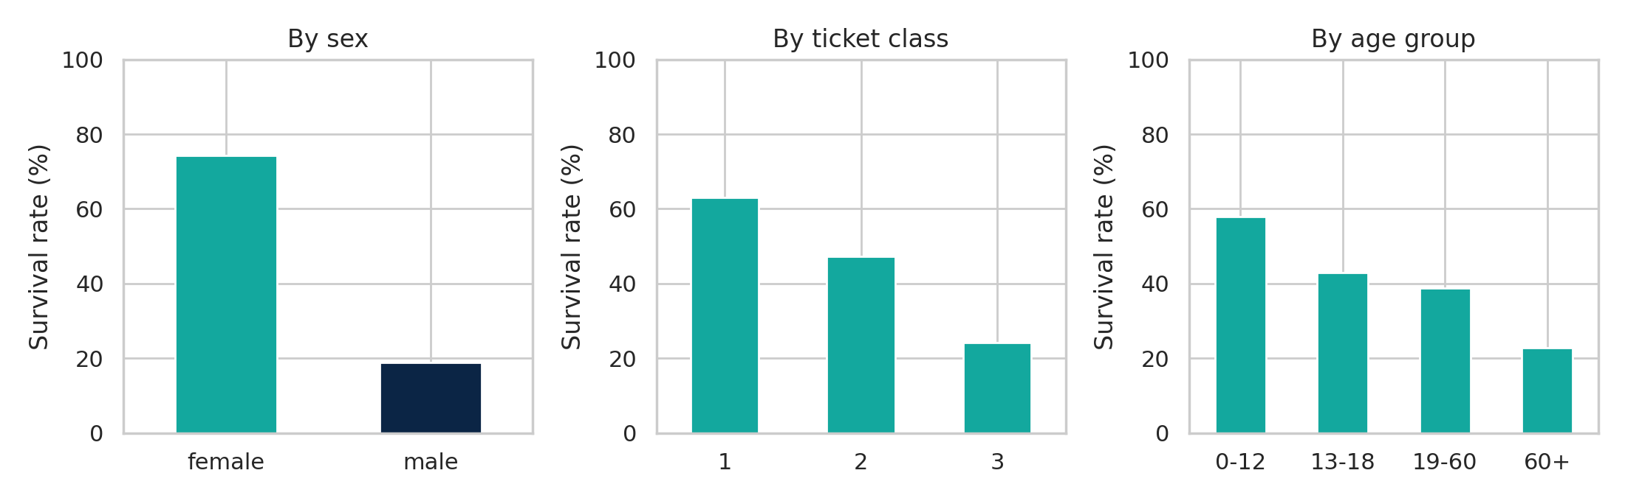
Figure 1: Survival rate by sex, ticket class and age group
- Sex: 74% of women survived compared with only 19% of men. This is the strongest single factor and reflects the “women and children first” policy.
- Ticket class: survival fell from 63% in first class to 47% in second and 24% in third class.
- Age: children up to 12 years had the highest survival rate (58%), while passengers over 60 had the lowest (23%).
- Fare: survivors paid more (median £26 versus £10.50), which is consistent with the class effect.
- Family: passengers travelling alone survived at 30%, while small families of 2 to 4 people survived at 55% to 72%. Very large families did poorly.

4. Preprocessing and Feature Engineering

4.1 Feature engineering
Three new features were created because the raw columns hide useful information:
- Title: extracted from the Name (Mr, Mrs, Miss, Master, Rare). It combines sex, age, and social status in one variable.
- FamilySize: SibSp + Parch + 1, the number of family members travelling together.
- IsAlone: 1 if FamilySize equals 1, otherwise 0.
The final model uses eight features: Pclass, Age, Fare, FamilySize, IsAlone, Sex, Embarked and Title.

4.2 Preprocessing pipeline
All preprocessing is implemented with scikit-learn Pipeline and ColumnTransformer objects:
- Numeric features: median imputation followed by standardisation (StandardScaler).
- Categorical features: most-frequent imputation followed by one-hot encoding.
Because the imputers, scaler, and encoder are part of the pipeline, they are fitted on training data only. This prevents data leakage, and the same steps are applied automatically to new passengers in the web app.

4.3 Train/test split
The data was split 80/20 into 712 training and 179 test passengers, using stratified sampling so that both sets keep the same survival ratio. The test set was not used for any modelling decision; it was used only once, for the final evaluation.

5. Methodology

5.1 Algorithms compared
Algorithm | Idea | Main setting
Logistic Regression | Linear model that estimates class probability | max_iter = 1000
Decision Tree | Sequence of yes/no splits | max_depth = 5
Random Forest | Many trees voting together | 200 trees
K-Nearest Neighbors | Classifies by the closest passengers | k = 5
Gaussian Naive Bayes | Probabilistic model assuming independent features | Default

5.2 Cross-validation
The test set contains only 179 passengers, so a single split can change accuracy by two to three percentage points by luck alone. To compare models fairly, 5-fold stratified cross-validation was run on the training set, and the mean accuracy across the five folds was used.

5.3 Hyperparameter tuning
GridSearchCV with 5-fold cross-validation was applied to the two most promising families. For Logistic Regression, the regularisation strength C was searched over [0.01, 0.1, 1, 10, 100]. For Random Forest, the search covered the number of trees (100, 200, 300), maximum depth (3, 5, 7, None), and minimum samples to split (2, 5, 10). The final model was selected by its cross-validation score, not by the test score.

6. Results

6.1 Model comparison
Model | CV accuracy | Test accuracy
Random Forest (tuned) | 82.9% | 82.7%
Logistic Regression | 82.3% | 83.8%
KNN | 80.3% | 81.6%
Decision Tree | 80.3% | 79.9%
Random Forest (default) | 79.2% | 79.9%
Naive Bayes | 79.2% | 78.8%

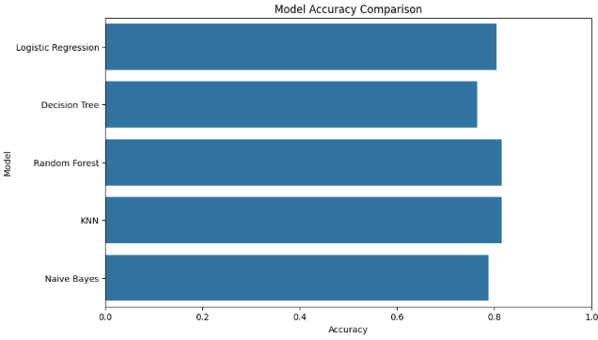
Figure 2: Cross-validated accuracy of the compared models
The default Random Forest performed worst, together with Naive Bayes, because a fully grown forest overfits a small dataset. After tuning, limiting tree depth to 5, it became the best model with a cross-validated accuracy of 82.9%. Logistic Regression was a very close second and is a strong, simple alternative. Best parameters: max_depth = 5, min_samples_split = 5, n_estimators = 100.

6.2 Effect of feature engineering
In the first version of the project, which used only the raw features, the tuned Random Forest reached 80.4% test accuracy. After adding Title, FamilySize and IsAlone, Logistic Regression's cross-validated accuracy rose from 79.6% to 82.3% and the final model reached 82.7% on the test set. The improvement therefore came mainly from better features rather than a more complex algorithm.

6.3 Final evaluation on the test set
Class | Precision | Recall | F1-score | Support
Did not survive | 0.84 | 0.89 | 0.86 | 110
Survived | 0.81 | 0.72 | 0.76 | 69
Accuracy |  |  | 0.83 | 179

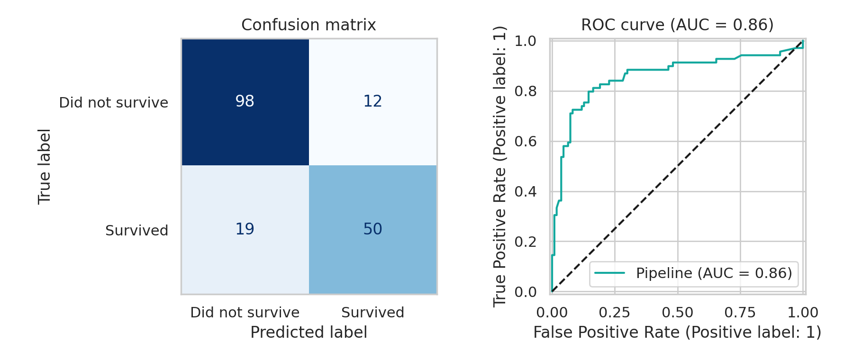
Figure 3: Confusion matrix and ROC curve on the test set
The model classified 148 of 179 test passengers correctly (98 true negatives and 50 true positives), with 12 false positives and 19 false negatives. The ROC-AUC of 0.86 means that a randomly chosen survivor receives a higher predicted probability than a randomly chosen non-survivor 86% of the time. Recall for survivors (72%) is lower than for non-survivors (89%), so the model is somewhat cautious about predicting survival.

6.4 Feature importance
Permutation importance measures how much test accuracy falls when one feature is randomly shuffled.
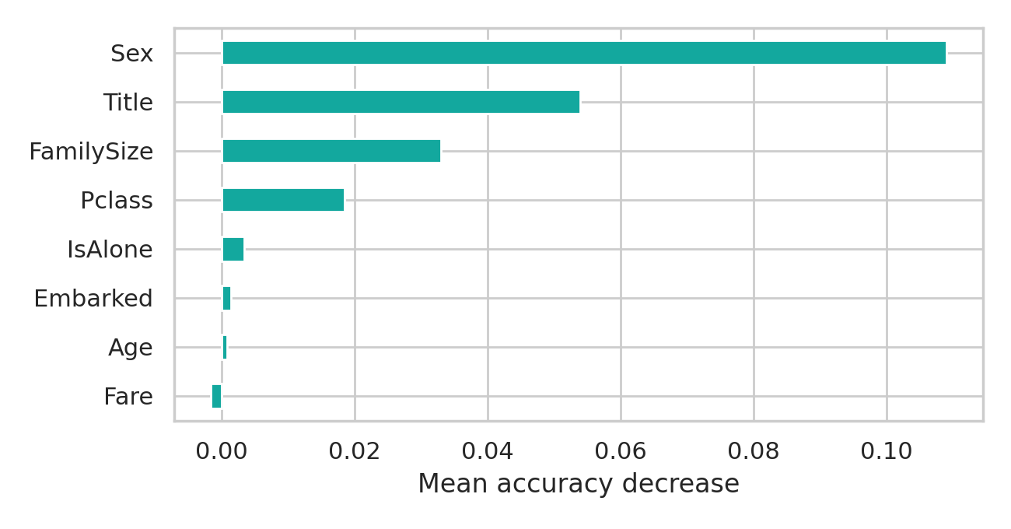
Figure 4: Permutation importance of the features
Sex is by far the most important feature (accuracy drops by about 11 points when shuffled), followed by Title, FamilySize and Pclass. Fare, Age, and Embarked add little once these are known, because their information is largely captured by class, title and family size.

7. Deployment
The winning pipeline (preprocessing and model together) was saved with joblib and loaded by a Streamlit application (app.py). The user enters a passenger's ticket class, sex, age, title, family members, fare and port; the app computes FamilySize and IsAlone automatically, calls the model and displays the predicted survival probability together with a clear survive / not-survive message. The sidebar shows the model's test accuracy and ROC-AUC. The app was tested with Streamlit's testing framework: a young third-class man receives a survival probability of about 11%, while a first-class woman receives about 84%, which matches the patterns found in the EDA.

8. Discussion and Limitations
- Small dataset: with 891 rows and a 179-row test set, the accuracy estimates carry roughly ±3% uncertainty. Differences of one or two points between models are not conclusive.
- Lower survivor recall: the model misses 28% of actual survivors. Lowering the decision threshold could trade some precision for higher recall if that matters more.
- Dropped information: Cabin (deck location) and Ticket were not used; carefully engineered versions might add signal.
- Historical data: the model describes one event and should not be used to make real-world decisions about people. It is a learning project.

9. Conclusion and Future Work
This project delivered a complete machine-learning workflow on the Titanic dataset. The main conclusions are: (1) sex, title, family size and ticket class explain most of the variation in survival; (2) feature engineering gave the largest improvement; (3) hyperparameter tuning was essential for Random Forest, which moved from the weakest to the strongest model; and (4) a well-built pipeline makes the model easy to deploy. The final model reaches 82.7% accuracy and 0.86 ROC-AUC on unseen data.
Future work includes engineering deck and ticket-group features, trying gradient-boosting methods such as XGBoost or LightGBM, tuning the decision threshold for better survivor recall, and submitting predictions to the Kaggle leaderboard.

References
- Kaggle. Titanic: Machine Learning from Disaster (dataset and competition). https://www.kaggle.com/c/titanic
- Pedregosa et al. Scikit-learn: Machine Learning in Python. Journal of Machine Learning Research, 12, 2011.
- Streamlit documentation. https://docs.streamlit.io

Appendix: Repository Structure and How to Run
Path | Content
notebooks/Titanic_Capstone.ipynb | Full analysis with code and explanations
app.py | Streamlit web application
models/ | Saved pipeline (joblib) and metrics.json
data/train.csv | Dataset
reports/ | Presentation, this report and quiz preparation notes
requirements.txt, README.md | Dependencies and instructions

To run: install the dependencies with pip install -r requirements.txt and start the app with streamlit run app.py.

