Software Requirements
Specification
for
Tourist Management System

Prepared by
Alishba Nazem

Submitted to
Dr. Hafsa Shareef Dar

Copyright © 1999 by Karl E. Wiegers. Permission is granted to use, modify, and distribute this document.

Software Requirements Specification for TMS i
Table of Contents
Table of Contents ................................................................................................................... ii Revision History ..................................................................................................................... ii 1. Introduction 1
1.1 Purpose 1
1.2 Document Conventions 1
1.3 Intended Audience and Readingx Suggestions 1
1.4 Product Scope 1
1.5 References 1
2. Overall Description 3
2.1 Product Perspective 3
2.2 Product Functions 3
2.3 User Classes and Characteristics 3
2.4 Operating Environment 3
2.5 Design and Implementation Constraints 3
2.6 User Documentation 3
2.7 Assumptions and Dependencies 4
3. External Interface Requirements 4
3.1 User Interfaces 4
3.2 Hardware Interfaces 4
3.3 Software Interfaces 4
3.4 Communications Interfaces 4
4. System Features 5
4.1 User Management 5
4.2 Booking Management 5
4.3 Payment Module 5
4.4 Feedback Module 5
5. Use case Diagram 6
6. Other Nonfunctional Requirements 6
6.1 Performance Requirements 6
6.2 Software Quality Attributes 6
7. Other Requirements 7
7.1 Inverse Requirement 7
7.2 Domain Requirement 7
7.3 Design and Implementation Constraint 7

1. Introduction

1.1 Purpose
This document outlines the software requirements for the Tourist Management System (Version 1.0). It covers the complete functionality of the system, including modules such as user registration, booking management, payment processing, and feedback handling. The SRS is developed for course completion, academic assessment, learning purposes, and to better understand customer needs.

1.2 Document Conventions
- Tourist Management System: TMS
- Admin and Tourist: Users
- Headings: 1.1, 1.2, 2.1…
- Requirements: all have equal priority unless mentioned

1.3 Intended Audience and Reading Suggestions
This document is intended for our instructor and classmates who are evaluating or reviewing the TMS as part of the Software Engineering course. It includes an overview of TMS, along with its functional and nonfunctional requirements, and use case descriptions. Readers are suggested to start with the introduction section to understand the background of TMS, then move on to the overall system description and functional requirements for a complete understanding of the system’s structure and behavior.

1.4 Product Scope
The TMS is a system developed to manage tourism-related activities through modules like Registration, Booking Management, Payment Management, and Feedback Management. It helps administrators handle user information, manage tour bookings, process payments securely, and collect feedback. This project follows software engineering principles to build a complete system for smooth and effective tourism service management..

1.5 References
The following online systems and documents were referred to during the development of this Software Requirements Specification (SRS) for the Tourist Management System (TMS):
- Tourism Management System – GitHub Repository
GitHub: https://github.com/ShivamSeth05/Tourism_Management_System
Description: Open-source tourism management system used as a reference for system structure and module implementation ideas.

- Tourism SRS – Scribd Document
Scribd: https://www.scribd.com/document/416063718/Kupdf-net-Tourism-Srs
Description: A sample SRS document consulted for understanding formatting, sectioning, and scope representation.

- Travel and Tourism Management System SRS – Studocu Document
Studocu: https://www.studocu.com/in/document/dit-university/software-engineering/traveland-tourism-management-system-srs/38131242
Description: A university-level SRS used for guidance on requirement listing, use case formatting, and overall SRS structure.

2. Overall Description

2.1 Product Perspective
The Tourism Management System is a new web-based application aimed at improving the efficiency of tourismrelated activities. It is designed for travel agencies or tourism service providers and does not replace any existing system .It consists of modules such as User Management, Booking, Payment, and Feedback, which work together seamlessly.

2.2 Product Functions

The system will handle user registration, login, and profile management. It will allow users to browse tour packages, book services, and make secure payments. After completing tours, users can submit feedback through reviews, ratings, or complaints.

2.3 User Classes and Characteristics
There are two main user types: Admins, who manage the system, add or edit tour packages, and view reports; and Registered Users, who can book tours, make payments, and give feedback.

2.4 Operating Environment
This is a web-based system accessible via modern browsers like Chrome, Firefox, and Edge. It will run on a Linux or Windows server using Apache or Nginx, with PHP and MySQL on the backend, and HTML, CSS, and JavaScript on the client side.

2.5 Design and Implementation Constraints
The system must support responsive design, use secure protocols (HTTPS), and work with third-party payment gateways. Only open-source tools and frameworks will be used, and data must be stored securely following privacy laws.

2.6 User Documentation
Documentation will include a User Manual (PDF), Quick Start Guide, an online help section, and optionally, a video tutorial for basic operations.

2.7 Assumptions and Dependencies
It is assumed users will have stable internet and modern browsers. The project depends on hosting services supporting PHP/MySQL and the availability of maintained open-source tools. Admins will need basic training, and changes in security or legal policies could affect the system.

3. External Interface Requirements

3.1 User Interfaces
The user interface of the TMS follows a clean and intuitive layout with a top navigation bar and a central content display area. The design uses a calm blue and white theme for better readability. Buttons like “Book Now”, “Pay”, “Submit Feedback”, and “Cancel” are clearly labeled and consistently styled. Input fields such as text boxes, dropdowns, and date pickers are well-aligned. Dialog boxes are used for confirmations and error alerts. Each screen is task-specific, including modules for registration, bookings, payments, and feedback.

3.2 Hardware Interfaces
The Tourist Management System (TMS) is designed to operate on standard desktop and laptop systems running Windows OS. Basic hardware requirements include a monitor for interface display, and keyboard and mouse for user input. No additional devices like scanners or printers are integrated at this stage, but support for such peripherals may be considered in future enhancements.

3.3 Software Interfaces
The Tourist Management System (TMS) is developed using a modern IDE (e.g., IntelliJ IDEA or Eclipse) and connects to a relational database (e.g., MySQL or PostgreSQL) through JDBC for managing tourist, payment, and booking data. The system runs on Windows OS and uses Java Standard Libraries for handling data processing and user interface interactions. Data flows between user interface components and the database are managed using Java classes and model objects.

3.4 Communications Interfaces
The Tourist Management System (TMS) requires internet connectivity for secure data transfer. The system uses HTTPS as the communication protocol to ensure encrypted and secure transactions for booking details, user profiles, and payment processing. HTTPS guarantees the privacy and integrity of the data exchanged between the users and the system.

4. System Features

4.1 User Management
4.1.1 REQ-1: The system shall allow users to register with email and password.
4.1.2 REQ-2: The system shall allow users to customize their profile after registration.

4.2 Booking Management
4.2.1 REQ-3: The system shall allow users to search for bookings based on available packages.
4.2.2 REQ-4: The system shall provide an option to automatically verify users before allowing bookings.
.

4.3 Payment Module
4.3.1 REQ-5: The system shall support online payment methods for booking confirmation.
4.3.2 REQ-6: The system shall process refund requests within 24 hours.

4.4 Feedback Module
4.4.1 REQ-7: The system shall allow users to submit star rating feedback for completed bookings.
4.4.2 REQ-8: The system shall allow attaching supporting documents with complaints.
4.4.3 REQ-9: The system shall allow the user to edit or delete the submitted reviews.

5. Use case Diagram

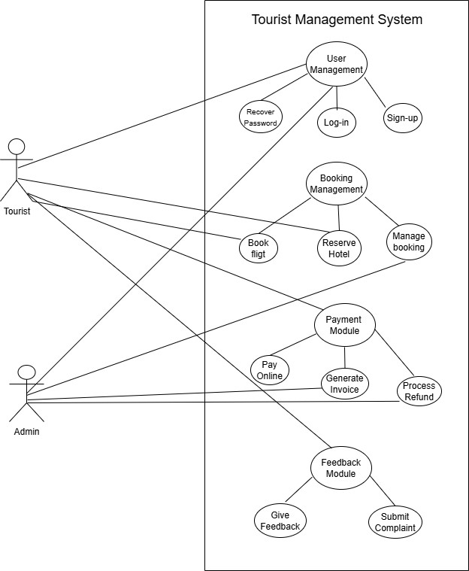

6. Other Nonfunctional Requirements

6.1 Performance Requirements

6.1.1 REQ-1 The system shall provide a streamlined booking process that allows users to complete a tour booking in a minimal number of steps.

6.2 Software Quality Attributes
6.2.1 REQ-2 The system shall offer user-friendly and efficient booking experience by minimizing the number of steps required to complete a booking.

7. Other Requirements

7.1 Inverse Requirement
7.1.1 REQ-1 The system shall not allow users to make bookings without a verified user account.

7.2 Domain Requirement
7.2.1 REQ-2 The system shall store emergency contact numbers for each tour package.

7.3 Design and Implementation Constraint
7.3.1 REQ-3 The system shall be implemented using a web-based architecture and must be compatible with both desktop and mobile browsers.

