**Father’s Name:** Muhammad Laeeq Anwar Qureshi

**Domicile:** Islamabad (Pakistan)

**NIC No:** 61101-8643485-8

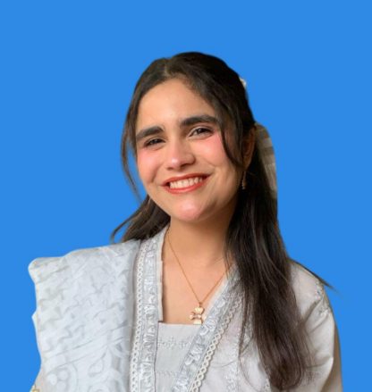**ALISHBA QURESHI**

**Address:** House # 2018, Phase 2, Frash Town, Islamabad

**Email Address:** [alishbaqureshi593@gmail.com](mailto:rajahabib@gmail.com)

**Phone Number:** 0317-5873486

# EDUCATION

|  |  |  |
| --- | --- | --- |
|  |  |  |
| **B.S.** | Software Engineering **CGPA: 3.97**  Capital University of Science and Technology, Islamabad | **2022-present** |
| **ICS** | Computer Science **Marks: 769/1100**  ICG F-6/2, Islamabad | **2022** |
| **Matric** | Science **Marks: 779/1100**  Al-Farabi Islamic School and College, Frash Town, Islamabad | **2020** |

# COURSES LEARNED

|  |  |  |
| --- | --- | --- |
| **Data Structures** | Implemented stacks, queues, trees, and graphs using C++ |  |
| **Database Management** | Designed and managed relational databases using MySQL via XAMPP |  |
| **Web Engineering** | Built dynamic websites using HTML, CSS, JavaScript, and React |  |
| **Artificial Intelligence** | Studied search algorithms, rule-based agents, and machine learning fundamentals |  |
| **Mobile Development** | Created Android apps using Java and Android Studio |  |
| **Object-Oriented Programming (OOP)** | Learned principles of encapsulation, inheritance, and polymorphism using Java/C++ |  |
| **Operating Systems** | Studied process management, memory handling, and file systems |  |
| **Computer Networks** | Covered network protocols, IP addressing, and client-server models |  |
| **Human-Computer Interaction (HCI)** | Studied UI/UX principles and user-centered design |  |

**SKILLS**

|  |  |  |
| --- | --- | --- |
| **Unity** | C# programming and UI design |  |
| **Visual Studio** | Python, C++, Java, HTML/CSS, JavaScript |  |
| **Android Studio** | XML, Java, SQLite |  |
| **SQL Server Mangement** | SQL Queries, Database design |  |

**HONORS AND AWARDS**

|  |  |  |
| --- | --- | --- |
| **Chancellor’s Honor Certificate** | Awarded for achieving a **4.00/4.00 GPA** in three semesters at Capital University of Science and Technology |  |
| **Dean’s Honor Certificate** | Awarded for achieving a GPA of **3.88 and 3.95** in consecutive semesters at Capital University of Science and Technology |  |
| **Hackathon Participation Certificate** | Participated in CUST Hackathon’25, showcasing problem-solving and teamwork skills |  |
| **Event Coordinator & Decor Head Certificate** | Recognized for successfully managing event coordination and decoration at RoboCust |  |
| **Hackathon Marketing**  **Team Certificate** | Contributed to marketing and promotions for CUST Hackathon’25 |  |

**PROJECTS**

|  |  |  |
| --- | --- | --- |
| **Hand Gesture Recognition Model** | Trained a hand gesture recognition model using Teachable Machine to classify various gestures for potential sign language applications. |  |
| **Weather Forecast Prediction Model** | Built a forecasting model using Poisson regression, trained on historical weather data to predict rainy days based on temperature, humidity, and wind speed. |  |
| **Lushdrobe** | Developed an e-commerce makeup selling Android app using Java and Android Studio, featuring product listings, user authentication, and order management. |  |
| **Hire a Helper Website** | Created a React-based platform to connect laborers with clients, including user registration, helper listings, and contact functionalities |  |
| **End of the World** | Developed a 3D game with **two maps** where the player completes missions, built using **Unity and C#**, demonstrating skills in game design and programming |  |
|  |  |  |