**HTTP Analysis**

**1. What is the name of the website?**

* [**http://httpforever.com**](http://httpforever.com/)

**2. Find the packet that contains the first GET request for the website you have accessed.**

* Packet #2279 - This is the first GET request: GET / HTTP/1.1

**3. Describe all headers and their values in this GET request message.**

* From Packet #2240

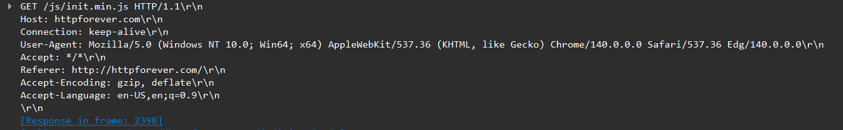

**4. Identify the status code in the first server response.**

* **200 OK** (from Packet #2331 - the first server response to GET /)
* The server successfully returned the requested content

**5. How many HTTP response messages are exchanged in total?**

* **At least 8 HTTP responses** visible in your capture:
  1. Packet #2331: HTTP/1.1 200 OK (text/html) - Main page
  2. Packet #2396: HTTP/1.1 200 OK (application/json) - Script
  3. Packet #2812: HTTP/1.1 200 OK (text/css) - CSS file
  4. Packet #2830: HTTP/1.1 200 OK (text/css) - CSS file
  5. Packet #2961: HTTP/1.1 200 OK - Image
  6. Packet #2961: HTTP/1.1 200 OK - Image
  7. Packet #2981: HTTP/1.1 200 OK (image/x-icon) - Favicon
  8. Packet #3996: HTTP/1.1 200 OK - File download

**6. Determine whether the connection is persistent or not. Justify with evidence from packet captures.**

Answer: Yes, the connection is persistent