
SHIFA TAMEER-E-MILLAT UNIVERSITY
SCHOOL OF COMPUTING

Natural Language Processing LAB
Assignment # 02
Alishba Zafar
BSAI-23F-0066

Q1(a): PDF Reading and Text Extraction

Code:
import fitz
import pandas as pd

pdf_path = "book.pdf"
doc = fitz.open(pdf_path)

full_text = ""
for page in doc:
full_text += page.get_text()

print(f"Total Number of Pages: {len(doc)}")

print("\nSample Extracted Text:")
print(full_text[:500])

Output:

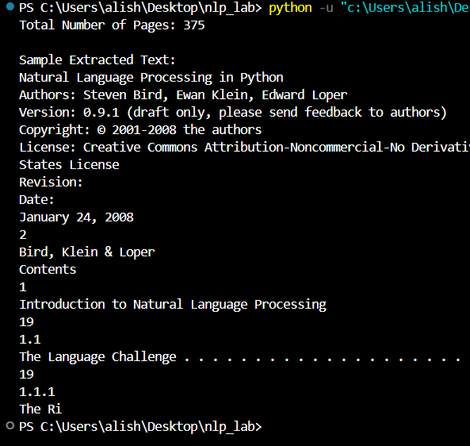

Q1(b): Text Preprocessing

Code:
import fitz
import re
import nltk
import pandas as pd
from nltk.corpus import stopwords
from nltk.tokenize import word_tokenize
from nltk.stem import PorterStemmer, WordNetLemmatizer

nltk.download('punkt')
nltk.download('punkt_tab')
nltk.download('stopwords')
nltk.download('wordnet')
nltk.download('omw-1.4')

pdf_path = "book.pdf"
doc = fitz.open(pdf_path)

full_text = ""
for page in doc:
full_text += page.get_text()

print(f"Total Number of Pages: {len(doc)}")
print("\nSample Extracted Text:")
print(full_text[:500])

text = full_text.lower()

text = re.sub(r'\d+', '', text)
text = re.sub(r'[^\w\s]', '', text)
text = re.sub(r'\s+', ' ', text).strip()
words = word_tokenize(text)

stop_words = set(stopwords.words('english'))
valid_words = [w for w in words if w not in stop_words]

print(f"\nTotal Stop Words Found: {len(words) - len(valid_words)}")
print(f"Count of Valid Words after stop word removal: {len(valid_words)}")

ps = PorterStemmer()
lemmatizer = WordNetLemmatizer()

print("\nStemming Output (First 10 words):")
print([ps.stem(w) for w in valid_words[:10]])

print("\nLemmatization Output (First 10 words):")
print([lemmatizer.lemmatize(w) for w in valid_words[:10]])

Output:

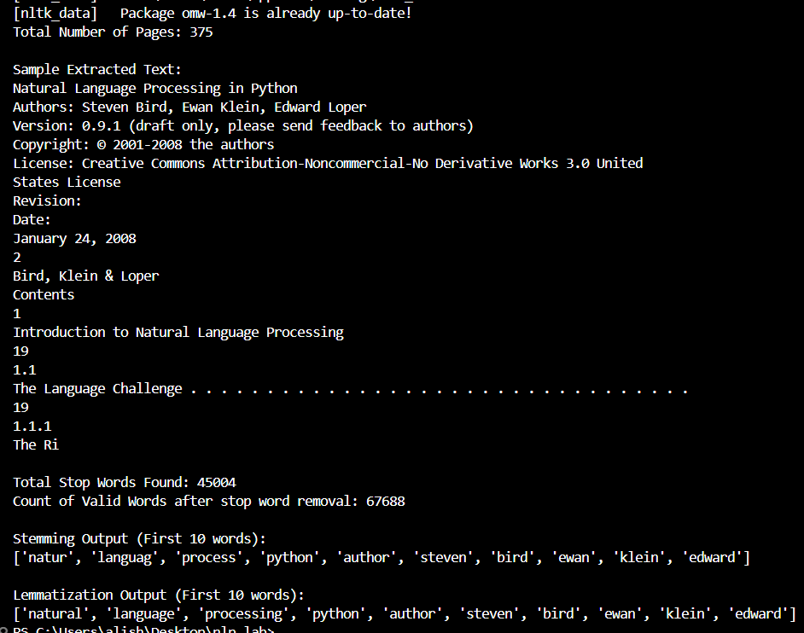

Q1(c): Feature Extraction

Code:
import fitz # PyMuPDF
import re
import nltk
import pandas as pd
import numpy as np
import plotly.express as px
from nltk.corpus import stopwords
from nltk.tokenize import word_tokenize
from nltk.stem import PorterStemmer, WordNetLemmatizer
from sklearn.feature_extraction.text import TfidfVectorizer
from sklearn.preprocessing import OneHotEncoder

# Download NLTK resources
nltk.download('punkt')
nltk.download('punkt_tab')
nltk.download('stopwords')
nltk.download('wordnet')
nltk.download('omw-1.4')

# --- Q1(a): PDF Reading and Text Extraction ---
pdf_path = "book.pdf"
doc = fitz.open(pdf_path)
full_text = "".join([page.get_text() for page in doc])

print(f"Total Number of Pages: {len(doc)}")
print("\nSample Extracted Text:")
print(full_text[:500])

# --- Q1(b): Text Preprocessing ---
text = full_text.lower()
text = re.sub(r'\d+', '', text) # Remove numbers
text = re.sub(r'[^\w\s]', '', text) # Remove special symbols
text = re.sub(r'\s+', ' ', text).strip() # Remove extra spaces

words = word_tokenize(text)
stop_words = set(stopwords.words('english'))
valid_words = [w for w in words if w not in stop_words]

print(f"\nTotal Stop Words Found: {len(words) - len(valid_words)}")
print(f"Valid Words Count: {len(valid_words)}")

ps = PorterStemmer()
lemmatizer = WordNetLemmatizer()
print("\nStemming (Sample):", [ps.stem(w) for w in valid_words[:5]])
print("Lemmatization (Sample):", [lemmatizer.lemmatize(w) for w in valid_words[:5]])

# --- Q1(c): Feature Extraction ---
# One Hot Encoding
sample_for_ohe = np.array(list(set(valid_words[:50]))).reshape(-1, 1)
ohe = OneHotEncoder(sparse_output=False)
ohe_df = pd.DataFrame(ohe.fit_transform(sample_for_ohe),
columns=ohe.get_feature_names_out(),
index=sample_for_ohe.flatten())
print("\nOne Hot Encoding Output (Sample):")
print(ohe_df.head())

# TF-IDF
vectorizer = TfidfVectorizer(max_features=50)
tfidf_matrix = vectorizer.fit_transform([text])
tfidf_df = pd.DataFrame(tfidf_matrix.toarray(), columns=vectorizer.get_feature_names_out())
print("\nTF-IDF Output (Tabular):")
print(tfidf_df)

# --- Q1(d): TF-IDF Scatter Plot Using Plotly ---
fig = px.scatter(x=vectorizer.get_feature_names_out(),
y=tfidf_matrix.toarray().flatten(),
labels={'x': 'Words', 'y': 'TF-IDF Score'},
title='TF-IDF Values Scatter Plot')
fig.show()

Output:

