10PEARLS SHINE INTERNSHIP PROGRAM
Data Sciences Domain — Cohort 9
13 July 2026 – 4 September 2026 (8 Weeks)

Karachi Air Quality Index (AQI)
Forecasting System
An End-to-End, Serverless Machine Learning Pipeline for Real-Time Air Quality Forecasting and Public Health Alerting

Submitted by
Alishba Jawaid
7th Semester, BS (Artificial Intelligence)
Live Deployment
https://aqi-karachi-forecasting.streamlit.app/

Table of Contents
Table of Contents 2
1. Executive Summary 4
2. Introduction 4
2.1 Background & Motivation 4
2.2 Objectives 4
2.3 Scope 5
3. System Architecture 5
4. Technology Stack 6
5. Data Pipeline 6
5.1 Data Sources 6
5.2 Full Historical Backfill — aqiPipeline.py 6
5.3 Feature Engineering — the Core Logic 7
Time & calendar features 7
Lag features 7
Rolling statistics 7
Derived pollutant features 7
Upwind features 7
Weather trend & tendency features 8
Future-weather features 8
Forecast targets & feature pruning 8
5.4 Incremental Hourly Updates — hourly_feature_update.py 8
6. Why a Feature Store and Model Registry 9
6.1 Feature Store 9
6.2 Model Registry 9
7. Model Training 9
7.1 Daily Retraining Orchestration — refresh_training_split.py 9
7.2 Train / Test Split Strategy 11
7.3 Candidate Algorithms 11
7.4 Evaluation Methodology 12
7.5 Feature Handling Details 12
7.6 Results 12
7.7 Model Registration 12
8. Serving Layer 13
8.1 FastAPI Backend — api_backend.py 13
8.2 model_service.py — Prediction Logic 13
8.3 Explainability — shap_utils.py 13
8.4 Alerting — alerts.py 14
9. Frontend Dashboard — streamlit_app.py 14
1- Forecast 14
2- EDA & Trends 14
3- Model Explainability 15
4- Alerts 16
10. Resilience Engineering — hopsworks_read_utils.py 16
11. CI/CD & Automation 17
12. Deployment 17
12.1 Deployment Target 17
12.2 The Two-Services-in-One-Host Problem 17
12.3 Two Requirements Files 18
13. Challenges Faced & How They Were Resolved 18
13.1 Accidental Credential Exposure 18
13.2 Free Hosting Platform Restrictions 19
13.3 Conflicting Dependency Requirements 19
13.4 setuptools Dropped pkg_resources 19
13.5 Hopsworks Client / Backend Version Mismatch 20
13.6 Daily Training Pipeline: Silent Split-Creation Failure 20
13.7 Unstable Query-Service Connections on CI Runners 20
13.8 Post-Deployment: Intermittent NaN Crash in the Daily Training Job 21
14. Security & Best Practices Applied 22
15. Live Demonstration 22
16. Limitations & Future Work 23
17. Conclusion 23
18. References 24
Appendix A — Repository File Reference 25

1. Executive Summary
This report documents the design, development, and deployment of a real-time Air Quality Index (AQI) forecasting system for Karachi, built during an 8-week Data Sciences internship under the 10Pearls Shine program (Cohort 9). The project delivers a fully automated, serverless machine learning pipeline that ingests live weather and air-quality data, engineers a rich hourly feature set, trains and evaluates multiple forecasting models for three time horizons (24, 48, and 72 hours ahead), and serves the resulting predictions through a public, interactive web dashboard.
The system is organised around two Hopsworks-managed MLOps components — a Feature Store and a Model Registry — that decouple data engineering from model training and model training from serving. Automated GitHub Actions workflows keep the Feature Store current on an hourly basis and retrain candidate models on a recurring schedule, while a FastAPI backend and a Streamlit frontend together form the always-on serving layer, deployed free of cost on Streamlit Community Cloud.
Beyond the modelling work itself, a significant part of this internship involved solving real production engineering problems: an accidentally committed API credential, hosting-platform restrictions, dependency and library-version conflicts, and unreliable network behaviour on CI runners. Section 13 documents each of these problems and the reasoning behind their resolution in detail, since diagnosing and fixing this class of issue was one of the most valuable learning outcomes of the internship.
The final trained models beat a naive persistence baseline by a wide and widening margin as the forecast horizon increases (see Section 7.6), and the live system is deployed and publicly accessible at:
https://aqi-karachi-forecasting.streamlit.app/

2. Introduction

2.1 Background & Motivation
Karachi, like many rapidly urbanising South Asian cities, regularly experiences air quality levels that fall into the “Unhealthy” or worse categories on the US EPA Air Quality Index scale, driven by vehicular emissions, industrial activity, seasonal weather patterns, and regional dust/smoke transport. Timely, reliable forecasts of AQI — not just its current value — allow residents, schools, and health-sensitive groups to plan ahead rather than react after exposure has already occurred. This project treats AQI forecasting as a time-series regression problem and builds a complete, production-style system around it, rather than a one-off notebook analysis.

2.2 Objectives
- Build an automated pipeline that continuously collects and engineers weather and air-quality features for Karachi.
- Train and rigorously evaluate multiple candidate machine learning models for 24h/48h/72h-ahead AQI forecasting.
- Serve real-time predictions, historical trend analysis, model explainability, and health alerts through an interactive dashboard.
- Deploy the entire system publicly and free of cost, using an MLOps-appropriate separation of feature storage, model registry, and serving layer.
- Apply sound software-engineering and security practice throughout — credential hygiene, dependency management, CI/CD automation, and resilience to third-party service instability.

2.3 Scope
The scope covers one city (Karachi) and three fixed forecast horizons (24h, 48h, 72h), using publicly available, license-free weather and air-quality data from Open-Meteo. The system is designed so that extending it to additional cities or horizons requires configuration changes rather than architectural changes (see Section 16, Future Work).

3. System Architecture
At a high level, the system is a pipeline of four cleanly separated stages: data collection & feature engineering, feature storage, model training & registry, and serving. Each stage reads from the stage before it and writes only to its own outputs, which keeps the system easy to reason about, debug, and redeploy independently. Figure 1 shows the complete data and control flow, from raw API data through to the end user's browser.
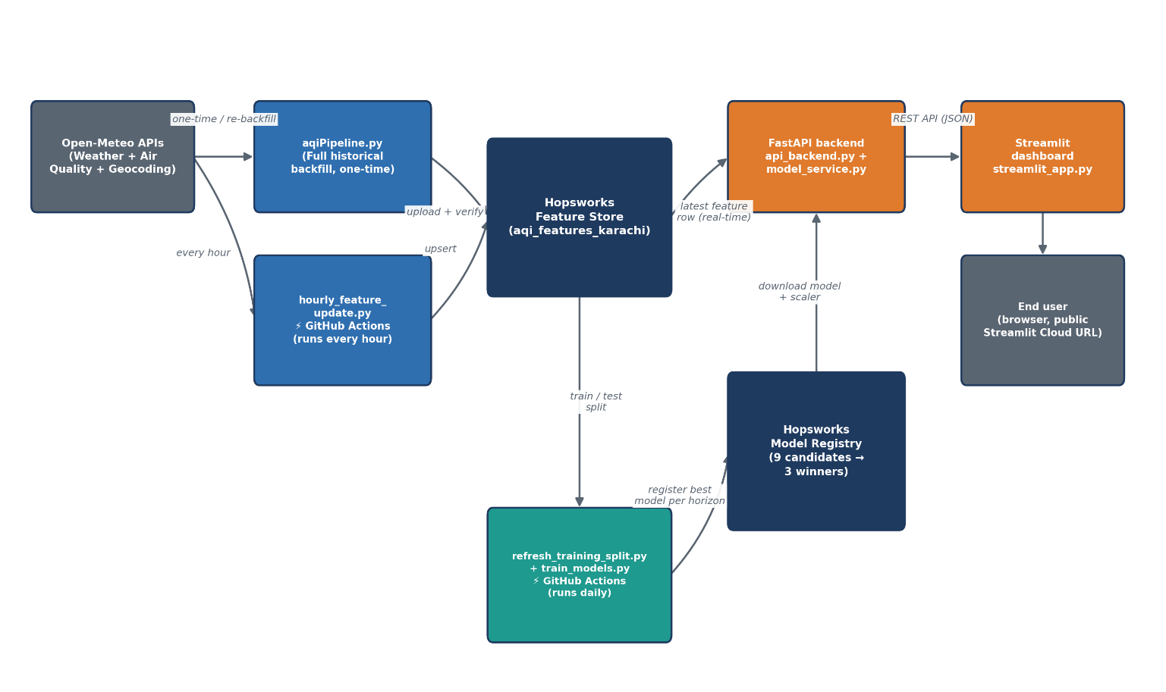
Figure 1 — End-to-end system architecture: data collection, Feature Store, training, Model Registry, and serving.
Two Hopsworks-managed components sit at the centre of this design and are what make the system “serverless” from an infrastructure-management point of view — no databases or model servers were manually provisioned:
- Feature Store — a single source of truth for engineered features (“consume once, use everywhere”): the same aqi_features_karachi feature group is read by the training pipeline and by the live prediction endpoint, so there is no risk of training/serving feature skew.
- Model Registry — versioned storage for trained models; the serving layer always downloads the current best-registered model for each horizon rather than shipping model files inside the application deployment itself.

4. Technology Stack
Layer | Technology | Purpose
Data source | Open-Meteo Archive, Air-Quality & Geocoding APIs | Free, no-API-key weather + air-quality history and forecasts
Feature engineering | pandas, numpy | Cleaning, resampling, lag/rolling/cyclical feature construction
Feature Store | Hopsworks Feature Store | Central, versioned store of engineered features; serves both training and inference reads
Model training | scikit-learn, XGBoost (TensorFlow optional) | Ridge / Random Forest / XGBoost candidates, tuned via RandomizedSearchCV
Model Registry | Hopsworks Model Registry | Versioned storage of trained model + scaler artifacts per horizon
Explainability | SHAP | Local & global feature attribution for each forecast
Backend API | FastAPI, Uvicorn | REST endpoints for predictions, EDA, SHAP, alerts
Frontend | Streamlit, Plotly | Interactive multi-tab dashboard
Automation | GitHub Actions | Scheduled hourly feature refresh and periodic model retraining
Hosting | Streamlit Community Cloud | Free, GitHub-integrated hosting for the live dashboard

5. Data Pipeline

5.1 Data Sources
All raw data comes from Open-Meteo's free, key-less REST APIs: the Geocoding API resolves a city name to coordinates, the Archive Weather API supplies historical hourly meteorological variables, and the Air-Quality API supplies hourly pollutant concentrations and the pre-computed US AQI value that serves as both a feature and the prediction target. Weather variables collected include temperature, humidity, precipitation, pressure, cloud cover (total and by altitude band), wind speed/direction/gusts, dew point, apparent temperature, vapour pressure deficit, and surface pressure. Air-quality variables include PM10, PM2.5, carbon monoxide, nitrogen dioxide, sulphur dioxide, ozone, and the US AQI itself.

5.2 Full Historical Backfill — aqiPipeline.py
aqiPipeline.py performs the one-time (or on-demand) full rebuild of the dataset. It fetches data in 90-day chunks (Open-Meteo's practical query-size limit) going back a configurable number of years, automatically anchored to “today” so no dates are hard-coded. Because reliable air-quality (CAMS) data is only available from 1 August 2022 onward, the effective history begins there. The pipeline then:
- Cleans the merged weather + air-quality data — removing duplicate timestamps, interpolating small gaps, and clipping physically impossible negative pollutant readings.
- Engineers the full feature set (Section 5.3).
- Uploads the result as a single Hopsworks Feature Group, deleting and recreating it so the group version always stays at 1 (a deliberate simplicity trade-off for a single-city, single-pipeline project).
- Polls Hopsworks until materialisation finishes and reads the data back to verify the upload actually landed correctly before continuing.
- Computes a chronological train/validation/test split and registers it as a Hopsworks Feature View training-dataset version, in addition to saving local CSV copies.

5.3 Feature Engineering — the Core Logic
The feature set is the most important design decision in the project, since AQI forecasting is fundamentally about capturing (a) how pollution levels evolve over time and (b) how weather conditions govern dispersion or accumulation of pollutants. Features fall into several families:

Time & calendar features
Hour of day, day of week, and month are extracted directly. Because these are cyclical (hour 23 is adjacent to hour 0, December is adjacent to January), they are additionally sine/cosine-encoded so the model sees the true circular distance between, say, 11pm and 1am, instead of a misleading numeric jump.

Lag features
Past AQI values at 24h, 48h, and 72h lag are included — deliberately matching the three forecast horizons, since “where was AQI at exactly this lag last time” is a strong autocorrelation-based predictor. Additional finer-grained lags at 6h, 12h, 36h, and 60h fill in the trend between those anchor points. The same lag logic is applied to individual pollutants (PM2.5, PM10, etc.), not just the composite AQI.

Rolling statistics
A 24-hour rolling mean captures short-term smoothing of noisy hourly readings, while a 7-day (168-hour) rolling mean captures longer seasonal/meteorological trend for both AQI and key pollutants. Rolling minimum/maximum (“rolling extremes”) capture recent volatility, and an AQI “acceleration” feature (the change in the rate of change) captures whether pollution is building up faster or slower than before.

Derived pollutant features
A PM2.5/PM10 ratio feature helps distinguish combustion-sourced fine particulates from coarser dust-sourced particulates, and a PM2.5 change-rate feature captures short-term momentum specifically in the pollutant most tied to health outcomes.

Upwind features
For each of the four cardinal bearings (N/E/S/W), coordinates roughly 50km upwind of Karachi are computed and queried for their own air-quality readings. The intuition: pollution often arrives via regional transport, so conditions upwind can be a leading indicator of what reaches the city next.

Weather trend & tendency features
Short-term trends in pressure, wind, and humidity are included, since falling pressure and stagnant wind are classic precursors to pollutant accumulation (temperature inversions trap pollutants near the surface), while strong or shifting wind tends to disperse them.

Future-weather features
Each forecast horizon gets its own set of {variable}_future_{h}h columns, letting the 24h, 48h, and 72h models each see a distinct, horizon-specific weather signal rather than sharing identical inputs. (During training this is approximated from historical data actually observed at that future timestamp; at real-time inference, only true forecast/most-recent values are available — this asymmetry is a known, documented characteristic of the approach and is called out explicitly in the code as an area for future refinement, see Section 16.)

Forecast targets & feature pruning
The three regression targets (target_us_aqi_24h_ahead, _48h_ahead, _72h_ahead) are created by shifting the AQI column backward by the horizon in hours. A final drop_low_value_features step removes columns identified as contributing negligible predictive value, keeping the final feature matrix lean.

5.4 Incremental Hourly Updates — hourly_feature_update.py
Re-running the full backfill every hour would be slow and wasteful, so a lightweight companion script keeps the Feature Store current with only the newest data. It deliberately re-uses (imports, never duplicates) the exact same feature-engineering functions from aqiPipeline.py, so the two pipelines can never silently drift out of sync with each other.
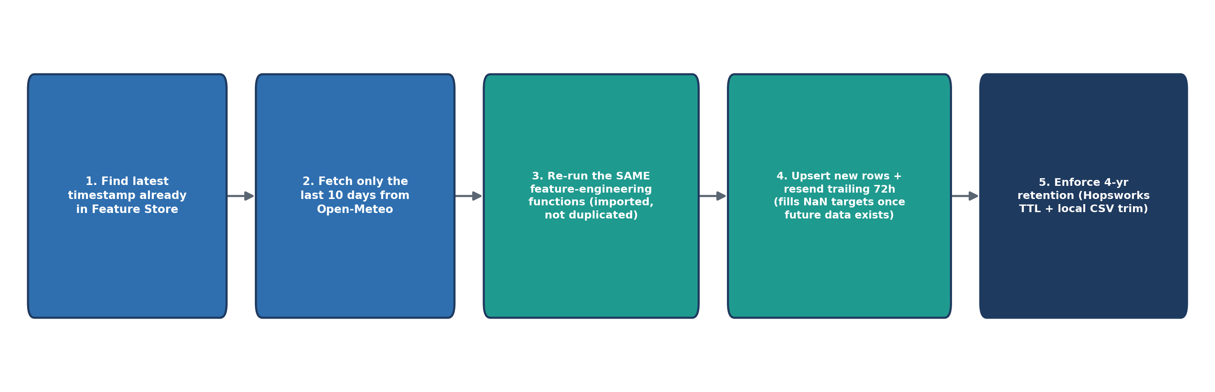
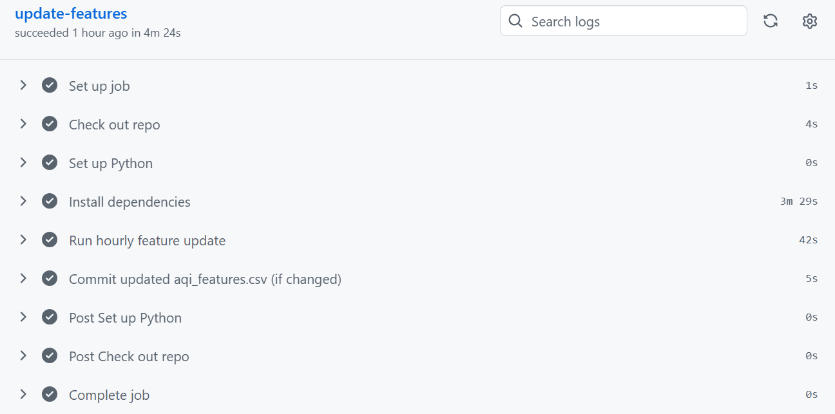
One subtlety worth explaining: a row's 24h/48h/72h-ahead targets can only be computed once real future data exists for that timestamp. A row inserted at the newest edge of any given hourly run is therefore stored with the longer-horizon targets still NaN. The script deliberately resends the trailing 72 hours of already-stored rows on every run (an upsert on the datetime primary key), so that once real future data eventually arrives, Hopsworks's upsert semantics overwrite that earlier NaN with the true value. Retention (default 4 years) is enforced both natively via Hopsworks' Feature Store TTL setting and by trimming the local aqi_features.csv mirror to the same rolling window, so neither storage location grows unbounded.

6. Why a Feature Store and Model Registry
Two MLOps design choices deserve explicit justification, since they are what elevate this project above a single training notebook:

6.1 Feature Store
- Single source of truth: the exact same aqi_features_karachi feature group is read by train_models.py during training and by model_service.py at real-time inference, eliminating training/serving skew (a very common source of silent production ML bugs).
- Point-in-time correctness: querying by explicit time windows keeps both the training split and the live “latest row” read consistent with how the feature engineering functions expect data to be shaped.
- Decoupling: the feature pipeline, training pipeline, and serving layer can all run on entirely independent schedules and infrastructure, communicating only through the Feature Store.

6.2 Model Registry
- Versioning: every training run registers a new model version rather than overwriting a file, preserving a full history of what was deployed and when.
- Clean separation from serving: the deployed dashboard never bundles model files directly — model_service.py always downloads the current best-registered model for each horizon at runtime, so retraining and redeploying the model does not require redeploying the application.
- Metadata: each registered model carries its training metrics, so list_available_models() (used by the /models/{horizon} endpoint) can surface version history without needing a separate tracking system.

7. Model Training

7.1 Daily Retraining Orchestration — refresh_training_split.py
A subtlety made the daily retraining job trickier than “just re-run train_models.py every day.” The Feature View training-dataset split that aqiPipeline.py originally registers (via fv.create_train_test_split()) is a materialised snapshot, not a live query — and train_models.py always reads it by a fixed --td-version (default 1). Meanwhile hourly_feature_update.py keeps appending fresh rows to the underlying feature group every hour, but that frozen snapshot never automatically follows along. Without an extra step, “daily retraining” would silently retrain on the exact same stale split every single day and never actually learn from the new hourly data — the training job would appear to succeed while providing no real value.
refresh_training_split.py exists specifically to close that gap, and runs once daily, immediately before train_models.py, as the first step of the same scheduled GitHub Actions job:
- Re-reads the current state of the feature group (all rows accumulated so far, including everything the hourly pipeline has added).
- Recomputes the split boundaries using the same logic as aqiPipeline.py — train on everything except the most recent 12 months, test on the most recent 12 months — so the test window always stays anchored to “today” rather than drifting stale.
- Scans for any row with a NaN in the current AQI reading or one of the three target columns — not just the trailing-edge rows that haven't accumulated full lag/target history yet, but anywhere in the timeline — and drops it before the split is computed, logging exactly which timestamp(s) were affected.
- Registers a NEW training-dataset version under the Feature View (create_feature_view_split() no longer deletes-and-reuses version 1; it always creates a fresh version, keeping the most recent 7 and pruning older ones — see the note below).
- Reads the new split back (with a few retries) and checks its row count against what was just computed, before trusting it — a safety net against the specific staleness failure mode described below — then writes the confirmed version number to latest_td_version.txt.
train_models.py then reads latest_td_version.txt and trains against whatever split version is confirmed to genuinely exist, so the daily job always retrains on fresh, current data rather than a forgotten snapshot.
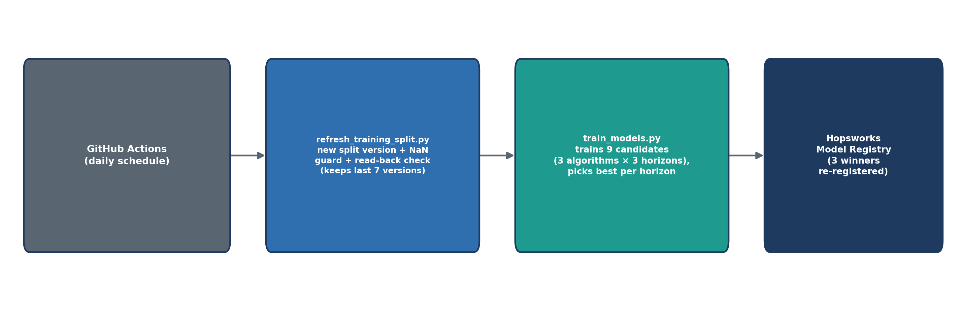
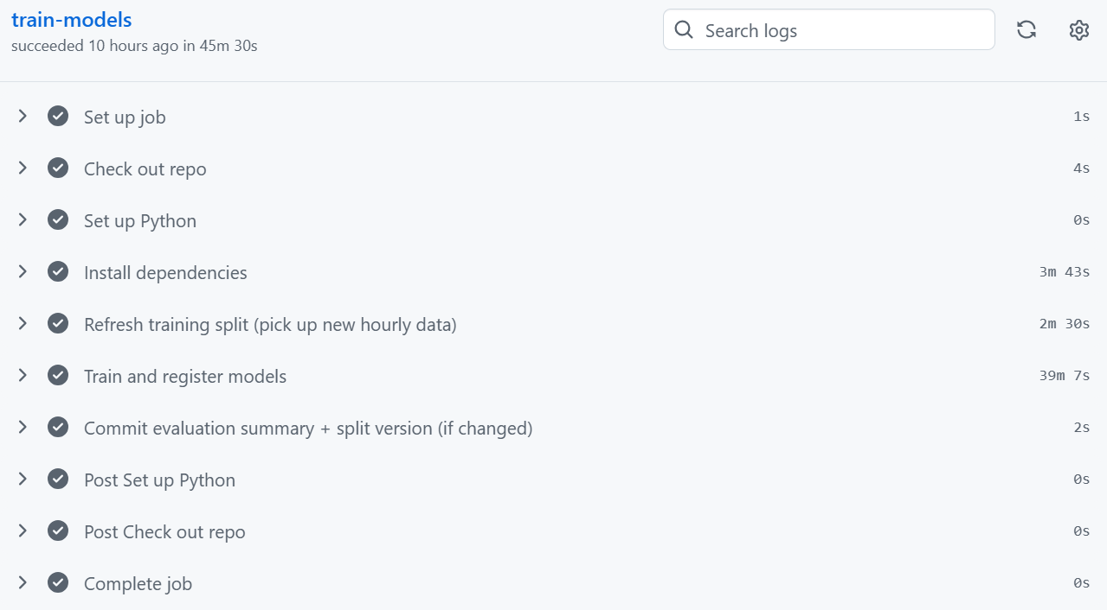

7.2 Train / Test Split Strategy
The split is strictly chronological and calendar-anchored — the most recent 12 months of data form the test set, and everything before that forms the training set (in the current dataset: roughly 26,065 training rows spanning August 2022–August 2025, and 8,760 test rows spanning the most recent 12 months). This is deliberate: a random row-wise split would let the model “see the future” through neighbouring rows sharing near-identical lag/rolling features, producing a badly over-optimistic evaluation. A calendar-anchored split additionally ensures the test set spans a full annual cycle of seasonal AQI variation rather than an arbitrary slice.

7.3 Candidate Algorithms
Three lightweight, non-deep-learning candidates are trained independently for each of the three horizons (24h, 48h, 72h), for nine models trained in total per run:
Model | Tuning approach | Rationale
Ridge Regression | RidgeCV, then RandomizedSearchCV over regularisation strength | Strong, well-regularised linear baseline; fast to train and to serve
Random Forest | RandomizedSearchCV with TimeSeriesSplit cross-validation | Captures non-linear interactions without heavy tuning
XGBoost | RandomizedSearchCV with TimeSeriesSplit cross-validation | Gradient-boosted trees; typically strong on structured/tabular data

A fourth candidate — a small Keras neural network — is also implemented (KerasWrapper class, guarded by a try/except around the TensorFlow import so its absence never breaks the rest of the pipeline), but is intentionally not the primary focus: a genuinely serverless deployment target typically caps package size well below what a full TensorFlow install needs, so the three lightweight candidates above were prioritised as the core comparison, with the neural network available as an optional fourth candidate rather than a required one.
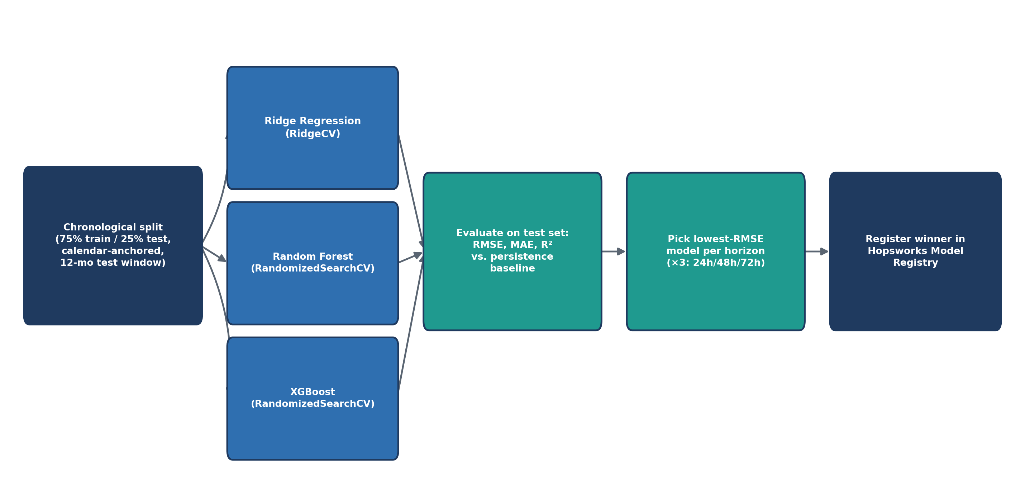
Figure 3 — Training and model-selection pipeline (repeated independently for each of the 3 horizons).

7.4 Evaluation Methodology
Every candidate is scored on RMSE, MAE, and R² on the held-out chronological test set. Critically, each horizon's results are also compared against a persistence baseline — the naive forecast that simply assumes AQI stays exactly where it currently is. This baseline is what actually justifies building a model at all: if a trained model cannot beat “assume nothing changes,” it has no practical value. The best model per horizon is the one with the lowest test RMSE.

7.5 Feature Handling Details
select_features_for_horizon() restricts each horizon's model to the appropriate lag/future-weather columns for that horizon specifically (so the 24h model isn't trained on 72h-specific future-weather columns it will never usefully see at that lead time, and vice versa). report_feature_target_correlations() and report_feature_importance() are used purely for diagnostic logging during training — they surface the top correlated/most important features per horizon in the console output, which was useful during development for sanity-checking that the model was learning sensible relationships (e.g. AQI lag features and PM2.5 dominating, rather than an unrelated column).

7.6 Results
Final test-set results for the currently registered models (all three winning candidates turned out to be the tuned Ridge Regression model):
Horizon | Winning model | Test RMSE | Test MAE | Test R² | Baseline R² | R² improvement
24h | Ridge | 12.46 | 8.72 | 0.67 | 0.432 | +0.237
48h | Ridge | 16.86 | 12.31 | 0.41 | 0.101 | +0.302
72h | Ridge | 17.82 | 13.30 | 0.342 | −0.093 | +0.427

Two observations stand out. First, the well-regularised linear model outperformed both Random Forest and XGBoost at every horizon — plausible given that AQI's relationship to its own recent lags and rolling averages is largely smooth and monotonic, which is exactly the regime where a properly regularised linear model can match or beat more flexible learners while generalising better on a moderately sized dataset. Second, and more importantly from a product standpoint, the model's advantage over the naive persistence baseline widens sharply as the horizon grows — from +0.238 R² at 24h to +0.435 R² at 72h. This is intuitive: persistence gets steadily worse the further out you forecast (its baseline R² even turns negative at 72h, i.e. worse than predicting the mean), while the trained model continues to extract real signal from lag structure, rolling trends, and weather features. In other words, the system is most valuable exactly where a naive approach is least useful — longer-range forecasts. (These figures update automatically with each daily retraining run; the table above reflects the most recent run at time of writing.)

7.7 Model Registration
register_model() persists each horizon's winning model and its fitted StandardScaler to a local model_aqi_{city}_{h}h/ directory (model.pkl + scaler.pkl, or keras_model.keras + scaler.pkl for a neural-network winner), then registers that directory as a new version of aqi_{city}_{horizon}h in the Hopsworks Model Registry, with delete_existing_model_versions() first clearing out prior versions so the registry doesn't accumulate unbounded stale artifacts for a project that always wants “the current best.”

8. Serving Layer

8.1 FastAPI Backend — api_backend.py
The backend exposes a small, focused REST surface. CORS is deliberately configured wide-open (allow_origins=["*"]) since this is a public, read-only demonstration API with no user accounts or write operations.
Endpoint | Purpose
GET /health | Liveness check
GET /predict?force_refresh= | 24h/48h/72h AQI predictions from the latest Feature Store row; force_refresh re-downloads models from the registry instead of using the in-process cache
GET /eda/summary | Row count, date range, mean/max/min AQI, % time “Unhealthy-or-worse”
GET /eda/trend | Daily-average AQI time series
GET /eda/hourly | Average AQI by hour of day
GET /eda/monthly | Monthly AQI seasonality (mean/min/max)
GET /shap/{horizon} | Local + global SHAP feature-attribution for that horizon's model
GET /models/{horizon} | Registered model version history and training metrics for that horizon

8.2 model_service.py — Prediction Logic
This module is the bridge between Hopsworks and the API layer. It logs into Hopsworks once per process and caches the connection; get_latest_feature_row() attempts a fast time-filtered read (last ~96 hours) and only falls back to a full feature-group read if that filtered read fails or returns nothing. load_model_for_horizon() always fetches the highest-versioned registered model for that horizon, downloads it via hsml's own local caching mechanism, and caches the loaded model/scaler in memory for the life of the process (unless force_refresh is requested). predict_next_3_days() ties this together: it pulls the single latest engineered feature row, applies each horizon's own fitted scaler and model, and returns predictions alongside the reference timestamp they were computed from.

8.3 Explainability — shap_utils.py
Rather than treating the models as black boxes, every prediction can be explained on demand. get_recent_feature_rows() pulls a fresh background sample directly from the Feature Store (deliberately not from the possibly-stale local aqi_features.csv snapshot) to guarantee the SHAP background distribution matches exactly what the model was trained on. explain_prediction() then computes two complementary views: a local explanation (which features pushed this specific forecast up or down, and by how much) and a global explanation (which features the model relies on most heavily overall, via mean absolute SHAP value). Both are rendered as horizontal bar charts in the dashboard.

8.4 Alerting — alerts.py
classify_aqi() maps any numeric AQI value onto the standard 6-category US EPA scale (Good → Hazardous), each with an associated colour and public-health message. build_alerts() then scans all three forecast horizons and raises a “warning” alert at AQI ≥ 150 or a “severe” alert at AQI ≥ 200, so the dashboard can proactively surface hazardous conditions before they arrive rather than only reporting the current reading.

9. Frontend Dashboard — streamlit_app.py
The dashboard is organised into four tabs, each backed by one or more of the API endpoints above.

1- Forecast
Shows the current AQI reading alongside three metric cards (24h/48h/72h), each colour-coded by EPA category, plus a “now → next 3 days” line chart. A manual refresh button forces the backend to re-download the latest registered models rather than relying on the in-memory cache.
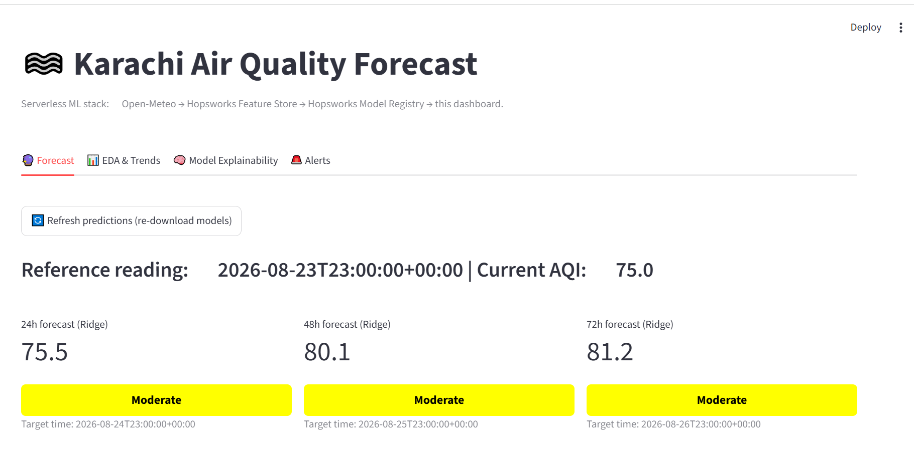
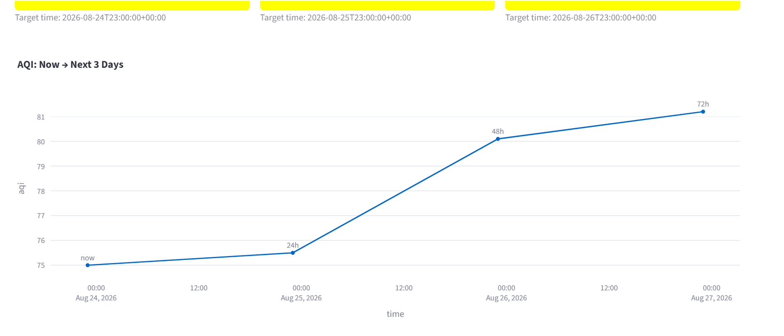

2- EDA & Trends
Summary statistic cards (row count, mean/max AQI, % time unhealthy-or-worse, data date range) followed by a daily-average AQI time series, an average-AQI-by-hour-of-day chart, and a monthly seasonality chart (mean/min/max per month).
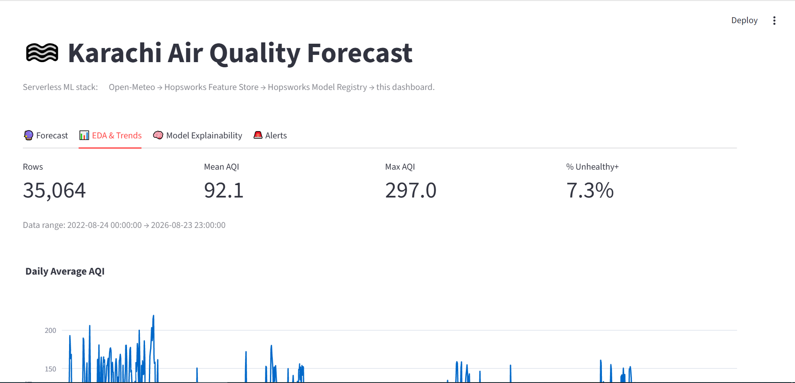
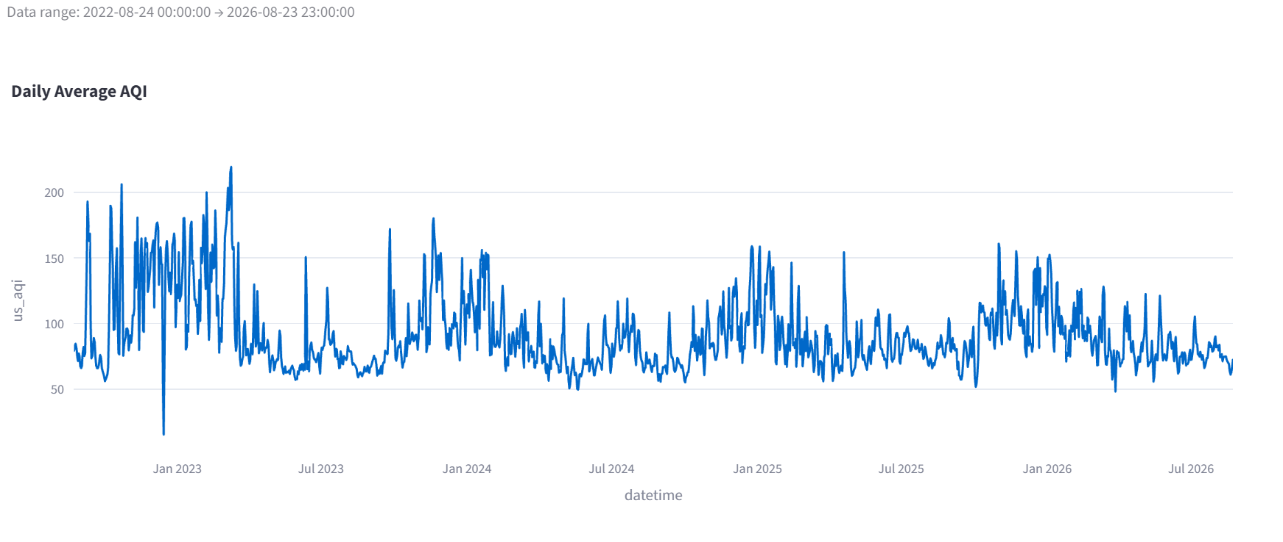
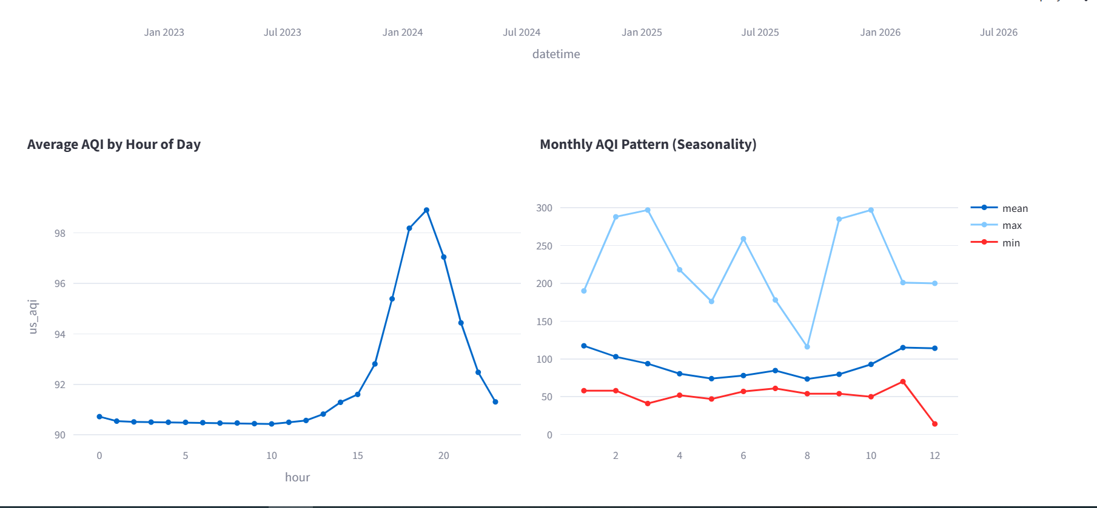

3- Model Explainability
A horizon selector plus an “Explain this prediction” button that computes and displays the local and global SHAP charts described in Section 8.3, side by side.
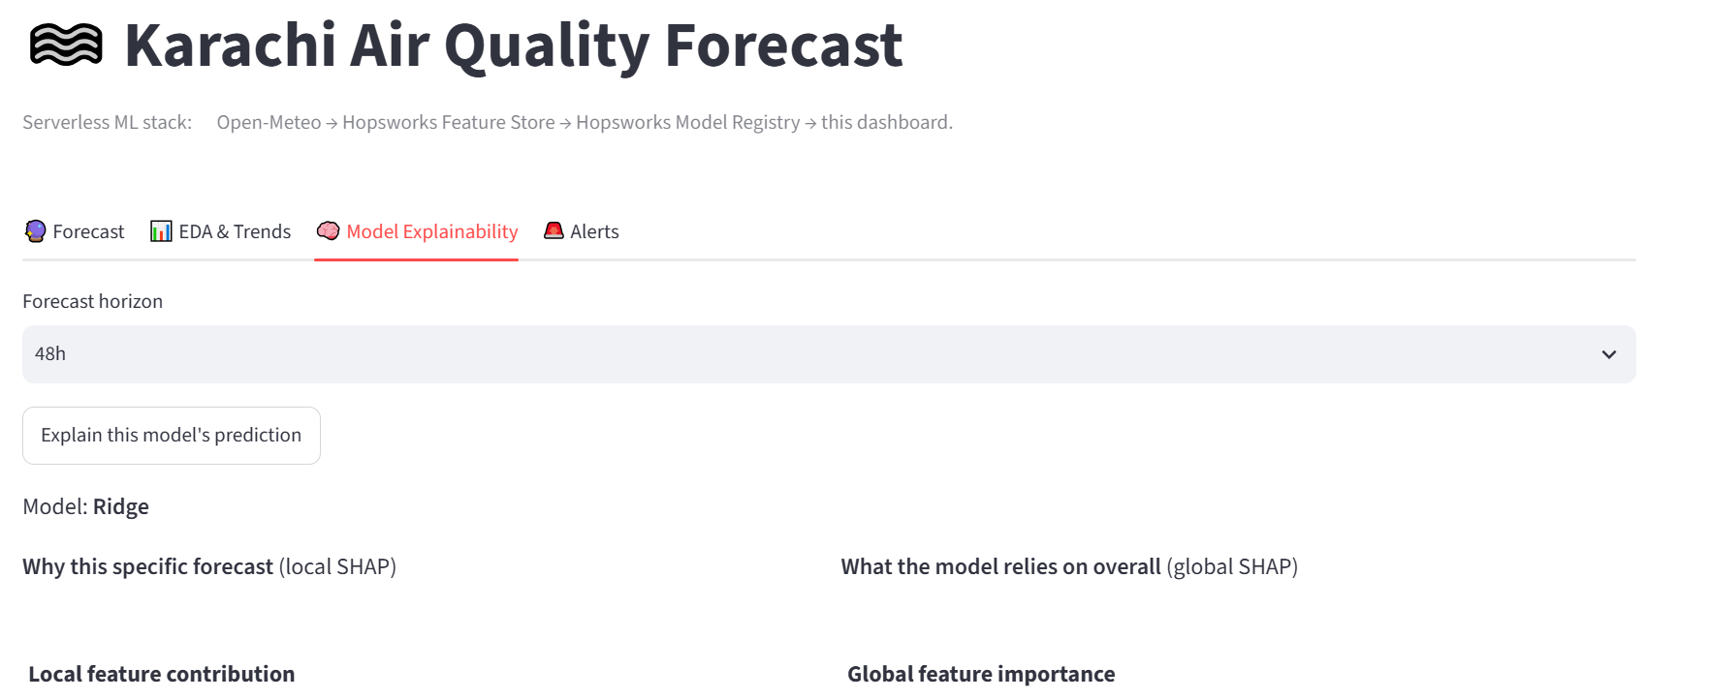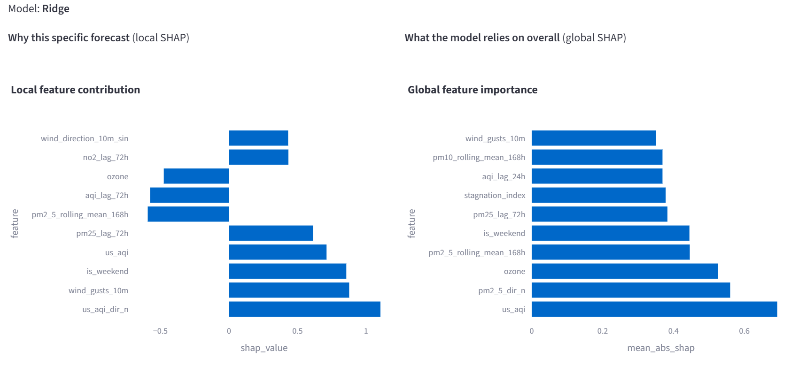

4- Alerts
Any active warning/severe alerts across the three horizons, rendered as coloured banners, plus an always-visible legend of all 6 EPA AQI categories with their associated colours and health messages.
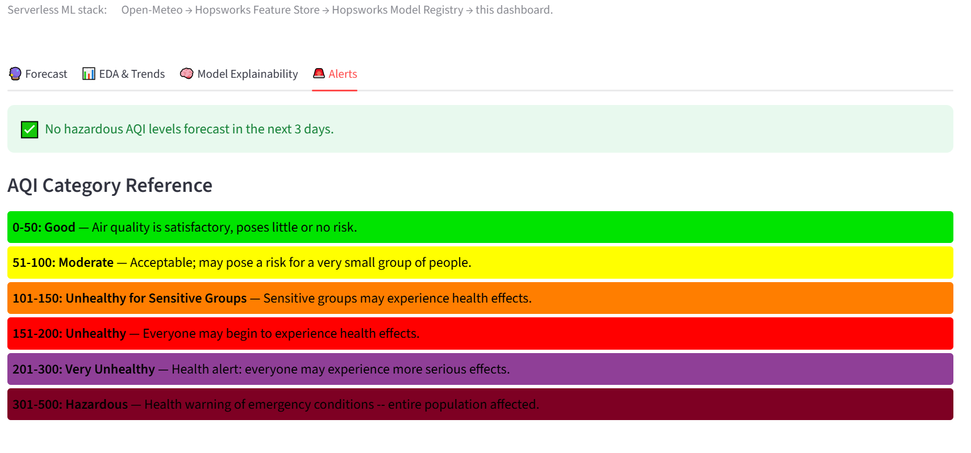

10. Resilience Engineering — hopsworks_read_utils.py
During development, GitHub Actions runners showed intermittent failures talking to Hopsworks' Arrow-Flight/gRPC-based Query Service — reads would hang for minutes and then fail with connection errors, even on modest data volumes. Diagnosis showed this was a connection-stability issue specific to that transport on shared CI runners, not a query-correctness problem. The fix, centralised in a single shared module used by both the hourly feature pipeline and the daily training pipeline, is a layered retry strategy:
- Try reading via the older Hive-based path first (read_options={"use_hive": True}), which avoids the Arrow Flight service entirely — retried up to 3 times with linear backoff (20s × attempt number).
- If the installed hsfs client version doesn't support that option at all, or the Hive path is exhausted, fall back to the default (Arrow Flight) path — again retried up to 3 times with backoff.
- Only if both paths are exhausted does the underlying error finally propagate to the caller.
This same pattern is applied both to plain feature-group reads (robust_read()) and to Feature-View train/test split retrieval (robust_train_test_split()), since both go through the same underlying Query Service and show the same failure profile.

11. CI/CD & Automation
Two scheduled GitHub Actions workflows keep the system self-sustaining without manual intervention:
- Hourly workflow — runs hourly_feature_update.py to keep the Feature Store current with the latest available weather/air-quality data (Section 5.4).
- Daily/periodic training workflow — refreshes the train/test split and re-runs train_models.py so the registered models are periodically retrained on the latest data, keeping the deployed forecasts from drifting stale as conditions and seasons change.
Both workflows install their dependencies from requirements-pipeline.txt (the full dependency list, including TensorFlow, MLflow, and Confluent-Kafka), kept intentionally separate from the much slimmer requirements.txt used purely for the live dashboard deployment (see Section 12.3).

12. Deployment

12.1 Deployment Target
The live dashboard is deployed on Streamlit Community Cloud, a free, GitHub-integrated hosting service purpose-built for Streamlit apps. Every push to the connected GitHub branch triggers an automatic rebuild and redeploy.

12.2 The Two-Services-in-One-Host Problem
The application is architecturally two separate services — a FastAPI backend and a Streamlit frontend communicating over HTTP — but most free hosting tiers, Streamlit Community Cloud included, run exactly one process per app. This was solved with a small startup snippet placed at the very top of streamlit_app.py: on first load, it checks whether the backend's port is already accepting connections, and if not, spawns uvicorn api_backend:app as a background subprocess before the rest of the Streamlit script runs. Because Streamlit re-executes the script on every rerun, the port check makes this idempotent — the backend is only ever started once per running container.
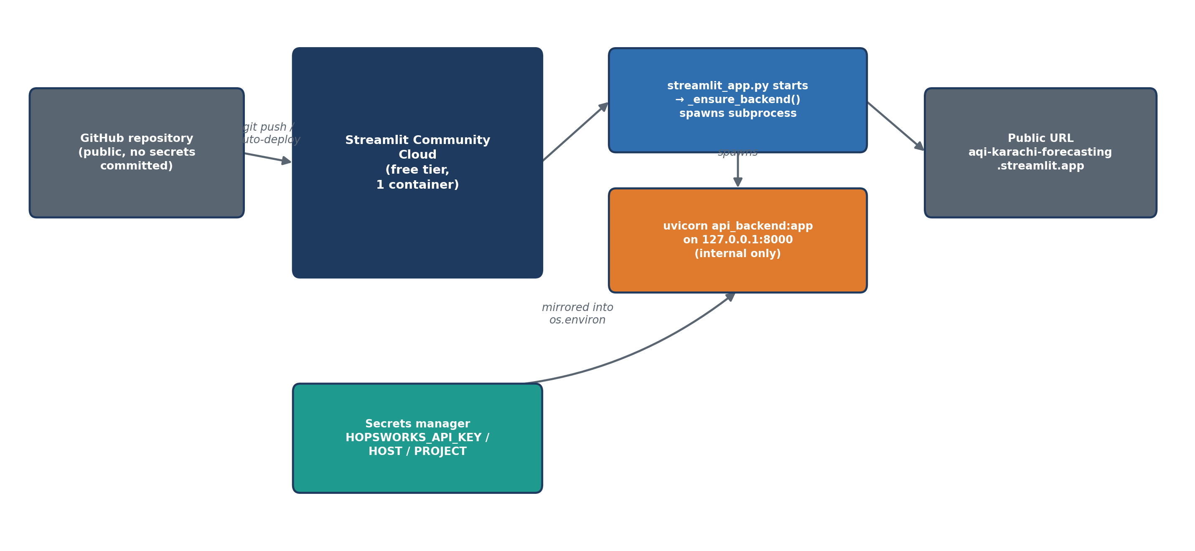
Figure 4 — Deployment architecture: one Streamlit Cloud container running both services via a subprocess launcher.
A related subtlety: Streamlit Cloud's secrets manager (st.secrets) does not automatically populate the process's OS environment variables, but model_service.py reads its Hopsworks credentials via os.environ.get(...) — exactly as it did locally with a .env file. The startup snippet therefore explicitly mirrors the required secrets from st.secrets into os.environ before spawning the backend subprocess, so the rest of the codebase needed no changes at all to work in this new environment.

12.3 Two Requirements Files
The training/ingestion pipelines (GitHub Actions) and the live dashboard deployment (Streamlit Cloud) have genuinely different dependency needs, and Streamlit Cloud additionally requires requirements.txt to live in the same directory as the app's entrypoint file — so both could not simply coexist under the same filename. The resolution was to keep the full dependency list as requirements-pipeline.txt (used only by the GitHub Actions workflows) and maintain a separate, much slimmer requirements.txt at the repository root for the deployed dashboard, deliberately excluding TensorFlow, MLflow, and Confluent-Kafka — none of which are needed simply to serve predictions from already-trained scikit-learn/XGBoost models.
requirements.txt (deploy — read by Streamlit Cloud)
fastapi, uvicorn[standard], streamlit, plotly, pandas, numpy,
scikit-learn, xgboost, shap, joblib, pyarrow, setuptools<81,
hopsworks==5.0.6, hsfs, hsml, nest_asyncio, ...

requirements-pipeline.txt (training/ingestion — used by GitHub Actions)
...all of the above, PLUS tensorflow, mlflow, confluent-kafka,
matplotlib, seaborn, statsmodels, holidays, ...

13. Challenges Faced & How They Were Resolved
This section documents, in the order they were encountered, every non-trivial engineering problem hit during development and deployment, along with the diagnosis and fix for each — as this problem-solving process was one of the core learning outcomes of the internship.

13.1 Accidental Credential Exposure
Problem
A routine review of the project's git history revealed that the .env file — containing the real Hopsworks API key, host, and project name — had been committed in the very first commit and remained tracked through the latest commit, despite the intention to keep it out of version control.

Resolution
The Hopsworks API key was rotated immediately (the step that actually neutralises the exposure, regardless of git history). .env was then removed from tracking, a proper .gitignore was added covering secrets, the local virtual environment, and regenerable local artifacts, and the option to fully purge the key from git history using git-filter-repo was documented for extra hygiene.

13.2 Free Hosting Platform Restrictions
Problem
The first deployment plan used Hugging Face Spaces with a Dockerfile running both services in one container. The account's Docker SDK option turned out to be gated behind phone/payment verification, and the fallback plain “Streamlit” SDK option was also unavailable on that account's “New Space” page (only “Static” was offered).

Resolution
Pivoted to Streamlit Community Cloud — native, GitHub-integrated hosting for Streamlit apps with no SDK-gating at all — and solved the underlying two-process requirement with the subprocess-launcher pattern described in Section 12.2, rather than depending on Docker being available.

13.3 Conflicting Dependency Requirements
Problem
The training/ingestion pipelines need the full, heavy dependency list (TensorFlow, MLflow, Confluent-Kafka, etc.), while the live deployment needed a much slimmer, faster-to-build list — and Streamlit Cloud requires requirements.txt to sit in the same directory as the entrypoint, so the two lists could not simply share one filename.

Resolution
Split into requirements-pipeline.txt (full list, used by GitHub Actions) and a slim requirements.txt (deploy-only, read by Streamlit Cloud), as detailed in Section 12.3.

13.4 setuptools Dropped pkg_resources
Problem
Deployment failed with ModuleNotFoundError: No module named 'pkg_resources'. Tracing the traceback showed a deep transitive dependency (hsfs → great_expectations) still importing the deprecated pkg_resources API — and recent setuptools releases have removed that module entirely (its removal took effect around 30 November 2025).

Resolution
Pinned setuptools<81 in the deploy requirements.txt, restoring the module the transitive dependency still expects, without needing to modify any third-party package code.

13.5 Hopsworks Client / Backend Version Mismatch
Problem
After the packaging fix, the app deployed but /predict failed with TypeError: Project.__init__() got an unexpected keyword argument 'namespace'. The cause: hopsworks was left unpinned in the deploy requirements, so pip resolved an old 3.0.5 client — incompatible with the connected Hopsworks backend (5.0.3), which now returns a namespace field the old client's Project class doesn't know how to parse.

Resolution
Pinned hopsworks==5.0.4 (later 5.0.6) in the deploy requirements to match the backend's minor version, resolving the login/parsing error and restoring correct predictions.

13.6 Daily Training Pipeline: Silent Split-Creation Failure
Problem
A GitHub Actions training run failed with repeated “Path not found” errors reading the train/test split. Investigation traced this to the previous run: the Hopsworks job that materialises a Feature-View split had actually FAILED server-side, but the client-side fallback logic found a version record for it anyway and wrote latest_td_version.txt as if it had succeeded — so the next run tried to read data that was never actually written.

Resolution
Aligned requirements-pipeline.txt's hopsworks/hsfs/hsml pins with the connected backend version (the same class of fix as 13.5, applied to the pipeline side too), and used the direct Hopsworks job-execution log link from the run output to confirm the underlying failure reason rather than relying on the ambiguous client-side status.

13.7 Unstable Query-Service Connections on CI Runners
Problem
GitHub Actions runners intermittently failed reading from Hopsworks' Arrow-Flight-based Query Service, even for modest read volumes — a connection-stability issue with that specific transport rather than a query problem.

Resolution
Built hopsworks_read_utils.py: a shared Hive-path-first, retry-with-backoff wrapper (Section 10) used by every Feature Store read in both the hourly and training pipelines.

13.8 Post-Deployment: Intermittent NaN Crash in the Daily Training Job
Problem
After the system had been live for some time, the daily training GitHub Actions run began failing intermittently with ValueError: Input contains NaN, raised deep inside scikit-learn while scoring the persistence baseline — meaning a NaN existed in either the current AQI reading or a target column of the split train_models.py had just loaded.

Investigation
The edge-row filter that drops rows lacking full lag/target history (the trailing newest rows, which haven't accumulated 72h of future data yet) is recency-based, not a full scan — so a gap from, say, one missed hourly run could sit undetected in the middle of the timeline instead of at the edge. That explained how a NaN could exist, but a second, more telling clue emerged from comparing consecutive runs: refresh_training_split.py reported a different, correct row count on every run (as expected from a calendar-anchored split shifting daily), while train_models.py kept reading the exact same row count run after run — including on runs from before the day's refresh had even executed. That pointed to something more specific than a data gap: the daily job's own versioning design deleted every existing training-dataset version and always recreated the replacement as version 1, so that the Feature View never accumulated an ever-growing pile of versions. Reusing the same version number seconds apart looked like exactly the kind of pattern that could race a caching layer on the read side, rather than genuinely re-resolving the freshly written data every time.

Resolution
Two complementary changes, addressing both the symptom and the suspected root cause. First, defensive NaN scanning was added in both refresh_training_split.py and train_models.py — not just at the trailing edge, but across the whole loaded split — with any affected row dropped and its timestamp logged, so a genuine data gap degrades to a one-line warning instead of a crash. Second, and more importantly, create_feature_view_split() was changed to always create a new training-dataset version rather than deleting everything and reusing version 1, keeping only the most recent 7 versions (oldest pruned first) to keep Hopsworks storage bounded. refresh_training_split.py was also given a read-back verification step — re-reading the newly created split, with retries, and checking its row count before trusting it — as a second line of defense in case a genuinely new version is still momentarily stale on the read path immediately after creation.

14. Security & Best Practices Applied
- No credentials are ever hard-coded; all secrets are read from environment variables (.env locally, GitHub Actions secrets in CI, Streamlit Cloud's secrets manager in production).
- A proper .gitignore excludes secrets, the local virtual environment, downloaded model caches, and other regenerable local artifacts from version control.
- The “rotate first, clean history second” principle was applied to the accidentally-exposed API key — rotating the credential neutralises the exposure immediately, independent of whether git history is also scrubbed.
- Dependencies critical to correct operation (the Hopsworks client family) are explicitly version-pinned rather than left to float, after the version-mismatch incidents in Sections 13.5–13.6 demonstrated the real cost of leaving them unpinned.
- The public GitHub repository is deliberately scoped to exclude the local virtual environment, downloaded model-registry caches, and large intermediate training CSVs.

15. Live Demonstration
The complete system is deployed and publicly accessible at:
https://aqi-karachi-forecasting.streamlit.app/
Visitors can view the current AQI reading and 3-day forecast, explore historical trends and seasonality, request a SHAP-based explanation of any forecast, and see any active health alerts — all computed live from the Hopsworks Feature Store and Model Registry, with no static or cached demo data.



16. Limitations & Future Work
- Single city, single feature set: extending to additional cities is a configuration change (new coordinates, new feature-group name) but has not yet been tested end-to-end for a second city.
- Future-weather feature asymmetry: as noted in Section 5.3, the {variable}_future_{h}h features are approximated differently at training time (from historical realised values) than at real-time inference (from the most recent available data) — a documented characteristic worth quantifying and potentially tightening in future work.
- No automated test suite currently covers the pipelines or API; given how much of the debugging in Section 13 involved silent/ambiguous failure modes (Section 13.6 especially), lightweight integration tests around split creation and model loading would likely catch several of these issues earlier.
- No monitoring/alerting exists for the automated pipelines themselves — a failed hourly or daily GitHub Actions run currently has to be noticed manually in the Actions tab rather than actively notifying anyone.
- The optional neural-network candidate is implemented but not the current focus of the model comparison; a fuller deep-learning comparison (e.g. an LSTM/temporal architecture) is a natural extension once/if package-size constraints for deployment are relaxed.
- Docker-based deployment (Hugging Face Spaces or similar) remains a reasonable path once account-level payment verification is completed, and would remove the need for the subprocess-launcher workaround described in Section 12.2.

17. Conclusion
This project delivered a complete, automated, and publicly deployed AQI forecasting system for Karachi — covering data engineering, feature-store-backed MLOps, multi-model training and evaluation, model explainability, real-time serving, and free-tier cloud deployment. Beyond the machine learning itself, the internship's most transferable lessons came from the deployment and production-engineering process documented in Section 13: diagnosing dependency conflicts, resolving a real credential-exposure incident correctly, adapting an architecture around a hosting platform's constraints, and building resilience against an unreliable third-party network transport. The models trained substantially and increasingly outperform a naive persistence baseline as the forecast horizon grows, validating the practical value of the approach, and the live system remains publicly accessible for continued use and iteration.

18. References
- Open-Meteo Weather, Air Quality, and Geocoding APIs — https://open-meteo.com/
- Hopsworks Feature Store & Model Registry documentation — https://docs.hopsworks.ai/
- Streamlit documentation — https://docs.streamlit.io/
- FastAPI documentation — https://fastapi.tiangolo.com/
- scikit-learn documentation — https://scikit-learn.org/
- XGBoost documentation — https://xgboost.readthedocs.io/
- Lundberg, S. & Lee, S. — A Unified Approach to Interpreting Model Predictions (SHAP), NeurIPS 2017.
- US EPA — Air Quality Index (AQI) Basics — https://www.airnow.gov/aqi/aqi-basics/

Appendix A — Repository File Reference
File | Role
aqiPipeline.py | Full historical data backfill, feature engineering, Feature Store upload, split creation
hourly_feature_update.py | Incremental hourly feature refresh (reuses aqiPipeline.py's functions)
hopsworks_read_utils.py | Shared resilient-read helper (Hive-path fallback + retry/backoff)
train_models.py | Model training, evaluation, and registration (Ridge / RF / XGBoost × 3 horizons)
refresh_training_split.py | Standalone helper to refresh/recreate the training-dataset split
dashboard_config.py | Shared configuration constants for the API + dashboard
model_service.py | Hopsworks connection caching, model download/caching, real-time prediction logic
eda_utils.py | Exploratory data analysis helper functions
shap_utils.py | SHAP local/global explanation computation
alerts.py | AQI classification and threshold-based alert generation
api_backend.py | FastAPI REST backend
streamlit_app.py | Streamlit dashboard frontend (+ backend subprocess launcher for deployment)
requirements-pipeline.txt | Full dependency list for GitHub Actions pipelines
requirements.txt | Slim dependency list for the deployed dashboard (Streamlit Cloud)

