**Create an application to integrate Google Tasks with Notion database**

**Following are the steps to make this project:**

**Assumptions: Only single user application. In app we have start stop sync buttons to control the sync.**

**Step 1: Google API settings**

1. Open the link: [console.developers.google.comGoogle Cloud Platform](https://r.search.yahoo.com/_ylt=Awr.3GfhBrZnSBQCG31XNyoA;_ylu=Y29sbwNncTEEcG9zAzEEdnRpZAMEc2VjA3Ny/RV=2/RE=1741192161/RO=10/RU=https%3a%2f%2fconsole.developers.google.com%2f/RK=2/RS=GH1T80_FdQJD23lDD.3ByPQXjHk-)
2. Select a project you want or create new project

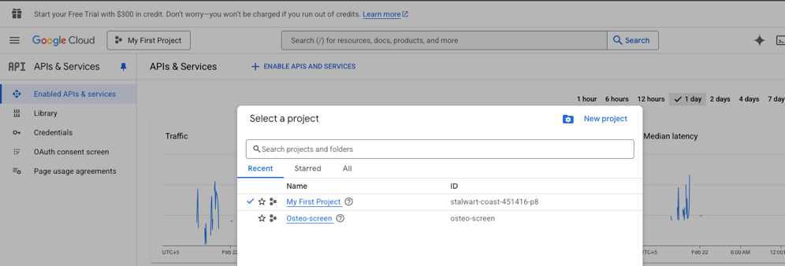

1. Go to Library.
2. Search for Google Task API.
3. Enable google task API

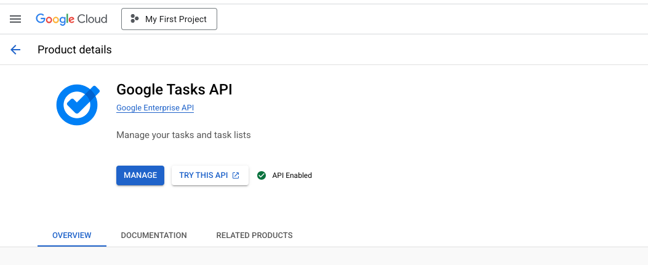

1. Go back to first page and under API & SERVICES go to Credentials.
2. Click on create credentials
3. Select OAuth ClientID

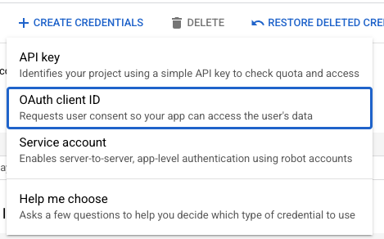

1. Select Application type ‘**Desktop APP’,** enter your name and create it.

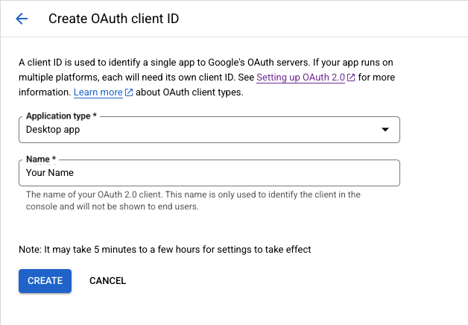

1. Your OAuth 2.0 Client IDs is created, Download Json file

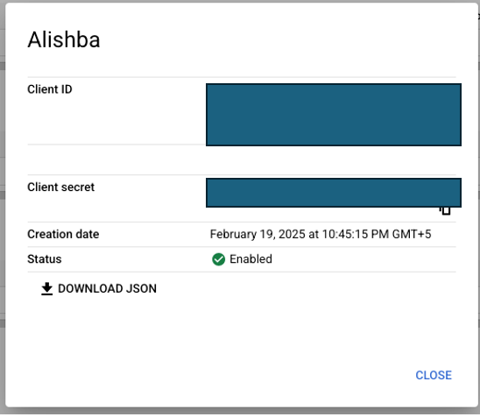

1. Go back to first page and under API & SERVICES go to OAuth consent screen.
2. This will open new page.

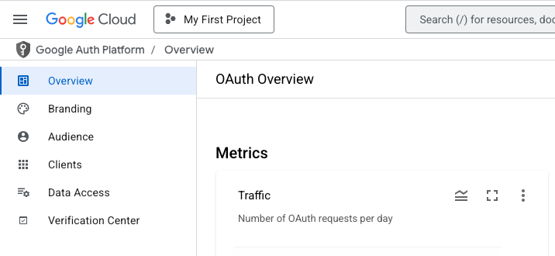

1. Go to Audience. Under Test user click on add user and enter your email.

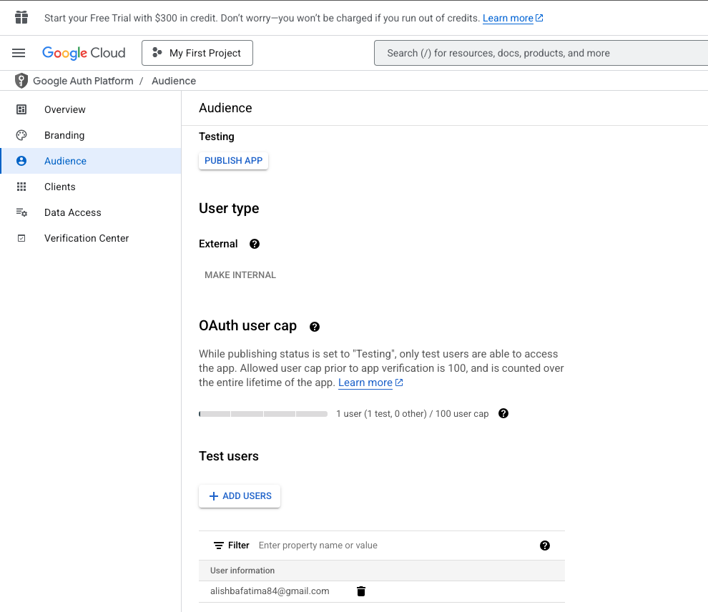

**Step 2: Notion API**

1. Using below link join my notion database named “Project APIMatic”

<https://www.notion.so/invite/fd0435d555f1c046585661617cd937caa0d24264>

1. Follow below link to if you want to setup your personal notion page to get Notion API Key and database ID and update that in code.

<https://developers.notion.com/docs/create-a-notion-integration>

**Step 3: Setup in Visual Studio Code**:

1. Create a folder and download following files.

* **Google with Notion.py**
* **app.py**
* **index.html**

1. Create folder named ‘templates’ and put index.html file inside templates.
2. Place your credentials.json file in the folder.
3. Now Create a virtual environment on visual studio code and install Api

* python3 -m venv my_env
* source my_env/bin/activate
* pip install --upgrade google-api-python-client google-auth-httplib2 google-auth-oauthlib
* pip install flask

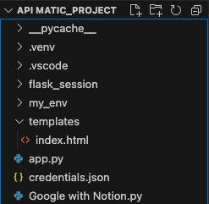

**Step 4: Start**:

1. Run app.py file.
2. In terminal you will see a link like <http://127.x.x.x.5000> . Click that link app will be opened.

1. when you will click start sync it will take you to authentication. Choose and account.

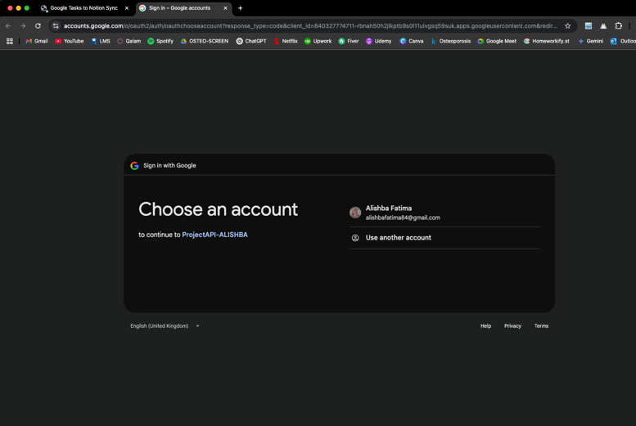

1. Click continue.

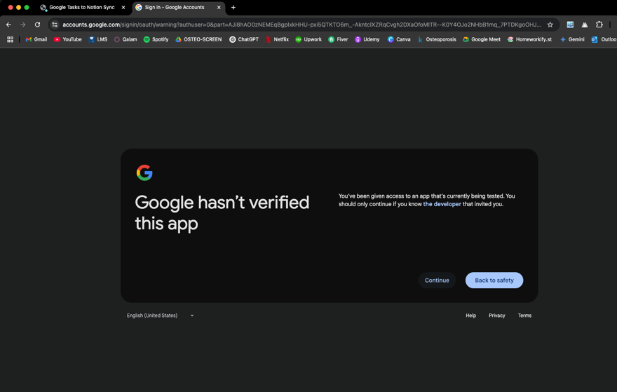

1. Again, click continue.

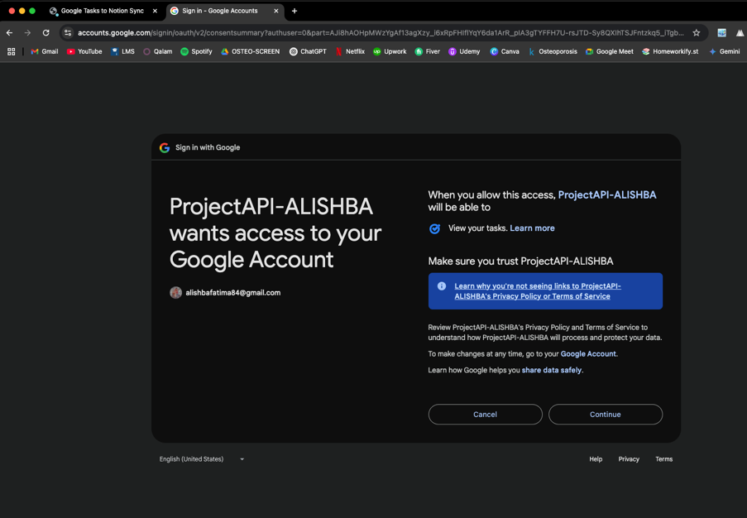

1. Your authentication has completed. You can see token, task_mapping and tasklists_mapping json files are downloaded.

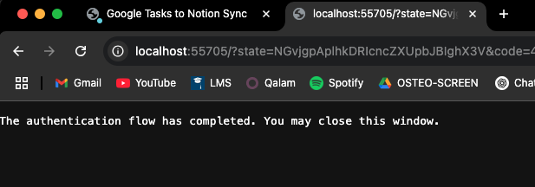 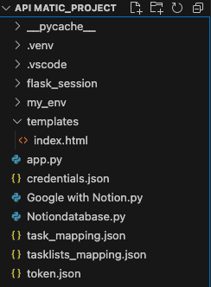

1. Open google task and notion database. Here I have created google task list already.

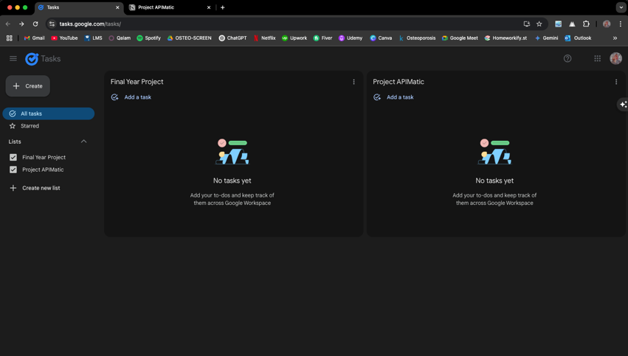

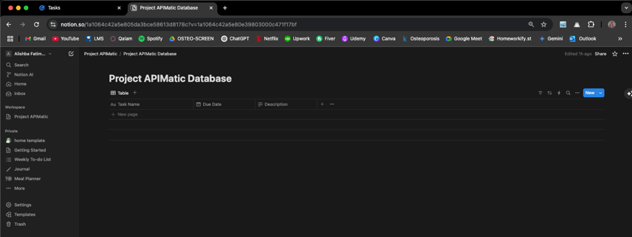

1. Now you can perform following operations.
2. Create a new task on google task, which goes to notion database.
3. Update a task on google task, which updates task in notion database.
4. Delete a task on google task, which archives task in notion database.
5. Delete a task list on google task, which archives task those task in notion database which were present in that specific task list.
6. If you press stop sync button no operation will be performed if you create a task that will not go in notion database when you will start sync button, then it will go to notion database.

**Resources:**

To setup google API (Python). Follow this guide till Install Google client Library

<https://developers.google.com/tasks/quickstart/python>