­­­­­­

**ONLINE EBOOK SYSTEM**

PROJECT GROUP MEMBERS

|  |  |
| --- | --- |
| STUDENT ID | STUDENT NAME |
| Student1419861 | Alishba Hashmi |
| Student1421223 | Rabia Kanwal |
| Student1419864 | Talha Shehzore Khan |

**CURRICULUM : 7602 BATCH : 2210B3**

**FACULTY : EBAD-UDDIN-AHMED**

**CO-ORDINATOR : MISS MUNAZZAH**

**User Registeration:**

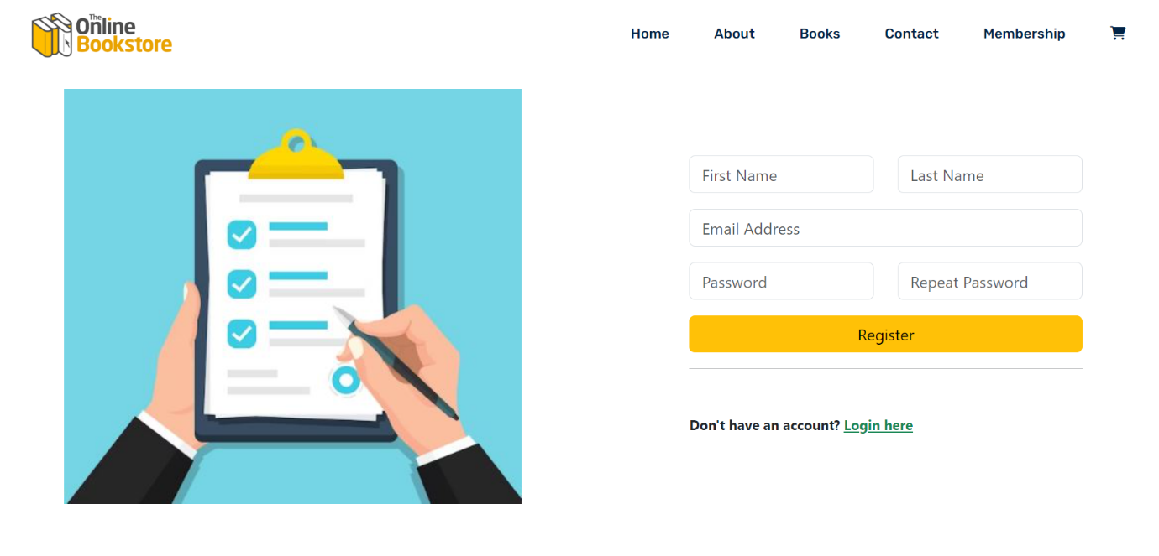

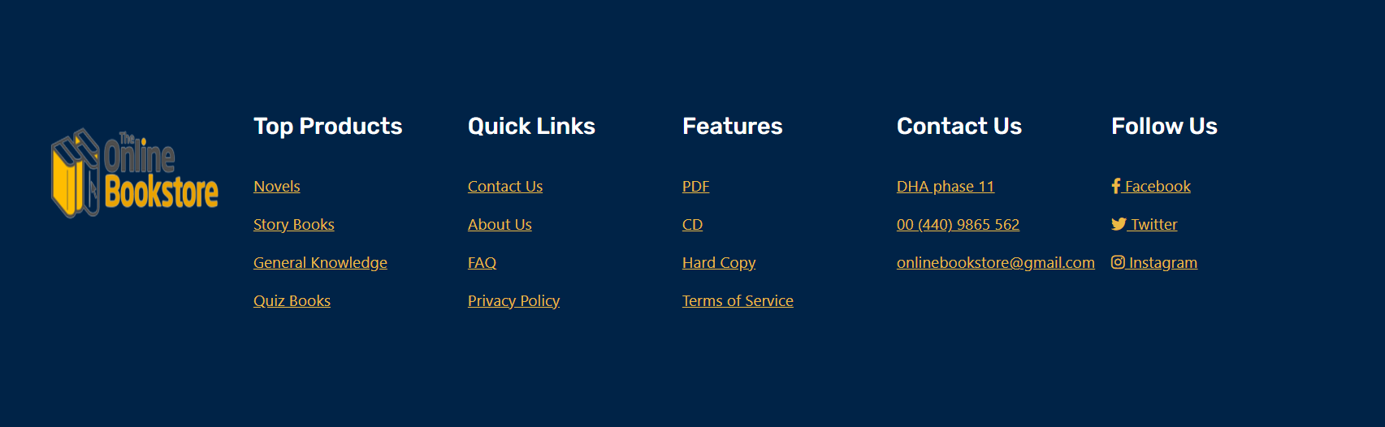

**LOGIN user :**

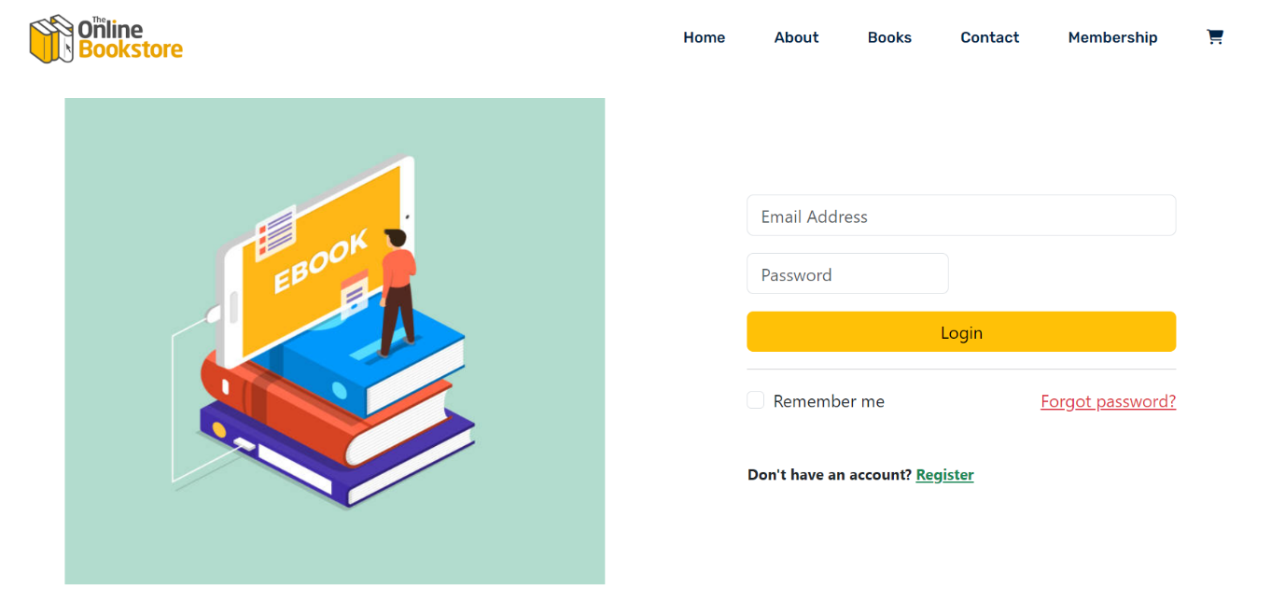



**MEMBERSHIP REGISTERATION**

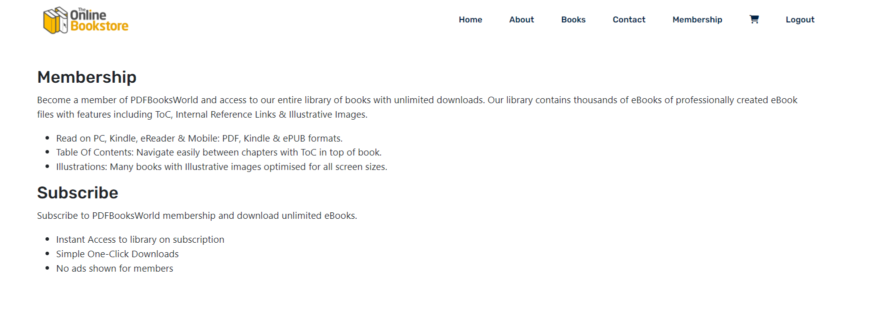

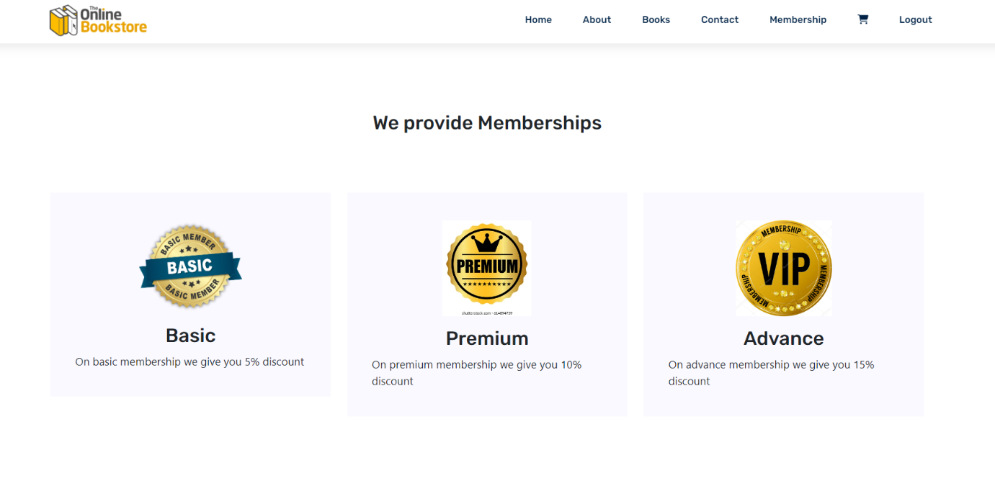

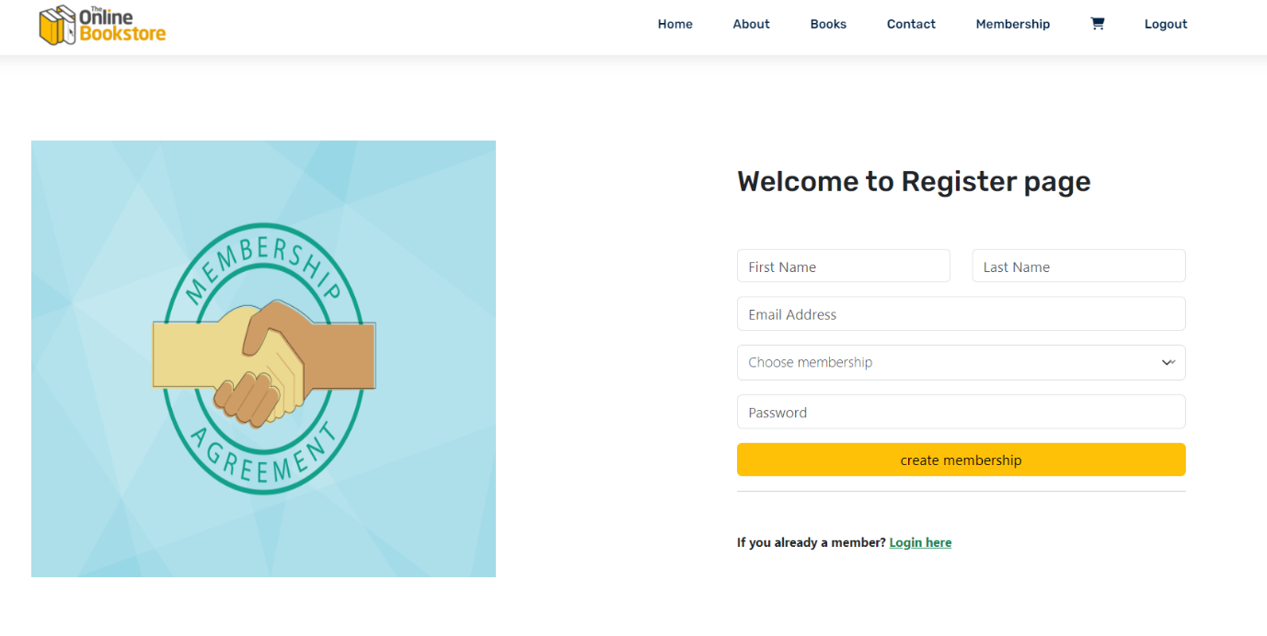



**MEMBERSHIP LOGIN**





**Essay competition**

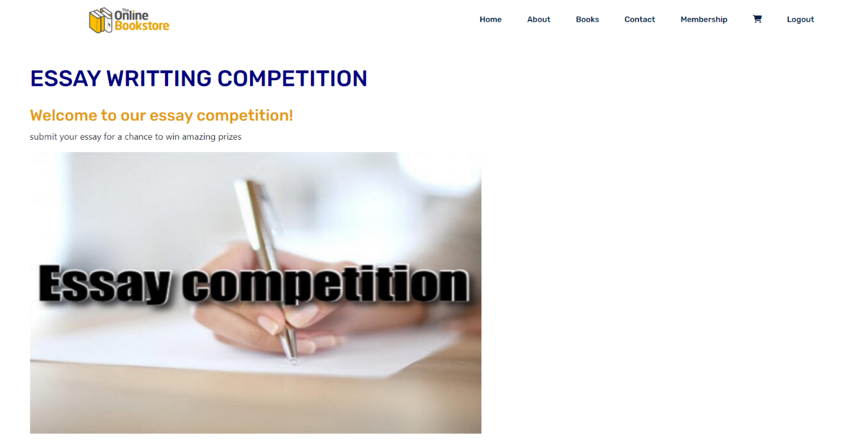

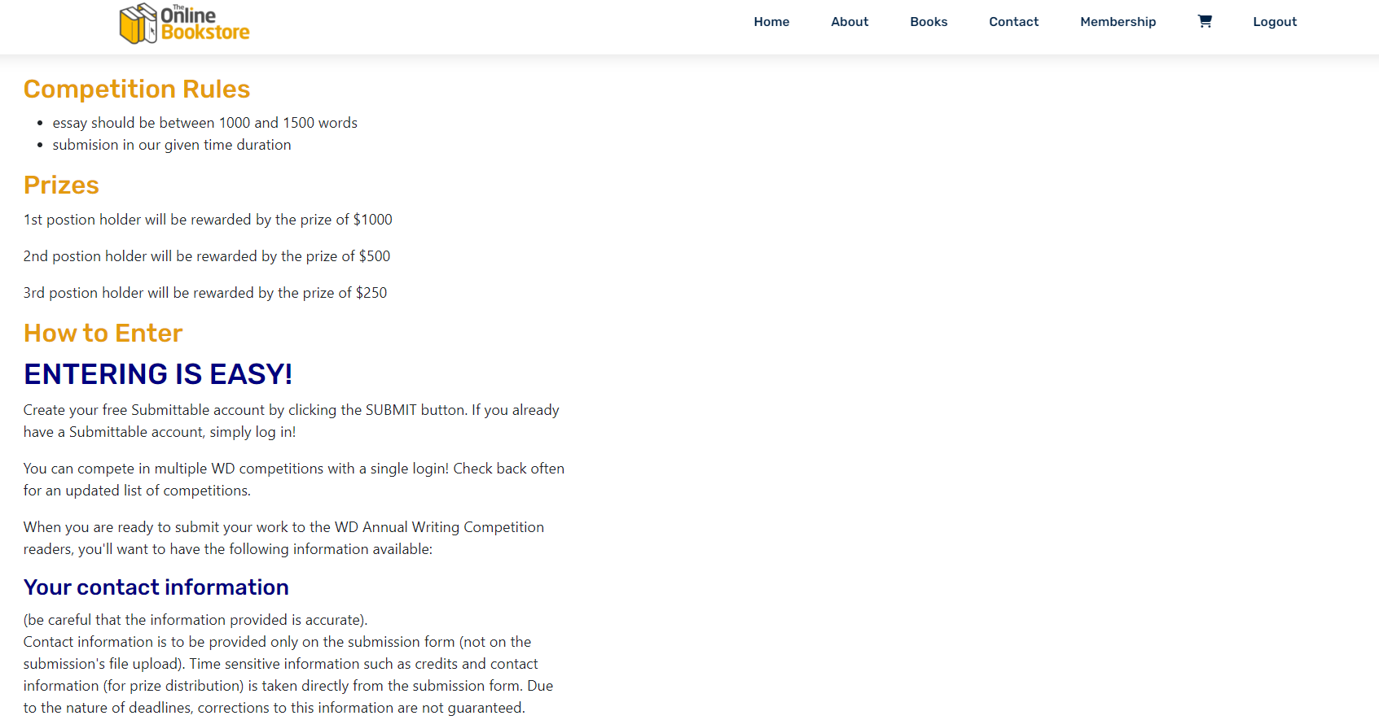

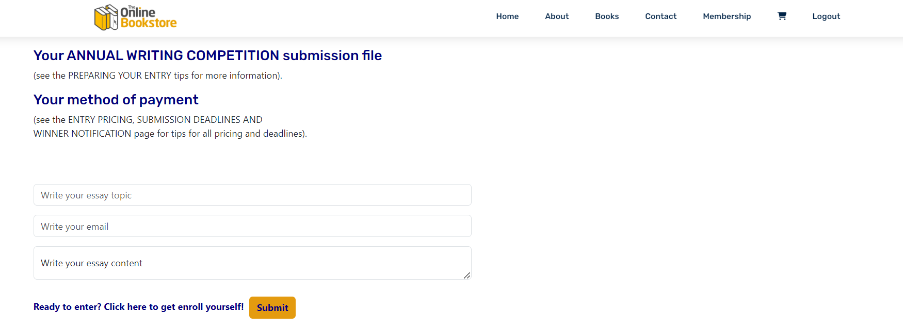



**story competition**



