**Data Mining & Warehousing**

**BCS-7B**

**Project – 1**

**Team Members**

**21F-9222 Alishba Nazir**

**21F-9179 Sidra Malik**

**21F-9219 Usman Aziz**

**Task – 1**

**Using Julius**

1. Uploading files in julias:

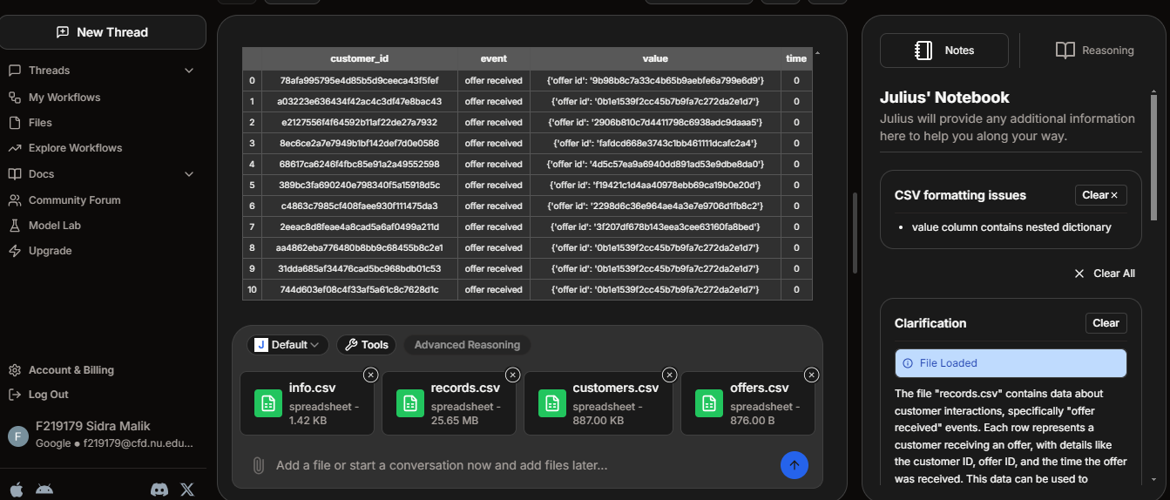

1. Identifying data quality issues and cleaning data:

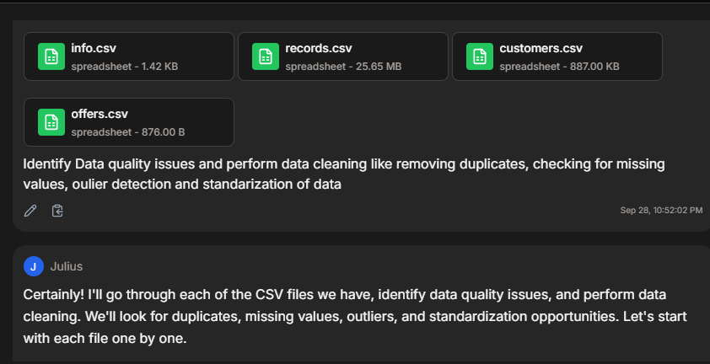

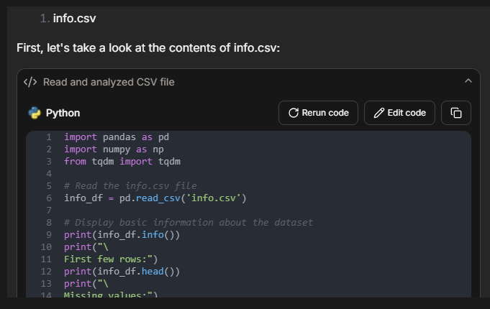

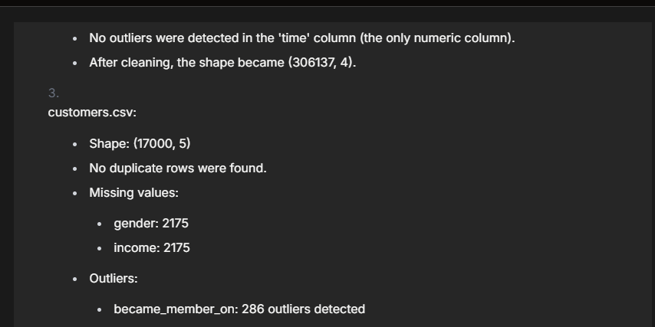

2- Descriptive statistics performed on relevant data of cleaned data:

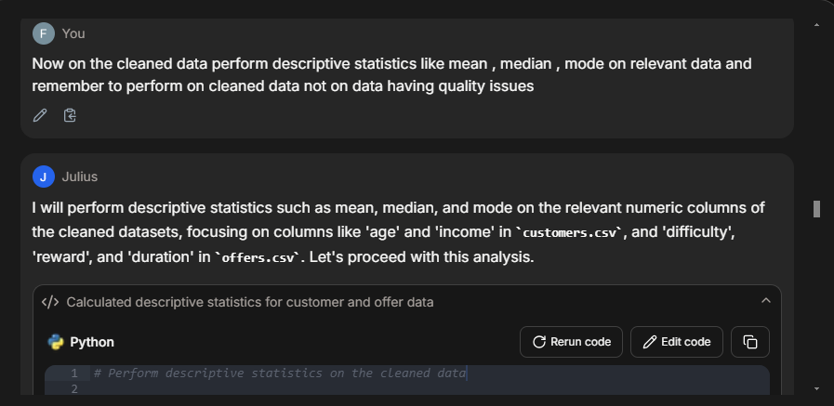

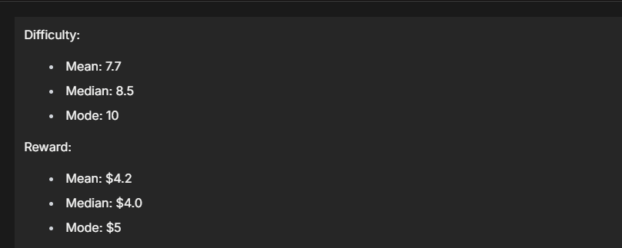

1. Visualization:

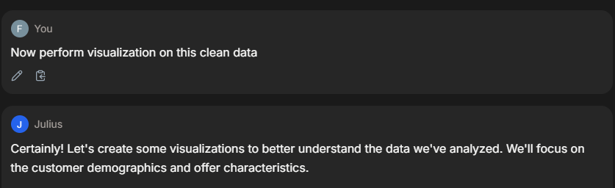

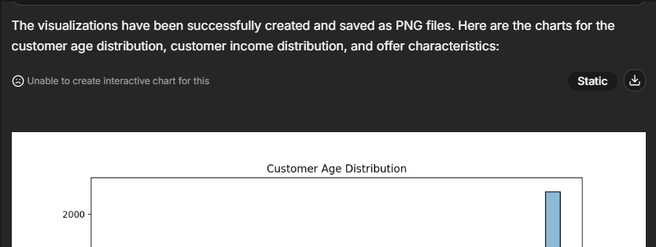

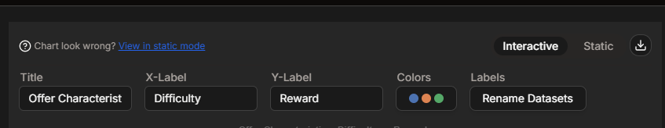

These visualizations provide insights into the distribution of customer ages and incomes, as well as the relationship between offer difficulty, reward, and duration.

**Task – 2**

**Using Chat-GPT**

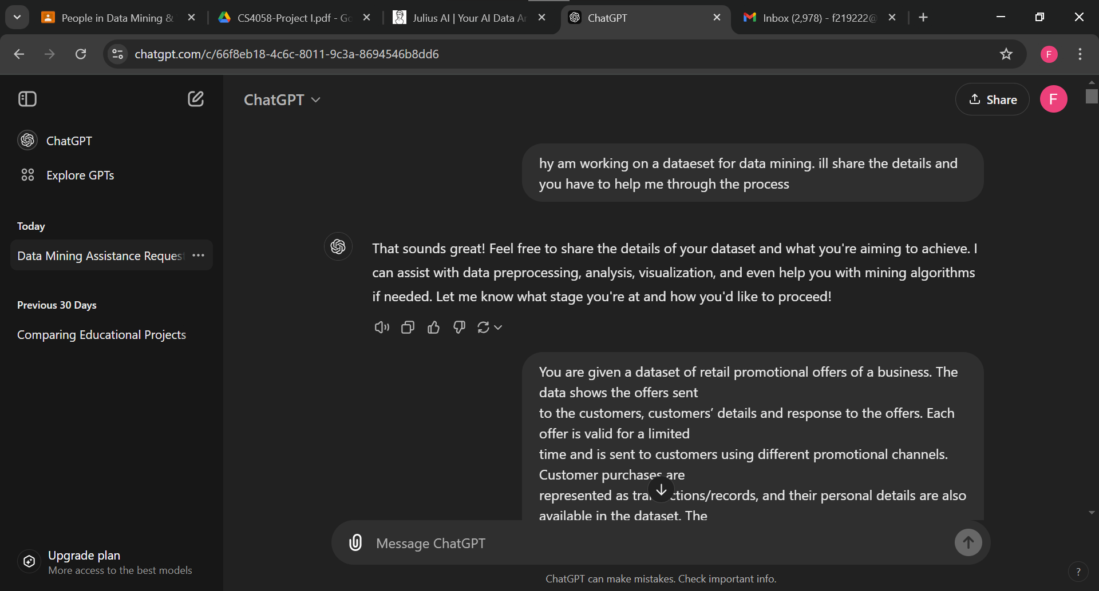

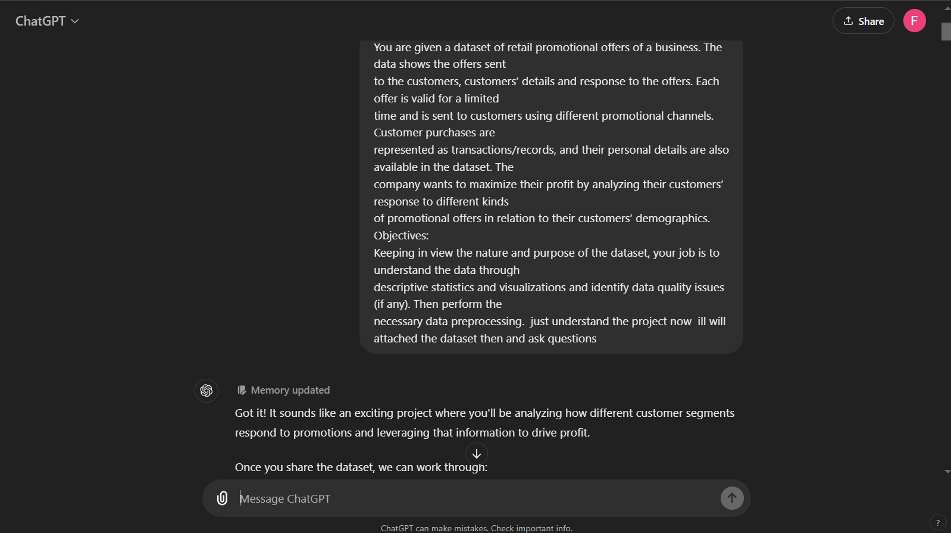

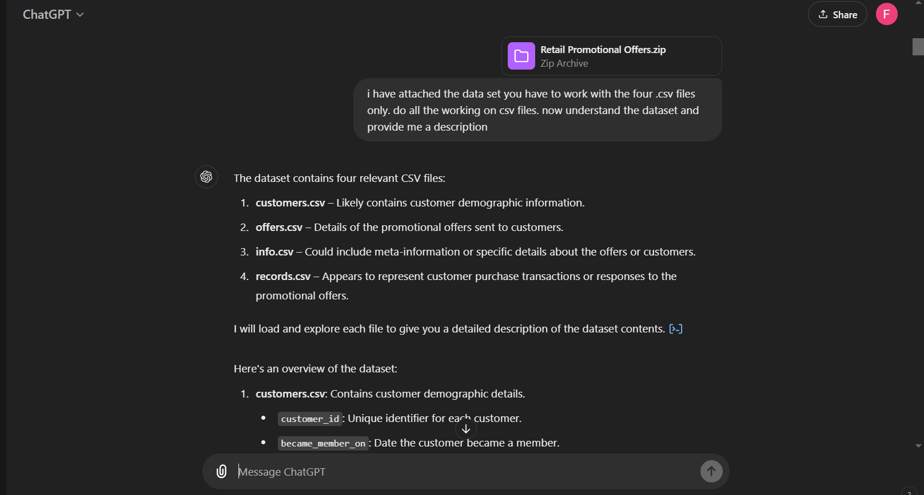

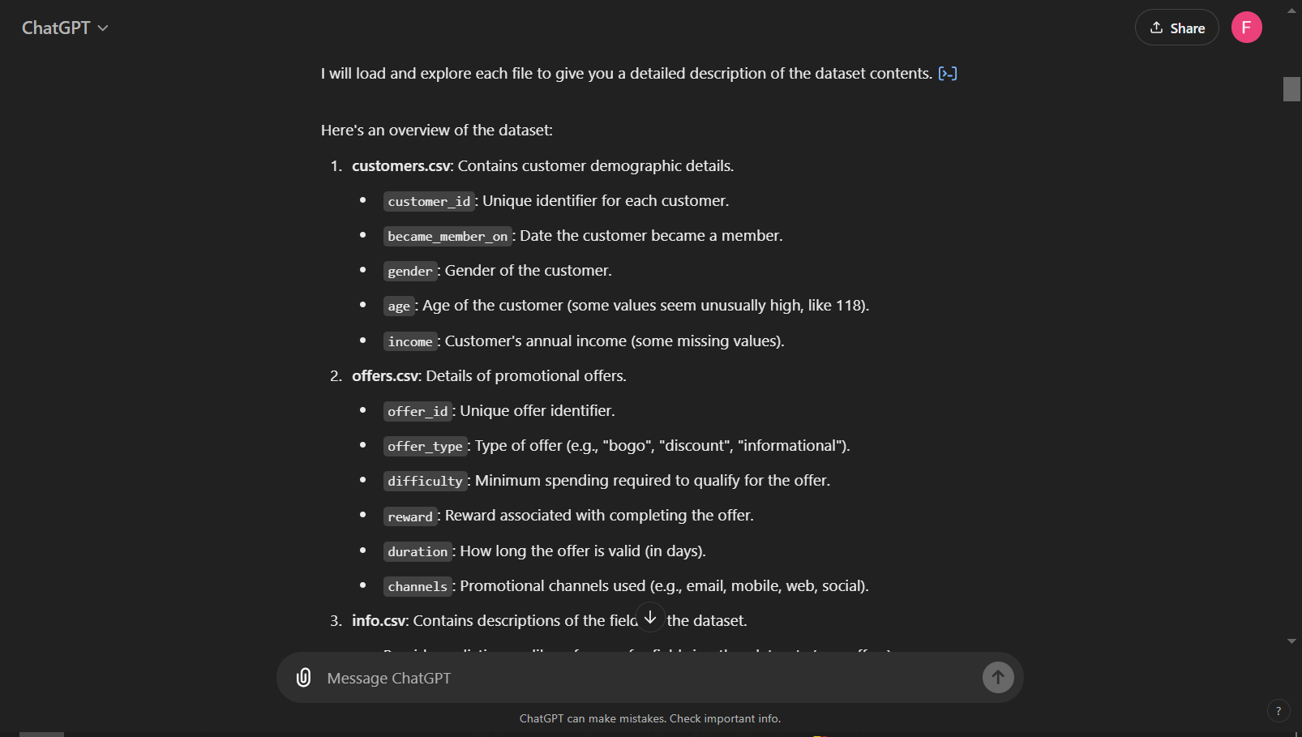

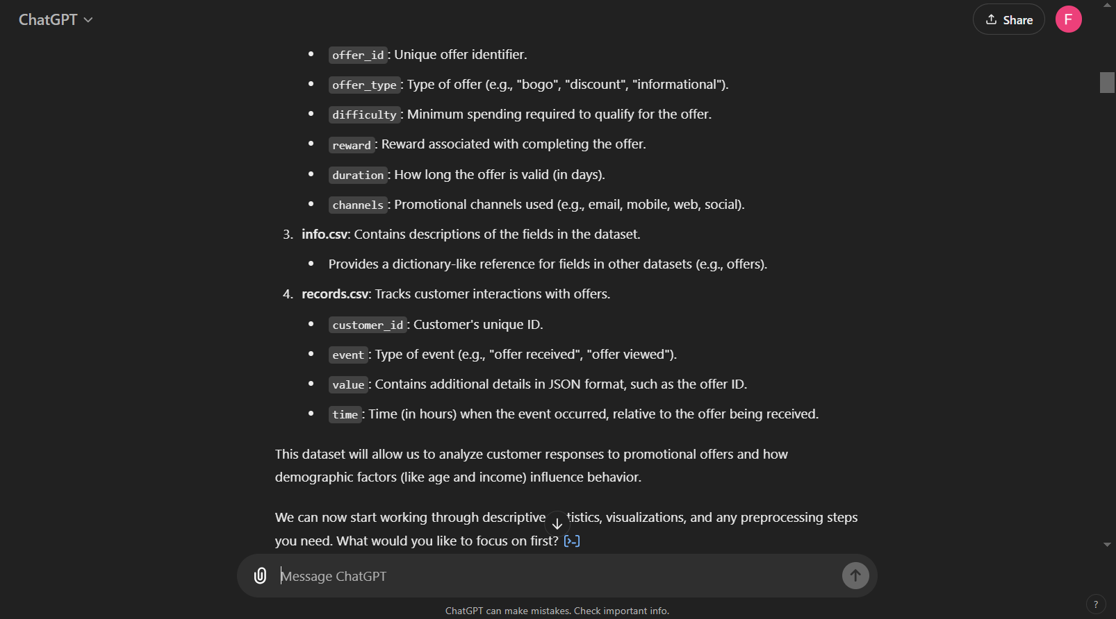

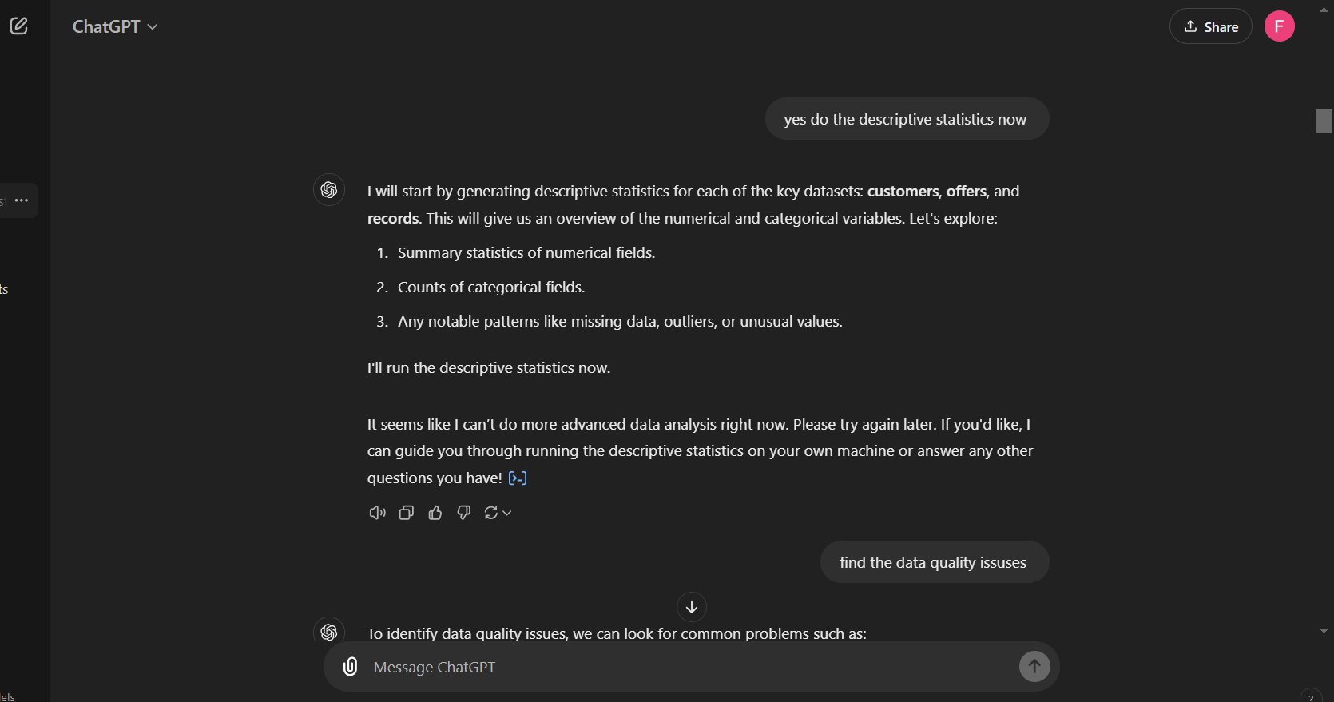

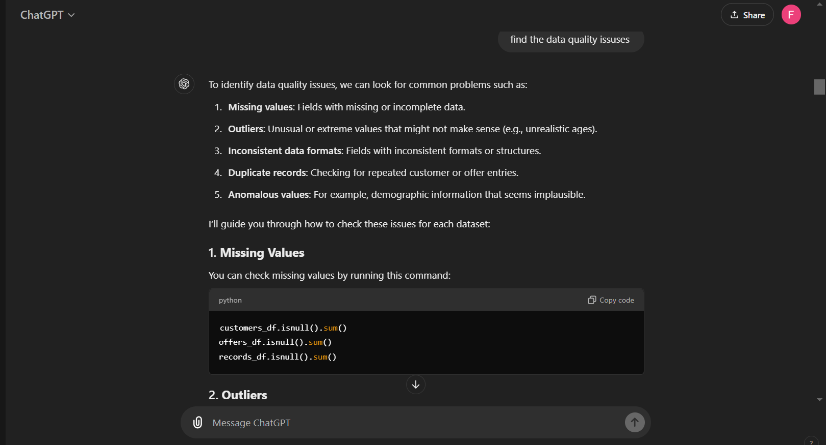

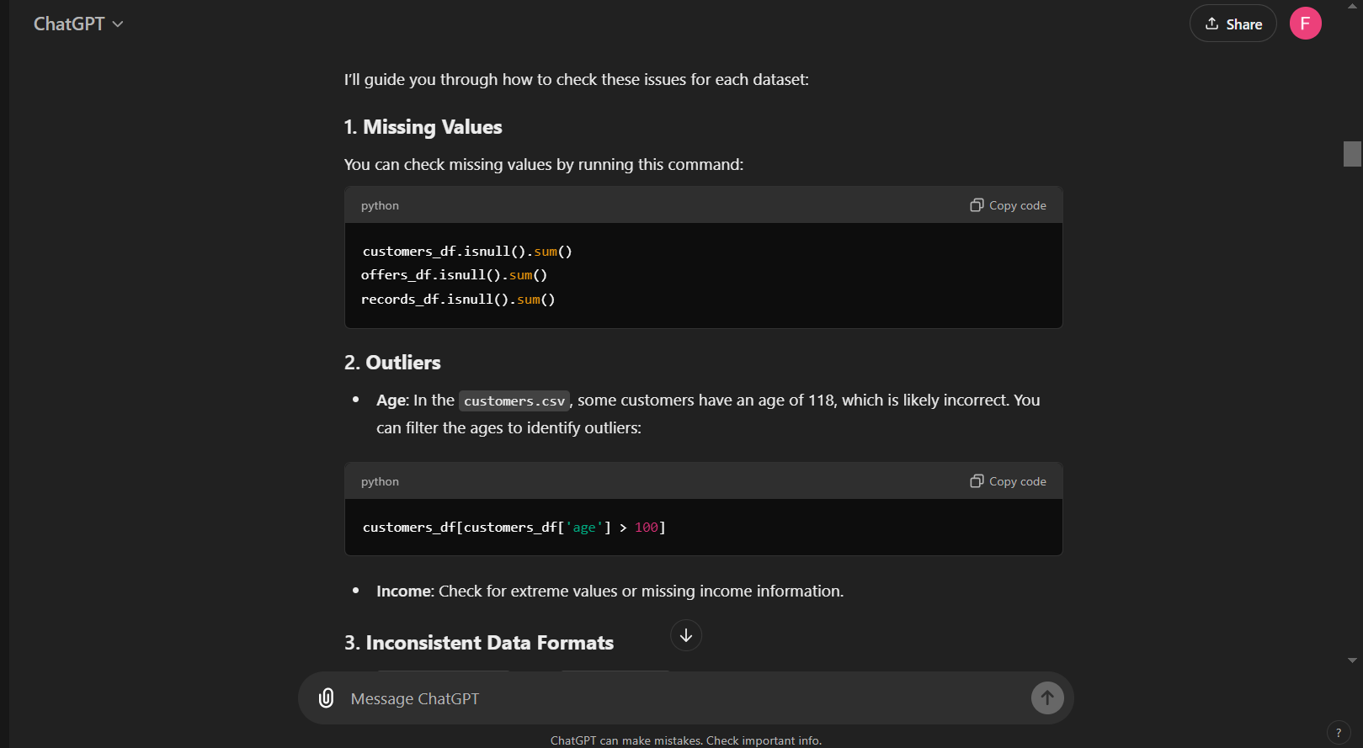

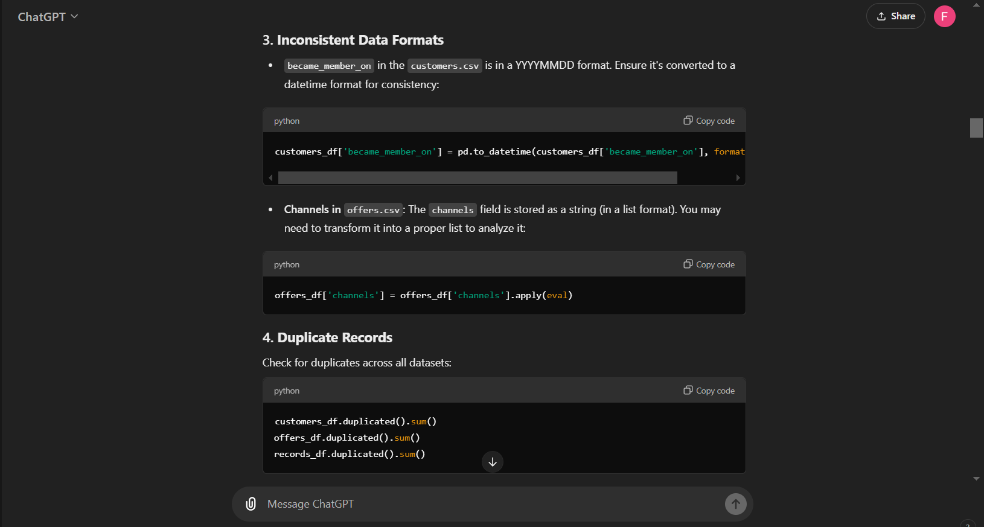

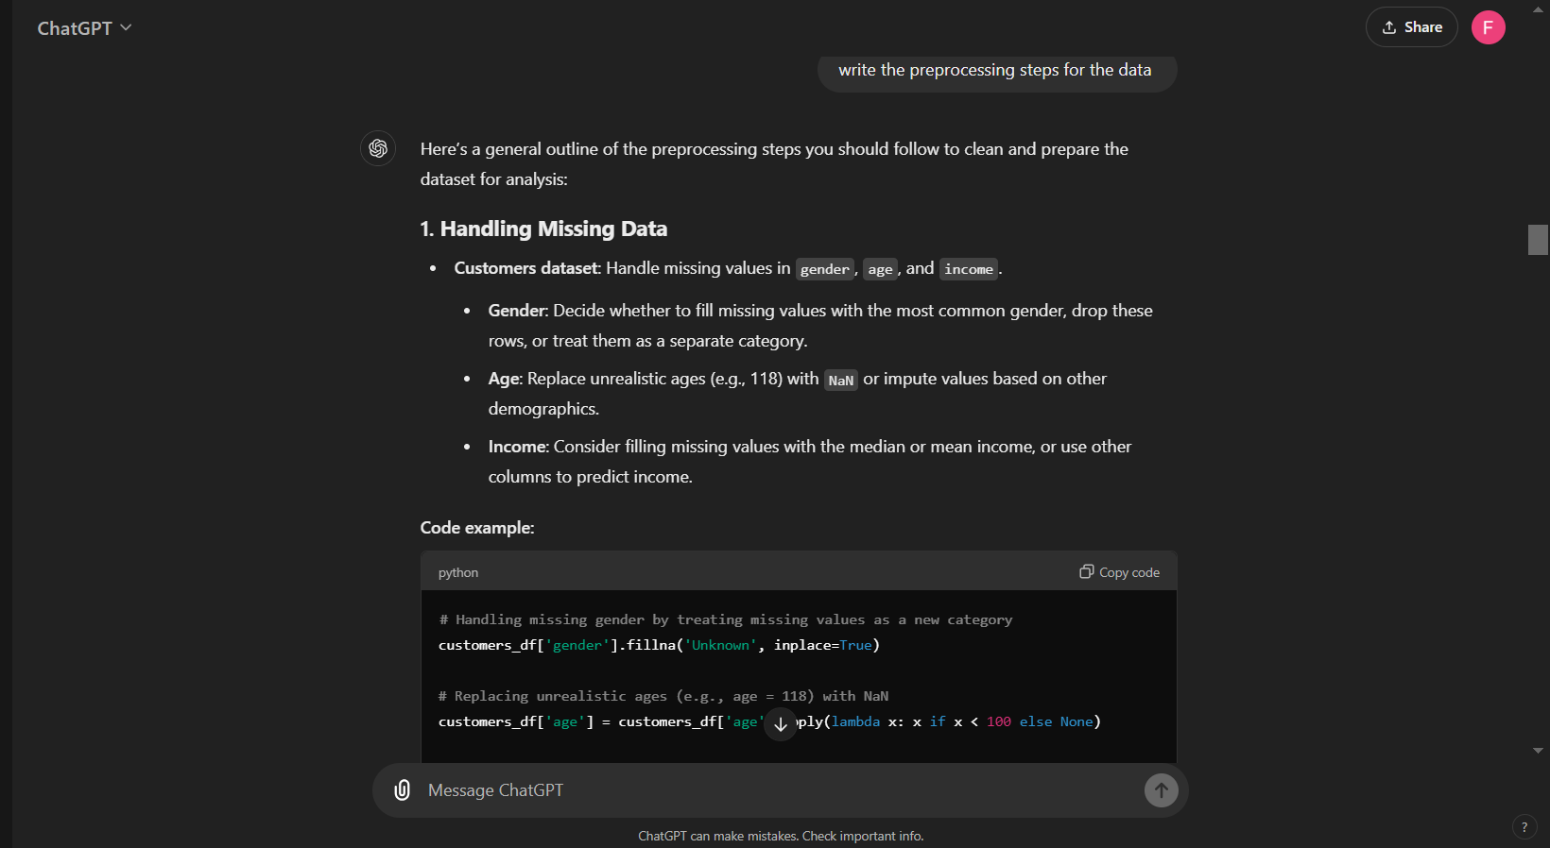

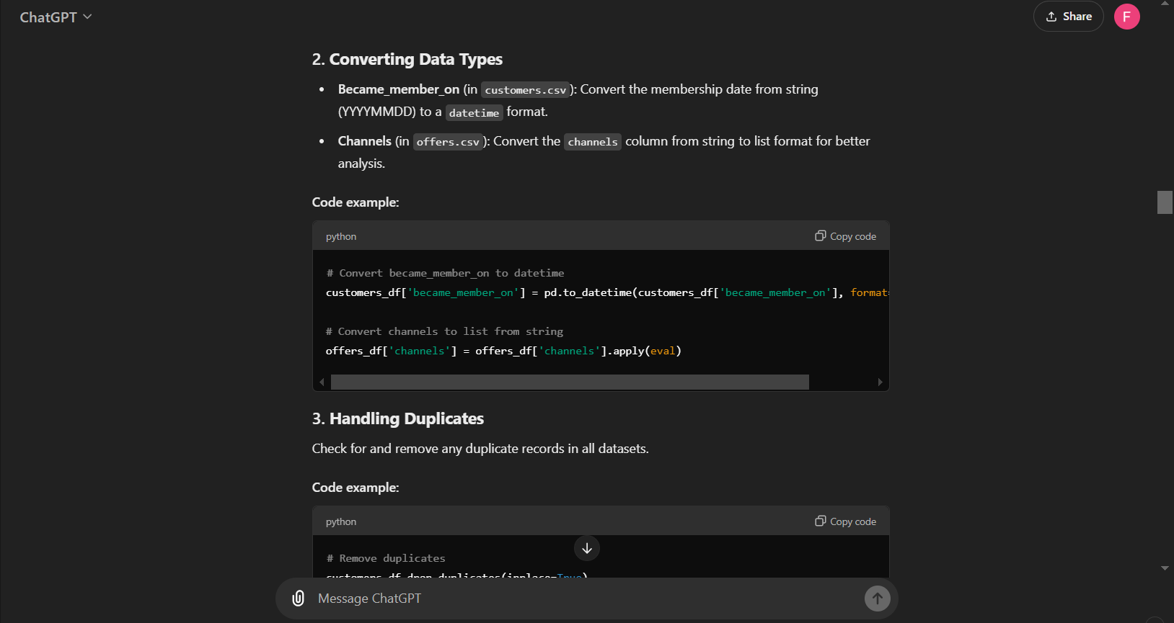

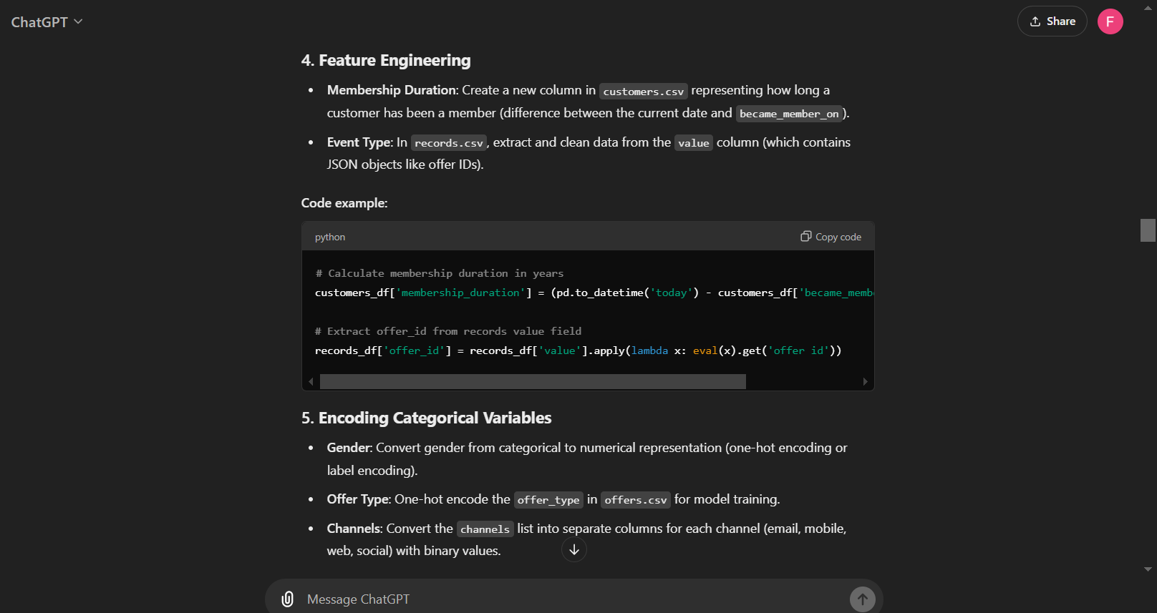

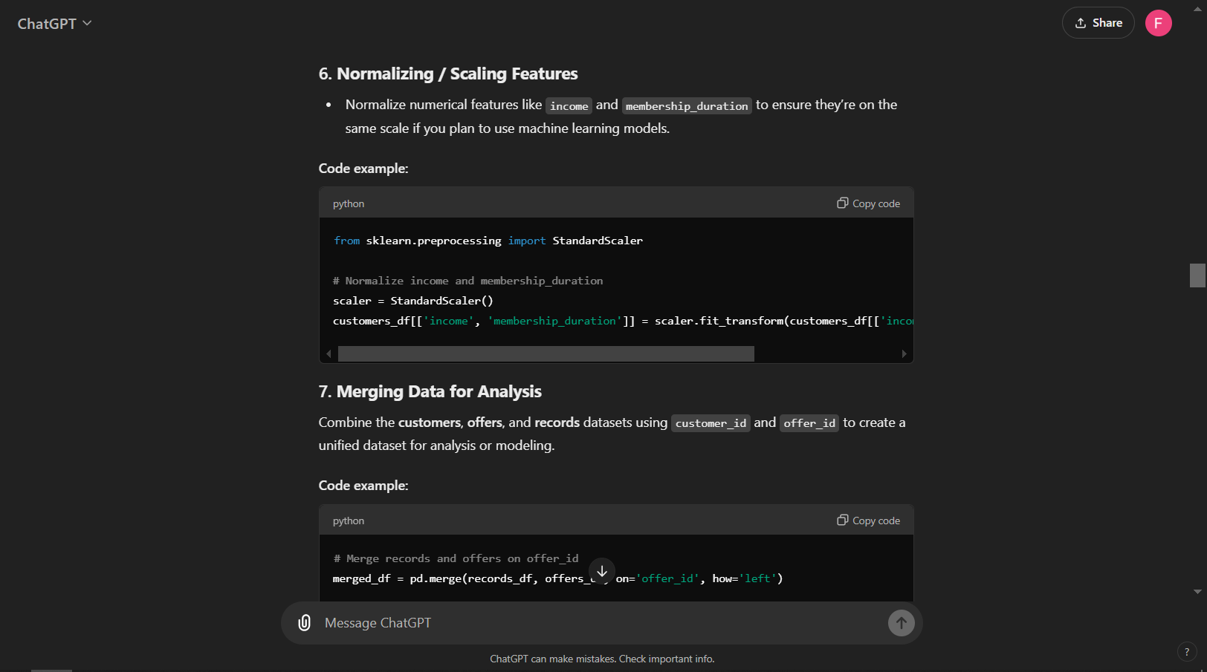

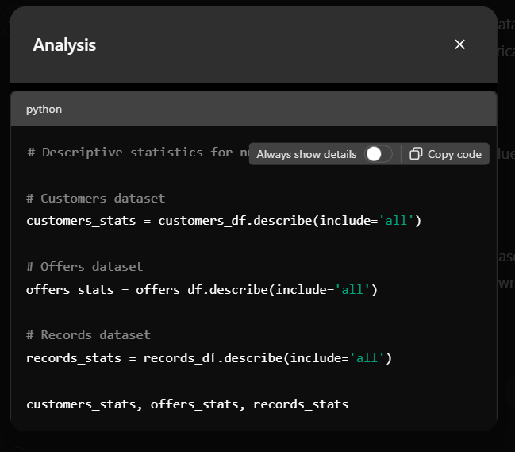

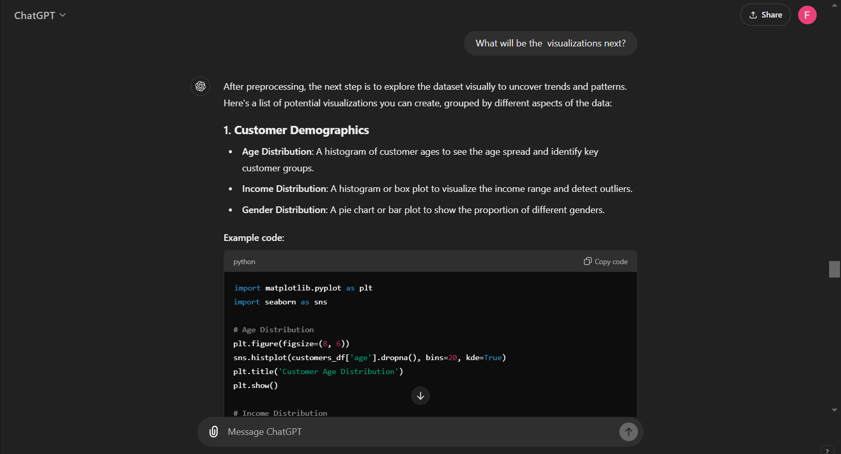

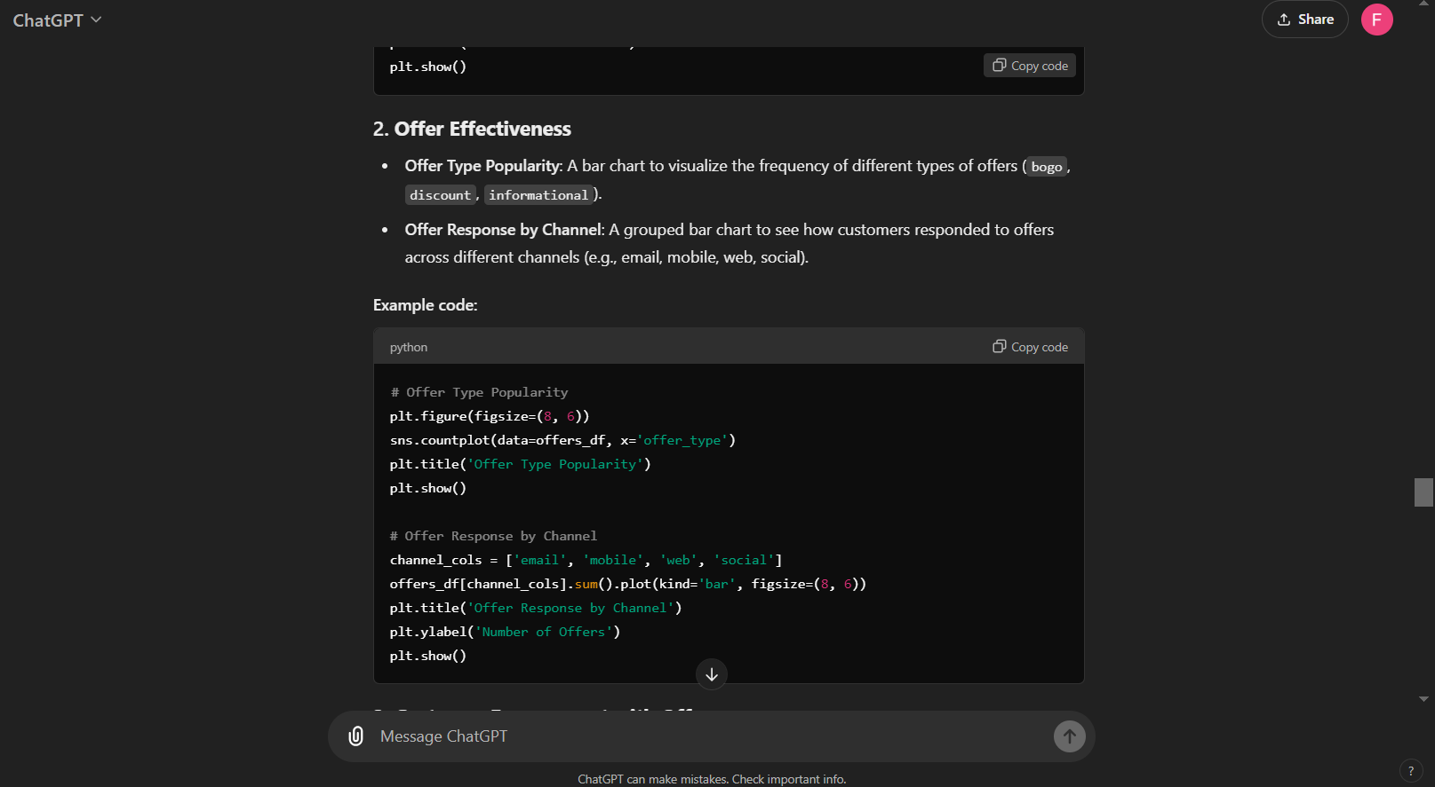

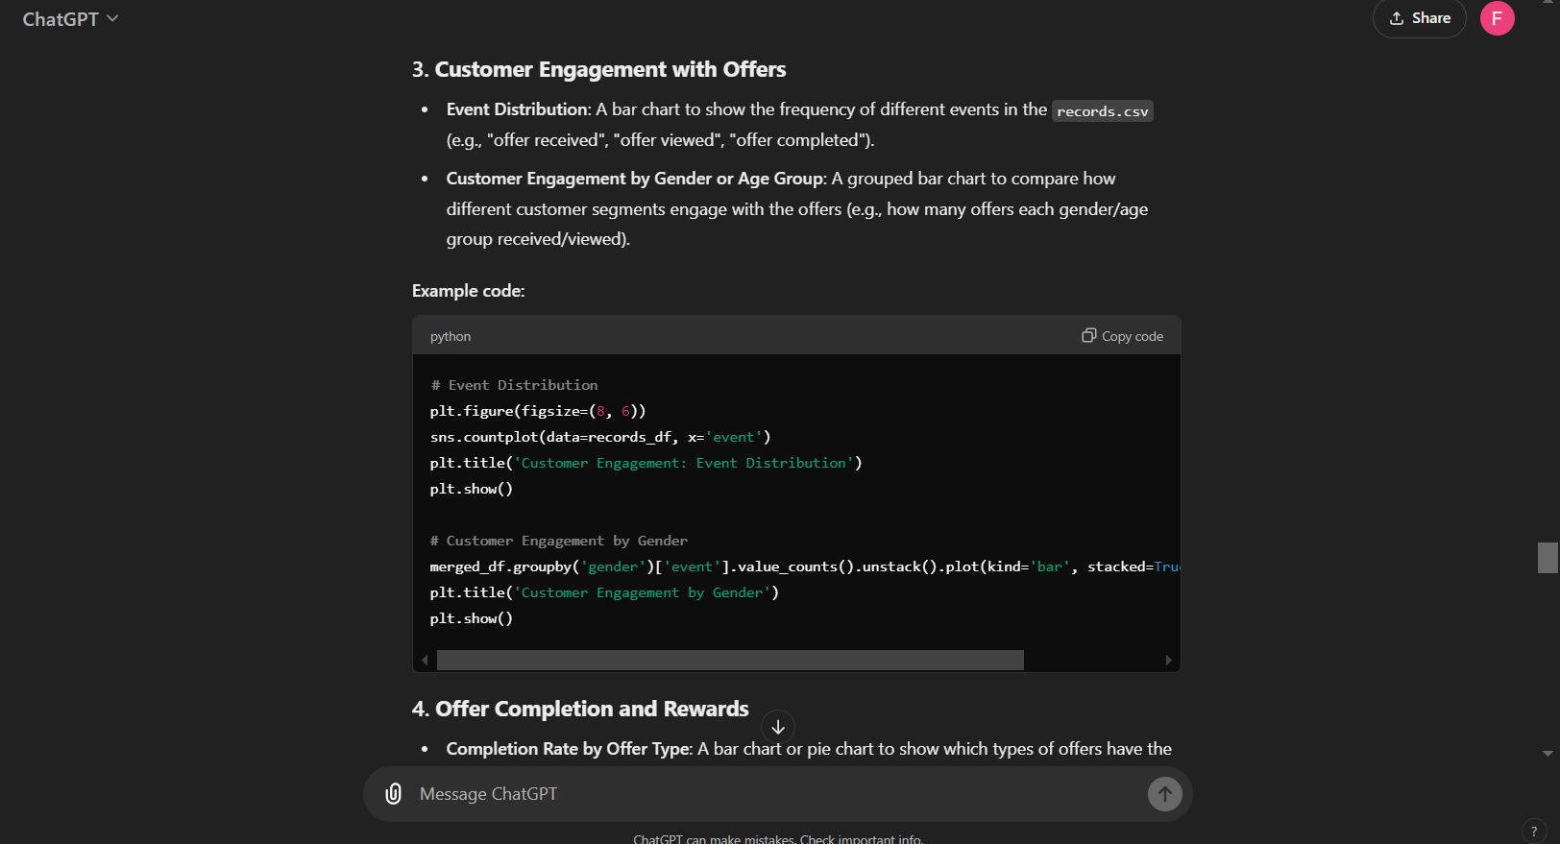

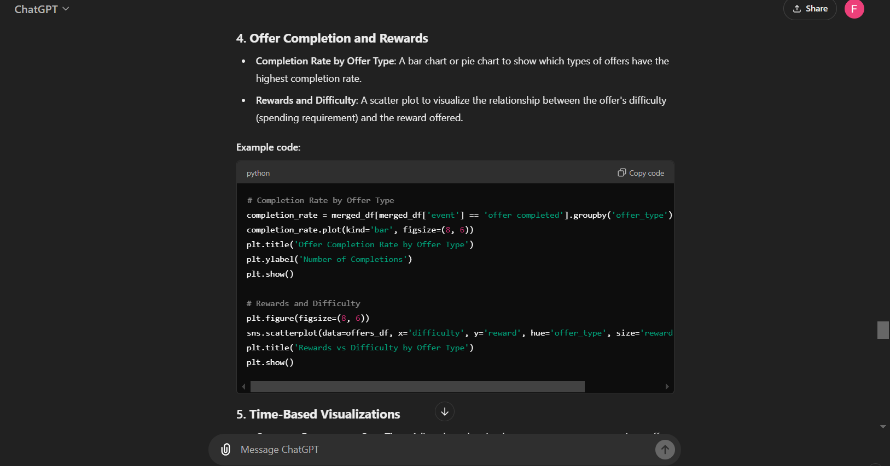

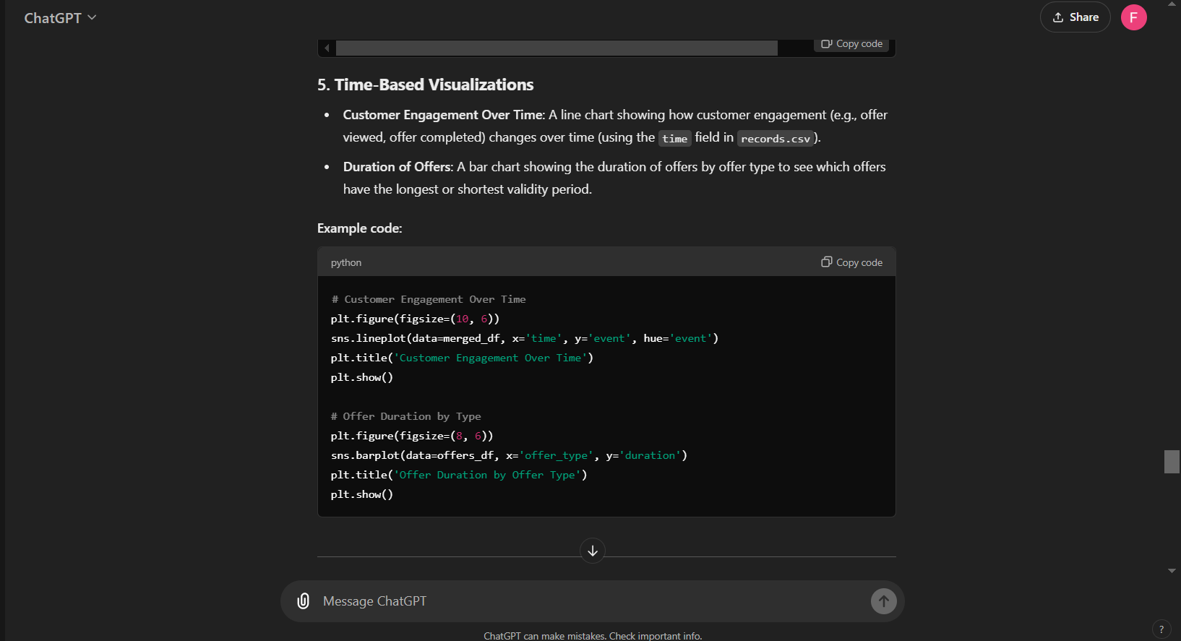

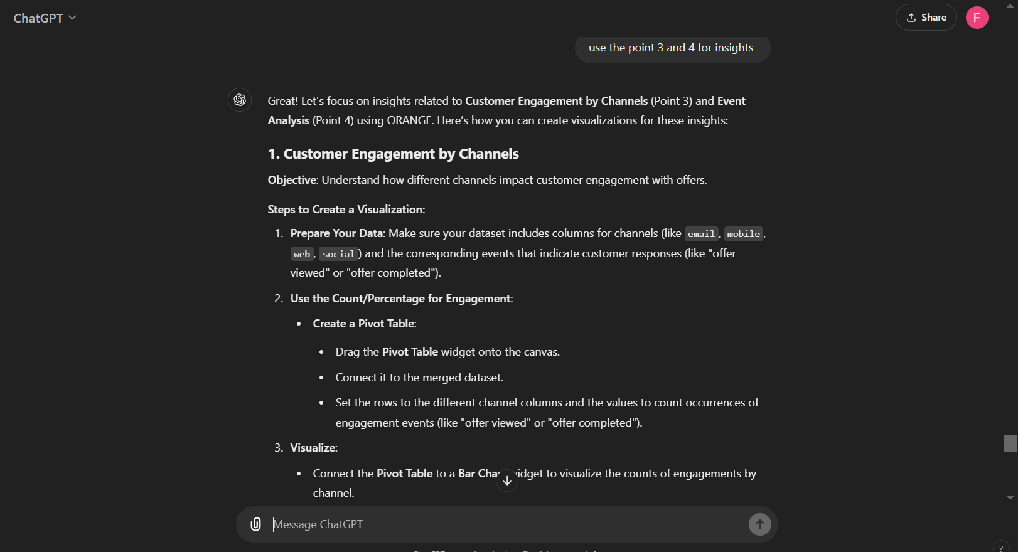

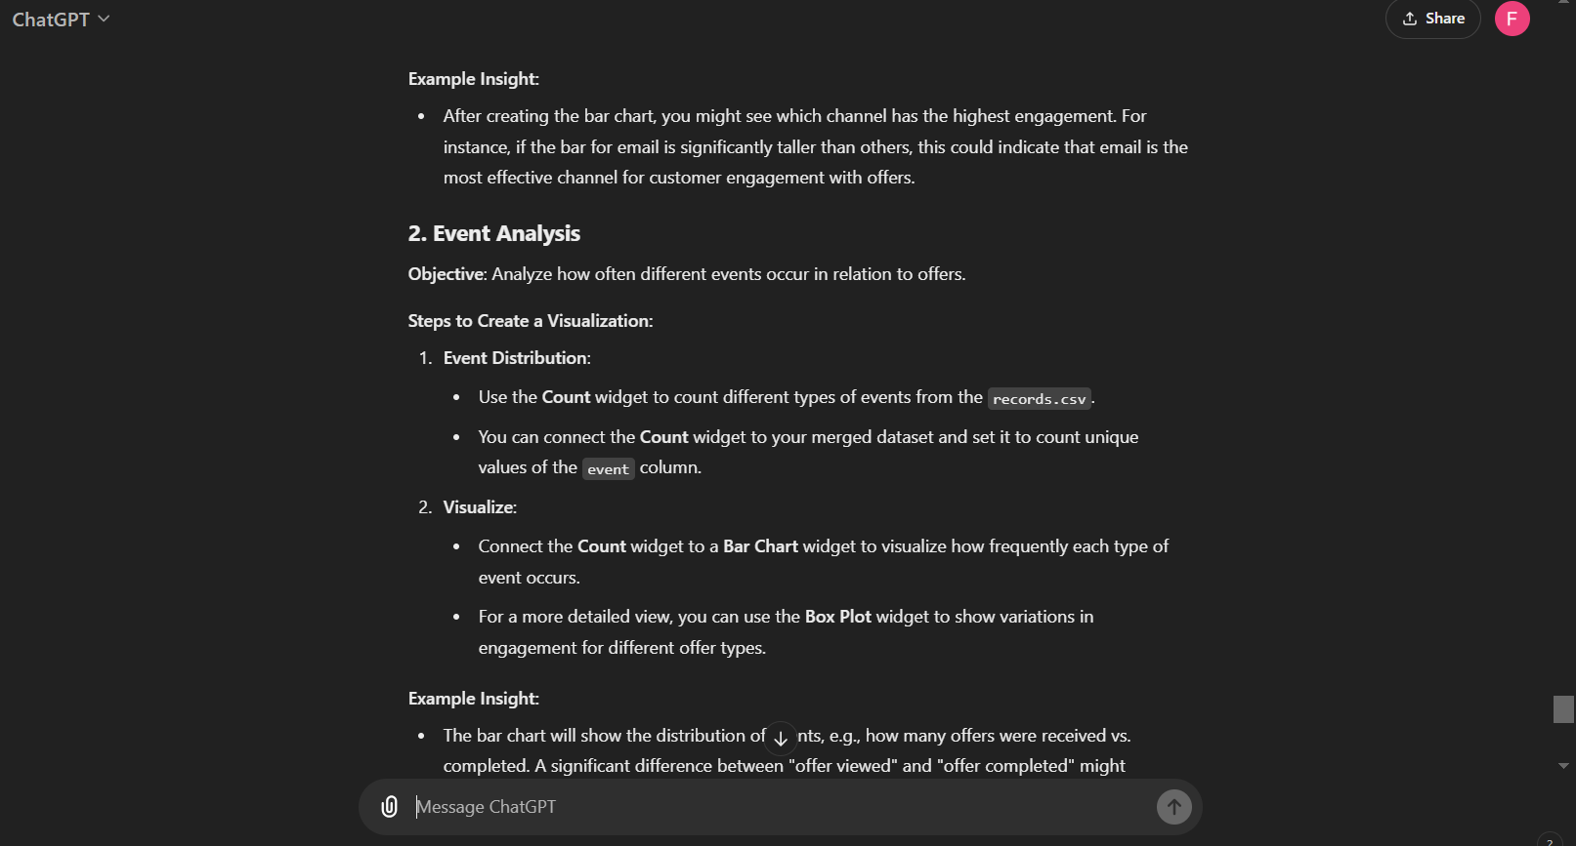

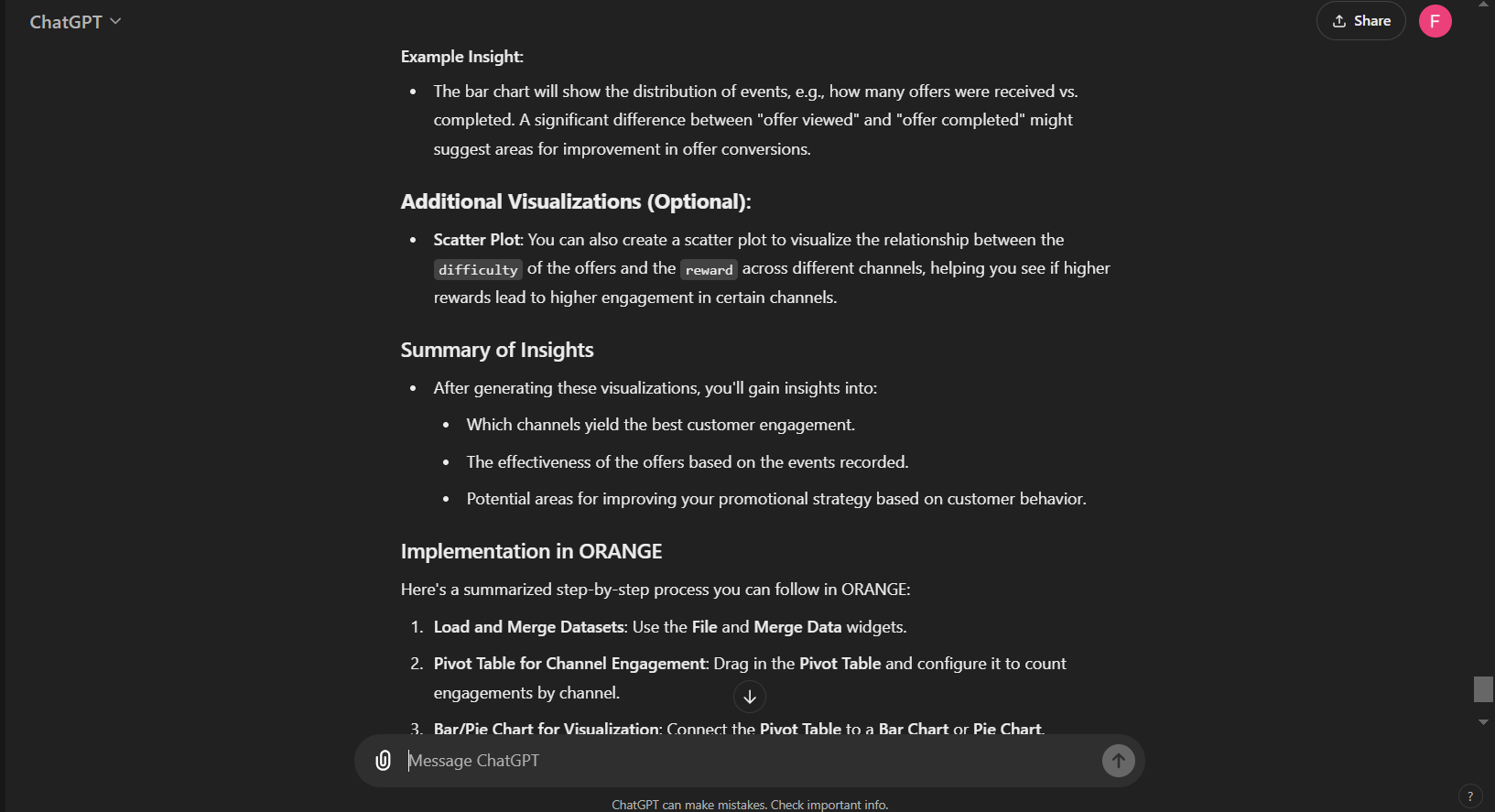

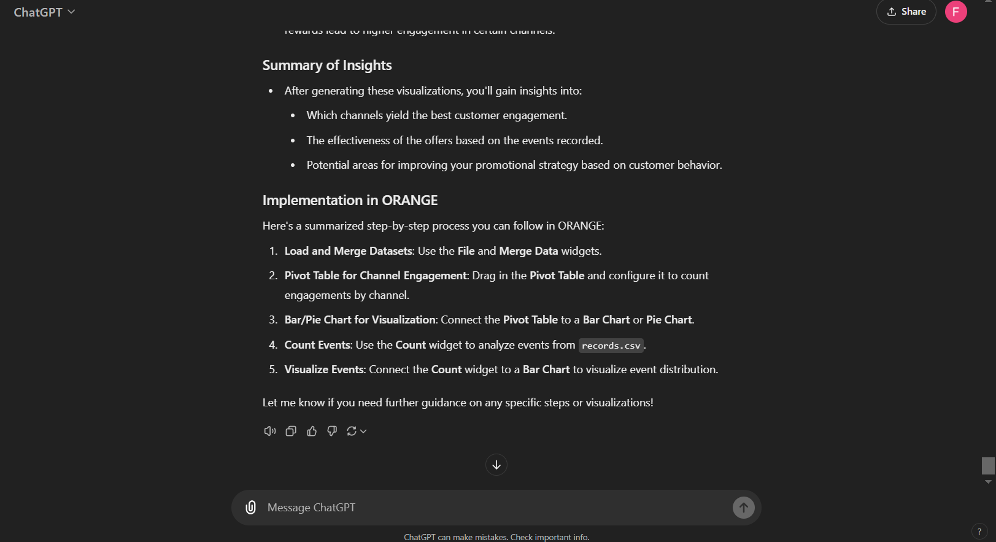

Complete Transcript:

<https://chatgpt.com/share/66f8f520-1f14-8011-9c75-32897e7aff69>

**Task – 3**

**Using Orange Tool**

