**ChatGPT is friend or foe?**

**INTRODUCTION**

A chatbot, or conversational application, is described as one that facilitates customer service, engagement, and support via the use of artificial intelligence (AI) and other automation technologies that may converse with end-users through chat in place of or in addition to human support agents**.** Chatbots are computer programmes that mimic and analyse human conversation (either verbal or written) in order to make electronic gadgets seem more human. There is a wide spectrum of chatbots, from simple programmes that only answer in a single instance to complex virtual assistants that may grow and evolve as they gather and analyse data in order to enable unprecedented degrees of customization. In the 1960s, MIT professor Joseph Weizenbaum created the first chatbot. They coined the name "ELIZA" for it. More information on ELIZA and other well-known chatbots created in the latter half of the twentieth century will be provided later on in this text.

**A short chatbot timeline, from ELIZA to ChatGPT**

**ELIZA 1966**

The first chatbot was ELIZA. Joseph Weizenbaum designed it in 1966 to simulate speech using pattern matching and replacement. The software was developed to seem natural when conversing with a person. The words typed into the chatbot ELIZA were sent to a computer and matched with preprogrammed answers. A psychotherapist-like script was used. Copies and versions of the script protruded at schools all around the nation, demonstrating its far-reaching effect on NLP and AI.

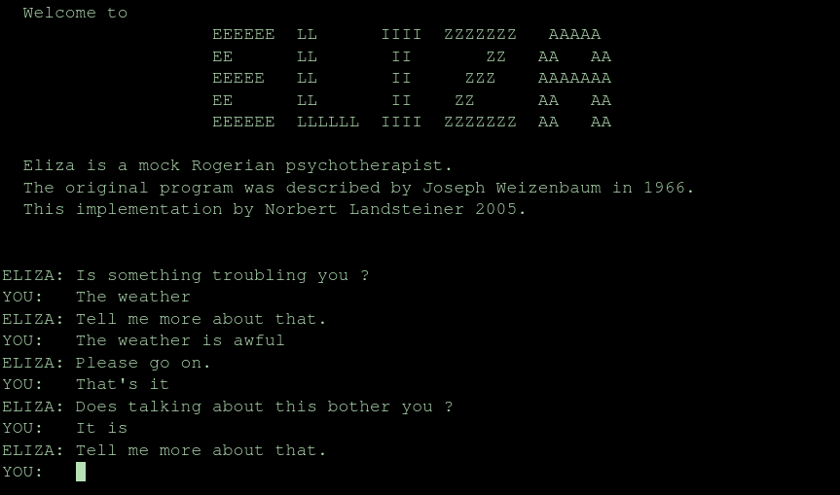

Chatbot producers have improved Weizenbaum's approach to mimic human interactions in the decades afterwards. Passing the Turing test, which pits new computers' conversational skills against human judges, has become a goal. The Turing test's open-endedness is the hardest part.

**PARRY 1988**

In the 1980s, British designer Rollo Carpenter invented Jabberwacky, a chatterbot that was distinct from its conventional forebears. Jabberwacky has spawned more innovations in technology. Since its inception, the website has been used by certain people doing academic research.

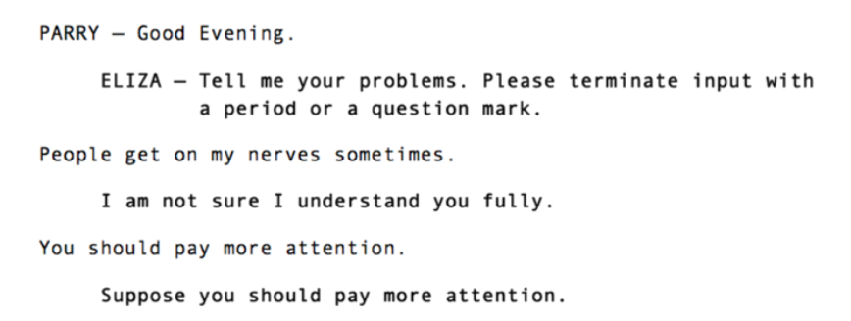

The chatbot is said to use a kind of artificial intelligence known as "contextual pattern matching."

**Dr. Sbaitso 1992**

In 1992, Creative Labs produced a chatbot called Dr. Sbaitso for Microsoft Windows DOS. It is notable for being one of the first voice-operated chat programmes and for being an early attempt at combining artificial intelligence into a chatbot.

The software would have therapeutic conversations with the user. Rather of engaging in a nuanced conversation, it mostly asked, "Why do you feel that way?"

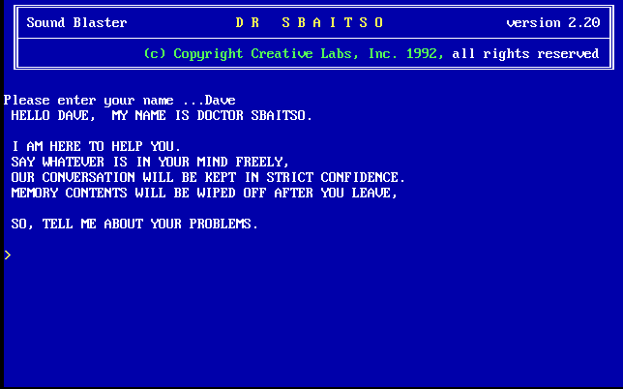

**A.L.I.C.E. (Artificial Linguistic Internet Computer Entity) 2001**

When it came to natural-language processing, ALICE was much superior than her predecessor, ELIZA. In 1995, Richard Wallace came up with it. Even though ALICE failed to pass the Turing test, its improved conversational abilities marked a significant step forward. In 1995, Wallace and 500 foreign programmers got to work on Alice. Three of this year's Loebner Awards went to chatbots. Apparently, Spike Jonze's "Her," a science fiction film, was inspired by Alice.



**SmarterChild**

ActiveBuddy released SMARTERCHILD in 2001 after developing it in 2000. Distributed mostly via short message service (SMS) systems. It was a forerunner to voice assistants like Siri by Apple and S Voice by Samsung.

**Siri**

Apple created Siri in 2010 for iOS; it is a smart assistant as well as a navigator with a natural language user interface. It paved the way for future AI apps and personal assistants. SIRI, introduced in 2010 for Apple products, is a voice-activated virtual assistant. She would be treated as a buddy who assists you in getting things done. Siri is a game-changer for chatbots. She can carry out a broad variety of user tasks, including as making calls, creating reminders and appointments, adjusting the device's settings, doing web searches, travelling to new locations, providing entertainment, and interacting with applications built specifically for iOS.

**Google Now/Google Assistant**

In 2012, Google debuted Google Now with Google Inch. In response to queries, it sends requests to a collection of online services and returns results or suggestions. Google Now's original purpose was to provide timely and relevant information depending on the user's location and schedule. Over time, it became even more intricate and involved, with a wide variety of information types presented via cards.

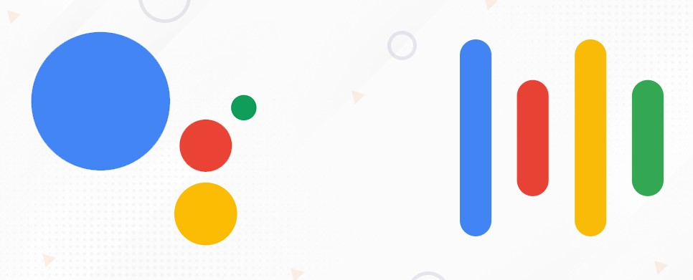

In 2017, Google Now was discontinued and replaced with Google Assistant. The assistant is now integrated into Google's more robust plan for expanding its search offerings. The concept is straightforward: Google hopes to preemptively meet your information needs by presenting relevant content in an approachable style.

**Cortana**

At Microsoft's Build 2014 developer conference, Cortana was initially shown off, and since then, it has become an integral part of Windows 10 on both phones and computers. This program is able to recognise human speech and act upon it by using appropriate algorithms.

**Alexa**

Amazon's ALEXA is a voice-activated digital assistant released in 2014. Playing music, setting alarms, listening to podcasts or audiobooks, and much more can all be done with only your voice. Alexa may act as a home automation system, allowing you to manage several smart devices with a single interface. She is able to hear, decode, and act on speech instructions thanks to an NLP system.



A simple command like "Alexa, play some music" or "Alexa, find me a Nepali restaurant in Northampton, UK" will get you exactly what you need.

**ChatGPT**

OpenAI's large-scale language model, ChatGPT. In 2021, the OpenAI group started the company. Its purpose is to facilitate the creation of natural-sounding text from user input. Both conversation generating and language translation are possible with ChatGPT.

**Significances of chatbot**

1. **Person-to-Person Interactions:**

Chatbots listen in on user interactions in order to get information about those users. Using this information, actual CSRs may personalise their interactions with customers. Real-time (during a call) access to client data helps agents deliver better service by considering both the customer's current situation and their history with the company when making decisions about what services to provide**.**

1. **Cost reduction:**

The first cost of using robots will be figured out. But this cost is a lot less than the usual customer service model, which includes training, pay, infrastructure costs, and a number of important tools. With robots on websites, customer service is much better. Also, it doesn't cost much to keep up.

1. **Collecting and analysing info about customers:**

Chatbots are a great way to communicate with buyers. You can improve the quality of your products or services and even optimise your website by using the answers to easy queries to change pages that don't convert well. Because it has AI, chatbot analytics, and ML built in, the robot can figure out what the user means by what they don't say.

With this new technology, you can learn important things about how your customers act and what services they expect from your business. With this knowledge, you may be able to improve the interaction with customers even more.

1. **More customer involvement:**

However, chatbots provide another channel through which to contact prospective buyers. its versatility in adjusting to different mediums is its crowning glory. A bot may interact with your target audience wherever they may be online or through instant messaging services like WhatsApp as well as Facebook Messenger. As a consequence, they may replace pricey live chat in a variety of situations where it was previously the sole option for increasing customer interaction.

1. **Informational virtual assistants for mobile devices:**

Google Now, Microsoft's Cortana, Apple's Siri, and Amazon's Alexa are just some of the popular voice assistants used often by smartphone owners. The virtual assistant will take your commands and act accordingly, sending emails, searching the web, launching applications, giving you the weather report, and so on**.**

1. **Lead generation:**

In recent years, chatbots have gained in popularity, and this trend is predicted to continue. Given that many contemporary customers, including millennials, prefer to interact with businesses via messaging platforms or bots, this presents an excellent opportunity for companies to generate leads and even qualify those leads.

**Types of Chatbots**

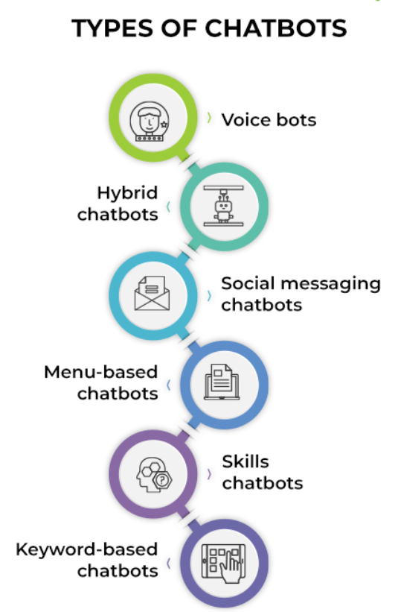

* **Voice bots**

A voice bot is an artificially intelligent and NLU-enabled system for voice-to-text and text-to-speech communication. Artificial intelligence helps pick out important cues in communication and figure out how to best respond. After the conversation is started, the text-to-speech (TTS) engine turns the text into voice.

* **Hybrid chatbots**

A hybrid chatbot combines the finest features of chatbots with human chat operators. If a consumer has a query that can't be answered by the help system's bots, they may always talk to a human being in real time.

* **Social messaging chatbots**

These days, businesses may use a single artificial intelligence algorithm across all of their customers' favourite message channels, thanks to the proliferation of new social networking interfaces. These include not just WhatsApp and WeChat but also Messenger on Facebook, Twitter, and Instagram.

* **Menu-based chatbots**

Menu-driven chatbots are the most basic form of this technology currently available. These chatbots often operate according to a predetermined decision tree presented to the user in the form of menu options. These chatbots (much like the automated dial pad menus on telephones) need the user to go through a series of steps, selecting possibilities that seem like the best fit, before arriving at the desired result.

* **Skills chatbots**

A chatbot with skills is a kind of bot whose functionality may be expanded with the help of predefined skills software in order to carry out a certain set of activities. The chatbot may be able to do things like tell you the weather, switch off your lights if they're linked to a smart device, do an online grocery purchase, etc.

* **Keyword-based chatbots**

In contrast to menu-based chatbots, keyword-based chatbots can accurately respond to user input. These chatbots employ natural language processing (NLP) and user-defined keywords to identify action triggers in a discussion and provide the relevant response.

* **Rules-based chatbots**

If you have a good sense of the kinds of questions your consumers may have, a chatbot built on a set of rules can help answer them. In order to build a chatbot, you must first determine the languages it will need to support before you can begin creating conversation flows using if/then logic.

* **AI-powered contextual chatbots**

Usually a customer relationship management (CRM) or customer data platform (CDP) system is used as the backbone of a website or app that employs contextual chatbots.

* **Support chatbots**

Support The primary purpose of chatbots is to provide consumer service and after-sale assistance. They do not share offers, promotions, or other consumer engagement materials, unlike algorithms on social media platforms or websites.

**1.1** **REFERENCES**:

Ina (2017). *The History of Chatbots - From ELIZA to Alexa*. [online] Chatbots and Voice Assistants from Onlim. Available at: <https://onlim.com/en/the-history-of-chatbots/>.

Suryadinata, A.B. (2019). *The History of Chatbots*. [online] Vutura. Available at: <https://medium.com/vutura/the-history-of-chatbots-2d5b493403c9> [Accessed 14 Apr. 2023].

The Indian Express. (2023). *Alice, Racter and Jabberwacky: A timeline of AI chatbots before ChatGPT and Bard*. [online] Available at: <https://indianexpress.com/article/technology/artificial-intelligence/timeline-of-ai-chatbots-before-chatgpt-and-bard-8436004/>.

Adaptive Learning in ELT. (2016). *Chatbots*. [online] Available at: <https://adaptivelearninginelt.wordpress.com/2016/12/01/chatbots/> [Accessed 14 Apr. 2023].

**IMAGE REFERENCES**

Aesthetic-programming.net. (2023). Available at: <https://aesthetic-programming.net/pages/ch10_5.png> [Accessed 14 Apr. 2023].

Classicreload.com. (2023). Available at: <https://classicreload.com/sites/default/files/dr-sbaitso.png> [Accessed 14 Apr. 2023].

Internationalaccountingbulletin.com. (2023). Available at: <https://www.internationalaccountingbulletin.com/wp-content/uploads/sites/9/2021/05/alice-bot.jpg> [Accessed 14 Apr. 2023].

Anpoimages.com. (2023). Available at: <https://static1.anpoimages.com/wordpress/wp-content/uploads/2022/06/Amazon-Alexa.jpg> [Accessed 14 Apr. 2023].

**1.2 REFERENCES:**

**SIGNIFICANCE OF CHAT BOT**

Marketing, A.S.-E.T.S. & (2022). *The significance of using Conversational AI: Chatbot*. [online] Fakhroo IT Services. Available at: <https://www.fakhroo.net/post/the-significance-of-using-conversational-ai-chatbot> [Accessed 14 Apr. 2023].

Spiceworks. (n.d.). What Is a Chatbot? Meaning, Working, Types, and Examples. [online] Available at: <https://www.spiceworks.com/tech/artificial-intelligence/articles/what-is-chatbot/>.