# Universal Data Analysis Tool

A powerful, user-friendly web app for analyzing any Excel or CSV file—no coding required!

Built with **Streamlit** and **Pandas**, this tool empowers anyone to explore, summarize, and visualize their data with just a few clicks.

---

## 🚀 Features

- **Upload any Excel or CSV file** (no template required)

- **Automatic detection of numeric columns**

- **Interactive data preview** with filtering

- **Descriptive statistics** (mean, median, min, max, std) for selected columns

- **Plain-language summary insights** for easy understanding

- **Conditional formatting** to highlight key values

- **Compare any rows and columns** side-by-side

- **Visualizations:**

- Bar chart

- Line chart

- Box plot

- **Export** statistics, comparisons, and plots (CSV, Excel, PNG)

- **No coding skills required!**

---

## 🖥️ How to Use

1. **Clone or download this repository**

2. Install requirements:

```bash

pip install -r requirements.txt

```

3. Run the app:

```bash

streamlit run main.py

```

4. Open your browser to the provided local URL

5. Upload your Excel/CSV file and start exploring!

---

## 📊 Example Use Cases

- Quickly summarize large datasets

- Compare sales, grades, or any metrics across different entries

- Visualize trends and distributions

- Export insights for reports or presentations

---

## 🤝 Who Is This For?

- Business analysts

- Students and educators

- Researchers

- Anyone with data in Excel/CSV format!

---

## 🛠️ Tech Stack

- Python

- Streamlit

- Pandas

- Matplotlib

---

## 🌐 Demo

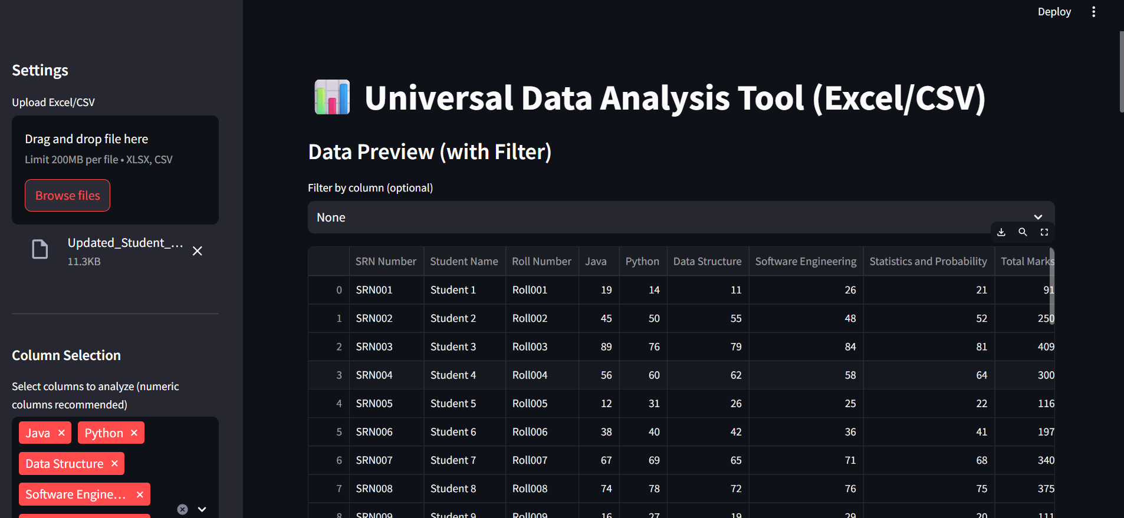 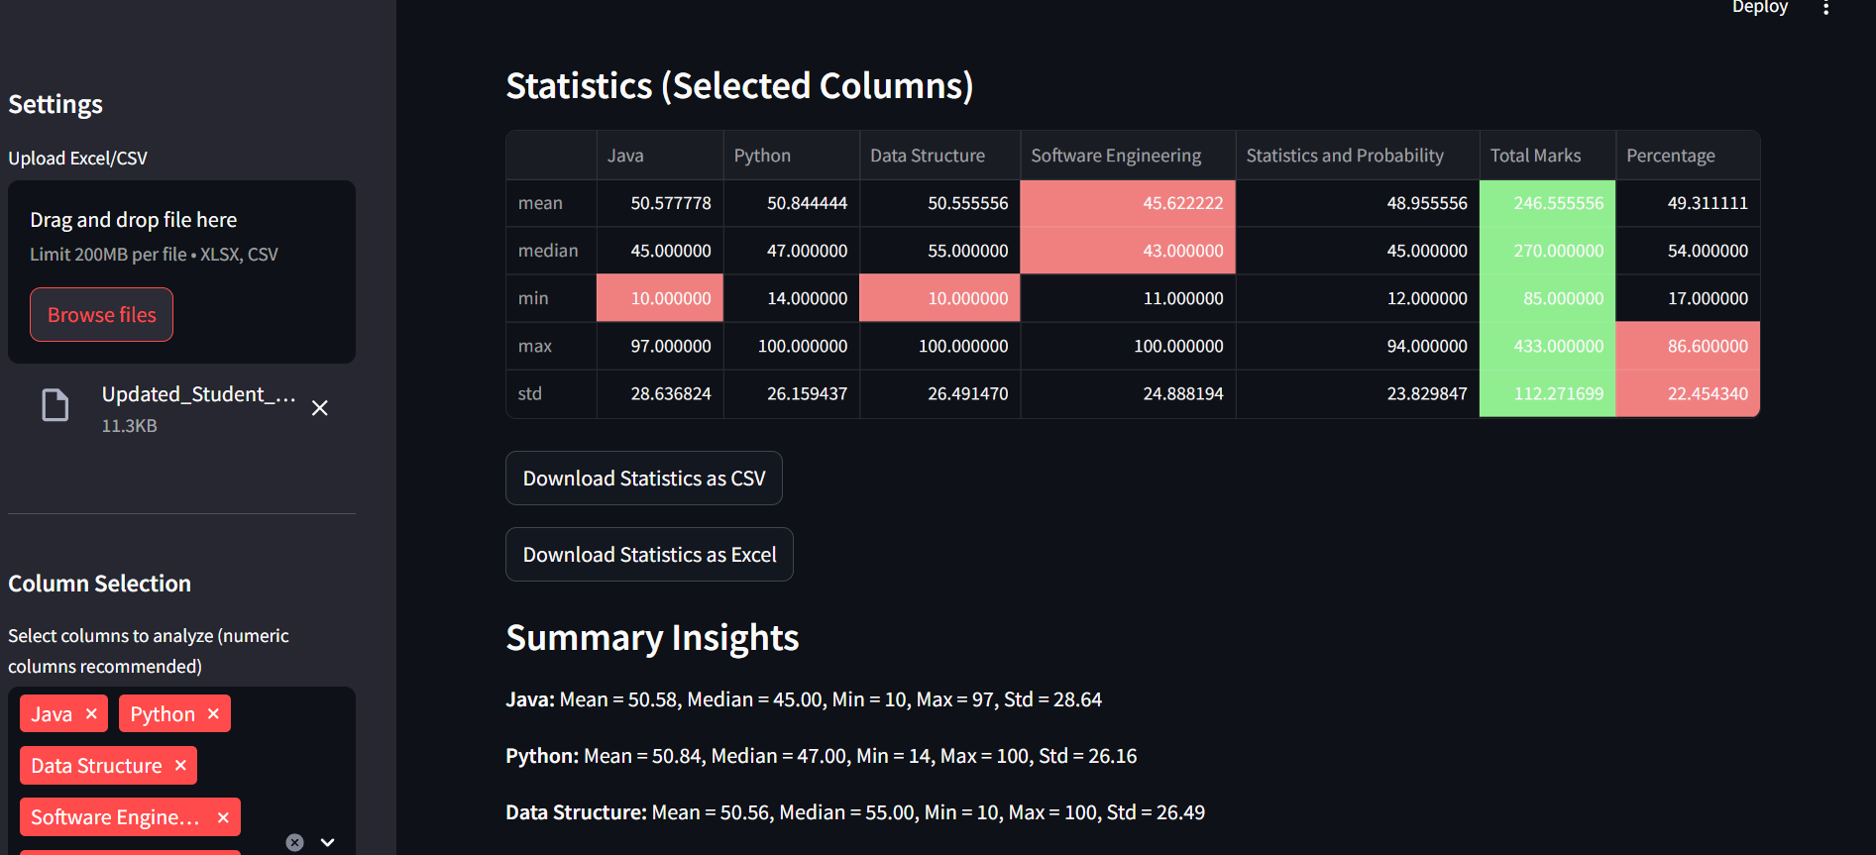

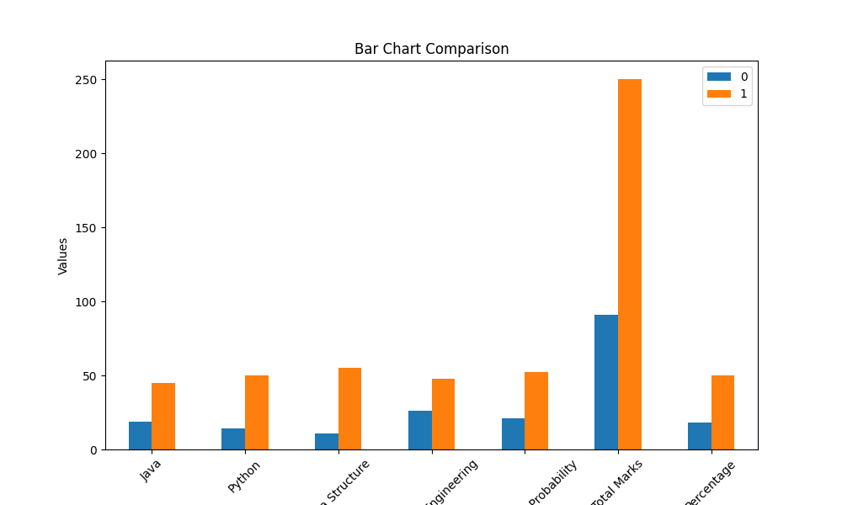

---

## 📣 Connect

If you like this project, feel free to star ⭐ it on GitHub and connect with me on [LinkedIn]( https://www.linkedin.com/in/ali-shaikh-75569931a/)!

_You can personalize this section with your own LinkedIn link and GitHub profile._

---