# **THE NEARLY EXTINCTION OF BEES AND FUTURE OF THE ROBOBEES**

| Duvan Ramírez.  Eafit University.  Colombia.  daramirezs@hotmail.com | Santiago Santacruz Ramirez.  Eafit University.  Colombia.  ssantacrur@eafit.edu.co | Mauricio Toro  Universidad Eafit  Colombia  mtorobe@eafit.edu.co |
| --- | --- | --- |

# **ABSTRACT**

It is well known that all around the world, several species of bees are listed as endangered species, which is a problem due to the fact that bees are one of the most important pollinators and are responsible of about the 70% of the food that is consumed worldwide because it depends on pollination. On the other hand, a big part of the Terrestrial biodiversity depends largely on pollination, which implies that the extinction of bees embrace a complete change in the earth and in the way our lives are going on, affecting the things we eat, the clothes we wear and the plants and animals that surround us. This is why this essay have the purpose to analyse the problematic that revolves around the extinction of the bees and the facts that influence their disappearance. As well as coming up with solutions that get to brake the actual problem.

## **Keywords**

Data structure, nodes, HashMap, data, LinkedList, especial hash.

# **1.** **INTRODUCTION:**

Since the beginning, humans have been individuals that make changes over the time, we advance in terms of technology, science and economy. The first and second industrial revolution bring benefits like exportation and articles production, whoever while the enterprises were growing along with the economy of the countries, the demand of more primary products brings more contamination like water, atmospheric and land pollution. These facts affects the equilibrium of the ecosystem, putting in danger animals, some of them are already extinct and were essential for the ecosystem. Nowadays the bees are the principal species that have a very important task, this specie is in charge of pollination of the plants and in an indirect way they contribute more than 80% of the food production of the world, but the human being push this specie at the edge of extinction. We need to generate some solutions for this problem, and this document have the purpose to give a solution of a alternative that are electronic bees, using algorithms pre-programmed taking into account the cardinal position of every bee ant their spatial dimensions.[1]

**2. PROBLEM**

The use of insecticides (such as neonicotinoids), climate change and loss of habitat with the human invasion on wild ecosystems, have led to the deaths of millions of honeybees and put at risk of extinction to many of these. With the permanent artificial bees implementation, plants pollination can be achieved globally (or at least nationally) in case this crisis worsens. with this it is not intended to allow bees to become extinct and we supplant them but rather to look for alternatives to solve a global problem such as the disappearance of 70% of the food we consume daily

**3. TRABAJOS RELACIONADOS**

The alternative that we want to implement are the robobees, that could perform the same activities as the bees but there are problems with the collision they can have if they are close to each other, so we present some data structured alternatives so we can solve this type of problem.

**3.1 The Quadtree**

“Quadtree” is a type of data structure invented by Jon Bentley in 1970, where each original or parent node has four lower-level or subsequent child nodes, where each element is continually split into four pieces. These are used to efficiently store data of points on a two-dimensional space. These data structure can be used to detect collisions in some video games like worms, and also it could be used to detect collisions in robobees. figure 1.

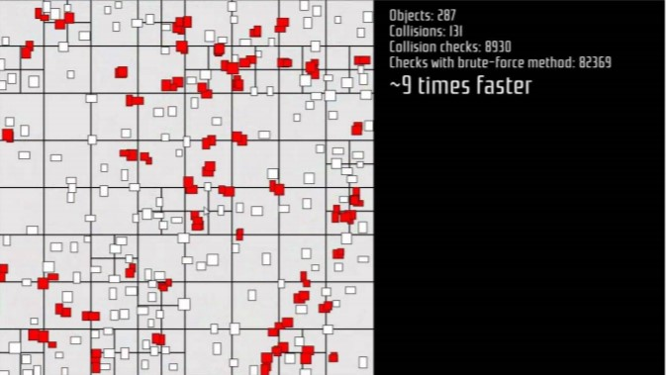

Vinh, T. SFML-Quadtree Collision Detection, 14 october 2012. Retrieved february 17,2019, from YouTube: <https://bit.ly/2DTyK0i>

**Figure 1.**

## **3.2 Spatial hashing**

## “Spatial hashing” is a 2 or 3 dimensional extension of the hash table, and then is projected into a 1d hash table, allowing fast location of objects and if they collide. If there are many objects, they part the space so only you need to verify if they are about to collide. For the Robobees problem, it could be used because if the number of robobees are too many, the spatial hashing will help to determinate only the ones that are close. Figure 2.

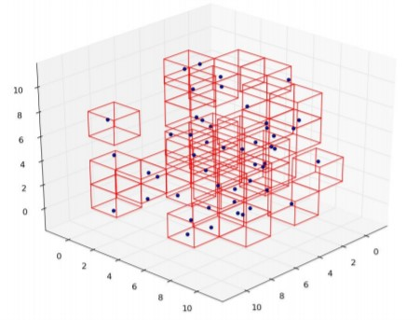

Spatial Hashing in C++, Part 1, 23, july 2016 . Retrieved february 15,2019, from My Internet Weblog: <https://bit.ly/2GwK3Pr>.

**Figure 2.**

**3.3 AABB tres**

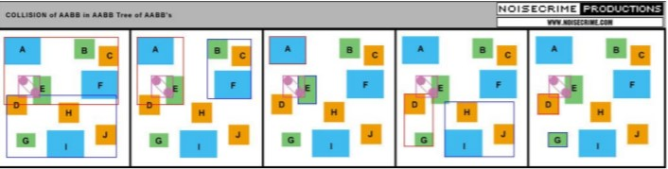AABB trees is a simply binary tree, where all the AABB are stored at the leave. The main advantage for this kind of broad-phase is that this is a border-less data structure, and it doesn’t require you to explicitly specify an area which other kinds of data structures such as grids or QuadTrees require. These data structure is not as optimize as other data structure like the spatial hashing, because it will need to compare all the squares that are in the position. But it can be used for objects collision. Figure 3.

**Figure 3.**

Jungle, B. AABB Tree - Where's the poly o_O?, March 22, 2005. Retrieved february 17,2019. from gamedev: https://bit.ly/2Sa0T8n

**3.4 Separate axis theorem (SAT)**

The “SAT” is a method to determine if two convex shapes are intersecting. The algorithm can also be used to find the minimum penetration vector which is useful for physics simulation and a number of other applications. SAT is a fast generic algorithm that can remove the need to have collision detection code for each shape type pair thereby reducing code and maintenance. 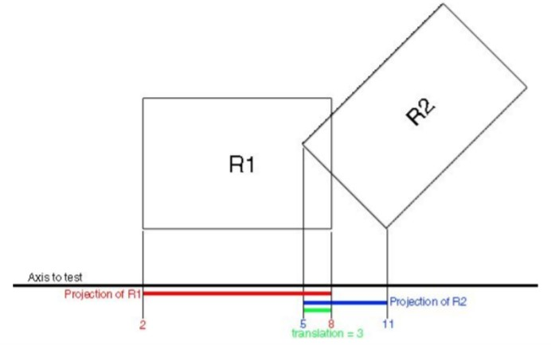

Translation direction in separating axis theorem, december 2013. Retrieved february 17,2019.from stackoverflow: <https://bit.ly/2SGKAVr>

**.**

## **4.Spatial Hash**

## 

## **4.1 Data structure operations**

Compare:

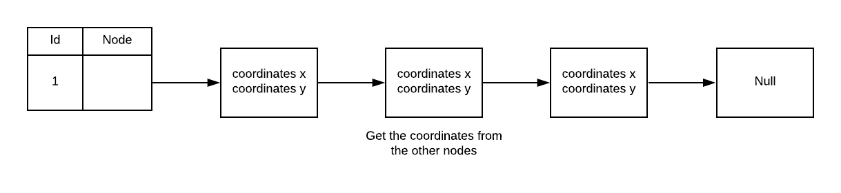This method compare the bees belonging to the key that they have, the coordinates of each one are in a linked list. This method is important to calculate the distance in another method. Figure 4.

**Figure 4.**

This method add a key to a new bee.

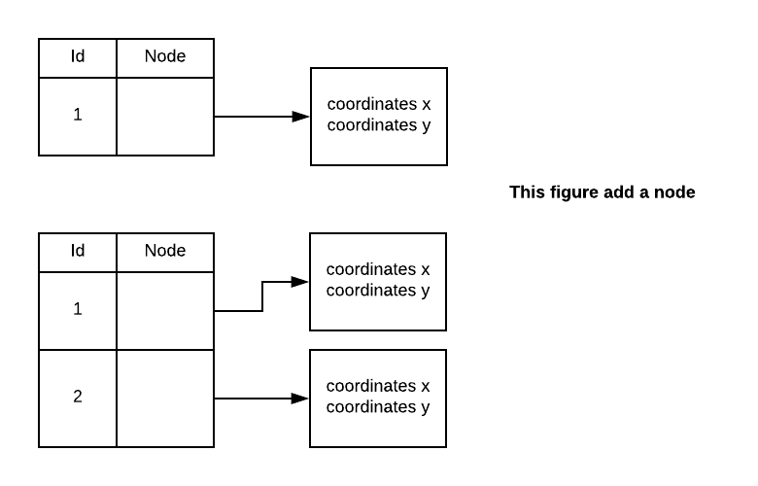

Distance:

This method calculates the distance between two points, and if the hypotenuse is equal or greater than 100 these two bees are colliding. Figure 5.

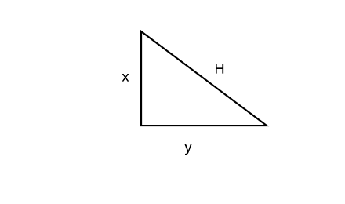

**Figure 5.**

NewBee:

This method use the file reading to create a bee.

**4.2 Criteria of the data structure**

Our team select this data structure in base of the Big O-notation of the different types of data structures, we focus on the search of the data, because we need to analyse all the bees that are in the same key in the hash map,. The function Hash map has a complexity of O(1), so it is very effective in the search of a very bast number of data.

**4.3 Analysis Complexity**

|  |  |
| --- | --- |
| Method | Complexity |
| NewBee | O(1) |
| Distance | O(nLong(n)) |
| Insert | O(1) |
| Compare | O(nLong(n)) |

## **4.4 Process Time**

|  |  |  |  |  |  |
| --- | --- | --- | --- | --- | --- |
|  | Data set 1 | Data set 2 | Data set 3 | Data set 4 | Data set 5 |
| Operation 1 | 1 millis | 1 millis | 3 millis | 12 millis | 140 millis |
| Operation 2 | 1 millis | 2 millis | 4 millis | 15 millis | 169 millis |
| N Operation | 2 millis | 1 millis | 3 millis | 15 millis | 145 |

## **4.6 Analysis of results.**

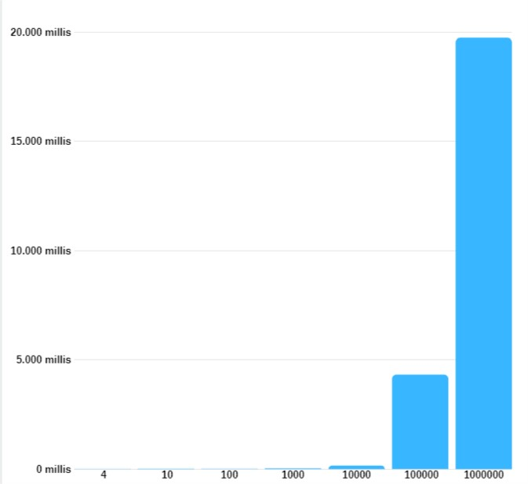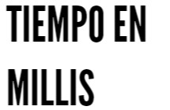

In the program, while the data increases, the execution time increases. Fortunately for the one houndred data taken from each data set, the problem does not reach his worst case.

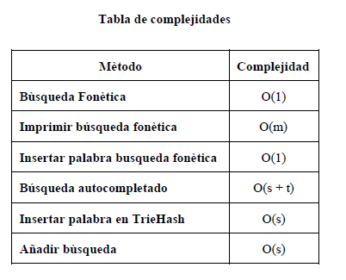

# **REFERENCIAS**

Referenciar las fuentes usando el formato para referencias de la ACM. Léase en <http://bit.ly/2pZnE5g> Vean un ejemplo:

1.Adobe Acrobat Reader 7, Asegúrense de justificar el texto. <http://www.adobe.com/products/acrobat/>.

2. Fischer, G. and Nakakoji, K. Amplifying designers’ creativity with domainoriented design environments. in Dartnall, T. ed. Artificial Intelligence and Creativity: An Interdisciplinary Approach, Kluwer Academic Publishers, Dordrecht, 1994, 343-364.