|  |  |  |  |
| --- | --- | --- | --- |
|  |  | **Command Line Basics** |  |

|  |
| --- |
| **Your Tasks (Mark these off as you go)** |
| * Open the command line * List the contents of a directory * Navigate between directories * Create directories * Have Ms. Pluska check off Create directories, Navigate between directories, and List contents of a directory before you continue * Create a file * Rename a file * Have Ms. Pluska check off Create a file and Rename a file before you continue * Remove a file * Remove a directory * Create your AP Computer Science A directories * Have Ms. Pluska check off Create your AP Computer Science A course directories and Work with your partner * Receive credit for the group portion of this lab |

* **Open the command line**

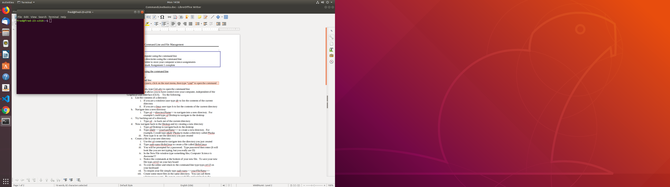The command line, also referred to as the terminal, provides you a means of interacting with your computer. All the programs you write in this class can be ran (and compiled) using the command line. If you want to be a serious programmer, or even half serious, you must learn the command line.

Although the command line may seem intimidating at first, over the course of the year, you will come to appreciate its utility and power.

To locate the command line on Linux type ctrl-alt-t

Windows users, click on the start menu, then type “cmd” to open the command line

If all goes well, you should see screen similar to the one shown to the right.

* **List the contents of a directory**

Directories are just folders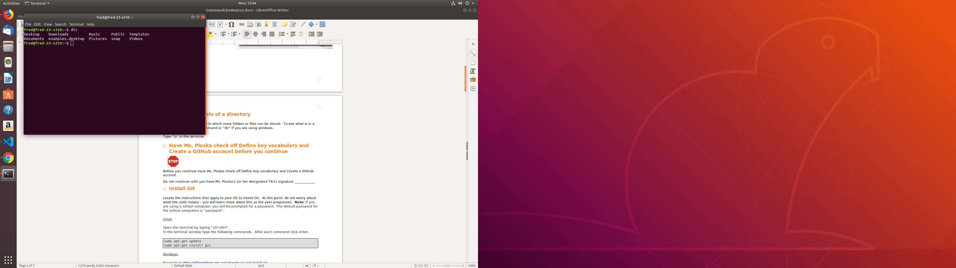 in which more folders or files can be stored. To see what is in a directory, use the “ls” command or “dir” if you are using windows.

* Type “ls” in the terminal to display the contents of your home directory.
* Indicate the names of the folders and files you see below. If you see more than 5, just list the first 5.

|  |
| --- |
|  |

* **Navigate between directories**

To navigate to a different directory use the “cd” command. For example, if I want to navigate to the Desktop directory, I would type “cd Desktop”.

What if you want to back out of a directory? To do this, use the “cd ..” command.

* Try navigating into the different directories from your home directory using the “cd” command, then once inside the new directory try listing the contents using the “ls” command. Remeber to use the “cd ..” command to return to the home directory each time.

If you computer is new, or you are using a school computer, you probably didn’t see much. But there is a ton of stuff stored on your computer – lets go find it!

* From the home directory, type “cd ..”. This command will move us one level higher than the home directory where we started. Once there type “ls”
* Now type “cd ..” again to go up yet another directory. Once there type “ls” again.
* Write the names of the first five directories you see below,

|  |
| --- |
|  |

Go explore these directories... Try not to get lost. If you do get lost type “cd ~” to return to the home directory.

* **Create directories**

To make a directoy you will use the “mkdir” command followed by the name of the directory you want to create. For example the following command would create a directory called APComSciA.

mkdir APCompSciA

* Navigate to the Desktop. Create a directory called APCompSciA using the mkdir command.
* Now navigate inside the APCompSciA directory you just created and create a few more directories. Call these “Labs”, “Projects”, and “Tutorials”

**NOTE**: NEVER put spaces between directory names or file names

**NOTE**: ALWAYS use “camel case”. Camel case means you start all names with a upper or lower case letter, and capitalize only the first letter of each word that follows. Examples include: homeworkFiles, myStuff, pluskaComputerScience.

* **Have Ms. Pluska check off Create directories, Navigate between directories, and List contents of a directory before you continue**



Before you continue have Ms. Pluska check off Create directories, Navigate between directories, and list contents of a directory

Do not continue until you have Ms. Pluska’s (or her designated TA’s) signature ___________

* **Create a file**

Linux has several built in text editors. In this class we will utilize gedit. You can easily create a new file using gedit using the following command. The command below will create a new file called testFile.java.

gedit testFile.java

Once you type this command the editor will automatically open and you can begin adding content.

**NOTE**: Where you are when you type the command is where the file will be created

**NOTE**: Never put spaces between directory names or file names

**NOTE**: ALWAYS use “camel case”. Camel case means you start all names with a upper or lower case letter, and capitalize only the first letter of each word that follows. Examples include: homeworkFiles, myStuff, pluskaComputerScience.

* In each of the directories you just created, create a file using the gedit <filename> command. You can call these files whatever you like. Add some content to each file.
* Be sure to save each file.
* **Rename a file**

The “mv” command can be used to rename a file. The following command could be used to rename testFile to testFile2 for example

mv testFile testFile2

* Navigate to each of the files you created above. Rename each file as follows: testFile1, testFile2, testFile3

**NOTE**: Never put spaces between directory names or file names

**NOTE**: ALWAYS use “camel case”. Camel case means you start all names with a upper or lower case letter, and capitalize only the first letter of each word that follows. Examples include: homeworkFiles, myStuff, pluskaComputerScience.

* **Have Ms. Pluska check off Create a file and Rename a file**



Before you continue have Ms. Pluska check off Create a file and Rename a file

Do not continue until you have Ms. Pluska’s (or her designated TA’s) signature ___________

* **Remove a file**

The “rm” command can be used to remove a file. The following command could be used to rm the testFile1 file you created previously,

rm testFile1

* Remove testFile1 and testFile2. Keep testFile3 however!
* **Remove a directory**

If you have been following along correctly to this point you should have the following file hierarchy something like the one shown below.

APCompSciA

Labs

Projects

Tutorials

- testFile3

Notice that two of the directories above (Labs and Projects are empty), but Tutorials contains a file.

The following command could be used to remove the Labs directory,

rmdir Labs

But if you were to try the following you would get an error. Why? because it is not empty.

rmdir Tutorials

The following command could be used to remove the Tutorials directory however,

rm -rf Tutorials

**NOTE**: Be cautious when removing files and directories from the command line. They DO NOT go in the garbage. They are removed from the machine permanently!

* Remove the Labs and Projects directories using the “rmdir” command
* Remove the tutorials directory using the “rm -rf” command
* **Create your AP Computer Science A course directories**

This course is largely broken down into labs, projects, and exams.

* To help you stay organized in the course, create three directories inside your APCompSciA folder called “Labs”, “Projects”, “Exams”
* Feel free to add additional folders now or later as we progress through the course.
* **Work with your partner**

Before you complete this lab, BOTH group members must have an APCompSci directory created with the appropriate subfolders.

* Work together to make sure you are set for the class!
* **Have Ms. Pluska check off Create your AP Computer Science A course directories and Work with your partner**



Before you continue have Ms. Pluska check off Create your AP Computer Science A course directories and Work with your partner

Do not continue until you have Ms. Pluska’s (or her designated TA’s) signature ___________

* **Receive Credit for the group portion of this lab**

Make sure Ms. Pluska has signed off all STOPS. Make sure to indicate the names of all group members, then submit this lab to the needs to be graded folder to receive credit for the group portion of this lab.