|  |  |  |  |
| --- | --- | --- | --- |
|  |  | **GitHub Workshop** |  |

|  |
| --- |
| **Your Tasks (Mark these off as you go)** |
| * Define key vocabulary * Create a GitHub account * Have Ms. Pluska check off Define key vocabulary and Create a GitHub account before you continue * Install Git * Set the Git commit username and email * Have Ms. Pluska check off Install Git and Set the Git commit username and email before you continue * Fork a repository * Clone a repository to your computer * Calculate your bit rate * Watch the video: Wires, Cables, & WiFi and complete the reflection questions * Receive credit for the group portion of this lab |

* **Define key vocabulary**
* Open up your browser and search for definitions to the following terms as they relate to “Git”. For example you could type “Git vocabulary”.
* Work with your partner to write definitions for the following terms.

|  |  |
| --- | --- |
| **Git** |  |

|  |  |
| --- | --- |
| **GitHub** |  |

|  |  |
| --- | --- |
| **repository** |  |

|  |  |
| --- | --- |
| **local** |  |

|  |  |
| --- | --- |
| **remote** |  |

|  |  |
| --- | --- |
| **commit** |  |

|  |  |
| --- | --- |
| **push** |  |

|  |  |
| --- | --- |
| **clone** |  |

|  |  |
| --- | --- |
| **fork** |  |

|  |  |
| --- | --- |
| **pull** |  |

|  |  |
| --- | --- |
| **origin/master** |  |

* **Create a GitHub account**

Navigate to the following address,

<https://education.github.com/students>

Locate the “Get Benefits for Students” button and click on it.

Locate the “Create an account” link and click on it.

Create your account when prompted

* **Have Ms. Pluska check off Define key vocabulary and Create a GitHub account before you continue**



Before you continue have Ms. Pluska check off Define key vocabulary and Create a GitHub account

Do not continue until you have Ms. Pluska’s (or her designated TA’s) signature ____________

* **Install Git**

Locate the instructions that apply to your OS to install Git. At this point, do not worry about what the code means – you will learn more about this as the year progresses. **Note**: If you are using a school computer, you will be prompted for a password. The default password for the school computers is “password”.

Linux

Open the terminal by typing “ctrl-alt-t”.

In the terminal window type the following commands. After each commend click enter.

|  |
| --- |
| sudo apt-get update  sudo apt-get install git |

Windows

Navigate to [https://gitforwindows.org](https://gitforwindows.org/)and download and install git

Mac

Open a Terminal on your Mac. Now, type the following command into your Terminal.

|  |
| --- |
| git --version |

If you don’t have git installed already, it will prompt you to install it.

* **Set the Git commit username and email**

Anyone who has access to your repository can see your commits and the email address associated with them. Since we're using the free account right now, we need to use the no-reply email address that GitHub gives you as your commit email in order to stay safe online. To find it, go to the Email page under your account's Settings page and look at the "Primary Email" section below. Below are some pictures to help you find it:

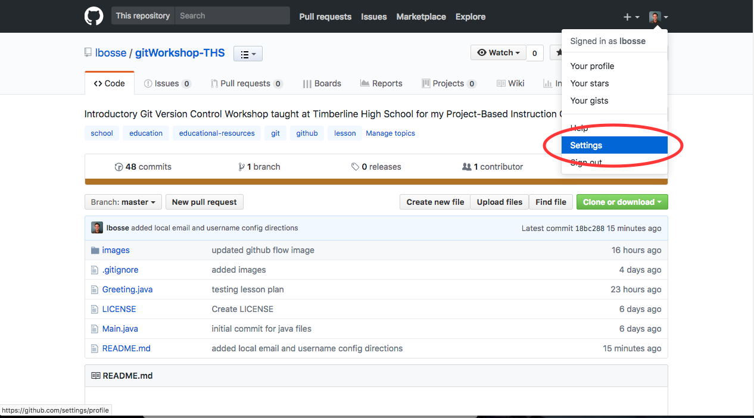

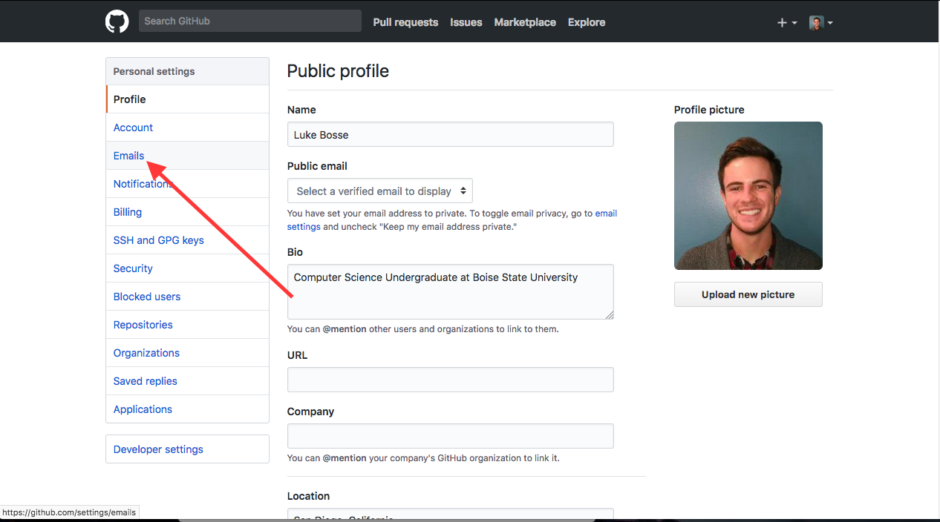

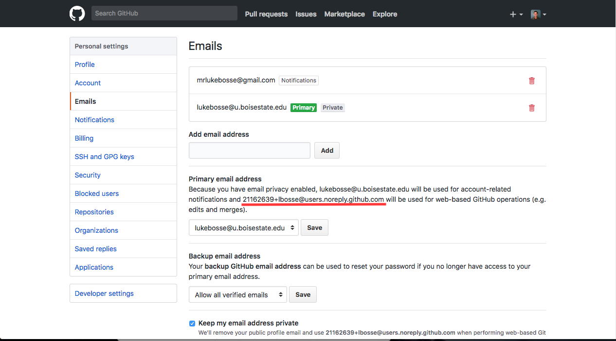

* Once you locate the no-reply email, highlight it and copy it to your clip board (ctrl-c).
* Now open your command line and type the following. Replace “<your-name-here”>” with your user name. Replace “<your-email-here>” with the email you copied to your clip board. To paste in the command line type ctrl-shift-v. NOTE: Do not include quotes. Do not include < or >.

|  |
| --- |
| git config --global user.name “<your-name-here>”  git config --global user.email “<your-email-here>” |

|  |
| --- |
| git config --list |

* **Have Ms. Pluska check off Install Git and Set the Git commit username and email before you continue**



Before you continue have Ms. Pluska check off Install Git and Set the Git commit username and email

Do not continue until you have Ms. Pluska’s (or her designated TA’s) signature ____________

* **Fork and repository**
* Navigate to <https://github.com/TimberlineCS/GitWorkshop.git>
* Click the "Fork" button in the upper right hand corner of the screen. This will create your own personal copy of the repository in your account, where you can modify it freely without changing the code in my repository. This is often used when using someone else's code as a starting point for your own project or for proposing changes to their project.
* You should now see your own copy of this repository on your Github profile page! Click on the repository name to go to it's page.
* Click on the "Settings" tab right underneath the "Fork" button to go to the settings page. Then click the "Collaborators" button on the menu on the left side of the settings page. Use the search box to search for my username (**hpluska**) to add me as a collaborator on your repository. This will allow me to see your code and assess whether or not I did a good job teaching this lesson :)
* Click on the "Code" tab on the right side of the screen to go back to your files. You'll see a lot of buttons and options on this page! We'll get to those shortly. For now, click on the **"Clone or Download"** button and copy the link it gives you. You can also download it as a .zip file, but we're going to do things the cool way ;)
* **Clone a repository to your computer**

A **bit rate** is a measure of how fast a system transmits bits. You can calculate your protocol’s bit rate by dividing the number of bits sent by the amount of time it takes. Note, if you send 4 bits back and forth, you’ve actually transmitted 8 bits (4 bits to your partner + 4 bits back to you equals 8 bits)

Try sending an 8 bit signal to your partner and have them send it back for a total of 16 bits. How long does this take? Record the bits, the time, and the bit rate for your best run.

Bits Transmitted: __________ Time in Seconds: __________ Bit rate: ________ bits/sec

* **Watch the video: Wires, Cables, and WiFi and complete the reflection questions**

Following the link below to watch the vide: Wires, Cables, and WiFi

<https://www.youtube.com/watch?v=ZhEf7e4kopM>

Once you have completed the video, complete the following reflection question.

Now that you have completed the lesson, in your group discuss what you think is meant by each term. Write definitions to these terms below,

|  |  |
| --- | --- |
| **Bit** |  |
| **Bandwidth** |  |
| **Bit Rate** |  |
| **Latency** |  |

Why is it important to communicate a timing protocol prior to sending a message?

|  |
| --- |
|  |

Base on what you saw in the video, indicate the pros and cons of each of the following,

|  |  |  |
| --- | --- | --- |
|  | **Pros** | **Cons** |
| **Electricity** |  |  |
| **Light** |  |  |
| **Radio waves** |  |  |

Where is copper wire most commonly used? Why don’t we use it everywhere?

|  |
| --- |
|  |

Where is fiber-optic cable most commonly used? Why don’t we use it everywhere?

|  |
| --- |
|  |

Where are radio waves most commonly used? Why don’t we use them everywhere?

|  |
| --- |
|  |

* **Receive Credit for the group portion of this lab**

Make sure to indicate the names of all group members, then submit this lab to the needs to be graded folder to receive credit for the group portion of this lab.